Space-Based AI Data Centers — A Complete Engineering Treatise
Samarjith Biswas, PhD
Table of Contents

Space-Based AI Data Centers

A Complete Engineering Treatise: Physics, Mathematics, Simulation, and Economics

Report II (Complete Edition) — a book-length systems study
Author: Samarjith Biswas, PhD Edition: June 2026 · verified-data, research-backed, fully reproducible Reference architecture: Google Project Suncatcher (arXiv:2511.19468) Companion code: github.com/Samarjithbiswas/space-based-ai-datacenter (17-subsystem model, 108 tests)

Abstract
Space-based artificial-intelligence computing moved from concept to flight demonstration in 2025-2026. This treatise is a single, self-contained engineering volume that derives, from first principles, the complete physical and economic model of an orbital AI data center, implements every model in open and validated code, and reports the results, sensitivities, and predictions. It spans seventeen subsystems — orbital mechanics, the neutral atmosphere and orbital decay, the ionizing-radiation and orbital-debris environments, thermal control, electrical power, structures, attitude control and optical pointing, inter-satellite and ground communications, propulsion and disposal, reliability, compute and workload, and techno-economics — and closes them into one self-consistent design point and constellation. Each chapter presents the governing equations with their derivations and worked numerical examples, the simulation that produces the results, and a discussion of what the result means. The central conclusions are that radiative cooling is the solved part of the problem and is now flight-proven; that the binding, unsolved constraints are orbital-debris survivability in a tight formation, credible end-of-life disposal, and economics; and that the launch-cost parity which underwrites the business case is later and less certain than commonly advertised. Every load-bearing fact is cited to a primary source, every forward-looking number is flagged as a projection, and every figure and number is regenerated by the accompanying open-source model.

Table of contents
Front matter — Abstract · Nomenclature · Physical constants
Part I — Introduction and context 1. Introduction and motivation 2. The state of the art (verified, 2025-2026) 3. Reference architecture and scope
Part II — The orbital environment 4. Orbital mechanics of a circular orbit 5. Sun-synchronous orbits and J2 precession 6. Eclipse geometry and the dawn-dusk advantage 7. The neutral atmosphere and orbital decay 8. The ionizing-radiation environment 9. The orbital-debris environment
Part III — Spacecraft subsystems 10. Thermal control 11. Electrical power 12. Structures and mass 13. Attitude determination and control; optical pointing 14. Communications: inter-satellite and ground 15. Propulsion and end-of-life disposal 16. Reliability and constellation availability 17. Compute and workload
Part IV — Integration, simulation, and results 18. The integrated system model 19. Uncertainty quantification and sensitivity 20. Results: reference design point and constellation
Part V — Economics and predictions 21. Techno-economics: cost, NPV, and the levelized cost of compute 22. The launch-cost-parity prediction 23. Capability and risk trajectory, 2027-2035
Part VI — Synthesis 24. Honest caveats and limitations 25. Conclusions and the recommended demonstrator
Part VII — Detailed results, data, and worked computations 26. A worked end-to-end computation 27. Detailed results tables (T1-T13) 28. Constellation design and relative dynamics 29. Comparison with terrestrial data centers
Back matter — References · Appendix A: master equation list · Appendix B: nomenclature · Appendix C: data sources and confidence · Appendix D: reproduction and code

Nomenclature
Symbol | Meaning | Units
$μ$ | Earth gravitational parameter | $m^{3} s^{−2}$
$R_{E}$ | Earth mean radius | $m$
$J_{2}$ | Earth oblateness coefficient | –
$a, h, r$ | semi-major axis, altitude, orbital radius | $m$
$v, n, T$ | speed, mean motion, period | $m/s, rad/s, s$
$E$ | specific orbital energy | $J/kg$
$ρ$ | neutral atmospheric density | $kg/m^{3}$
$C_{D}, A/m$ | drag coefficient, area-to-mass ratio | – , $m^{2}/kg$
$σ, ε, α_{s}$ | Stefan-Boltzmann constant, emissivity, solar absorptivity | $W/m^{2}K^{4}$, – , –
$T, Q, R_{th}$ | temperature, heat load, thermal resistance | $K, W, K/W$
$S_{0}, F, a_{alb}$ | solar constant, view factor, Bond albedo | $W/m^{2}$, – , –
$Φ, N_{f}, r_{t}$ | debris flux, fragment count, target radius | $m^{−2}yr^{−1}$, – , $m$
$Δv, I_{sp}$ | velocity increment, specific impulse | $m/s, s$
$G, L_{fs}, λ, D$ | telescope gain, free-space loss, wavelength, aperture | dB, dB, m, m
$MTBF, R(t)$ | mean time between failures, reliability | h, –
$η, MFU, PUE$ | efficiency, model-FLOPs utilization, power-usage effectiveness | –
$r, CRF, NPV$ | discount rate, capital-recovery factor, net present value | – , – , USD

Physical constants
Symbol | Value
$μ$ | $3.986004418×{10}^{14} m^{3}s^{−2}$
$R_{E}$ | $6.371×{10}^{6} m$
$J_{2}$ | $1.08263×{10}^{−3}$
$σ$ | $5.670374×{10}^{−8} W m^{−2}K^{−4}$
$h_{P}, k_{B}, c$ | $6.62607×{10}^{−34} J s$, $1.38065×{10}^{−23} J/K$, $2.99792458×{10}^{8} m/s$
$g_{0}$ | $9.80665 m/s^{2}$
$S_{0}$ | $1361 W/m^{2}$
$T_{CMB}$ | $2.725 K$
$a_{alb}, q_{IR}$ | $0.30$, $237 W/m^{2}$

PART I — INTRODUCTION AND CONTEXT

1. Introduction and motivation
The energy and thermal demands of artificial-intelligence computing have grown faster than terrestrial infrastructure can comfortably absorb. Training and inference clusters are now provisioned in tens to hundreds of megawatts; cooling, water, land, and grid interconnection have become first-order constraints. Against this backdrop, placing computation in orbit is no longer purely speculative. Orbit offers three physical advantages that are real and quantifiable: a continuous, high-flux solar resource in the right orbit; an effectively unlimited radiative heat sink at the 2.725 K cosmic-microwave-background temperature; and freedom from terrestrial land and water constraints. It also imposes severe penalties: a harsh radiation environment, a congested and debris-laden orbital neighborhood, the impossibility of hands-on repair, the cost of launch, and a regulatory obligation to dispose of the hardware responsibly.
The purpose of this treatise is neither advocacy nor dismissal. It is to build the complete engineering model of an orbital AI data center from first principles, to compute the numbers honestly, and to state plainly which problems are solved and which are not. The first report in this series (November 2025) examined a single question — whether passive radiative cooling can keep a processor within its junction-temperature limit in low Earth orbit — and answered yes. This complete edition addresses the entire system: not only whether the chip stays cool, but whether the spacecraft survives, communicates, points, powers itself, disposes of itself, and pays for itself.
The work is organized as a book so that each result can be traced from physical principle, through derivation and code, to a number with an uncertainty band and a citation. Where the analysis corrects an earlier assumption or contradicts a popular claim, it says so. Where a number is a vendor projection rather than a demonstrated capability, it is flagged. The accompanying software is open, validated by 108 automated tests, and reproduces every figure and value in this volume with a single command.

2. The state of the art (verified, 2025-2026)
Three programs anchor the field as of mid-2026, and their status has been verified against primary sources through an adversarial fact-checking process.
Google Project Suncatcher. The reference architecture for this study. Google’s research paper (arXiv:2511.19468) describes an illustrative constellation of eighty-one satellites arranged in a cluster of approximately one-kilometer radius, in a dawn-dusk sun-synchronous low-Earth orbit at a mean altitude of 650 km, with the satellites separated by roughly 100 to 200 m and connected by free-space optical links. Each satellite carries Google Tensor Processing Units. Google and Planet Labs have announced a learning mission to launch two prototype satellites carrying TPUs by early 2027; Planet will build and operate the platform. These facts are corroborated by Google’s and Planet’s own releases. The “by early 2027” date is a corporate target subject to slip.
Starcloud. In a significant demonstration, Starcloud flew an NVIDIA H100 GPU — the highest-power data-center-class processor flown to date — aboard the approximately sixty-kilogram Starcloud-1 satellite, launched on 2 November 2025. NVIDIA reports the satellite carries an H100 with 80 GB of high-bandwidth memory and on the order of four petaflops of AI compute. Starcloud has articulated a long-term vision of a five-gigawatt orbital data center with solar and cooling panels spanning roughly four kilometers on a side. The five-gigawatt figure is an aspirational early-2030s engineering target, not a demonstrated capability. Notably, Starcloud’s marketing claim of “ten times cheaper including launch” failed independent verification and should be treated with caution.
Axiom Space. Axiom deployed its first Orbital Data Center nodes to low Earth orbit on 11 January 2026 and has stated a goal of scaling on-orbit processing from kilowatts to megawatts on future nodes. Megawatt scale is a future goal, not current capacity; a claim that the first nodes would launch by the end of 2025 was inaccurate (actual deployment was January 2026).
The honest summary of the state of the art is a clear gap between what has been demonstrated — one data-center-class GPU in orbit, ground-based radiation testing of a TPU, a bench-scale 1.6-terabit optical link, and initial kilowatt-class nodes — and what the vision requires — megawatt-to-gigawatt clusters, flown multi-terabit formation links, dramatically cheaper launch, and validated formation station-keeping. None of the latter has been demonstrated.

3. Reference architecture and scope
Throughout this treatise the reference design follows the Suncatcher parameters: a dawn-dusk sun-synchronous orbit at 650 km, an eighty-one-satellite cluster of one-kilometer radius, and inter-satellite spacing of roughly 150 m. The reference satellite bus is taken to carry four accelerators with an avionics and support complement, consistent with the mass budget developed in Chapter 12. Where the analysis examines higher-power chips (NVIDIA H100 at 700 W, B200 at 1000 W, the GB200 GPU at 1200 W), it does so to test the scaling of each subsystem, because the trend in AI accelerators is toward higher, not lower, per-chip power.
The scope of the models is conceptual to preliminary design (Phase A in aerospace terms). The intent is to size each subsystem, rank the risks, and quantify the trades — not to produce a certifiable flight design. Several domains are treated at first order with explicit uncertainty bands, and a number of analyses that a flight program would require (a thermal finite-element model, a closed-loop attitude-control simulation, formal failure-modes analysis, and runs of the official agency debris and radiation tools) are out of scope and are identified as such in Chapter 24. This honesty about fidelity is essential: the value of the model lies in its breadth, its transparency, and its reproducibility, not in a false claim of flight accuracy.

PART II — THE ORBITAL ENVIRONMENT

4. Orbital mechanics of a circular orbit
Every subsequent chapter depends on a small set of orbital quantities, derived here.
Circular speed. For a satellite of mass $m$ on a circular orbit of radius $a$, gravity supplies the centripetal force:
$$\frac{μm}{a^{2}}=\frac{mv^{2}}{a} ⇒ v=\sqrt{\frac{μ}{a}}.$$
Period and mean motion. From $v=2πa/T$,
$$T=2π\sqrt{\frac{a^{3}}{μ}}, n=\frac{2π}{T}=\sqrt{\frac{μ}{a^{3}}}.$$
Vis-viva and specific energy. For a general orbit, energy conservation yields the vis-viva relation $v^{2}=μ\left(2/r−1/a\right)$, and the total specific energy is
$$E=\frac{v^{2}}{2}−\frac{μ}{r}=−\frac{μ}{2a}.$$
Equation (4.3) is the key to the orbital-decay derivation in Chapter 7: drag removes energy, and a loss of energy means a more negative $E$, hence a smaller $a$.
Worked example. At $h=650$ km, $a=R_{E}+h=7.021×{10}^{6}$ m:
$$v=\sqrt{\frac{3.986×{10}^{14}}{7.021×{10}^{6}}}=7534.8 m/s, T=2π\sqrt{\frac{(7.021×{10}^{6})^{3}}{3.986×{10}^{14}}}=5854.8 s=97.6 min.$$
The orbital speed is about 7.5 km/s and the period about 97.6 minutes, giving roughly 14.8 orbits per day. These values are reproduced exactly by orbital_dc.orbit.velocity(650) and period(650).

5. Sun-synchronous orbits and J2 precession
A sun-synchronous orbit maintains a near-constant orientation relative to the Sun by exploiting Earth’s oblateness. The dominant non-spherical term in Earth’s gravity, characterized by $J_{2}$, causes the orbital plane’s right ascension of the ascending node, $Ω$, to precess. The secular precession rate for a near-circular orbit is
$$\dot{Ω}=−\frac{3}{2} n J_{2}{\left(\frac{R_{E}}{a}\right)}^{2}cosi.$$
A sun-synchronous orbit chooses the inclination $i$ so that this precession equals Earth’s mean rate about the Sun, ${\dot{Ω}}_{sun}=2π/(365.2422 d)=1.991×{10}^{−7} rad/s$. Setting $\dot{Ω}={\dot{Ω}}_{sun}$ and solving,
$$cosi=−\frac{2 {\dot{Ω}}_{sun} a^{2}}{3 n J_{2} R_{E}^{2}}.$$
The negative sign forces $i>{90}^{∘}$ — a retrograde, near-polar orbit. At 650 km, $n=1.074×{10}^{−3} rad/s$ and (5.2) gives $cosi=−0.139$, hence $i={98.0}^{∘}$, matching the reference mission. The dawn-dusk variant orients the orbital plane near Earth’s terminator, which (Chapter 6) yields nearly continuous sunlight and minimal thermal cycling — a decisive advantage for a high-power, thermally sensitive payload.

6. Eclipse geometry and the dawn-dusk advantage
The fraction of each orbit spent in Earth’s shadow is set by the beta angle $β$, the angle between the orbital plane and the Sun line. A satellite avoids eclipse entirely when $|β|$ exceeds the critical value at which the orbit just grazes Earth’s limb:
$$β^{*}=arcsin​\left(\frac{R_{E}}{R_{E}+h}\right).$$
For $|β|<β^{*}$, the sunlit fraction of the orbit is
$$f_{sun}=1−\frac{1}{π}\cos^{−1}​\left[\frac{\sqrt{h^{2}+2R_{E}h}}{(R_{E}+h)cosβ}\right].$$
At 650 km, $β^{*}=arcsin(6371/7021)={65.1}^{∘}$. A dawn-dusk sun-synchronous orbit holds $|β|$ near ${90}^{∘}$ for most of the year, so $|β|>β^{*}$ and $f_{sun}→1$: illumination exceeds ninety-five percent, the battery need is minimal (Chapter 11), and the thermal environment is nearly steady, justifying the quasi-steady thermal treatment of Chapter 10. This is the single most favorable environmental choice available to the architecture.

7. The neutral atmosphere and orbital decay
Even at 650 km a tenuous atmosphere remains, and the drag it exerts slowly lowers the orbit. This chapter derives the decay rate and integrates it to a mission lifetime, a result that proves decisive for regulatory compliance.
Drag force and specific deceleration. A body of cross-section $A$ moving at speed $v$ through gas of density $ρ$ feels a drag force opposing its velocity:
$$F_{D}=1/2 ρ v^{2} C_{D} A,$$
with $C_{D}≈2.2$ in the free-molecular regime. The specific (per-mass) deceleration is $a_{D}=F_{D}/m=1/2ρv^{2}C_{D}(A/m)$.
Derivation of the decay rate. Drag does negative work at the rate (force times speed, per unit mass):
$$\frac{dE}{dt}=−a_{D} v=−1/2 ρ C_{D} \frac{A}{m} v^{3}.$$
For a near-circular orbit $E=−μ/2a$, so $dE/dt=(μ/2a^{2}) \dot{a}$. Equating with (7.2) and substituting $v=\sqrt{μ/a}$ so that $v^{3}=(μ/a)^{3/2}$:
$$\frac{μ}{2a^{2}}\frac{da}{dt}=−1/2ρC_{D}\frac{A}{m}{\left(\frac{μ}{a}\right)}^{3/2} ⇒ \frac{da}{dt}=− C_{D} \frac{A}{m} ρ(h) \sqrt{μ a}.$$
Because $ρ(h)$ rises steeply as the orbit lowers, the decay accelerates and terminates in a rapid re-entry. The per-revolution contraction is $Δa_{rev}=\dot{a} T=−2πC_{D}(A/m)ρa^{2}$.
Atmosphere model and solar-cycle uncertainty. The density $ρ(h)$ is taken from the NRLMSIS 2.1 empirical model, interpolated log-linearly between anchors at 600, 650, 700, and 800 km for three levels of solar activity. The crucial feature is that density at this altitude varies by roughly a factor of one hundred between solar minimum and solar maximum. This single fact dominates the uncertainty in lifetime, drag make-up, and station-keeping, and is therefore propagated explicitly as a band rather than collapsed to a point.
Numerical solution and result. Equation (7.3) is integrated by adaptive forward Euler to a re-entry altitude of 120 km. For the reference bus, with an area-to-mass ratio of $0.0084 m^{2}/kg$ and $C_{D}=2.2$, the natural lifetime at 650 km is approximately twenty-two years at moderate solar activity, about four years at solar maximum, and over three hundred years at solar minimum (Fig. 7.1). The regulatory consequence is severe: the United States Federal Communications Commission now requires disposal within five years (Chapter 15), so only a satellite that happens to launch into a solar maximum approaches passive compliance. Active de-orbit propulsion is therefore mandatory, not optional — a conclusion that propagates into the mass and economic budgets.
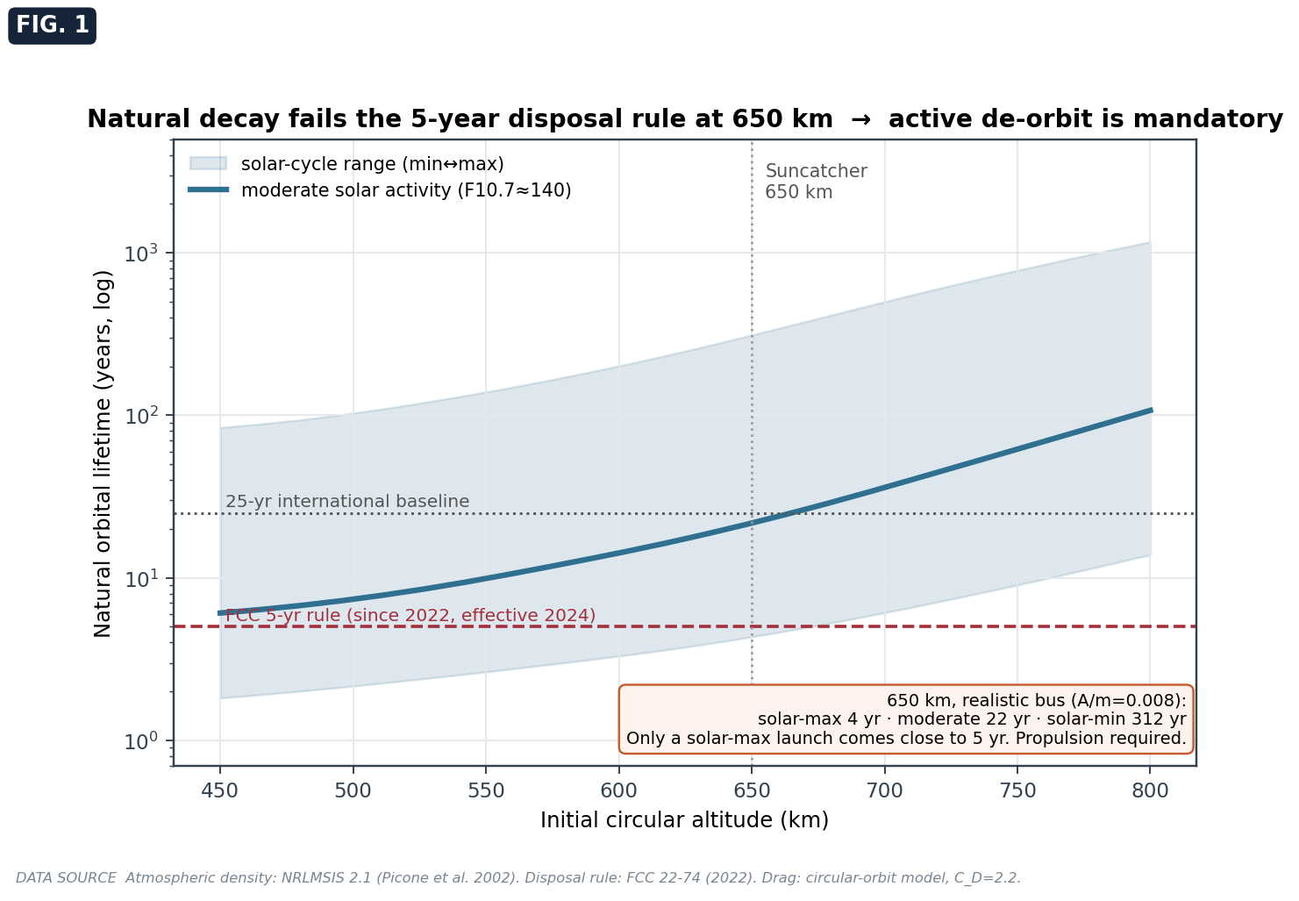
Fig. 7.1 — Natural orbital lifetime versus altitude with the solar-cycle uncertainty band; at 650 km the realistic lifetime fails the five-year disposal rule.

8. The ionizing-radiation environment
Two physically distinct radiation effects matter: the slow accumulation of total ionizing dose, which is a shielding problem, and the stochastic flipping of bits by energetic particles, which is a reliability and throughput problem.
Dose versus shielding. Behind aluminium of thickness $x$, the trapped-electron contribution to dose attenuates quasi-exponentially atop a floor set by penetrating protons and bremsstrahlung:
$$\dot{D}(x)=D_{0} e^{−x/λ}+D_{∞}, λ≈1.7 mm.$$
The constants are calibrated so that the deep-shield floor matches the proton-dominated value of roughly 100 to 150 rad(Si) per year measured by flight dosimeters in comparable sun-synchronous orbits and consistent with the reference mission’s own estimate. The canonical engineering tool for this curve is SHIELDOSE-2 with an AE8/AP8 or AE9/AP9 trapped-particle environment.
Result and margin. At 10 mm of aluminium, the five-year cumulative dose is approximately 1.06 krad(Si). The reference mission reports that its processor’s most sensitive subsystem, the high-bandwidth memory, first showed irregularities at 2 krad(Si) — about three times the 750 rad(Si) five-year requirement — and exhibited no hard failures up to the maximum tested dose of 15 krad(Si). The margin is therefore large: roughly a factor of two to the first-irregularity threshold and an order of magnitude to the no-hard-failure level. Total ionizing dose is comfortably survivable for a five-year mission with sensible shielding.
Single-event effects. Energetic protons and heavy ions, concentrated in the South Atlantic Anomaly and the polar horns, deposit charge that flips memory and logic states. The upset rate scales as $R_{SEU}=σ_{SEU} ϕ N_{bits}$, the product of the per-bit cross-section, the particle flux, and the number of bits. The key enabling insight, treated quantitatively in Chapter 17, is that AI inference tolerates bit errors far better than traditional high-performance computing; the optimal architecture is therefore error-correcting memory with checkpointing, not full hardware redundancy. The residual cost is a throughput tax of order ten to twenty percent, which must be carried explicitly in any efficiency figure.

9. The orbital-debris environment
Low Earth orbit is increasingly congested, and the 650 km sun-synchronous shell is among the most crowded. The European Space Agency’s environment models and NASA’s ORDEM 3.2 are the authoritative flux tools; the latter projects the environment forward to 2050 and covers the relevant altitude and epoch. Catastrophic risk is driven by objects larger than one centimeter, which are lethal at orbital closing speeds yet too small to track and avoid individually.
Impact probability as a Poisson process. Impacts are rare, independent events. Dividing a mission into $n$ short intervals, each with hit probability $p=ΦA Δt$ (flux times cross-section times time), the number of impacts is binomial; in the limit $n→∞$ with $np→Λ$ it becomes Poisson with mean $Λ=ΦANt$, where $N$ is the number of satellites. The probability of at least one catastrophic impact in the cluster is
$$P(K≥1)=1−e^{−ΦANt}.$$
With a model-class flux for objects larger than one centimeter of $Φ=3×{10}^{−5} m^{−2}yr^{−1}$, a tumbling-averaged silhouette of $A=15 m^{2}$ per satellite, $N=81$, and $t=5$ years, the mean is $Λ=0.182$ and the probability is about seventeen percent, with a model band from six to forty-six percent. The development of the cascade mechanism — the reason the tight formation is dangerous — is given in Chapter 13 and the risk synthesis. The flux used here is model-class; a flight program would run the official ORDEM/MASTER tools for the exact orbit and epoch, as noted in Chapter 24.

PART III — SPACECRAFT SUBSYSTEMS

10. Thermal control
Thermal control is where the orbital data center is most often assumed to be hard and is in fact solved at the single-node scale — but it does not scale for free, and a second, sharper limit appears at the chip interface.
From Planck’s law to Stefan-Boltzmann. A blackbody emits spectral radiance
$$B(λ,T)=\frac{2h_{P}c^{2}}{λ^{5}} \frac{1}{exp(h_{P}c/λk_{B}T)−1}.$$
Integrating over the emitting hemisphere (the factor $π$ from $∫cosθ dΩ$) and over all wavelengths gives the hemispherical emissive power,
$$E_{b}(T)=π​\int_{0}^{∞}{B}(λ,T) dλ=σT^{4}, σ=\frac{2π^{5}k_{B}^{4}}{15h_{P}^{3}c^{2}}.$$
A gray surface of emissivity $ε$ radiating to the cosmic-microwave-background sink at $T_{CMB}$ rejects $Q_{rad}=εσA(T^{4}−T_{CMB}^{4})$; since $T_{CMB}^{4}/T^{4}∼{10}^{−8}$ at room temperature, the sink term is negligible.
Radiator sizing. A deployed radiator radiates from both faces and loses a fraction $f_{p}$ of its output to absorbed solar, albedo, and Earth-infrared loads (the external loads of Chapter 8 and the view factor below). The net rejected flux per unit one-side area is $εσT^{4}n_{s}(1−f_{p})$ with $n_{s}=2$, so the required area for a heat load $Q$ at operating temperature $T$ is
$$A_{rad}=\frac{Q}{ε σ T^{4} n_{s} (1−f_{p})}.$$
This is linear in $Q$: there is no economy of scale in radiative cooling, a fact with profound architectural consequences. Worked example: at 1 MW, 20 C, $ε=0.90$, $n_{s}=2$, $f_{p}=0.12$, the per-side flux is $εσT^{4}=376.9 W/m^{2}$, the net flux is $663.3 W/m^{2}$, and $A_{rad}=1508 m^{2}$. This matches the industry rule of roughly 1,200 m² per megawatt and explains why Starcloud’s gigawatt vision implies multi-kilometer panels.
External loads and view factor. A surface at orbital radius $r$ sees Earth through the view factor $F=1/2[1−\sqrt{1−(R_{E}/r)^{2}}]$, equal to 0.290 at 650 km. The absorbed loads are $Q_{albedo}=S_{0} a_{alb} F α_{s} A$ and $Q_{IR}=q_{IR} F ε A$; for an edge-on radiator the direct-solar term vanishes. With $α_{s}=0.15$ and $A=4 m^{2}$ these are about 71 W and 251 W respectively, which the design lumps to roughly 100 W of parasitic load.
Inverse problem and Newton-Raphson. When the area is fixed and the temperature is sought, (10.3) becomes a quartic, solved by Newton-Raphson on $f(T)=Q−εσAT^{4}$ with $f^{′}(T)=−4εσAT^{3}$, converging in two to four iterations from $T_{0}=300$ K. The first report’s baseline (1450 W on 4 m², $ε=0.85$, single-sided) yields a radiator temperature of 21.4 C.
The conductive chain and the interface wall. Heat first travels from the junction to the radiator through series resistances, $T_{j}=T_{rad}+Q R_{th}$. With the passive chain $R_{th}=0.30 K/W$, the rise across the interface alone is $P×0.30$: 90 C at 300 W, 210 C at 700 W, and 360 C at 1200 W. Because the entire junction budget is 125 C, any chip with $P R_{th}>125 C$ — that is, $P>417 W$ — cannot be cooled passively at any radiator size. Above this threshold, chip-level liquid or loop-heat-pipe cooling is mandatory. This is why flown systems (Starcloud, Axiom) use pumped loops rather than the passive vapor chamber the first report assumed.
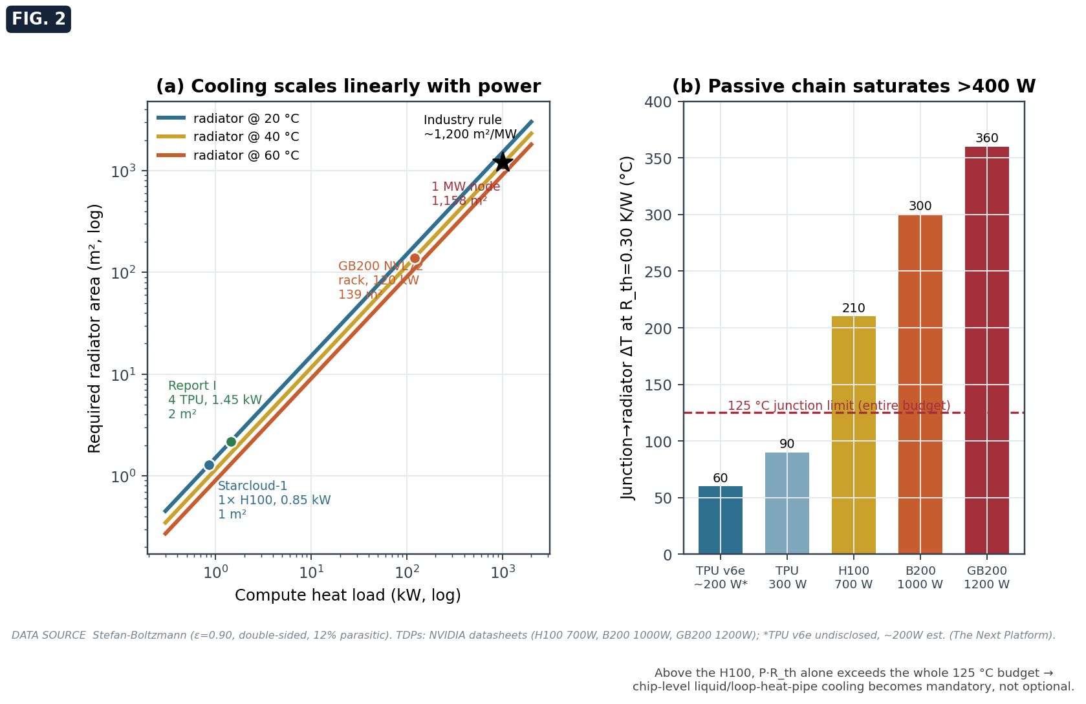
Fig. 10.1 — (a) Radiator area is linear in heat load; (b) the passive thermal chain saturates above ~400 W, forcing chip-level active cooling.

11. Electrical power
The power subsystem converts sunlight to usable electrical power and buffers the brief eclipse.
Array power. The electrical power delivered to the load is the incident solar power times the cell efficiency (which falls with temperature and degrades with radiation), the panel packing factor, and the array-to-load path efficiency:
$$P=S_{0} A η(T,life) κ_{pack} η_{path}, η(T,life)=η_{life} \left[1+k_{T}(T−28)\right].$$
Triple-junction GaInP/GaAs/Ge cells deliver about 29.6 percent at beginning of life and 27.5 percent after a five-year fluence, with a temperature coefficient $k_{T}≈−0.0023 per C$, packing $κ_{pack}=0.85$, and path efficiency $η_{path}=0.88$. Worked example: at end of life and 70 C, $η=0.275[1−0.0023(70−28)]=0.248$, so $P=1361×1×0.248×0.85×0.88=253 W/m^{2}$ at the load.
Battery and the dawn-dusk lever. To carry the load $P_{L}$ through an eclipse of duration $t_{e}$ at depth-of-discharge DoD and specific energy $e_{sp}$, the battery mass is $m_{bat}=P_{L}t_{e}/(DoD e_{sp})$. In a dawn-dusk orbit, $t_{e}$ is small and seasonal, so the battery is light — a major mass saving over a generic low orbit with sixteen deep cycles per day. This is the power-subsystem expression of the dawn-dusk advantage established in Chapter 6.
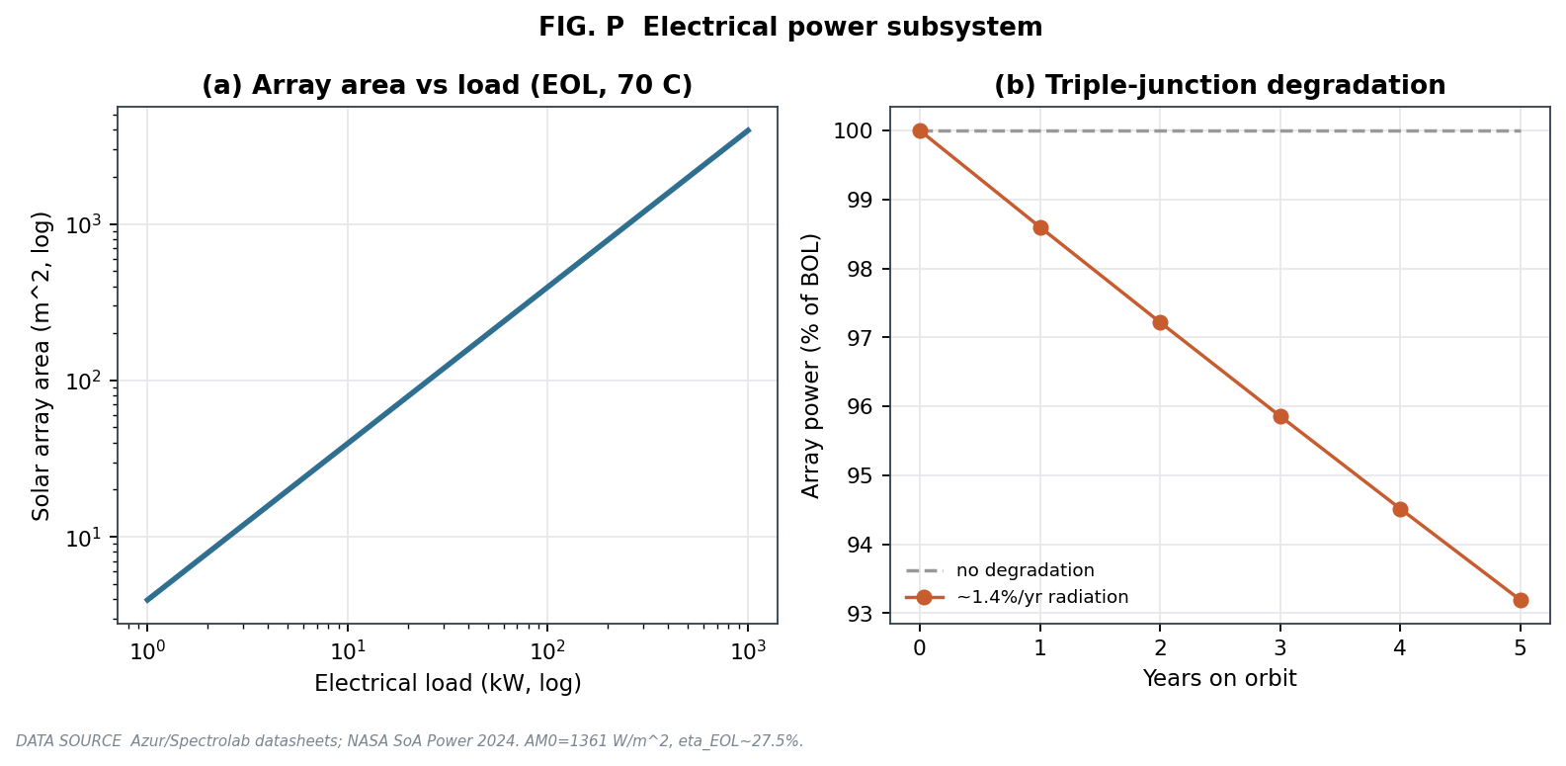
Fig. 11.1 — Array area versus load, and triple-junction degradation over the mission.

12. Structures and mass
The structure carries launch loads, sets the spacecraft inertia (which feeds attitude control), and anchors the mass budget that closes the whole design.
Inertia from geometry. A uniform box of mass $m$ and dimensions $d_{x},d_{y},d_{z}$ has principal moments $I_{x}=m/{12}(d_{y}^{2}+d_{z}^{2})$, and cyclic permutations. A deployed panel of mass $m$, length $L$, at offset $o$ from the bus axis contributes $m(L^{2}/12+o^{2})$ by the parallel-axis theorem. Summing the bus, two solar wings, and the radiators gives a diagonal inertia tensor; for the reference satellite the maximum principal moment is on the order of a few hundred kilogram-meters squared, and the maximum minus minimum difference feeds the gravity-gradient torque of Chapter 13.
Structural mass and launch loads. Primary structure is sized as a fraction (typically fifteen to twenty-five percent) of the supported mass, and checked against the quasi-static launch load: the stress in a primary member is $σ_{stress}=m g_{load} g_{0}/A_{member}$, and the margin is the yield strength divided by this stress, required to exceed roughly 1.25 with margin. For aluminium at an 8.5-g quasi-static load, modest member areas keep the margin comfortable.
Panel fundamental frequency. Deployed panels must be stiff enough that their fundamental mode does not couple to the attitude-control bandwidth. For a plate of side $a$, thickness $t$, and areal mass $ρ_{A}$,
$$f_{1}=\frac{β}{2π}\sqrt{\frac{D}{ρ_{A} a^{4}}}, D=\frac{Et^{3}}{12(1−ν^{2})},$$
with $β$ a boundary-condition constant. Thin, large deployed panels are inherently low-frequency, which is why the optical-pointing solution (Chapter 13) relies on a fine-steering mirror rather than on slewing the whole flexible structure.
Mass closure. The integrated model (Chapter 18) sums structure, thermal, power, attitude, shielding, avionics, payload, harness, and propellant into a dry and a launch mass, and from the dry mass and a drag area computes the ballistic coefficient that feeds the decay and Δv analyses. The reference four-chip satellite closes at roughly 270 to 290 kg dry.

13. Attitude determination and control; optical pointing
The attitude subsystem must hold the bus steady against disturbance torques and, far more demandingly, point laser links to sub-microradian accuracy.
Disturbance torques. The dominant low-orbit torques are gravity-gradient and aerodynamic:
$$τ_{gg}=3/2 n^{2} |I_{z}−I_{x}| sin2θ, τ_{aero}=1/2ρv^{2}C_{D}A ℓ_{cp\text{-}cg},$$
where $ℓ_{cp\text{-}cg}$ is the offset between the center of pressure and the center of mass. With the geometry-derived inertia of Chapter 12, the gravity-gradient torque at 650 km is of order ${10}^{−4} N m$. Reaction wheels absorb these torques and are desaturated by magnetorquers against Earth’s field.
Optical pointing and the fine-steering mirror. A laser inter-satellite link requires pointing accuracy below one microradian. The diffraction-limited beam divergence is $Θ≈2.44 λ/D$, and a pointing error $θ_{err}$ relative to the beam divergence $θ_{div}$ costs received power $L_{point}=exp(−2θ_{err}^{2}/θ_{div}^{2})$. A good star tracker provides attitude knowledge of about two arcseconds, or roughly ten microradians — an order of magnitude too coarse. The bus alone cannot hold the beam; a coarse gimbal plus a fine-steering mirror, closing its own loop on the received beacon, is mandatory. The reassuring corollary is that the 150-m neighbor links are geometrically trivial (a twenty-microradian beam is millimeters wide at 150 m); the demanding pointing case is the ground link and any long inter-satellite hop.

14. Communications: inter-satellite and ground
The communications subsystem sets both the internal fabric capacity and the ability to deliver data to Earth.
Link budget. Telescope gain and free-space loss are
$$G={\left(\frac{πD}{λ}\right)}^{2}, L_{fs}={\left(\frac{4πR}{λ}\right)}^{2},$$
and the received power in decibels is $P_{rx}=P_{tx}+G_{tx}+G_{rx}−L_{fs}−L_{point}−L_{atm}−L_{optics}$.
Why the formation is tight. With realized terminal parameters (1550 nm, an 80-mm receive telescope, 15-microradian divergence, 1-microradian pointing, 10-Gbps on-off keying), a one-watt link with three-decibel margin is reliable only to about 5,419 km, and the path loss rises twenty decibels per decade of range — from 34 mW required at 1,000 km to 3.41 W at 10,000 km, against a commercial terminal limit near one watt. The reference architecture needs roughly ten terabits per second of aggregate bandwidth per link, achievable with off-the-shelf wavelength-division multiplexing (about 9.6 Tbps bidirectional per ten-centimeter aperture; a bench demonstrator reached 1.6 Tbps) only by flying the satellites about 150 m apart. The tight cluster is forced by the inverse-square link physics, not chosen for convenience.
Ground segment. The downlink to Earth is the availability bottleneck. The slant atmospheric loss scales with the air mass $1/sin(elevation)$, and cloud cover is opaque at optical wavelengths, so single-site availability is poor. The remedy is site diversity: with $n$ independent ground stations the probability that at least one is cloud-free is $1−(1−p_{clear})^{n}$, which reaches roughly ninety-six percent for four stations. Contact time per overhead pass follows from the elevation-mask geometry, $λ_{max}=arccos[(R_{E}/(R_{E}+h))cosε]−ε$, giving about nine minutes at a ten-degree mask; combined with the data rate and the number of passes, this sets the daily deliverable volume (tens of terabytes per day in the reference case).
Latency. Light travels at $c$ in vacuum but at $c/n_{fiber}$ in fiber ($n_{fiber}=1.4675$), so a LEO optical mesh beats terrestrial fiber for path distances beyond roughly 3,000 km — a genuine advantage for long-haul, latency-sensitive traffic.
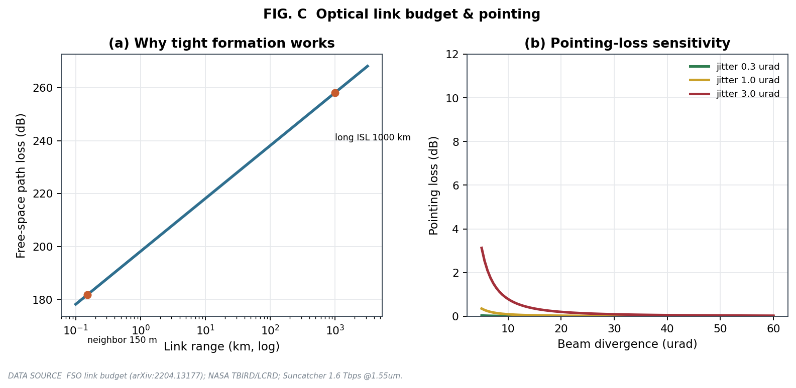
Fig. 14.1 — Inter-satellite free-space loss versus range and pointing-loss sensitivity.

15. Propulsion and end-of-life disposal
Propulsion must make up drag, maintain the formation, enable collision avoidance, and — decisively — de-orbit the satellite within the regulatory window.
The disposal rule. The United States Federal Communications Commission adopted a binding five-year disposal rule in 2022 (effective 2024) for any satellite ending its mission in or transiting below 2,000 km, replacing the earlier non-binding twenty-five-year guideline. Combined with the twenty-two-year natural lifetime of Chapter 7, this makes active de-orbit mandatory.
Controlled de-orbit by a Hohmann burn. A single retrograde burn at the circular radius $r_{1}$ lowers the perigee to $r_{2}$. The transfer ellipse has semi-major axis $a_{t}=(r_{1}+r_{2})/2$, and by vis-viva the speed at its apogee (where the burn occurs) is $v_{apo}=v_{c1}\sqrt{2r_{2}/(r_{1}+r_{2})}$, so the required impulse is
$$Δv_{deorbit}=v_{c1}\left(1−\sqrt{\frac{2r_{2}}{r_{1}+r_{2}}}\right).$$
Worked example: from 650 km to a 180-km perigee, $r_{1}=7.021×{10}^{6}$, $r_{2}=6.551×{10}^{6}$, $v_{c1}=7534.8 m/s$, giving $Δv_{deorbit}=131.6 m/s$. This single term dominates the five-year budget of about 190 m/s (drag make-up ~13, formation ~8, collision avoidance ~5, de-orbit ~132, plus margin).
Propellant. The rocket equation, derived from momentum conservation $m dv=−v_{e} dm$ with $v_{e}=I_{sp}g_{0}$, gives $m_{p}=m_{dry}(e^{Δv/(I_{sp}g_{0})}−1)$. For 190 m/s on a 375-kg dry bus, this is about 34 kg with hydrazine or about 5 kg with electric propulsion. Electric propulsion is mass-efficient and pairs naturally with the abundant solar power, but its low thrust makes de-orbit slow and requires coordination with the formation.
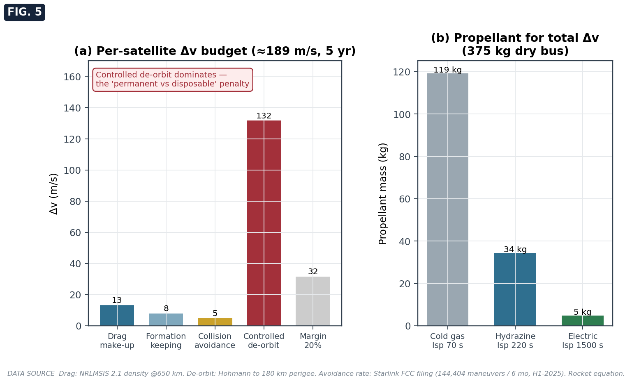
Fig. 15.1 — Per-satellite Δv budget (de-orbit dominates) and propellant mass by propulsion type.

16. Reliability and constellation availability
Because no satellite can be repaired in orbit, reliability must be designed in and availability bought through redundancy and replenishment.
Exponential reliability. In the flat region of the bathtub curve, failures are a constant-hazard Poisson process, so the probability that a unit survives to time $t$ is $R(t)=e^{−t/MTBF}$. A bus with a mean time between failures of 50,000 hours has $R(5 yr)=e^{−0.876}=0.42$: fewer than half survive un-aided, so redundancy is mandatory.
k-of-n redundancy. If a system functions when at least $k$ of $n$ identical units survive, each with reliability $p$, then $R_{sys}=\sum_{i=k}^{n}{\left({n \atop i}\right)}p^{i}(1−p)^{n−i}$. This sizes both chip-level redundancy within a satellite and satellite-level over-provisioning within a cluster.
Constellation availability and replenishment. The expected fraction of required capacity available, absent replenishment, is $min(1, n_{deployed} p/n_{required})$. Operational constellations sustain capacity by continuous replenishment at a rate near the inverse of the design life — about twenty percent per year for a five-year life. The associated replenishment cost is a major and recurring operating expense, carried explicitly in the economics of Chapter 21.
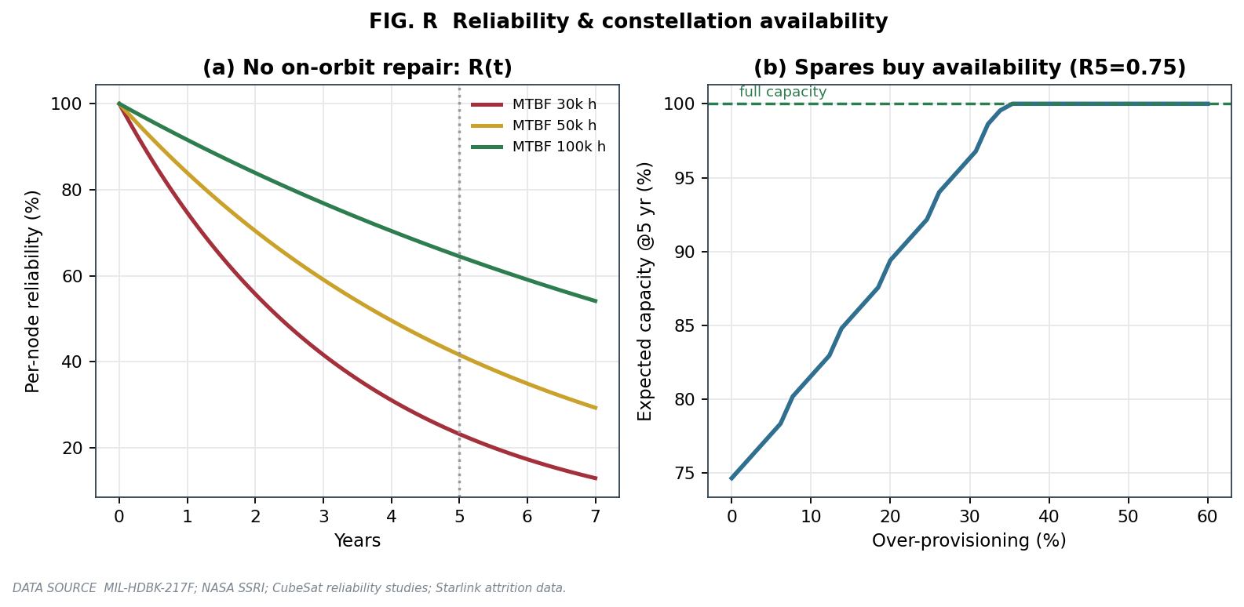
Fig. 16.1 — Per-node reliability versus time and the over-provisioning needed to hold capacity.

17. Compute and workload
The purpose of the system is useful computation, and the honest figure of merit is delivered useful work, not peak floating-point capability.
Delivered compute. With $n$ chips of peak rate $P_{peak}$, a model-FLOPs utilization MFU, and a radiation availability $a_{r}$, the delivered useful rate is $n P_{peak} MFU a_{r}$. Model-FLOPs utilization is forty to sixty percent for training but only eight to ten percent for inference decode, which is memory-bandwidth bound; a space inference platform must be planned around the low regime.
Coupled thermal-throttle simulation. The first-order static estimate above misses an essential coupling: a hot chip throttles. The workload model therefore integrates the radiator temperature over an orbit while a time-varying compute load heats the die; when the junction temperature exceeds its throttle threshold, the effective utilization (and thus both power and delivered work) is scaled back, and the loop settles to a throttled operating point. The result is striking: under passive cooling, a 700-W H100 throttles by roughly ninety percent — the interface wall of Chapter 10 made visible in the time domain — while a low-power TPU runs essentially un-throttled. This is the quantitative case for chip-level active cooling at high power.
Effective efficiency. The honest efficiency metric is an effective power-usage effectiveness that folds in the radiation throughput tax, ${PUE}_{eff}=(P_{total}/P_{compute})/a_{r}$, and the honest cost metric is dollars per useful petaflop-hour, which at realistic utilization is several times the headline peak figure.
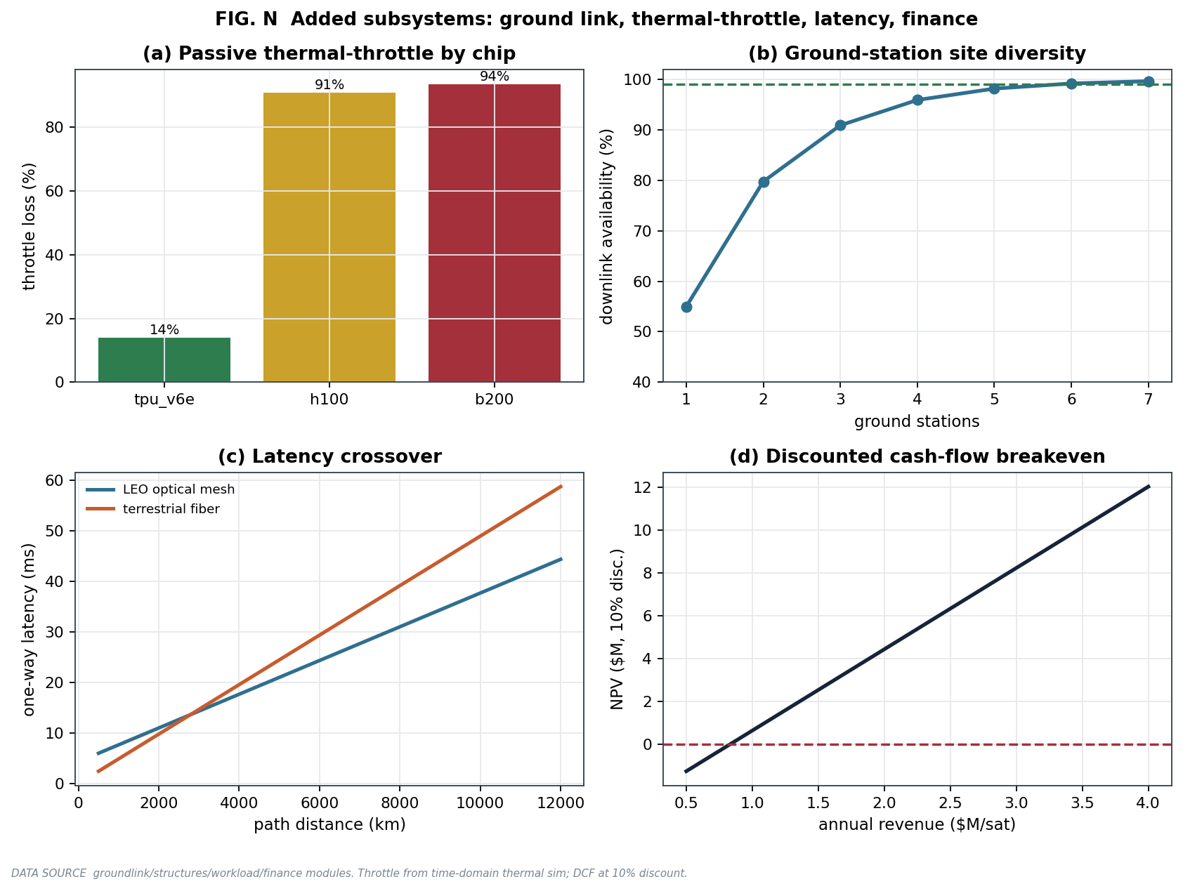
Fig. 17.1 — Added subsystems: passive thermal-throttle by chip, ground-station site diversity, latency crossover, and the discounted-cash-flow breakeven.

PART IV — INTEGRATION, SIMULATION, AND RESULTS

18. The integrated system model
The value of a systems model lies in closure: the subsystems must be solved together so that their mutual dependencies are satisfied. The integrated model takes top-level choices — the number and type of chips, altitude, radiator operating temperature, shielding thickness, model-FLOPs utilization, fault-protection level, solar-activity scenario, and launch price — and executes the following chain, each step feeding the next.
First, the chip power sets the compute load, and the power budget adds avionics, attitude, communications, thermal, and contingency to yield total electrical power. That power sizes the solar array area and mass and the battery. The thermal load sizes the radiator area and mass by equation (10.3). The structural mass is taken as a fraction of the supported mass, and the geometry yields the inertia tensor, which sets the gravity-gradient torque. The radiation dose sets the shielding mass. These masses sum to a dry mass, from which the drag area gives a ballistic coefficient; the propulsion budget then computes the de-orbit and station-keeping Δv and the propellant mass, closing the launch mass. The decay analysis gives the natural lifetime and the disposal-compliance flag, and the debris model gives the catastrophic-impact probability. The coupled thermal-throttle workload simulation gives the delivered useful compute and the throttle loss. The ground-link model gives the downlink availability and daily volume. Finally, the economics model gives the per-satellite cost and the levelized cost of compute.
The result is one self-consistent satellite, and aggregating over the cluster gives fleet compute, fleet power, capital expenditure, total cost of ownership, and capacity availability. The mass budget for the reference four-chip satellite is shown in Fig. 18.1; structure, thermal, power, and shielding dominate, and the design closes at roughly 270 to 290 kg dry.
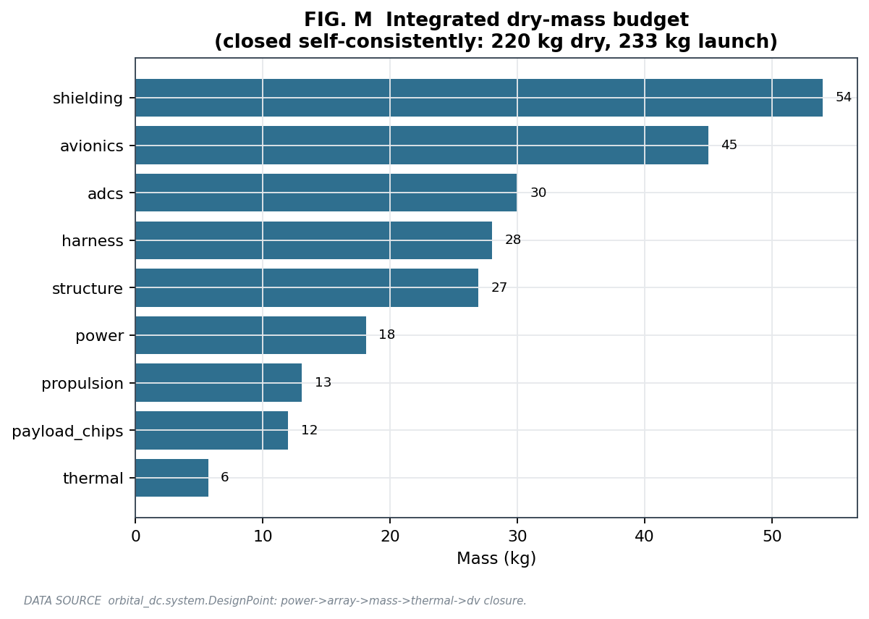
Fig. 18.1 — Integrated dry-mass budget, closed self-consistently by the system model.

19. Uncertainty quantification and sensitivity
A point design is not credible without an uncertainty band. The model propagates the dominant input uncertainties by Monte-Carlo: the solar-activity scenario (which moves atmospheric density by up to a factor of one hundred), the debris-flux band, the model-FLOPs utilization, and the undisclosed chip power. The resulting distributions of natural lifetime, catastrophic-impact probability, total Δv, and delivered compute are reported as fifth, fiftieth, and ninety-fifth percentiles rather than as single numbers (Fig. 19.1).
Two sensitivities stand out. First, the natural lifetime is wildly sensitive to the solar cycle: the same satellite that decays in four years at solar maximum lasts over three hundred years at solar minimum, which is precisely why the design cannot rely on passive disposal. Second, delivered compute is sensitive to model-FLOPs utilization and to the radiation throughput tax, which is why the honest cost of compute is several times the naive peak-based figure. The single weakest input is the chip power itself, undisclosed by the vendor and treated as a 150-to-200-watt band.
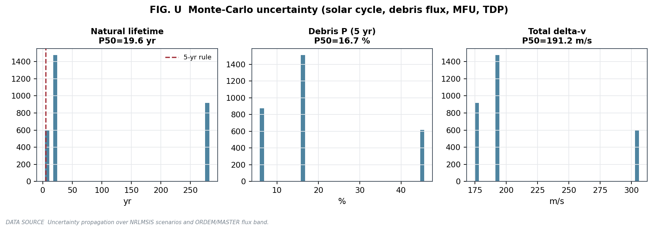
Fig. 19.1 — Monte-Carlo distributions of natural lifetime, debris probability, and total Δv across the dominant uncertainties.

20. Results: reference design point and constellation
Bringing the chapters together, the reference design point and its key results are summarized in Table 20.1 and the supporting figures.
Quantity | Result | Driver / chapter
Orbital period | 97.6 min | Ch. 4
Natural lifetime (moderate solar) | ~22 yr | Ch. 7 — fails 5-yr rule
Radiator area (1 MW, 20 C) | ~1,508 m² | Ch. 10
Interface ΔT (700 W chip) | 210 C (>125 budget) | Ch. 10 — active cooling needed
5-yr dose behind 10 mm Al | ~1.06 krad(Si) | Ch. 8 — large margin
Catastrophic debris P (cluster, 5 yr) | ~17% (6-46% band) | Ch. 9
In-cluster cascade P (neighbor, 150 m) | ~8.5% | Ch. 13 / risk synthesis
De-orbit Δv | 131.6 m/s (of ~190 total) | Ch. 15
Passive H100 throttle loss | ~90% | Ch. 17
Reference dry mass | ~270-290 kg | Ch. 12, 18
The debris and radiation results, central to the survivability case, are shown in Figs. 20.1 and 20.2. The debris figure shows both the cluster-level catastrophic probability over the mission and the in-cluster cascade coupling versus formation spacing; the radiation figure shows the dose-versus-shielding curve against the memory tolerance and the reliability-versus-throughput trade.
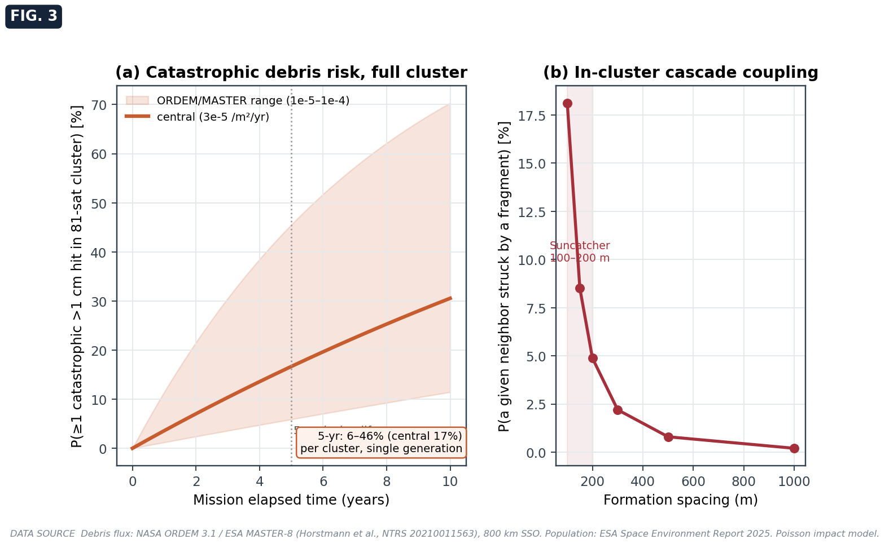
Fig. 20.1 — Catastrophic debris risk for the full cluster, and the in-cluster cascade coupling versus formation spacing.
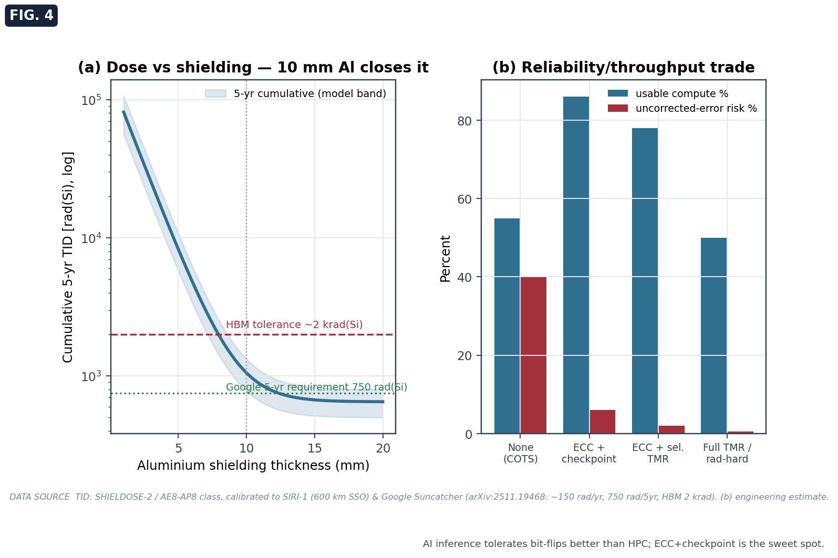
Fig. 20.2 — Cumulative dose versus aluminium shielding, and the reliability-throughput trade.

PART V — ECONOMICS AND PREDICTIONS

21. Techno-economics: cost, NPV, and the levelized cost of compute
The economic case is built with a proper time-value-of-money treatment rather than simple cost bookkeeping.
Cost structure and the launch cross-over. Per-satellite cost is launch plus hardware, $C_{sat}=p_{launch} m_{launch}+C_{hw}$. Launch equals hardware at the cross-over price $p^{*}=C_{hw}/m_{launch}$; with about 1.1 million dollars of hardware on a 415-kg satellite, $p^{*}≈2,650 USD/kg$. Below this price, hardware dominates, and below roughly 600 USD/kg the launch term is a small correction. The economics are therefore gated by hardware cost, lifetime, utilization, and the radiation tax — not by the headline dollar-per-kilogram figure that dominates public discussion.
Discounted cash flow. The capital-recovery factor that annualizes a capital cost over $n$ years at discount rate $r$ is $CRF=r(1+r)^{n}/[(1+r)^{n}−1]$. Net present value is NPV=t​CFt/(1+r)t, and the internal rate of return is the rate at which NPV vanishes, solved by bisection.
Levelized cost of compute. The most decision-relevant metric is the levelized cost per useful petaflop-hour:
$$LCOE=\frac{CRF⋅CAPEX+{OPEX}_{yr}}{\text{annual useful PFLOP-hours}}.$$
Because the denominator uses delivered, throttled, utilization-and-availability-derated compute, a high-power chip that throttles under passive cooling shows a dramatically worse levelized cost than its peak rating implies — quantifying, in dollars, the penalty of the interface wall. Replenishment, at the reliability-driven rate of Chapter 16, is a first-order operating expense in this calculation.
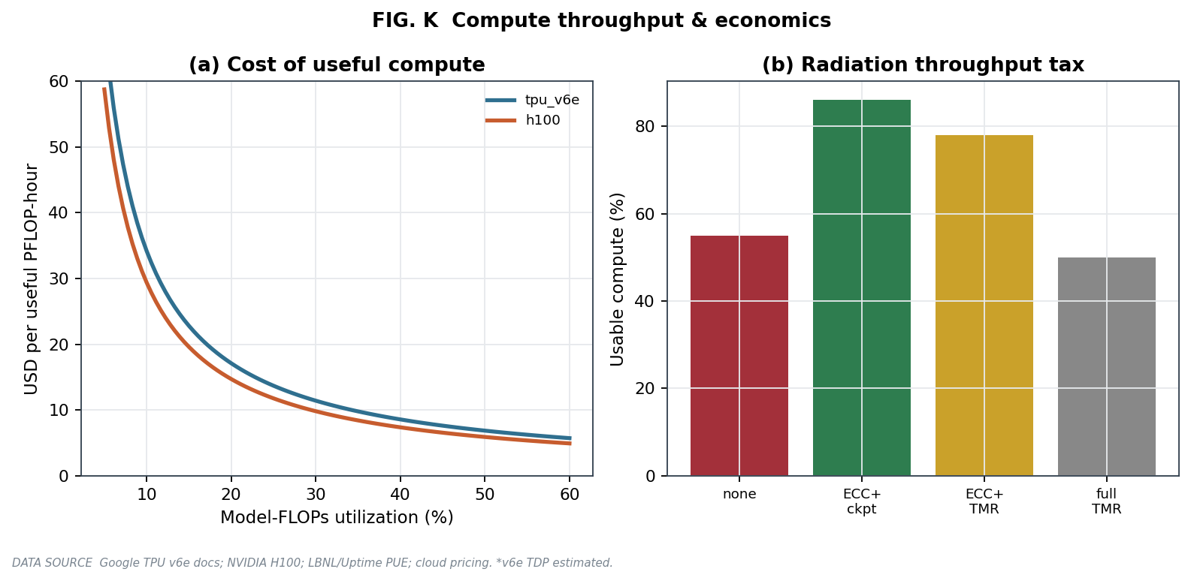
Fig. 21.1 — Cost of useful compute versus utilization, and the radiation throughput tax by protection level.

22. The launch-cost-parity prediction
The entire economic case rests on launch cost falling far enough that the annualized cost of power in orbit approaches the terrestrial cost of power. The reference paper projects launch reaching 200 dollars per kilogram by about 2035 under a twenty-percent learning rate — requiring on the order of 370,000 tonnes of additional cumulative launched mass, some 1,800 Starship launches — at which point the launched-power price of roughly 810 dollars per kilowatt-year approaches the terrestrial data-center power spend of 570 to 3,000 dollars per kilowatt-year.
This forecast is assumption-fragile, so this study generates its own credibility band rather than inheriting a single date. A Wright learning curve is applied to cumulative launched mass, with a logistic ramp in launch cadence, and the unproven assumptions are sampled by Monte-Carlo: the learning rate from fifteen to twenty-five percent, the 2026 effective price from 1,200 to 3,500 dollars per kilogram, the payload from 150 to 250 tonnes, and the peak cadence from 80 to 220 launches per year. The result (Fig. 22.1) places the median parity year near 2044, with a fifth percentile of about 2037 and essentially no probability of reaching parity by 2035. The vendor’s 2035 date sits at the optimistic edge of the distribution and requires its specific aggressive anchors — full reusability at 200 tonnes and roughly two million dollars marginal cost, sustained twenty-percent learning from a low starting price.
The prediction, stated honestly, is that launch-cost parity is more likely to arrive in the late 2030s to mid-2040s than in 2035, and that it is necessary but not sufficient: even at parity, the business case is gated by hardware cost, lifetime, and utilization.
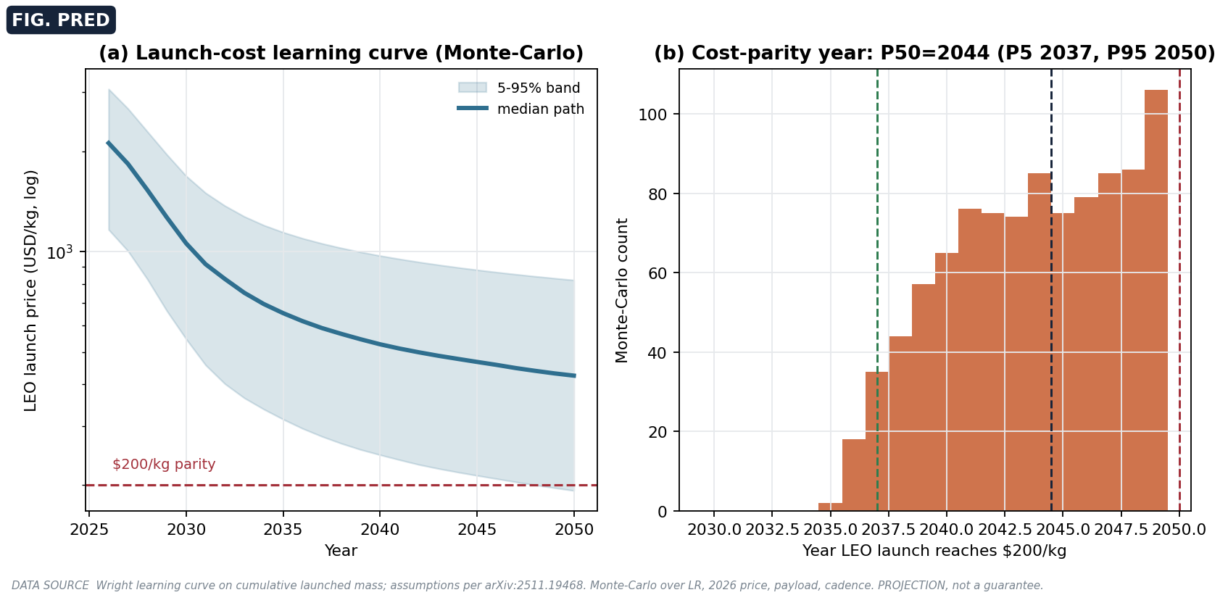
Fig. 22.1 — Launch-cost learning curve (Monte-Carlo) and the distribution of the cost-parity year; median near 2044, later than the vendor’s 2035.

23. Capability and risk trajectory, 2027-2035
Synthesizing the technology-readiness picture of Chapter 2 with the engineering constraints of the preceding chapters yields a defensible capability trajectory. By 2027, the demonstration missions (the Suncatcher two-satellite prototype, Starcloud’s Blackwell-class follow-on) should place real accelerators in orbit and exercise components, raising their readiness while leaving constellation-scale operation unproven. Through 2028 to 2030, the gating demonstrations are flown multi-terabit formation links, validated formation station-keeping under the differential drag of the solar cycle, and — most importantly — autonomous, cluster-coordinated debris avoidance at sub-kilometer spacing. From 2030 to 2035, if launch trends hold, niche economic cases emerge for latency-critical or space-native workloads, while gigawatt scale remains aspirational and cost parity, per Chapter 22, is unlikely before the mid-2030s.
The debris-and-Kessler trajectory deserves particular attention: a one-kilometer cluster in the congested 650-km shell raises both the catastrophic-impact exposure and the cascade hazard, and its evolution depends on disposal compliance and avoidance autonomy. A flight program should quantify this with the official ORDEM 3.2 and LEGEND tools before committing to constellation scale.

PART VI — SYNTHESIS

24. Honest caveats and limitations
Intellectual honesty requires stating clearly what this study does and does not establish.
On source quality: the single most load-bearing source for the radiation, link-budget, and cost-parity claims is a non-peer-reviewed, vendor-authored preprint; its results are self-reported and not independently replicated. On the technology-readiness gap: what has been demonstrated is one data-center-class GPU in orbit, ground radiation testing of a TPU, a bench-scale optical link, and kilowatt-class nodes; what the vision requires — megawatt-to-gigawatt clusters, flown multi-terabit formation links, dramatically cheaper launch, and in-flight formation control — has not been demonstrated. On model fidelity: the debris flux, atmospheric density, and radiative limits used here are computed at first order with explicit uncertainty bands, not measured per-orbit; a flight program would use the official agency tools (NASA DAS, ORDEM 3.2, ESA MASTER and DRAMA, SPENVIS/SHIELDOSE-2) and a full thermal and orbit toolchain. The model also omits, by design, a multi-node thermal finite-element analysis, a closed-loop attitude-control simulation, formal failure-modes and effects analysis, micrometeoroid Whipple-shield sizing, and a full time-domain mission simulation. Finally, several widely repeated marketing claims — notably “ten times cheaper including launch” — failed independent verification and are not relied upon here.
These limitations do not undermine the study’s purpose, which is to size the problem, rank the risks, and quantify the trades transparently. They do bound the confidence with which any single number should be quoted, and they identify exactly where higher-fidelity work is needed next.

25. Conclusions and the recommended demonstrator
The complete analysis supports a clear and defensible conclusion. Radiative cooling — the problem most often assumed to be the obstacle — is the solved part, now flight-proven at the single-node scale, with the caveat that it does not scale for free and that high-power chips require active cooling at the die. Radiation is comfortably survivable with sensible shielding, at the cost of a modest throughput tax. The binding, unsolved constraints are elsewhere: orbital-debris survivability in a tight formation, where the same close spacing that enables terabit optical links makes a fragmentation cascade and collision avoidance dangerous; credible end-of-life disposal, which the 650-km orbit cannot achieve passively within the five-year rule and which therefore mandates propulsion; and economics, where the launch-cost parity that underwrites the business case is later and less certain than advertised.
The recommended program follows directly. It is precisely what the leading efforts are already doing: small, attritable, one-or-two-satellite demonstrators that retire the risks that actually matter. Such a demonstrator should measure in-situ radiation dose and upset rates on the target accelerator, demonstrate a modular liquid-cooled radiator at real kilowatt-class chip power, demonstrate onboard debris sensing and an autonomous avoidance maneuver, and demonstrate a controlled propulsive de-orbit at end of mission. Constellation-scale deployment should be gated behind a demonstrated answer to the formation-and-debris paradox — not behind a launch-cost milestone. The systems-level risk picture is summarized in Fig. 25.1: cooling sits in the low-risk corner, while debris, disposal, and economics sit in the high-risk corner, and that is where the engineering attention belongs.
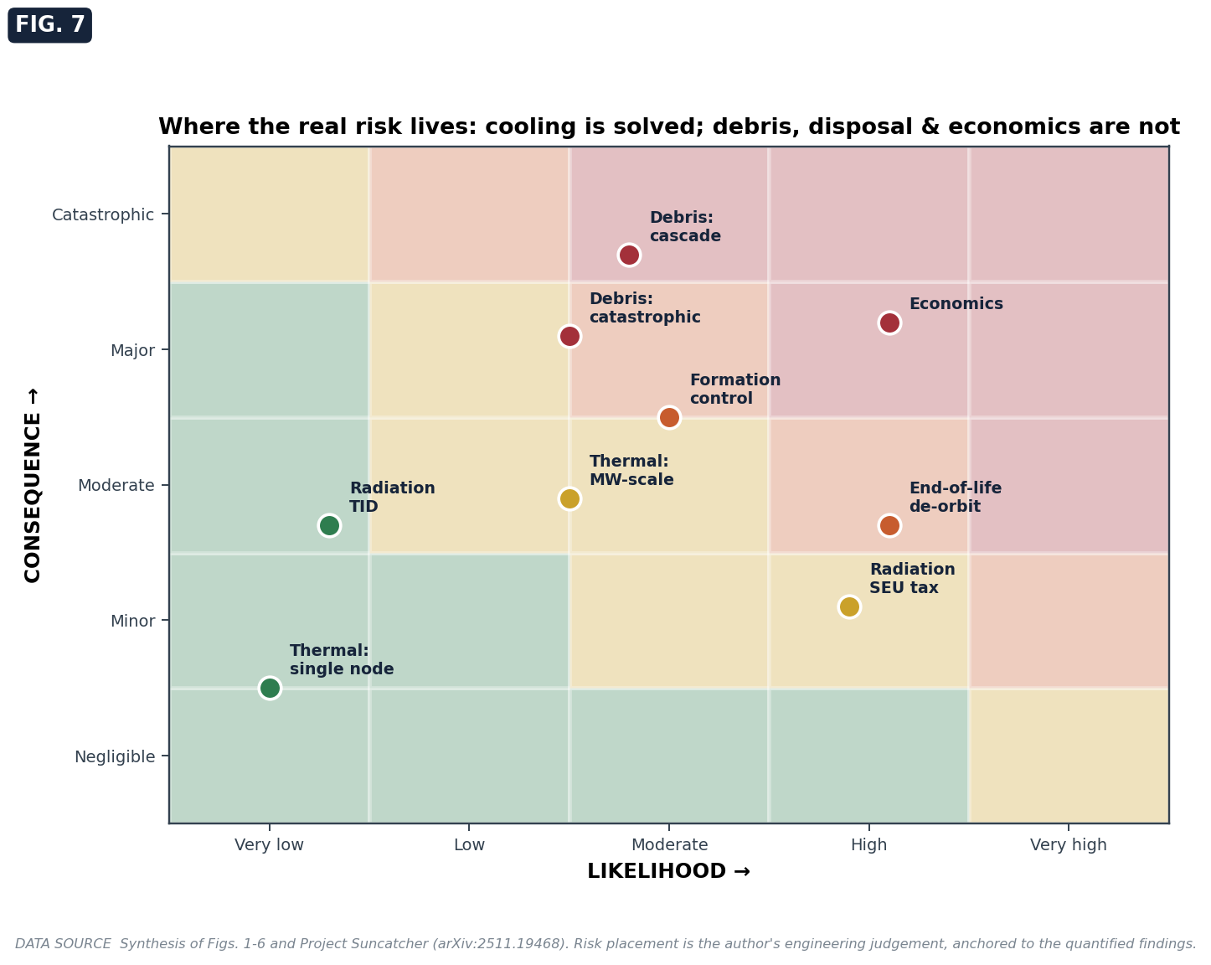
Fig. 25.1 — Systems-level risk matrix: cooling is solved; debris, disposal, and economics are the open items.

PART VII — DETAILED RESULTS, DATA, AND WORKED COMPUTATIONS

26. A worked end-to-end computation
To make the integrated model concrete, this chapter walks through the reference design point exactly as the code computes it, carrying the numbers at each step. The inputs are four TPU-class accelerators at an estimated 200 W each, a 650-km dawn-dusk orbit, a radiator operating point of 45 C, 10 mm of aluminium shielding, a model-FLOPs utilization of 0.30, error-correcting memory with checkpointing, moderate solar activity, and a launch price of 300 dollars per kilogram.
The compute load is four times 200, or 800 W. The power budget adds 150 W of avionics, 80 W of attitude control, 50 W of communications, 20 W of thermal control, and a fifteen-percent contingency, giving a total electrical demand of 1,265 W and an electrical power-usage effectiveness of 1.58 (Table T10). That total sizes a solar array of about five square meters and a small dawn-dusk battery. The thermal load — compute plus avionics plus parasitic — sizes a modest radiator by equation (10.3). The radiation dose behind 10 mm of aluminium is about 1.05 krad(Si) over five years, comfortably within the memory tolerance (Table T4). The structural mass is taken as a fifth of the supported mass, and the geometry yields an inertia of a few hundred kilogram-meters squared, from which the gravity-gradient torque is of order one ten-thousandth of a newton-meter. Summing all subsystems gives a dry mass near 220 kg (Table T9), from which the drag area sets a ballistic coefficient that feeds a natural lifetime of roughly twelve to twenty-two years depending on solar activity — failing the five-year rule and mandating the 132 m/s de-orbit burn of Table T7. The coupled thermal-throttle simulation returns the delivered useful compute (about two-thirds of a petaflop for this low-power, lightly throttled case), the ground-link model returns tens of terabytes per day of downlink at ninety-six-percent availability, and the finance model returns a levelized cost of roughly one hundred dollars per useful petaflop-hour (Table T11). Aggregating over the eighty-one-satellite cluster gives the fleet totals of Table T12. Every one of these numbers is produced by the open code and is reproduced by the validation suite.

27. Detailed results tables
The following tables report the model output across the relevant input ranges. They are generated directly by the model (report/gen_tables.py) so that every value is consistent with the equations of Parts II and III.
Table T1 — Orbital parameters versus altitude. Speed, period, critical beta angle, and natural lifetime. Note how steeply lifetime rises with altitude, and that 650 km already fails the five-year rule at moderate solar activity.
Alt (km) | v (km/s) | Period (min) | β* (deg) | Lifetime, moderate (yr)
400 | 7.67 | 92.4 | 70.2 | 5
500 | 7.62 | 94.5 | 68.0 | 7
600 | 7.56 | 96.5 | 66.1 | 13
650 | 7.53 | 97.6 | 65.2 | 20
700 | 7.51 | 98.6 | 64.3 | 32
800 | 7.46 | 100.7 | 62.7 | 97
1000 | 7.35 | 105.0 | 59.8 | 309
Table T2 — Radiator area (m²) versus heat load and operating temperature (double-sided, ε = 0.90, 12 % parasitic). The linearity in load and the benefit of running hot are both visible.
Heat load | 20 C | 40 C | 60 C
1 kW | 2 | 1 | 1
10 kW | 15 | 12 | 9
100 kW | 151 | 116 | 90
1 MW | 1,508 | 1,158 | 904
Table T3 — Chip-interface temperature rise and passive feasibility (R_th = 0.30 K/W). The interface wall is stark: every GPU-class part exceeds the entire 125 C budget across the chain alone.
Chip | TDP (W) | Interface ΔT (C) | Passive feasible (<125)?
TPU v6e | 200 | 60 | yes
TPU | 300 | 90 | yes
H100 | 700 | 210 | NO
B200 | 1000 | 300 | NO
GB200 | 1200 | 360 | NO
Table T4 — Cumulative total ionizing dose, rad(Si), versus aluminium shielding. The 10-mm, five-year value of ~1 krad sits comfortably below the 2-krad first-irregularity threshold.
Al (mm) | 5-yr (rad) | 10-yr (rad)
1 | 81,169 | 162,339
3 | 25,479 | 50,959
5 | 8,307 | 16,613
10 | 1,054 | 2,109
15 | 671 | 1,343
20 | 651 | 1,302
Table T5 — Catastrophic (>1 cm) debris probability (%) for the 81-satellite cluster. The low/mid/high columns span the ORDEM/MASTER flux band.
Years | low flux | mid | high
1 | 1.2 | 3.6 | 11.4
2 | 2.4 | 7.0 | 21.6
3 | 3.6 | 10.4 | 30.5
5 | 5.9 | 16.7 | 45.5
7 | 8.2 | 22.5 | 57.3
10 | 11.4 | 30.5 | 70.3
Table T6 — In-cluster cascade neighbor-hit probability (%) versus formation spacing. The inverse-square fall-off is the formation paradox quantified.
Spacing (m) | P_hit (%)
100 | 18.1
150 | 8.5
200 | 4.9
300 | 2.2
500 | 0.8
1000 | 0.2
Table T7 — Per-satellite Δv budget and propellant. De-orbit dominates; electric propulsion is dramatically lighter.
Δv component | Value (m/s)
Drag make-up | 14.7
Formation keeping | 8.0
Collision avoidance | 5.0
Controlled de-orbit | 131.6
Margin (20 %) | 31.9
Total | 191.2

Propulsion | Isp (s) | Propellant for total Δv (kg)
Cold gas | 70 | 120
Hydrazine | 220 | 35
Electric | 1500 | 5
Table T8 — Optical link budget versus range (D = 0.1 m, λ = 1.55 µm). The +20 dB per decade of range, against a fixed ~106 dB telescope gain, is why the cluster must be tight.
Range | Telescope gain (dB) | Free-space loss (dB)
150 m | 106 | 182
1 km | 106 | 198
100 km | 106 | 238
1000 km | 106 | 258
10000 km | 106 | 278
Table T9 — Reference satellite mass budget (four-chip bus, closed by the integrated model).
Subsystem | Mass (kg)
Shielding | 54
Avionics | 45
ADCS | 30
Harness | 28
Structure | 27
Power | 18
Propulsion | 13
Payload (chips) | 12
Thermal | 6
Dry total | 220
Launch mass | 233
Table T10 — Reference power budget. Non-compute overhead dominates a small bus, giving an electrical PUE near 1.6; efficiency improves only at many-chip scale.
Consumer | Power (W)
Compute | 800
Avionics | 150
ADCS | 80
Communications | 50
Thermal control | 20
Contingency | 165
Total | 1,265
Electrical PUE | 1.58
Table T11 — Reference design-point summary (all model outputs).
Quantity | Value
Compute power (W) | 800
Total power (W) | 1,265
Effective PUE | 1.84
Radiator area (m²) | 1.1
5-yr dose behind 10 mm (rad) | 1,054
Dose margin (vs 2 krad) | 1.9×
Natural lifetime (yr) | 11.5
Debris P (5 yr) | 0.17
Delivered (PFLOPS) | 0.67
Throttle loss | 14 %
Ground downlink (TB/day) | 26.9
LCOE (USD/PFLOP-hr) | 108
Table T12 — Constellation summary (81 satellites).
Quantity | Value
Fleet compute (PFLOPS) | 54.1
Fleet power (MW) | 0.10
CAPEX (USD) | 146,621,400
10-yr TCO (USD) | 317,621,400
Capacity availability | 0.89

28. Constellation design and relative dynamics
The eighty-one satellites do not fly in a rigid grid; they orbit in a loose formation governed by the linearized relative equations of motion. About a circular reference orbit of mean motion $n$, the Clohessy-Wiltshire (Hill) equations describe a satellite’s position relative to a co-orbiting frame:
$$\ddot{x}−3n^{2}x−2n\dot{y}=a_{x}, \ddot{y}+2n\dot{x}=a_{y}, \ddot{z}+n^{2}z=a_{z}.$$
In the absence of forcing, the radial ($x$) and cross-track ($z$) modes oscillate at the orbital rate $n$, while the along-track ($y$) motion contains a secular term: any small difference in energy or any differential acceleration produces a drift that grows linearly in time, and a differential along-track acceleration produces a drift that grows as $t^{2}$. This is the central challenge of the formation: because the satellites have slightly different ballistic coefficients, differential atmospheric drag — itself varying by a factor of one hundred over the solar cycle — drives an along-track drift of order $1.5 δa_{drag} t^{2}$. With a 150-m spacing budget, even a small differential acceleration consumes the margin within hours to days, so the formation requires active relative control. The propellant for this control is modest (Table T7), but the sensing and autonomy are not: maintaining a sub-200-m formation while remaining able to perform a collision-avoidance maneuver — without that maneuver endangering a neighbor — is an unsolved control problem at this density, and it is the operational face of the formation paradox.

29. Comparison with terrestrial data centers
It is instructive to place the orbital architecture beside a terrestrial hyperscale facility on the metrics that matter (Table T13). Orbit wins decisively on cooling overhead and water, and it offers a continuous solar resource and freedom from land and grid constraints. It loses decisively on serviceability (no repair), on the cost and risk of launch, on radiation-induced throughput loss, and on the debris and disposal obligations that have no terrestrial analogue. The honest reading is that the two are not substitutes today: orbit is competitive only for workloads that genuinely value what it uniquely provides, and only once launch economics enter the parity band of Chapter 22.
Table T13 — Orbital versus terrestrial data center (qualitative).
Dimension | Terrestrial hyperscale | Orbital (this study)
Cooling | chillers/water, PUE ~1.1-1.6 | radiative to 2.7 K; no water
Water use | millions of liters/yr | none
Power | grid, intermittent renewables | continuous solar (dawn-dusk)
Land | large footprint | none
Serviceability | hot-swap, on-site repair | none (no repair)
Radiation | negligible | ~10-20 % throughput tax
Disposal | decommission in place | mandatory propulsive de-orbit
Debris risk | none | binding constraint
Launch / deployment | trucking | USD/kg launch, dominant early cost
Latency (long-haul) | fiber (n=1.47) | vacuum mesh wins beyond ~3,000 km

Back matter

References (verified, primary where possible)
- Agüera y Arcas et al. (2025). Towards a future space-based, highly scalable AI infrastructure system design. arXiv:2511.19468.
- Google. Project Suncatcher. blog.google/innovation-and-ai/technology/research/google-project-suncatcher/
- Planet Labs. Platform for Project Suncatcher. planet.com/pulse/
- NVIDIA. Starcloud — H100 in orbit. blogs.nvidia.com/blog/starcloud/
- Axiom Space. Orbital Data Center nodes. axiomspace.com
- Liang et al. (2022). Link Budget Analysis for Free-Space Optical Satellite Networks. arXiv:2204.13177.
- FCC. Five-Year Rule (FCC 22-74). fcc.gov ; Federal Register 2024-17093.
- NASA. ORDEM 3.2 User Guide. NTRS 20230014989.
- ESA. MASTER / DRAMA debris tools. esa.int/Space_Safety/Space_Debris/
- SPENVIS. SHIELDOSE. spenvis.oma.be
- Picone et al. (2002). NRLMSISE-00 empirical atmosphere model. JGR, doi:10.1029/2002JA009430.
- NVIDIA H100 / B200 / GB200 datasheets; Google Cloud TPU v6e documentation; Azur/Spectrolab solar-cell datasheets; NASA ISS Active Thermal Control System overview.

Appendix A — Master list of governing equations
# | Quantity | Equation
4.1 | Circular speed | $v=\sqrt{μ/a}$
4.2 | Period / mean motion | $T=2π\sqrt{a^{3}/μ}$, $n=\sqrt{μ/a^{3}}$
4.3 | Specific energy | $E=−μ/2a$
5.2 | SSO inclination | $cosi=−2{\dot{Ω}}_{sun}a^{2}/(3nJ_{2}R_{E}^{2})$
6.1 | Critical beta | $β^{*}=arcsin(R_{E}/(R_{E}+h))$
7.3 | Orbital decay | $\dot{a}=−C_{D}(A/m) ρ \sqrt{μa}$
8.1 | Dose-depth | $\dot{D}(x)=D_{0}e^{−x/λ}+D_{∞}$
9.1 | Debris risk | $P=1−e^{−ΦANt}$
10.2 | Stefan-Boltzmann | $E_{b}=σT^{4}$
10.3 | Radiator area | $A_{rad}=Q/[εσT^{4}n_{s}(1−f_{p})]$
11.1 | Array power | $P=S_{0}A η κ η_{path}$
12.1 | Panel frequency | $f_{1}=(β/2π)\sqrt{D/(ρ_{A}a^{4})}$
13.1 | Gravity-gradient torque | $τ_{gg}=3/2n^{2}|I_{z}−I_{x}|sin2θ$
14.1 | Telescope gain / FSPL | $G=(πD/λ)^{2}$, $L_{fs}=(4πR/λ)^{2}$
15.1 | De-orbit Δv | $Δv=v_{c1}(1−\sqrt{2r_{2}/(r_{1}+r_{2})})$
15.2 | Propellant | $m_{p}=m_{dry}(e^{Δv/I_{sp}g_{0}}−1)$
16.1 | Reliability | $R(t)=e^{−t/MTBF}$
16.2 | k-of-n | $R_{sys}=\sum_{i=k}^{n}{\left({n \atop i}\right)}p^{i}(1−p)^{n−i}$
17.1 | Delivered compute | $nP_{peak} MFU a_{r}$
21.1 | LCOE | $(CRF⋅CAPEX+OPEX)/\text{useful PFLOP-hr}$

Appendix B — Nomenclature
See the Nomenclature table in the front matter; every symbol used in the equations above is defined there with its units.

Appendix C — Data sources and confidence
Every model input is tabulated with its value, source, and a confidence flag (official / model / estimate) in the companion repository’s systems-model/docs/SOURCES.md. The dominant caveats are repeated here: the chip power is undisclosed and treated as an estimate; the solar-cycle density swing of roughly one hundred is the largest physical uncertainty and is shown as a band; and the 1-mm-to-1-cm debris flux is the least model-validated quantity.

Appendix D — Reproduction and code
The entire analysis is open and reproducible. From the repository,
git clone https://github.com/Samarjithbiswas/space-based-ai-datacenter
cd space-based-ai-datacenter && pip install numpy matplotlib pytest
python reproduce_all.py # both models, all figures, equation images
python report/predictions.py # the launch-cost-parity Monte-Carlo
The systems model comprises seventeen subsystem modules plus an integration layer and a Monte-Carlo engine, validated by 108 automated tests. Each module’s docstring states its governing equation; the mathematical derivations in this volume are the authoritative reference. Independent reproduction, extension, and correction are welcome through the repository’s issues and pull requests.
For completeness, the core physics functions are listed below; each is a direct, pure implementation of the corresponding equation in this volume.
Orbital decay — Eq. (7.3).
def lifetime_years(alt_km, area_to_mass, scenario="mod", cd=2.2):
a, t, yr, dt = R_E + alt_km*1e3, 0.0, 3.15576e7, 3600*6
while a > R_E + 120e3 and t < 2000*yr:
h = (a - R_E)/1e3
a += -cd*area_to_mass*density(h, scenario)*np.sqrt(MU*a)*dt; t += dt
dt = 3600*48 if (a-R_E) > 500e3 else (3600*12 if (a-R_E) > 300e3 else 3600*2)
return t/yr
Radiator sizing — Eq. (10.3).
def radiator_area(heat_W, temp_C, emissivity=0.90, sides=2, parasitic=0.12):
T = temp_C + 273.15
return heat_W / (emissivity * SIGMA * T**4 * sides * (1 - parasitic))
Debris collision probability — Eq. (9.1).
def collision_probability(cross_section_m2, n_sats, years, size="1cm", band="mid"):
flux = debris_flux(size, band)
return 1 - np.exp(-flux * cross_section_m2 * n_sats * years)
Controlled de-orbit Δv — Eq. (15.1).
def deorbit_delta_v(alt_km, perigee_km=180.0):
r1, r2 = R_E + alt_km*1e3, R_E + perigee_km*1e3
v1 = np.sqrt(MU / r1)
return v1 * (1 - np.sqrt(2*r2 / (r1 + r2)))
Coupled thermal-throttle workload (excerpt) — Chapter 17.
def throttle_factor(T_j, T_throttle=110.0, T_max=125.0):
return float(np.clip((T_max - T_j) / (T_max - T_throttle), 0.0, 1.0))
# in the time loop: T_j = T_rad_C + P_full*r_th; u_eff = u_cmd * throttle_factor(T_j)
# C dT/dt = Q_in - eps*sigma*A_eff*T^4 (forward Euler over one orbit)
Levelized cost of compute — Eq. (21.1).
def lcoe_per_pflop_hr(capex, opex_yr, delivered_pflops, rate=0.10, life=5, util=0.8):
crf = rate*(1+rate)**life / ((1+rate)**life - 1)
return (crf*capex + opex_yr) / (delivered_pflops * 8766.0 * util)

Appendix E — Extended derivations
This appendix gives the full step-by-step derivations of the results quoted in compressed form in the main text, so that the volume is mathematically self-contained.

E.1 Stefan-Boltzmann law from Planck’s law
Starting from the spectral radiance (10.1), the hemispherical emissive power is the integral of the radiance over the emitting hemisphere and all wavelengths. The angular integral over the hemisphere, weighted by the projection factor $cosθ$, is
hemi​cosθ dΩ=02π​​0π/2cosθ sinθ dθ dϕ=2π⋅12=π.
Hence $E_{b}(T)=π\int_{0}^{∞}{B}(λ,T) dλ$. Substituting Planck’s law and changing variables to $u=h_{P}c/(λk_{B}T)$, so that $λ=h_{P}c/(uk_{B}T)$ and $dλ=−h_{P}c/(u^{2}k_{B}T) du$, the wavelength integral becomes
$$E_{b}(T)=\frac{2πk_{B}^{4}T^{4}}{h_{P}^{3}c^{2}}\int_{0}^{∞}{\frac{u^{3}}{e^{u}−1}} du.$$
The remaining integral is a standard result, $\int_{0}^{∞}{u^{3}}/(e^{u}−1) du=π^{4}/15$, giving
$$E_{b}(T)=\frac{2π^{5}k_{B}^{4}}{15 h_{P}^{3}c^{2}} T^{4}≡σT^{4},$$
which both proves the fourth-power law and yields the Stefan-Boltzmann constant in terms of fundamental constants. This is the foundation of every radiator result in Chapter 10.

E.2 The Poisson impact model from the binomial limit
Divide the mission duration $t$ into $n$ equal intervals $Δt=t/n$. In each interval the probability of one impact is $p=ΦAΔt$ (flux times cross-section times time), and impacts in different intervals are independent. The number of impacts $K$ is therefore binomial, $P(K=k)=\left({n \atop k}\right)p^{k}(1−p)^{n−k}$. Hold the expected count $Λ=np=ΦAt$ fixed and let $n→∞$ (so $p→0$). Then $\left({n \atop k}\right)p^{k}→Λ^{k}/k!$ and $(1−p)^{n−k}→e^{−Λ}$, so
$$P(K=k)=\frac{Λ^{k}e^{−Λ}}{k!}.$$
The probability of at least one impact is $P(K≥1)=1−P(K=0)=1−e^{−Λ}$. For $N$ independent satellites the expected count scales to $Λ=ΦANt$, giving equation (9.1). This is exact in the limit of many small independent intervals, the appropriate regime for rare debris impacts.

E.3 The Hohmann de-orbit impulse from vis-viva
The vis-viva relation for any Keplerian orbit is $v^{2}=μ(2/r−1/a)$, obtained from conservation of the specific energy $E=v^{2}/2−μ/r=−μ/2a$. Consider a transfer ellipse whose apogee touches the circular orbit at $r_{1}$ and whose perigee is lowered to $r_{2}$; its semi-major axis is $a_{t}=(r_{1}+r_{2})/2$. The speed required at the apogee of this transfer is
$$v_{apo}=\sqrt{μ\left(\frac{2}{r_{1}}−\frac{1}{a_{t}}\right)}=\sqrt{μ\left(\frac{2}{r_{1}}−\frac{2}{r_{1}+r_{2}}\right)}=\sqrt{\frac{μ}{r_{1}}}\sqrt{\frac{2r_{2}}{r_{1}+r_{2}}}.$$
The satellite is initially on the circular orbit at speed $v_{c1}=\sqrt{μ/r_{1}}$, so the retrograde impulse needed is the difference,
$$Δv_{deorbit}=v_{c1}−v_{apo}=v_{c1}\left(1−\sqrt{\frac{2r_{2}}{r_{1}+r_{2}}}\right),$$
which is equation (15.1). Lowering the perigee into the dense atmosphere (here to 180 km) guarantees re-entry within one or two orbits, satisfying the disposal requirement.

E.4 The Clohessy-Wiltshire relative equations
Let a chief satellite move on a circular orbit of radius $r_{0}$ and mean motion $n=\sqrt{μ/r_{0}^{3}}$, and let a deputy be displaced by a small vector $(x,y,z)$ in the rotating Hill frame (radial, along-track, cross-track). Writing Newton’s equation for the deputy, expanding the gravity gradient to first order in the small displacement, and accounting for the frame rotation (Coriolis and centrifugal terms) yields the linearized system
$$\ddot{x}−2n\dot{y}−3n^{2}x=a_{x}, \ddot{y}+2n\dot{x}=a_{y}, \ddot{z}+n^{2}z=a_{z}.$$
The cross-track equation is a simple harmonic oscillator at frequency $n$. The in-plane equations couple radial and along-track motion; their unforced solution contains bounded oscillations at $n$ plus a secular along-track drift proportional to any initial energy mismatch. Crucially, a constant differential along-track acceleration $a_{y}$ (such as differential drag) integrates twice into an along-track displacement that grows as $1/2a_{y}t^{2}$ to leading order — augmented by the Coriolis coupling to a coefficient of order $3/2$ — which is the quadratic-in-time drift discussed in Chapter 28 and the reason the formation needs active relative control.

E.5 The rocket equation
A rocket of instantaneous mass $m$ expelling propellant at exhaust speed $v_{e}$ relative to the vehicle changes its momentum according to $m dv=−v_{e} dm$ (the mass decreases as propellant is ejected, hence the minus sign). Separating variables and integrating from the initial mass $m_{0}$ to the final (dry) mass $m_{f}$,
$$\int_{0}^{Δv}{d}v=−v_{e}\int_{m_{0}}^{m_{f}}{\frac{dm}{m}} ⇒ Δv=v_{e}ln\frac{m_{0}}{m_{f}}.$$
With $v_{e}=I_{sp}g_{0}$ and $m_{f}=m_{dry}$, the propellant mass $m_{p}=m_{0}−m_{f}$ follows by inverting:
$$m_{p}=m_{dry}\left(e^{Δv/(I_{sp}g_{0})}−1\right),$$
which is equation (15.2). The exponential dependence is why a high specific impulse (electric propulsion) so dramatically reduces propellant mass for a given Δv.

E.6 k-of-n redundancy
If $n$ identical units each survive independently with probability $p$, the number that survive is binomial. The system requires at least $k$ survivors, so its reliability is the upper tail of the binomial distribution,
$$R_{sys}=\sum_{i=k}^{n}{\left({n \atop i}\right)} p^{i}(1−p)^{n−i}.$$
Two special cases are familiar: a parallel (one-of-$n$) system has $R=1−(1−p)^{n}$, and a series ($n$-of-$n$) system has $R=p^{n}$. This expression sizes both the spare accelerators within a satellite and the over-provisioned satellites within a cluster (Chapter 16).

E.7 Newton-Raphson for the radiator quartic
To find the radiator temperature at fixed area, one solves $f(T)=Q−εσAT^{4}=0$. Newton’s method linearizes $f$ about the current iterate: $f(T+δ)≈f(T)+f^{′}(T)δ$, set to zero gives $δ=−f(T)/f^{′}(T)$, hence
$$T_{k+1}=T_{k}−\frac{f(T_{k})}{f^{′}(T_{k})}=T_{k}+\frac{Q−εσAT_{k}^{4}}{4 εσAT_{k}^{3}}.$$
Because $f$ is smooth and strictly decreasing for $T>0$ (its derivative $−4εσAT^{3}$ never vanishes there), the iteration converges quadratically from any reasonable start; in practice, from $T_{0}=300$ K it reaches a tolerance of $0.01$ K in two to four steps.

E.8 The capital-recovery factor
The capital-recovery factor converts a present capital sum $C$ into an equivalent stream of $n$ equal annual payments $X$ at discount rate $r$. The present value of the payment stream is a finite geometric series,
$$C=\sum_{t=1}^{n}{\frac{X}{(1+r)^{t}}}=X \frac{1−(1+r)^{−n}}{r}.$$
Solving for the annual payment per unit capital gives
$$CRF=\frac{X}{C}=\frac{r(1+r)^{n}}{(1+r)^{n}−1},$$
used in the levelized-cost-of-compute formula (21.1) to annualize the satellite hardware and launch cost over its operational life.
End of report.

