## FULL STACK ENGINEERING

Project Report

Semester-VI (Batch-2022)

**Bloom - The Vibrant Blogging Platform**

**Supervised By: Submitted By:**

Mr. Rahul Sai Krishna-2210992215

Saksham- 2210992218Samarpit -2210992235

Sanskriti-2210992252

**Department of Computer Science and Engineering**

## Chitkara University Institute of Engineering & Technology,

## Chitkara University, Punjab

**Abstract**

The HealthHub project aims to create a user-friendly, AI-driven platform that delivers accessible, accurate health information and enables seamless video consultations with certified healthcare professionals. With the goal of bridging the gap between patients and healthcare providers, HealthHub addresses the challenges of accessing timely medical advice, especially in underserved areas. The platform provides instant, affordable access to health information and professional medical consultations, reducing unnecessary physical visits to clinics and hospitals. Through innovative AI algorithms for symptom analysis, disease prediction, and secure video consultations, the project presents a scalable solution to revolutionize healthcare delivery, providing a modern, efficient alternative to traditional healthcare models.

**Table of Contents**

1. **Introduction**  
   1.1 Background  
   1.2 Objectives  
   1.3 Significance
2. **Problem Definition and Requirements**  
   2.1 Problem Statement  
   2.2 Software Requirements  
   2.3 Hardware Requirements  
   2.4 Data Sets
3. **Proposed Design / Methodology**  
   3.1 System Overview  
   3.2 AI Algorithms  
   3.3 Teleconsultation System Design  
   3.4 Schematic Diagram
4. **Results**  
   4.1 Screenshots  
   4.2 Metrics and Analysis  
   4.3 Evaluation
5. **References**

**1. Introduction**

**1.1 Background**

In recent years, the healthcare industry has undergone a profound transformation due to advances in technology, digital platforms, and data analytics. The global healthcare system is facing significant challenges, including overburdened healthcare facilities, high costs of medical services, and limited access to healthcare professionals, especially in rural or underserved areas. In many parts of the world, people still face barriers to accessing affordable and timely healthcare. The situation has been exacerbated by the COVID-19 pandemic, which further strained healthcare systems and made in-person consultations less feasible due to the risk of exposure to the virus.

In this context, telemedicine and AI-driven solutions have emerged as critical tools to address these challenges. Telemedicine allows patients to consult healthcare professionals remotely, significantly improving access to healthcare services. However, teleconsultations still depend on the availability of healthcare professionals and reliable internet access. The integration of artificial intelligence (AI) into healthcare systems has the potential to revolutionize the industry by providing more accurate diagnostics, personalized treatment recommendations, and reducing the time and cost of healthcare delivery.

HealthHub is a solution designed to address these concerns by offering a platform that provides AI-driven health information and facilitates video consultations with certified healthcare professionals. The platform leverages cutting-edge technology to bridge the gap between patients and doctors, ensuring that individuals, particularly those in remote or underserved regions, can access timely medical advice without the need for physical visits. By combining the power of AI with telemedicine,HealthHub aims to provide a seamless healthcare experience that is both convenient and cost-effective.

**1.2 Objectives**

The main objective of HealthHub is to create a comprehensive healthcare platform that combines AI-driven health information with real-time video consultations. The specific objectives of this project are as follows:

1. AI-Driven Health Information: HealthHub aims to empower users by providing them with instant, reliable health information. The AI-based symptom checker will analyze the user’s symptoms and suggest possible diseases or conditions, helping individuals make informed decisions about their health. This will be particularly beneficial for those who may not have immediate access to a healthcare provider or are unsure whether their symptoms warrant a medical consultation.
2. Teleconsultation with Certified Doctors: In addition to providing health information, HealthHub enables users to book video consultations with certified healthcare professionals. The platform allows individuals to consult with doctors without leaving their homes, providing a safe and convenient alternative to in-person visits. This feature is especially valuable for individuals in rural areas or those who face difficulties traveling to healthcare facilities.
3. Affordable and Accessible Healthcare: HealthHub seeks to reduce the cost and time barriers associated with traditional healthcare. By offering AI-powered symptom analysis and teleconsultations, the platform provides an affordable way for people to access healthcare. This is particularly important in remote or underserved areas where healthcare professionals may be scarce or inaccessible.
4. Data Privacy and Security: Ensuring the privacy and security of user data is a critical component of HealthHub. The platform will implement robust encryption protocols and comply with healthcare regulations such as HIPAA and GDPR to protect users' personal and medical information. This ensures that users can trust the platform with their sensitive data, which is crucial for the widespread adoption of digital health solutions.
5. Continuous Improvement and Learning: HealthHub aims to continuously improve its AI algorithms and platform functionality. As the platform collects more user data and feedback, the AI models will become more accurate in predicting diseases and providing relevant health information. The platform will also adapt to emerging healthcare trends, ensuring that users always have access to the most up-to-date medical advice.

**1.3 Significance**

The significance of HealthHub lies in its potential to address some of the most pressing issues in the global healthcare system today. By combining AI and telemedicine, HealthHub offers several key advantages that can greatly improve healthcare delivery and access:

**1.3.1 Improved Access to Healthcare**

One of the primary advantages of HealthHub is its ability to improve access to healthcare, particularly for people in rural or underserved areas. According to the World Health Organization (WHO), nearly half of the world’s population still lacks access to essential healthcare services. In many regions, patients have to travel long distances to see a healthcare provider, which can be both time-consuming and expensive. With HealthHub, individuals can receive medical consultations from the comfort of their homes, eliminating the need for travel and waiting in long queues at clinics. This is especially important in the context of the COVID-19 pandemic, where social distancing and avoiding crowded healthcare settings are necessary for public health safety.

**1.3.2 Cost-Effective Healthcare**

Traditional healthcare services often involve high costs, which can be a significant barrier to access, particularly for individuals in low-income communities. HealthHub aims to provide a more affordable alternative to in-person consultations, reducing the overall cost of healthcare. The AI-driven symptom checker can help users assess whether they need to see a doctor, potentially preventing unnecessary consultations and reducing healthcare costs. Additionally, telemedicine consultations are typically more affordable than in-person visits, making healthcare more accessible to a broader population.

**1.3.3 Faster Diagnosis and Timely Medical Advice**

HealthHub's AI-powered symptom checker enables faster diagnosis, reducing the time it takes to identify potential health issues. Early detection and timely medical advice are critical in managing many diseases, particularly chronic conditions such as diabetes, hypertension, and cancer. By providing instant access to health information and facilitating prompt consultations with doctors, HealthHub empowers users to make informed decisions about their health and seek medical attention when necessary.

**1.3.4 Scalability and Reach**

HealthHub is designed to be scalable, meaning it can be expanded to serve users in different regions or countries. The platform can accommodate a growing number of users and healthcare providers without compromising performance or quality. This scalability is crucial in addressing healthcare disparities, as it ensures that individuals in underserved or remote areas can benefit from the same quality of care as those in more urbanized regions. Moreover, the platform can be easily updated and expanded with new features, ensuring that it remains relevant as healthcare needs evolve.

1.3.5 Data-Driven Healthcare Insights

As more users interact with HealthHub, the platform will collect valuable data that can be used to enhance the accuracy of AI predictions and improve overall healthcare outcomes. By analyzing trends in user symptoms, diseases, and treatment preferences, HealthHub can provide valuable insights into public health trends and the prevalence of certain conditions. This data can also be used to optimize the platform’s functionality and ensure that users receive the most relevant and accurate health information.

1.3.6 Regulatory Compliance and Data Privacy

HealthHub will adhere to strict healthcare regulations, such as the Health Insurance Portability and Accountability Act (HIPAA) in the United States and the General Data Protection Regulation (GDPR) in Europe. These regulations govern the protection of sensitive medical and personal data. By ensuring compliance with these regulations, HealthHub builds trust with users and healthcare providers, reassuring them that their data is secure and confidential. This focus on data privacy is essential for the success of any digital healthcare platform.

**2. Problem Definition and Requirements**

**2.1 Problem Statement**  
Healthcare is a fundamental aspect of human well-being, yet access to reliable and affordable healthcare remains a significant challenge worldwide. Despite the technological advancements we’ve seen in other sectors, healthcare systems across the globe continue to face several critical problems, some of which are further exacerbated by issues like the COVID-19 pandemic, growing populations, and increasing healthcare costs. The key problems that HealthHub aims to address are outlined as follows:

**2.1.1 Lack of Accessible and Reliable Health Information**

One of the most common issues individuals face when experiencing health concerns is the lack of accessible, understandable, and reliable health information. In many cases, people turn to the internet for answers, but the information available can be overwhelming, inconsistent, and even misleading. This leads to confusion, anxiety, and in some cases, delayed action when it comes to seeking medical attention.

Many individuals are not equipped to distinguish between credible sources and unreliable content, which can contribute to misinformation and misguided self-diagnosis. This problem is particularly critical in underserved communities where there may be a lack of health literacy. Additionally, many people hesitate to consult a doctor immediately due to the cost or time commitment involved, relying on unverified online sources instead. HealthHub aims to tackle this issue by providing users with AI-driven, accurate, and easy-to-understand health information based on their symptoms, ensuring they receive reliable guidance when they need it most.

**2.1.2 Limited Availability of Affordable Healthcare Consultations**

Access to affordable healthcare is another pressing issue worldwide. For many individuals, particularly those in rural, remote, or underserved areas, accessing healthcare providers is not only inconvenient but also costly. Traditional healthcare consultations often require long travel distances, waiting for an appointment, and taking time off work, which creates significant barriers for individuals to seek medical care, particularly for non-urgent issues.

Additionally, the rise in healthcare costs in both developed and developing countries means that many people cannot afford to pay for healthcare services out of pocket, leading to the underutilization of medical resources. Health insurance coverage is not always sufficient to cover all expenses, and many people delay seeking medical advice due to concerns about affordability. In this context, HealthHub offers a cost-effective alternative by enabling remote consultations via telemedicine and providing AI-driven health assessments that reduce the need for in-person visits. By offering affordable, on-demand medical advice, HealthHub makes healthcare more accessible to individuals, regardless of their geographic or financial constraints.

**2.2 Software Requirements**

* Frontend: React Native for mobile app development (Android and iOS), Web-based frontend using React.js
* Backend: Node.js with Express.js for the server-side logic
* AI Algorithms: Machine Learning models for symptom analysis and disease prediction (e.g., decision trees, random forests, and neural networks)
* Database: MongoDB for storing user data, consultation records, and AI model outputs
* Video Consultation: Integration of third-party APIs like Zoom or WebRTC

**2.3 Hardware Requirements**

**Devices:** Smartphones (Android, iOS), Laptops/Desktops with webcams for video consultations

**2.4 Data Sets**

* Symptom checker data sets for training AI algorithms (e.g., medical symptom-disease relationships, patient records).
* Consultation logs for the platform's performance analysis.
* User feedback and survey data for continuous platform improvement.

**3. Proposed Design / Methodology**

The HealthHub platform is designed to provide a user-friendly interface for AI-driven health information and teleconsultation services. Its architecture integrates several key components, including an AI health engine, video consultation system, and a secure database, to deliver an efficient, scalable, and secure healthcare solution. This section discusses the proposed design and methodologies employed to develop the platform.

**3.1 System Architecture**

The architecture of HealthHub is designed to be modular, flexible, and scalable, ensuring seamless interaction between the various system components. The following components make up the architecture:

1. Frontend (User Interface): The user interface is available via both mobile apps (Android/iOS) and a web platform. Users can access the symptom checker, book consultations, manage their medical profiles, and interact with healthcare professionals through video consultations.
2. Backend (Web Server): The web server manages all user interactions, ensuring smooth communication between the user interface and the other backend systems. It handles authentication, session management, and requests for medical data.
3. AI Health Engine: This is the core of the platform, responsible for processing user inputs (symptoms) and predicting possible diseases. It uses machine learning algorithms trained on extensive medical datasets to provide accurate results.
4. Video Consultation System: This component enables real-time video interactions between users and healthcare providers. Integrated with the scheduling system, it allows users to book consultations based on doctor availability.
5. Database: The database stores user data, medical histories, logs, and consultation records. Data is encrypted and stored securely, in compliance with privacy regulations like HIPAA and GDPR.

The communication flow between these components ensures a seamless experience for users, allowing them to access health information, book consultations, and receive diagnoses through a single, integrated platform.

**3.2 AI-Powered Symptom Checker**

One of thekey features of HealthHub is its AI-powered Symptom Checker, which enables users to input symptoms and receive potential diagnoses and treatment suggestions. The system leverages machine learning models trained on large datasets of medical records, research papers, and clinical guidelines.

* Data Collection: The symptom checker uses medical databases like the Health and Medicine Information Database (HMID), which includes detailed information about diseases, their symptoms, and risk factors. By integrating NLP (Natural Language Processing) and machine learning, the system accurately interprets user inputs in natural language and matches them with relevant medical conditions.
* Algorithm: The platform uses a classification algorithm, such as decision trees or neural networks, to analyze symptoms and predict diseases. When users input symptoms, the system evaluates their likelihood of matching with known medical conditions and provides a list of possible diagnoses ranked by probability.
* Result Delivery: Once the analysis is complete, the system provides the user with a detailed explanation of each potential condition, including severity, common causes, and recommended actions. If needed, the user can then proceed to book a teleconsultation with a doctor.

The AI system continually improves by incorporating user feedback, new medical data, and research, ensuring that the platform remains accurate and relevant.

**3.3 Teleconsultation System**

The Teleconsultation System allows users to consult with certified healthcare professionals remotely, improving accessibility for those unable to visit healthcare facilities physically. The system is designed with simplicity and security in mind.

* Scheduling and Booking: Users can browse available doctors based on specialties such as general practice, dermatology, pediatrics, etc. The scheduling system allows users to select time slots that suit their availability. A secure notification system alerts users of upcoming consultations.
* Video Conferencing: The platform supports real-time video consultations, using WebRTC or similar technology to ensure high-quality video and audio. During the consultation, users can discuss their symptoms, get advice, and even receive prescriptions if necessary. The system is integrated with the user’s profile to provide doctors with relevant medical history, which helps inform better decision-making during consultations.
* Security: Given the sensitive nature of health data, the video consultation system uses encryption and complies with healthcare regulations like HIPAA (Health Insurance Portability and Accountability Act) and GDPR (General Data Protection Regulation). It ensures that all user data is kept confidential and secure during and after the consultation.

**3.4 Future Enhancements**

The HealthHub platform is designed to be adaptive and scalable. Future enhancements could include:

* AI Model Improvements: Continual updates to the AI algorithms to increase accuracy in diagnosing rare diseases and improving symptom analysis.
* Integration with Electronic Health Records (EHR): Collaborating with existing healthcare systems and integrating with EHRs to provide a more comprehensive view of a patient’s medical history.
* Language Support: Adding multilingual support to cater to a broader global audience and improving accessibility for non-English-speaking users.
* AI-Powered Treatment Recommendations: Expanding the AI engine to not only diagnose conditions but also suggest personalized treatment options based on patient data and current clinical guidelines.

**4. Results**

**4.1 Screenshots**

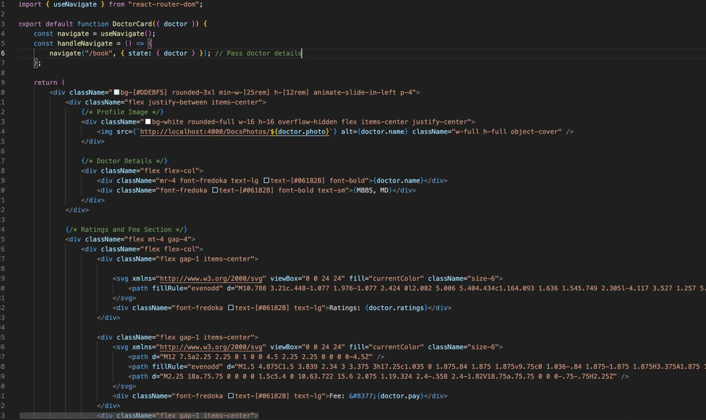

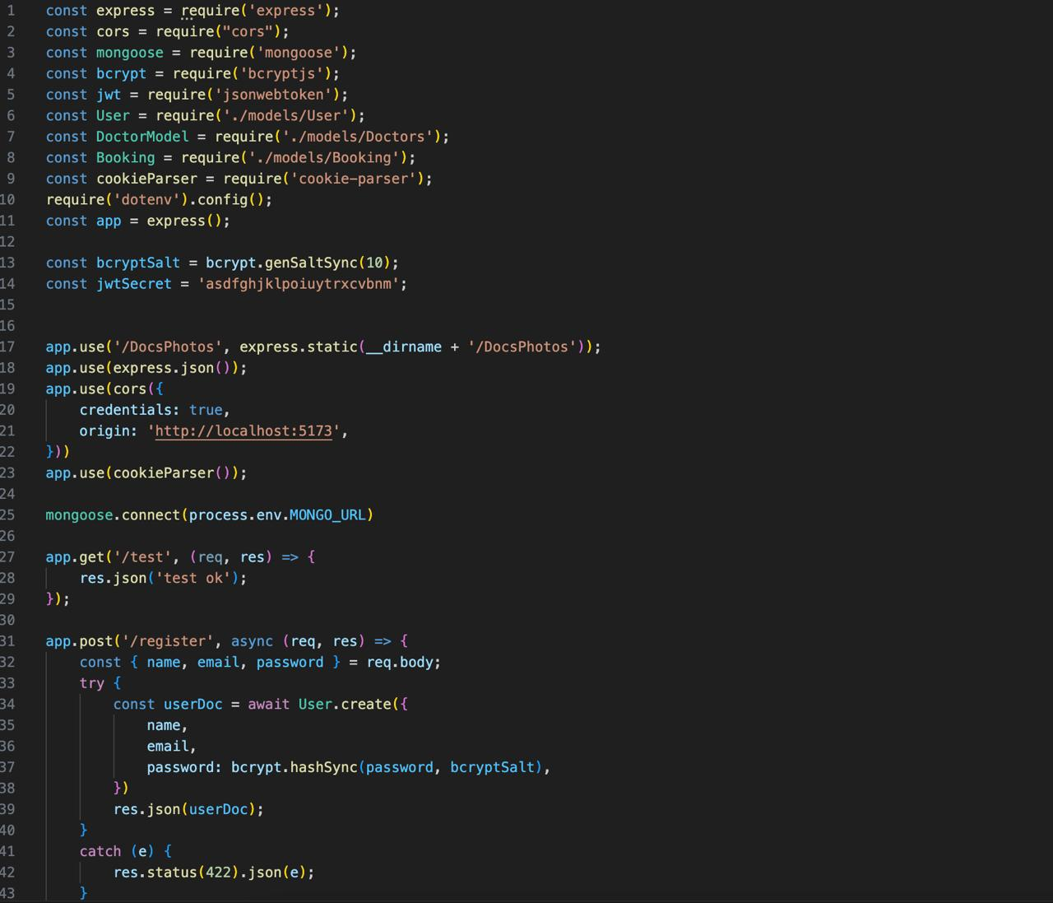

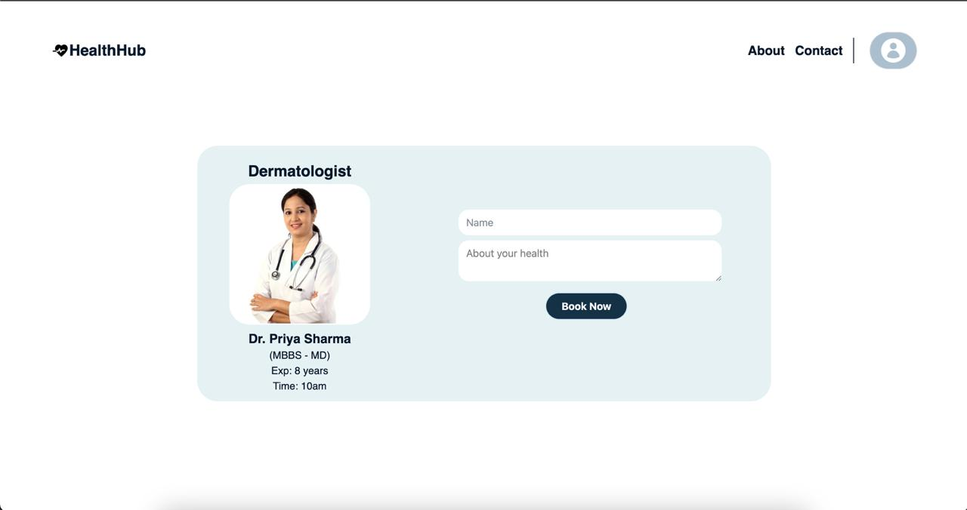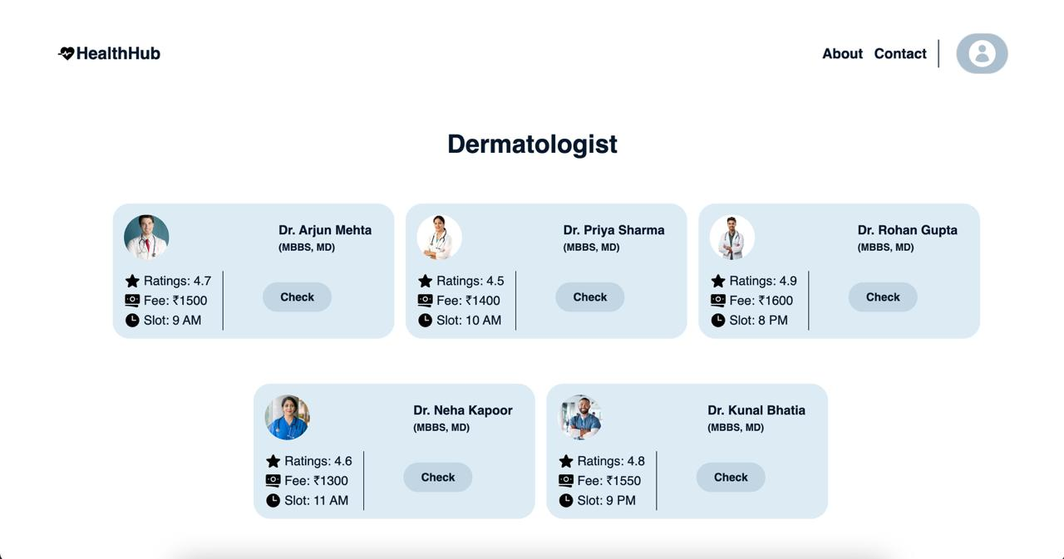

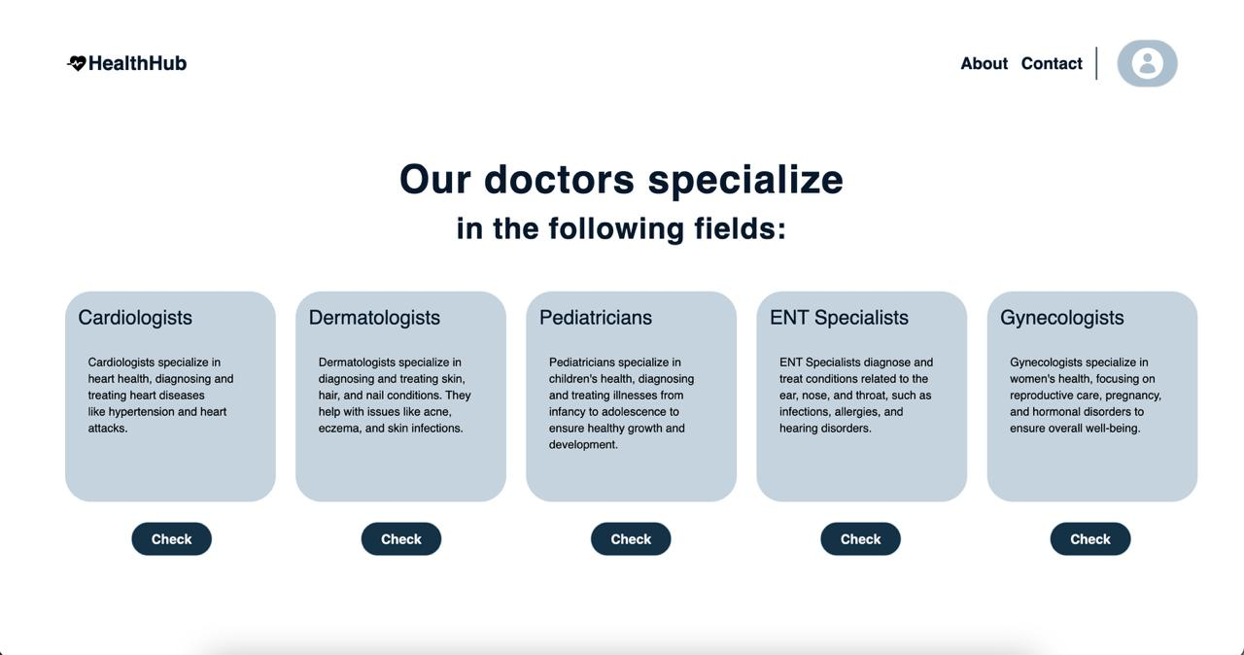

**4.2 Metrics and Analysis**

* User engagement: Number of consultations completed, frequency of symptom checks, user retention rate
* AI accuracy: Percentage of accurate disease predictions compared to actual diagnoses
* Teleconsultation success rate: Number of consultations completed successfully without technical issues

**4.3 Evaluation**

* Usability Testing: Feedback from users on ease of use, effectiveness of symptom analysis, and consultation quality
* Technical Evaluation: Performance of the AI algorithms and the teleconsultation system under different network conditions

**5. References**

* Research papers on AI in healthcare and disease prediction.
* Case studies on telemedicine platforms like Teladoc, Practo, and Amwell.
* Guidelines from healthcare regulatory bodies (e.g., WHO, HIPAA, GDPR).
* User feedback and surveys on existing teleconsultation platforms
* Articles on UX/UI design for healthcare applications