***EXPERIMENT – 01***

***Name: -*** *Samarth Passi*

***UID: -*** *23BCC70015*

***SUBJECT & CODE: -*** *ADBMS (23 CSP-333)*

***SECTION & GROUP :-*** *23BCC-1 A*

* ***AIM: -*** Author-Book Relationship Using Joins and Basic SQL Operations
* ***THEORY: -***

*SQL JOIN clauses are used to combine rows from two or more tables based on a related column—usually a primary key and a corresponding foreign key. Since data is normalized across multiple tables to reduce redundancy, joins are essential to retrieve complete and meaningful datasets. The ON keyword defines the relationship between the tables.*

* *INNER JOIN: Returns only rows with matching values in both tables.*
* *LEFT JOIN: Returns all rows from the left table, and matched rows from the right table. If there's no match, NULLs are returned for the right table’s columns.*
* *RIGHT JOIN: Returns all rows from the right table, and matched rows from the left table. If there's no match, NULLs are returned for the left table’s columns.*
* *FULL JOIN (or FULL OUTER JOIN): Returns all rows from both tables. Rows without a match in one of the tables will have NULLs in place of missing values.*
* ***SQL queries: -*** 
  1. *To create two tables author and books and show it :-*

*Create table authors(author_id int primary key , name VARCHAR(50) , CountryVARCHAR(50));*

*Create table books(book_id int primary key , title VARCHAR(100), author_id int , foreign key (author_id) REFERNCES authors(author_id);*

*Describe authors;*

*Describe books;*

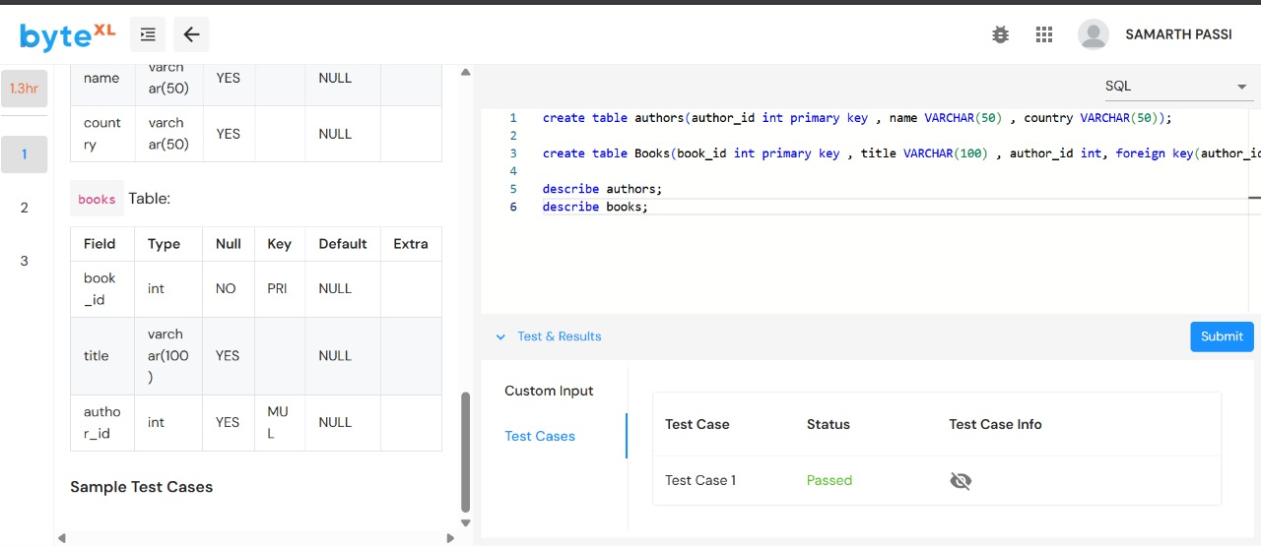

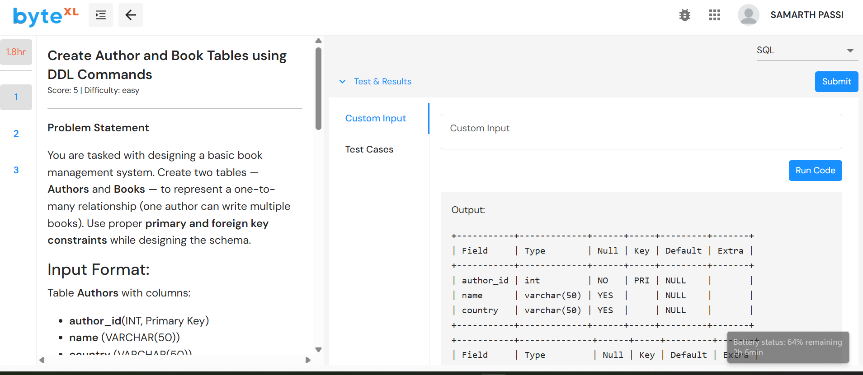

2.To insert values into authors and books and display the table:

Insert into authors values(1, ‘Ashish’, ‘India’),(2,’Smaran’, ‘USA’),(3,’Vaibhav’, ‘UK’);

Insert into books values(101, ‘Data Science Basics’,1),(102,’AI in Education’,2),(103,’SQL Simplified’, 1) ;

Select * from authors;

Select * from books;

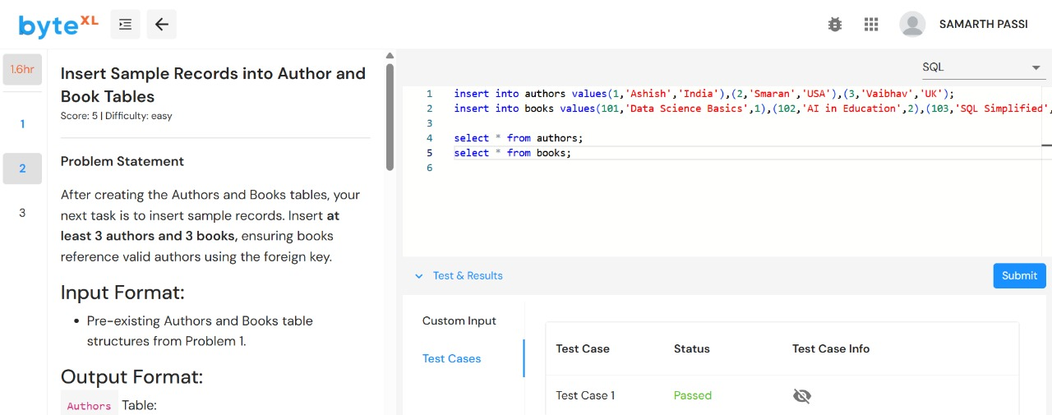

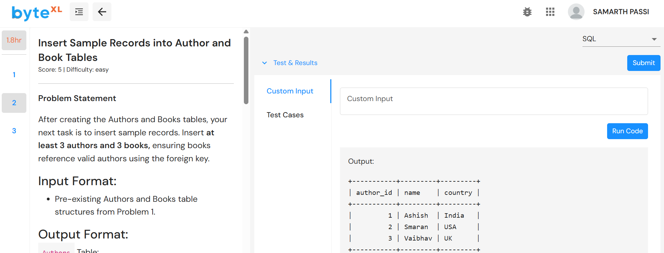

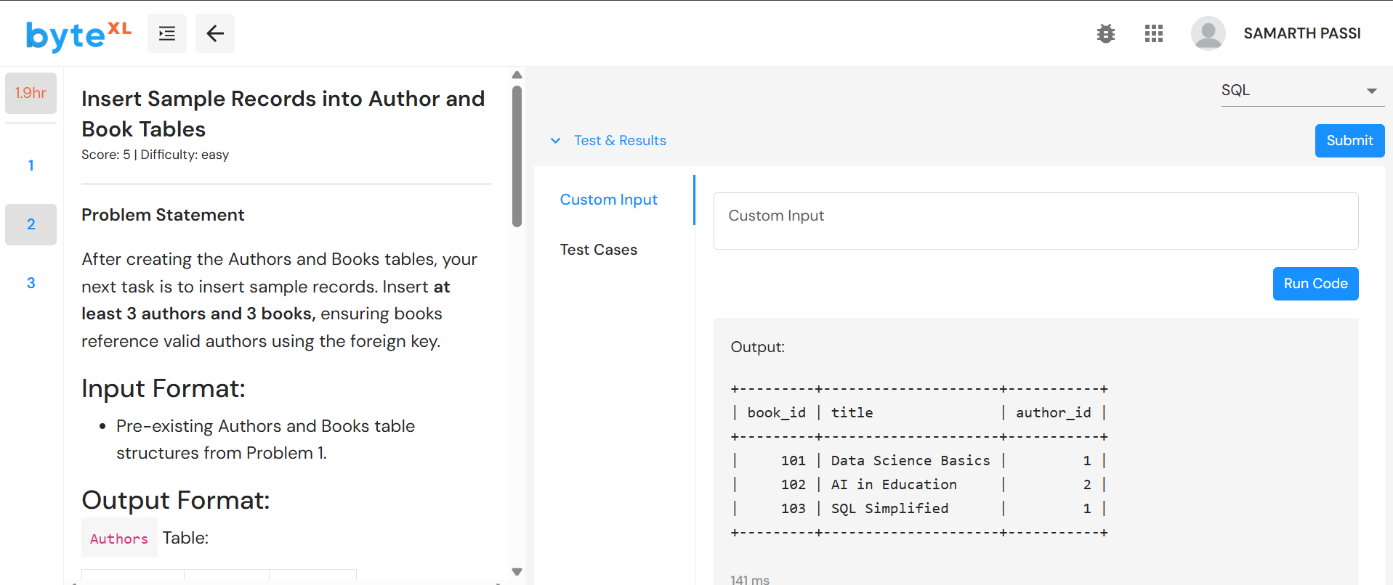

*3.* To retrieve the titles of all books along with their author's name and country:

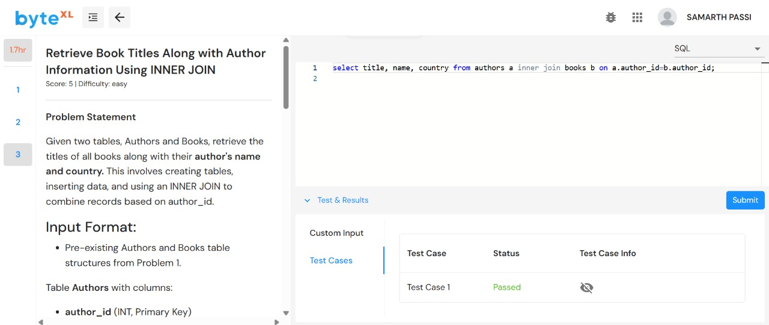select title,name,country from authors a inner join books b on a.author_id=b.author_id;

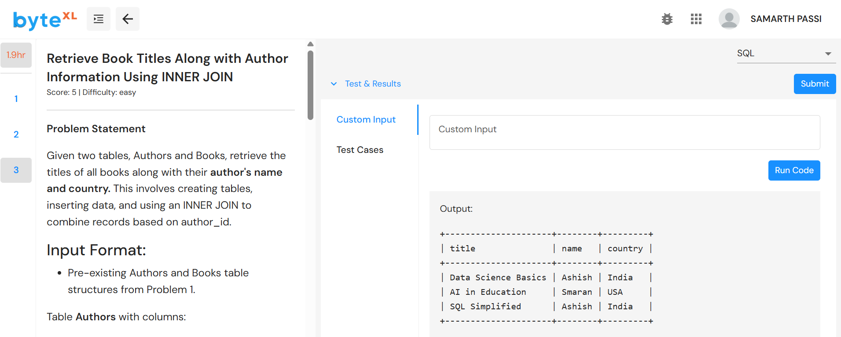

* ***Conclusion***
* *SQL JOIN clauses are crucial for combining related data stored across normalized tables, enabling comprehensive data retrieval.*
* *Choosing the right type of JOIN (INNER, LEFT, RIGHT, FULL) depends on whether you want to include unmatched records from one or both tables.*
* *Understanding JOINs improves your ability to write efficient queries and build meaningful reports from relational databases.*