***EXPERIMENT – 02***

***Name: -*** *Samarth Passi* ***UID: -*** *23BCC70015*

***Section & Group: -***  *23BCC 1 A*

* ***AIM: -*** Department-Course Subquery and Access Control
* ***THEORY: -***
* A **subquery** is a SELECT statement embedded within another query. It executes first and provides a result that the outer query uses—often within the WHERE clause—to filter data dynamically. For example, you can retrieve all employees working in the same department as 'John' without separately identifying his department.
* **Access control** in databases ensures security by defining what actions users can perform. Administrators use the GRANT command to provide permissions like SELECT or UPDATE, and the REVOKE command to withdraw them. This mechanism helps prevent unauthorized access and maintains data integrity.
* ***SQL QUERIES: -***

1. To create two tables- Departments and courses:

*create table department_samarth(dept_id int primary key , dept_name VARCHAR(50));*

*create table courses_samarth(course_id int primary key , course_name VARCHAR(100) , dept_id int, foreign key(dept_id) REFERENCES department_samarth(dept_id));*

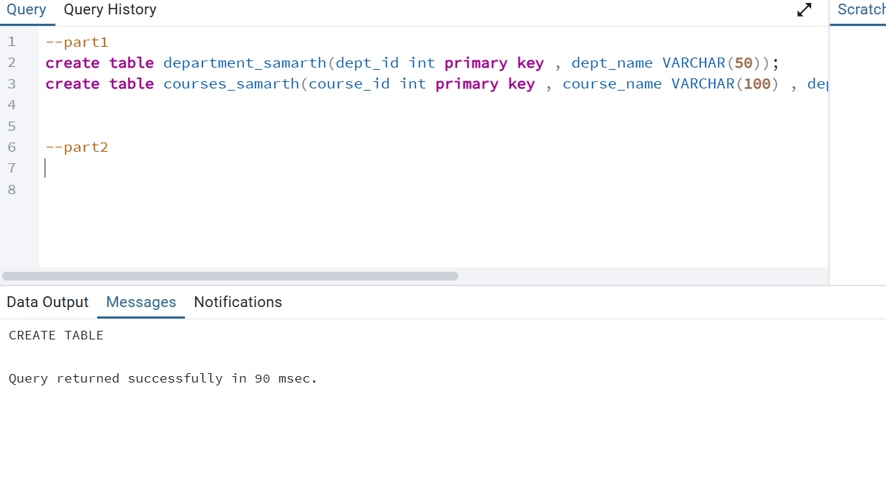

1. To insert values into Departments and Courses and display the table:

*insert into department_samarth values(1,'Computer Science'),(2,'Electrical'),(3,'Mechanical'),(4,'Civil'),(5,'Electronics');*

*insert into courses_samarth values(101,'DBMS',1),(102,'Operating Systems',1),(103,'Power Systems',2),(104,'Digital Circuits',2),(105,'Thermodynamics',3),(106,'Fluid Mechanics',4),(107,'Structural Engineering',4),(108,'Surveying',4),(109,'Embedded Systems',5),(110,'VLSI Design',5);*

*select * from department_samarth;*

*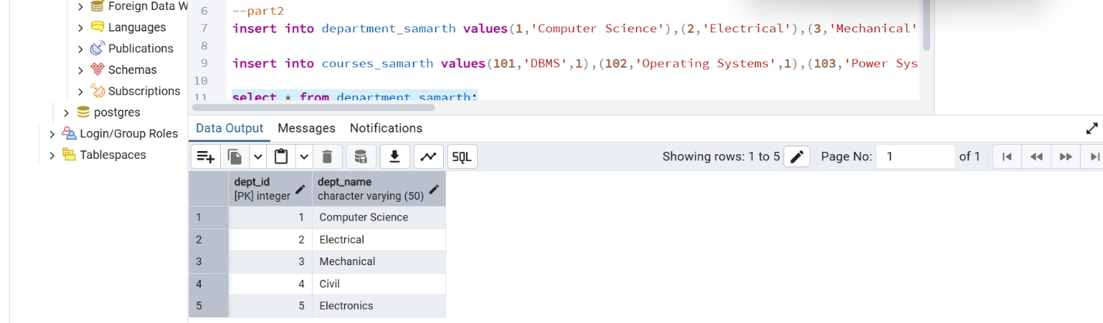select * from courses_samarth;*

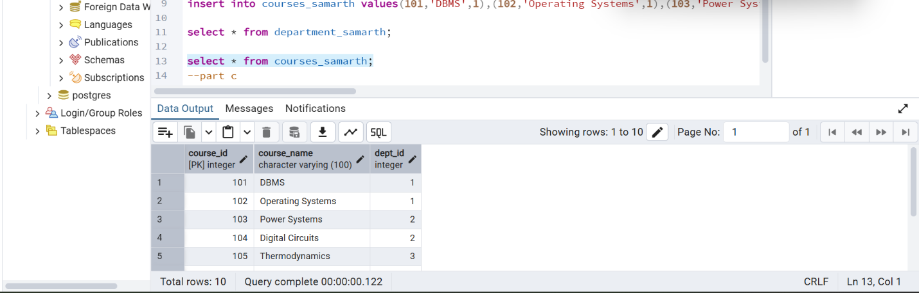

3.Retrieve Departments Offering More Than Two Courses Using Subquery:

select dept_name from department_samarth where dept_id in (select dept_id from courses_samarth group by dept_id having count(course_name)>2);

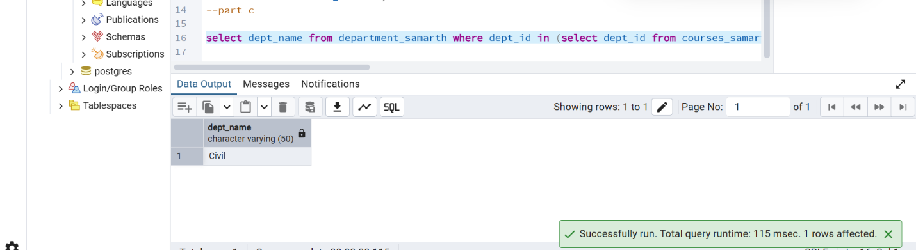

4. Grant SELECT Access on Courses Table Using DCL

create user viewer_user with password '123';

grant select on courses_samarth to viewer_user

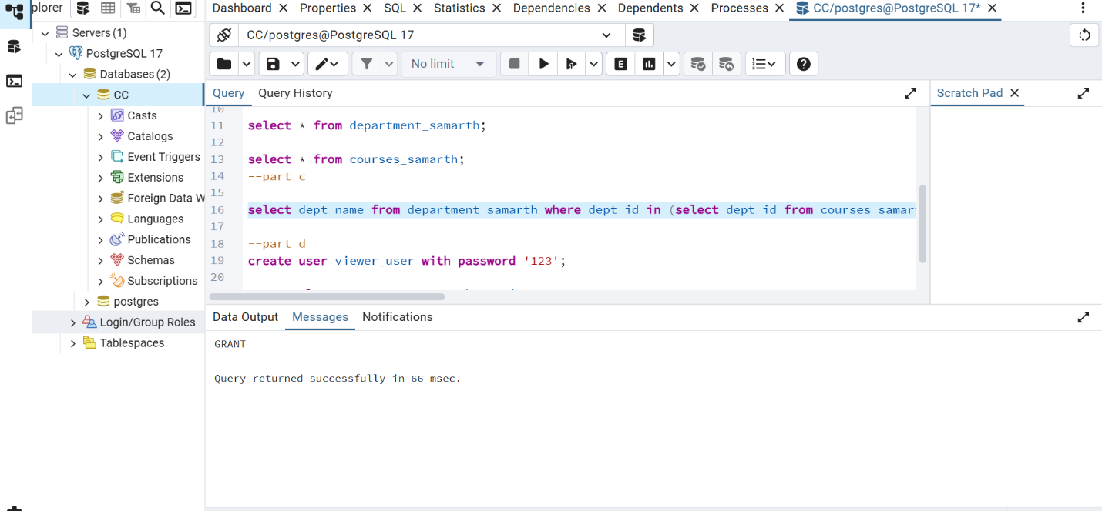

* ***CONCLUSION:*** *-***Subqueries** enhance query flexibility by allowing dynamic data filtering based on results from other queries.

**Access control** is essential for database security, ensuring that only authorized users can view or modify data.