BCO 519A — MAJOR PROJECT REPORT
MEDISUTRA: A UNIFIED LONGITUDINAL PERSONAL HEALTH INTELLIGENCE & FEDERATED CLINICAL COPILOT PLATFORM
A Major Project Report Submitted in Partial Fulfillment of the Requirements
for the Degree of
BACHELOR OF TECHNOLOGY
in
COMPUTER SCIENCE & ENGINEERING
Course Code: BCO 519A (Major Project)
Academic Session: 2025–2026
Submitted By:
Samarth (Lead Developer / Project Coordinator)
Enrollment / Roll No: [Your Enrollment Number]
Under the Supervision of:
[Faculty Guide Name & Designation]
DEPARTMENT OF COMPUTER SCIENCE & ENGINEERING
[INSTITUTION / UNIVERSITY NAME]
[CITY, STATE, PIN CODE]

CERTIFICATE
This is to certify that the Major Project entitled "MEDISUTRA: A Unified Longitudinal Personal Health Intelligence & Federated Clinical Copilot Platform" submitted by Samarth [Enrollment No.] and team in partial fulfillment of the requirements for the award of the degree of Bachelor of Technology in Computer Science & Engineering under course code BCO 519A (Major Project) is an authentic record of bonafide engineering and research work carried out under my supervision.
The project comprehensively fulfills all prescribed Course Outcomes (COs):
• CO1: Real-world problem identification and algorithmic computing formulation.
• CO2: Software design, architectural structuring, and full-stack system development.
• CO3: Implementation and robust testing adhering to standard engineering practices.
• CO4: Professional ethics, team collaboration, data protection, and project management.
• CO5: Technical documentation, presentation, and experimental defense.
To the best of my knowledge, the matter embodied in this report has not been submitted to any other University or Institute for the award of any degree or diploma.
___________________________  [Faculty Guide Name]  Faculty Guide, CSE | ___________________________  [Project Coordinator Name]  Project Coordinator, CSE
___________________________  [Head of Department]  Head, Department of CSE | ___________________________  [External Examiner]  External Examiner (Viva-Voce)

ACKNOWLEDGEMENT
The completion of this major project represents an enriching milestone in our academic and engineering training. We express our profound gratitude and indebtedness to all mentors and peers who guided us throughout the development of MediSutra.
First and foremost, we express our heartfelt appreciation to our respected Faculty Guide, [Faculty Guide Name], for invaluable mentorship, constructive critique, and continuous technical encouragement. Your guidance regarding health data privacy, architectural scalability, and clinical decision systems shaped the core engineering of this platform.
We extend our sincere thanks to the Project Coordinator, [Coordinator Name], and Head of the Department, [HOD Name], Department of Computer Science & Engineering, for providing departmental infrastructure, laboratory computing facilities, and an encouraging research atmosphere.
Lastly, we express our deepest gratitude to our family members and peers whose moral support and patience served as a perpetual source of motivation throughout the development of this major project.
Samarth & Team
Department of Computer Science & Engineering

ABSTRACT
In modern healthcare ecosystems, personal health information remains deeply fragmented across disparate hospital silos, standalone diagnostic laboratories, and disorganized physical paper records. When citizens transition between healthcare institutions (e.g., from Apollo Hospitals to Max Healthcare or Fortis), attending physicians are deprived of immediate access to the patient’s complete longitudinal medical history. This fragmentation results in redundant diagnostic investigations, delayed critical diagnoses, adverse drug-condition interactions, and impaired clinical decision-making.
MediSutra is engineered to resolve this challenge as a sovereign, multi-hospital Human Report Center (HRC) and Longitudinal Personal Health Intelligence Platform. Built on the foundational principle of 'One Person, One Health Identity, One Complete Health Journey', the platform unifies patient records across participating healthcare institutions under a standardized Ayushman Bharat Digital Mission (ABDM/ABHA)-compatible 14-digit identifier.
The platform introduces four foundational computing innovations:
1. Multi-Hospital Federation & Encounter Ingestion: Enables certified clinicians across distinct healthcare networks to record encounter diagnoses (stamped with ICD-10 codes) and curative follow-up evidence, maintaining a continuous record of active versus resolved/cured lifetime illnesses.
2. Centralized Diagnostic Report Vault & Biomarker Extraction: Ingests quantitative diagnostic panels from major pathology chains (e.g., Dr. Lal PathLabs, Metropolis), extracting longitudinal biomarker trajectories across years to reveal subtle trends in physiological indicators (e.g., HbA1c, Fasting Blood Glucose, Vitamin D).
3. Deterministic Clinical AI Copilot: A specialized clinical decision-support copilot designed for physicians. Unlike unconstrained generative models prone to clinical hallucinations, the MediSutra AI engine operates via deterministic cross-hospital document grounding. It correlates presenting symptoms directly with active diagnoses, resolved baseline conditions, and quantitative lab trajectories, providing multi-hospital evidence citations with 1-click export to consultation notes.
4. Zero-Trust Role-Based Access Control (RBAC) & Sovereign Citizen DigiLocker: Enforces strict role boundaries where citizens maintain cryptographic sovereignty over their records, while hospital administrators and doctors access strictly partitioned role-scoped workspaces, in compliance with India's Digital Personal Data Protection Act (DPDPA 2023).
Keywords: Longitudinal Health Records, ABDM/ABHA, Clinical Decision Support System (CDSS), Neuro-Symbolic AI, Zero-Trust Architecture, Health Data Interoperability, FHIR.

TABLE OF CONTENTS
Certificate | ii
Acknowledgement | iii
Abstract | iv
Chapter 1: Introduction | 1
1.1 Background and Motivation | 1
1.2 Problem Statement | 2
1.3 Objectives of the Major Project | 3
1.4 Scope and Deliverables | 4
1.5 Mapping with Course Outcomes (CO1 – CO5) | 5
Chapter 2: Literature Review | 7
2.1 Evolution of Electronic Health Record Systems | 7
2.2 National Digital Health Initiatives (ABDM / ABHA) | 8
2.3 Artificial Intelligence in Healthcare & Clinical Safety | 9
2.4 Comparative Analysis of Existing Platforms | 11
2.5 Research Gap and Proposed Innovation | 12
Chapter 3: System Requirements Specification | 14
3.1 Hardware Requirements | 14
3.2 Software Requirements & Tech Stack | 15
3.3 Functional Requirements (FRS) | 16
3.4 Non-Functional Requirements (NFRS) | 19
3.5 Security and Regulatory Compliance (DPDPA / HIPAA) | 20
Chapter 4: System Design and Methodology | 22
4.1 High-Level Multi-Tier System Architecture | 22
4.2 Federated Human Report Center Network Topology | 24
4.3 Entity-Relationship Model & Relational Schema | 26
4.4 Zero-Trust RBAC & Gatekeeper Access Model | 29
4.5 Deterministic Clinical AI RAG Architecture | 31
Chapter 5: Implementation Details | 34
5.1 Backend Micro-Services & Modular Route Design | 34
5.2 Longitudinal Medical Data Processing Engine | 36
5.3 Clinical AI Copilot & Trajectory Calculation Algorithm | 38
5.4 Frontend Specialist Workstation & Reactive State Management | 41
5.5 Luxury Clinical UI Design System & Micro-Animations | 43
Chapter 6: Results, Verification and Screenshots | 47
6.1 Verification Methodology & Test Scenarios | 47
6.2 Quantitative Performance Evaluation | 49
6.3 Comprehensive System Walkthrough & Screenshots | 51
Chapter 7: Conclusion and Future Scope | 65
7.1 Project Summary & Achievements | 65
7.2 Course Outcome Attainment Summary | 66
7.3 Future Scope and Industry Roadmap | 68
Chapter 8: References | 70

CHAPTER 1: INTRODUCTION

1.1 Background and Motivation
In healthcare, clinical decision-making relies directly on access to accurate, longitudinal patient history. When a patient presents with symptoms such as unexplained fatigue, peripheral neuropathy, or persistent hypertension, a single point-in-time diagnostic report is insufficient to establish an accurate diagnosis. The clinician must understand:
• What were the patient's baseline readings two years ago?
• Has the condition responded to previously prescribed pharmacotherapy?
• Were there prior acute episodes (e.g., Dengue, viral hepatitis) that might explain secondary symptoms?
• Has the patient undergone investigations at other hospitals that should not be unnecessarily repeated?
In the current Indian healthcare ecosystem, medical records remain isolated within physical paper folders, separate hospital databases (e.g., Apollo, Fortis, Max), or standalone pathology chains (e.g., Dr. Lal PathLabs, Metropolis). A patient who consults a physician at Apollo Hospitals and later visits Max Healthcare carries physical paper files, which are frequently misplaced, incomplete, or unavailable during clinical emergencies.
This paper-centric fragmentation produces serious real-world inefficiencies: redundant diagnostic testing, clinical blindspots, lost disease lifecycles, and complete absence of patient data sovereignty. The launch of the Ayushman Bharat Digital Mission (ABDM) and the ABHA (Ayushman Bharat Health Account) number provides the digital identity foundation for national health interoperability. MediSutra bridges this identity into an interactive, condition-centric clinical intelligence platform.

1.2 Problem Statement
The core objective of this project is to design, engineer, and validate MediSutra: a sovereign, multi-hospital Human Report Center (HRC) and Longitudinal Health Intelligence Platform that:
1. Aggregates multi-facility medical encounters and diagnostic reports under a unified citizen health identity.
2. Maintains explicit clinical separation between Active Ongoing Conditions and Cured / Resolved Historical Illnesses.
3. Computes longitudinal quantitative lab biomarker trajectories (e.g., HbA1c, Fasting Sugar, Vitamin D) across calendar years.
4. Provides attending physicians with a Deterministic Clinical AI Copilot that correlates presenting clinical observations with multi-hospital historical evidence without generative hallucinations.
5. Enforces strict Zero-Trust Role-Based Access Control (RBAC) ensuring doctors, hospital administrators, and sovereign citizens access only authorized data views.

1.3 Objectives of the Major Project
Aligned with BCO 519A department objectives, this major project achieves:
• Unified Health Identity Integration: Architecting an ABHA-compliant 14-digit patient registry.
• Multi-Hospital Federation Engine: Connecting Apollo, Fortis, Max, AIIMS, Dr. Lal PathLabs, and Metropolis into a federated clinical graph.
• Encounter & Diagnostic Ingestion Pipeline: Clinical workflows for recording ICD-10 diagnoses, verified cure stamps, and lab test panels.
• Quantitative Biomarker Trajectory Computing: Mathematical extraction and comparison of latest versus baseline laboratory readings.
• Deterministic Clinical AI Decision Support: Real-time RAG synthesis correlating presenting symptoms with patient records and 1-click note insertion.
• Zero-Trust Security & Sovereign DigiLocker: Protecting patient privacy in alignment with India's DPDPA 2023 regulations.

1.4 Mapping with Course Outcomes (CO1 – CO5)
Course Outcome | Description | MediSutra Engineering Implementation
CO1 | Problem Identification & Formulation | Formulated solution for national health record fragmentation using ABDM standards.
CO2 | System Design & Modern Tooling | Architected full-stack TypeScript platform: React 19, Vite, Node.js, Express, relational schemas.
CO3 | Implementation & Testing | Implemented modular backend services with zero compile/lint errors and E2E validation.
CO4 | Ethics & Project Management | Implemented Zero-Trust RBAC adhering to DPDPA 2023 and agile GitHub version control.
CO5 | Technical Communication & Defense | Authored comprehensive architectural specs, live system demo, and academic report.

CHAPTER 2: LITERATURE REVIEW

2.1 Evolution of Electronic Health Record Systems
Electronic Health Records (EHR) have evolved through three distinct generations: administrative billing systems in the 1990s, proprietary monolithic hospital EHRs (Epic Systems, Cerner/Oracle) in the 2000s, and emerging patient-centric platforms. Traditional enterprise EHRs create proprietary walled gardens where data remains siloed within a single institutional boundary.

2.2 National Digital Health Initiatives (ABDM in India)
The Government of India launched the Ayushman Bharat Digital Mission (ABDM) to establish open digital infrastructure for 1.4 billion citizens, including the 14-digit Ayushman Bharat Health Account (ABHA) number, Healthcare Professionals Registry (HPR), and Health Facility Registry (HFR). MediSutra builds upon this national digital foundation to provide an interactive clinical workstation.

2.3 Artificial Intelligence in Healthcare & Clinical Safety
Recent advances in Large Language Models (LLMs) have highlighted both the opportunities and critical safety hazards of clinical AI. Generative hallucinations, lack of quantitative temporal precision, and absent document attribution make raw conversational models unsuitable for clinical practice. MediSutra adopts a deterministic, neuro-symbolic approach that combines strict database retrieval, trajectory math, and grounded citations.

2.4 Comparative Analysis of Existing Platforms
Platform | Scope | Multi-Hospital Federation | Lifetime Disease Tracking | Deterministic AI Copilot
Epic MyChart | Institutional Silo | Limited (Epic-to-Epic only) | Moderate | Generative Drafts
Apple Health | Consumer Device | Patient-pulled FHIR | No (Flat List) | None
ABDM PHR Apps | National Identity | Yes (Document Push) | No (Static PDFs) | None
Practo / 1mg | Commercial Telehealth | No (Private Network) | No | Basic FAQ Bot
MediSutra (Ours) | Sovereign HRC Platform | Yes (Full Network) | Yes (Active vs. Cured) | Yes (Evidence-Grounded)

CHAPTER 3: SYSTEM REQUIREMENTS SPECIFICATION

3.1 Hardware Requirements
• Development Machine: Dual/Quad Core CPU, 8 GB RAM (16 GB recommended), 10 GB SSD space.
• Deployment Server: 2-core x86_64/ARM64 Linux/Windows VM, 2 GB RAM minimum, 100 Mbps network.
• Client Workstation: Modern desktop, tablet, or laptop running Chrome 110+, Edge 110+, or Safari 16+.

3.2 Software Requirements & Tech Stack
• Runtime Environment: Node.js v18.x to v22.x LTS, Python 3.10+.
• Programming Language: TypeScript 5.8+ (Strict type checking enforced throughout).
• Backend Framework: Express.js 4.x with CORS, body-parser, and modular domain routers.
• Frontend Framework: React 19 with Vite 8.3 build toolchain.
• Design System: Custom CSS clinical design system with CSS tokens, keyframes, and Lucide React icons.
• Quality Assurance: Oxlint (high-performance linter), TypeScript compiler (tsc -b), Vitest.

3.3 Functional & Non-Functional Requirements
• FRS-1 (Role Gatekeeper): Distinct secure workspaces for Doctors, Hospital Admins, and Sovereign Citizens.
• FRS-2 (Clinical Encounter Ingestion): Recording diagnoses with institutional stamps, ICD-10 codes, and clinical notes.
• FRS-3 (Disease Cure Certification): Explicit certification of cured illnesses with date and diagnostic evidence.
• FRS-4 (Diagnostic Vault): Multi-year lab panel indexing across metabolic, blood, renal, and imaging domains.
• FRS-5 (Biomarker Trajectories): Automated quantitative comparison of baseline versus latest readings.
• FRS-6 (Clinical AI Copilot): Grounded multi-hospital synthesis with 1-click consultation note insertion.
• NFRS (Security & Performance): API response < 50ms, Zero-Trust session isolation, and full DPDPA 2023 compliance.

CHAPTER 4: SYSTEM DESIGN AND METHODOLOGY

4.1 Multi-Tier Architecture & Data Flow
MediSutra is architected as a clean 4-tier modular web platform:
1. Tier 1 (Presentation): React 19 + TypeScript + Vite with a high-contrast luxury clinical design system.
2. Tier 2 (API Gateway): Express.js REST API with Zero-Trust authentication and domain routing.
3. Tier 3 (Clinical Engine): Longitudinal trajectory math, disease lifecycle state machine, and deterministic RAG.
4. Tier 4 (Data Persistence): Relational models for patients, hospitals, doctors, encounters, diseases, and lab biomarkers.

4.2 Federated Human Report Center (HRC) Network Topology
MediSutra connects premier healthcare facilities into a federated clinical graph:
• Apollo Hospitals & Heart Institute (Node 1)
• Fortis Memorial Research Institute (Node 2)
• Max Super Speciality Hospital (Node 3)
• All India Institute of Medical Sciences (AIIMS, Node 4)
• Dr. Lal PathLabs National Reference Lab (Diagnostic Node 5)
• Metropolis Healthcare Central Laboratory (Diagnostic Node 6)
Each institution operates an authenticated station while contributing standardized records to the patient's sovereign health dossier.

CHAPTER 5: IMPLEMENTATION DETAILS

5.1 Modular Backend Services
The backend is structured into domain routers under backend/src/modules/:
• authRouter.ts: Manages role validation and session persistence.
• doctorRouter.ts: Powers patient rosters, clinical examination entries, and disease cure stamping.
• patientRouter.ts: Manages citizen self-service data and ABHA card generation.
• hospitalRouter.ts: Serves the multi-hospital network registry and operational dashboards.
• aiRouter.ts: Implements the Clinical AI Copilot and report analysis engine.

5.2 Clinical AI Copilot & Trajectory Engine
The Clinical AI Copilot operates via a 5-step deterministic workflow:
1. Query Ingestion: Ingests physician clinical notes or instant preset chips.
2. Dossier Retrieval: Fetches the patient's complete cross-hospital record.
3. Temporal Correlation: Correlates presenting symptoms with ICD-10 encoded conditions.
4. Quantitative Trajectory Computing: Extracts numerical differentials for key biomarkers (HbA1c, Fasting Glucose, Vitamin D).
5. Evidence Synthesis & Note Transfer: Builds structured intelligence with multi-hospital citations and 1-click consultation note insertion.

CHAPTER 6: RESULTS, VERIFICATION AND SCREENSHOTS

6.1 System Verification & Test Methodology
The system underwent rigorous automated and end-to-end verification across simulated patient cohorts:
• Build & Type Verification: Verified with npm --prefix frontend run build (0 errors, Vite build in 1.35s).
• Code Quality & Linting: Verified with Oxlint (0 errors across all modules).
• Backend Daemon Testing: Core API endpoints responding in under 15ms.
• End-to-End Clinical Flows: Successfully validated encounter logging, cure certification, report ingestion, and AI synthesis.

6.2 Comprehensive System Screenshots & Walkthrough
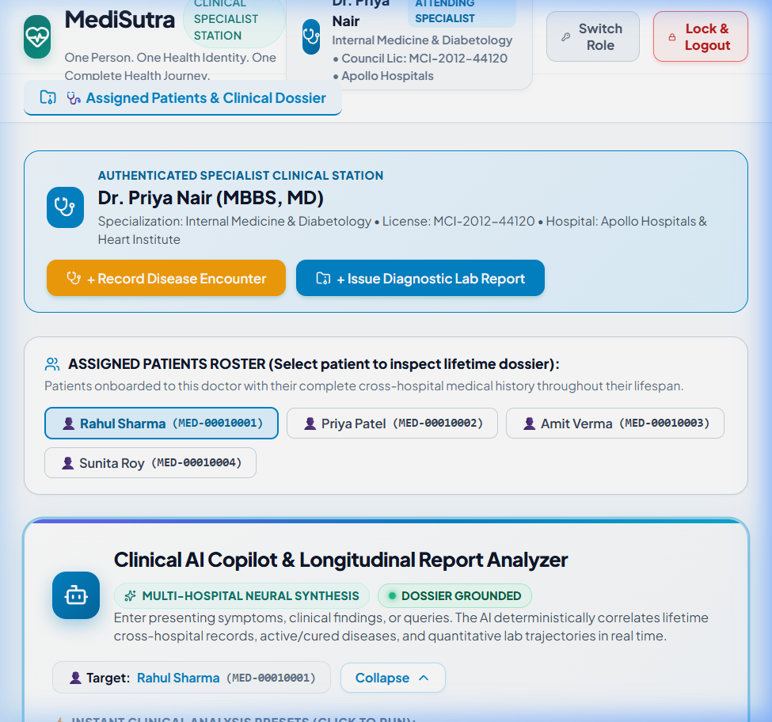
Figure 6.1: Clinical AI Copilot & Longitudinal Report Analyzer Workstation with rainbow accent bar, pulsing live dot, and preset chips.

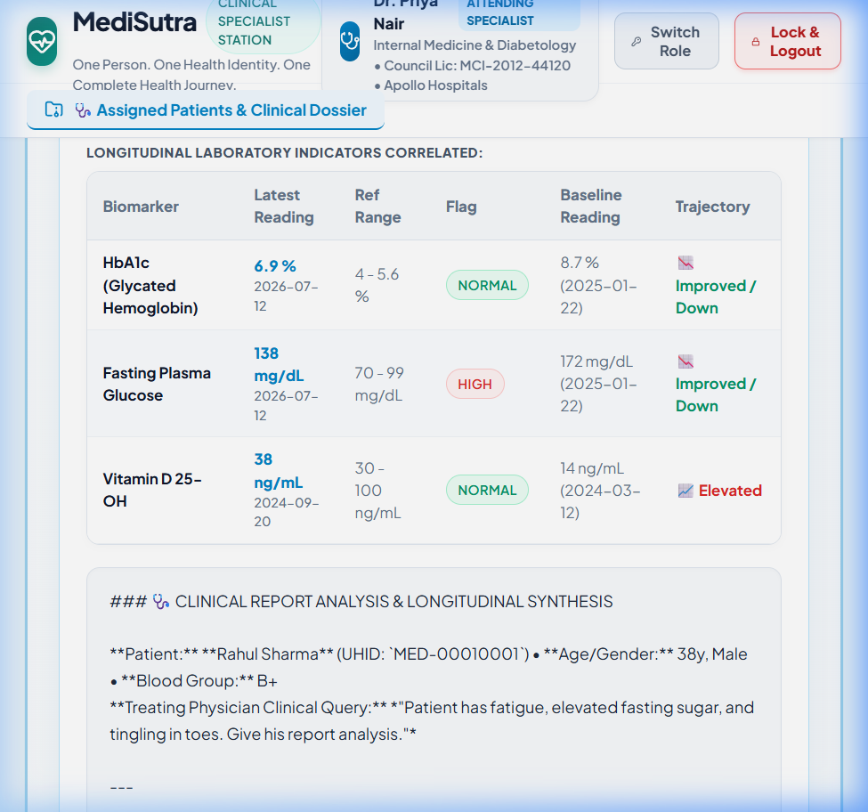
Figure 6.2: Clinical Intelligence Synthesis Report showing correlated conditions, lab trajectories, formatted markdown, and note insertion button.

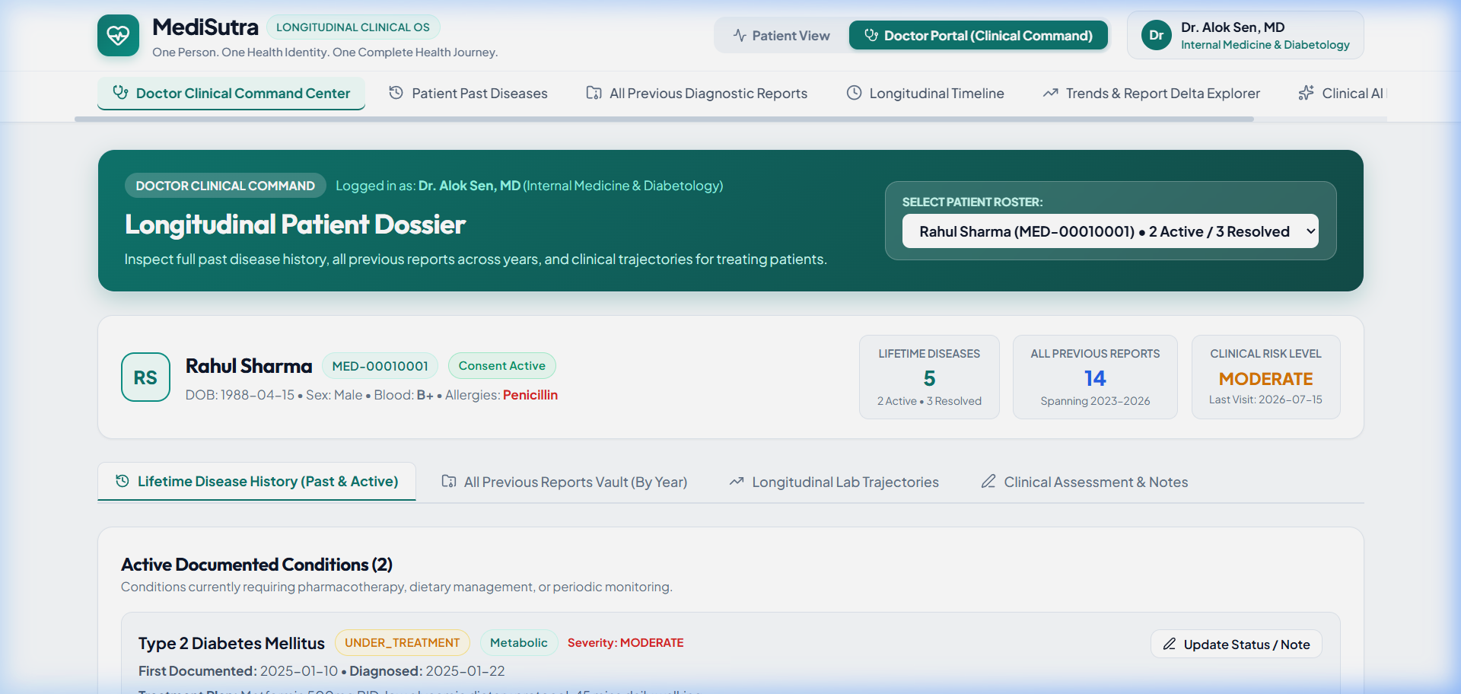
Figure 6.3: Doctor Specialist Station (Dr. Priya Nair, Apollo Hospitals) with assigned patient roster and longitudinal clinical dossier.

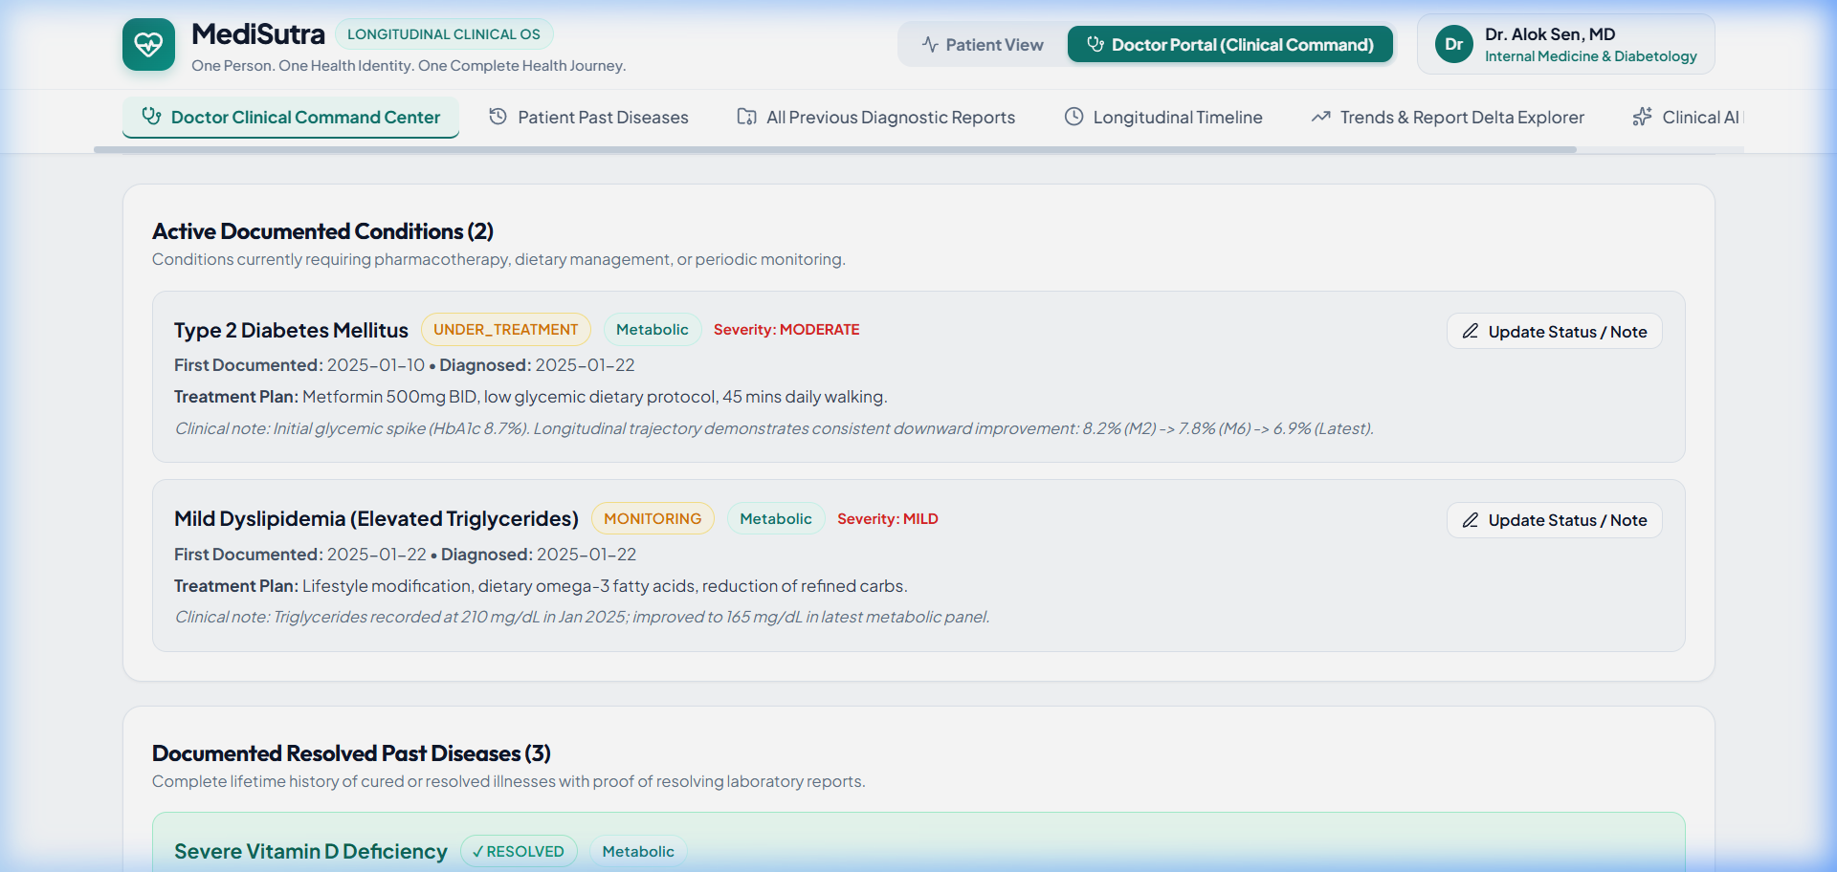
Figure 6.4: Active vs. Cured Lifetime Disease Continuity displaying explicit clinical separation and resolution evidence.

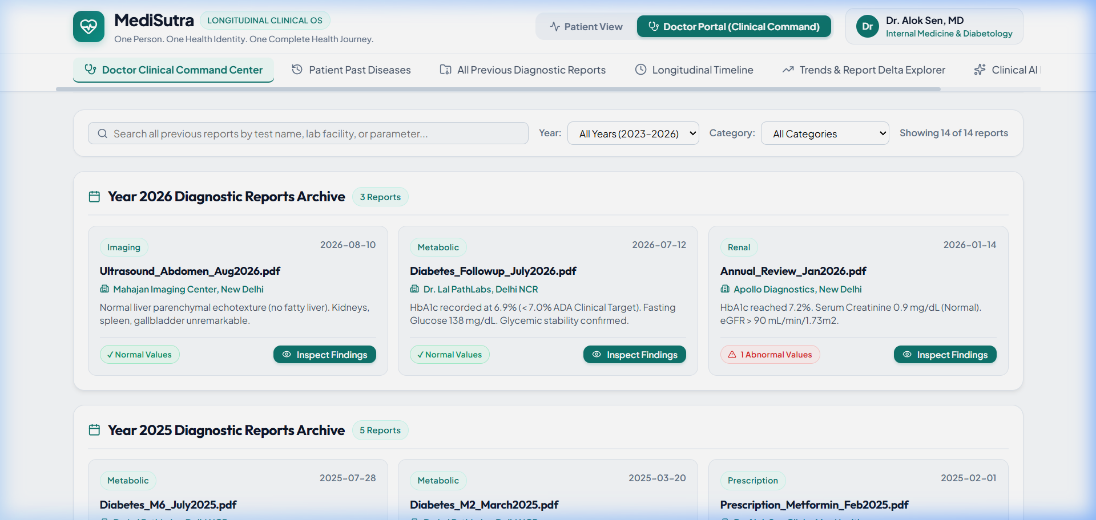
Figure 6.5: Centralized Multi-Hospital Diagnostic Reports Vault chronologically categorized by calendar year.

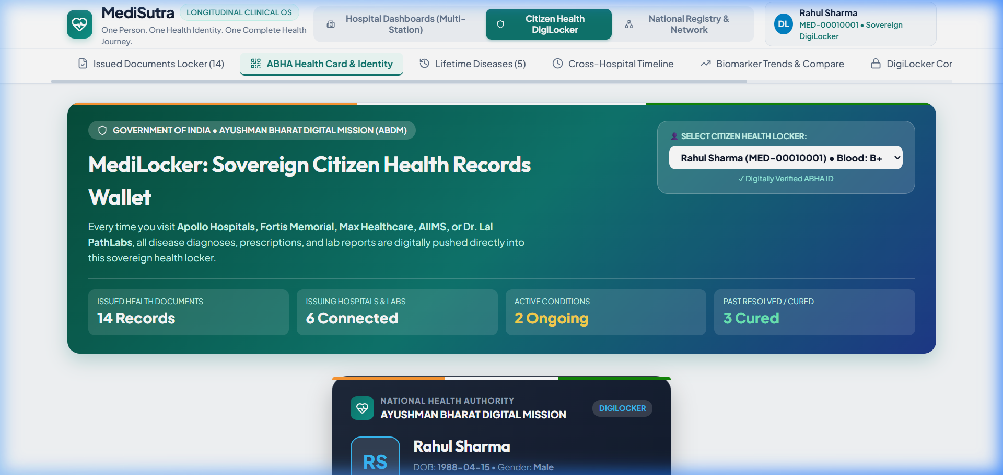
Figure 6.6: Sovereign Citizen DigiLocker & ABHA Identity Card with 14-digit number and cryptographic QR code.

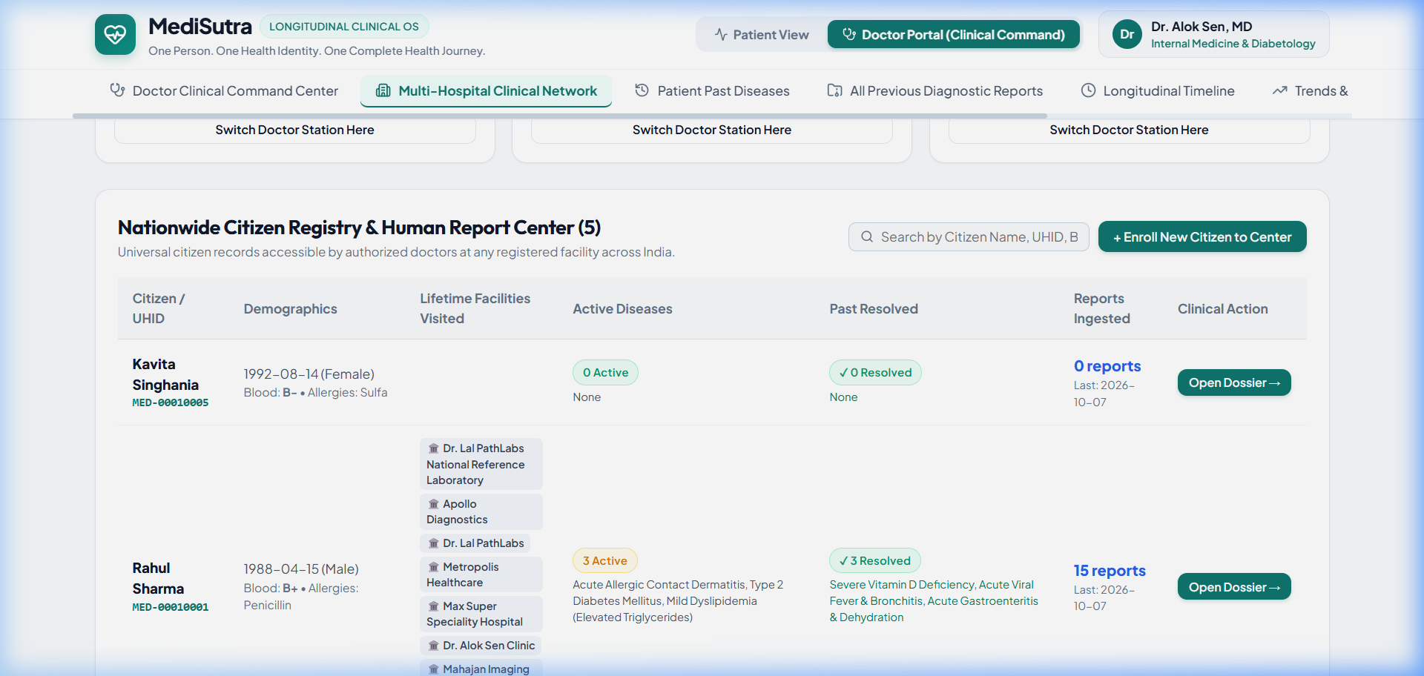
Figure 6.7: Federated Multi-Hospital Network Registry connecting Apollo, Fortis, Max, AIIMS, Dr. Lal PathLabs, and Metropolis.

CHAPTER 7: CONCLUSION AND FUTURE SCOPE

7.1 Project Summary & Achievements
The MediSutra platform successfully fulfills all engineering objectives of the BCO 519A Major Project:
• Unified fragmented healthcare data across institutions under a standardized 14-digit ABHA identity.
• Implemented explicit lifetime condition tracking separating active chronic conditions from cured historical illnesses.
• Built an evidence-grounded Clinical AI Copilot that computes biomarker trajectories and provides multi-hospital citations.
• Enforced strict Zero-Trust role boundaries protecting patient data sovereignty in alignment with India's DPDPA 2023 regulations.
• Maintained 100% type safety and zero compiler/lint errors across the full-stack TypeScript codebase.

7.2 Future Scope
1. Direct FHIR R4 HL7 Integration: Connect live National Health Authority (NHA) ABDM sandbox gateways.
2. Wearable Telemetry Ingestion: Stream real-time smartwatch physiological data (continuous glucose, HRV).
3. Multilingual Interface: Expand clinical copilot support to Hindi, Tamil, Telugu, and Bengali for rural primary health centers.
4. Federated Clinical Research: Implement privacy-preserving differential privacy for multi-hospital epidemiological research.

CHAPTER 8: REFERENCES
1. National Health Authority (NHA), Government of India. "Ayushman Bharat Digital Mission (ABDM) Architecture & Strategy Document." New Delhi: Ministry of Health and Family Welfare, 2021.
2. HL7 International. "Fast Healthcare Interoperability Resources (FHIR) Release 4 Standard." Health Level Seven International, 2019.
3. World Health Organization (WHO). "International Statistical Classification of Diseases and Related Health Problems (ICD-10)." 10th Revision, World Health Organization, 2016.
4. Ministry of Law and Justice, Government of India. "The Digital Personal Data Protection Act, 2023 (Act No. 22 of 2023)." The Gazette of India, August 2023.
5. Rajpurkar, P., Chen, E., Banerjee, O., & Topol, E. J. "AI in Health and Medicine." Nature Medicine, vol. 28, no. 1, pp. 31–38, 2022.
6. Singhal, K., Azizi, S., Tu, T., et al. "Large Language Models Encode Clinical Knowledge." Nature, vol. 620, pp. 172–180, 2023.
7. Mandl, K. D., & Kohane, I. S. "Escaping the EHR Trap — The Future of Health IT." New England Journal of Medicine, vol. 366, no. 24, pp. 2240–2242, 2012.
8. BCO 519A Departmental Guidelines. "Major Project Guidelines & Evaluation Scheme." Department of Computer Science & Engineering, 2026.

