Software Requirements Specification (SRS) Template

Project: Admission Automation System for Professional Courses
Version: 1.0
Authors: Student
Date: 03-09-2025
Status: Model Answer / Approved

Revision history
Version | Date | Author | Change summary | Approval
1.0 | 03-09-2025 | Student | SRS with diagrams embedded

Approvals
Role | Name | Signature / Email | Date
Course Coordinator

Table of Contents
1. Introduction
2. Overall description
3. External interfaces
4. System features (detailed)
5. Non-functional requirements (detailed)
6. Quality attributes & Acceptance tests
7. UML Use-Case Diagram
8. Requirements Traceability Matrix (RTM)

1. Introduction

1.1 Purpose
This document is a Software Requirements Specification (SRS) for a professional course admission automation system, defining its functional and non-functional requirements. It serves as a foundational blueprint for all stakeholders, from developers to evaluators, ensuring a shared understanding of the system's objectives and how it will automate the complex admission procedures for competitive exams like KCET and COMEDK.
1.2 Scope
This system automates the admission process for exams like KCET and COMEDK, including student registration, document submission, choice filling, seat allotment, and fee payment. It manages workflows for students, administrators, and college officials. The system's boundaries are defined by its integration with external services and its focus on the core admission lifecycle, from initial application to final seat confirmation.
1.3 Audience
This document is for Developers who will build the system, QA Engineers who will design test cases, System Integrators responsible for connecting with external services, and Assessment Evaluators who will validate the system against project goals.
1.4 Definitions
- KCET: Karnataka Common Entrance Test
- COMEDK: Consortium of Medical, Engineering and Dental Colleges of Karnataka
- OTP: One-Time Password
- UI: User Interface
- API: Application Programming Interface
- PCI-DSS: Payment Card Industry Data Security Standard

2. Overall description
2.1 Product Perspective
The Admission Automation System is a web-based portal that acts as a central hub for all admission activities. It is an integrated solution that interfaces with various external systems, including secure payment gateways and examination boards for data exchange and validation.

2.2 Major Product Functions
- Student registration and profile management: Enables students to create and maintain a personal profile throughout the admission cycle.
- Document upload and verification: Provides a secure way for students to submit required documents, which can then be verified by administrators.
- Merit list generation and seat allotment: Automatically processes exam ranks to generate merit lists and then runs a deterministic algorithm to assign seats based on student preferences.
- College preference selection (choice filling): Allows students to select and prioritize their preferred colleges and courses.
- Online fee payment and receipt generation: Facilitates secure online payment of fees and provides a digital receipt as proof of transaction.
- Administrative monitoring and reporting: Gives administrators a secure dashboard to monitor the entire process, track application statuses, and generate reports.

2.3 User Roles and Characteristics
- Student: The primary user, who needs an intuitive UI with clear instructions and timely communication.
- Exam Authority/Administrator: Requires a secure dashboard for data management, reporting, and process control.
- College/University Official: Needs limited, secure access to verify documents and confirm admissions for their specific institution.

2.4 Operating Environment
The system will run on a secure, scalable cloud platform, accessible via web browsers, and capable of handling high traffic.

2.5 Constraints
The system must comply with data privacy regulations, adhere to KCET/COMEDK rules, integrate with third-party APIs, and maintain stable performance under high concurrent user load.

3. External interface requirements

3.1 User Interfaces
- Primary UI: A responsive, web-based portal with distinct student and admin interfaces.
- Student UI: Provides step-by-step guidance with clear progress indicators.
- Admin UI: A secure, password-protected dashboard with reporting and data management features.

3.2 Hardware Interfaces
Standard computer and server hardware; compatible with document scanning devices.

3.3 Software Interfaces
- Payment Gateway API: For secure transactions.
- SMS/Email API: For notifications and OTPs.
- Third-party exam authority APIs: For validating ranks and data.

3.4 Communications
All data must be encrypted with TLS 1.2+. The system should implement a reliable retry mechanism for API calls to external services.

4. System features (detailed)

Each requirement includes an acceptance criterion and a test case. The IDs follow the format "ADM-F-###" for functional requirements.

4.1 Student Registration and Profile Management
Description: the core functions that allow students to create and maintain their personal information within the system.
Req ID | Requirement | Acceptance Criteria / Test Case
ADM-F-001 | The system shall allow new students to register with a valid email and mobile number, using a one-time password (OTP) for verification. | A new user can successfully create an account, verify their email and phone via OTP, and log in. Test: TC-Reg-01.
ADM-F-002 | The system shall allow students to update personal and academic details before the final application submission deadline. | A student can edit their profile information and save changes. Test: TC-Prof-01.
ADM-F-003 | The system shall securely validate and store uploaded documents (e.g., marks cards, domicile certificates) and ensure they meet specified file type and size requirements. | The system accepts and securely stores documents that meet the specified file requirements, which can be retrieved by an authorized administrator. Test: TC-Doc-01.

4.2 Choice Filling and Seat Allotment

Req ID | Requirement | Acceptance criteria / Test case ref
ADM-F-010 | Display available colleges and courses based on eligibility and rank. | Student dashboard shows correctly filtered options. Test: TC-CF-01.
ADM-F-011 | Allow students to rank college and course preferences. | Student can add, remove, and reorder choices. Test: TC-CF-02.
ADM-F-012 | Run the seat allotment algorithm based on rank and preferences. | System produces correct seat allotment for test data. Test: TC-SA-01.

4.3 Document Verification and Administrative Functions
Req ID | Requirement | Acceptance Criteria / Test Case
ADM-F-013 | Provide an administrator dashboard to view, approve, or reject uploaded documents. | An admin can change a document's status to 'Approved' or 'Rejected' with a reason. Test: TC-Admin-Doc-01.
ADM-F-014 | Automatically send notifications to students whose documents have been verified or rejected. | An email/SMS notification is sent to the student upon a document status change. Test: TC-Admin-Doc-02.
ADM-F-015 | Allow administrators to generate merit lists based on submitted ranks. | An admin can trigger merit list generation and view the final list. Test: TC-Admin-ML-01.

4.4 Seat Allotment and Final Admission
Req ID | Requirement | Acceptance Criteria / Test Case
ADM-F-016 | Automatically initiate the seat allotment process based on the pre-defined schedule. | The system runs the seat allotment algorithm on the specified date. Test: TC-Auto-SA-01.
ADM-F-017 | Display the allotted seat to the student on their dashboard.. | The student's dashboard shows the college and course they have been allotted. Test: TC-SA-02.
ADM-F-018 | Allow students to either accept and freeze the allotted seat, or accept and upgrade for a subsequent round. | Student can select an option, and their status is updated. Test: TC-SA-03.
ADM-F-019 | Generate and provide an official admission letter for download after a student has frozen their seat and paid the fees. | A PDF admission letter is generated and available for download. Test: TC-Fin-01.
ADM-F-020 | Securely process payments via a third-party gateway. | Payment is successful and a confirmation is sent. Test: TC-Pay-01.
ADM-F-021 | Generate a digital receipt and update admission status. | A receipt is generated and accessible on the dashboard. Test: TC-Pay-02.
ADM-F-022 | Provide a feature for college officials to confirm the admission of students. | A college official can search for a student and update their status to "Admission Confirmed". Test: TC-College-Verify-01.

5. Non-functional requirements (detailed)
NFRs below are measurable and tied to test plans. IDs ATM-NF-###.

Req ID | Requirement | Acceptance criteria / Measurement
ADM-NF-001 | Main pages load in ≤3 seconds for 95% of users. | 95th percentile page load time is ≤3s. Test: TC-Perf-01.
ADM-NF-002 | The system shall maintain 99.9% availability during peak periods. | Uptime reports show ≥99.9% availability. Test: Ops reports.
ADM-NF-003 | First-time users complete registration and choice-filling in ≤15 minutes. | Usability tests show average completion time ≤15 minutes. Test: TC-UX-01.
ADM-NF-004 | The system shall handle up to 50,000 concurrent users | Load testing shows stable performance with 50,000 concurrent users. Test: TC-Perf-02.
ADM-NF-005 | Retain all data for 7 years for audit. | Automated archival/retrieval is verified. Test: TC-OPS-01.

5.1. Security

5.1.1 Security Objectives
> Confidentiality: Protect all sensitive student data from unauthorized access.
> Integrity: Ensure the accuracy of all application data and ranks, preventing any unauthorized modifications.
> Non-repudiation: Provide verifiable proof of actions.

5.1.2 Security Requirements
> PRJ-SR-001: Enforce multi-factor authentication (MFA) for all admin and college official accounts.
> PRJ-SR-002: Encrypt all sensitive data in transit (TLS 1.2+) and at rest (AES-256).
> PRJ-SR-003: Implement role-based access control to restrict data access.
> PRJ-SR-004: Log all access to student data and admin actions.
> PRJ-SR-005: Do not store credit card info; use a PCI-DSS compliant payment gateway.

6. Quality attributes & Acceptance tests
Exit criteria: All high-priority requirements implemented and verified; no critical NFR failures.
Acceptance test suites: Registration, Profile Management, Document Verification, Choice Filling, Seat Allotment, Fee Payment, Performance, and Security.

7. System models and diagrams

7.1 UML Use-Case diagram
UML Use-Case Diagram: A visual representation of user interactions (Student, Administrator, College Official) with the system.

• Student: The primary user of the system who performs actions such as registering, uploading documents, filling choices, and viewing their final seat allotment.
• Administrator: An internal user responsible for overseeing the entire process, with use cases including verifying documents, generating merit lists, and managing the overall system.
• College Official: A user with restricted access to confirm a student's final admission at a specific college.
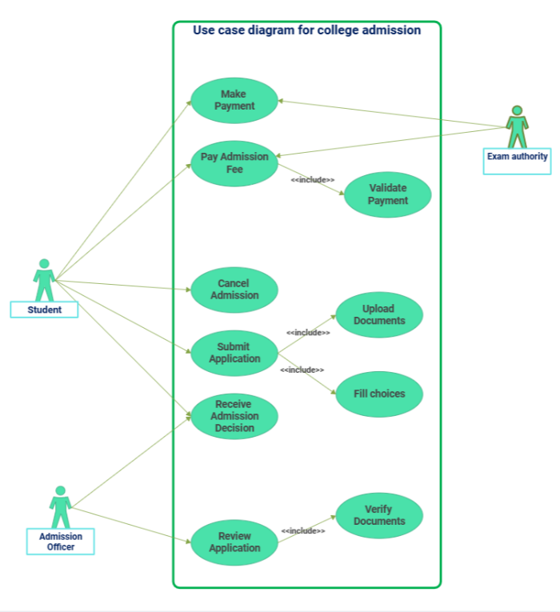

8. Requirements Traceability Matrix (RTM)

Req ID | Requirement short | Section ref / Design Spec | Module | Test case(s) | Status (N/P/A) | Comments
ADM-F-001 | Student registration | 4.1 / DS-Reg-01 | AuthModule | TC-Reg-01 | N
ADM-F-010 | Display college list | 4.2 / DS-CF-01 | ChoiceFillingModule | TC-CF-01 | N
ADM-F-020 | Process online payments | 4.3 / DS-Pay-01 | PaymentModule | TC-Pay-01 | N
ADM-NF-001 | Page load time | 5 / DS-Perf-01 | WebUI | TC-Perf-01 | N
PRJ-SR-002 | Encrypt sensitive data | 5.1 / DS-Sec-01 | SecurityModule | TC-Sec-02 | N

