Game Design Document
BONKERS!
Team name

Team Members
Name | Roles | E-mail & GitHub ID
Samarth Borade | Team Captain, Gameplay programming | borade@usc.edu  Samarth-Borade
Shivam Bhosle | Product Manager, Analytics | sbhosle@usc.edu  007-Shivam
Aashwin Singh | Stenographer, Level design | aashwins@usc.edu  Ash-Si
Prachi Dave | Physics, Player feel | prdave@usc.edu  prachicode-design
Harsh Mangukiya | Hazards, UI | hmanguki@usc.edu  harshmangukiya-usc
Note: everyone codes. Roles above are a proposal; confirm them as a team.

Links
Unity Project GitHub Repository | GitHub Classroom repo link
Paired Prototype (reference) | https://samarth-borade.github.io/bonkers/
Playable Alpha Progress Check Build | https://samarth-borade.github.io/bonkers/alpha-check/
Playable Alpha Build | https://samarth-borade.github.io/bonkers/alpha/ (for 10/23)
Alpha Gameplay Video | link
Alpha Survey | link
Playable Beta Build | https://samarth-borade.github.io/bonkers/beta/
Beta Gameplay Video | link
Beta Survey | link
Playable Gold Build | https://samarth-borade.github.io/bonkers/gold/
Gold Gameplay Video | link

Game Introduction

Logline
A two-player, one-keyboard platform race where whoever falls behind gets the weapons, attack power-ups and trap levers, while the leader can only defend, so every race stays close until the flag.

Player Goals / Win Conditions
- Race: be the first to touch the flag at the top of the level.
- Match: first player to win 2 races (best of 3, each race on a different level).

Game Description
BONKERS! is a same-screen, two-player 2D platform race. Both players climb six zig-zag rows to the flag, jumping lava, spikes, rolling saws and water. A match is best of three races, each on a different level (Classic Climb, Lever Lab, The Gauntlet).
Our twist is that falling behind gives you the tools to catch up, with no luck involved. Every hidden ? box has two fixed prizes: the chaser gets attacks and catch-up powers (Bonk Fist, Freeze Ray, Gravity Bomb, Brick Wall, Ghost, Swap), while the leader only gets defence (Shield, Banana, Fake Box). Levers on small ledges spring traps further up the course, and only the chaser can pull them. Every attack is telegraphed and can be dodged, so the chaser has to aim and the leader has to read and react. The race becomes a constant tug-of-war instead of a sprint decided by the first mistake.

Controls
Action | Red player | Yellow player
Move | A / D | Left / Right
Jump (tap in water to swim) | W | Up
Use power-up | S | Down
Shove / Stomp | run into rival / land on head | same
Pull a lever (chaser only) | jump onto its ledge | same
Start, next race / Restart race / Menu | Space / R / Esc | Space / R / Esc
Platform: keyboard on a laptop (two players share one keyboard).

Detailed Design

Game Mechanics (How to Play)
- Run and climb: each row runs one way; jump up through the gap at its end to reach the next row.
- Hazards: lava, spikes and rolling saws send you back to the start of your row; water slows you and lets you swim.
- Place-based ? boxes (core): every box has a chaser prize and a leader prize; which one you get depends on who is ahead right now. Each box works once per player every 7 s.
- Power-ups (12): chaser: Bonk Fist, Freeze Ray, Gravity Bomb, Brain Scramble, Brick Wall, Super Jump, Rocket Shoes, Ghost, Swaparoo. Leader: Bubble Shield, Banana Peel, Fake Box.
- Levers and traps: a lever on a ledge springs its matching trap (same letter and color) further up the course: a gate to jump or a spike strip. Only the chaser can pull it; 8 s cooldown.
- Telegraphed attacks: punches fly along the row (jump them), drop-bombs and brick walls flash a warning first. A hit = BONK: knockback, slow-down, then 1.2 s immunity.
- Shove and stomp: run into your rival to push them; land on their head to stomp (BONK).
- Progress bar: both racers on one bar, plus a LEADING / CHASING tag, so nobody is ever lost.

Game Mechanic Research
Samarth Borade (confirm after playing it yourself)
Game Title | Mario Kart 8 Deluxe
Mechanic/System | Position-based item distribution
Interest | It is the classic way to keep a race close, and it is exactly what our paired prototype was criticised for: it feels like luck.
Interaction with other mechanics | Item odds depend on your place, so it feeds the racing: last place gets Bullet Bills and Blue Shells to catch up, first place mostly gets Bananas and Green Shells to defend. Coins and drafting add speed on top.
Innovation | Keep the 'behind gets help' idea but remove the dice: every box has two fixed prizes, chaser vs leader, so catching up is learnable and readable instead of random.
Harsh Mangukiya (confirm after playing it yourself)
Game Title | SpeedRunners
Mechanic/System | Screen-edge elimination and sabotage boxes
Interest | It is the closest genre match: a side-scrolling race where players directly mess with each other.
Interaction with other mechanics | Players race the same track; item boxes give weapons; whoever falls off the shrinking screen loses the round, so position, items and the camera all interact.
Innovation | Instead of punishing the player who falls behind (elimination), we reward them: falling behind gives you better tools, so nobody is ever knocked out of the race.
Prachi Dave (confirm after playing it yourself)
Game Title | Celeste
Mechanic/System | Forgiving jump physics (coyote time, jump buffering, variable jump height)
Interest | Our players jump over hazards constantly, so the jump has to feel fair and readable.
Interaction with other mechanics | Small timing windows (jumping just after leaving a ledge, pressing jump just before landing) make hard platforming feel fair and support the dash and climbing.
Innovation | Use the same forgiving jump so a BONK or trap feels like the rival's doing, never the controls: frustration should come from your opponent, not the physics.
Aashwin Singh (confirm after playing it yourself)
Game Title | Ultimate Chicken Horse
Mechanic/System | Players place traps into a shared level
Interest | It turns the level itself into a weapon between players, which fits a versus race.
Interaction with other mechanics | Each round players place traps, then everyone races through them; traps only score if others fail but you succeed, so placing and running are linked.
Innovation | Our levers let only the chaser spring pre-placed traps ahead of the leader, in real time, so the level becomes the chaser's catch-up tool.
Shivam Bhosle (confirm after playing it yourself)
Game Title | Fall Guys
Mechanic/System | Physical player-to-player interaction (grab and push)
Interest | Shoving another player is the simplest, funniest form of interaction and needs no items.
Interaction with other mechanics | Grabbing slows both players, so it is a trade-off; it interacts with obstacles (push someone into a hazard) and with qualification order.
Innovation | Our shove and head-stomp work the same way: a short slow-down that can knock a rival into lava, so contact matters even with no power-up in hand.

Matrices

Twist & Mechanics Matrix
Twist: the player behind gets the weapons, the player ahead can only defend.
Mechanics | Description | Interaction with Twist | Affected Genre Elements | Supports
Core: Place-based ? boxes | Each box has a fixed chaser prize and a fixed leader prize; your current place decides which you get. | This IS the twist: catch-up without luck. The chaser gets attacks, the leader gets defence. | Item boxes, rubber-banding | Close races, comebacks, readable strategy
A: Chaser-only levers and traps | Jump onto a ledge to spring a gate or spike trap further up the course. | The level itself becomes a catch-up tool that only works when you are behind. | Level hazards, obstacle courses | Route choice: spend a jump to set a trap or keep running
B: Telegraphed attacks and defence | Punches fly along the row; bombs and walls warn first; shields block; bananas and fake boxes trap. | Turns the chaser's help into a skill test (aim, timing) and gives the leader a fair answer (dodge, block). | Combat items in racers | Skill over luck, 'edge to edge' races
C: Shove and stomp | Body contact: push your rival, or land on their head for a BONK. | Works with no item, so the chaser always has a way to interact when close. | Player collision in platformers | Constant interaction, combos with hazards

Mechanic Interaction Matrix
Subject / Object | Place-based boxes | Levers and traps | Telegraphed attacks | Shove and stomp
Place-based boxes | Leading vs chasing changes as you grab boxes and pass each other
Levers and traps | Only the CHASER (as judged by the same place check) can pull levers | A trap can block the gap the leader needs, delaying them for the next lever
Telegraphed attacks | Boxes hand out the attacks (chaser) and the defence (leader) | Brick Wall works like a lever trap you aim; a slowed leader is easier to trap | Shield blocks one attack; Swap can turn a hit leader into the chaser
Shove and stomp | Shoving a rival back can flip who is leading, which changes the next prize | Shove the leader into a sprung spike trap | A BONKed (slowed) rival is easy to stomp or shove | Stomp bounce helps you jump gates and walls

Sketches and Diagrams

Gameplay Loop
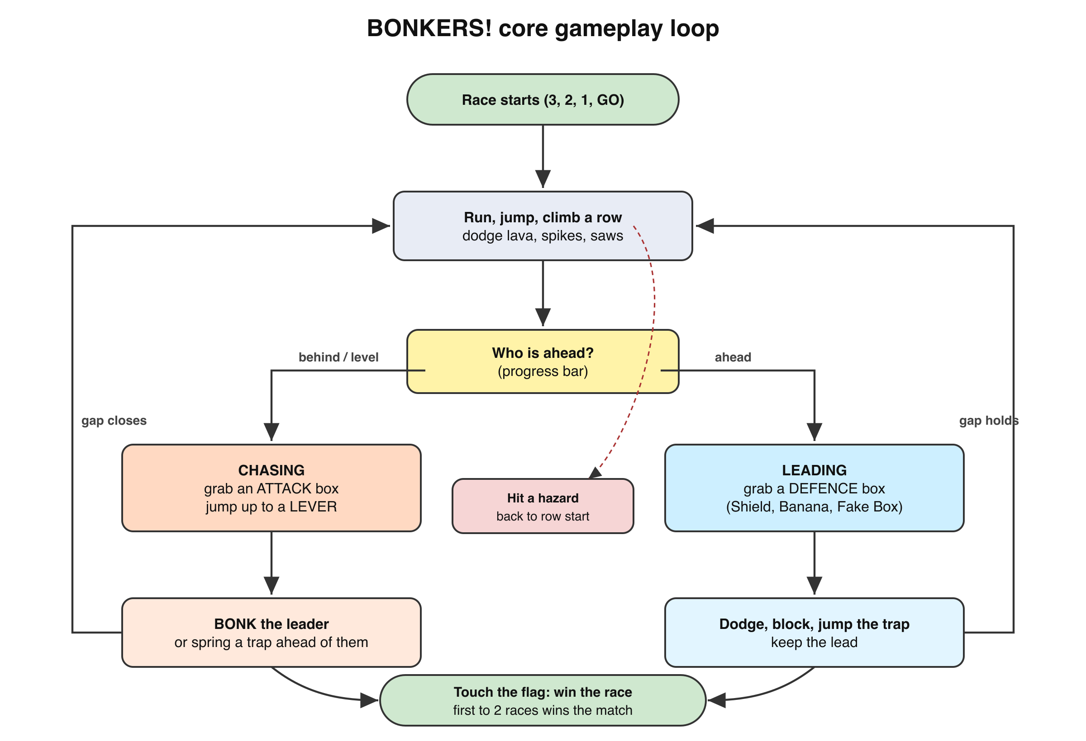
Core loop: run, check your place, then attack (chasing) or defend (leading) until someone reaches the flag.

Mechanic/Level Sketches
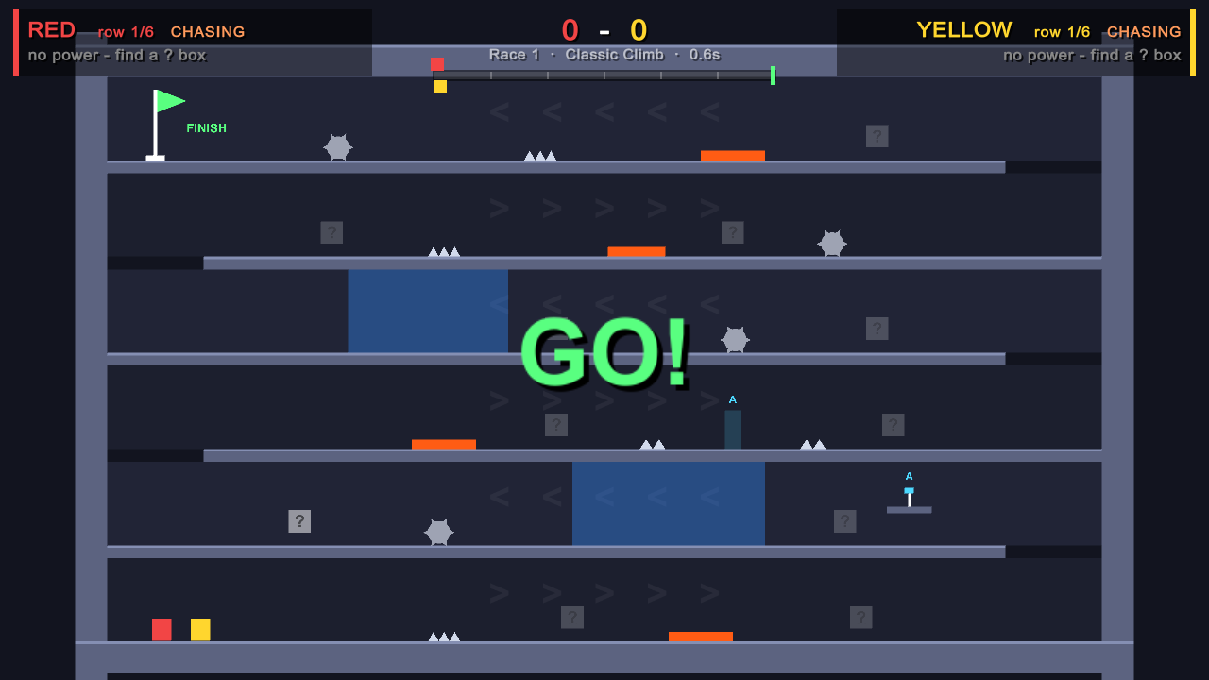  Level 1: Classic Climb (paired layout + lever A) | 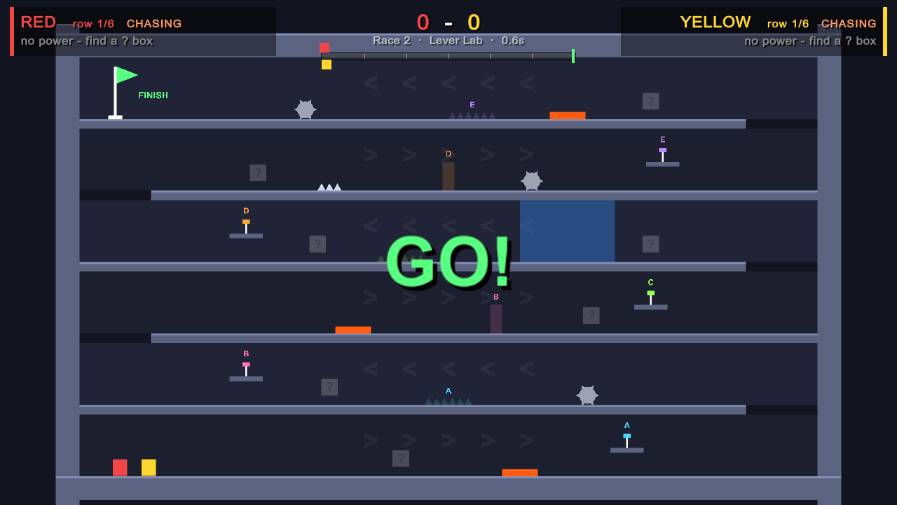  Level 2: Lever Lab (a lever on every row)
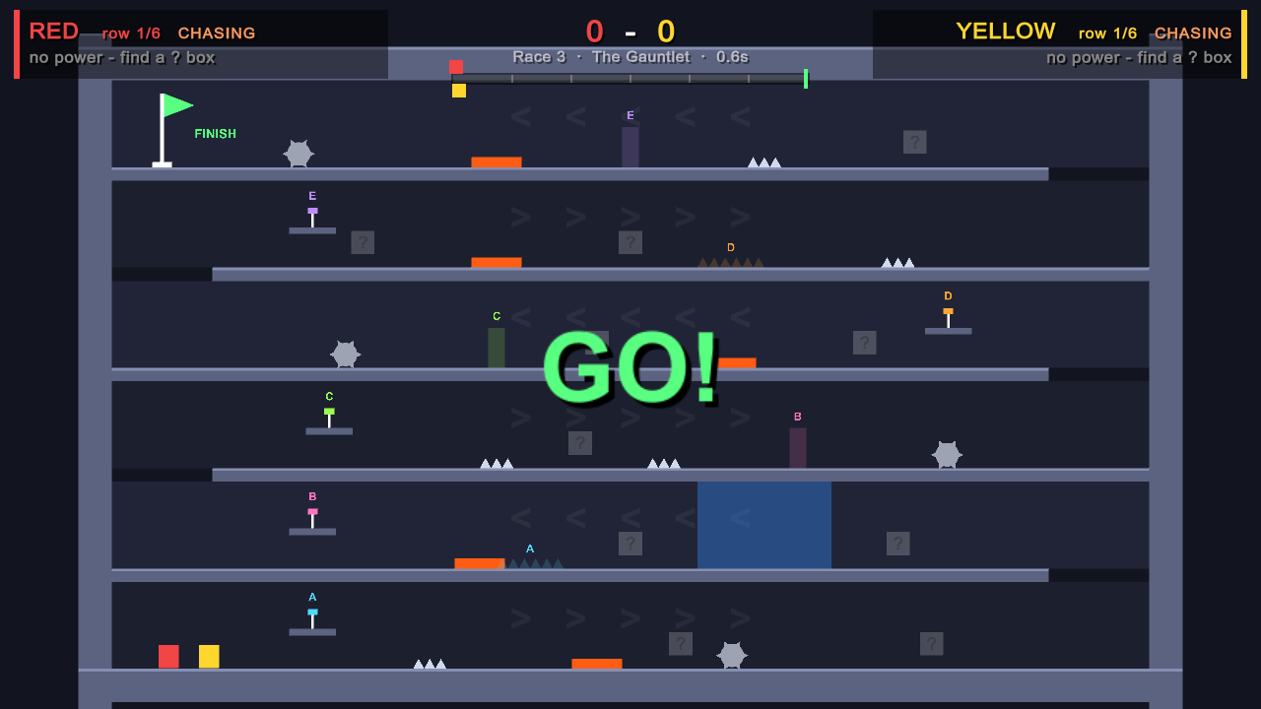  Level 3: The Gauntlet | 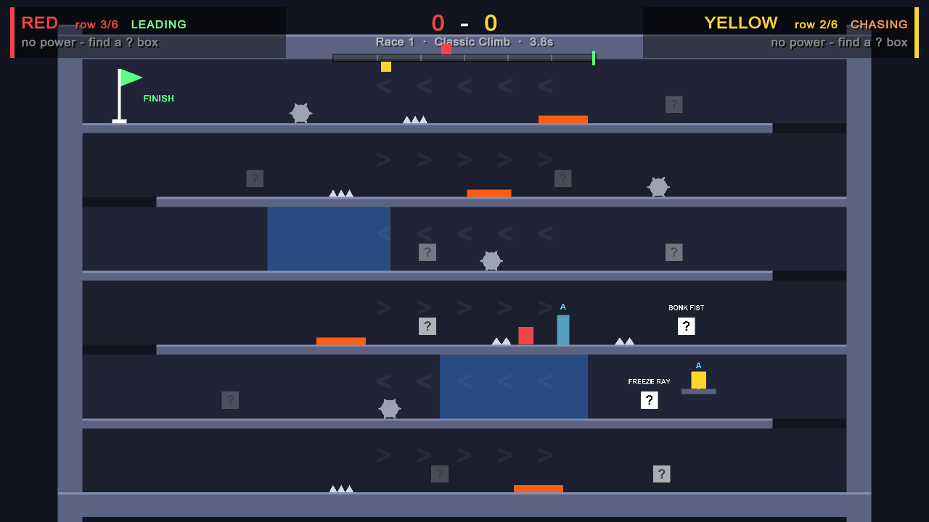  Yellow (chasing) pulls lever A: gate A pops up ahead of Red
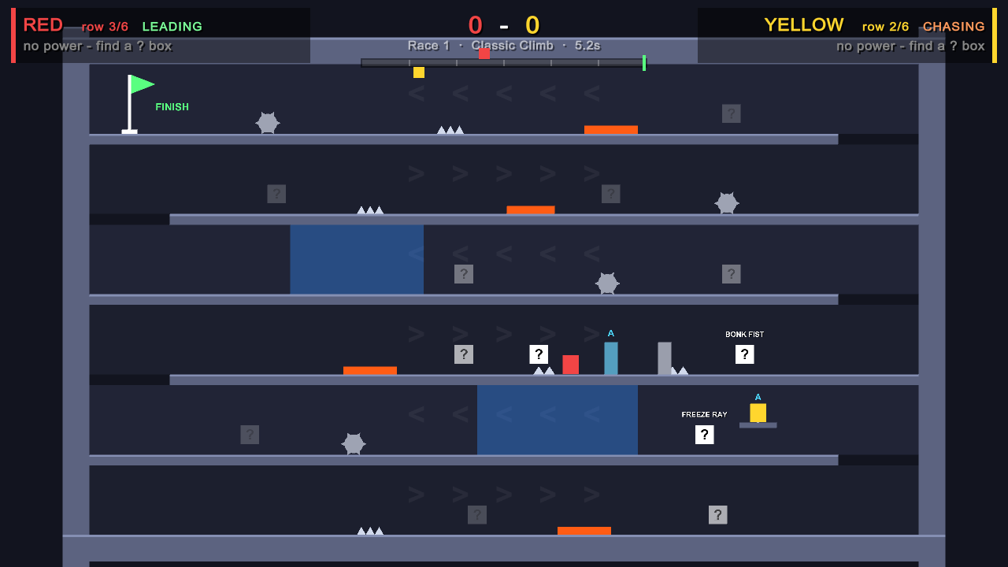  Brick Wall in front of the leader; Fake Box behind them | 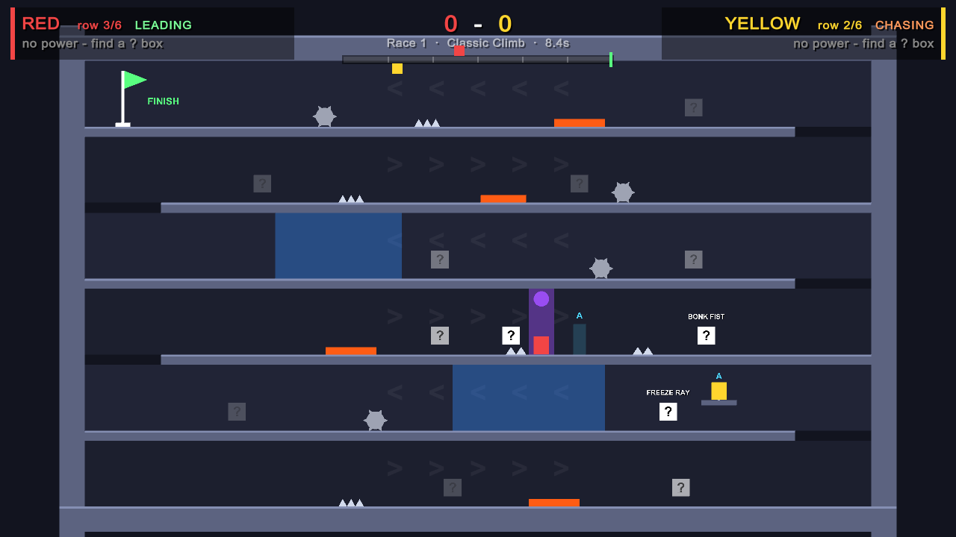  Gravity Bomb warning beam: time to dodge
Ideas for Beta: one-way trap doors, a lever that reverses a row's conveyor, short tutorial race that introduces one mechanic per row.

Analytics
Methodology Used:
- Data collection: Assets/Scripts/Analytics/RaceAnalytics.cs counts events during a race and, when someone wins, sends one row to a Google Form (UnityWebRequest POST) that fills a Google Sheet. Columns: build, level, winner, race time, lead changes, finish gap, deaths by row and hazard, power-ups used and hits, levers, stomps.
- Data visualization: Analytics/visualize.py (pandas + matplotlib) reads the sheet's published CSV and draws one chart per metric into Analytics/charts/.
- Status: pipeline implemented for all four metrics; charts below are mockups until playtest data arrives. PM: create the Google Form and paste its IDs into AnalyticsConfig.cs

Metrics
Metric #1: Lead changes per race
Description: How many times the lead switches between players during one race.
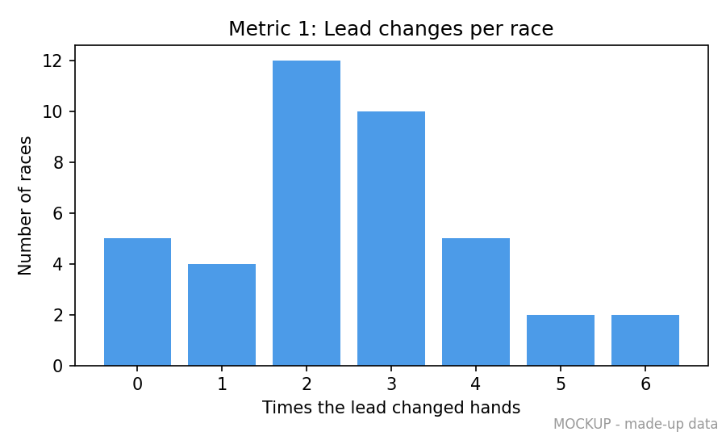
Mockup (made-up data)
Justification: Our whole design claims races stay close. Lead changes measure that directly; if they are rare, the catch-up tools are too weak.
Interpretation: Mostly 0-1 changes: the leader runs away, catch-up is too weak. 2-5: healthy back-and-forth. 6+: the lead is meaningless and skill doesn't matter.
Hypothesis: Races average at least 3 lead changes. If not, stronger chaser prizes or more levers should raise it.
Metric #2: Finish gap
Description: How far behind (in rows) the loser is when the winner touches the flag, per level.
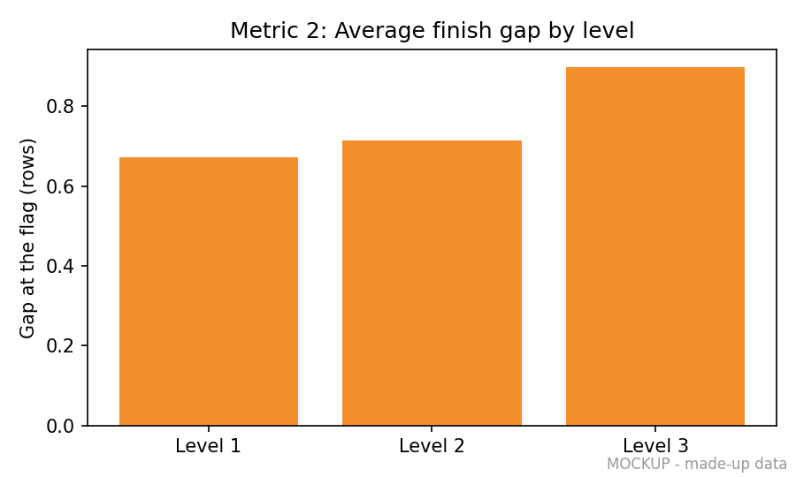
Mockup (made-up data)
Justification: Tells us whether finishes are 'edge to edge' and which level produces the closest endings.
Interpretation: Small gap (< 0.5 rows): photo finishes. Large gap (> 1.5 rows): blowouts; that level needs more catch-up or less punishing hazards.
Hypothesis: The Gauntlet has a larger average gap than Lever Lab, because hazards punish more and levers help less there.
Metric #3: Power-up hit rate
Description: For each attack power-up: how often a use actually hits the rival.
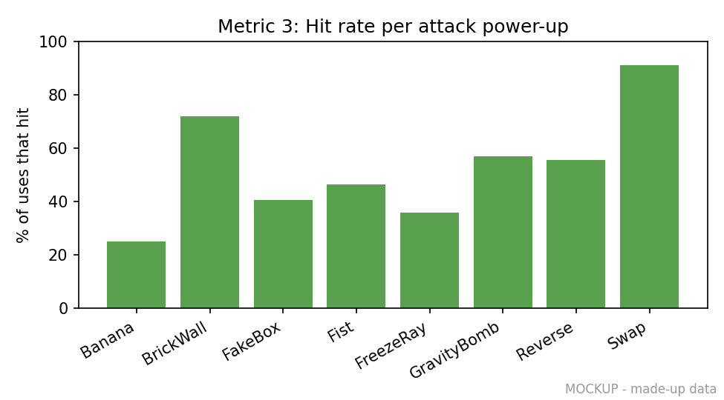
Mockup (made-up data)
Justification: Shows whether every power-up is worth picking and whether the warnings make attacks dodgeable but not useless.
Interpretation: Near 0%: too easy to dodge, buff it. Near 100%: no counterplay, nerf it or add a longer warning.
Hypothesis: Telegraphed attacks (Gravity Bomb, Brick Wall) land 40-70% of the time; the straight Bonk Fist lands less because it can be jumped.
Metric #4: Deaths by row and hazard
Description: Where players die (row 1-6) and to what (lava, spikes, saws, traps).
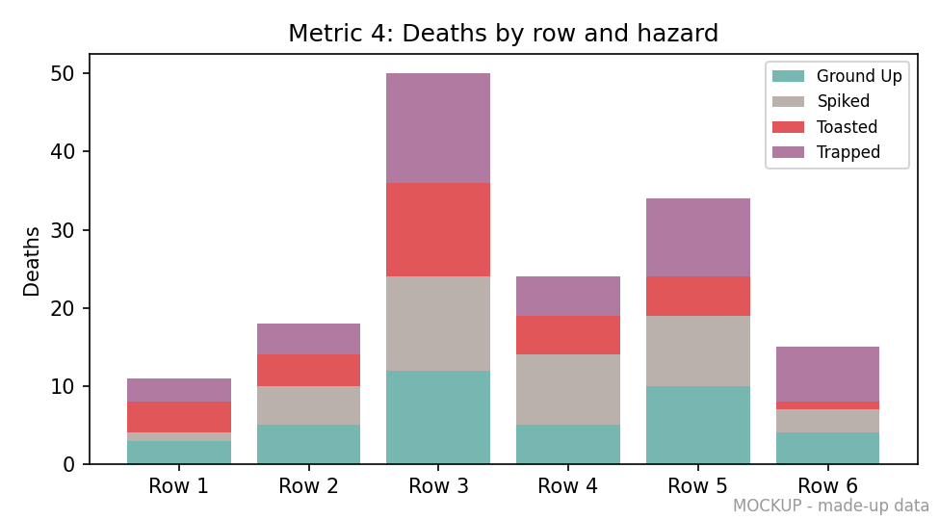
Mockup (made-up data)
Justification: Finds unfair spots in our levels and tells us if traps feel like part of the race or like a wall.
Interpretation: One row with far more deaths = a difficulty spike to fix. Trap deaths near zero = levers too weak; very high = too strong.
Hypothesis: Most deaths happen on rows 3 and 5, where saws and traps overlap; spacing them out will flatten the curve.

Weekly Prototype Descriptions
Week 7:
- After the paired-prototype feedback ('feels like luck'), replaced random ? boxes with place-based fixed prizes.
- Kept the art minimal (plain shapes, plain BONK text). Made jumps easier: smaller players, more headroom on the top row, low rolling saws, lava no wider than 2.
- Two new members joined; roles assigned and mechanic research started.
Week 8:
- Best-of-3 match across three levels: Classic Climb, Lever Lab, The Gauntlet.
- New mechanic: chaser-only levers on ledges that spring gate or spike traps further up the course.
- Three new power-ups: Brick Wall (chaser), Ghost (chaser), Fake Box (leader). Total 12.
- Race analytics: one summary row per race (lead changes, finish gap, hit rates, deaths) and a chart script.
- Moved lever ledges away from hazards after our test runs showed players bumping their heads mid-jump and falling in.
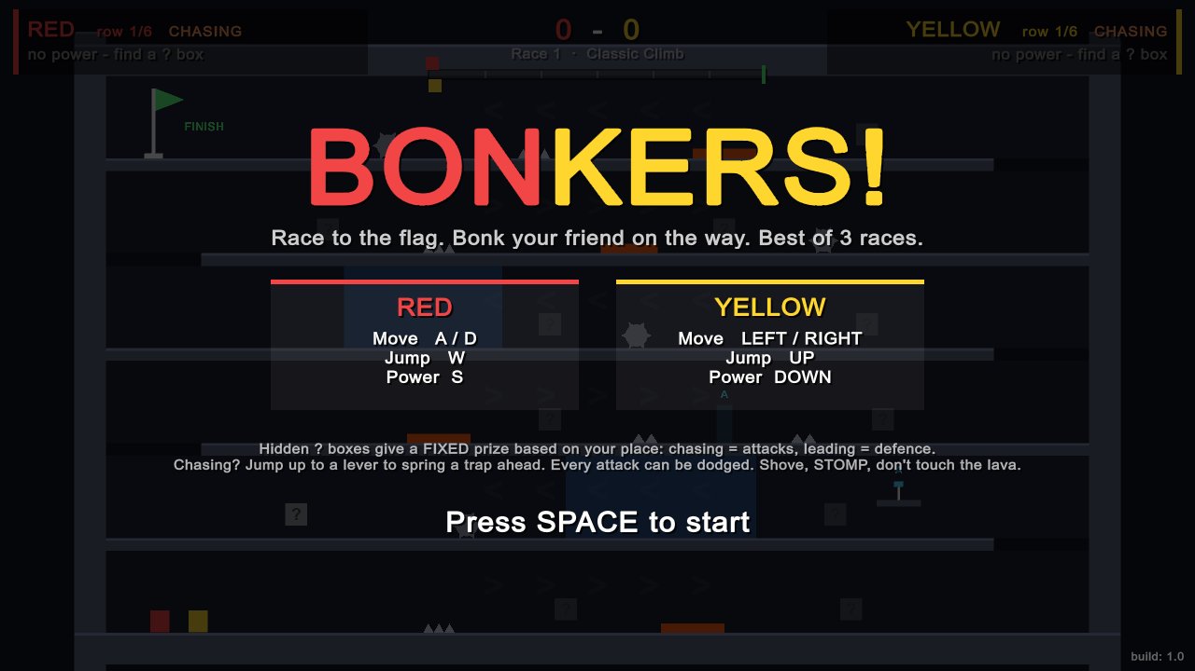  Alpha title screen (best of 3) | 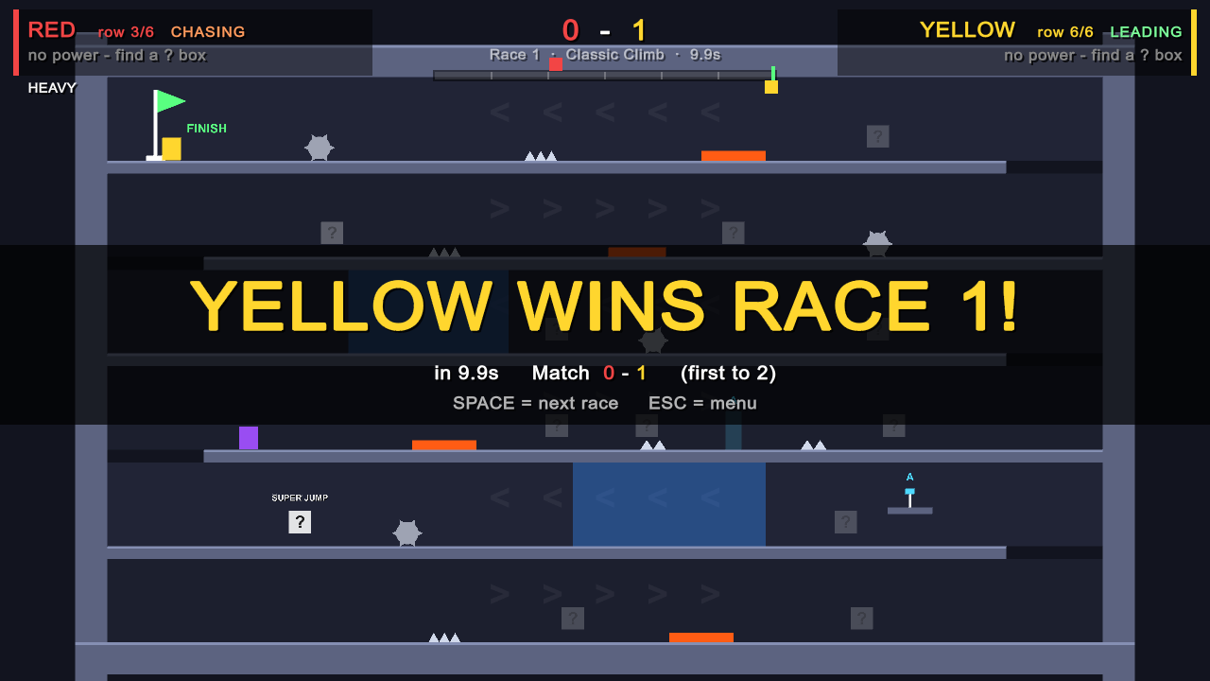  Race won; match continues on the next level

Weekly Progress
Week | Team Member | Team Member
Week 7 | Samarth Borade work + commit link | Harsh Mangukiya work + commit link
 | Prachi Dave work + commit link | Aashwin Singh work + commit link
 | Shivam Bhosle work + commit link
Week 8 | Samarth Borade work + commit link | Harsh Mangukiya work + commit link
 | Prachi Dave work + commit link | Aashwin Singh work + commit link
 | Shivam Bhosle work + commit link

Review Notes
[Staff feedback, paired prototype, 10/02/2026]
- The game felt luck-based ('Super Mario Bros. + Mario Kart'); the player who falls behind feels lost.
- Our response: fixed place-based prizes, dodgeable attacks, chaser-only levers, a progress bar, and 1.2 s immunity after a hit.
- Grader: build features (more power-ups) in Alpha and Beta, no art until Gold.
[Playtest 1 date]
- Stenographer: notes from the live playtest

External References
Name | Link | Usage
Claude (Anthropic) | https://claude.ai | AI coding assistant, used with TA approval: drafting C# scripts from our design notes, debugging, the WebGL build setup, the analytics chart script and diagrams. confirm Alpha approval
Google Forms + Sheets | https://forms.google.com | Receives one analytics row per race.
pandas, matplotlib | https://matplotlib.org | Python libraries used by Analytics/visualize.py to draw the charts.
No external art, audio or code assets: all shapes and sounds are generated in code.

