Paired Prototype Descriptive Document
BONKERS!

Team Members
Name | Email | GitHub Username
Samarth Borade | borade@usc.edu | samarthborade007
[Teammate 2] | [usc email] | [github]
[Teammate 3] | [usc email] | [github]

Logline
(2D Platformer Race + Place-Based Sabotage)
BONKERS! is a two-player, one-keyboard platform race where hidden ? boxes hand attacks to whoever is behind and only defence to whoever is ahead, so no lead is ever safe and every race stays neck and neck until the flag.

Genre Research
Our game sits between two genres: the platformer and the item-based racer. We started from Fireboy and Watergirl (two players, one keyboard, one screen) and flipped it from co-op to versus. Then we studied three games:
- Super Mario Bros. (platformer): run, jump, hazards, power-ups that change how you move.
- Mario Kart 8 Deluxe (item racer): item boxes, attack items, catch-up items for players in last place.
- SpeedRunners (platformer racer): 2 to 4 players race on one screen, can sabotage each other, and anyone left off-screen loses.

Tropes
Across these games we found the same building blocks over and over:
- Run-and-jump traversal: tight, responsive movement is the core skill; the level is the challenge.
- Hazards that cost time: pits, lava, spikes and saws push you back instead of ending the game.
- Item boxes: pick-ups placed along the course that give a one-shot power.
- Attack and defence items: things you throw forward (shells, punches) and things you leave behind or wear (bananas, shields).
- Rubber-banding: players in last place get better items so the race stays close (Mario Kart's blue shell is the famous example).
- Same-screen head-to-head: both players always see each other, so every pass and every hit is visible.
- Checkpoints / respawn: a mistake sends you back a little, not to the very start.
- Short rounds with instant rematch: one race takes about a minute, and you can play again straight away.

The problem we found
Our first build used a random ? box, like Mario Kart. In class feedback, our instructor pointed out that it felt like luck: "Super Mario Bros. + Mario Kart". The player who fell behind felt lost, and a single lucky pick-up decided the race. Mario Kart has the same issue: its catch-up is random, so a player can't plan around it and often can't see it coming. SpeedRunners has no randomness, but it also has no real catch-up, so once someone is ahead the race is often over.

Twist
Our core twist is the Place-Based Power-Up Box: catch-up that is fixed and readable instead of random.
- No dice rolls: every ? box has two fixed prizes. Walk close to it and the box shows which prize you would get.
- Your place decides the prize: if you are behind (or level), you get an attack or catch-up power. If you are ahead by more than a tenth of a row, you only get defence: a Bubble Shield or a Banana Peel.
- Nobody can steal a box: each box works separately for each player (7 s cooldown each), so the leader can't grab it and leave the chaser with nothing.
- Every attack can be dodged: punches and ice balls fly along the row (jump over them). Drop-bombs lock onto a spot with a flashing warning beam before they fall.
- No stun-lock: after a BONK you get 1.2 s of immunity, so one hit slows you down but never ruins the round.
- Always know the gap: a progress bar and a LEADING / CHASING tag are always on screen.

How the Twist Innovates on the Genre
- Rubber-banding without luck: the chaser always gets help, but it is the same help every time, so the result comes from skill, not the dice.
- Route knowledge becomes a skill: the layout and prizes are fixed, so players learn it: "if I'm behind on row 4, the Freeze box is mine".
- Leading is active, not passive: the leader can't just run. They have to read the warning beams, jump the punches and place bananas where the chaser will land.
- Close finishes by design: the last row's box gives the chaser a Swaparoo (swap places), so a lead is never safe until the flag.
Together, this keeps the fun of Mario Kart-style chaos but turns every hit into a decision (when to fire, when to dodge) instead of a lucky draw.

Prototype Description
BONKERS! is a 2D, same-screen platform race for two players on one keyboard: run, jump and climb six zig-zag rows past lava, spikes, saws and water to reach the flag first. Hidden ? boxes give a fixed prize based on your place: attacks (Bonk Fist, Freeze Ray, Gravity Bomb, Swap and more) when you're chasing, and only a Shield or Banana when you're leading. Every attack can be dodged, and players can also shove each other or stomp on each other's heads. This turns the race into a constant tug-of-war where the chaser has to aim well and the leader has to defend well.

Controls
Action | Red player | Yellow player
Move | A / D | Left / Right arrows
Jump (tap again in water to swim) | W | Up arrow
Use power-up | S | Down arrow
Start / rematch | Space | Space
Restart round / menu | R / Esc | R / Esc

Power-ups
Power-up | Who gets it | What it does
Bonk Fist | Chaser | A punch flies forward along the row. On a hit: BONK, knockback and 2.5 s slow.
Freeze Ray | Chaser | A slower ice ball. On a hit the opponent is frozen for 1.8 s.
Gravity Bomb | Chaser | A bomb tracks the opponent, locks on with a warning beam, then drops. On a hit: heavy for 4 s (slow, tiny jumps).
Brain Scramble | Chaser | Same drop-bomb, but it flips the opponent's left and right for 4 s.
Super Jump | Chaser | For 6 s your jumps go through the floors, so you can skip ahead.
Rocket Shoes | Chaser | Run 1.7x faster for 4 s.
Swaparoo | Chaser (last row) | Swap places with the opponent.
Bubble Shield | Leader | Blocks the next attack (lasts 10 s).
Banana Peel | Leader | Drop it behind you. Whoever steps on it spins out.

Mechanic Matrices

Twist & Mechanics Matrix
Mechanic | Description | Interaction with Twist | Affected Genre Elements | Type of Genre Innovation
Place-Based Power-Up Box | Each hidden ? box holds two fixed prizes. When a player touches it, the game checks who is ahead: the chaser gets an attack or catch-up power, the leader only gets defence. Each box works once per player every 7 s. | Replaces random item luck with readable, fixed catch-up. Because every attack can be dodged or blocked, the gap closes through aiming and dodging, keeping races neck and neck. | Item boxes; rubber-banding; attack vs. defence items; head-to-head racing | Core Mechanic Innovation

GitHub Repository
https://github.com/[username]/bonkers

WebGL Playable Link
https://[username].github.io/bonkers/

Gameplay Video
[Google Drive / YouTube link, under 1 minute]

Individual Contributions
Name | Contributions
Samarth Borade | [e.g. player movement and physics (jump, push, stomp), place-based box logic, WebGL build and hosting]
[Teammate 2] | [e.g. level layout and hazards (lava, spikes, saws, water), respawn rows, level diagram]
[Teammate 3] | [e.g. power-up effects, BONK feedback (text, shake, sounds), HUD, title and win screens]

Use of AI Tools
With approval from [producer / grader name, date], we used an AI coding assistant (Claude) as a helper during development:
- Writing first drafts of the C# scripts from our design notes, which we then read through, played and tuned.
- Debugging, and setting up the Unity build and the WebGL export.
- Drawing the level diagram and flowchart below from our layout, and tidying the wording of this document.
The game concept, the power-up and hazard ideas, and the decisions on how to respond to class feedback came from our team, and we playtested and tuned the prototype ourselves.

Diagram / Sketch
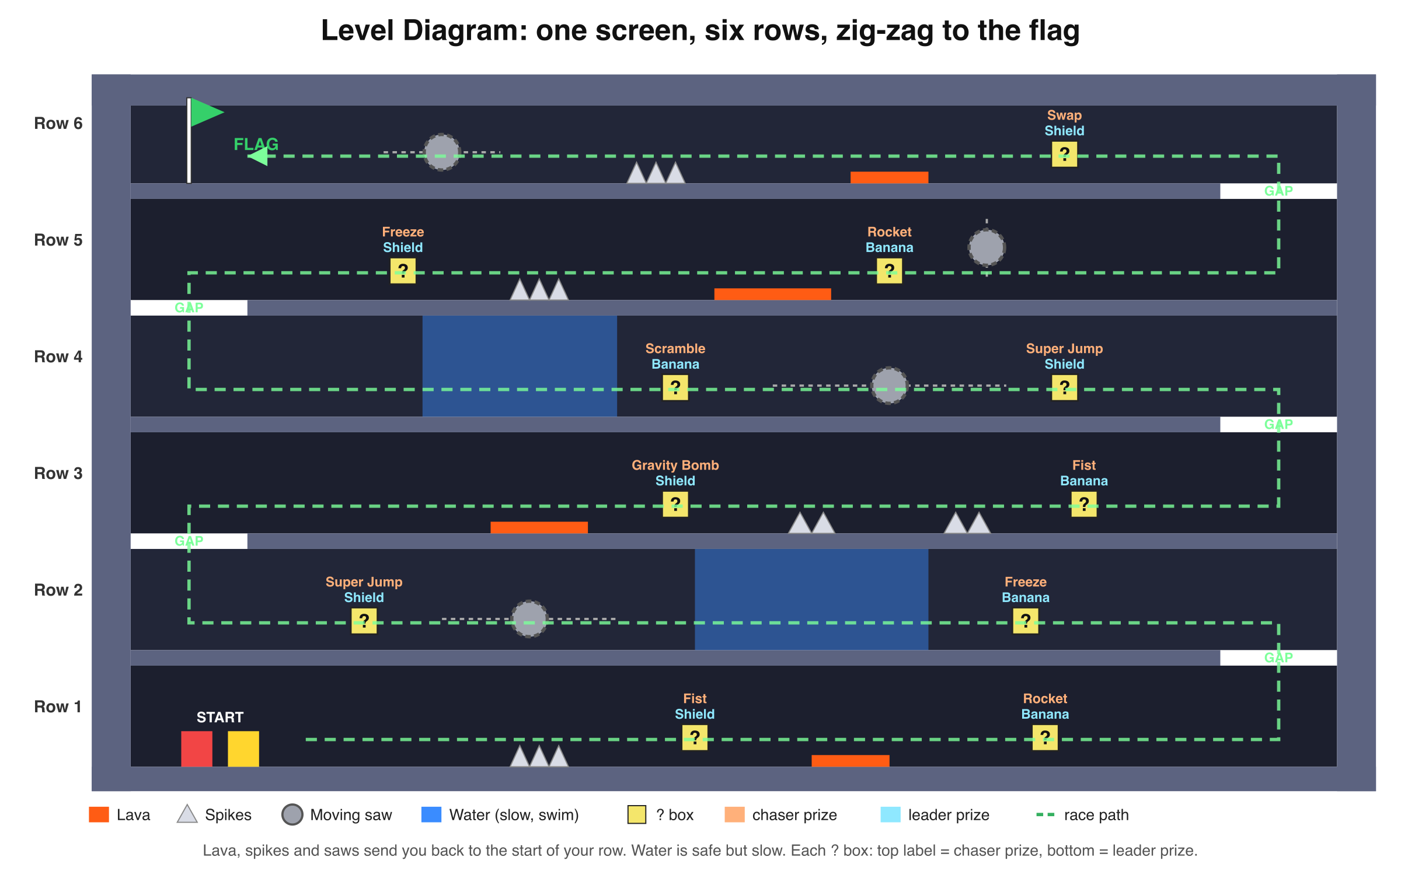
Figure 1: Level diagram. Each ? box shows its chaser prize (orange) and leader prize (blue).
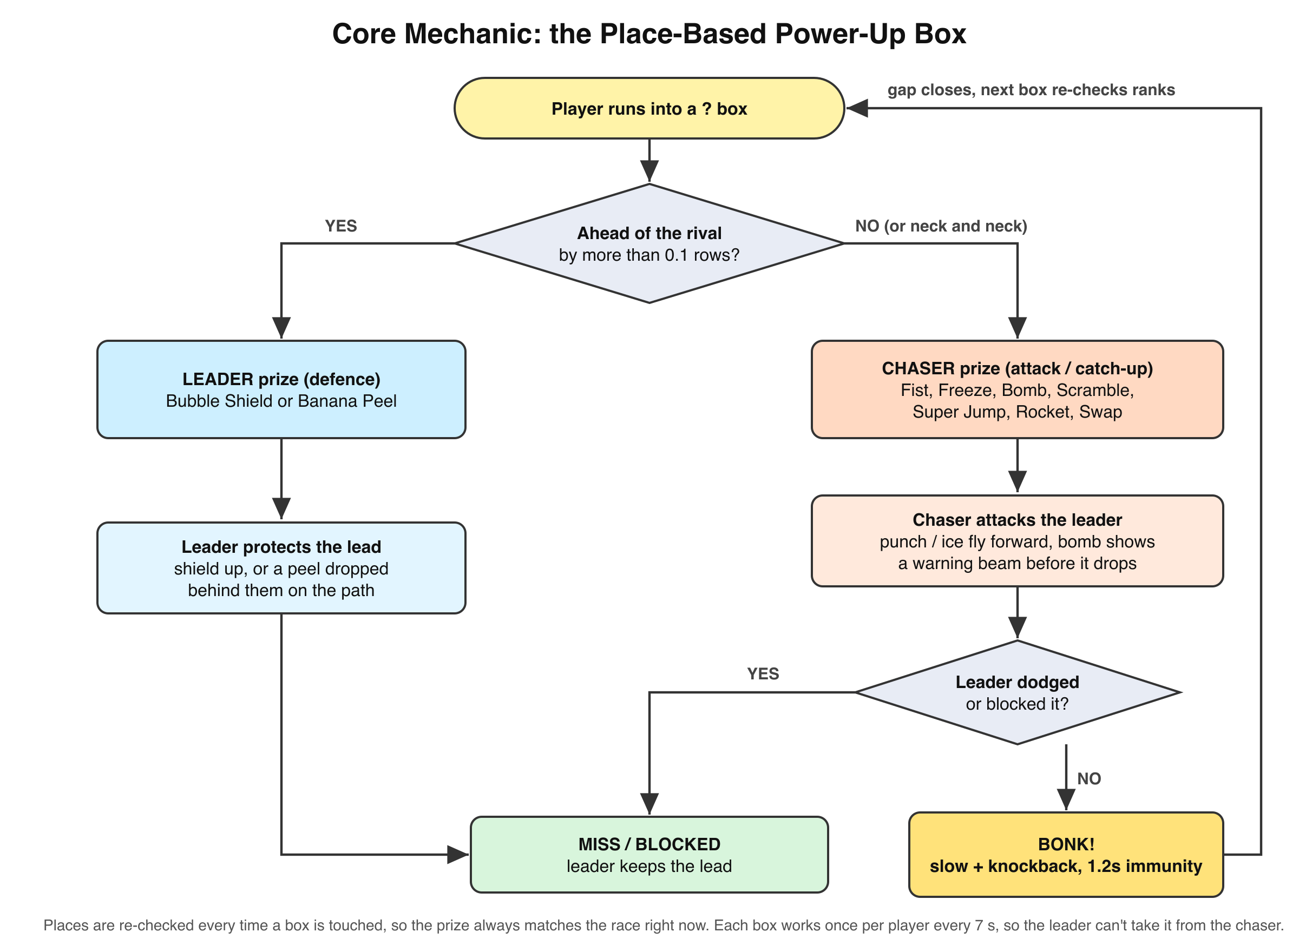
Figure 2: Core mechanic flowchart for the place-based power-up box.

Screenshots
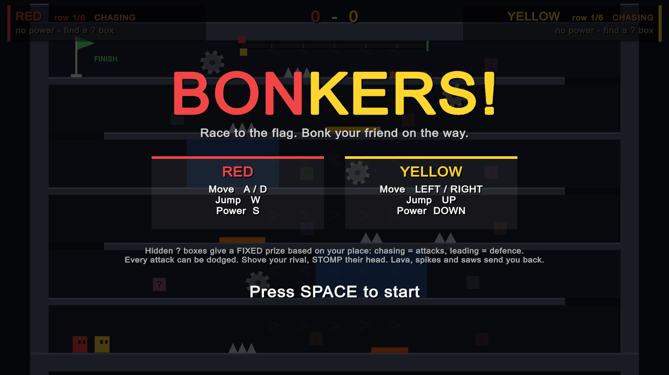  Title screen | 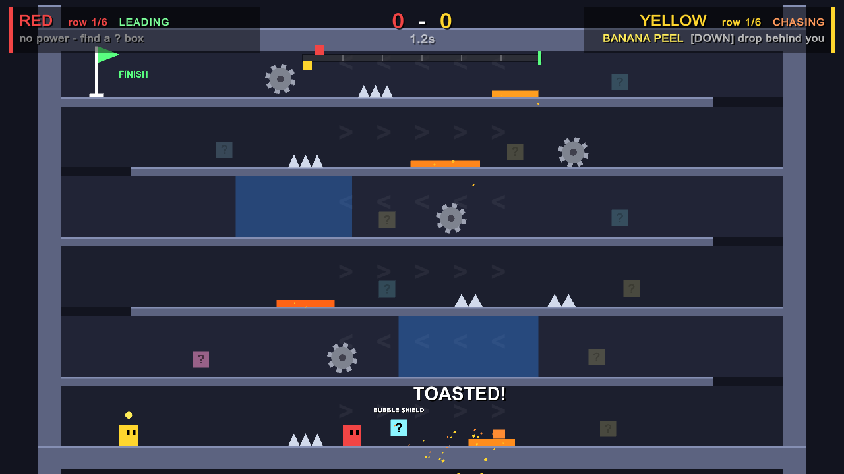  A Bonk Fist lands: BONK!
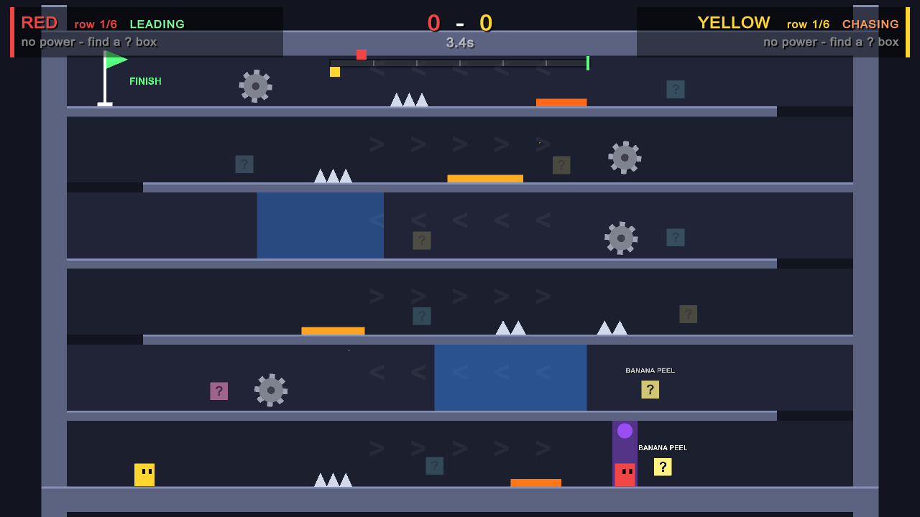  Gravity Bomb warning beam: time to dodge | 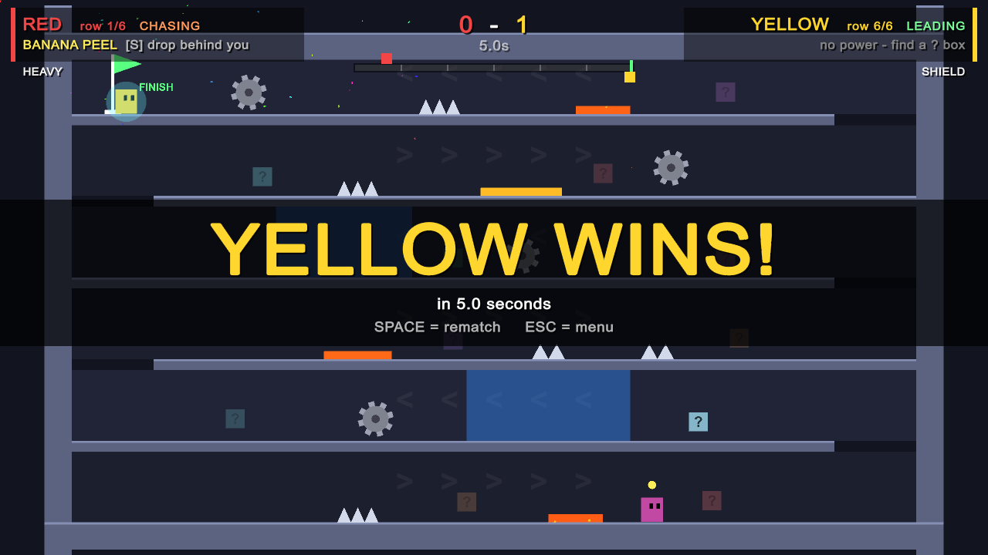  First to the flag wins

