Cognizant Deep Nurture 4.0

Algorithms And Data Structures

**Candidate Name:** Samarth Chourey  
**Superset ID:** 6394625

**Exercise 7: Financial Forecasting**

**Scenario:**

You are developing a financial forecasting tool that predicts future values based on past data.

**Steps:**

1. **Understand Recursive Algorithms:**
   * Explain the concept of recursion and how it can simplify certain problems.
2. **Setup:**
   * Create a method to calculate the future value using a recursive approach.
3. **Implementation:**
   * Implement a recursive algorithm to predict future values based on past growth rates.
4. **Analysis:**
   * Discuss the time complexity of your recursive algorithm.
   * Explain how to optimize the recursive solution to avoid excessive computation.

**Solution (For theory check txt file)**

1. Understood the concept of Recursion
2. Created a Financial Forecasting Algorithm
3. Implemented Base case to return principle when time/period is 0
4. Applied Recursive calls with updating principal and time.
5. Optimization can be achieved by using Iterative solution
6. Tested both recursive and iterative methods.

**Screenshots**

**FinancialForecasting.java**

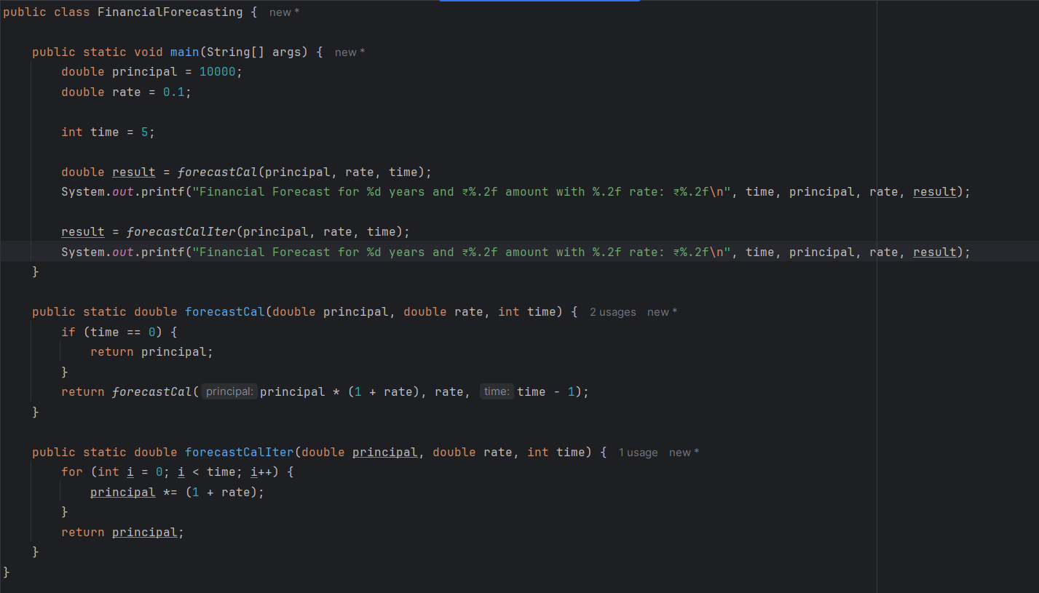

**Output**

