**Spring Framework – Exercise 1 & 2 Documentation**

**Exercise 1: Configuring a Basic Spring Application**

1. **Project Setup**

Created a Maven project named LibraryManagement.

Added Spring Core dependency in pom.xml:

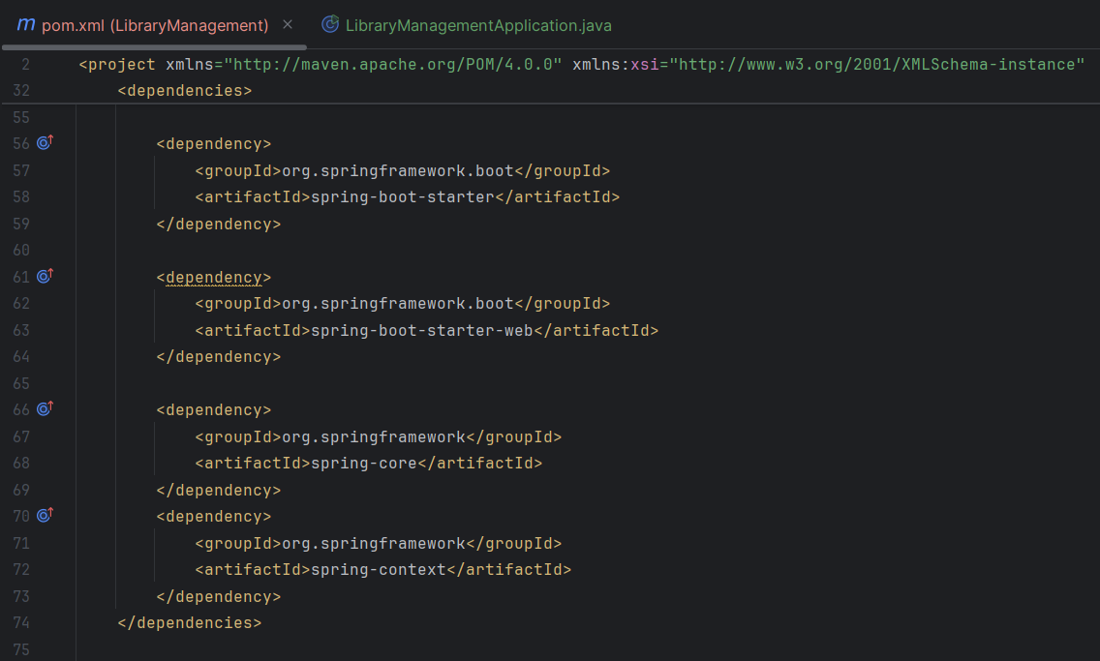

**2. XML Configuration**

Created applicationContext.xml under src/main/resources

Defined beans for BookService and BookRepository

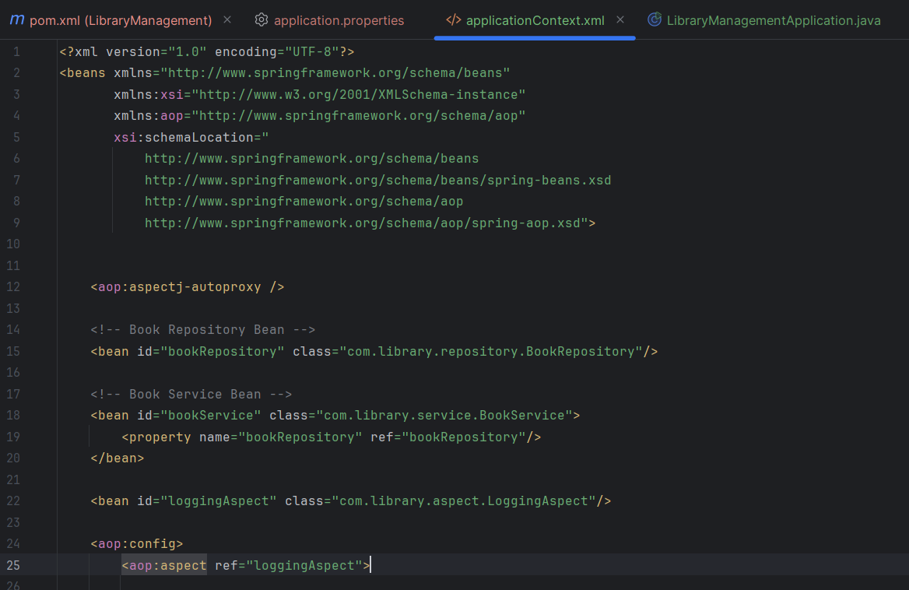

**3. Service and Repository Classes**

**BookRepository.java**

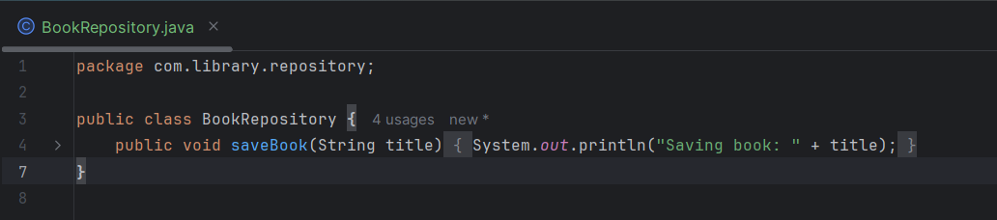

**BookService.java**

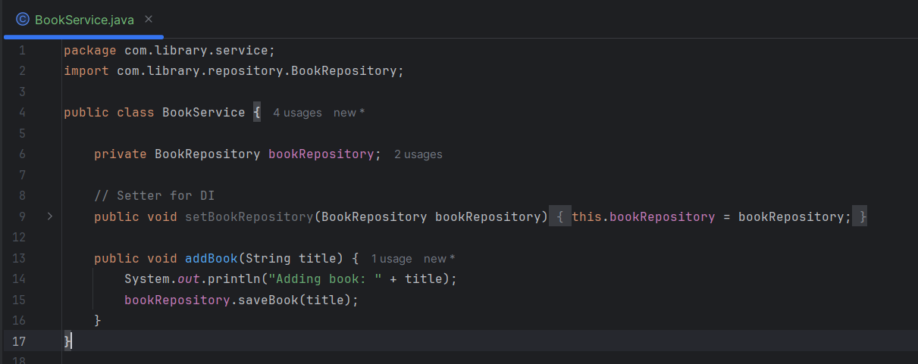

**4. Main Class for Testing**

**LibraryManagementApplication.java**

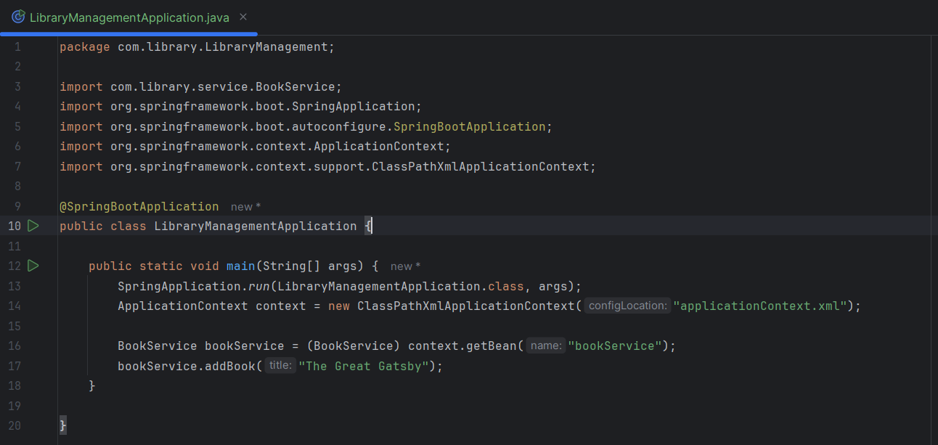

**Exercise 2: Implementing Dependency Injection**

**1. XML Configuration Updated**

Confirmed bookRepository is injected into bookService using <property> tag.

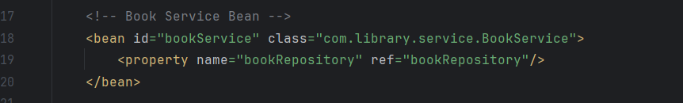

1. **Setter in BookService**

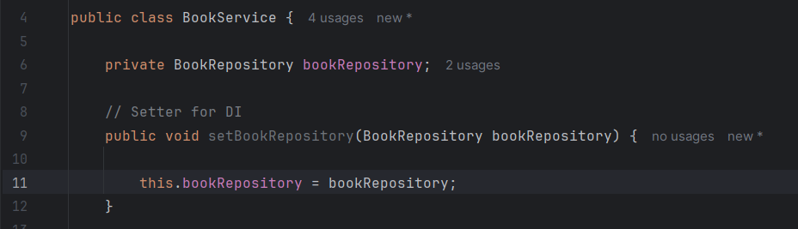

**3. Execution Result**

Run LibraryManagementApplication.java

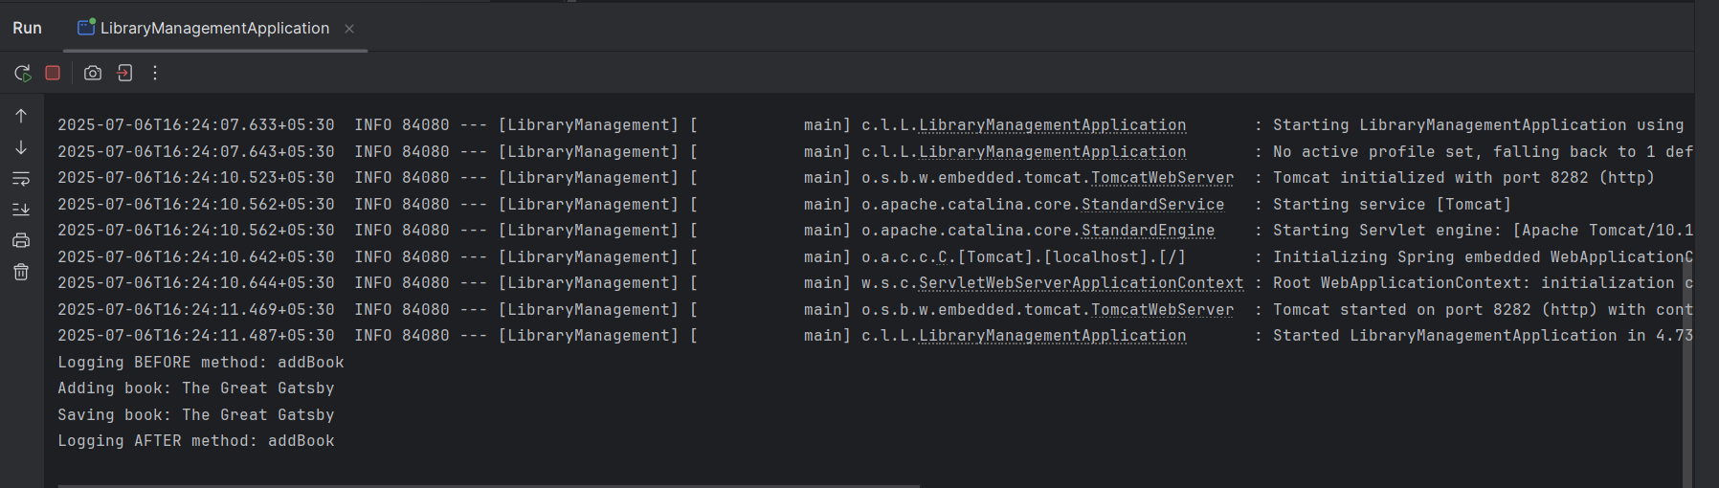

* **Project Structure Overview**

