**Spring Framework – Exercise 4 Documentation**

**Maven Project Creation**

A new Maven project named LibraryManagement was created using IDE support (Eclipse/IntelliJ) or manually using the Maven CLI.

**Directory Structure:**

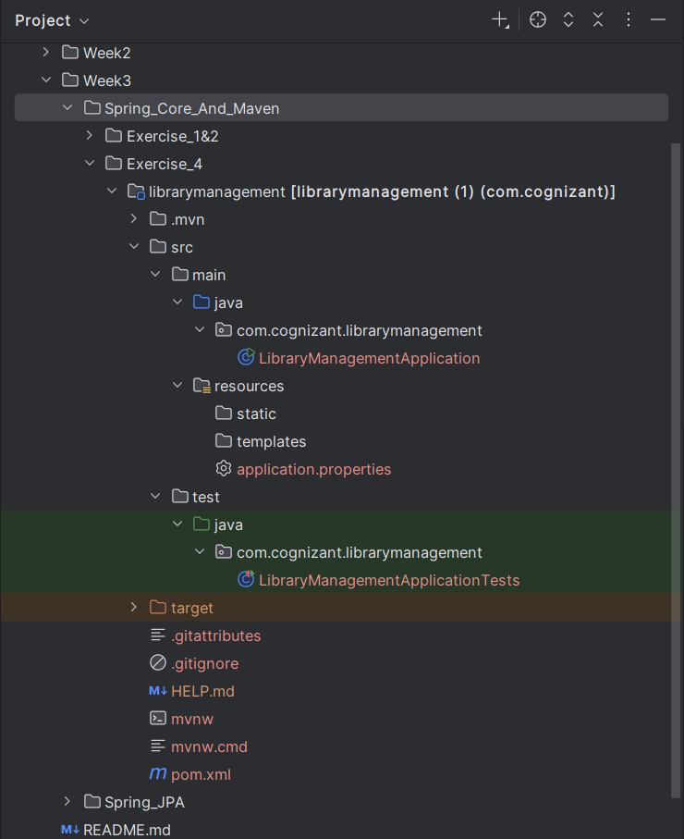

**Spring Dependencies in pom.xml:**

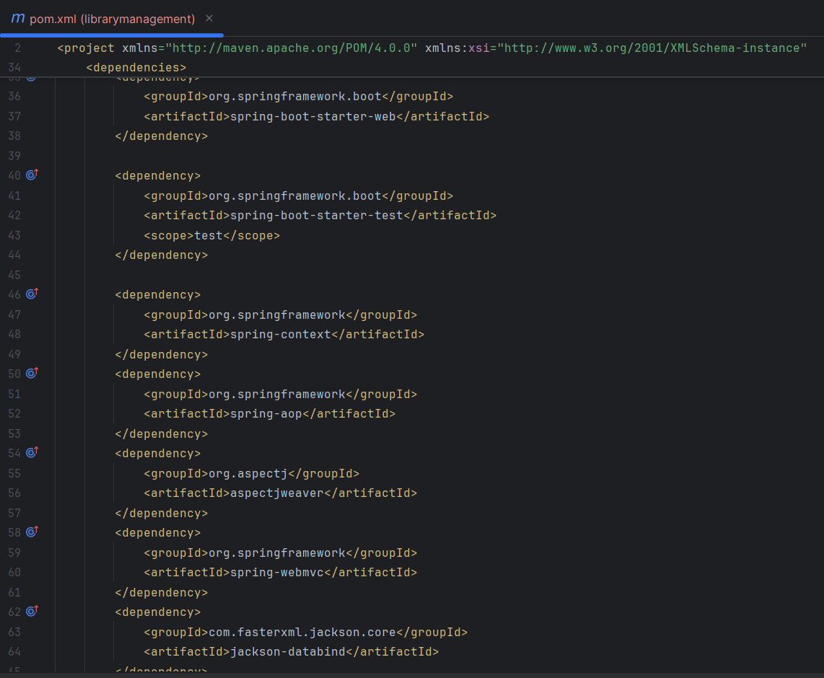

**Maven Compiler Plugin:**

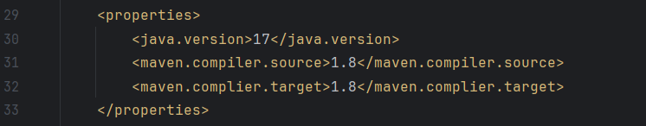

**Build Verification:**

Executed: mvn clean and install

