Hands-On 1: Introduction to React & Creating First React App

What I Learned
- SPA stands for Single Page Application. It improves performance by loading a single HTML page and dynamically updating it without refreshing the whole page.
- React is a JavaScript library for building UI. It uses components and virtual DOM for efficient updates.
- Virtual DOM is a lightweight copy of the real DOM that allows React to update the UI more efficiently.
- SPAs reduce server load and offer a smoother user experience, but can be difficult to manage in large apps.
Hands-On Steps
- Installed Node.js and npm from https://nodejs.org/en/download/.
- Installed create-react-app globally:
npx create-react-app myfirstreact
- Navigated into the folder:
cd myfirstreact
- Opened the folder in VS Code:
code . 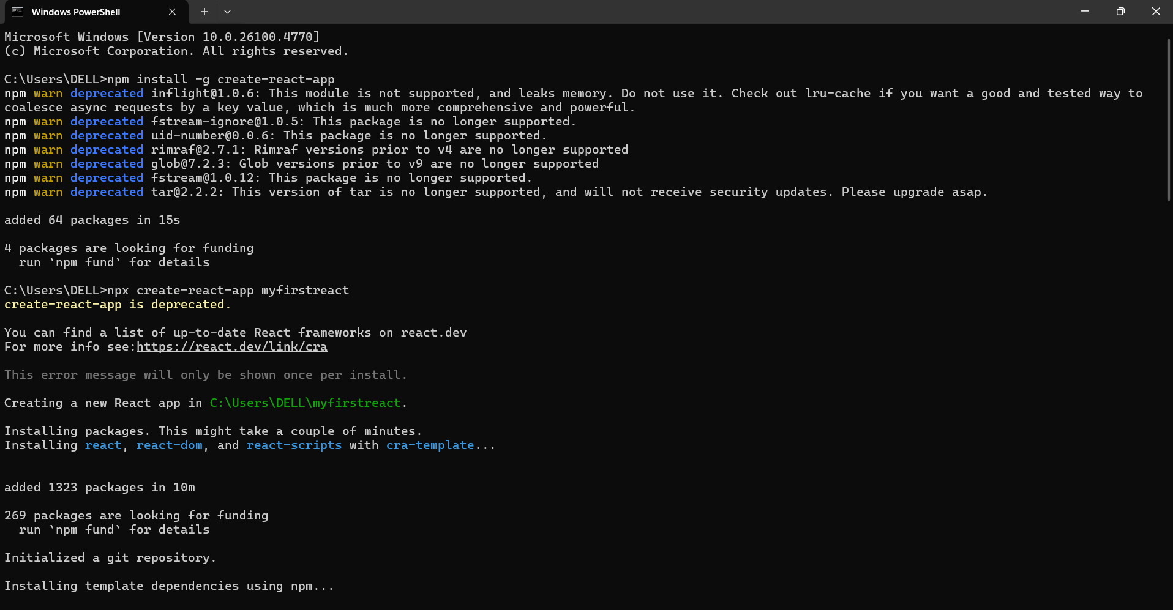
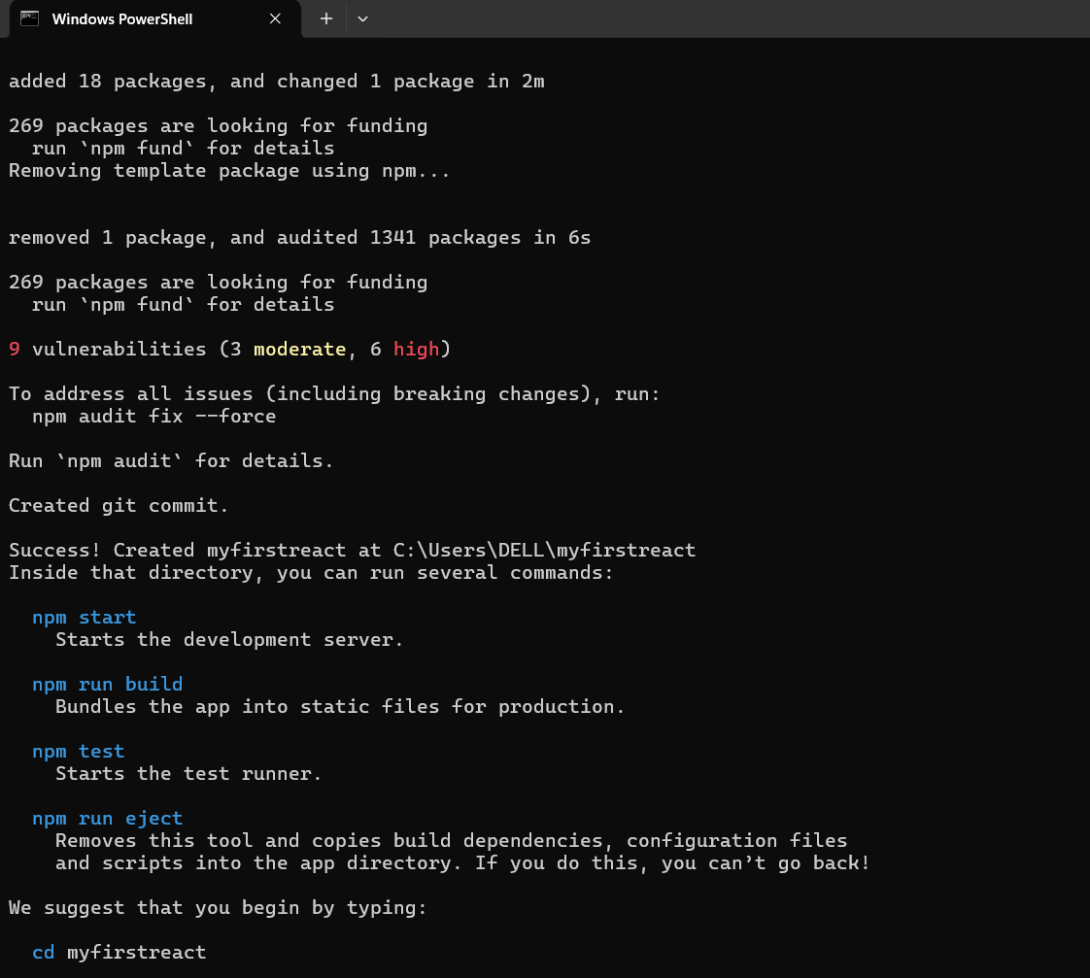

- Opened App.js under src, removed all default code, and replaced it with:

function App() {
return (
<h1>Welcome to the first session of React</h1>
);
}

export default App;

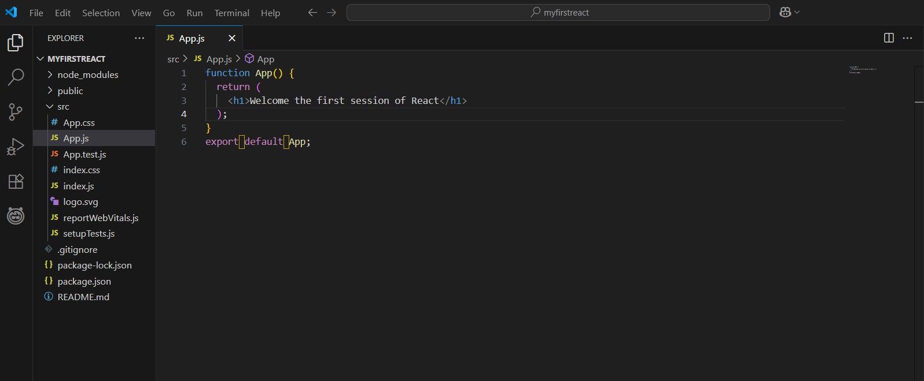

- Ran the application:
npm start

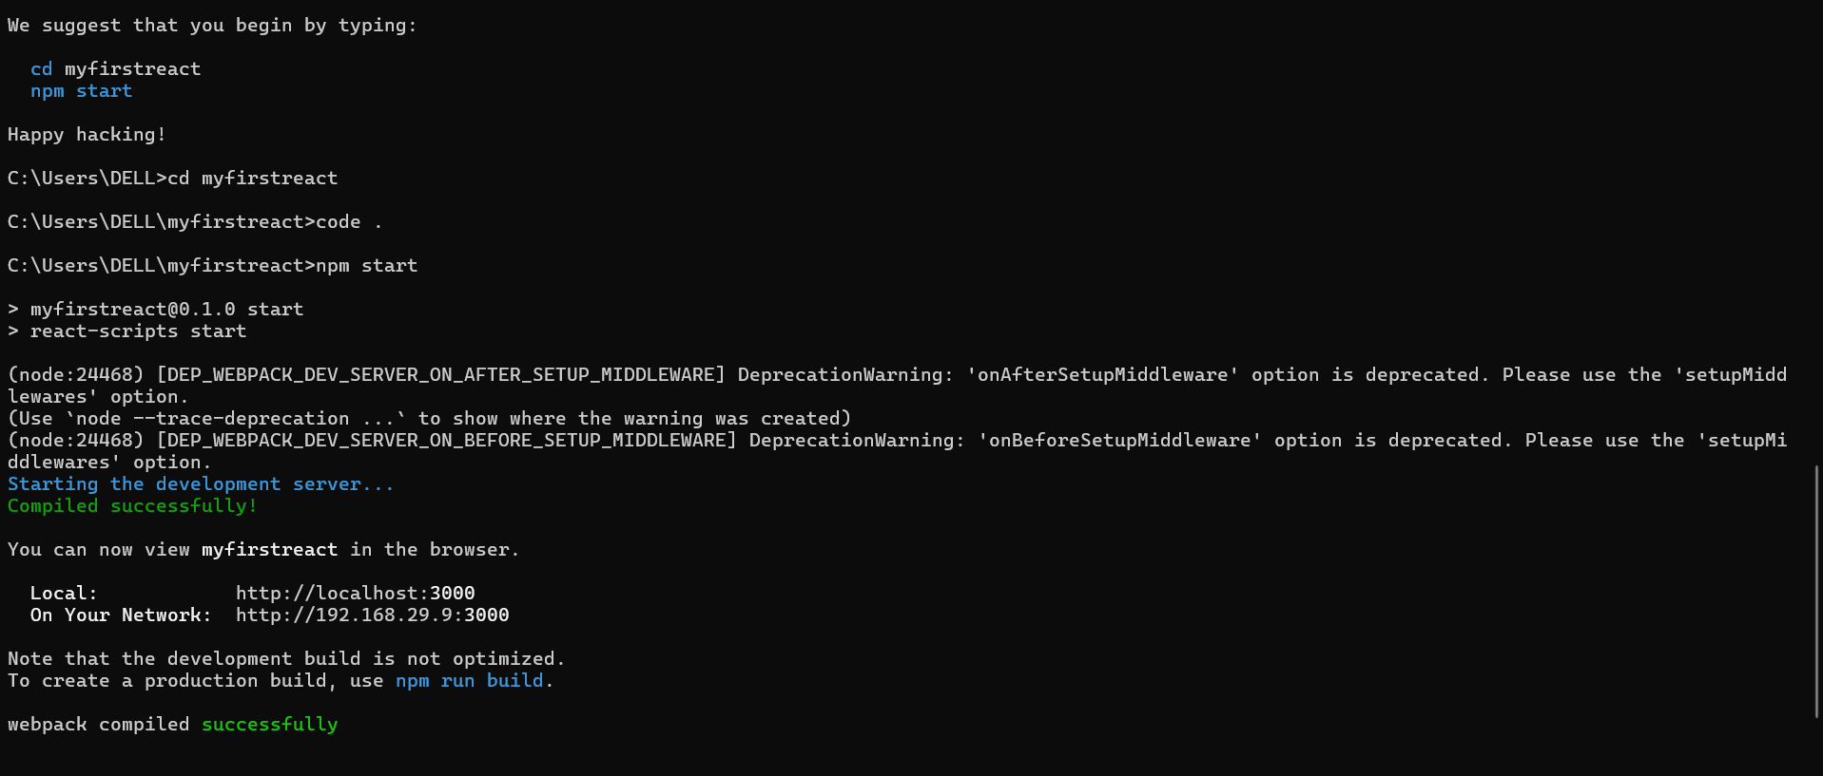

- Visited http://localhost:3000 to verify the output.

Output:
A heading is displayed:
“Welcome to the first session of React

