Hands-On 2: React Components - Class & Function

What I Learned

- Components are reusable UI blocks in React.
- Functional components are simple functions that return JSX.
- Class components use ES6 classes, can hold state, and use lifecycle methods.
- The constructor() sets initial state. The render() method returns JSX to render UI.

Hands-On Steps

- Created a new app:
npx create-react-app studentapp

- Navigated into the app folder:
cd studentapp

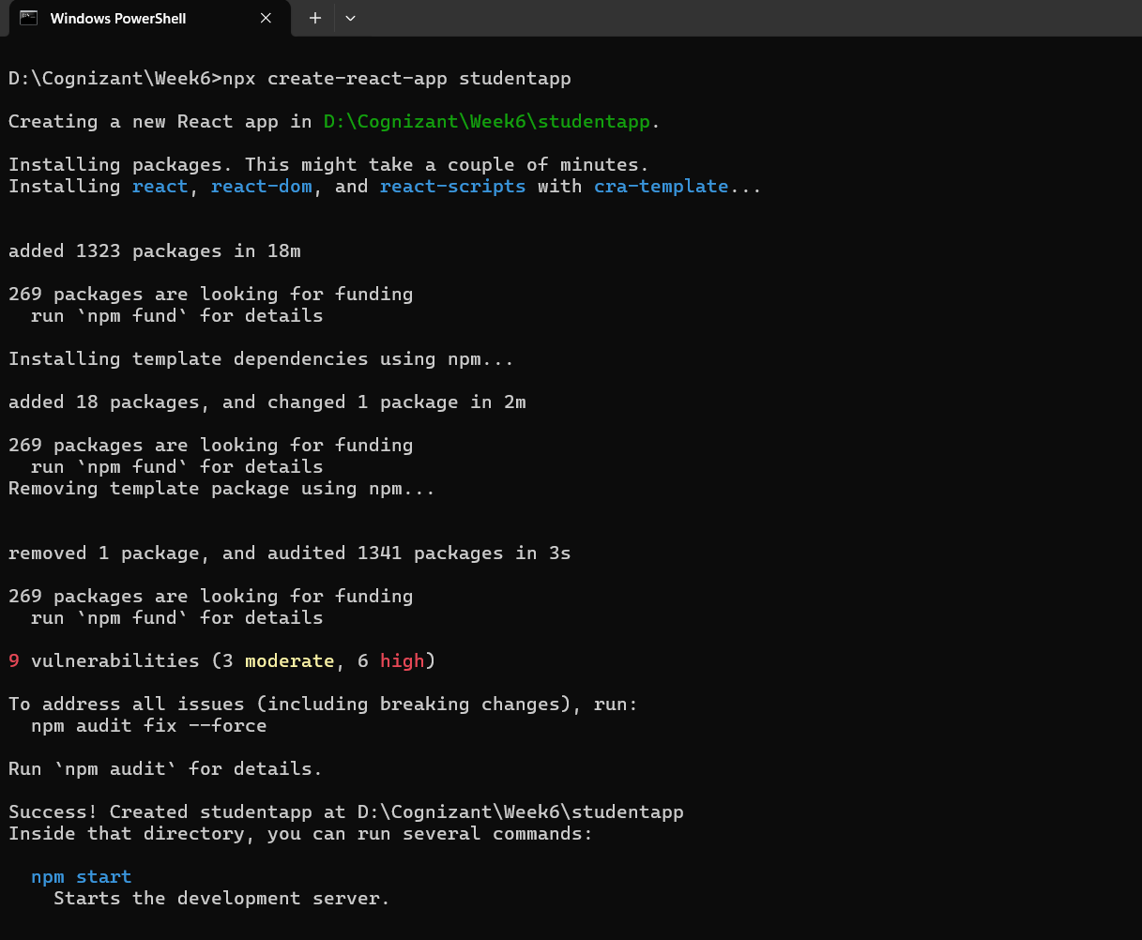

- Created a Components folder inside src.
- Created the file Home.js in Components:

import React, { Component } from 'react';
class Home extends Component {
render() {
return (
<div>
<h3>Welcome to the Home page of Student Management Portal</h3>
</div>
);
}
}
export default Home;
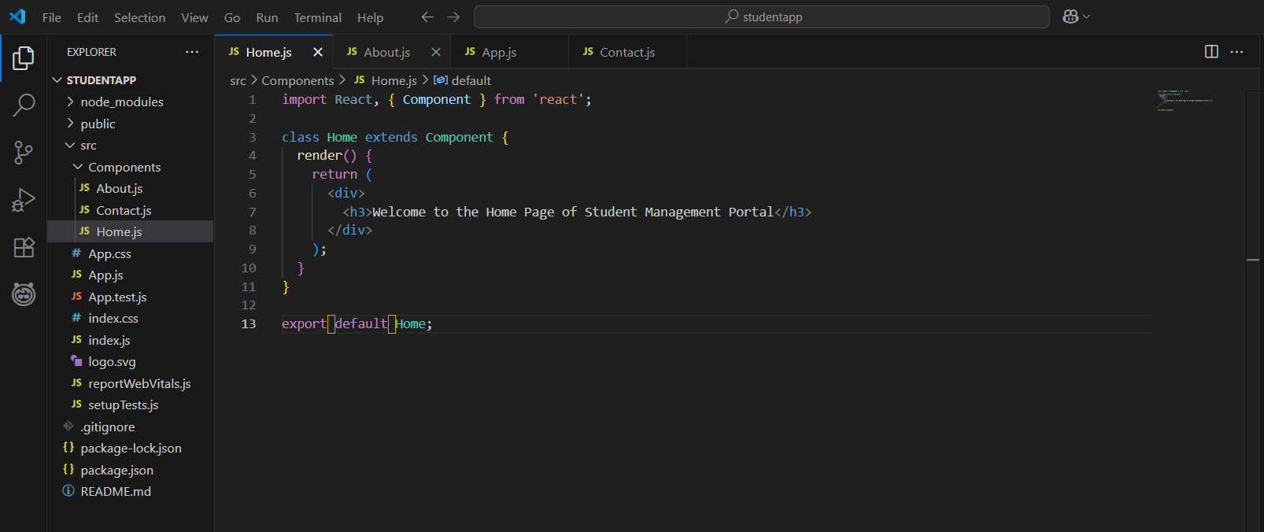

- Created About.js in the same way:

import React, { Component } from 'react';

class About extends Component {
render() {
return (
<div>
<h3>Welcome to the About page of the Student Management Portal</h3>
</div>
);
}
}

export default About;

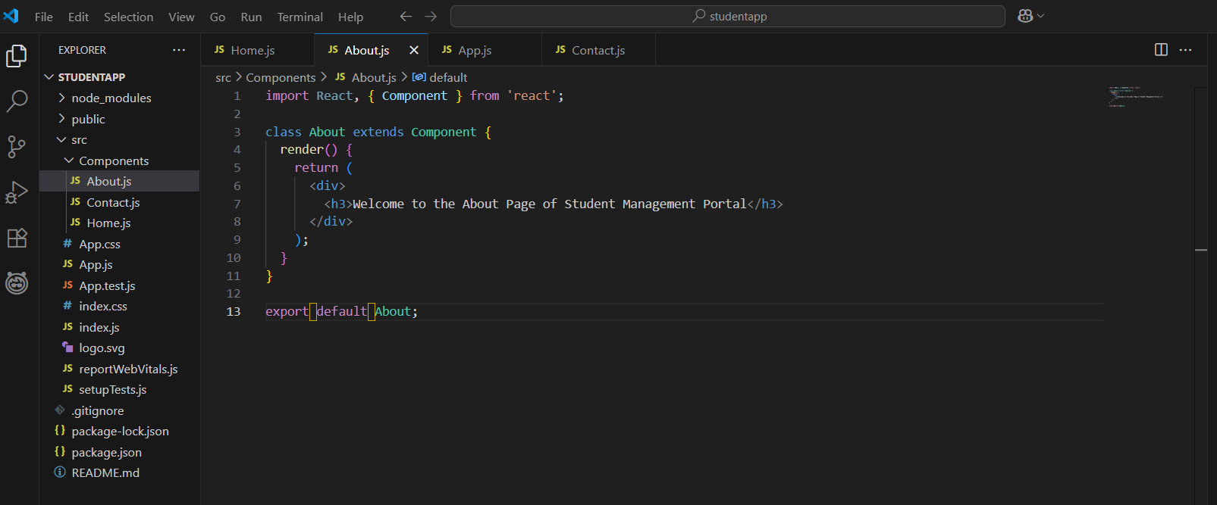

- Created Contact.js similarly:

import React, { Component } from 'react';

class Contact extends Component {
render() {
return (
<div>
<h3>Welcome to the Contact page of the Student Management Portal</h3>
</div>
);
}
}

export default Contact;

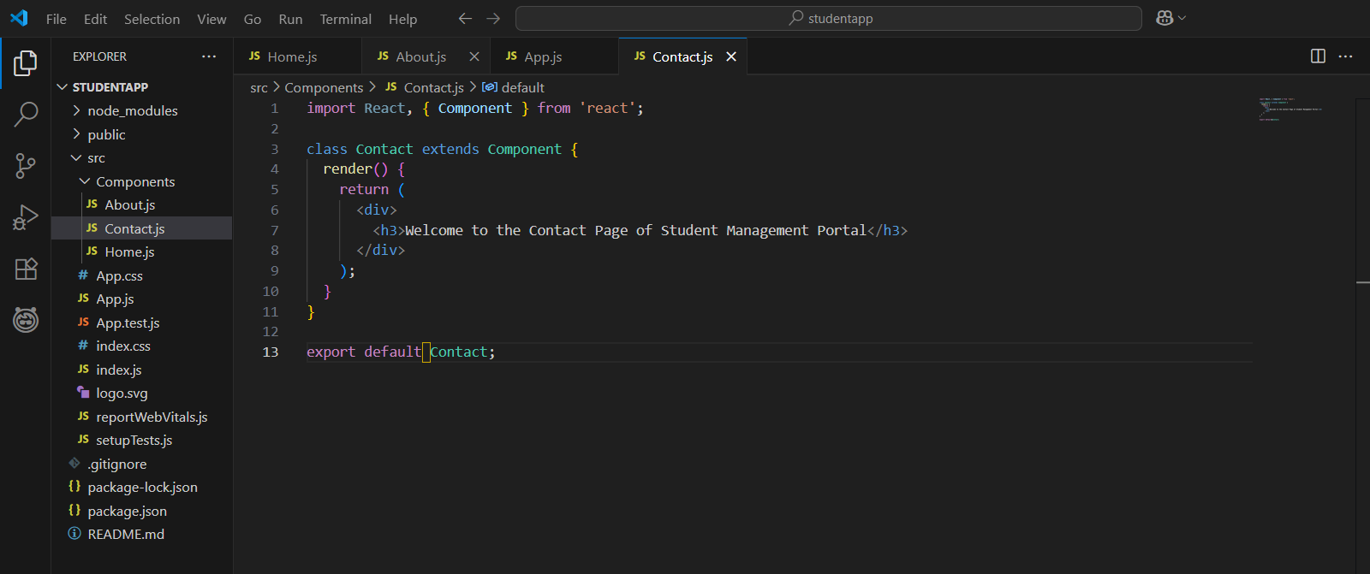

- Edited App.js to call all components:

Import ‘./App.css’;
import Home from './Components/Home';
import About from './Components/About';
import Contact from './Components/Contact';

function App() {
return (
<div className=”container”>
<Home />
<About />
<Contact />
</div>
);
}

export default App;

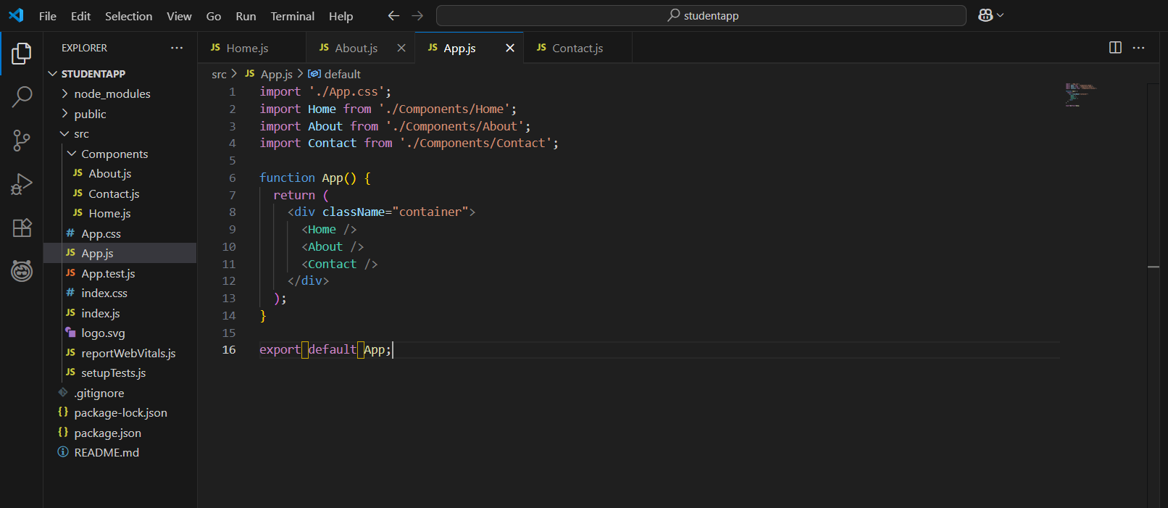

- Ran the project:

npm start

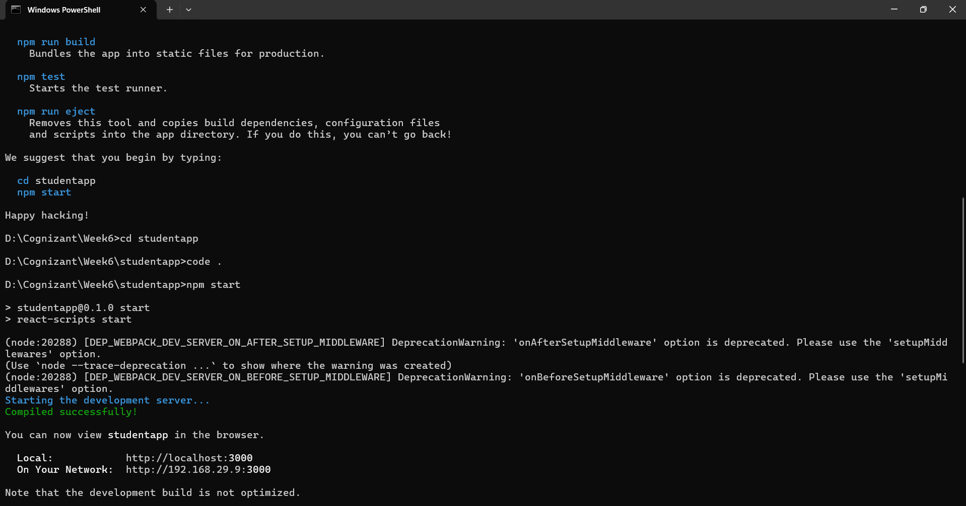

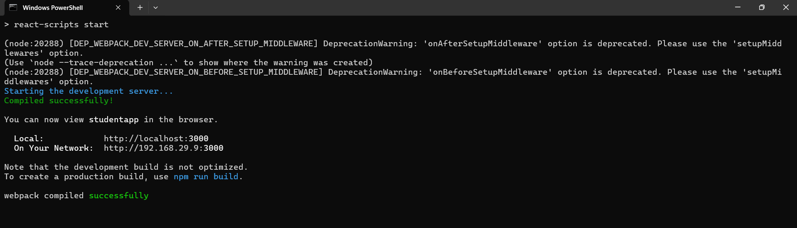

- Verified the output at http://localhost:3000.

Output:
All three messages were displayed:
- Home Page
- About Page
- Contact Page

