Hands-On 3: React Styling and Functional Components

What I Learned
- Functional components are stateless and written using regular JavaScript functions or ES6 arrow functions.
- React allows separation of logic and styling by creating a Stylesheets folder and using .css files.
- CSS styles can be imported directly into components using import './filename.css'.

Hands-On Steps
- Created a new React app:
npx create-react-app scorecalculatorapp

- Navigated into the app directory:
cd scorecalculatorapp

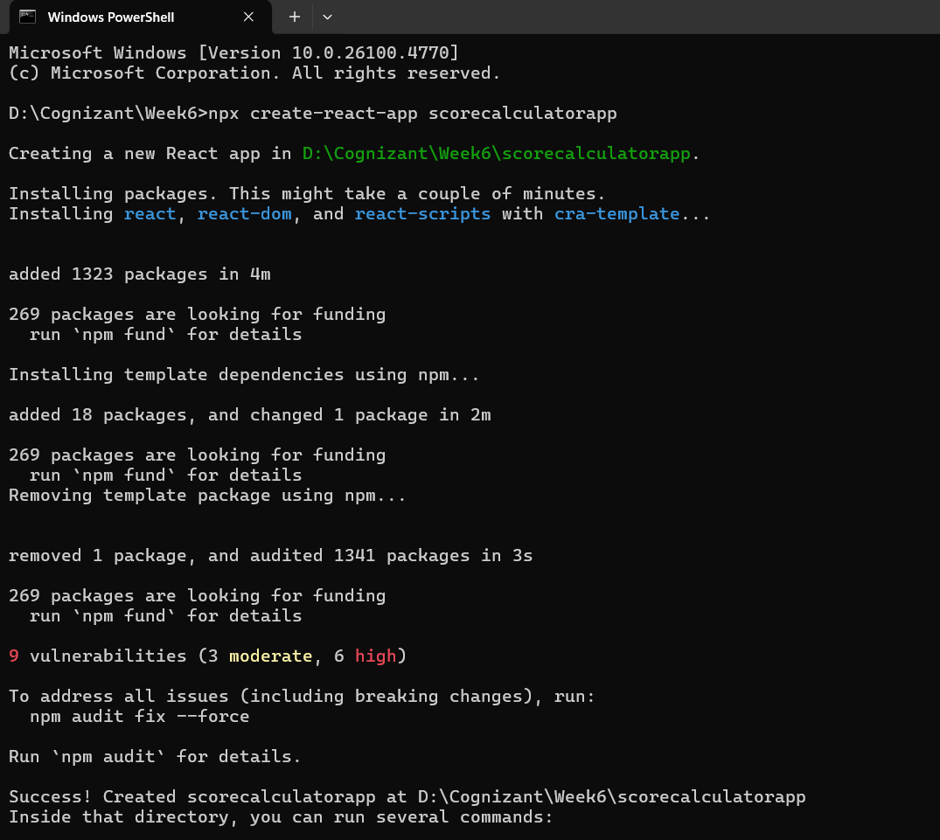

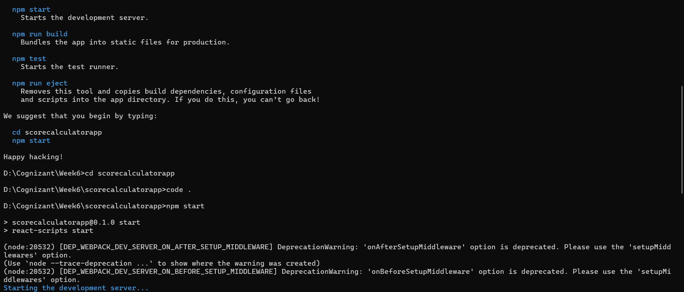

- Created a folder named Components inside the src directory.

- Created a file named CalculateScore.js inside the Components folder and added the following code:

import '../Stylesheets/mystyle.css';

const percentToDecimal = (decimal) => {
return (decimal.toFixed(2) + "%");
};

const calcScore = (total, goal) => {
return percentToDecimal(total / goal);
};

export const CalculateScore = ({ Name, School, total, goal }) => (
<div className="formatstyle">
<h1><font color="brown">Student Details:</font></h1>
<div className="Name">
<b><span> Name: </span></b>
<span>{Name}</span>
</div>
<div className="School">
<b><span> School: </span></b>
<span>{School}</span>
</div>
<div className="Total">
<b><span>Total: </span></b>
<span>{total}</span>
<span> Marks</span>
</div>
<div className="Score">
<b>Score:</b>
<span>
{calcScore(total, goal)}
</span>
</div>
</div>
);

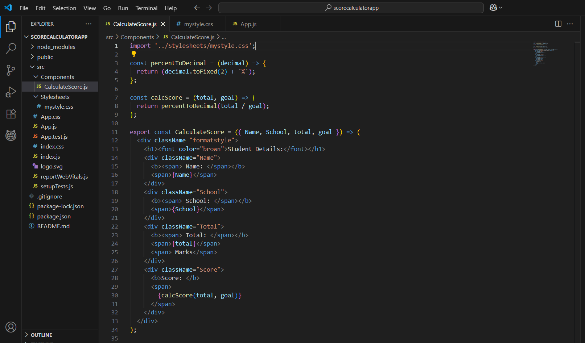

- Created a folder named Stylesheets inside src.

- Inside the Stylesheets folder, created a file named mystyle.css and added the following CSS:

.Name {
font-weight: 300;
color: blue;
}
.School {
color: crimson;
}
.Total {
color: darkmagenta;
}
.formatstyle {
text-align: center;
font-size: large;
}
.Score {
color: forestgreen;
}

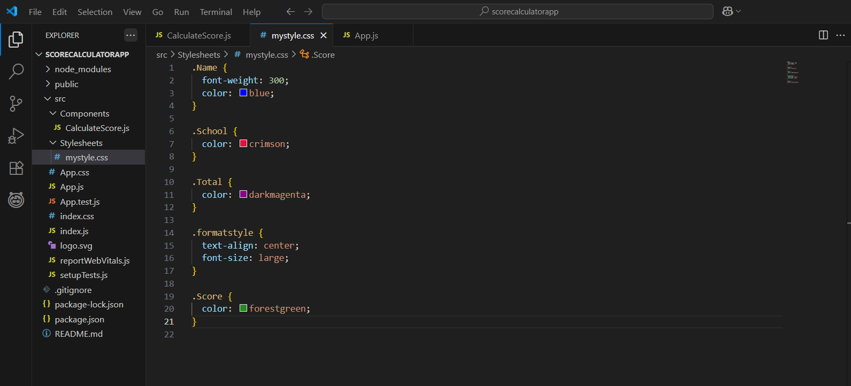

- Edited App.js to render the CalculateScore component:

import { CalculateScore } from './Components/CalculateScore';

function App() {
return (
<div>
<CalculateScore
Name=”Steeve”
School=”DNV Public School”
total={284}
goal={3}
/>
</div>
);
}

export default App;

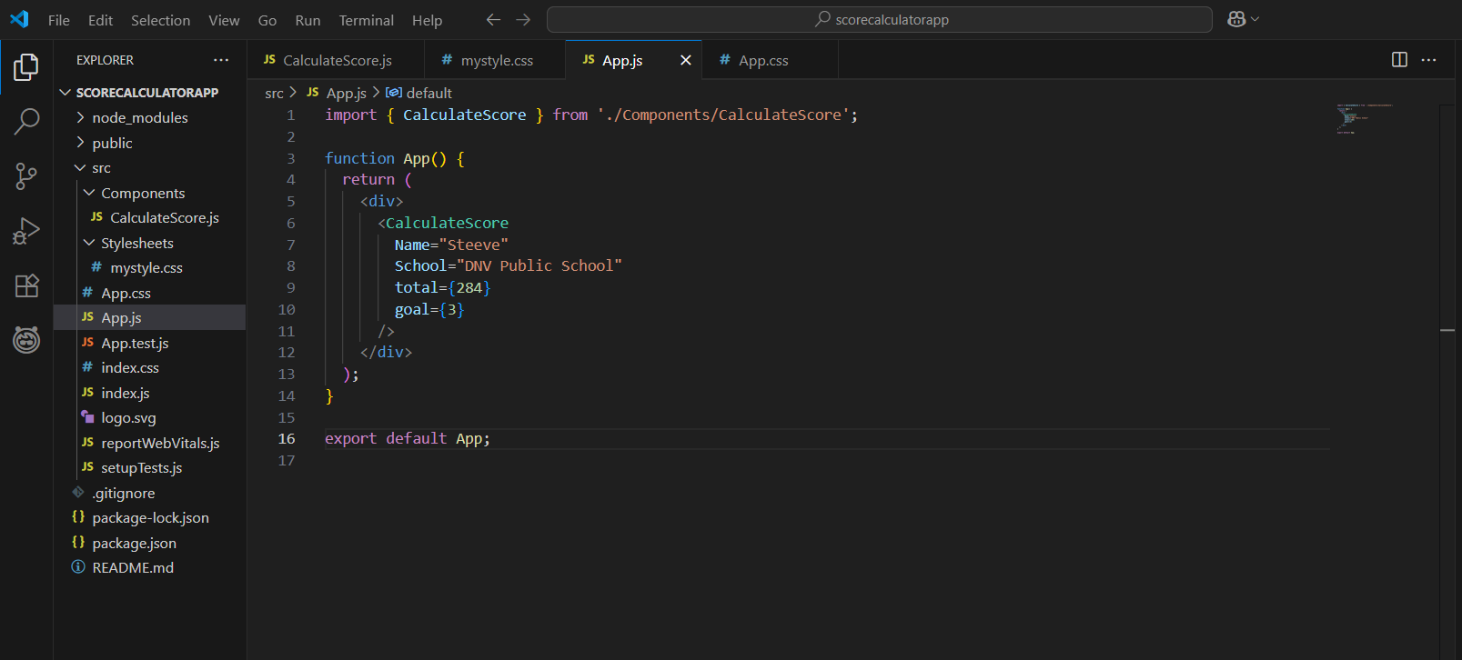

- Started the application:
npm start
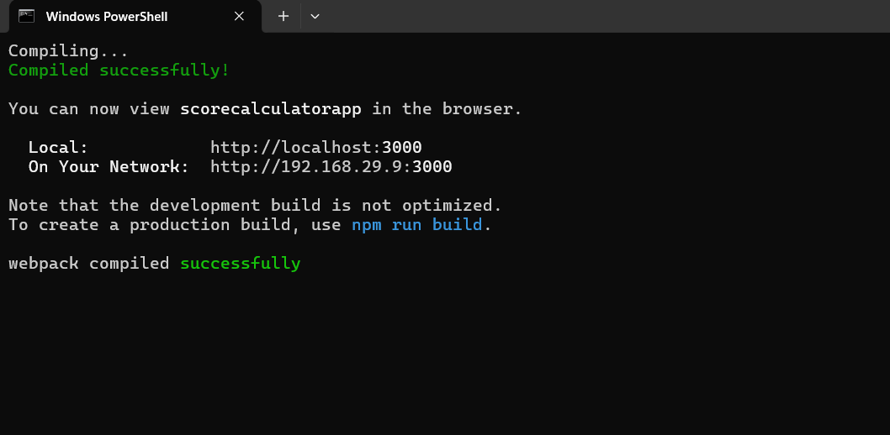
- Opened the browser and navigated to: http://localhost:3000

Output:
Displayed content with styles:
- A heading saying “Score Calculator” in navy blue
- A description below it saying “This is a simple app to calculate scores.” in green

