Hands-on 4: Component Life Cycle in React

What I learned
- The need and benefits of the component life cycle in React
- How to use different class-based life cycle methods
- Implemented componentDidMount() to load API data after mounting
- Used componentDidCatch() to handle and display errors gracefully
- Displayed dynamic data using render() method from component state

Hands-on steps

- Created a new React app using create-react-app and named it blogapp
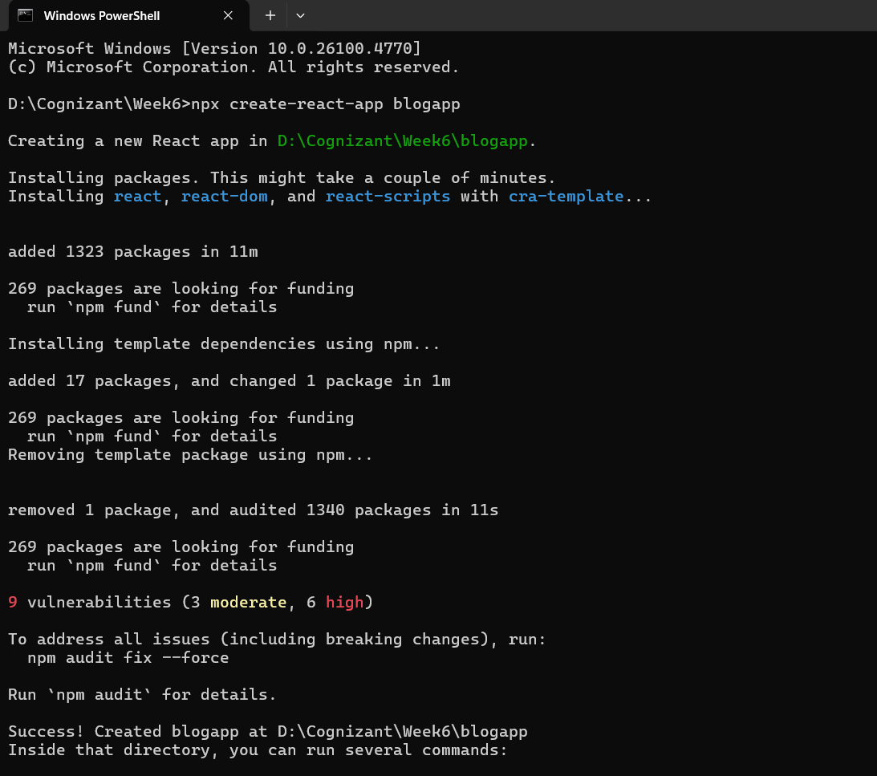

- Opened the project in Visual Studio Code

- Created a file Post.js in the src folder and defined a Post class with constructor accepting id, title, and body

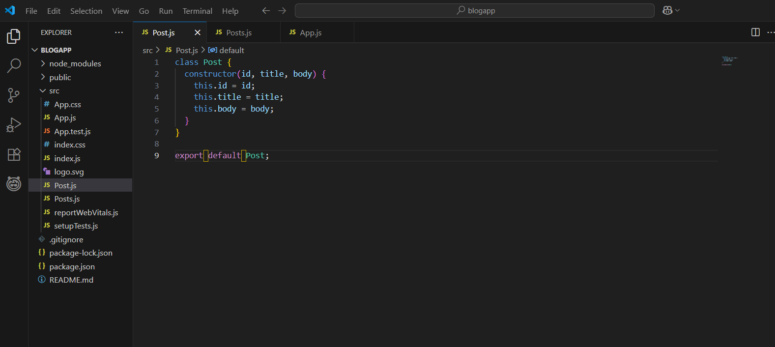

- Created another file Posts.js and defined a class component Posts using React.Component
- Inside the constructor, initialized state with an empty array for posts
- Created a method loadPosts() and used fetch() to get data from https://jsonplaceholder.typicode.com/posts
- Mapped the fetched data to Post objects and updated state using this.setState()
- Called the loadPosts() method inside componentDidMount()
- Implemented the render() method to display posts using JSX — titles in <h2> and body in <p> tags
- Used componentDidCatch() to handle errors and display alert messages if any error occurred

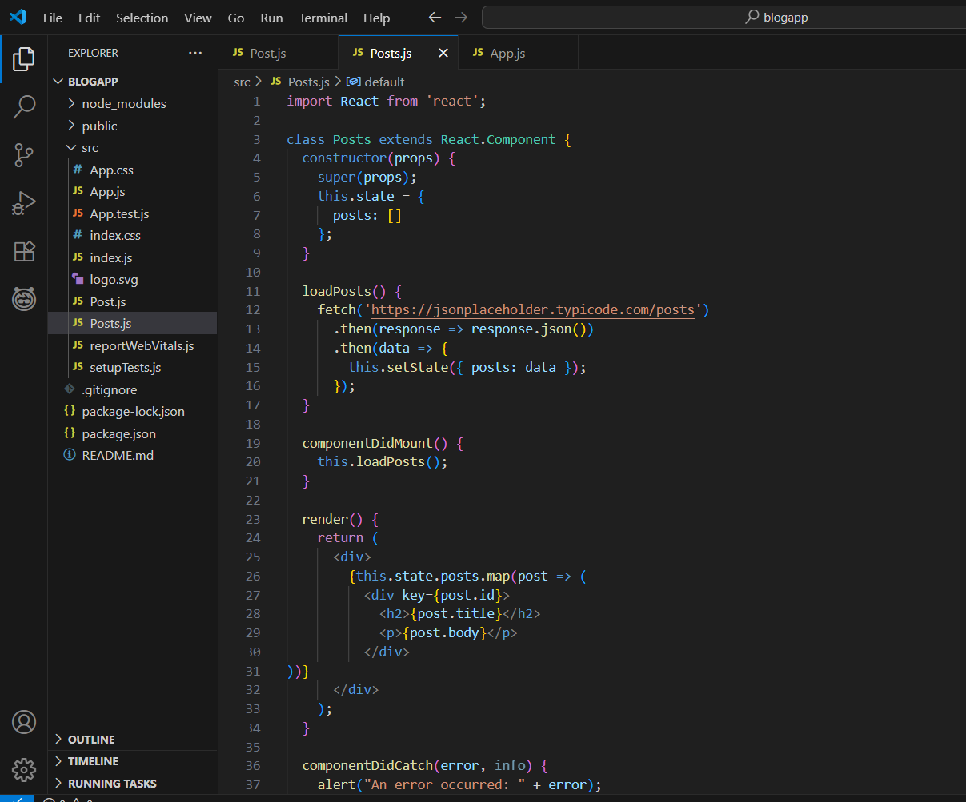
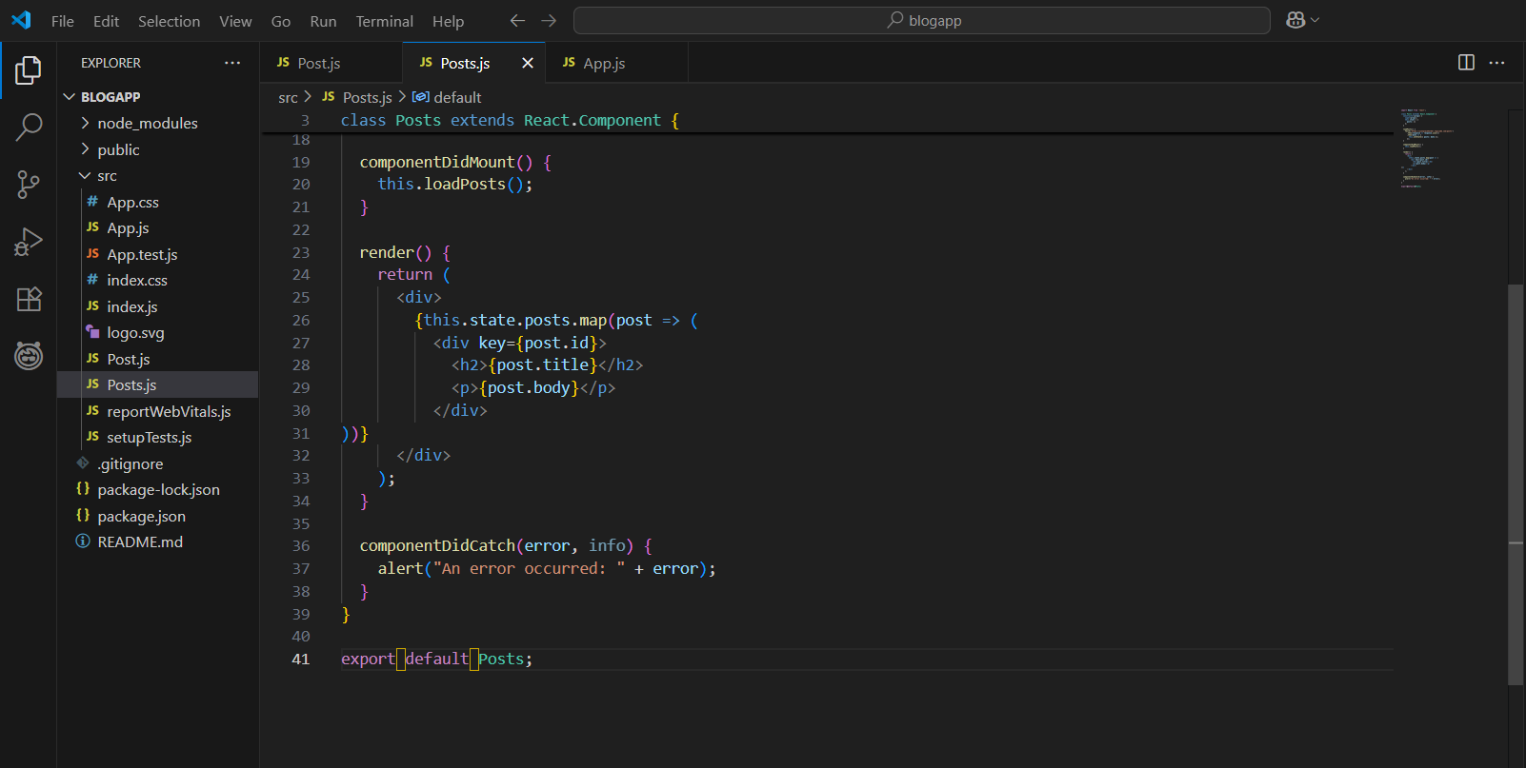

- Imported Posts component in App.js and added it inside the JSX
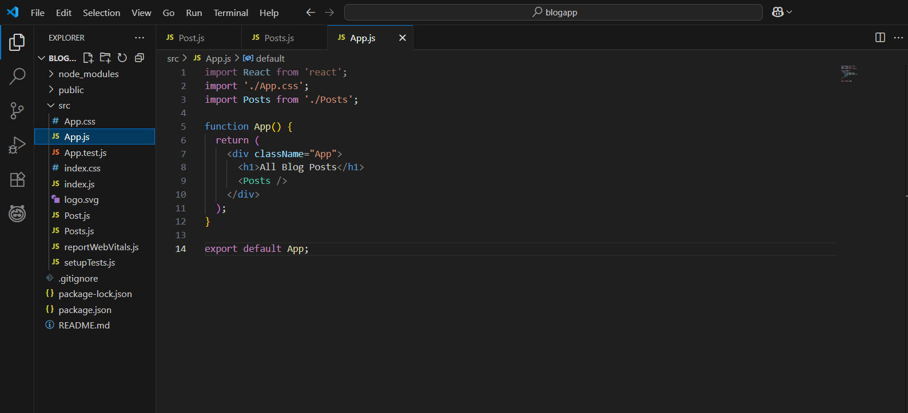

- Ran the app using npm start

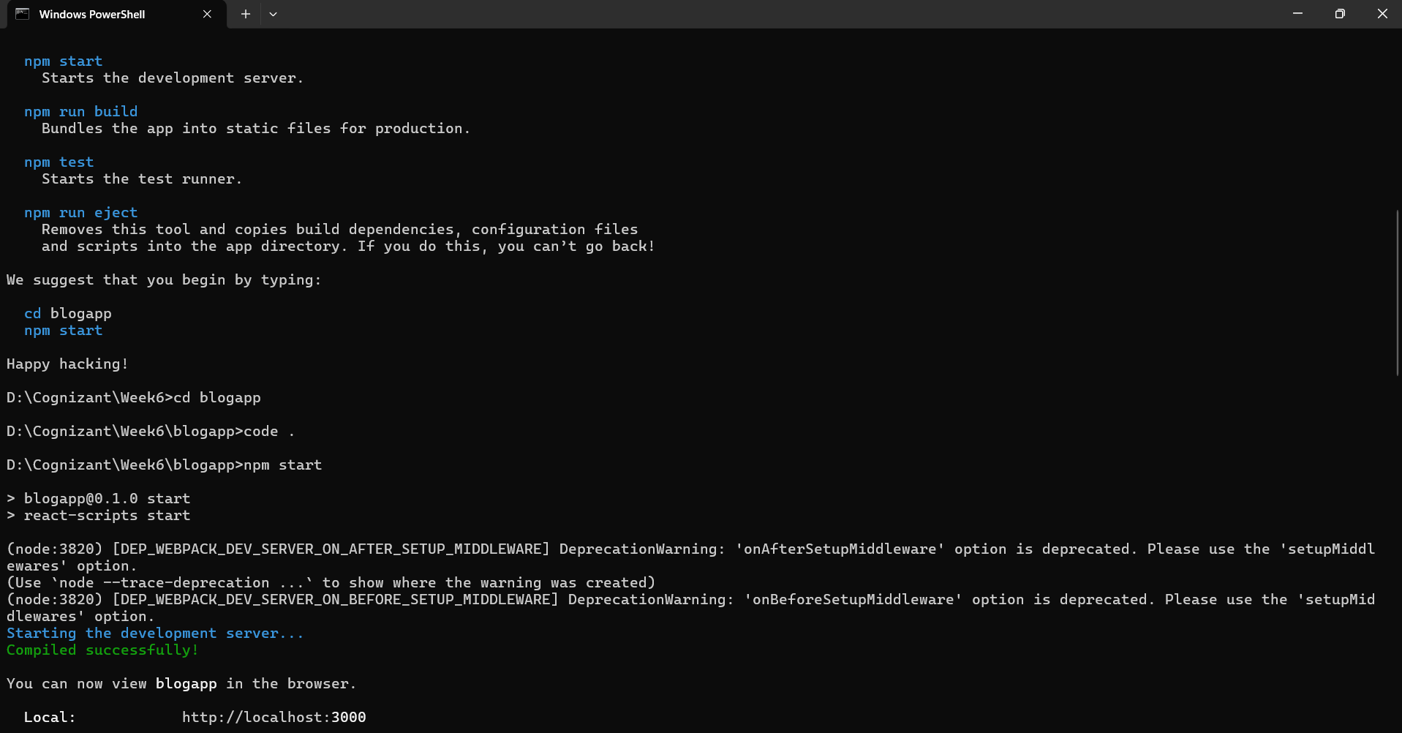
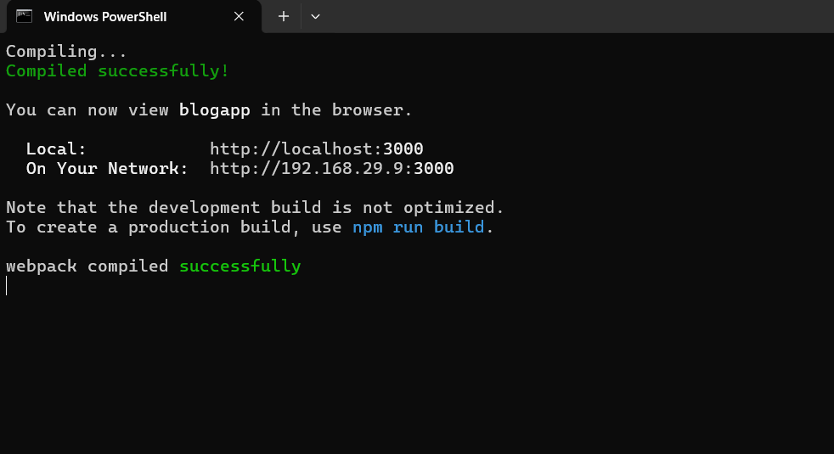

Output:
- On running the app, a list of blog posts appeared on the browser
- Each post displayed a title and body fetched from the API
- Error boundary handled gracefully using componentDidCatch() (tested with dummy error)

