Hands-on 5: Styling React Components

What I learned
- The need for styling React components to improve UI clarity and user experience
- How to apply styles using CSS Modules and inline styles
- Used className and style attributes to assign styles to components
- Differentiated between component-scoped styles and global styles in React
- Understood the use of modular, reusable styles for better maintainability

Hands-on steps
- Downloaded the given React project (cohorttracker.zip) and extracted it

- Opened the extracted folder in Visual Studio Code

- Installed all required node packages using:

npm install

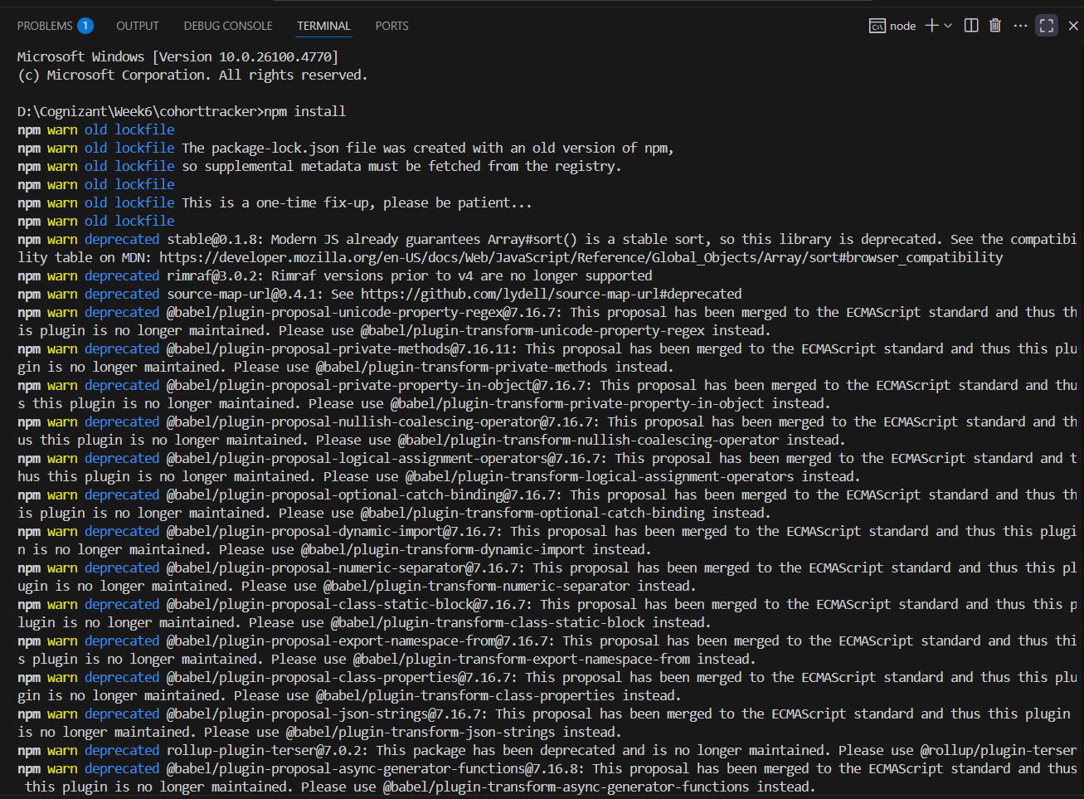

- Explored the existing React components for cohort dashboard

- Created a new CSS Module file CohortDetails.module.css to define scoped styles

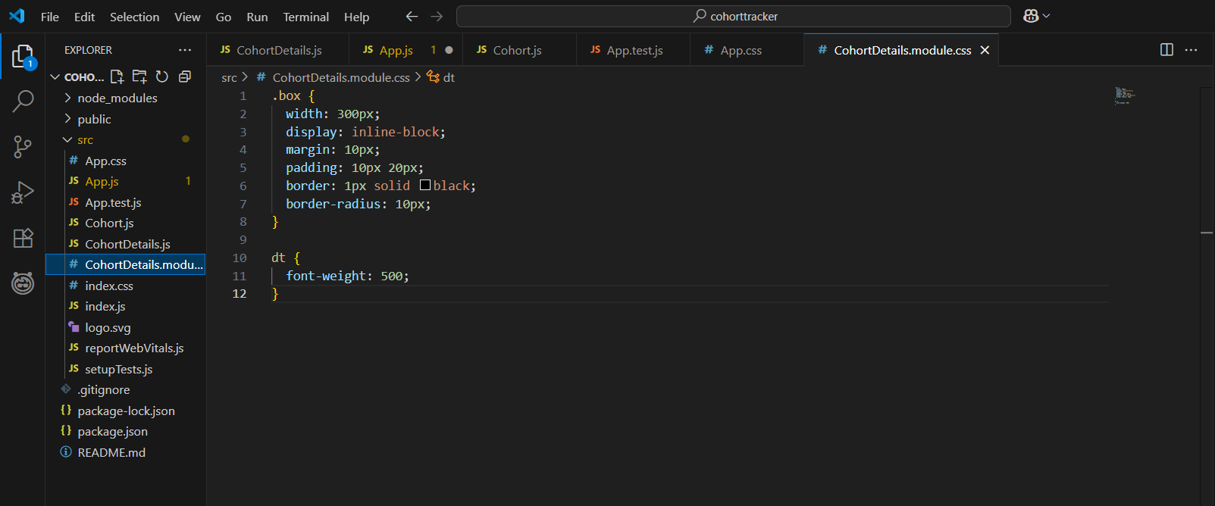
- Applied the styles using className={styles.className} for modular CSS

- Added inline styles to a few elements using the style={{ ... }} attribute

- Ensured different styling for completed and ongoing cohorts using conditional rendering
CohortDetails.js
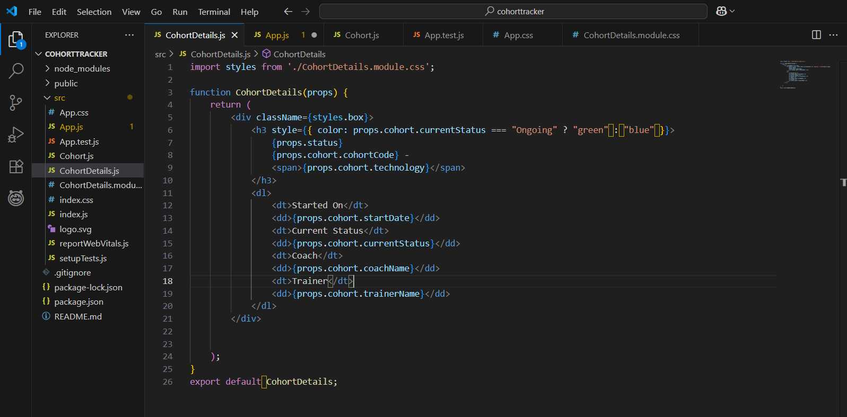

- Ran the application using:
npm start

Output:
- A dashboard displayed with styled cards for each cohort
- Completed cohorts appeared with a distinct background color
- Modular CSS ensured styles applied only to relevant components without global conflicts
- Inline styles were successfully applied to specific elements like headings or dates
