HANDS-ON 4: Resolving Merge Conflicts in Git
Objectives:
This document provides a step-by-step solution for the hands-on lab demonstrating how to handle and resolve merge conflicts in Git. A merge conflict occurs when Git is unable to automatically resolve differences in code between two commits. This typically happens when two developers have changed the same lines in the same file, or if one developer deleted a file while another developer was modifying it.
Creating a Merge Conflict:
- Create a Branch and Make a Change
- Ensure your master branch is in a clean state.
git status
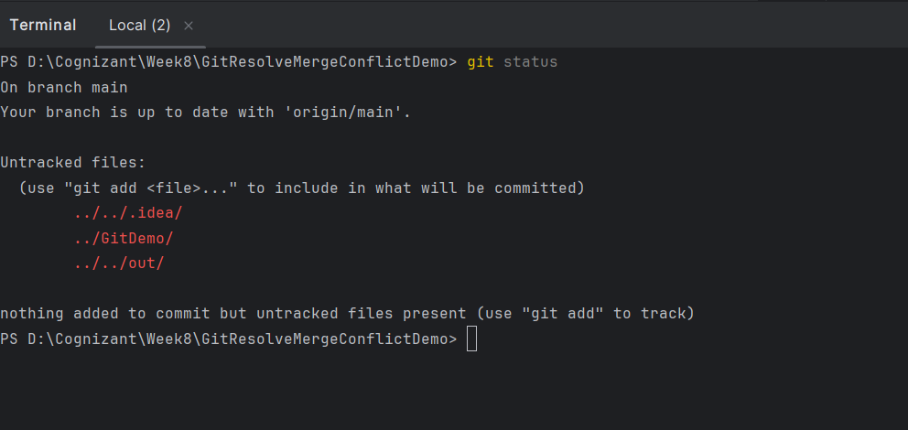
- Create a new branch named GitWork and switch to it.
git branch GitWork
git switch GitWork
- In the GitWork branch, create a new file hello.xml with some content.
echo '<?xml version="1.0" encoding="UTF-8"?>' > hello.xml
echo '<message>Hello from the GitWork Branch!</message>' >> hello.xml
- Stage and commit this change to the GitWork branch.
git add hello.xml
git commit -m "Add hello.xml in GitWork branch"

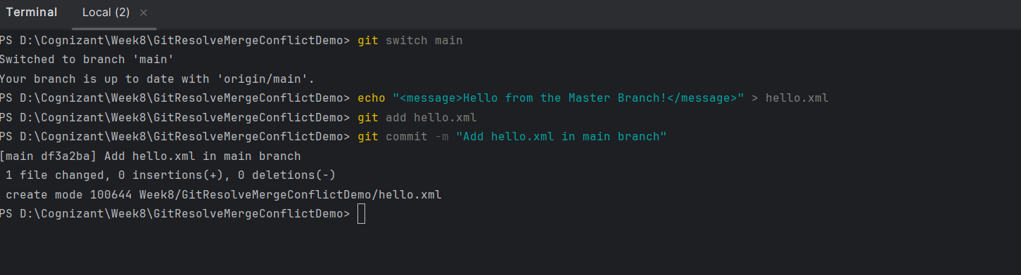
- Create a Competing Change in Master
- Switch back to the master branch
git switch main
- Create the same file, hello.xml, but add different content to it. This is the action that will cause the conflict.
echo "<message>Hello from the Master Branch!</message>" > hello.xml
- Stage and commit this new file to the master branch
git add hello.xml
git commit -m "Add hello.xml in master branch"

- Observe the Diverged History
- At this point, both branches have a unique commit that the other does not. To visualize this diverged history, run this git log command.
git log --oneline --graph --decorate --all
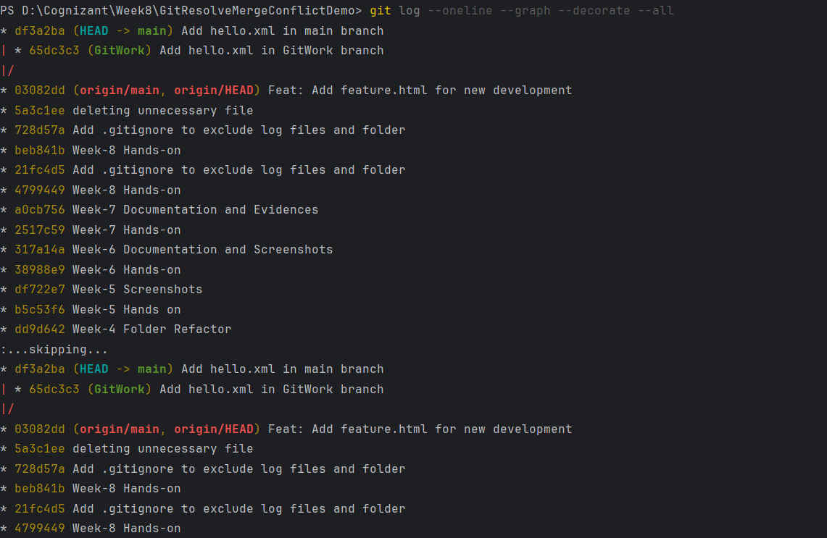
Resolving the Conflict:
- Attempt the Merge
- While on the master branch, attempt to merge the GitWork branch.
git merge GitWork
- Git will fail to merge automatically because it doesn't know which version of hello.xml to keep. The output will explicitly state a merge conflict.
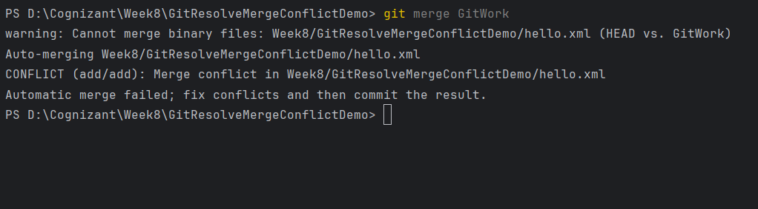
- Inspect the Conflict
- Check the status. Git provides helpful information, showing the "unmerged paths."
git status
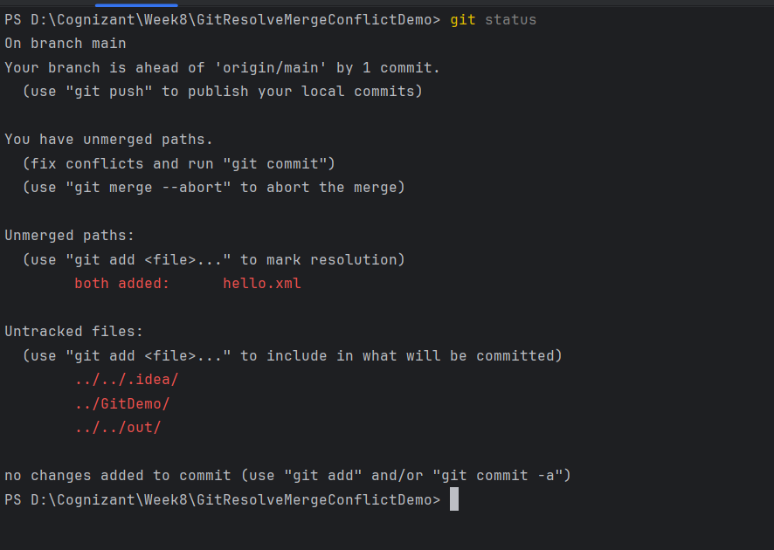
- Manually Resolve the Conflict
- Edit hello.xml, then save the file
<message>Hello from the Master Branch!</message>
<message>And also, hello from the GitWork Branch!</message>

- Complete the Merge

- Adding the fixed file to the staging area
git add hello.xml
- Commit the changes to finalize the merge. Git will open an editor with a pre-populated merge commit message. You can simply save and close it.
git commit

- Cleanup After Merging
- Handle Backup Files (if created)
- Add the pattern to .gitignore

echo "*.orig" >> .gitignore

- Commit the change to .gitignore

git add .gitignore

git commit -m "Update .gitignore to exclude merge tool backups"

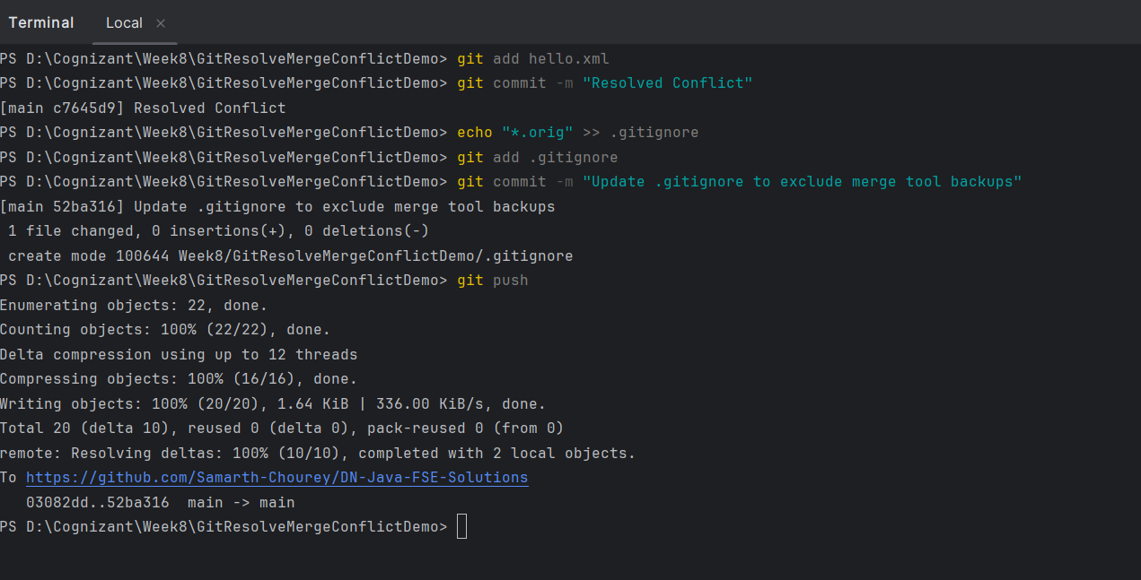

- Delete the Old Branch
- Delete the GitWork branch.
git branch -d GitWork
- Observe the Final History.
git log --oneline --graph –decorate
