HANDS-ON 5: Cleanup and Pushing to Remote
Objectives:
This document provides a step-by-step solution for the final hands-on lab in the Git series. The focus of this lab is to synchronize all the work completed locally—including adding files, creating branches, merging, and resolving conflicts—with a remote repository. This is a crucial final step in the development workflow, making your work accessible to others and creating a backup on a central server.
Step-by-Step Solution:
- List All Available Branches
- Verify that all temporary feature branches (like GitNewBranch and GitWork) have been deleted after their work was merged.
git branch
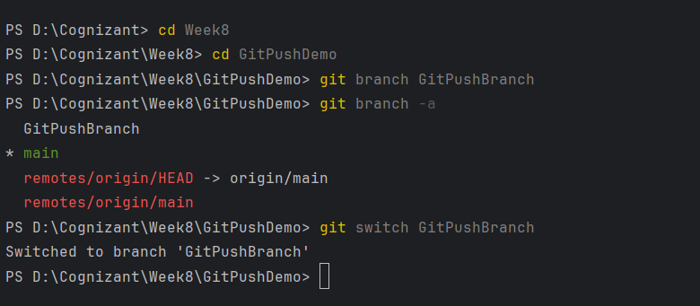

- Pull from the Remote Repository
- It is a best practice to pull from the remote repository before you push. This fetches any changes that may have been made by other developers since your last pull, allowing you to resolve any potential conflicts locally first.
git pull origin main

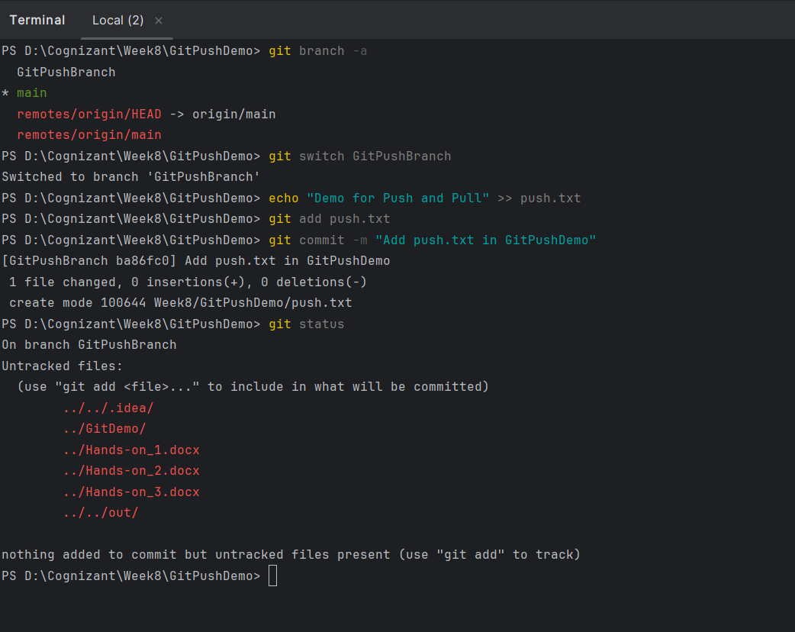

- Push All Local Changes to the Remote Repository
- Push all the commits you have made throughout these labs (adding files, merging branches, resolving conflicts) from your local master branch to the origin remote.
git push origin main
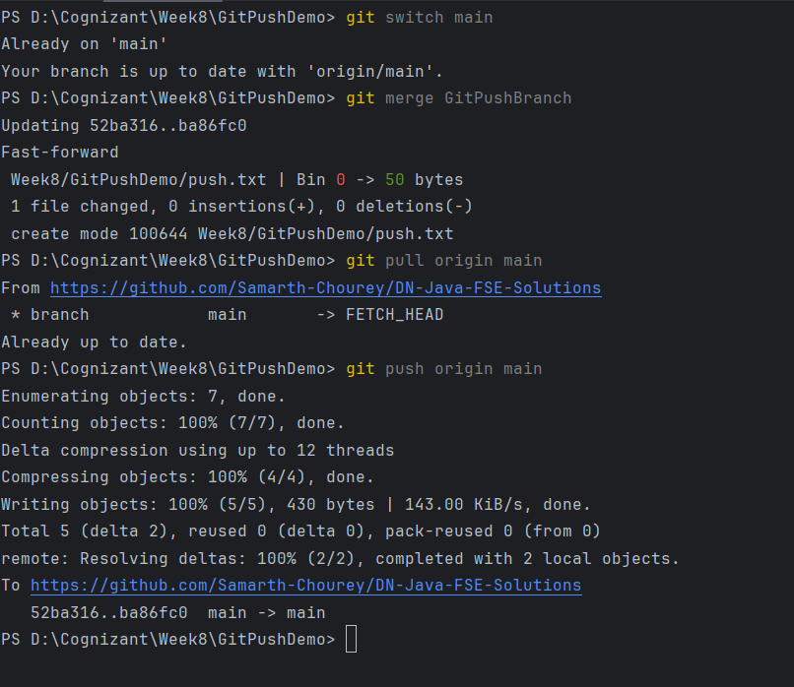

- Check the status

