HANDS-ON 10
Displaying Object Data Using JSX

Tools and Technologies Used
- ReactJS (using create-react-app)
- JavaScript (ES6)
- VS Code Editor
- Node.js & npm
Steps to Implement the Project
1. Project Setup
- Open VS Code terminal.
- Create a new React application by running:
npx create-react-app officespaceapp
cd officespaceapp
code .
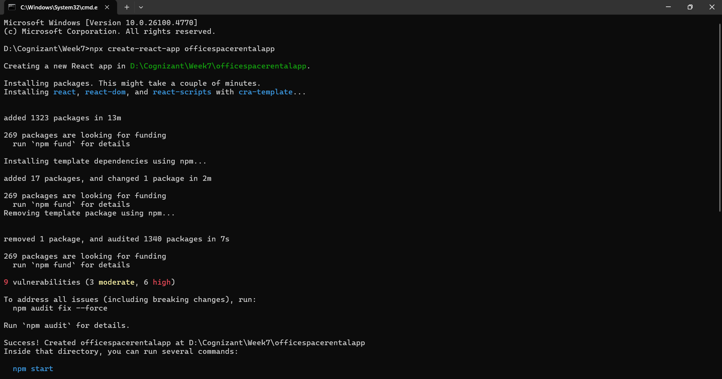

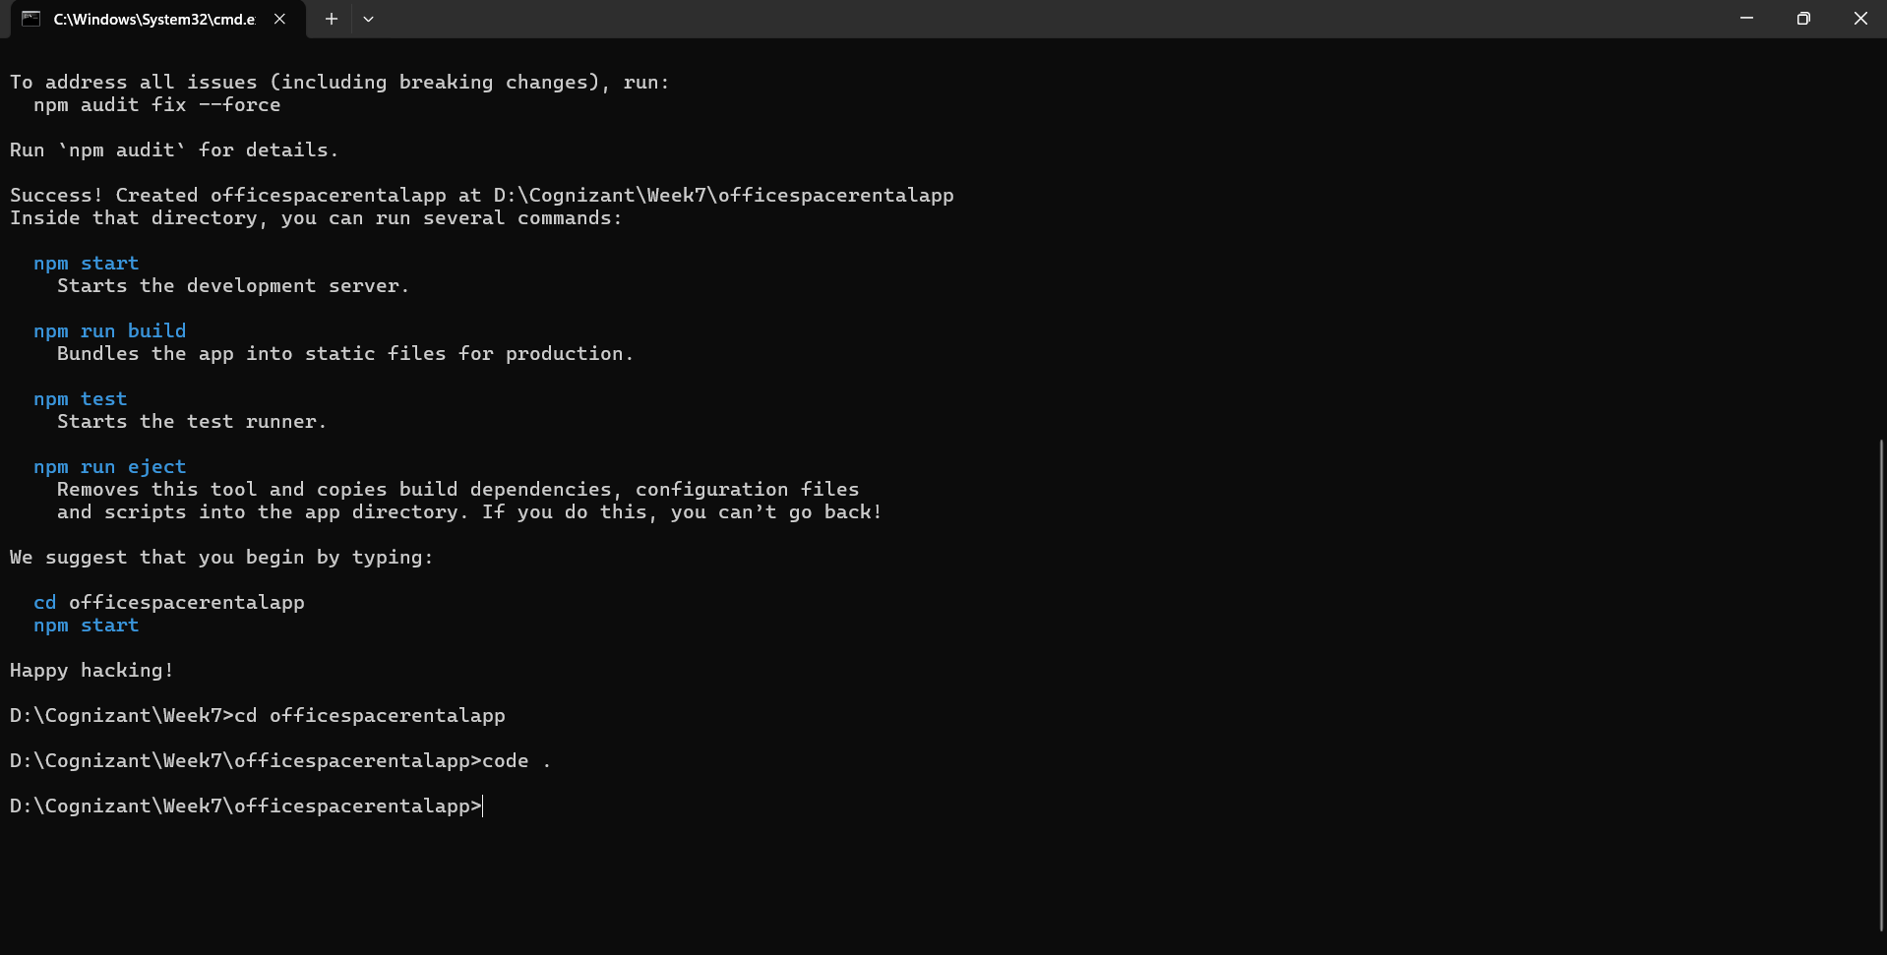

Folder and File Structure:
officespaceapp/
└── src/
└── App.js

Code Implementation
App.js
- A single React component is created.
- It stores office details in a JavaScript object.
- JSX is used to display object data (name, rent, address, image).
- Inline styling is used to color rent text red or green based on value.
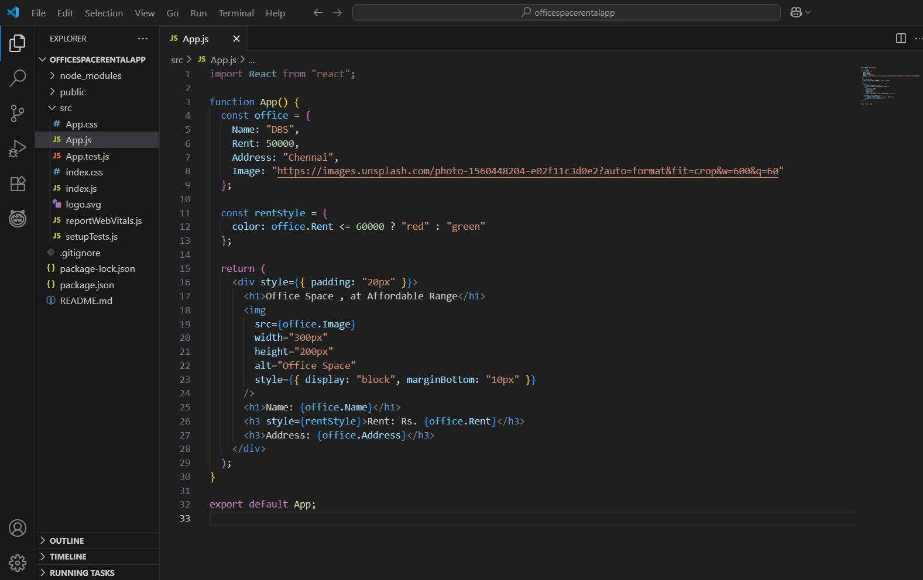

npm start

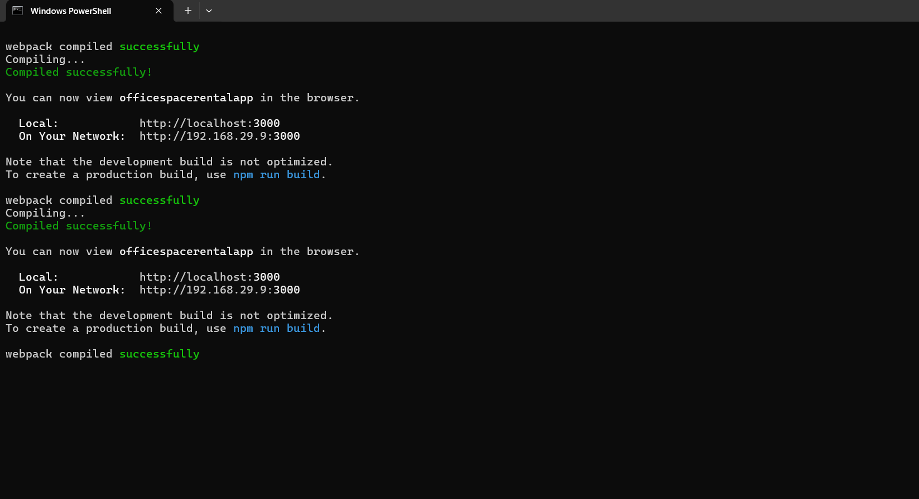

Output
Below 60000 (RED):
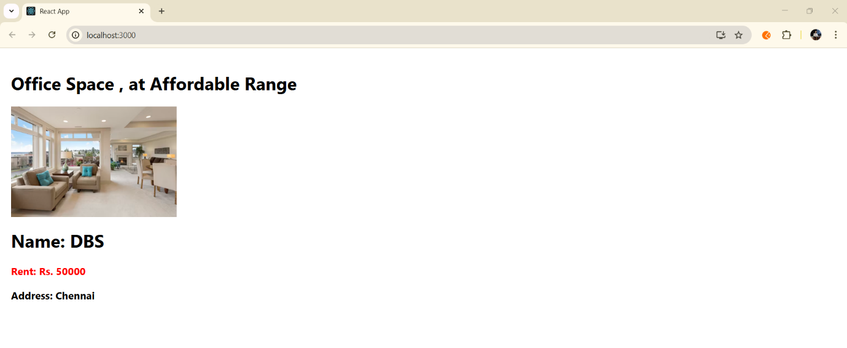

App.js for Above 60000:

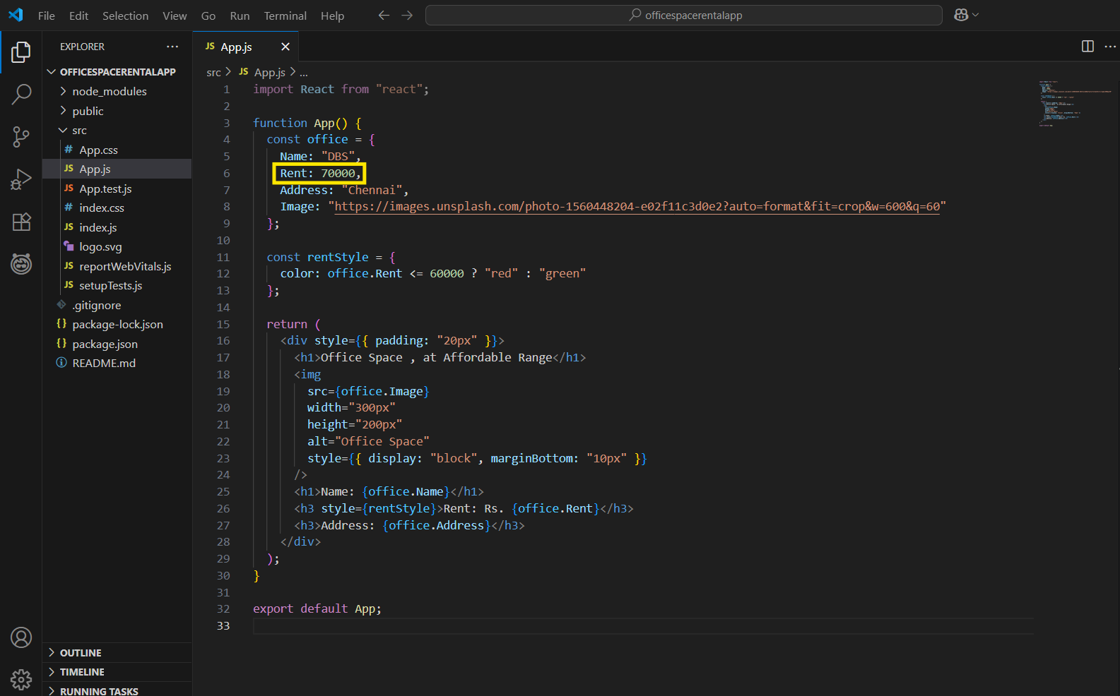

Output:
Above 60000 (GREEN):

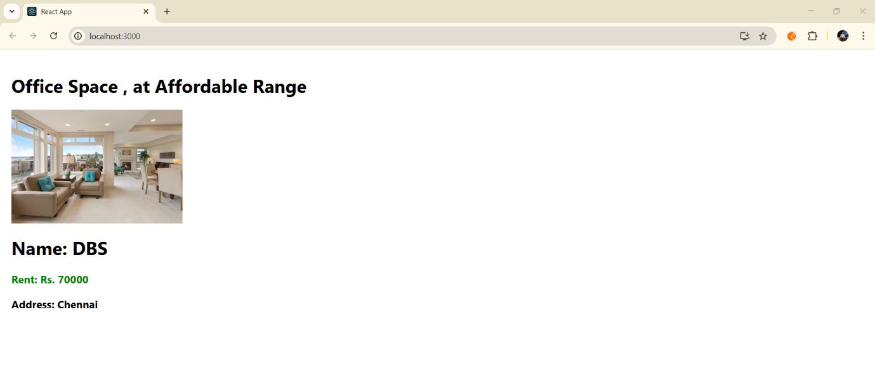
What I Learned
- How to create and render a React component using JSX
- How to define and use a JavaScript object in React
- How to display dynamic content using JSX expressions
- How to conditionally apply inline CSS styles
- How to structure a simple React app cleanly

Conclusion
This hands-on helped understand how JSX works with JavaScript objects. Conditional inline styling added logic to UI, and the exercise built foundational skills for data-driven UI rendering in React.

