HANDS-ON 11
Handling Events and Currency Conversion in React

Tools and Technologies Used
- ReactJS (using create-react-app)
- JavaScript (ES6)
- VS Code Editor
- Node.js & npm

Steps to Implement the Project
1. Project Setup
- Open VS Code terminal.
- Create a new React application by running:
npx create-react-app eventexamplesapp
cd eventexamplesapp
code .
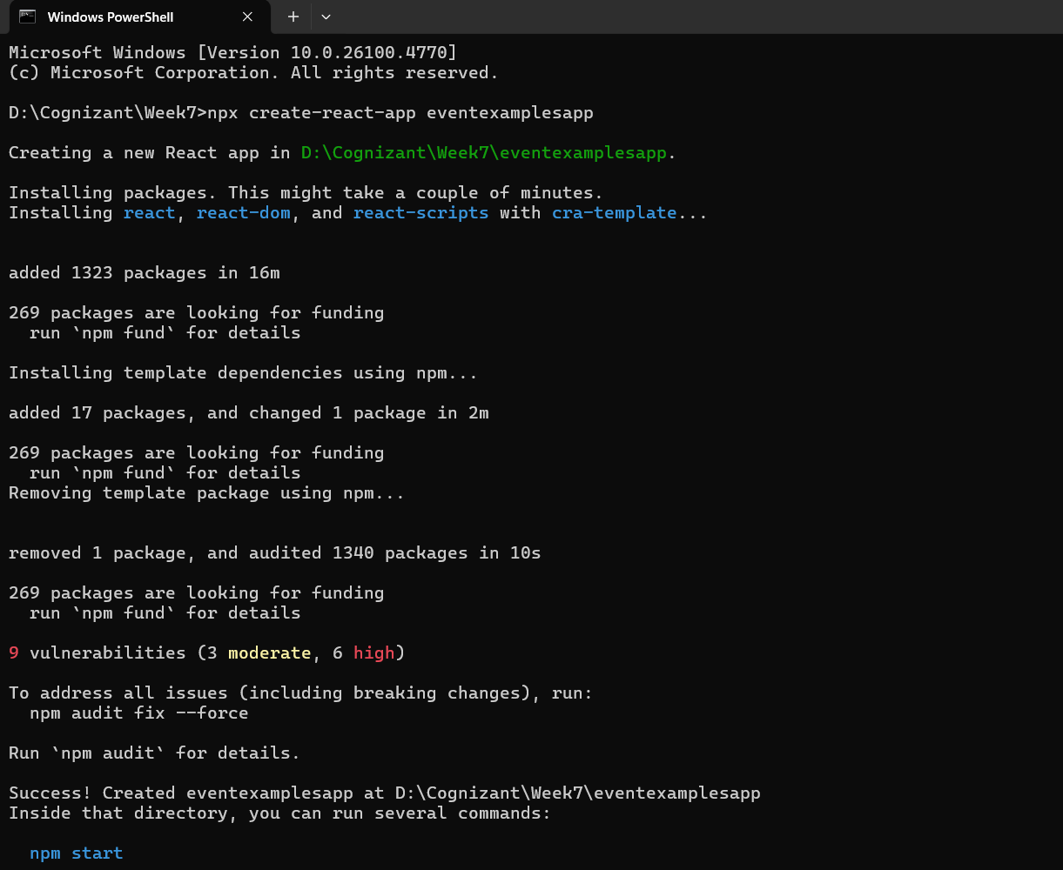
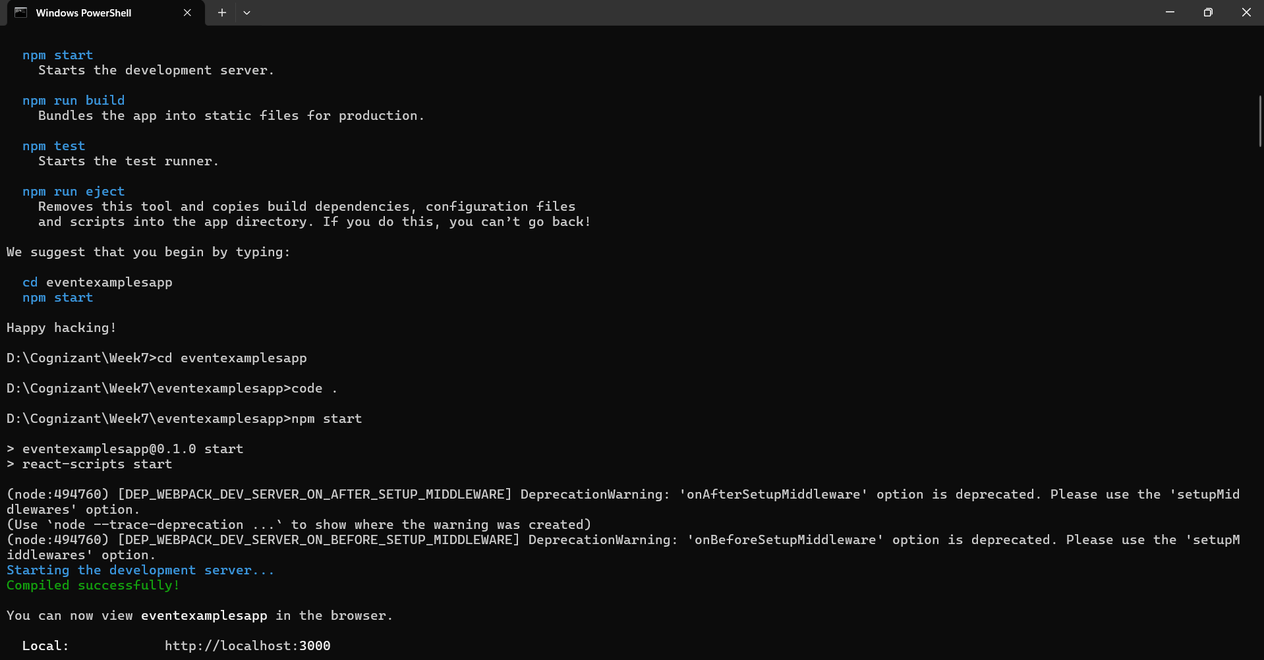
Folder and File Structure:

eventexamplesapp/
└── src/
└── App.js

Code Implementation
App.js
- A single class-based React component was used (App).
- The component demonstrates different types of event handling:
  - Increment / Decrement Counter
  - Custom Alert on Button Click with Argument
  - Synthetic Event Handling
  - Currency Conversion from INR to Euro
- State is used to manage the count and currency input fields.
- JSX and this keyword are used inside class components.
- CSS-like inline styles are used to align input fields and the submit button
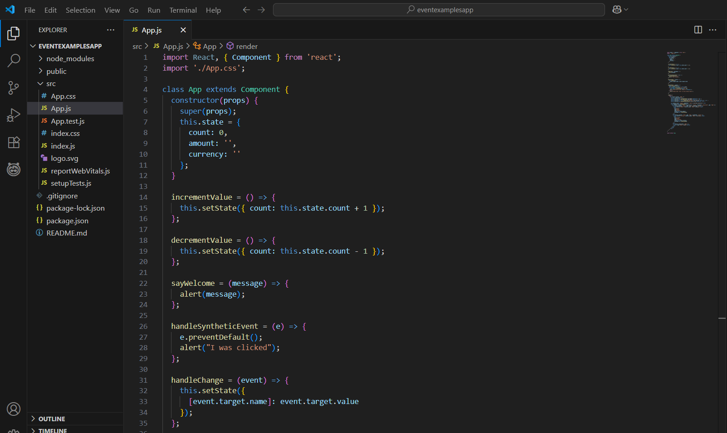
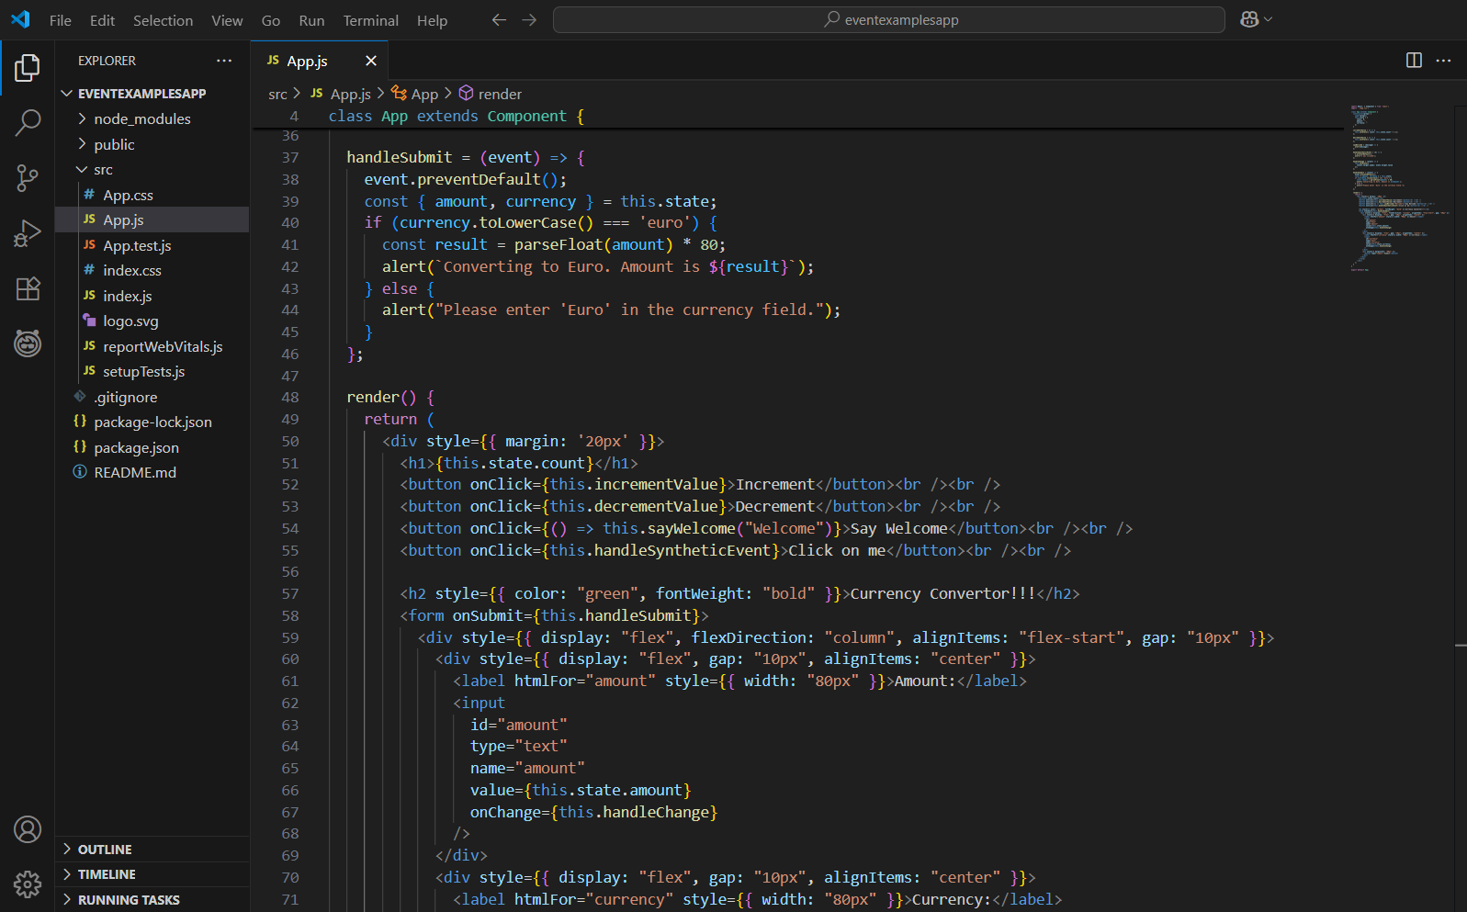
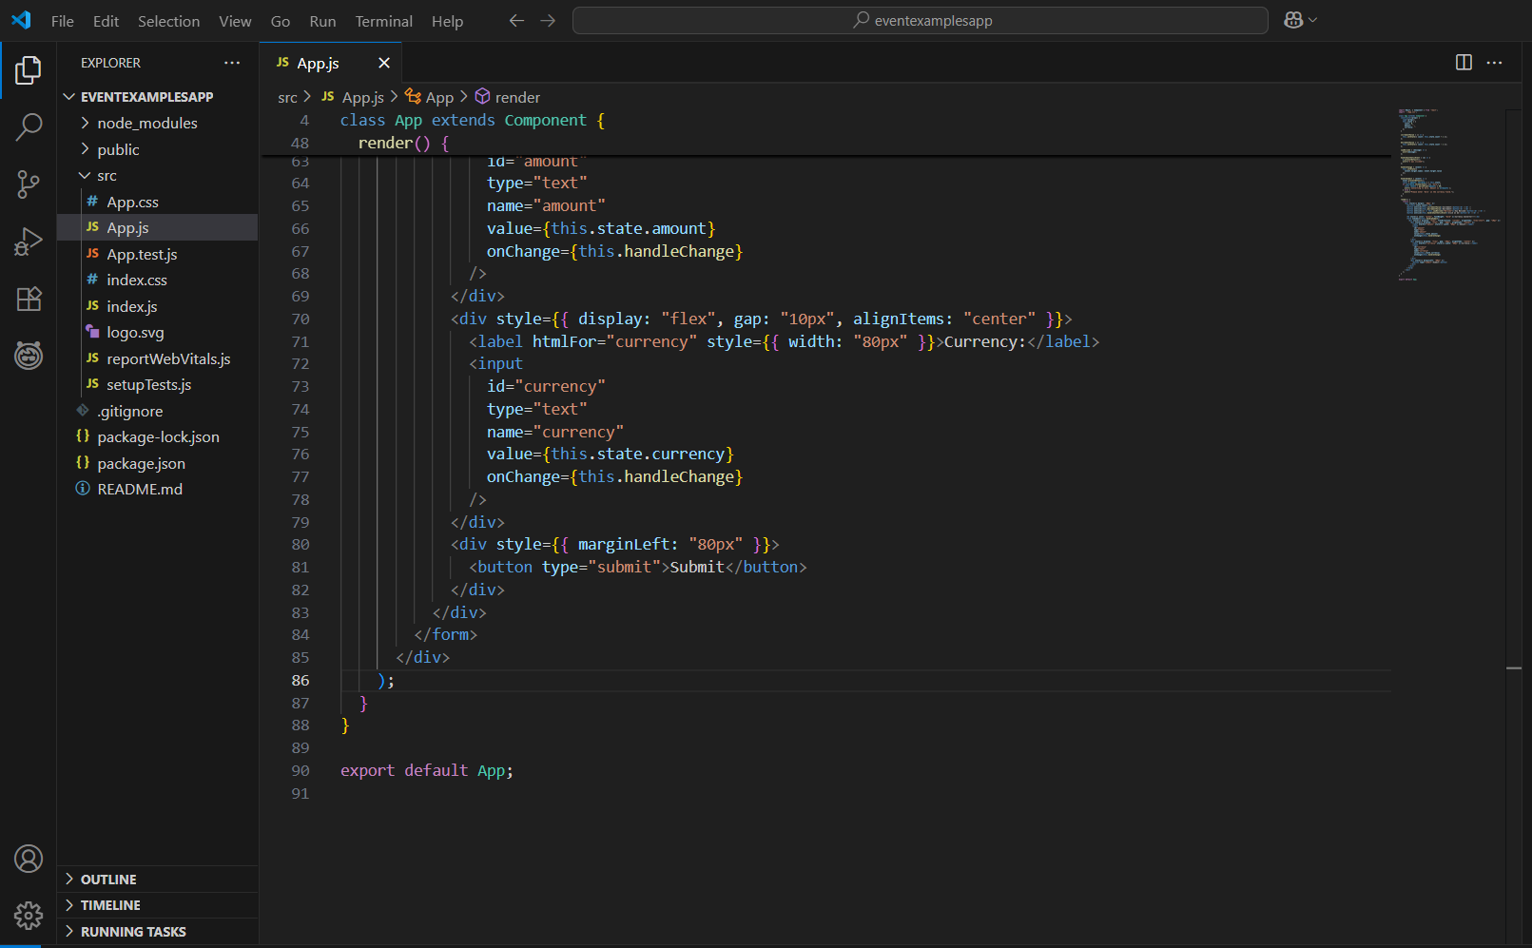

Key Features:
- Increment and Decrement buttons modify a number using setState.
- Say Welcome button shows a custom alert using a passed argument.
- Click on me demonstrates synthetic event handling using e.preventDefault().
- The Currency Converter form accepts input for amount and currency:
  - If currency is Euro, it converts using 1 Euro = ₹80 and shows the result.
  - Validation ensures users enter "Euro" to trigger conversion.
- The form layout matches the required UI using div styling and alignment logic.

Run the App:
npm start
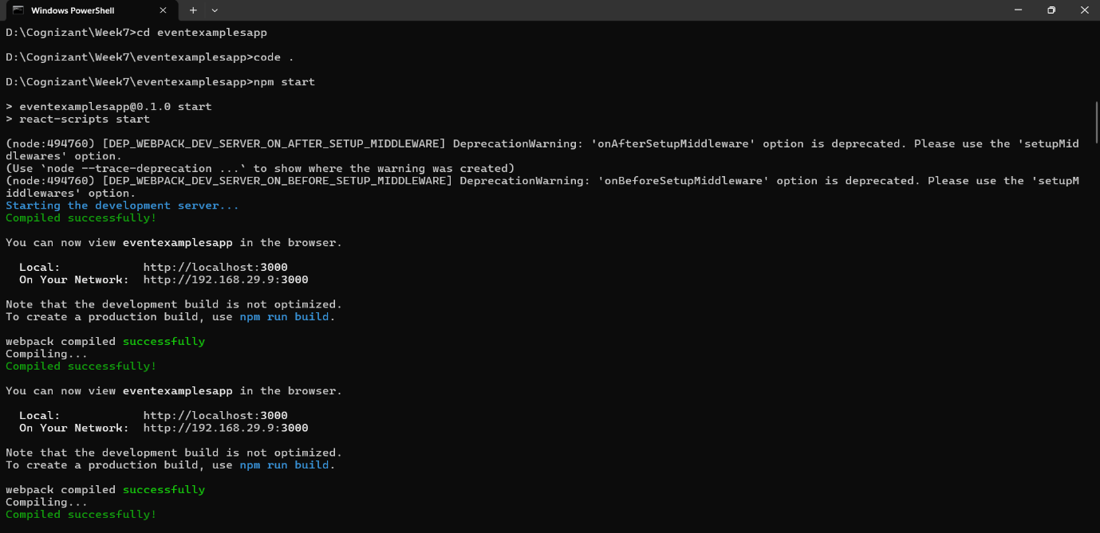
Output:
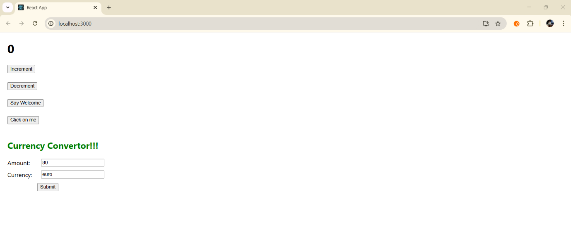
Event Buttons:
- Incrementing count updates the display.
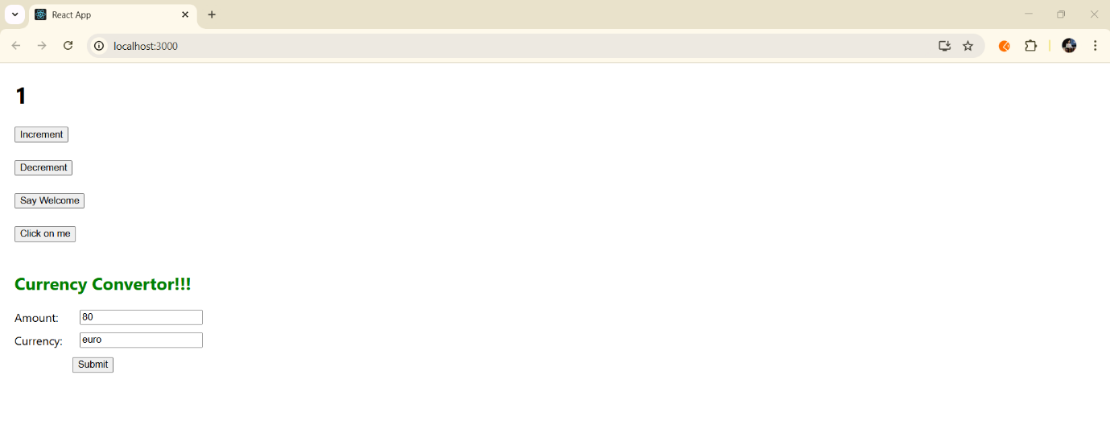
- Decrement works similarly.
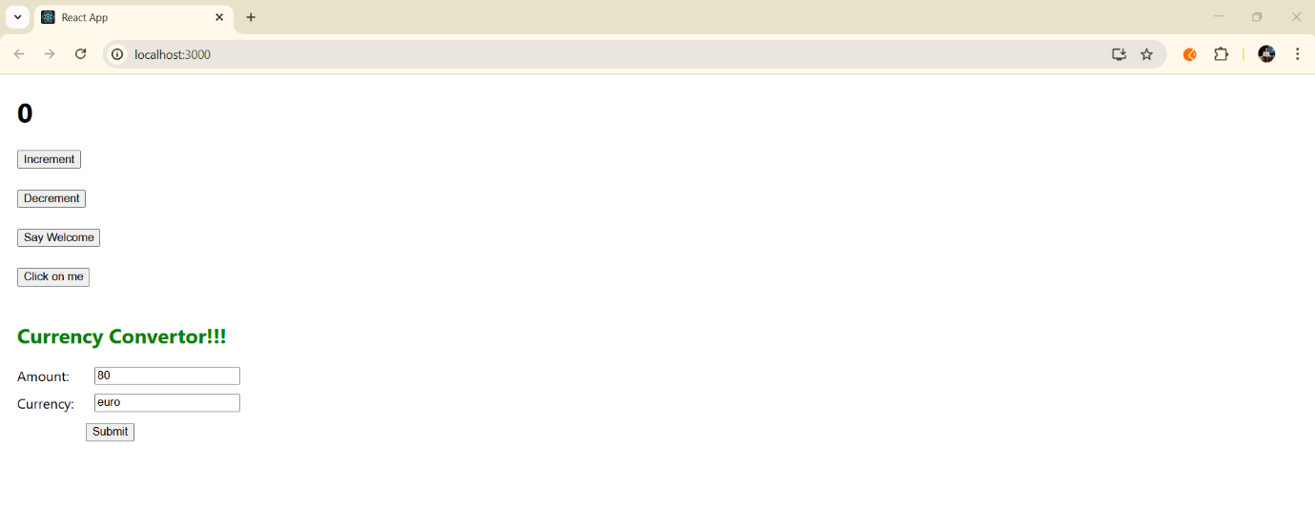
- Welcome message displays alert.
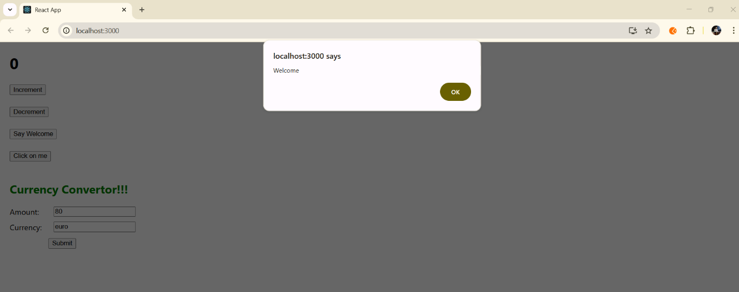

- Synthetic event shows: "I was clicked"

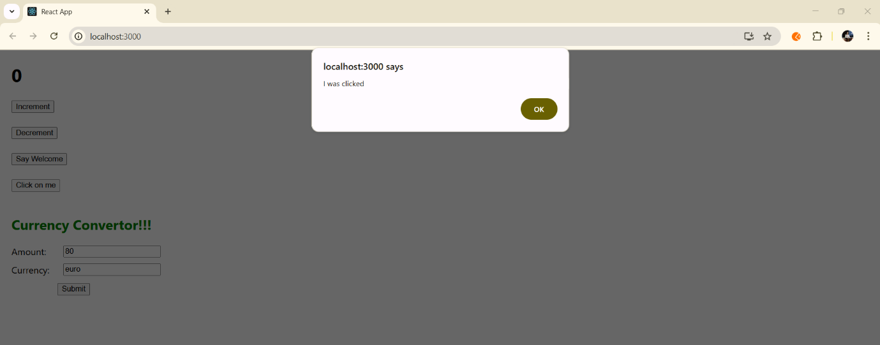

Currency Converter:
Input:
- Amount: 80
- Currency: Euro

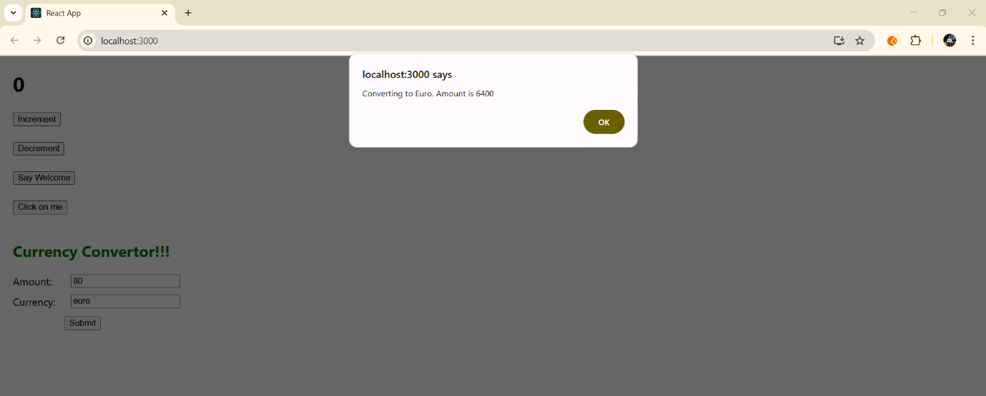

What I Learned:
- How to handle events in React using onClick and onSubmit
- The difference between regular and synthetic events
- How to pass arguments to event handler functions
- Using this.setState() to manage and update component state
- JSX layout techniques using div, style, and flex alignment
- Creating simple forms and reading input values with controlled components

Conclusion:
This hands-on improved understanding of React event handling using class components. It demonstrated practical skills like updating state, using synthetic events, and validating form input. Aligning the UI to match the provided design deepened experience with React layout and JSX usage, providing a solid base for more complex React form handling tasks.

