HANDS-ON 12
Conditional Rendering in React
Tools and Technologies Used
- ReactJS (using create-react-app)
- JavaScript (ES6)
- Node.js & NPM
- Visual Studio Code
Steps to Implement the Project
1. Project Setup
- Open terminal in VS Code.
- Create a new React app:
npx create-react-app ticketbookingapp
cd ticketbookingapp
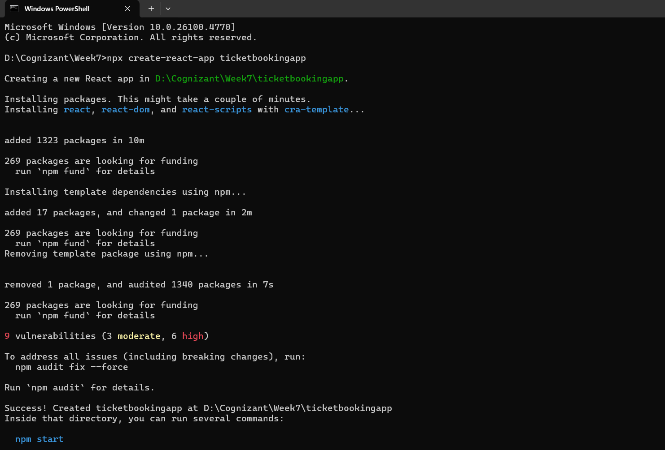

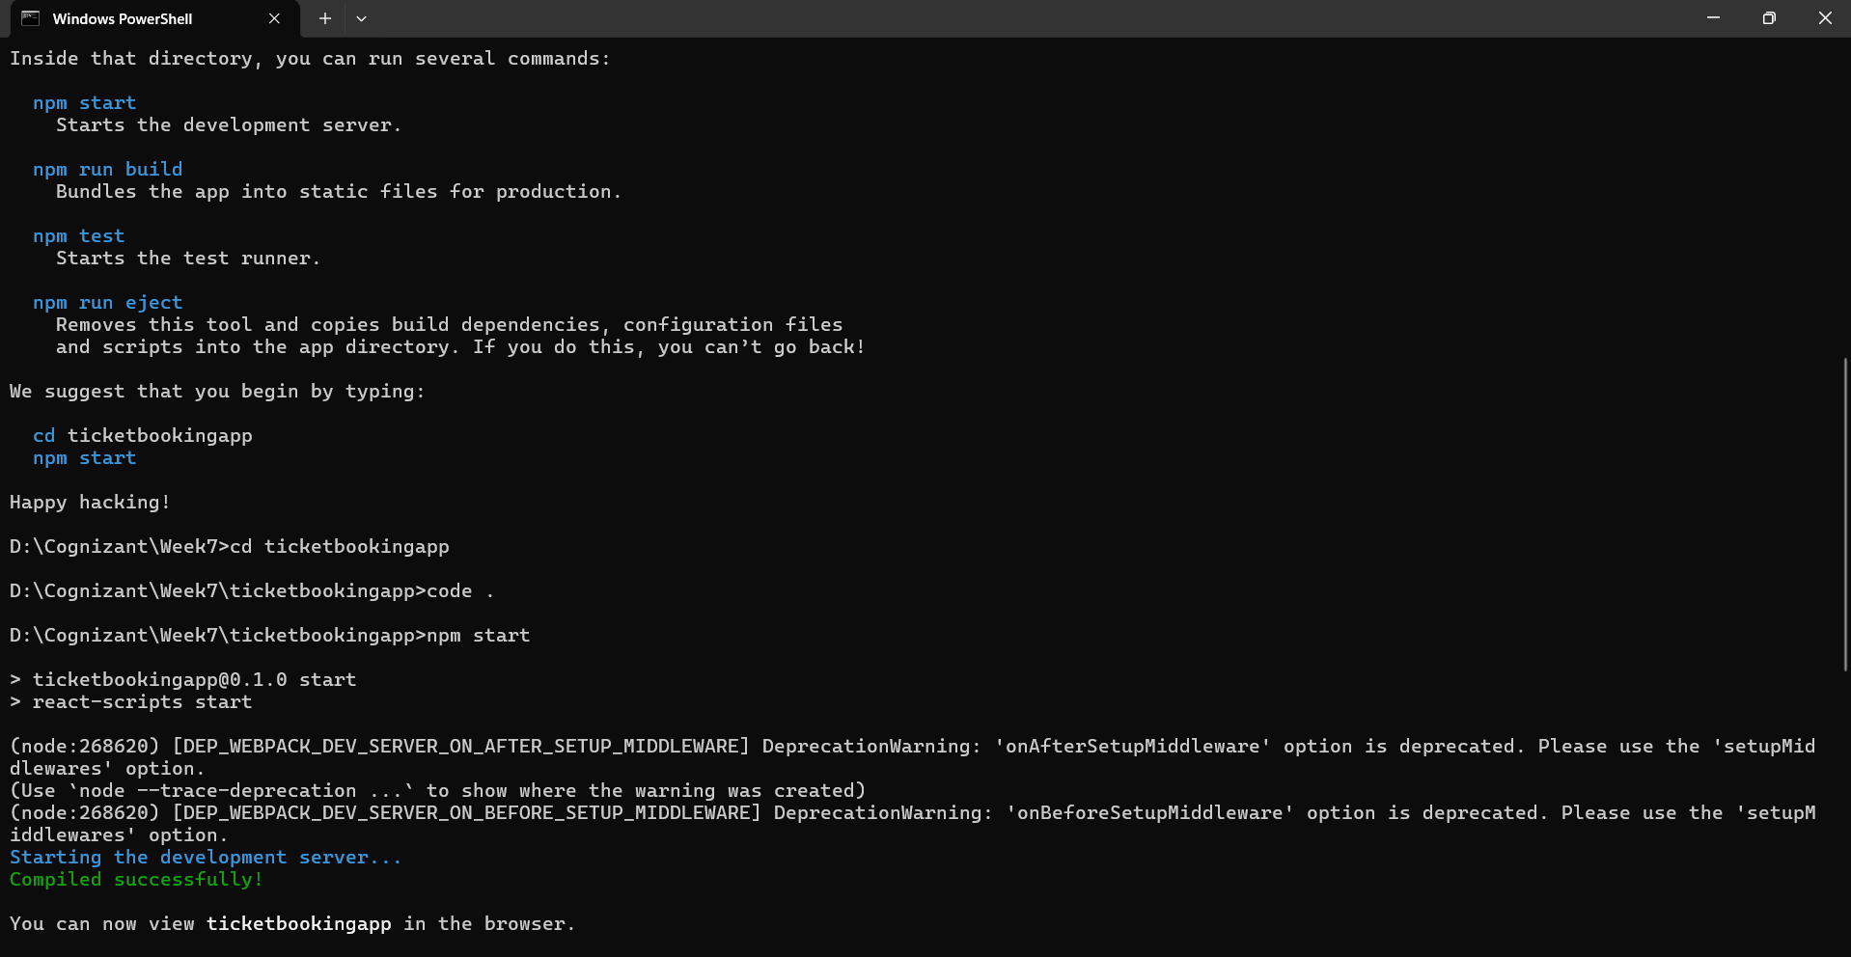

2. Create Components
- Create a folder named components inside src/.
- Inside it, create the following files:
  - UserGreeting.js
  - GuestGreeting.js
  - Greeting.js
  - LoginButton.js
  - LogoutButton.js

3. Modify App.js
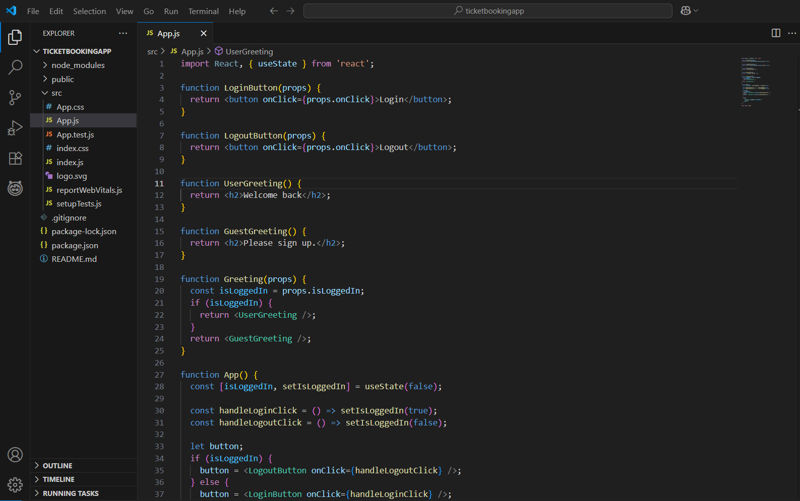
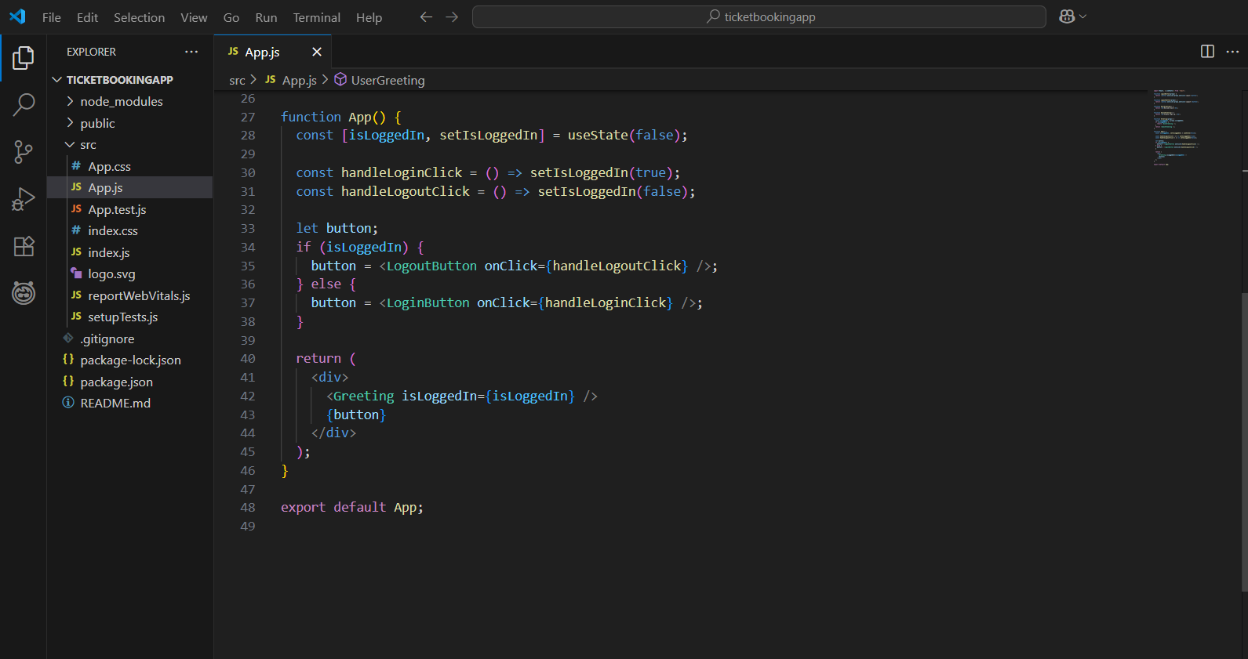

4. Run the Application
npm start

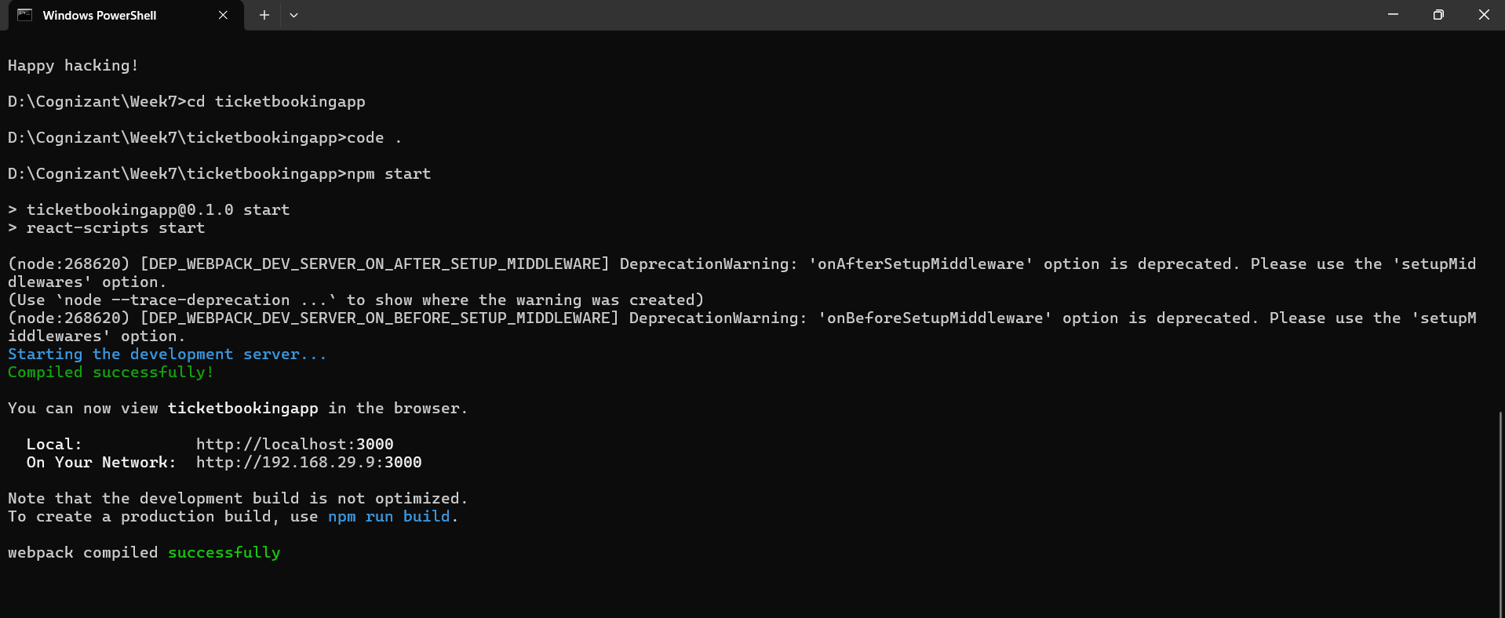

Output:
When User is Logged Out (Guest):
- Displays: "Please sign up."
- Shows: Login button
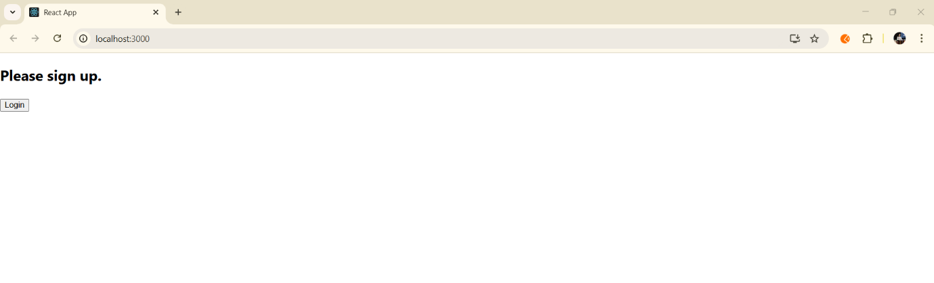
When User Clicks Login:
- Displays: "Welcome back"
- Shows: Logout button
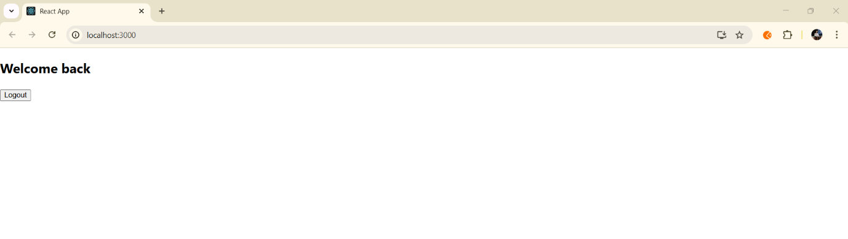When the user logs out, it switches back to the guest view.
What I Learned
- How to use conditional rendering in React to display different content based on user state.
- How to define and use element variables to simplify JSX logic.
- How to prevent components from rendering using conditional logic.
- How to handle user login/logout state dynamically with React.

Conclusion
In this hands-on, I understood how to dynamically render UI in React based on state using conditional logic. I also learned how to:
- Split components for clean structure.
- Use useState() for managing user login/logout.
- Render different content and buttons based on the user’s authentication state.

