HANDS-ON 13
Conditional Rendering, Lists, and Component Composition
Tools & Technologies Used:
- React JS (using create-react-app)
- Node.js & NPM
- Visual Studio Code
Project Structure:
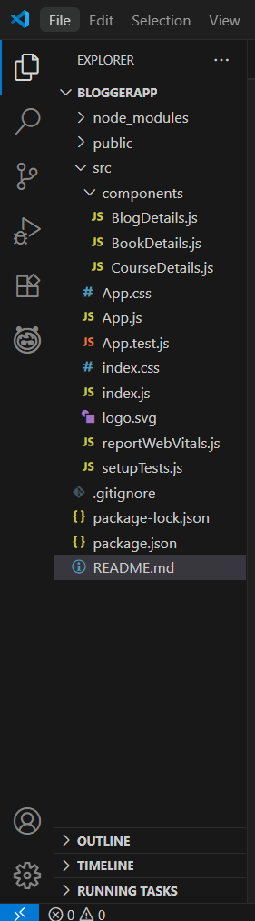
Step-by-Step Implementation:
- Create React App
npx create-react-app bloggerapp
cd bloggerapp
npm start

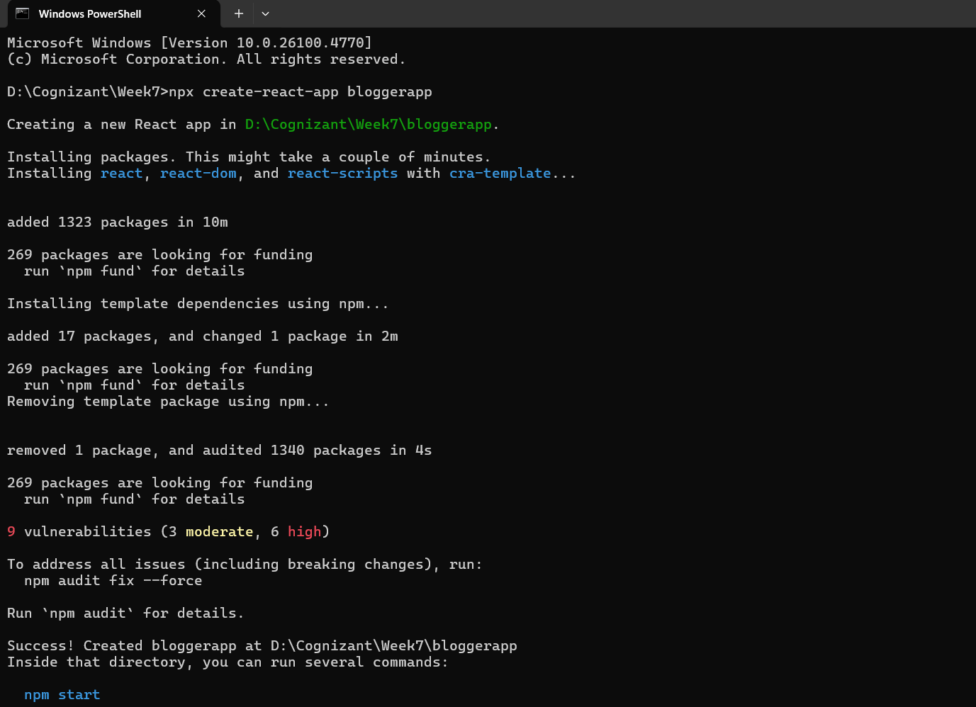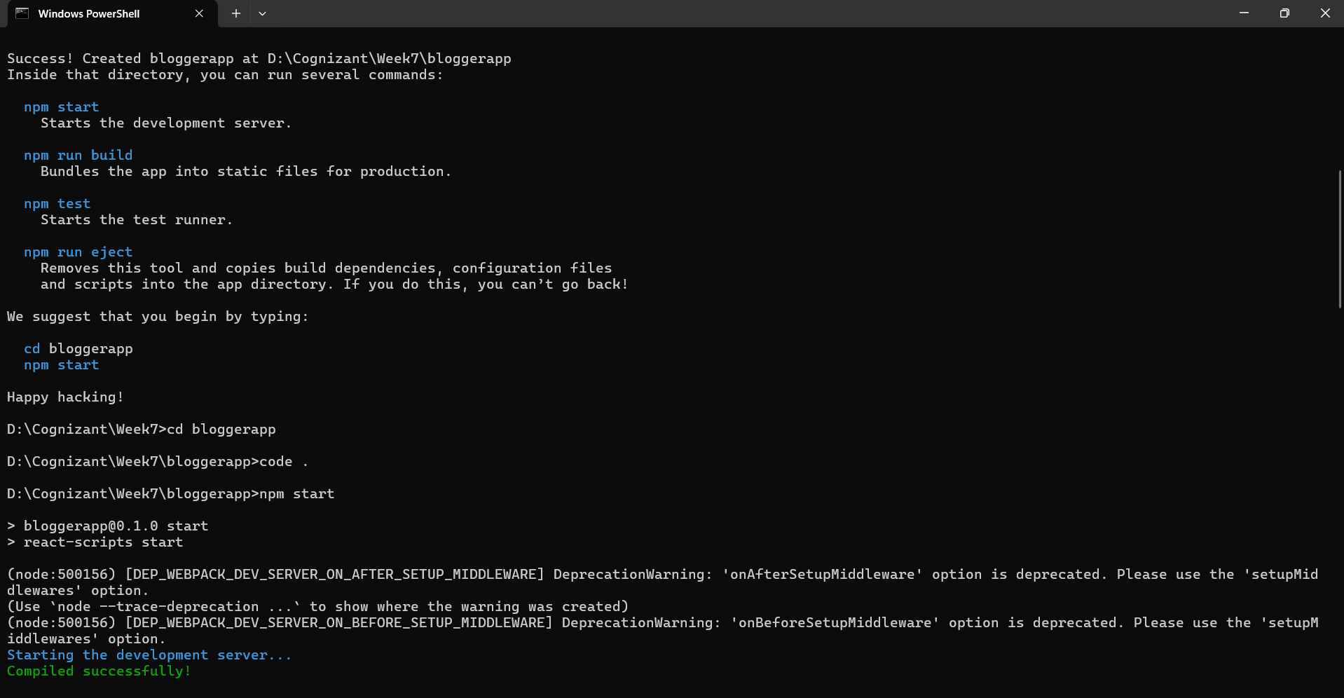
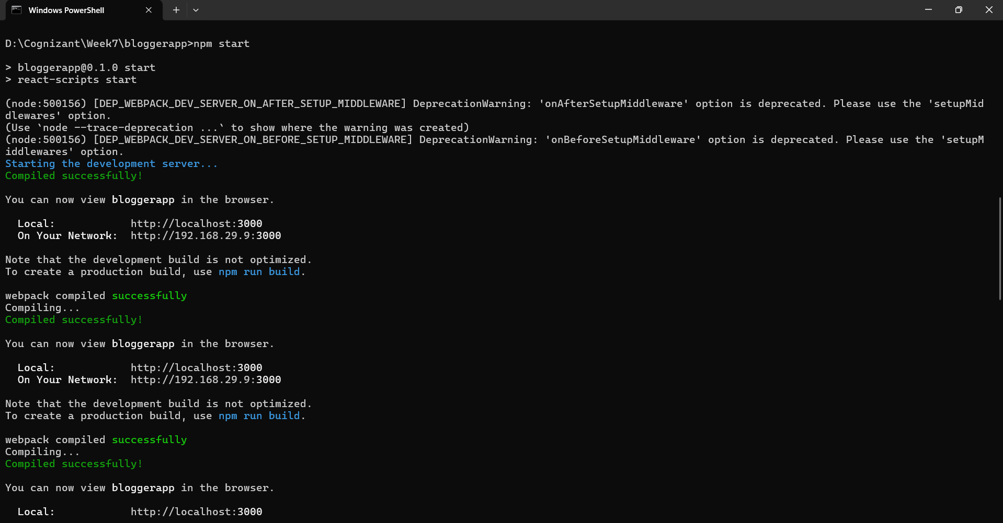
- Create Component Folder and Files
Under src, created a components folder containing:
- BookDetails.js
- BlogDetails.js
- CourseDetails.js
- Implement Each Component
BookDetails.js:
- Displays a list of books using .map()
- Uses props and keys properly
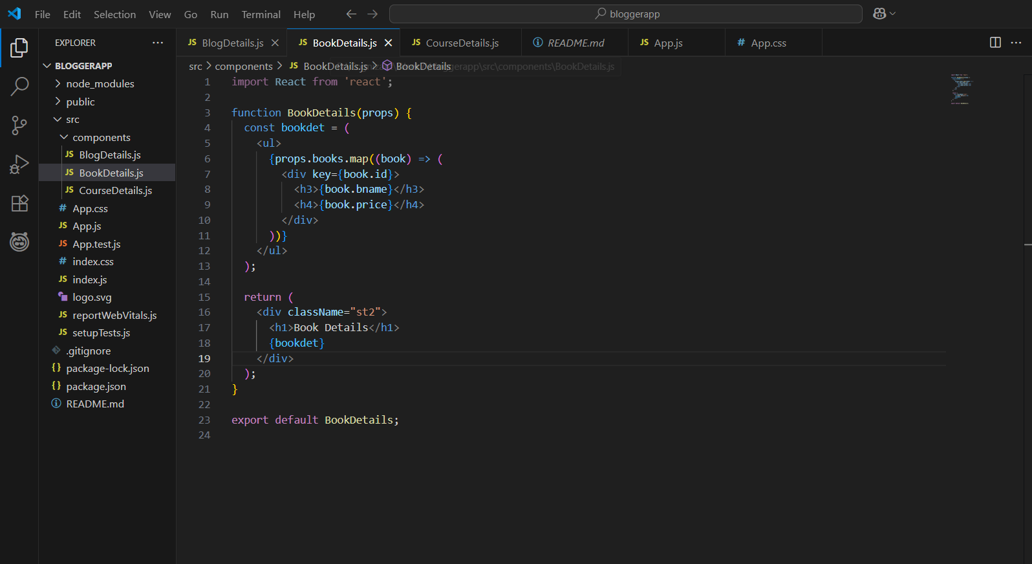
BlogDetails.js:
- Renders blog titles, authors, and summaries
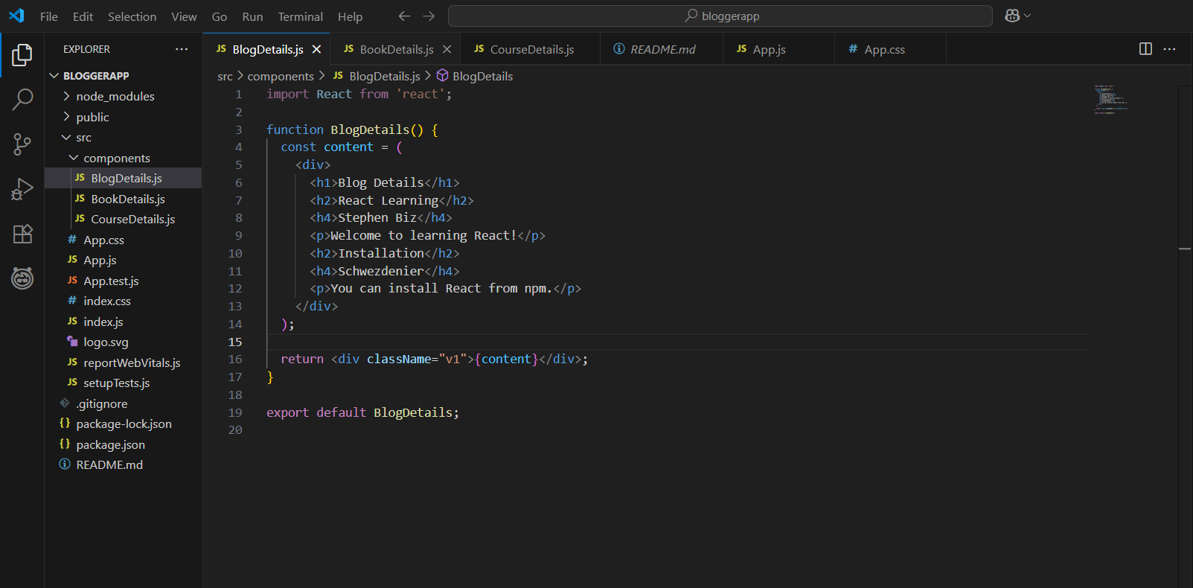

CourseDetails.js:
- Displays course name and date using semantic tags (<h3>, <p>) for layout consistency

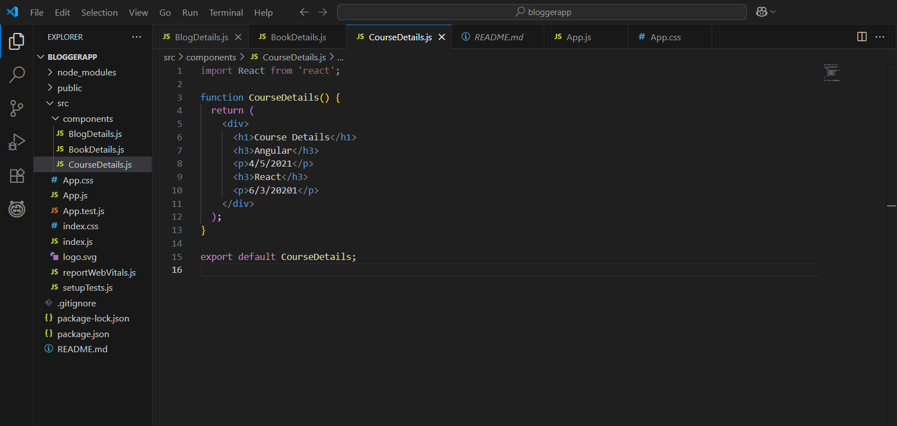

4. Update App.js to Compose Components and Pass Props
- Rendered all three components in a horizontal Flex layout
- Passed book data to BookDetails via props
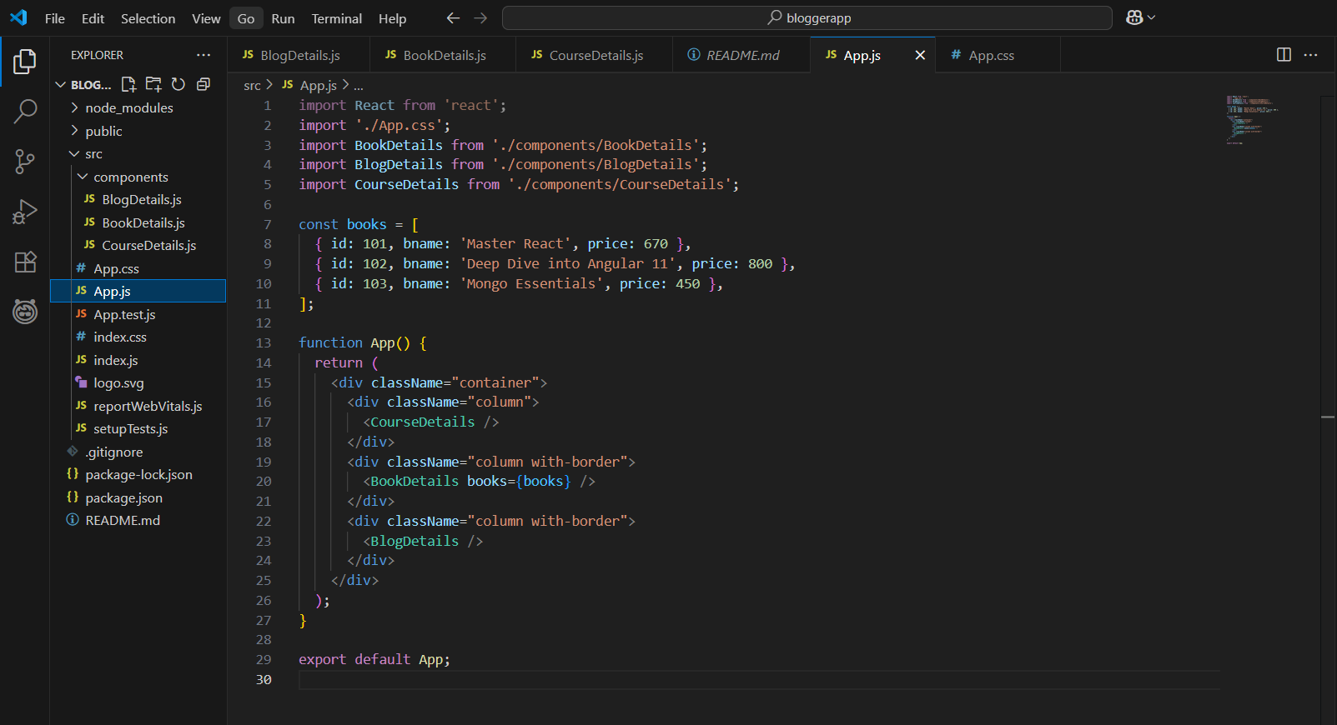

Styling via App.css
- Used Flexbox for horizontal layout
- Green vertical dividers added using CSS border-left
- Standardized spacing and typography
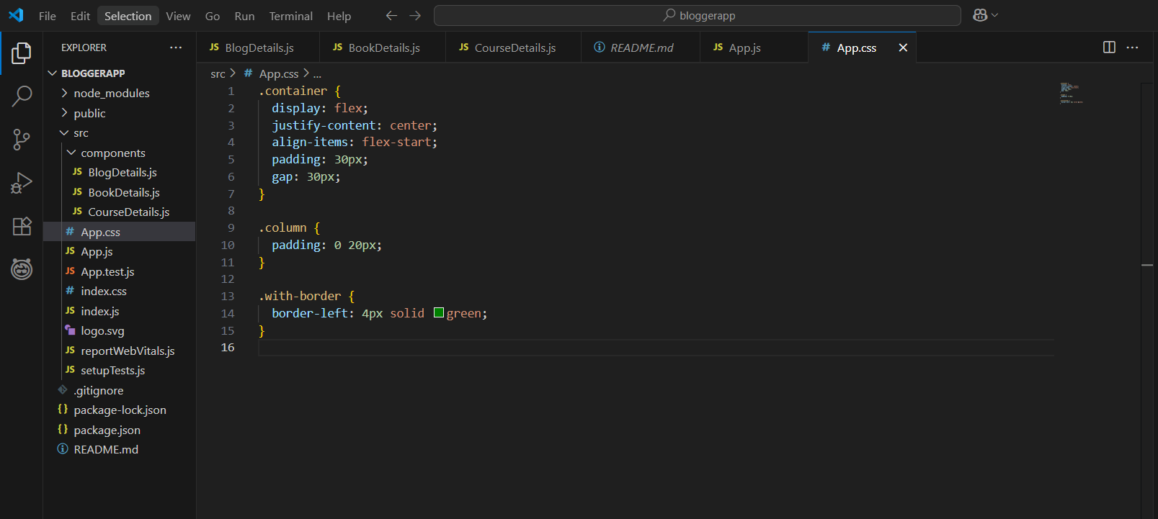
Output:

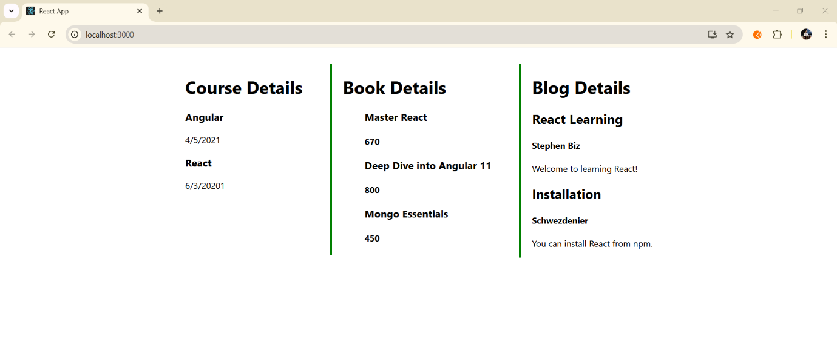

Conclusion
Through this hands-on, I successfully learned to:
- Implement multiple components in React
- Pass and display dynamic data
- Apply conditional rendering techniques (through .map())
- Build clean UI layouts using modern CSS and React best practices

