HANDS-ON 9
React Application Using ES6 Features

Tools and Technologies Used
- ReactJS (using create-react-app)
- JavaScript (ES6)
- VS Code Editor
- Node.js & npm

Steps to Implement the Project
1. Project Setup
- Open VS Code terminal.
- Create a new React application by running:
npx create-react-app cricketapp
cd cricketapp
code .
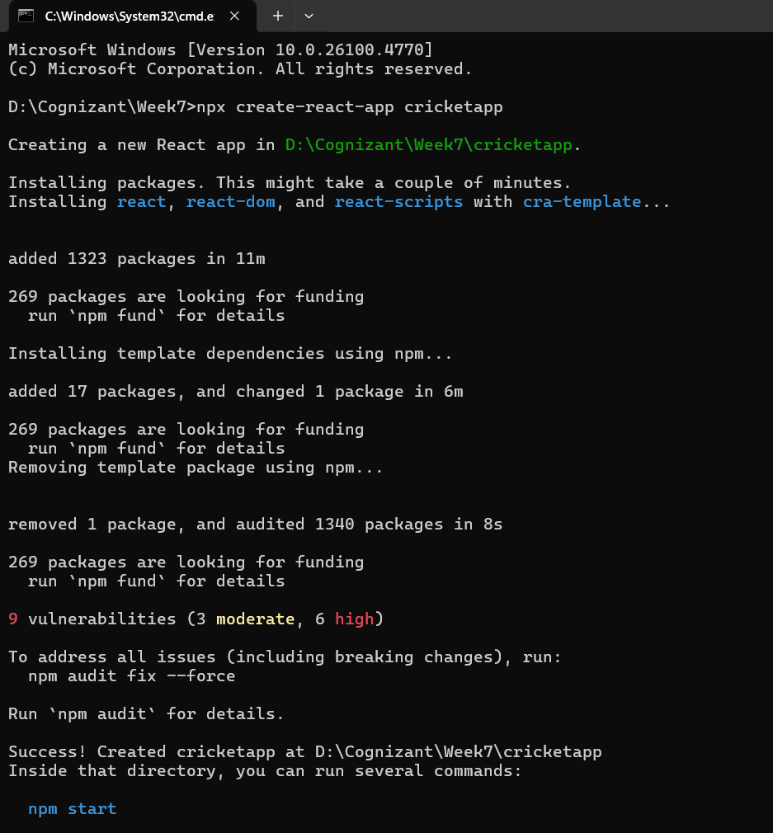
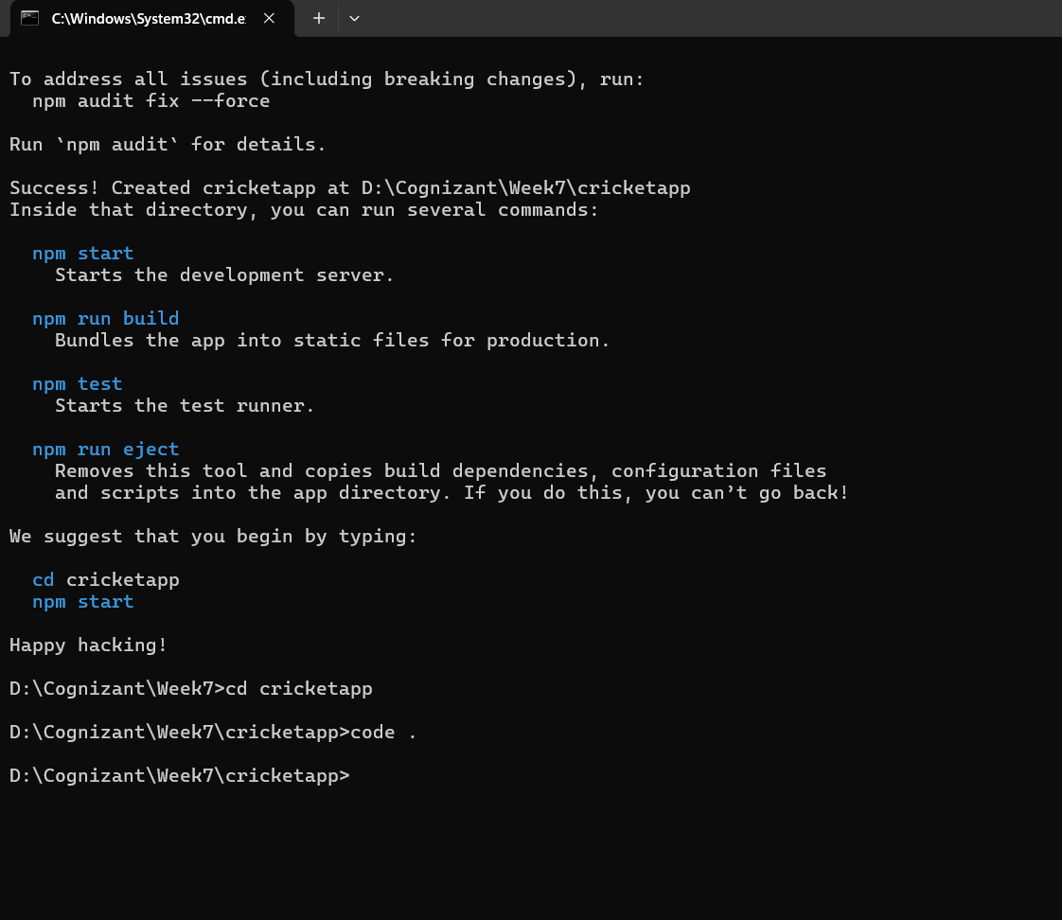
Folder and File Structure
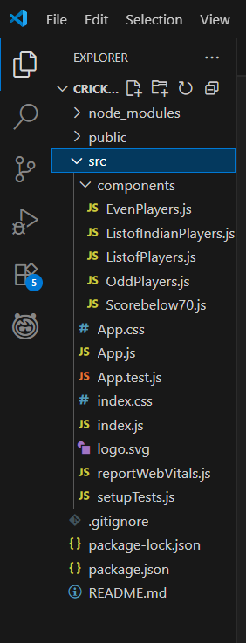
Code Implementation

App.js
- This file controls whether to display player details or Indian team details, using a boolean flag.

Components
- ListofPlayers.js: Displays a list of players with their names and scores using map().
- Scorebelow70.js: Filters players with scores less than or equal to 70 using arrow functions and filter().
- OddPlayers.js & EvenPlayers.js: Use array de-structuring to extract and show specific players.
- ListofIndianPlayers.js: Uses the spread operator (...) to merge two arrays and display the result.

Flag-Based Conditional Rendering
- A flag variable is used to control what output is rendered.

When flag = true:
- Displays:
  - All players and their scores
  - Players with scores ≤ 70

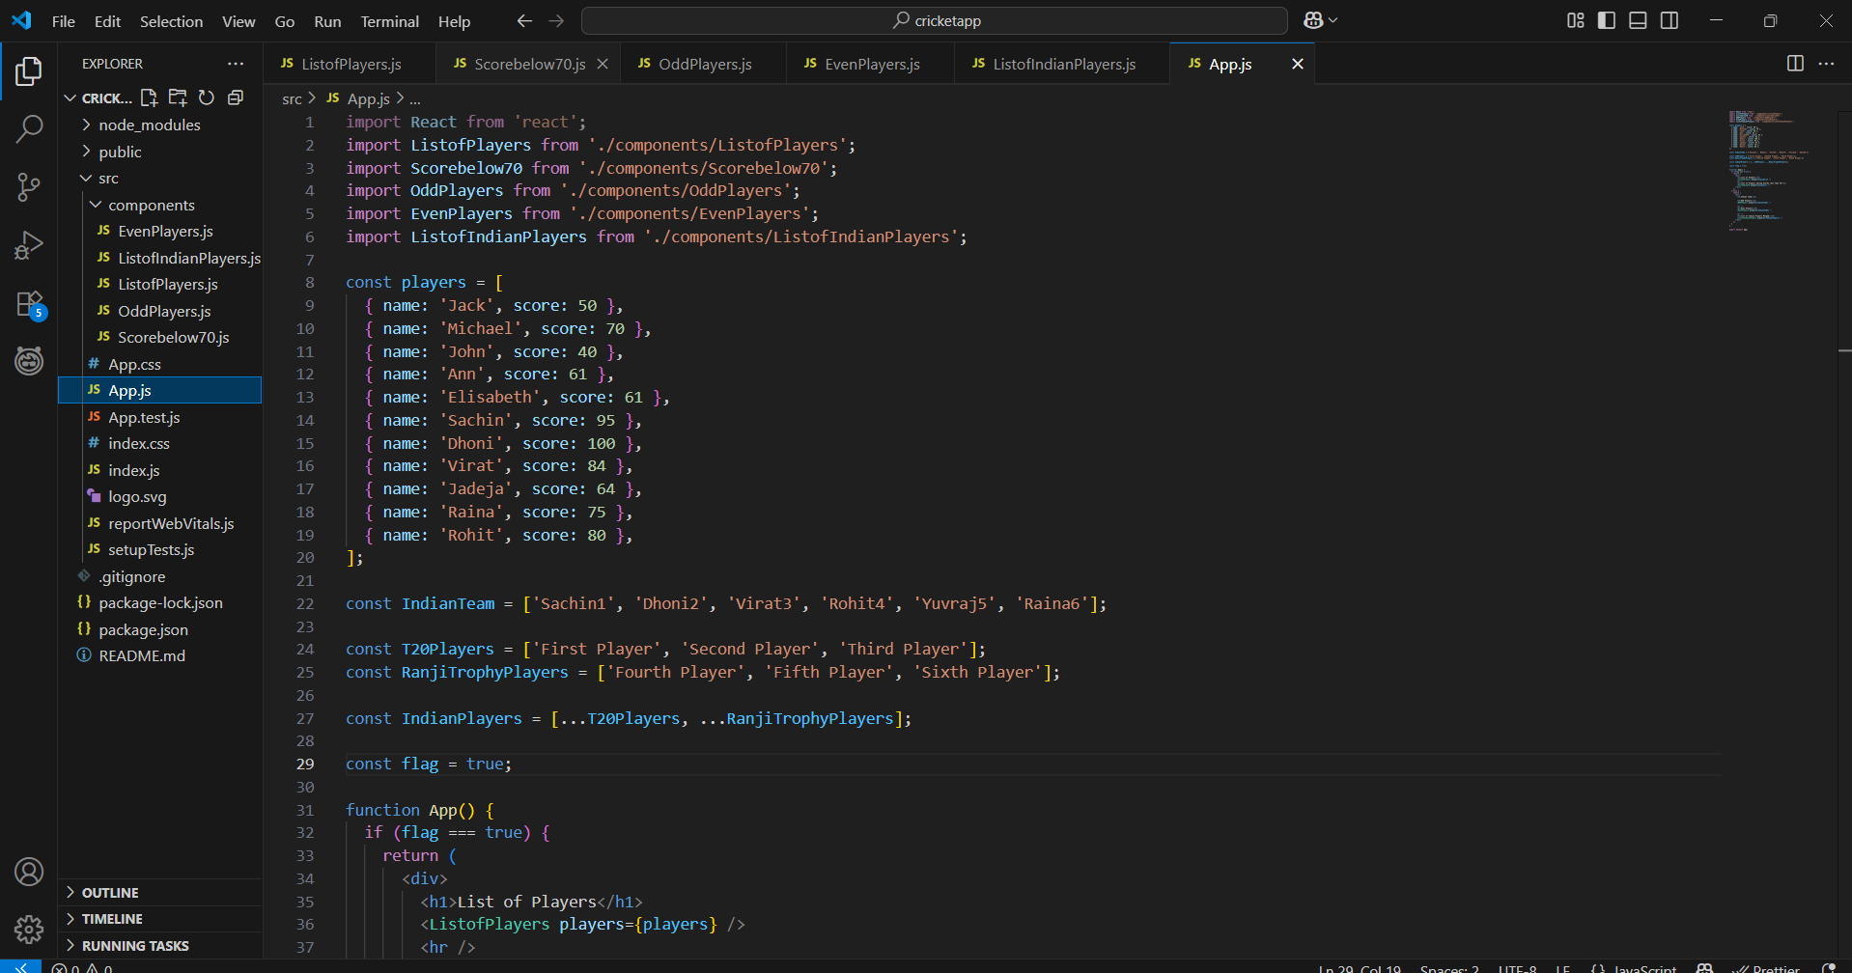
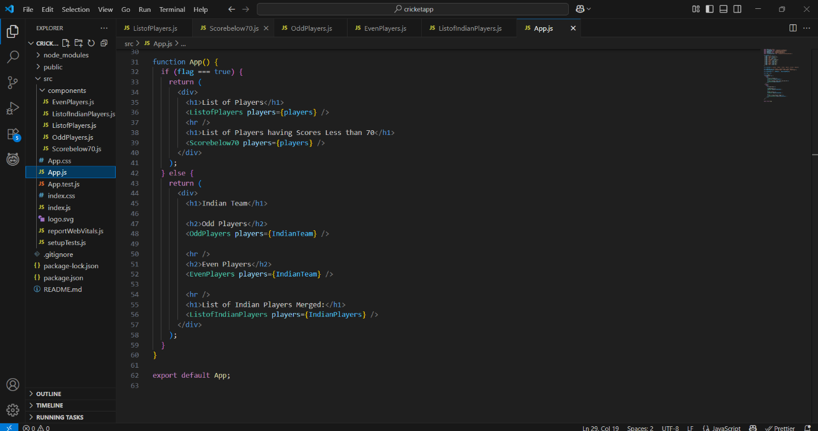

When flag = false:
- Displays:
  - Indian team odd-position players
  - Indian team even-position players
  - Merged list of T20 and Ranji Trophy players using spread operator
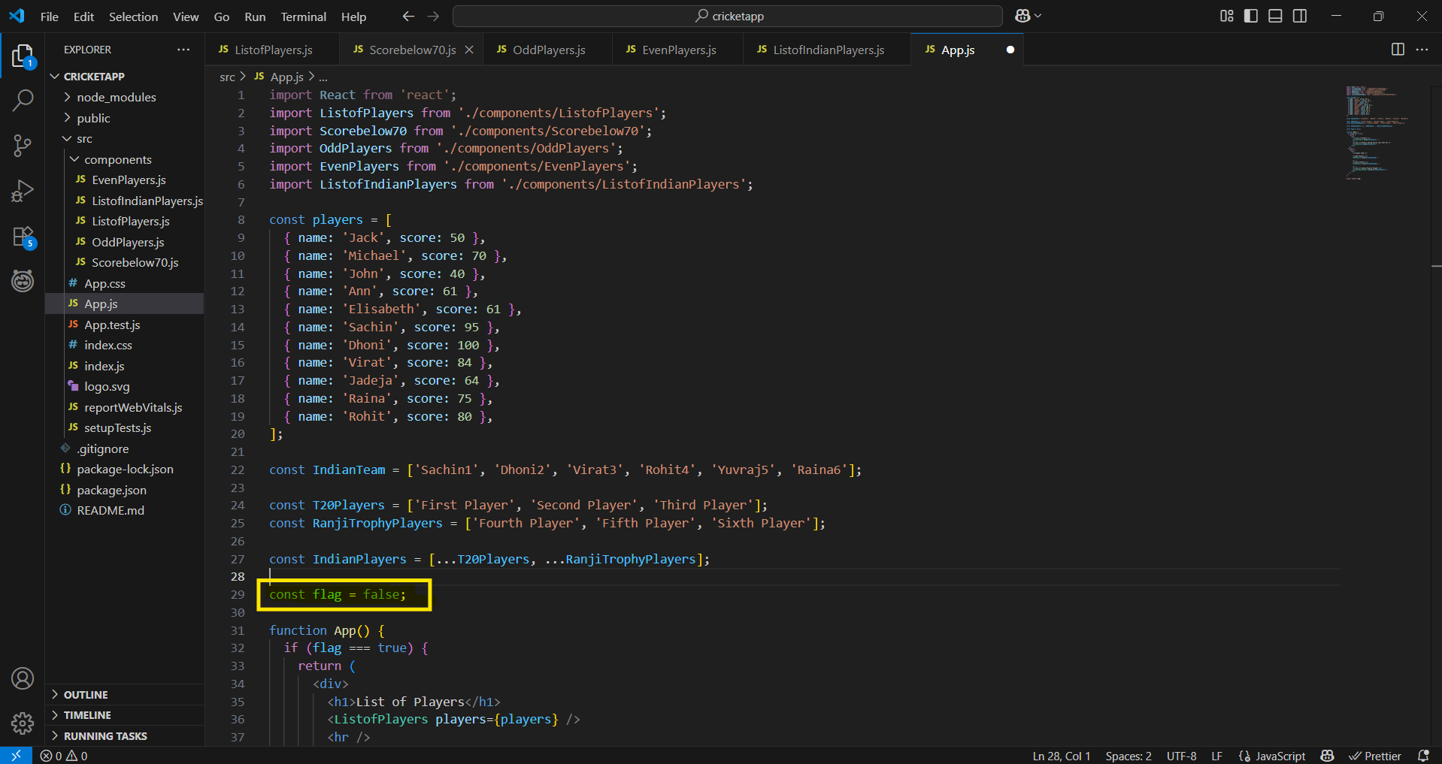

npm start

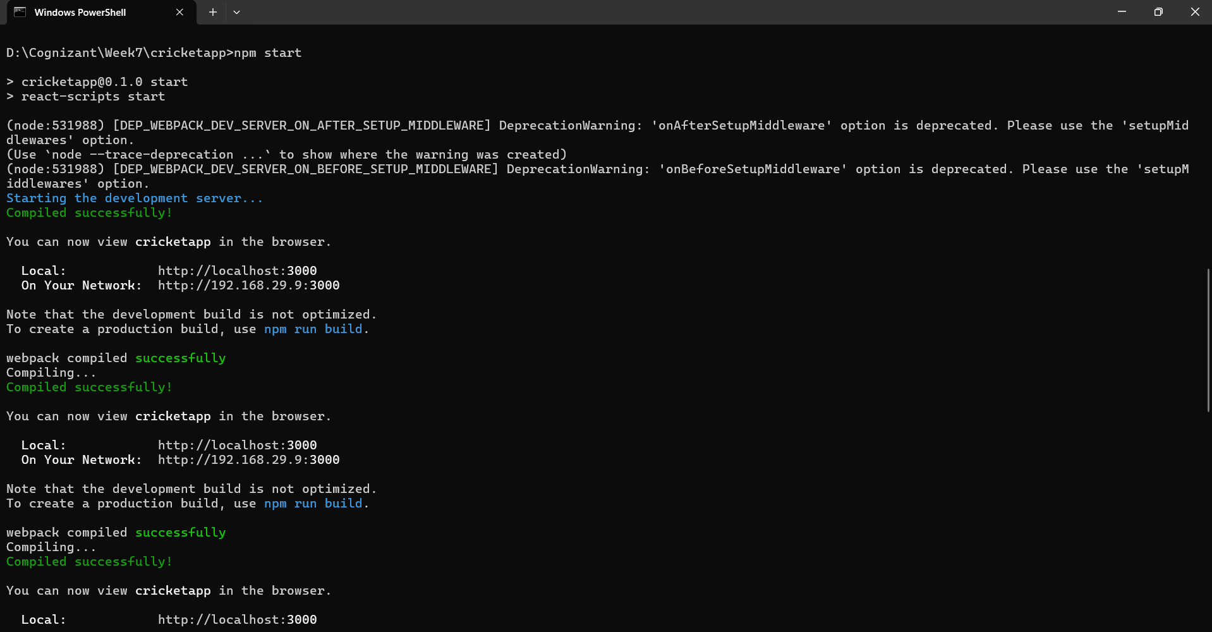

EvenPlayers.js
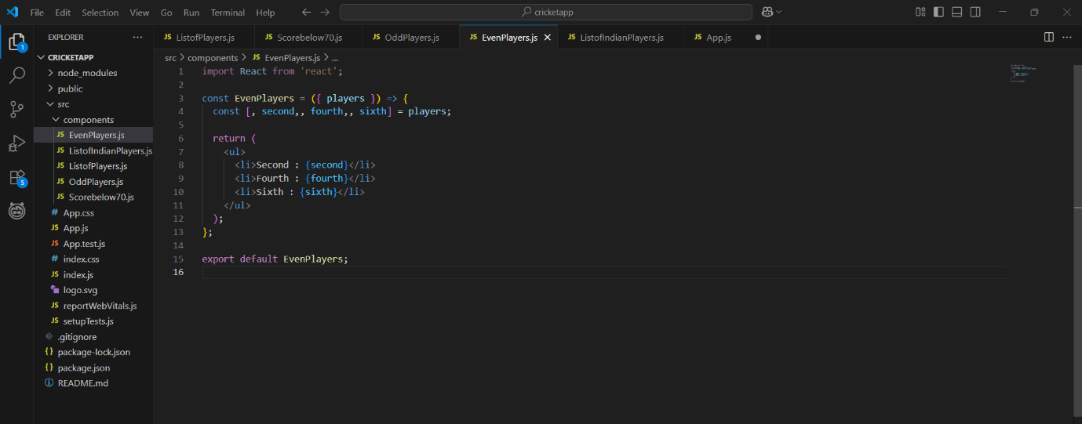

ListofIndianPlayers.js
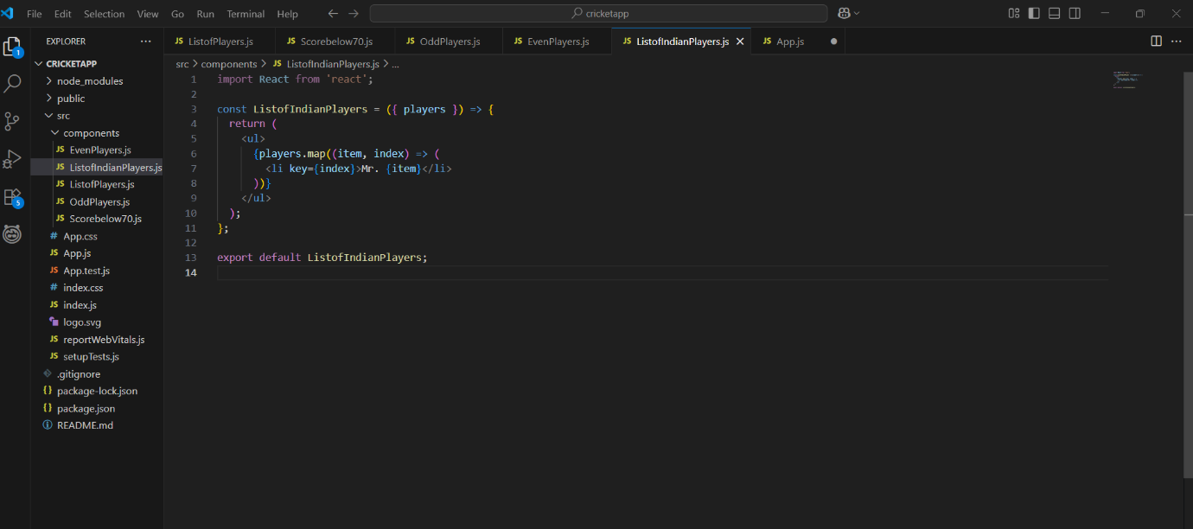

ListofPlayers.js
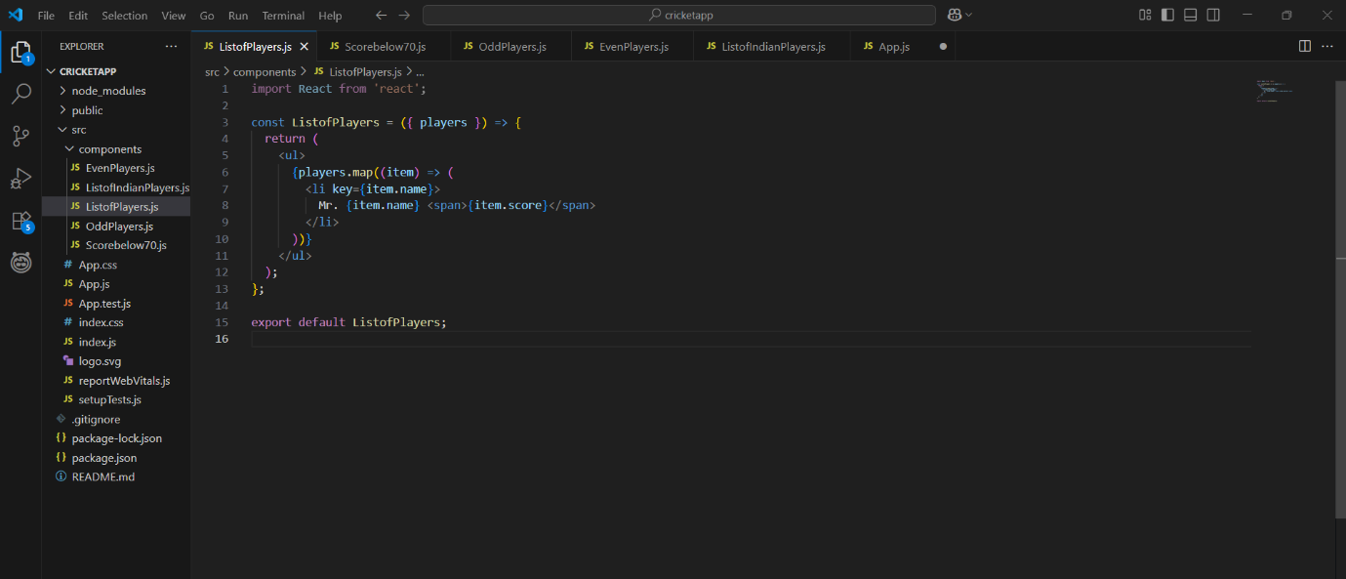
OddPlayers.js
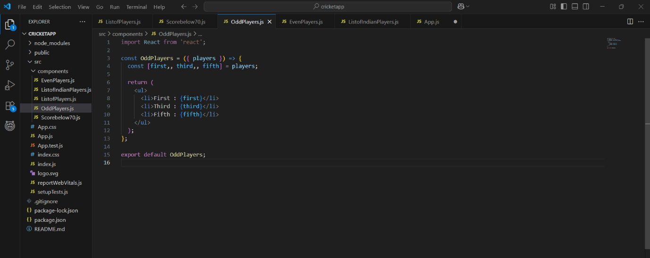
Scorebelow70.js
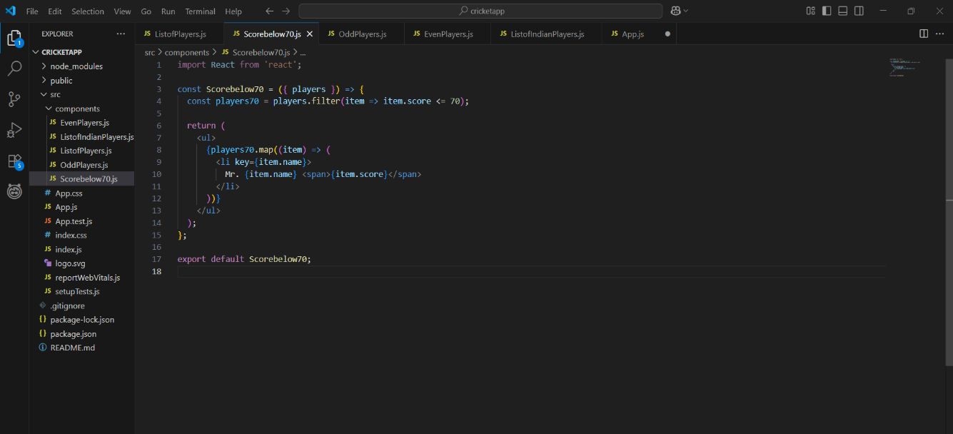
Output
When flag = true:
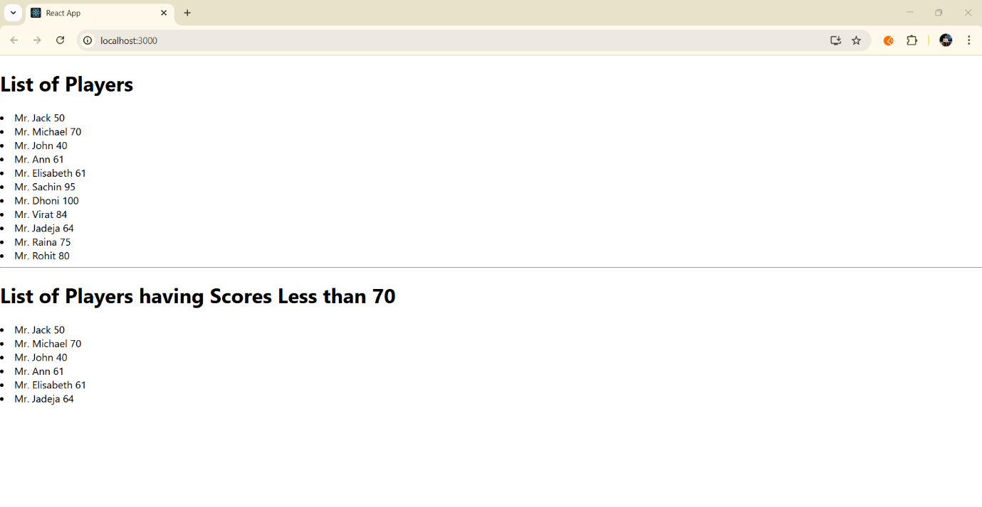
When flag = false:
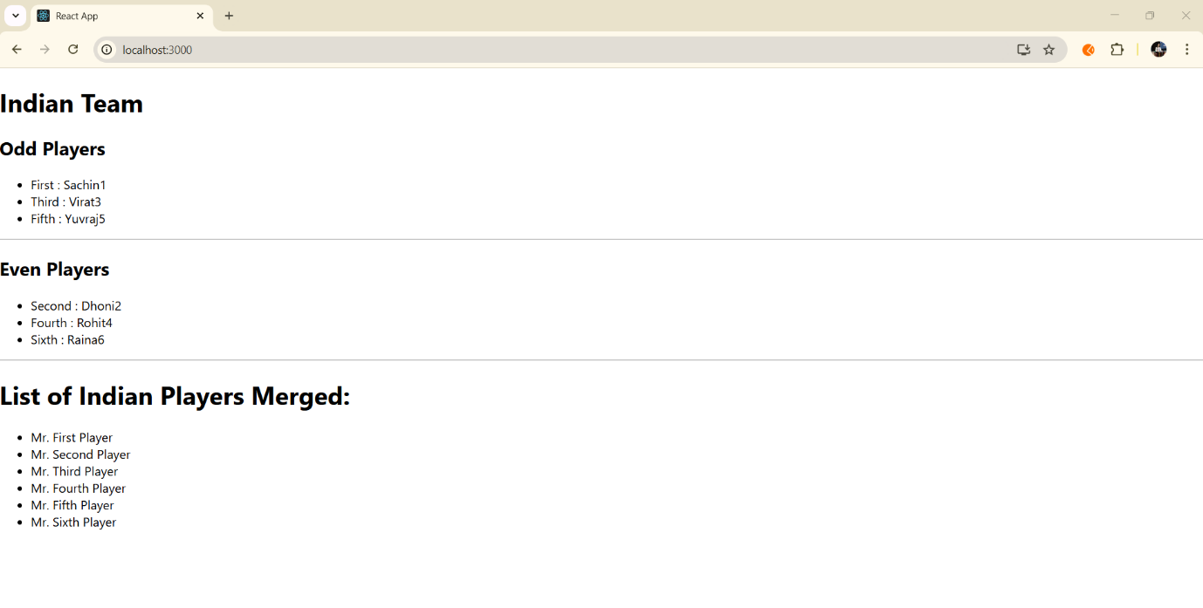

What I Learned
- How to create a React application using create-react-app
- Implemented various ES6 features practically, including:
  - map()
  - let vs const
  - Arrow functions
  - De-structuring
  - Spread operator for merging arrays
- Used conditional rendering in React (if...else)
- Improved understanding of React components and props

Conclusion
This hands-on project helped solidify core ES6 concepts by building a functional and interactive React application. The use of modern JavaScript syntax improves readability, efficiency, and maintainability of the code.

