HANDS-ON 1: Git Fundamentals
Objective:
This document provides a step-by-step solution for the Git hands-on lab. The primary goal is to become familiar with fundamental Git commands for version control covering initializing a repository, managing files, and synchronizing with a remote repository.
Step-by-Step Solution:
- Setup your machine with Git Configuration.
- Open Terminal: Launch the terminal. You can verify that Git is installed correctly by checking its version.
git –version

- Configure User ID and Email: Execute the following commands in the terminal to set your global user name and email address.
git config --global user.name "Your Name"
git config --global user.email "your.email@example.com"

- Verify Configuration: To check that the configuration has been set properly, run the following command.
git config --list

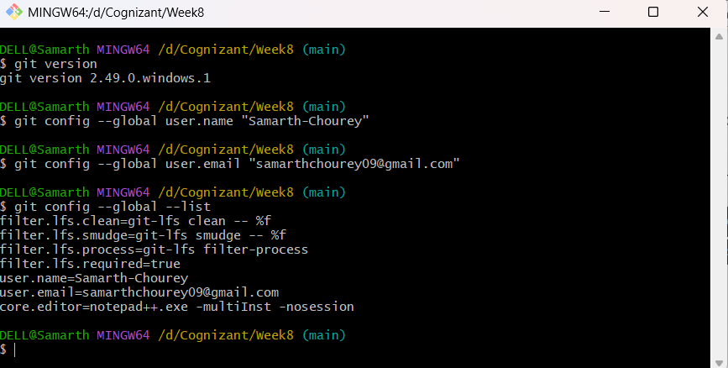

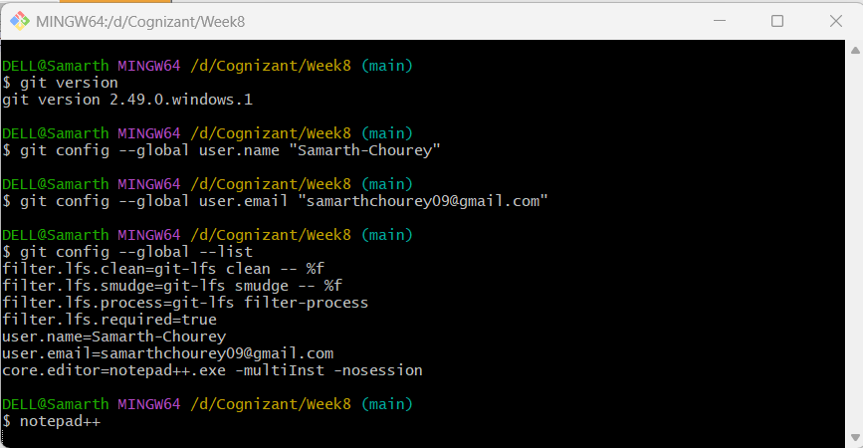
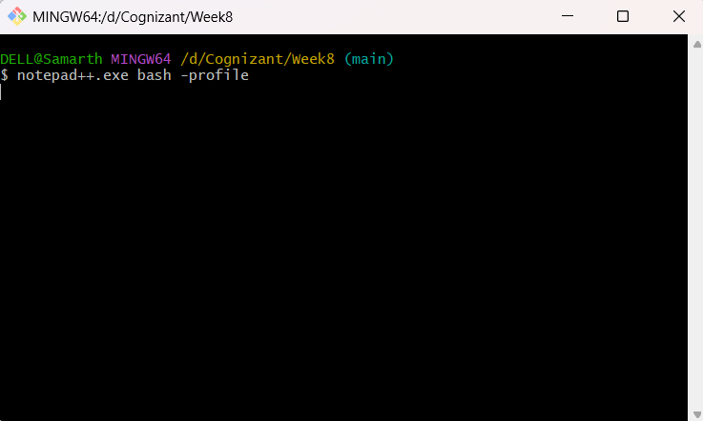
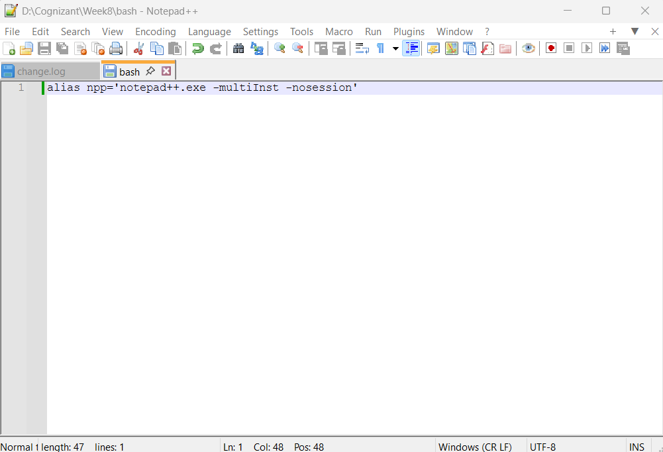

- Integrate notepad++.exe to Git and make it a default editor.
- Configure the Editor: To set Notepad++ as Git's default editor, you would execute the following command.
git config --global core.editor "notepad++ -multiInst -notabbar -nosession -noPlugin"
- Verify the Default Editor: To confirm that Notepad++ is the default editor, you can execute the verification command.
git config --global -e
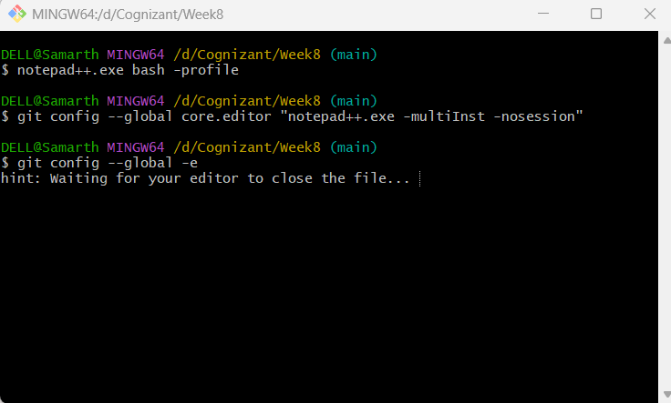
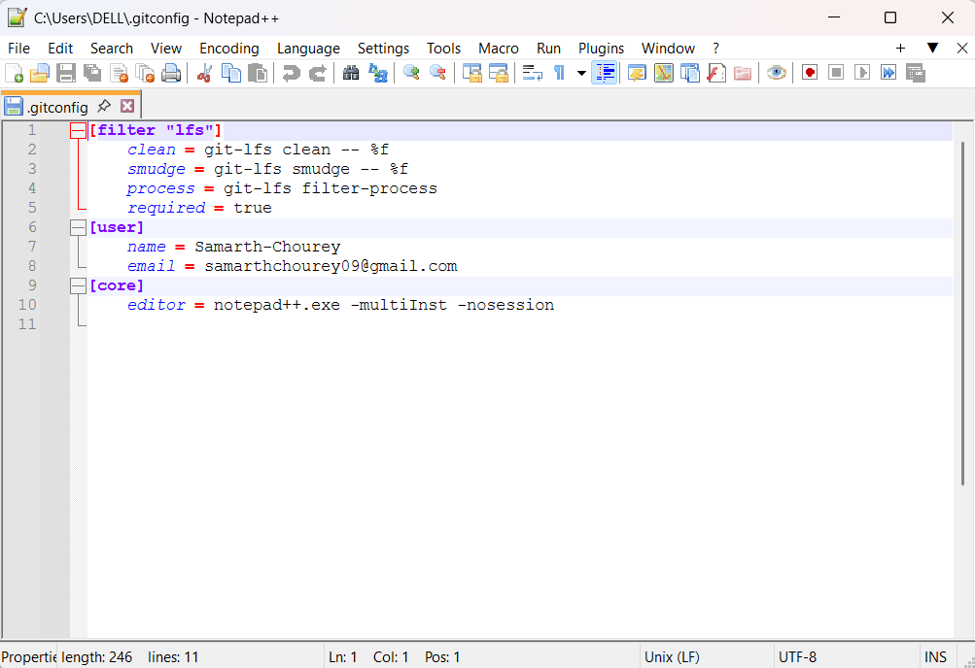
- Add a File to the Source Code Repository
- Initialize the Repository: Inside the GitDemo directory, initialize a new Git repository.
git init
- Verifying the hidden .git directory was created by listing all files.
ls -al
- Create a new file named welcome.txt with some content.
echo "Welcome to the GitDemo project" > welcome.txt
- Verify the file's content.
cat welcome.txt
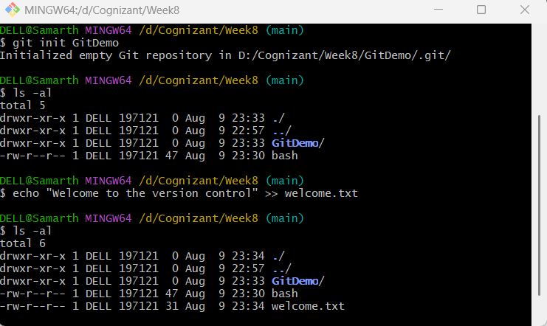
- Check the status of your repository. Git will show welcome.txt as an "untracked file".
git status
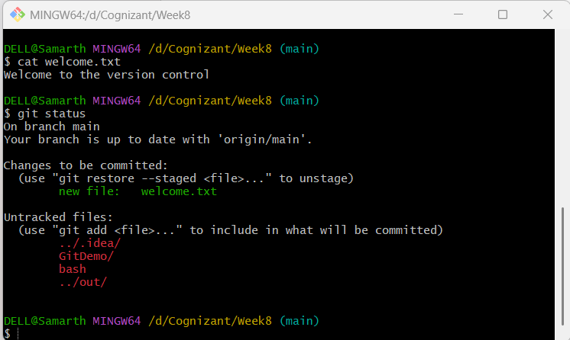
- To make the file tracked by the Git repository, you need to add it to the staging area.
git add welcome.txt

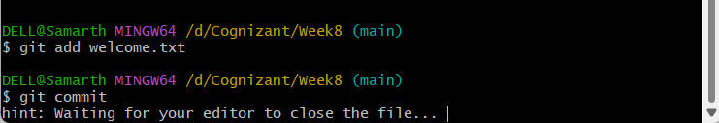
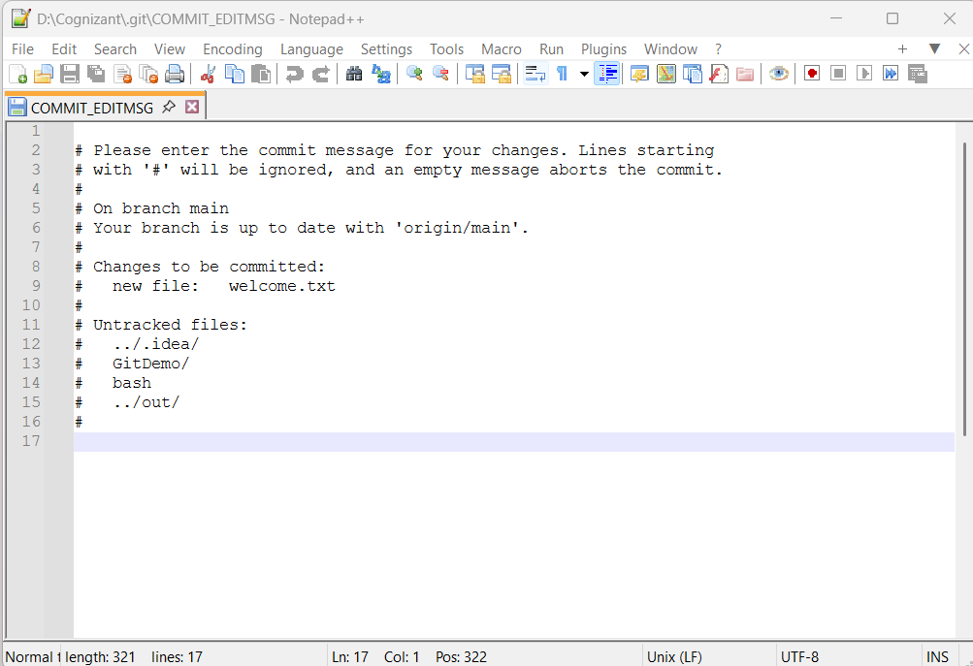

- Run git status again. The file will now appear under "Changes to be committed".
git status
- Commit the staged file. Executing git commit without a message flag will open the default editor.
git commit
- After saving the message in the editor, check the status one last time to see that your working directory is clean.
git status

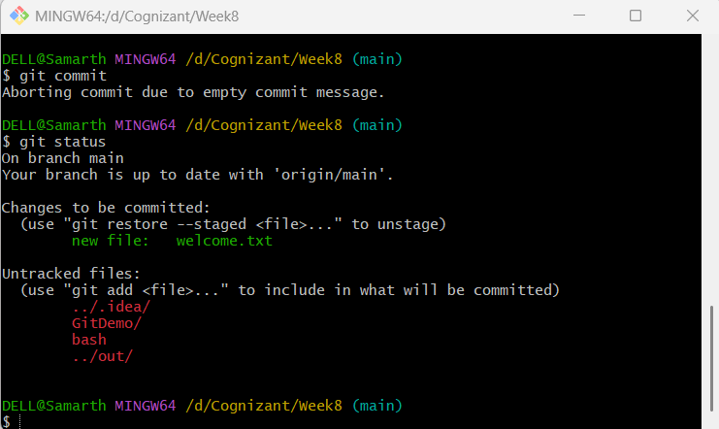

- Push to the Remote Repository: To upload your local commits to the master branch of the remote repository, execute the git push command.
git push origin main

- Pull from the Remote Repository: To download changes from the remote repository to your local machine, execute the git pull command.
git pull origin main

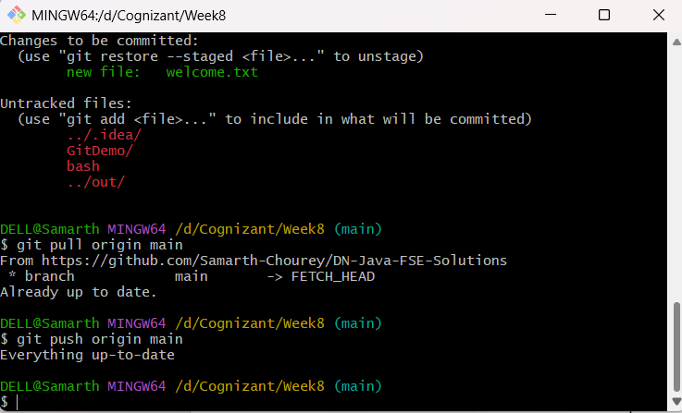

Conclusion:
This hands-on lab covered the essential Git workflow. You have successfully configured your Git environment, created a local repository, tracked and committed a file, and synchronized your work with a remote repository. These commands form the foundation of effective version control with Git.

