HANDS-ON 2: Ignoring Files with .gitignore
Objectives:
This document provides a step-by-step solution for the hands-on lab focused on using the .gitignore file. The purpose of a .gitignore file is to tell Git which files or folders it should intentionally ignore and not track.
Step-by-Step Solution:
- Prepare the Working Directory
- Navigate to your existing GitDemo project directory and check its current status to ensure there are no pending changes.
cd gitignore
git status

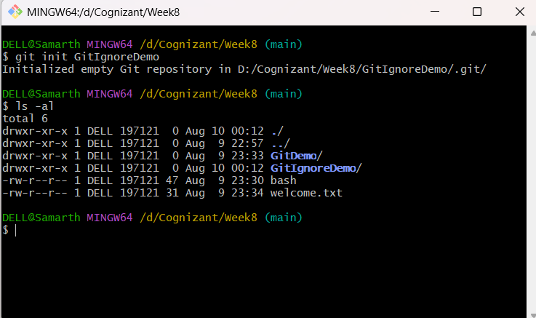

- Create Files and Folders to be Ignored
- Create a log file:
touch app.log
- Create a log folder with a file inside it:
mkdir log
touch log/debug.log

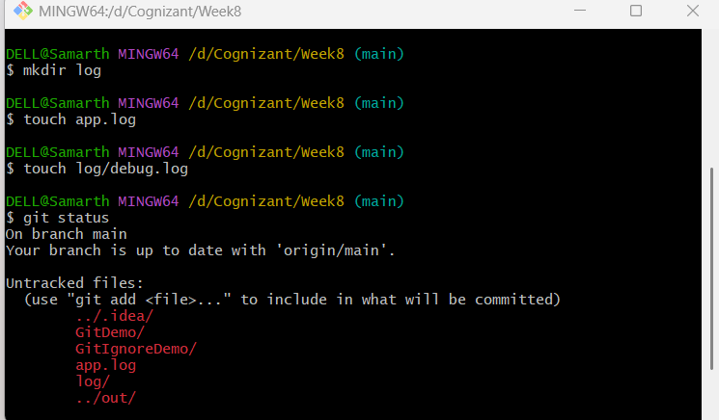

- Verify the new files with git status:
git status
Git sees the new app.log file and the log/ directory as "untracked files".

- Create and Configure the .gitignore file
Now, create the .gitignore file and add rules to ignore all files with a .log extension and the entire log directory.

- Create the .gitignore file:
touch .gitignore

- Add the ignore patterns to the file. You can use a text editor like nano or vim, or use the echo command as shown below. The * is a wildcard that matches any sequence of characters.
echo "*.log" >> .gitignore
echo "log/" >> .gitignore

- Verify the content of your .gitignore file:
cat .gitignore

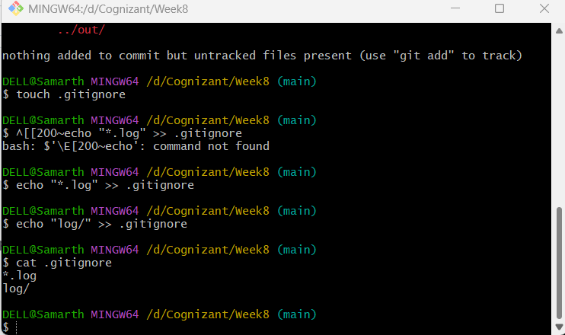

- Verify that the Files are Ignored

- Run git status again. You will now see that app.log and the log/ folder are no longer listed as untracked. Git is correctly ignoring them. The only new untracked file that Git sees is the .gitignore file itself, which is expected.
git status

- Commit the .gitignore file

- It is standard practice to add the .gitignore file to your repository. This ensures that the same ignore rules are shared with anyone else who clones the project.

- Add the .gitignore file to the staging area:
git add .gitignore

- Commit the staged file:
git commit -m "Add .gitignore to exclude log files and folder"

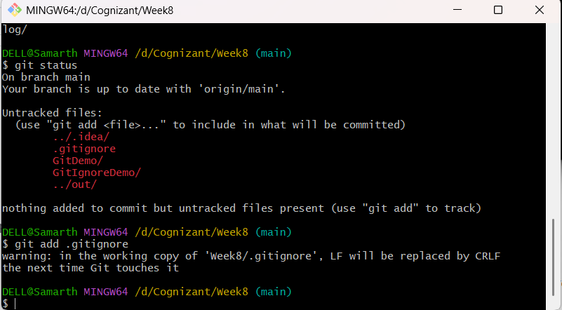

Final Verification
- Run git status one last time to confirm that the working directory is clean.
git status
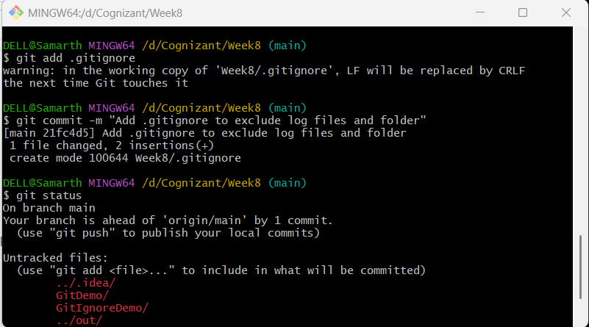

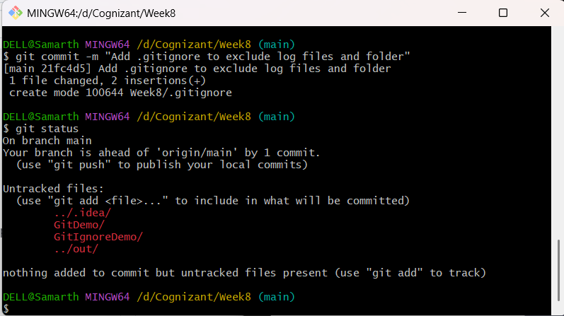

Conclusion
You have successfully configured a .gitignore file to prevent Git from tracking specific files and folders. You created rules to ignore files by their extension (*.log) and to ignore an entire directory (log/). Finally, you verified that git status respects these rules and committed the .gitignore file to the repository for future use.

