HANDS-ON 3: Git Branching and Merging
Objectives:
- This document provides a solution for the hands-on lab on Git's branching and merging capabilities.
- Branching allows for parallel development of features, bug fixes, or experiments without affecting the main codebase.
- Merging is the process of integrating the changes from a branch back into the main line of development.
BRANCHING:
- Create and List a New Branch
- Create a new branch named GitNewBranch.
git branch GitNewBranch
- List all available local and remote branches to see the new branch.
git branch -a
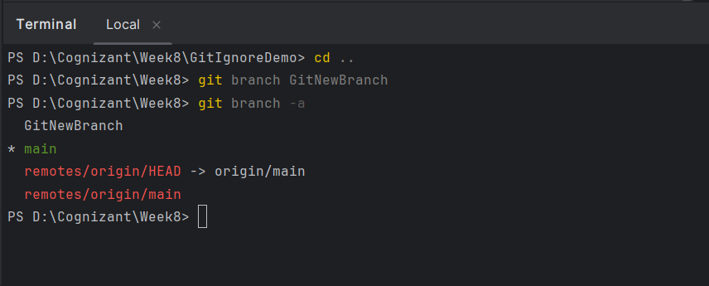
- Switch to the New Branch and Add Changes

- Switch your working context to the newly created GitNewBranch.
git switch GitNewBranch

- Add a new file with some content and commit this change to the branch.
echo "<h1>New Feature Under Development</h1>" > feature.html
git add feature.html
git commit -m "Feat: Add feature.html for new development"

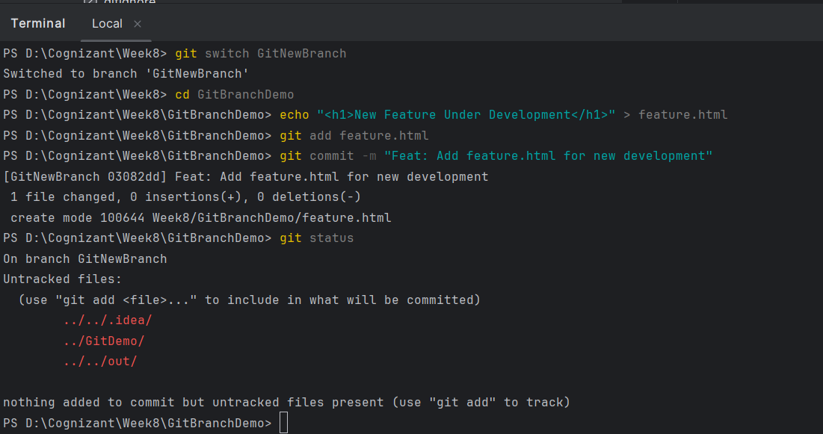

MERGING:
- Switch to main and View Differences
- First, return to the main branch.
git switch main
- Check the differences between the main branch and GitNewBranch. This command will show the new file that exists in the branch but not in the trunk.
git diff GitNewBranch

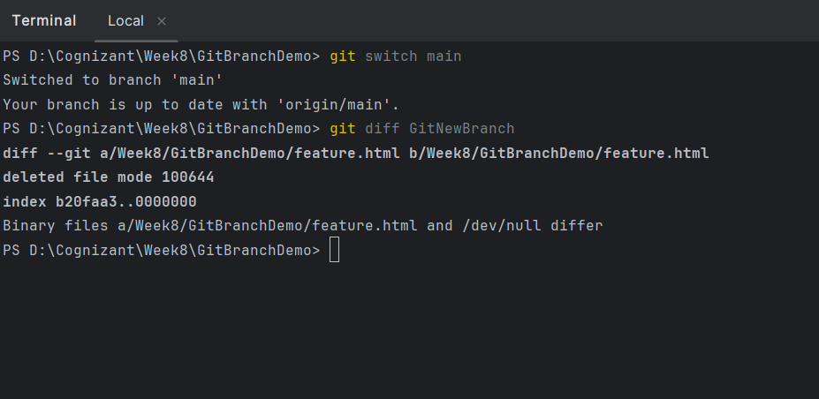

- Merge the Branch
- Execute the merge command to integrate the changes from GitNewBranch into your current branch (main).
git merge GitNewBranch
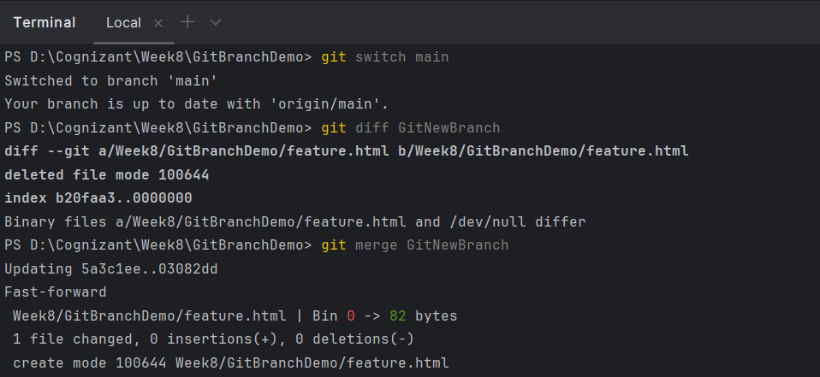
- Observe the Commit History
- Use the recommended git log command to view the commit history as a graph. You will see the commit from GitNewBranch is now at the tip of main.
git log --oneline --graph –decorate
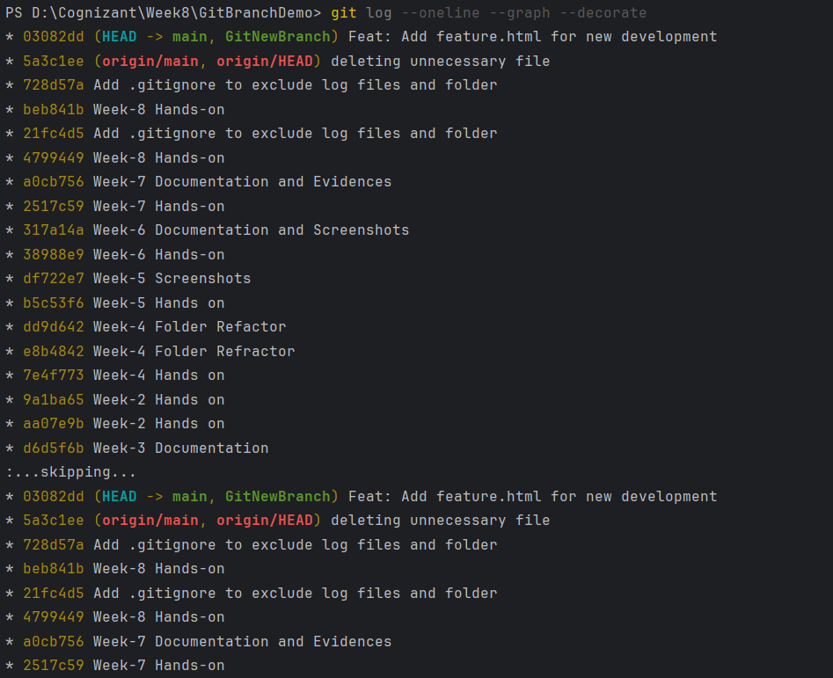
- Delete the Merged Branch
- Now that the work from GitNewBranch has been successfully merged, the branch is no longer needed and can be safely deleted.
git branch -d GitNewBranch
- You can list the local branches again to confirm GitNewBranch has been deleted.
git branch

