**Q.1) Create an IAM policy that allows full access to EC2 within the Mumbai region.**

**Ans :-**

**Step 1:- Sign in to AWS Management Console**

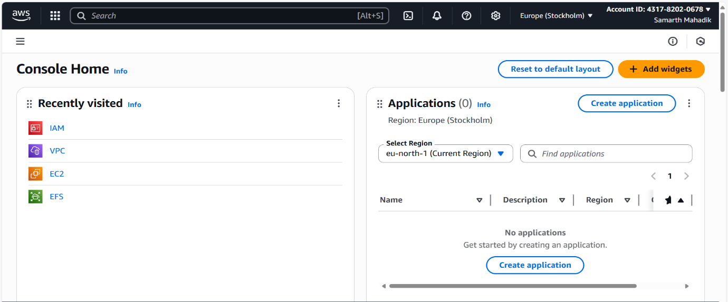

**Step 2:- Open IAM Service**

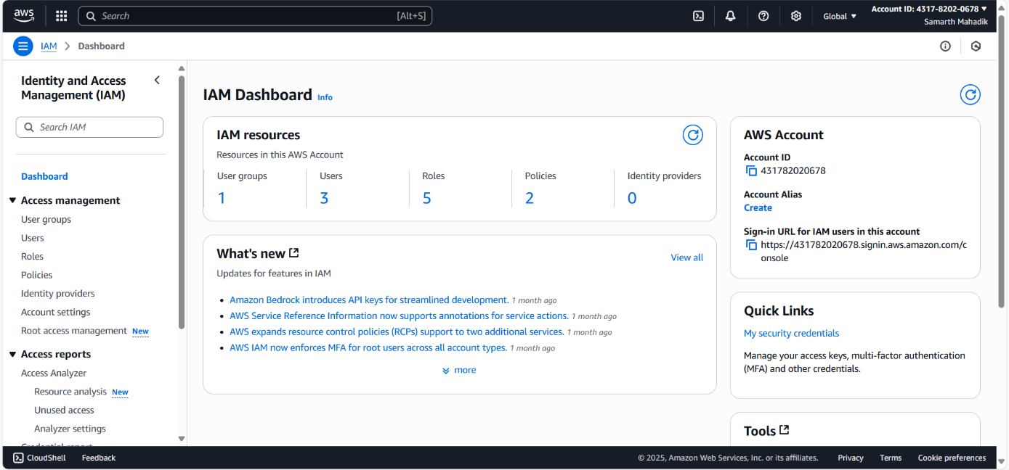

**Step 3:- Create a user samarth-mahadik**

1. Specify user details
2. Set permissions
3. Review and create

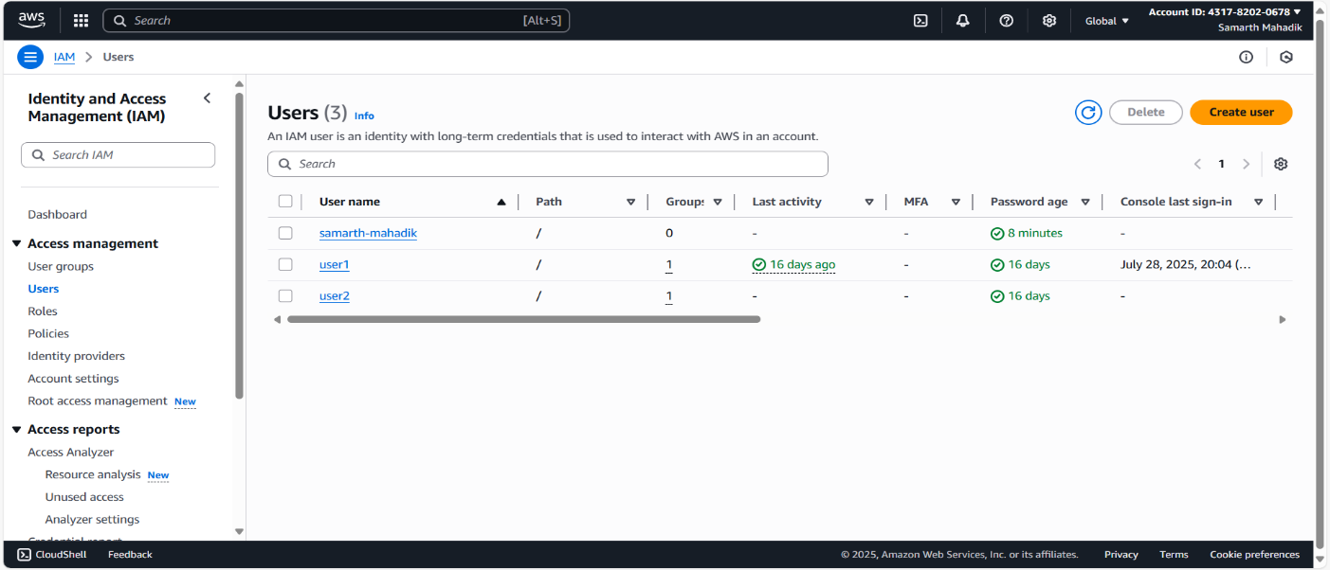

**Step 4:- Create a Custom Policy in visual Editor.**

1. In IAM dashboard, click Policies in the left menu.
2. Click Create policy.
3. Service: Search and select EC2.
4. Actions: Select All EC2 actions.
5. Resources: Select All resources
6. Request conditions:
   * Click Add condition.
   * Condition key: Search and select aws:RequestedRegion.
   * Operator: StringEquals.
   * Value: Type ap-south-1 (Mumbai region code).
7. Click Next.

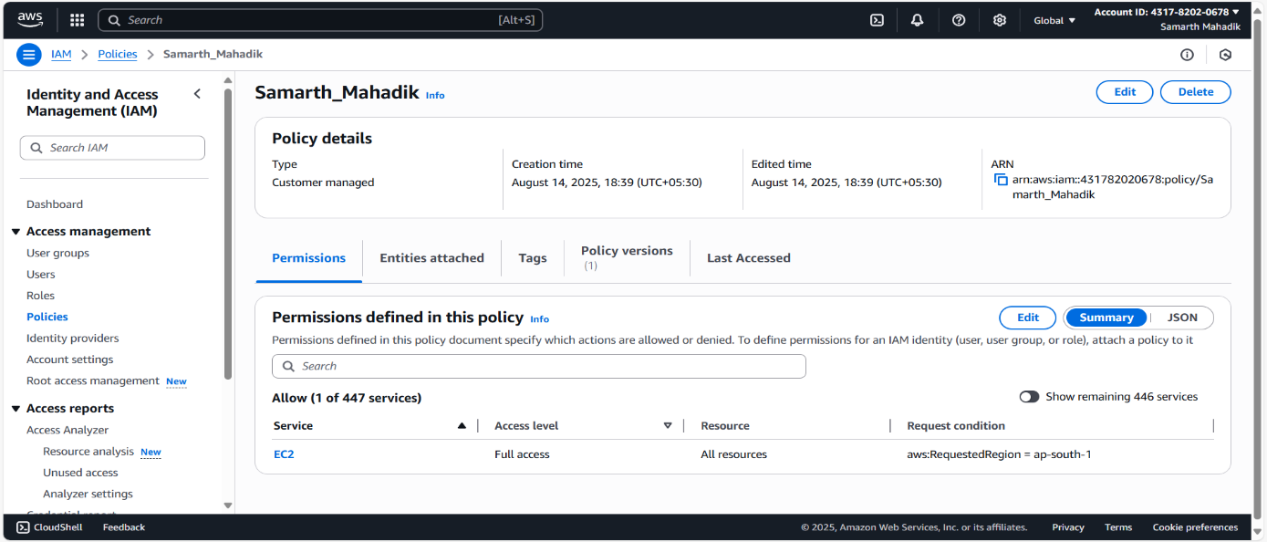

**Step 5:- Attach the Policy to User Vishvajit.**

1. In IAM dashboard, click Users → Select samarth-mahadik.
2. Go to Permissions tab → Click Add permissions.
3. Choose Attach policies directly.
4. Search for Samarth_Mahadik → Tick the checkbox.
5. Click Next → Add permissions.

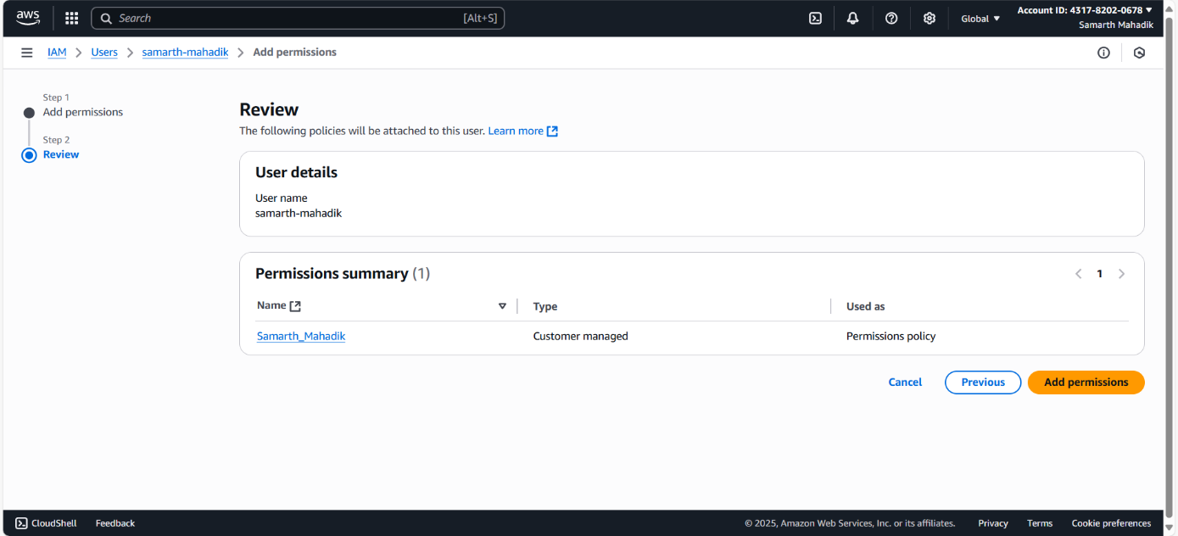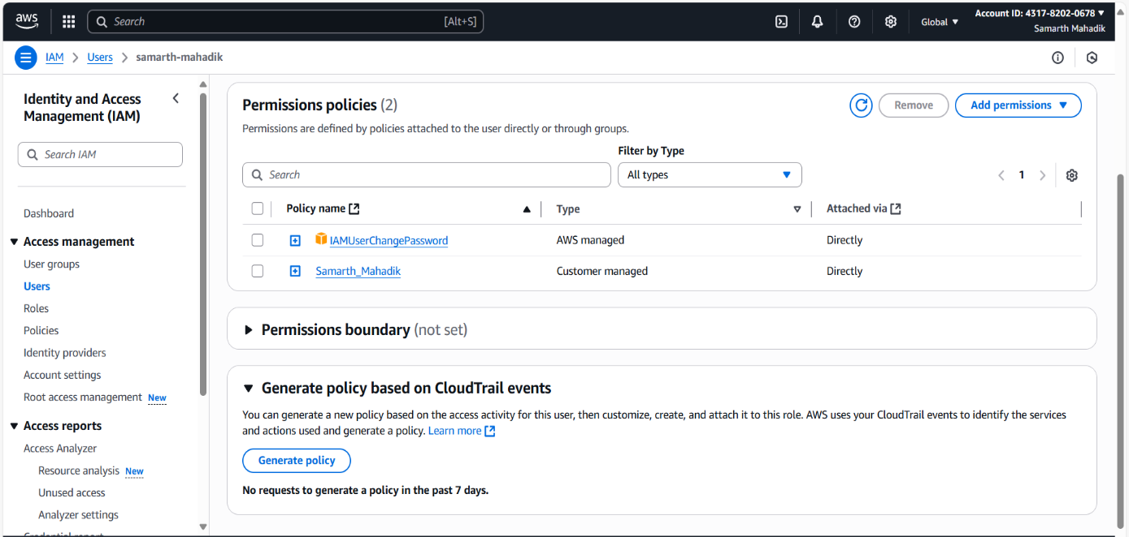

**Step 6:- Test the Policy**

launching EC2 in another region (N. Virginia)

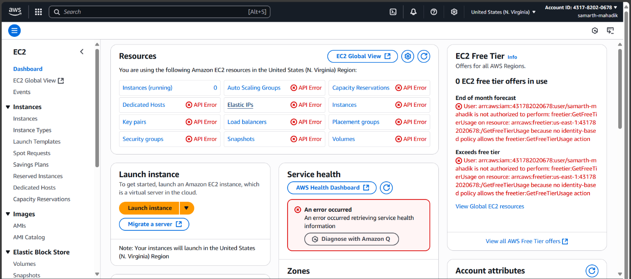

launching EC2 in Mumbai region (ap-south-1)

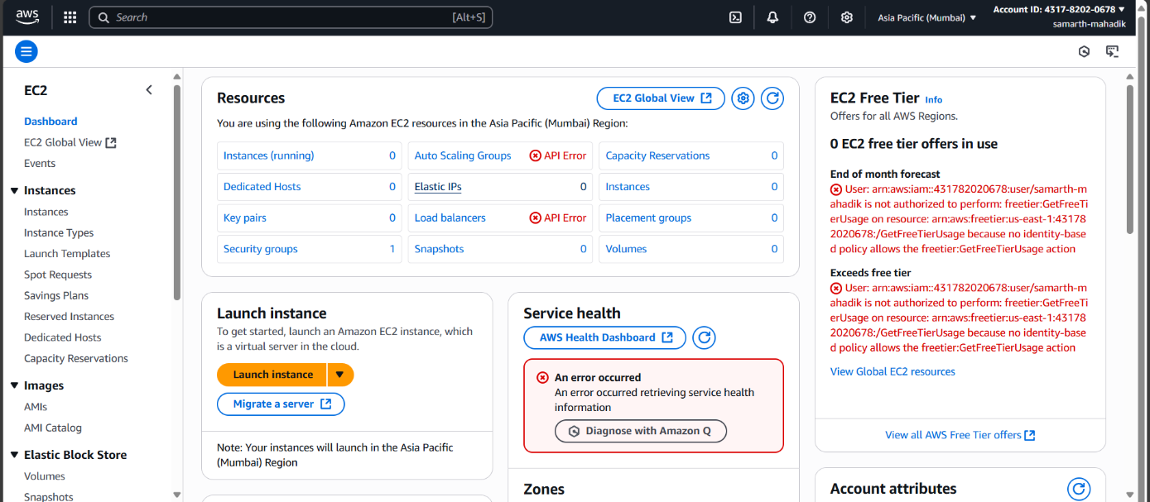

**Q.2) Create a temporary IAM user with access to a specific S3 bucket that automatically expires after 1 hour using time-based IAM policy conditions.**

**Ans :-**

**Step 1 :- Create a temp-s3-user**

1. Specify user details
2. Set permissions
3. Review and create

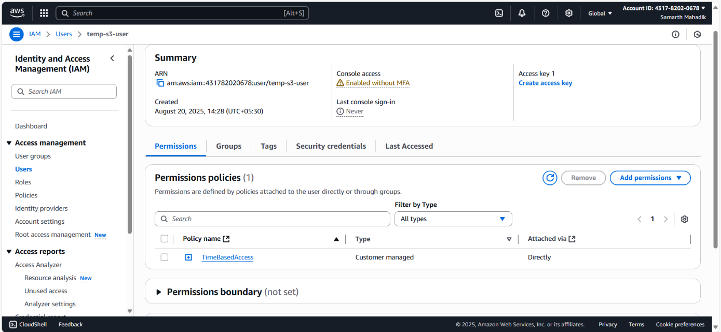

**Step 2:- Create a TimeBasedAccess**

1. In IAM, click Policies
2. Create policy
3. Service: Choose the service S3
4. Actions: Select All S3 actions.
5. Resources: Select All resources
6. Request conditions, Click Add condition:
   * Condition key: aws:CurrentTime
   * Operator: DateGreaterThanEquals
   * Value: 2025-08-20T09:26:00Z
7. Click Add another condition:
   * Condition key: aws:CurrentTime
   * Operator: DateLessThan
   * Value: 2025-08-20T10:26:00Z

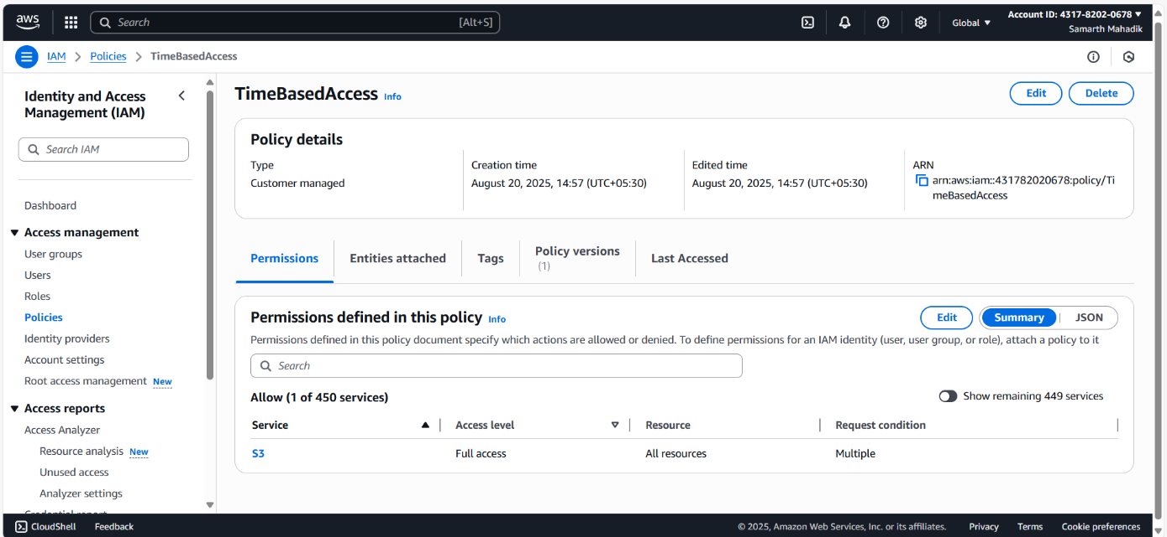

**Step 3:- Attach Policy to the Time-Based-Policy User**

1. In IAM, go to Users → Select temp-s3-user
2. Go to Permissions → Add permissions → Attach policies directly.
3. Search for TimeBasedAccess → Tick → Add permissions.

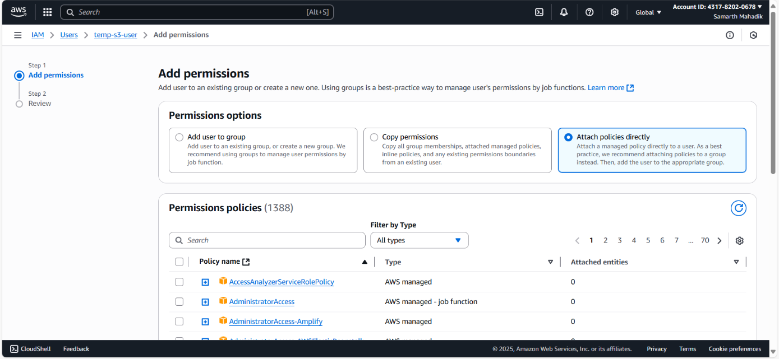

**Step 4: Test the Policy**

Log in as tembucket0707 during allowed time

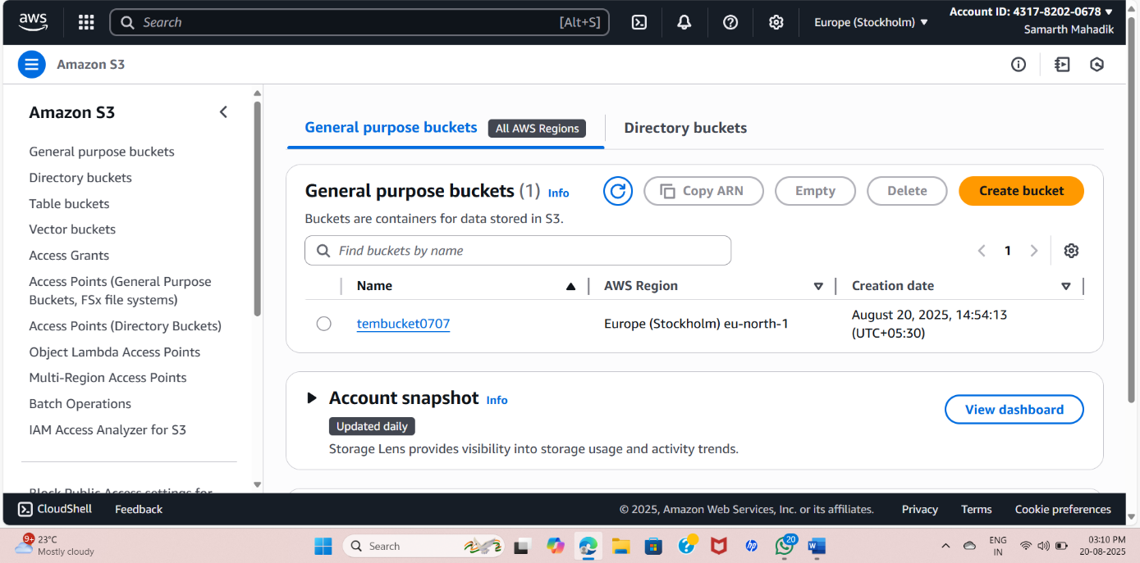

after allowed time

