**AWS S3 — Cross-Region Replication (CRR) — Completed Task Report**

Objective: Replicate **current versions** of objects from a source bucket to a destination bucket in another region.

# Environment Details

* Source bucket: **buckethub07** (Region: **EU**-**North**-**1 / Europe (Stockholm)**)
* Destination bucket: **my-dst-bucket-prod** (Region: **US**-**East**-**1 / N. Virginia**)
* Versioning: Enabled on both buckets
* Replication scope: Entire bucket (current versions)
* Optional backfill: One-time Batch Operations job to replicate existing objects

# Step 1 — Create / Verify Buckets in Different Regions

S3 console → Buckets. Ensure two buckets exist in different regions: the source (**buckethub07**) and the destination (**my-dst-bucket-prod**).

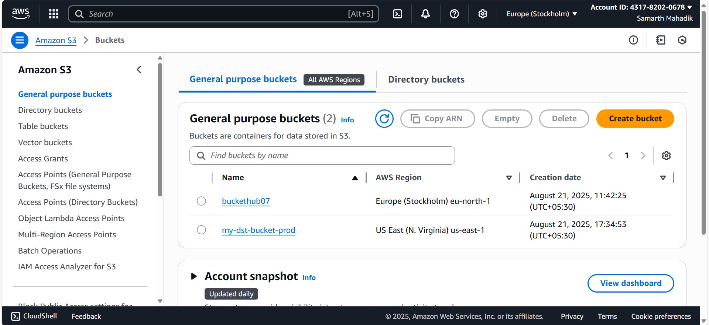

Figure 1: Two buckets created in EU■North■1 (source) and US■East■1 (destination).

# Step 2 — Enable Bucket Versioning (Required)

Open the **source bucket → Properties → Bucket Versioning → Enable**. Repeat for the destination bucket as well. Versioning must be enabled on both buckets for replication to work.

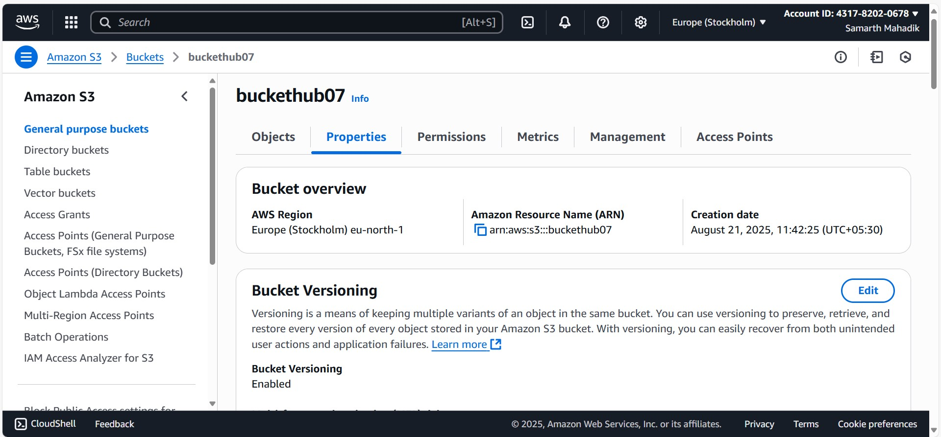

Figure 2: Versioning enabled on the source bucket (buckethub07).

# Step 3 — Create Replication Rule on the Source Bucket

Source bucket → **Management** → **Replication rules** → **Create rule**. Configure: • **Scope**: Entire bucket (or use a prefix/tag if needed) • **Destination**: my-dst-bucket-prod (US-East-1) • **Status**: Enabled • **Delete marker replication**: Disabled (replicate only current versions) • **Existing objects**: Keep Off for now (we will enable a one-time backfill in Step 4 if needed) Save the rule. The rule now appears as enabled.

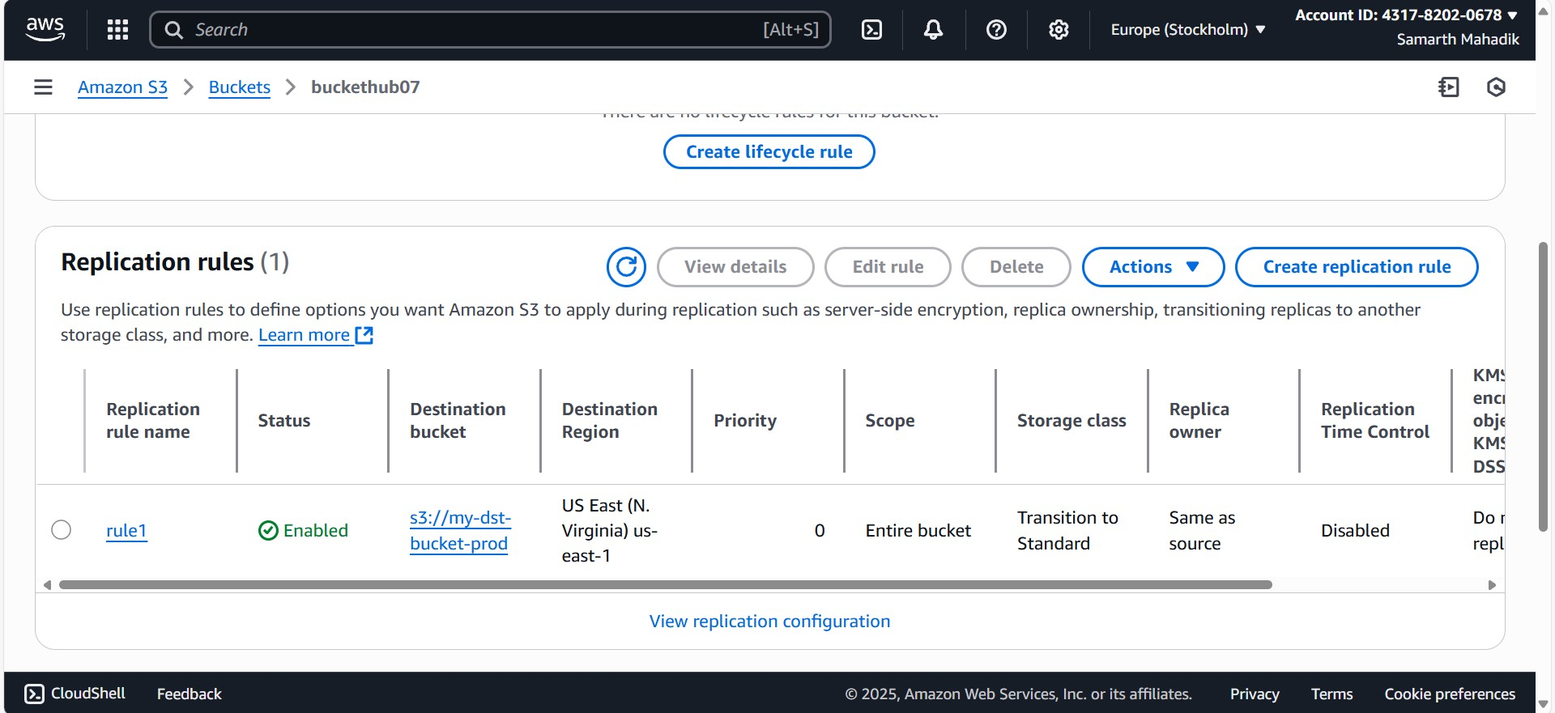

Figure 3: Replication rule created — destination is my-dst-bucket-prod (US-East-1).

# Step 4 (Optional) — Replicate Existing Objects via One-Time Backfill

If you also want to copy objects that already existed before the rule was created, enable the one-time Batch Operations backfill from the replication configuration. Choose **Yes, replicate existing objects** when prompted.

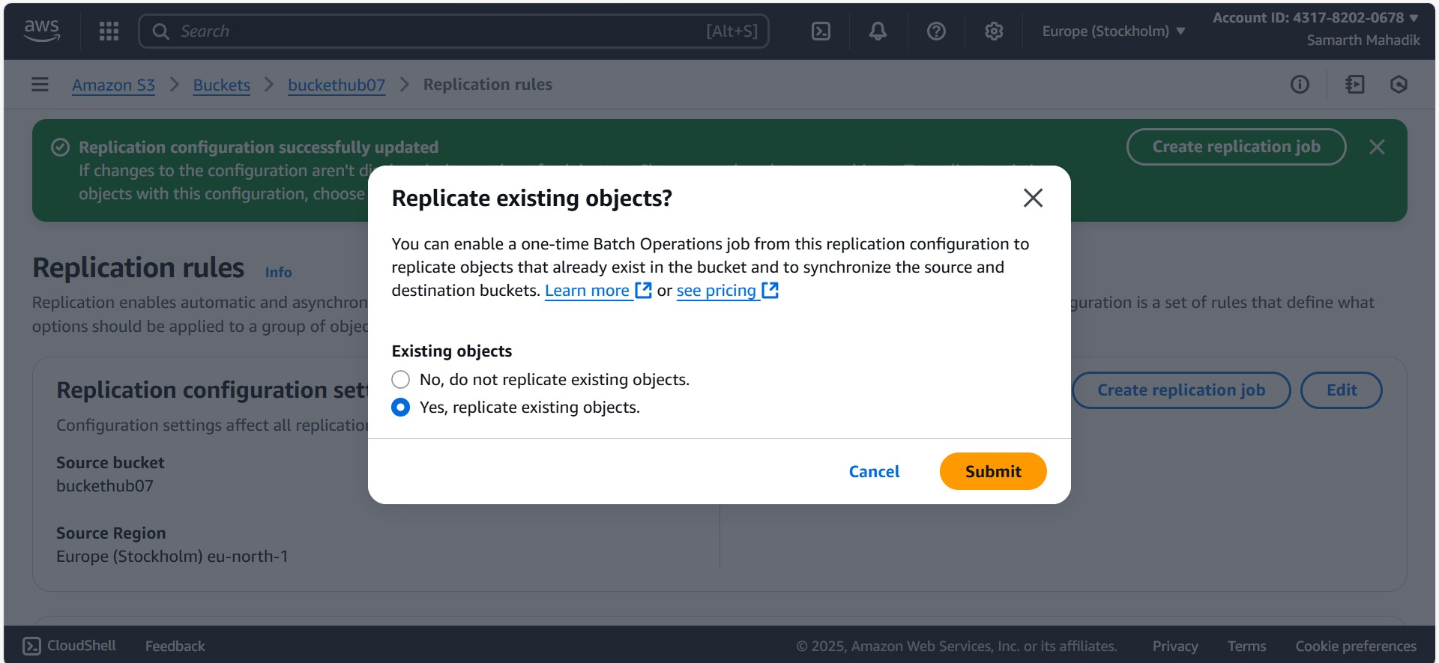

Figure 4: Enabling one-time backfill for existing objects.

# Step 5 — Batch Job Permissions (for Backfill)

When creating the Batch Operations job, allow S3 to assume an IAM role. Select **Create new role** so the console auto-creates the required role with the proper trust and permissions.

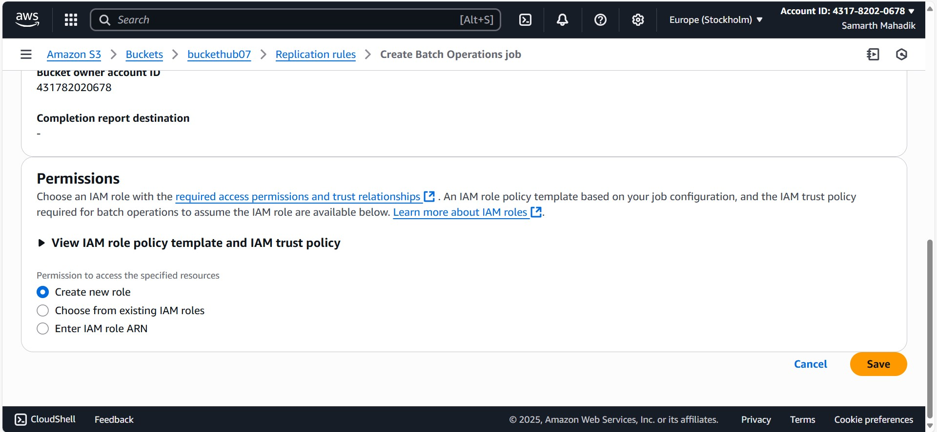

Figure 5: Batch Operations job — creating the IAM role automatically.

# Step 6 — Verification

Upload a new test object to the source bucket and verify that it appears in the destination bucket after a short delay. You can also view the Batch Operations job folders that get created during backfill.

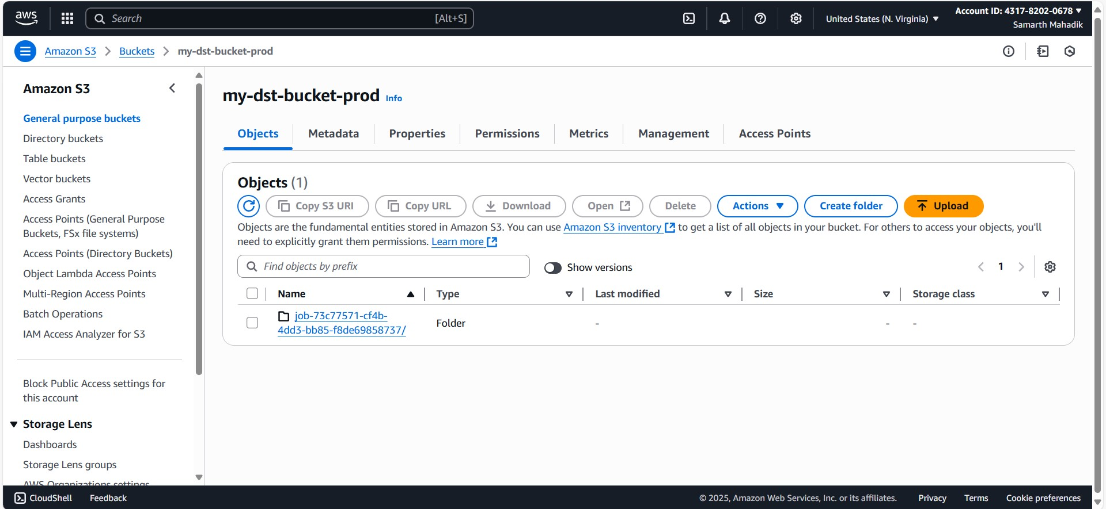

Figure 6: Source bucket — sample object and batch job folder visible.

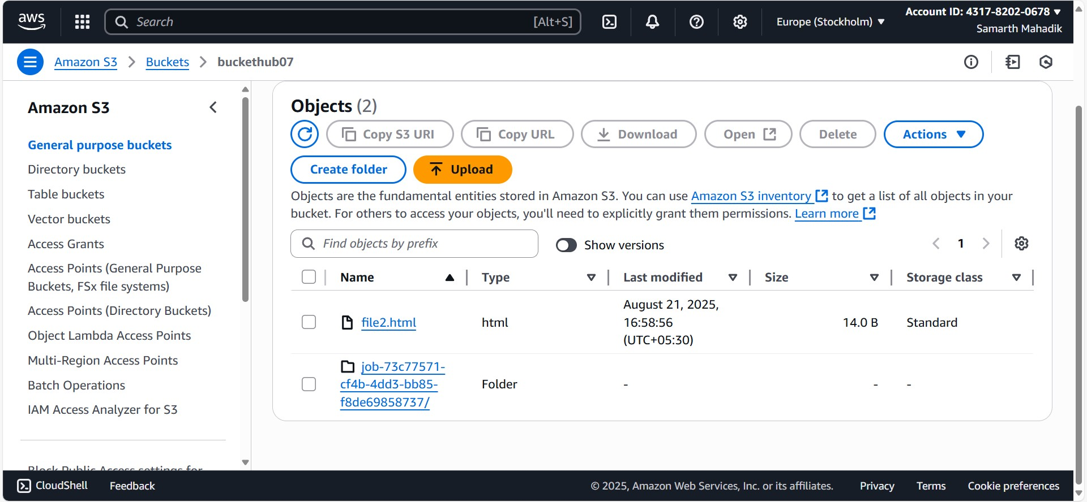

Figure 7: Destination bucket — replicated content / job artifacts visible.

# Notes & Good Practices

* Replication is asynchronous; allow a few minutes for objects to appear.
* Costs: inter-region data transfer + PUT requests + storage.
* If using SSE-KMS keys, ensure the replication role has encrypt/decrypt permissions on the relevant KMS keys. • To programmatically verify, check object headers for x-amz-replication-status: COMPLETED on the destination object.