Department of Computer Science and Engineering
(AI & ML)
B. Tech. CSE - 5th Semester
Aug – Dec 2026

UE23CS351A
DATABASE MANAGEMENT SYSTEMS (DBMS)

PROJECT REPORT on

PaperMatch: Intelligent Research Paper Recommendation and Discovery System

Submitted by:
PES1UG24AM396 | Samarth S. Maladkar | 5[sec]
PES1UG24AM372 | Krishna G Pai | 5[sec]

Class of Prof. [NAME]
[Lab Faculty]

Abstract
Researchers and students face a rapidly growing volume of publications, and conventional keyword search often misses papers that are conceptually related but worded differently. PaperMatch is a full-stack research-paper discovery and recommendation system that addresses this by combining a normalised PostgreSQL relational schema with the pgvector extension for dense-vector semantic search. Users can register, choose research interests, and search the catalogue in three modes: keyword (PostgreSQL full-text search with a GIN index), semantic (384-dimensional MiniLM embeddings compared by cosine distance through an HNSW index), and hybrid (a weighted blend of both). Every view, like and save is logged, and a recommendation engine scores papers as 0.60 × semantic similarity + 0.20 × interest match + 0.15 × interaction score + 0.05 × popularity, with a popularity-based fallback for new users. Administrators manage papers, authors and categories and see analytics computed entirely in SQL. The database layer uses 11 tables, 14 indexes, 2 views, 3 stored functions, triggers, transactions and CHECK constraints. The application is built with Next.js 14, TypeScript and Tailwind CSS, authenticates with bcrypt-hashed passwords and JWT session cookies, and is deployed locally with Docker Compose alongside a FastAPI embedding microservice.
Table of Contents
Sl. No | Topic | Page No.
 | Introduction  - Problem Statement | 4
 | User Requirements Specification- Tech Stack | 5
 | E-R Model  - List of Entities [labeling Weak ones]  - List non-simple Attributes  - ER Diagram Snapshot  - ERD from tool like draw.io | 7
 | Relational Model  - List of Relations that are not Entities in ER Model  - Schema Diagram [ensure light background image] | 9
 | SQL DDL Statements | 11
 | SQL DML Statements | 15
 | NoSQL/ Vector Database Commands | 17
8. | Results  - Resulting Tables’ Screenshots | 19
9. | Next.js-Project Tree Structure | 25
10. | Few sample Screenshots of application code and demo | 27
11. | Evaluation Rubrics- Completion Status | 34

1. Introduction

a) Problem Statement
Finding relevant research papers is slow and unreliable. Traditional keyword search matches only the exact words typed by the user, so a query such as “machine learning for medical image analysis” can miss a highly relevant paper that uses different terminology. Most catalogues also treat every visitor the same, with no memory of what a researcher has already read, saved or liked, so each session starts from scratch.
The problem addressed by this project is to design and build a database-driven system that (i) stores a structured catalogue of papers, authors and categories with full integrity guarantees, (ii) lets users find papers by meaning rather than only by exact words, and (iii) recommends new papers from each user’s declared interests and reading behaviour.

b) Short Description
PaperMatch is a web application with two roles, RESEARCHER and ADMIN. Researchers register, select research interests, search the catalogue using keyword, semantic or hybrid mode with category, year and author filters, open paper pages (which automatically record a VIEW), and save or like papers. A personalised dashboard shows recommended papers with a plain-language reason for each, and every paper page lists similar papers found by vector similarity. Administrators add and remove papers, add authors and categories, regenerate embeddings, and view platform analytics.
The relational data is stored in PostgreSQL 16 (11 tables in third normal form with PK, FK, UNIQUE, NOT NULL and CHECK constraints). Text embeddings generated by a Python microservice are stored in the same database using pgvector, so that relational filters and vector search can be combined in a single SQL statement. Advanced database features used by the running application include transactions, views, stored functions, triggers, CTEs, full-text search and HNSW vector indexing.

2. User Requirements Specification – Tech Stack

User requirements
• Researchers can create an account, log in securely and keep a personal profile of research interests.
• Researchers can search papers by keyword, by meaning (semantic) or by a hybrid of both, and filter by category, year and author.
• The system records views, likes and saves and uses them to produce personalised recommendations with explanations.
• Each paper page shows genuinely similar papers (based on embeddings, not just the same category).
• Administrators can manage papers, authors and categories, regenerate embeddings, and view analytics; ordinary users must not reach these functions.
• Data must stay consistent: no orphan rows, invalid years or malformed emails, and multi-step operations must be atomic.

Technology stack
Layer | Technology | Purpose in PaperMatch
Frontend | Next.js 14 (App Router), React 18, TypeScript, Tailwind CSS | Pages for search, dashboard, paper detail, saved, interests and admin screens
Backend / API | Next.js Route Handlers (Node.js), Zod 3 | REST endpoints under app/api; input validation; business logic
Relational DB | PostgreSQL 16 | Normalised schema, constraints, views, functions, triggers, full-text search
Vector DB | pgvector (extension), HNSW index | 384-dimensional embeddings and cosine-similarity search inside PostgreSQL
DB access | pg (node-postgres) 8.12 | Parameterised SQL (no ORM) so that pgvector operators, CTEs and functions are written directly
Authentication | bcryptjs, jose (JWT) | Password hashing; HTTP-only session cookie with 7-day expiry; role claim
Embedding service | Python 3.11, FastAPI, sentence-transformers (all-MiniLM-L6-v2) | Turns paper text and search queries into 384-dimensional vectors
Infrastructure | Docker Compose (ankane/pgvector image) | Runs PostgreSQL+pgvector and the embedding service; schema auto-loaded on first start
Tooling | tsx, ESLint, TypeScript 5.5 | Seeding and embedding scripts, linting, type checking

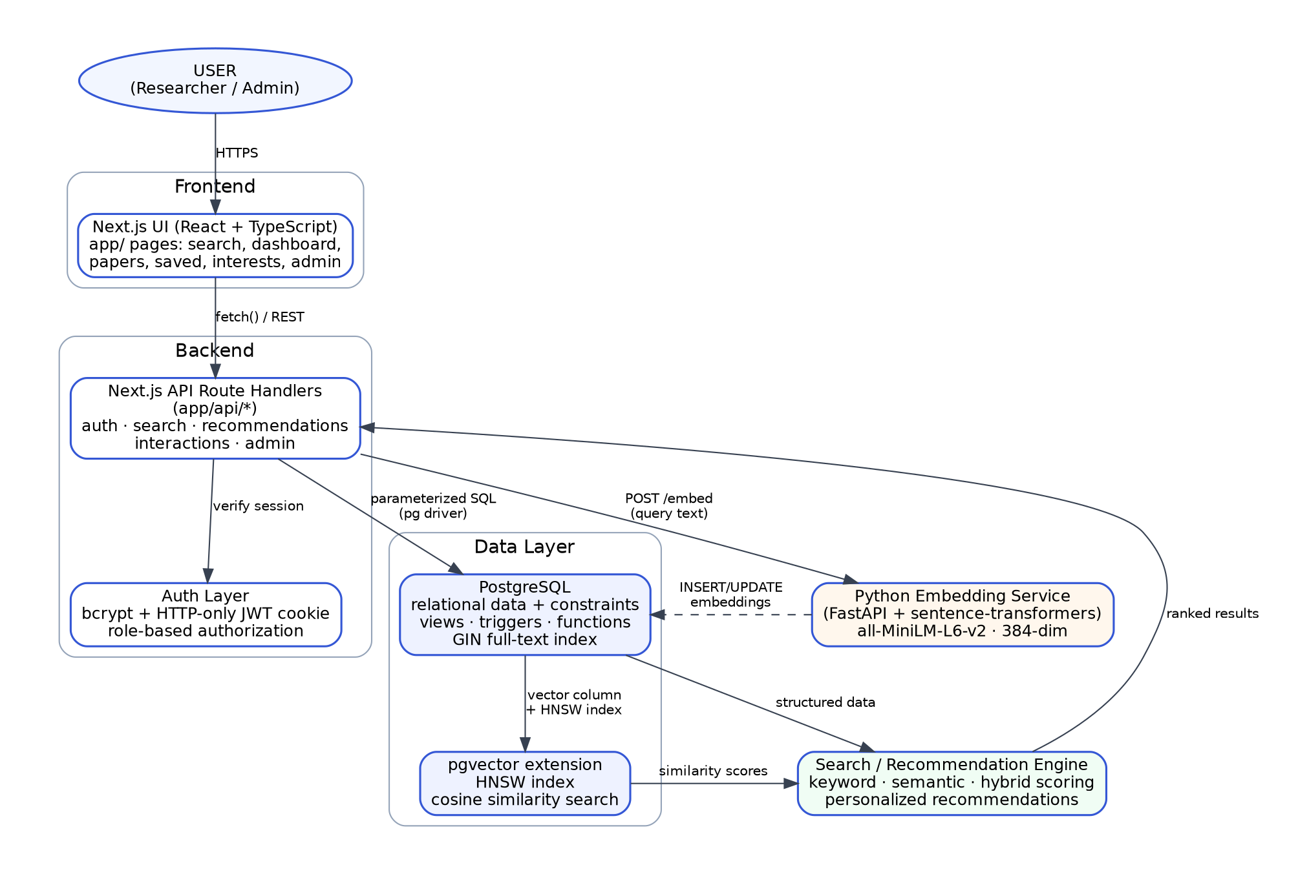
Figure 2.1: System architecture of PaperMatch

Why this stack
Next.js + TypeScript. One codebase serves both the user interface and the API (Route Handlers), which keeps a two-person project simple to run and demonstrate. TypeScript and Zod give end-to-end type and input checking, and server-side route handlers let every protected endpoint verify the session and role before touching the database.
PostgreSQL. The domain is strongly relational (papers, authors, categories, users, interactions) with many-to-many links, so ACID transactions, foreign keys, CHECK constraints, triggers, views and stored functions directly support the data-integrity requirements. PostgreSQL also provides built-in full-text search (tsvector, GIN) and a rich extension ecosystem.
Why pgvector as the vector (NoSQL-style) store. A separate vector database such as Pinecone, Qdrant or Redis would add a second system to deploy, secure and keep in sync. With pgvector the embedding lives in a table that references papers(id) with ON DELETE CASCADE, so deleting a paper automatically removes its vector and the two can never drift apart. Vector search can be joined with relational filters (category, year, author) in one query, runs inside the same transaction model, and uses an HNSW index for approximate nearest-neighbour search without a separate training step. For a catalogue of this size, a single database is simpler and fully adequate.
all-MiniLM-L6-v2 behind FastAPI. The model is small (about 80 MB, 384 dimensions), runs on CPU, and gives good semantic similarity for its size. A small Python microservice isolates the machine-learning dependency from the Node.js application.

3. E-R Model

a) List of Entities
Entity | Key attributes | Type
USER | id (PK), name, email (unique), password_hash, role, created_at, updated_at | Strong
PAPER | id (PK), title, abstract, publication_year, venue, doi (unique), url, category_id (FK), search_vector, created_at, updated_at | Strong
AUTHOR | id (PK), name, affiliation | Strong
CATEGORY | id (PK), name (unique), description | Strong
RESEARCH_INTEREST | id (PK), name (unique), description | Strong
PAPER_INTERACTION | id (PK), user_id (FK), paper_id (FK), interaction_type, created_at | Strong, existence-dependent on USER and PAPER (event log)
PAPER_EMBEDDING | id (PK), paper_id (FK, unique), embedding VECTOR(384), model_name, created_at | Strong, existence-dependent on PAPER (1:1, cascades on delete)

Note on weak entities. Every entity above has its own surrogate primary key, so none is a weak entity in the strict textbook sense. PAPER_INTERACTION and PAPER_EMBEDDING are the closest to weak entities because they cannot exist without their owner (ON DELETE CASCADE), and are marked as existence-dependent.

b) Non-simple Attributes
Attribute | Entity | Kind | How it is handled
authors | PAPER | Multi-valued | Resolved into the associative relation PAPER_AUTHORS, with author_order attribute
interests | USER | Multi-valued | Resolved into USER_INTERESTS (M:N with RESEARCH_INTEREST)
search_vector | PAPER | Derived | TSVECTOR GENERATED ALWAYS AS (title weighted A + abstract weighted B) STORED; indexed with GIN
embedding | PAPER_EMBEDDING | Array-valued (384 floats) | Stored as a single pgvector VECTOR(384) value; indexed with HNSW
view_count, like_count, save_count | PAPER | Derived (not stored) | Computed on demand by paper_popularity_view from PAPER_INTERACTION
saved/liked/viewed/interest counts | USER | Derived (not stored) | Computed by user_activity_view and get_user_research_activity()
role, interaction_type | USER, PAPER_INTERACTION | Enumerated | PostgreSQL ENUM types user_role and interaction_type

There are no composite attributes: name, address-style fields and dates are stored as single atomic columns.

c) ER Diagram Snapshot / d) ERD from a diagramming tool
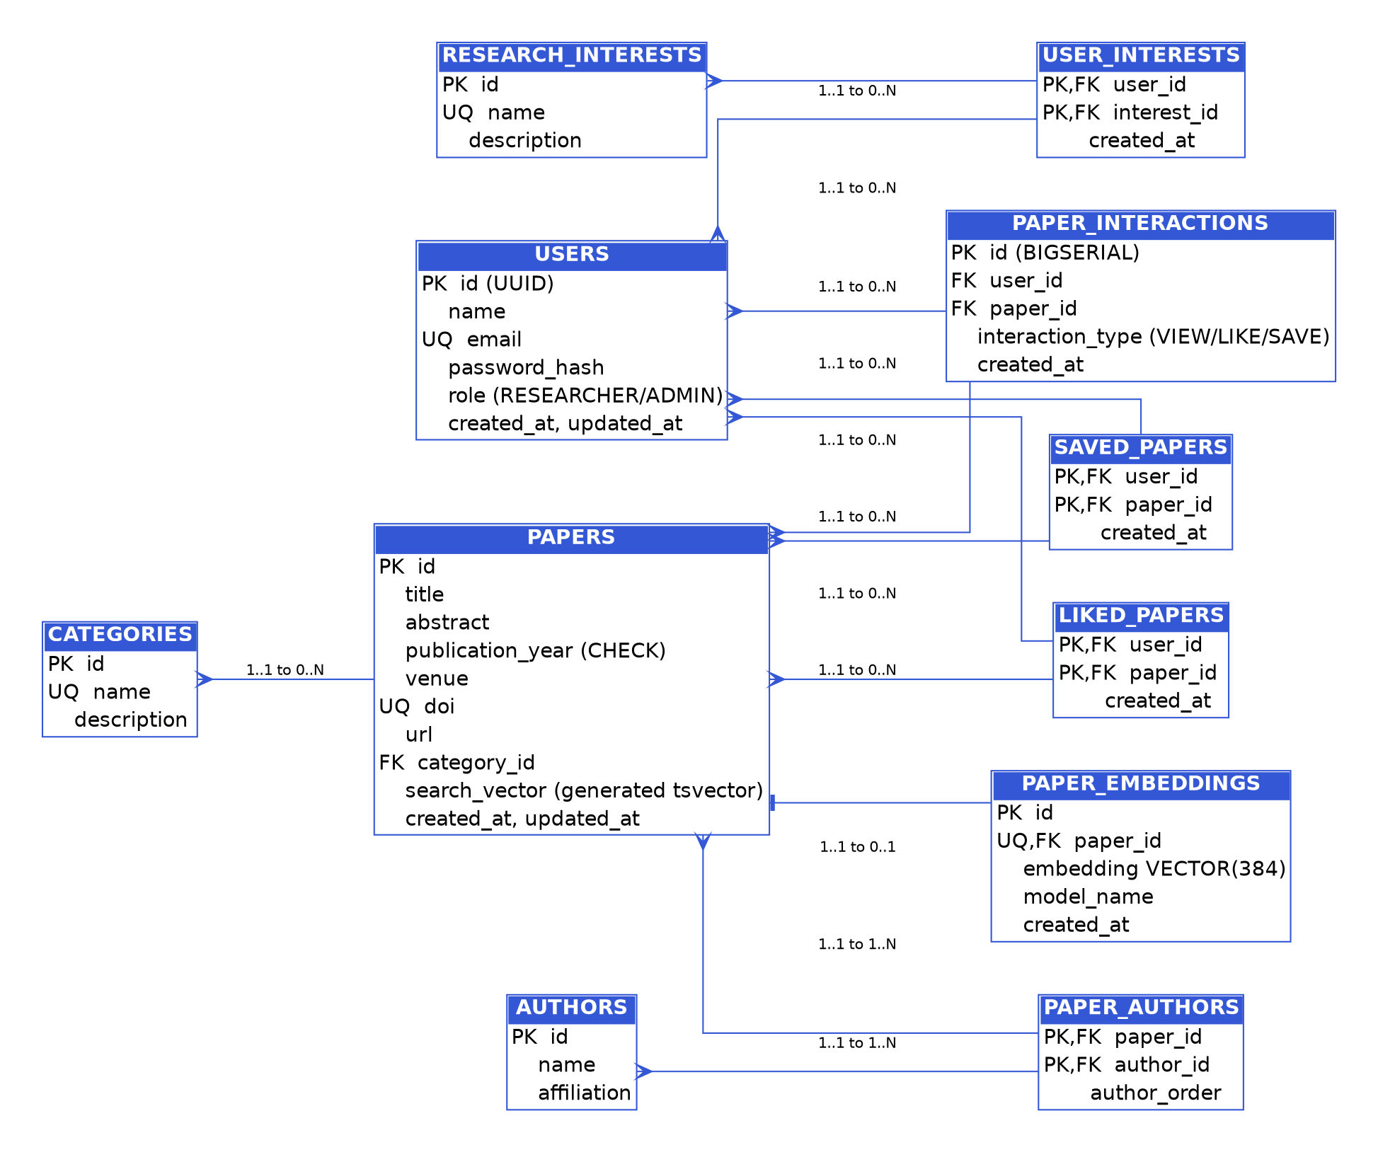
Figure 3.1: Entity-Relationship diagram of PaperMatch (docs/ER_Diagram.png)
Relationships: CATEGORY 1:N PAPER; PAPER M:N AUTHOR (via PAPER_AUTHORS); USER M:N RESEARCH_INTEREST (via USER_INTERESTS); USER M:N PAPER for saving (SAVED_PAPERS) and liking (LIKED_PAPERS); USER 1:N PAPER_INTERACTION; PAPER 1:N PAPER_INTERACTION; PAPER 1:1 PAPER_EMBEDDING.

4. Relational Model

a) List of Relations that are not Entities in the ER Model
Seven of the eleven tables come directly from entities. The remaining four are relations created from many-to-many relationships:
Relation | Derived from | Primary key | Foreign keys | Extra attribute
PAPER_AUTHORS | PAPER M:N AUTHOR | (paper_id, author_id) | paper_id → papers, author_id → authors | author_order
USER_INTERESTS | USER M:N RESEARCH_INTEREST | (user_id, interest_id) | user_id → users, interest_id → research_interests | created_at
SAVED_PAPERS | USER M:N PAPER (save) | (user_id, paper_id) | user_id → users, paper_id → papers | created_at
LIKED_PAPERS | USER M:N PAPER (like) | (user_id, paper_id) | user_id → users, paper_id → papers | created_at

All four use ON DELETE CASCADE on both foreign keys. Normal form: all relations are in 3NF; the only intentional redundancy is that a save or like is stored both as current state (SAVED_PAPERS / LIKED_PAPERS) and as an event in PAPER_INTERACTION, kept in sync by triggers.

Foreign keys and referential actions
Child table | Foreign key | References | ON DELETE
papers | category_id | categories(id) | SET NULL (paper kept, category cleared)
paper_authors | paper_id, author_id | papers(id), authors(id) | CASCADE
user_interests | user_id, interest_id | users(id), research_interests(id) | CASCADE
paper_interactions | user_id, paper_id | users(id), papers(id) | CASCADE
saved_papers / liked_papers | user_id, paper_id | users(id), papers(id) | CASCADE
paper_embeddings | paper_id (UNIQUE) | papers(id) | CASCADE

b) Schema Diagram
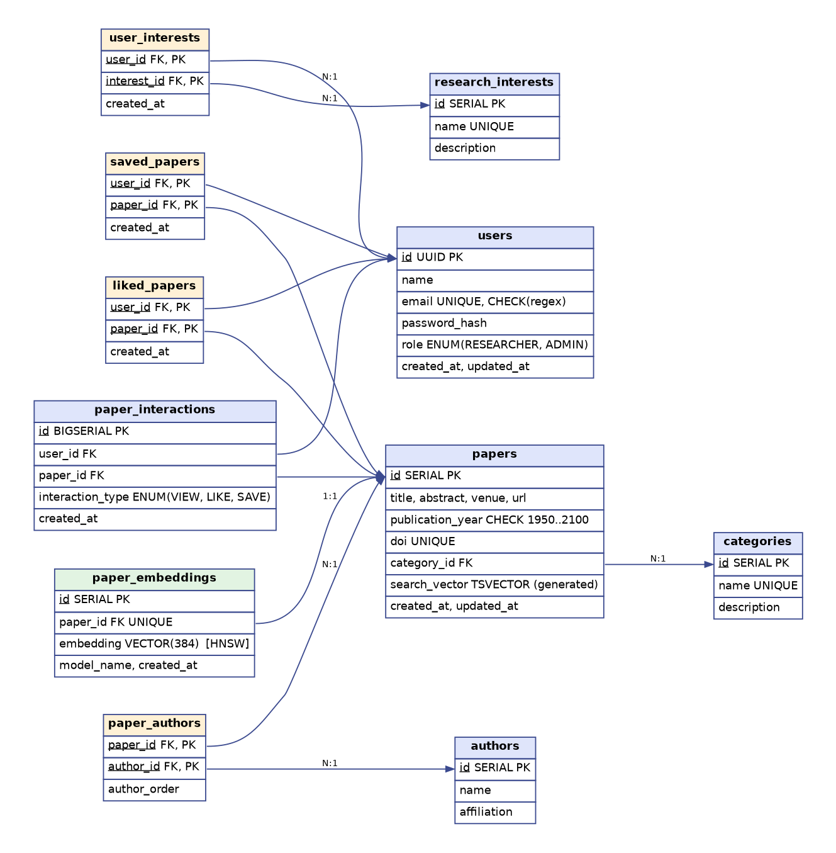
Figure 4.1: Relational schema (arrows point from foreign key to referenced primary key; yellow = relations from M:N relationships, green = vector table)

5. SQL DDL Statements
The complete DDL is in database/schema.sql. It is loaded automatically by Docker Compose on first start (mounted into /docker-entrypoint-initdb.d) or manually with npm run db:init. Statements are idempotent (IF NOT EXISTS / CREATE OR REPLACE).
-- PaperMatch — Core Relational + Vector Schema
-- PostgreSQL 15+ with pgvector extension
-- The pgvector project's PostgreSQL extension is named "vector".
CREATE EXTENSION IF NOT EXISTS vector;
CREATE EXTENSION IF NOT EXISTS pg_trgm;
-- ENUM TYPES
DO $$ BEGIN
CREATE TYPE user_role AS ENUM ('RESEARCHER', 'ADMIN');
EXCEPTION WHEN duplicate_object THEN NULL; END $$;
DO $$ BEGIN
CREATE TYPE interaction_type AS ENUM ('VIEW', 'LIKE', 'SAVE');
EXCEPTION WHEN duplicate_object THEN NULL; END $$;
-- USERS
CREATE TABLE IF NOT EXISTS users (
id UUID PRIMARY KEY DEFAULT gen_random_uuid(),
name VARCHAR(120) NOT NULL,
email VARCHAR(255) NOT NULL UNIQUE,
password_hash TEXT NOT NULL,
role user_role NOT NULL DEFAULT 'RESEARCHER',
created_at TIMESTAMPTZ NOT NULL DEFAULT now(),
updated_at TIMESTAMPTZ NOT NULL DEFAULT now(),
CONSTRAINT chk_email_format CHECK (email ~* '^[A-Za-z0-9._%+-]+@[A-Za-z0-9.-]+\.[A-Za-z]{2,}$')
);
-- CATEGORY
CREATE TABLE IF NOT EXISTS categories (
id SERIAL PRIMARY KEY,
name VARCHAR(120) NOT NULL UNIQUE,
description TEXT
);
-- AUTHOR
CREATE TABLE IF NOT EXISTS authors (
id SERIAL PRIMARY KEY,
name VARCHAR(200) NOT NULL,
affiliation VARCHAR(255)
);
-- PAPER
CREATE TABLE IF NOT EXISTS papers (
id SERIAL PRIMARY KEY,
title VARCHAR(500) NOT NULL,
abstract TEXT NOT NULL,
publication_year INTEGER NOT NULL,
venue VARCHAR(255),
doi VARCHAR(255) UNIQUE,
url VARCHAR(500),
category_id INTEGER REFERENCES categories(id) ON DELETE SET NULL,
created_at TIMESTAMPTZ NOT NULL DEFAULT now(),
updated_at TIMESTAMPTZ NOT NULL DEFAULT now(),
-- generated tsvector for full text search over title + abstract
search_vector TSVECTOR GENERATED ALWAYS AS (
setweight(to_tsvector('english', coalesce(title, '')), 'A') ||
setweight(to_tsvector('english', coalesce(abstract, '')), 'B')
) STORED,
CONSTRAINT chk_pub_year CHECK (publication_year BETWEEN 1950 AND 2100),
CONSTRAINT chk_title_not_blank CHECK (length(btrim(title)) > 0)
);
-- PAPER_AUTHOR (M:N)
CREATE TABLE IF NOT EXISTS paper_authors (
paper_id INTEGER NOT NULL REFERENCES papers(id) ON DELETE CASCADE,
author_id INTEGER NOT NULL REFERENCES authors(id) ON DELETE CASCADE,
author_order SMALLINT NOT NULL DEFAULT 1,
PRIMARY KEY (paper_id, author_id)
);
-- RESEARCH_INTEREST
CREATE TABLE IF NOT EXISTS research_interests (
id SERIAL PRIMARY KEY,
name VARCHAR(120) NOT NULL UNIQUE,
description TEXT
);
-- USER_INTEREST (M:N)
CREATE TABLE IF NOT EXISTS user_interests (
user_id UUID NOT NULL REFERENCES users(id) ON DELETE CASCADE,
interest_id INTEGER NOT NULL REFERENCES research_interests(id) ON DELETE CASCADE,
created_at TIMESTAMPTZ NOT NULL DEFAULT now(),
PRIMARY KEY (user_id, interest_id)
);
-- PAPER_INTERACTION (VIEW / LIKE / SAVE log — append-only event table)
CREATE TABLE IF NOT EXISTS paper_interactions (
id BIGSERIAL PRIMARY KEY,
user_id UUID NOT NULL REFERENCES users(id) ON DELETE CASCADE,
paper_id INTEGER NOT NULL REFERENCES papers(id) ON DELETE CASCADE,
interaction_type interaction_type NOT NULL,
created_at TIMESTAMPTZ NOT NULL DEFAULT now()
);
-- SAVED_PAPER (current-state bookmark; distinct from the SAVE event log above)
CREATE TABLE IF NOT EXISTS saved_papers (
user_id UUID NOT NULL REFERENCES users(id) ON DELETE CASCADE,
paper_id INTEGER NOT NULL REFERENCES papers(id) ON DELETE CASCADE,
created_at TIMESTAMPTZ NOT NULL DEFAULT now(),
PRIMARY KEY (user_id, paper_id)
);
-- LIKED_PAPER (current-state; mirrors saved_papers for LIKE)
CREATE TABLE IF NOT EXISTS liked_papers (
user_id UUID NOT NULL REFERENCES users(id) ON DELETE CASCADE,
paper_id INTEGER NOT NULL REFERENCES papers(id) ON DELETE CASCADE,
created_at TIMESTAMPTZ NOT NULL DEFAULT now(),
PRIMARY KEY (user_id, paper_id)
);
-- PAPER_EMBEDDING (pgvector)
-- all-MiniLM-L6-v2 -> 384 dimensions
CREATE TABLE IF NOT EXISTS paper_embeddings (
id SERIAL PRIMARY KEY,
paper_id INTEGER NOT NULL UNIQUE REFERENCES papers(id) ON DELETE CASCADE,
embedding VECTOR(384) NOT NULL,
model_name VARCHAR(120) NOT NULL DEFAULT 'sentence-transformers/all-MiniLM-L6-v2',
created_at TIMESTAMPTZ NOT NULL DEFAULT now()
);
-- INDEXES
-- Lookup / auth
CREATE INDEX IF NOT EXISTS idx_users_email ON users(email);
-- Paper browsing / filtering
CREATE INDEX IF NOT EXISTS idx_papers_title ON papers(title);
CREATE INDEX IF NOT EXISTS idx_papers_year ON papers(publication_year);
CREATE INDEX IF NOT EXISTS idx_papers_category ON papers(category_id);
-- Interaction / saved lookups (dashboard, recommendations, analytics)
CREATE INDEX IF NOT EXISTS idx_interactions_user ON paper_interactions(user_id);
CREATE INDEX IF NOT EXISTS idx_interactions_paper ON paper_interactions(paper_id);
CREATE INDEX IF NOT EXISTS idx_interactions_type ON paper_interactions(interaction_type);
CREATE INDEX IF NOT EXISTS idx_saved_user ON saved_papers(user_id);
CREATE INDEX IF NOT EXISTS idx_liked_user ON liked_papers(user_id);
-- M:N join tables
CREATE INDEX IF NOT EXISTS idx_paper_authors_paper ON paper_authors(paper_id);
CREATE INDEX IF NOT EXISTS idx_paper_authors_author ON paper_authors(author_id);
-- Full text search: GIN index on the generated tsvector column.
-- Rationale: GIN is the standard PostgreSQL index type for tsvector columns;
-- it supports fast containment/ranking queries over title+abstract text.
CREATE INDEX IF NOT EXISTS idx_papers_search_vector ON papers USING GIN (search_vector);
-- Trigram index to support fast ILIKE/fuzzy author & title lookups in the admin UI.
CREATE INDEX IF NOT EXISTS idx_authors_name_trgm ON authors USING GIN (name gin_trgm_ops);
-- Vector similarity: HNSW index for approximate nearest-neighbour search on
-- cosine distance. HNSW is chosen over IVFFlat because it gives better
-- recall/latency for a dataset of this size (tens of thousands of rows or
-- fewer) without requiring a separate "training"/list-count tuning step.
CREATE INDEX IF NOT EXISTS idx_paper_embeddings_hnsw
ON paper_embeddings USING hnsw (embedding vector_cosine_ops);
-- TRIGGERS
-- Generic updated_at maintenance
CREATE OR REPLACE FUNCTION set_updated_at()
RETURNS TRIGGER AS $$
BEGIN
NEW.updated_at = now();
RETURN NEW;
END;
$$ LANGUAGE plpgsql;
DROP TRIGGER IF EXISTS trg_users_updated_at ON users;
CREATE TRIGGER trg_users_updated_at
BEFORE UPDATE ON users
FOR EACH ROW EXECUTE FUNCTION set_updated_at();
DROP TRIGGER IF EXISTS trg_papers_updated_at ON papers;
CREATE TRIGGER trg_papers_updated_at
BEFORE UPDATE ON papers
FOR EACH ROW EXECUTE FUNCTION set_updated_at();
-- Activity-tracking trigger: whenever a row is inserted into saved_papers or
-- liked_papers, mirror it into the paper_interactions event log so the
-- analytics/recommendation layer has a single source of truth for events.
CREATE OR REPLACE FUNCTION log_save_interaction()
RETURNS TRIGGER AS $$
BEGIN
INSERT INTO paper_interactions (user_id, paper_id, interaction_type)
VALUES (NEW.user_id, NEW.paper_id, 'SAVE');
RETURN NEW;
END;
$$ LANGUAGE plpgsql;
DROP TRIGGER IF EXISTS trg_saved_papers_log ON saved_papers;
CREATE TRIGGER trg_saved_papers_log
AFTER INSERT ON saved_papers
FOR EACH ROW EXECUTE FUNCTION log_save_interaction();
CREATE OR REPLACE FUNCTION log_like_interaction()
RETURNS TRIGGER AS $$
BEGIN
INSERT INTO paper_interactions (user_id, paper_id, interaction_type)
VALUES (NEW.user_id, NEW.paper_id, 'LIKE');
RETURN NEW;
END;
$$ LANGUAGE plpgsql;
DROP TRIGGER IF EXISTS trg_liked_papers_log ON liked_papers;
CREATE TRIGGER trg_liked_papers_log
AFTER INSERT ON liked_papers
FOR EACH ROW EXECUTE FUNCTION log_like_interaction();
-- VIEWS
-- paper_popularity_view: aggregated engagement counts per paper
CREATE OR REPLACE VIEW paper_popularity_view AS
SELECT
p.id AS paper_id,
p.title,
p.category_id,
COUNT(*) FILTER (WHERE pi.interaction_type = 'VIEW') AS view_count,
COUNT(*) FILTER (WHERE pi.interaction_type = 'LIKE') AS like_count,
COUNT(*) FILTER (WHERE pi.interaction_type = 'SAVE') AS save_count
FROM papers p
LEFT JOIN paper_interactions pi ON pi.paper_id = p.id
GROUP BY p.id, p.title, p.category_id;
-- user_activity_view: per-user rollup used by the dashboard
CREATE OR REPLACE VIEW user_activity_view AS
SELECT
u.id AS user_id,
u.name,
COUNT(DISTINCT sp.paper_id) AS saved_count,
COUNT(DISTINCT lp.paper_id) AS liked_count,
COUNT(DISTINCT CASE WHEN pi.interaction_type = 'VIEW' THEN pi.paper_id END) AS viewed_count,
COUNT(DISTINCT ui.interest_id) AS interest_count
FROM users u
LEFT JOIN saved_papers sp ON sp.user_id = u.id
LEFT JOIN liked_papers lp ON lp.user_id = u.id
LEFT JOIN paper_interactions pi ON pi.user_id = u.id
LEFT JOIN user_interests ui ON ui.user_id = u.id
GROUP BY u.id, u.name;
-- STORED FUNCTIONS
-- get_paper_statistics(): global platform statistics for the admin dashboard
CREATE OR REPLACE FUNCTION get_paper_statistics()
RETURNS TABLE (
total_papers BIGINT,
total_users BIGINT,
total_authors BIGINT,
total_categories BIGINT,
total_saves BIGINT,
total_likes BIGINT,
total_views BIGINT
) AS $$
BEGIN
RETURN QUERY
SELECT
(SELECT COUNT(*) FROM papers),
(SELECT COUNT(*) FROM users),
(SELECT COUNT(*) FROM authors),
(SELECT COUNT(*) FROM categories),
(SELECT COUNT(*) FROM saved_papers),
(SELECT COUNT(*) FROM liked_papers),
(SELECT COUNT(*) FROM paper_interactions WHERE interaction_type = 'VIEW');
END;
$$ LANGUAGE plpgsql STABLE;
-- get_user_research_activity(user_id): per-user activity summary
CREATE OR REPLACE FUNCTION get_user_research_activity(p_user_id UUID)
RETURNS TABLE (
saved_count BIGINT,
liked_count BIGINT,
viewed_count BIGINT,
interest_count BIGINT
) AS $$
BEGIN
RETURN QUERY
SELECT saved_count, liked_count, viewed_count, interest_count
FROM user_activity_view
WHERE user_id = p_user_id;
END;
$$ LANGUAGE plpgsql STABLE;
-- match_similar_papers(): pgvector cosine-distance nearest-neighbour lookup,
-- used both for "similar papers" on a paper detail page and as a building
-- block for the recommendation engine.
CREATE OR REPLACE FUNCTION match_similar_papers(
p_paper_id INTEGER,
p_limit INTEGER DEFAULT 5
)
RETURNS TABLE (
paper_id INTEGER,
similarity DOUBLE PRECISION
) AS $$
BEGIN
RETURN QUERY
SELECT pe2.paper_id, (1 - (pe1.embedding <=> pe2.embedding))::DOUBLE PRECISION AS similarity
FROM paper_embeddings pe1
JOIN paper_embeddings pe2 ON pe2.paper_id <> pe1.paper_id
WHERE pe1.paper_id = p_paper_id
ORDER BY pe1.embedding <=> pe2.embedding
LIMIT p_limit;
END;
$$ LANGUAGE plpgsql STABLE;

6. SQL DML Statements
Section 6.1 lists the data-modification statements used by the seed script and the API routes (parameters shown as $1, $2…). Section 6.2 lists the query statements from database/demo_queries.sql and the application. Their output is shown in Section 8.

6.1 INSERT / UPDATE / DELETE
-- Reference data (database/seed.sql, scripts/seed.ts)
INSERT INTO categories (name, description) VALUES
('Artificial Intelligence', 'General AI systems, reasoning, and planning research.'),
('Machine Learning', 'Statistical learning algorithms and theory.'),
('Deep Learning', 'Neural network architectures and training methods.')
ON CONFLICT (name) DO NOTHING;
INSERT INTO authors (name, affiliation) VALUES ('Aisha Rahman', 'University of Toronto');
-- Registration (app/api/auth/register) - password is a bcrypt hash
INSERT INTO users (name, email, password_hash, role)
VALUES ($1, $2, $3, 'RESEARCHER') RETURNING id, email, role;
-- Admin creates a paper with its authors, in one transaction (app/api/papers)
INSERT INTO papers (title, abstract, publication_year, venue, doi, url, category_id)
VALUES ($1,$2,$3,$4,$5,$6,$7) RETURNING id;
INSERT INTO paper_authors (paper_id, author_id, author_order) VALUES ($1,$2,$3);
-- Interests, interactions, save and like (fires triggers, see Section 5)
INSERT INTO user_interests (user_id, interest_id) VALUES ($1,$2) ON CONFLICT (user_id, interest_id) DO NOTHING;
INSERT INTO paper_interactions (user_id, paper_id, interaction_type) VALUES ($1,$2,'VIEW');
INSERT INTO saved_papers (user_id, paper_id) VALUES ($1,$2) ON CONFLICT (user_id, paper_id) DO NOTHING;
INSERT INTO liked_papers (user_id, paper_id) VALUES ($1,$2) ON CONFLICT (user_id, paper_id) DO NOTHING;
-- UPDATE (PATCH /api/papers/[id] builds the SET list dynamically; equivalent example)
UPDATE papers SET venue = 'NeurIPS (Updated)' WHERE id = 1 RETURNING id;
-- DELETE
DELETE FROM saved_papers WHERE user_id = $1 AND paper_id = $2;
DELETE FROM liked_papers WHERE user_id = $1 AND paper_id = $2;
DELETE FROM user_interests WHERE user_id = $1 AND interest_id = $2;
DELETE FROM papers WHERE id = $1 RETURNING id; -- cascades to paper_authors, interactions, saves, likes, embeddings

6.2 SELECT queries (joins, aggregates, subqueries, CTEs, views, functions)
-- Q1 JOIN: papers with category and authors
SELECT p.id, p.title, c.name AS category, string_agg(a.name, ', ' ORDER BY pa.author_order) AS authors
FROM papers p
JOIN categories c ON c.id = p.category_id
JOIN paper_authors pa ON pa.paper_id = p.id
JOIN authors a ON a.id = pa.author_id
GROUP BY p.id, p.title, c.name ORDER BY p.id LIMIT 10;
-- Q2 GROUP BY + HAVING + aggregates
SELECT c.name, COUNT(p.id) AS paper_count, AVG(p.publication_year)::NUMERIC(6,1) AS avg_year,
MIN(p.publication_year) AS earliest, MAX(p.publication_year) AS latest
FROM categories c JOIN papers p ON p.category_id = c.id
GROUP BY c.name HAVING COUNT(p.id) > 2 ORDER BY paper_count DESC;
-- Q3 Nested subquery: papers never viewed
SELECT p.id, p.title FROM papers p
WHERE p.id NOT IN (SELECT paper_id FROM paper_interactions WHERE interaction_type = 'VIEW')
ORDER BY p.id;
-- Q4 Correlated subquery: authors with above-average paper count
SELECT a.name,
(SELECT COUNT(*) FROM paper_authors pa WHERE pa.author_id = a.id) AS paper_count
FROM authors a
WHERE (SELECT COUNT(*) FROM paper_authors pa WHERE pa.author_id = a.id) >
(SELECT COUNT(*)::FLOAT / COUNT(DISTINCT author_id) FROM paper_authors)
ORDER BY paper_count DESC;
-- Q5 Pagination
SELECT id, title, publication_year FROM papers ORDER BY publication_year DESC, id ASC LIMIT 10 OFFSET 0;
-- Q6 View and stored functions
SELECT * FROM paper_popularity_view ORDER BY view_count DESC, like_count DESC LIMIT 10;
SELECT * FROM get_paper_statistics();
SELECT * FROM match_similar_papers(1, 5);
-- Q7 Full-text search (tsvector + tsquery + GIN)
SELECT id, title, ts_rank(search_vector, query) AS rank
FROM papers, plainto_tsquery('english', 'privacy preserving machine learning') query
WHERE search_vector @@ query ORDER BY rank DESC LIMIT 10;
-- Q8 EXISTS subquery used by the author filter (lib/search.ts)
SELECT p.id FROM papers p
WHERE EXISTS (SELECT 1 FROM paper_authors pa2 JOIN authors a2 ON a2.id = pa2.author_id
WHERE pa2.paper_id = p.id AND a2.name ILIKE '%Walker%');
-- Q9 CTE: weighted preference signals for the recommendation engine (lib/recommendations.ts)
WITH signals AS (
SELECT paper_id, 1.5 AS weight FROM saved_papers WHERE user_id = $1
UNION ALL
SELECT paper_id, 1.5 AS weight FROM liked_papers WHERE user_id = $1
UNION ALL
SELECT paper_id, 1.0 AS weight FROM (
SELECT paper_id FROM paper_interactions
WHERE user_id = $1 AND interaction_type = 'VIEW' ORDER BY created_at DESC LIMIT 20) recent_views
)
SELECT pe.embedding::text AS embedding_text, s.weight
FROM signals s JOIN paper_embeddings pe ON pe.paper_id = s.paper_id;
-- Q10 Transaction with rollback on foreign-key failure
BEGIN;
INSERT INTO saved_papers (user_id, paper_id) VALUES ('00000000-0000-0000-0000-000000000000', 999999);
ROLLBACK;

The hybrid search CTE (WITH keyword AS …, kw_norm AS …, semantic AS …) is shown as a code screenshot in Section 10 (Figure 10.9).

7. NoSQL / Vector Database Commands
PaperMatch uses PostgreSQL with the pgvector extension as its vector database. The commands below create, populate, query, update and delete embeddings, with a short note on what each does in the project.

7.1 Setup, table and index
CREATE EXTENSION IF NOT EXISTS vector;
CREATE TABLE IF NOT EXISTS paper_embeddings (
id SERIAL PRIMARY KEY,
paper_id INTEGER NOT NULL UNIQUE REFERENCES papers(id) ON DELETE CASCADE,
embedding VECTOR(384) NOT NULL,
model_name VARCHAR(120) NOT NULL DEFAULT 'sentence-transformers/all-MiniLM-L6-v2',
created_at TIMESTAMPTZ NOT NULL DEFAULT now()
);
CREATE INDEX IF NOT EXISTS idx_paper_embeddings_hnsw
ON paper_embeddings USING hnsw (embedding vector_cosine_ops);

• CREATE EXTENSION vector enables the VECTOR type and the distance operators (<=> cosine, <-> L2, <#> inner product).
• VECTOR(384) fixes the dimension to match all-MiniLM-L6-v2; UNIQUE(paper_id) gives each paper at most one embedding and ON DELETE CASCADE removes it with the paper.
• HNSW index with vector_cosine_ops makes nearest-neighbour search approximate and fast, chosen over IVFFlat because it needs no list-count tuning.

7.2 Generating embeddings (Create)
# Embedding microservice (FastAPI) - health check and single/batch embedding
curl localhost:8000/health
curl -X POST localhost:8000/embed -H "Content-Type: application/json" -d '{"text":"machine learning for medical image analysis"}'
curl -X POST localhost:8000/embed/batch -H "Content-Type: application/json" -d '{"texts":["paper one text","paper two text"]}'
# Bulk-embed every paper that has no embedding yet (scripts/generate-embeddings.ts)
npm run db:embed

• /embed returns a normalised 384-dimensional vector for a query or paper text; /embed/batch is used by the bulk script (16 papers per request).
• npm run db:embed selects papers without a row in paper_embeddings, embeds title + abstract, and inserts the vectors; it is safe to re-run.

7.3 Insert / update an embedding (Create, Update)
INSERT INTO paper_embeddings (paper_id, embedding, model_name)
VALUES ($1, $2::vector, 'sentence-transformers/all-MiniLM-L6-v2')
ON CONFLICT (paper_id) DO UPDATE SET embedding = EXCLUDED.embedding, created_at = now();

Used when an admin creates a paper and by the “Regen. Embedding” button (POST /api/admin/papers/[id]/regenerate-embedding): the same upsert inserts a new vector or replaces the existing one.

7.4 Similarity search (Read)
-- Semantic search: embed the query text, then order by cosine distance (lib/search.ts)
SELECT p.id, p.title, 1 - (pe.embedding <=> $1::vector) AS score
FROM paper_embeddings pe JOIN papers p ON p.id = pe.paper_id
ORDER BY pe.embedding <=> $1::vector
LIMIT 10;
-- Similar papers for a paper page (stored function, see Section 5)
SELECT * FROM match_similar_papers(10, 5);
-- Recommendation candidates: nearest papers to the user's preference vector (lib/recommendations.ts)
SELECT p.id, p.title, 1 - (pe.embedding <=> $1::vector) AS semantic_similarity
FROM paper_embeddings pe JOIN papers p ON p.id = pe.paper_id
WHERE p.id <> ALL($2::int[])
ORDER BY pe.embedding <=> $1::vector LIMIT 100;
-- Confirm that the HNSW index is used
EXPLAIN SELECT paper_id FROM paper_embeddings
ORDER BY embedding <=> (SELECT embedding FROM paper_embeddings WHERE paper_id = 1) LIMIT 3;

• <=> is cosine distance, so 1 − distance is the similarity score shown to users (0 to 1 for these normalised vectors).
• The preference vector is the weighted average of the embeddings of the user’s saved, liked and recently viewed papers (saves/likes weight 1.5, views 1.0).
• EXPLAIN shows whether the planner chose idx_paper_embeddings_hnsw (see Figure 8.15).

7.5 Delete
-- Deleting a paper removes its vector automatically (ON DELETE CASCADE)
DELETE FROM papers WHERE id = $1 RETURNING id;
-- Manual removal of a single embedding (for example before regenerating)
DELETE FROM paper_embeddings WHERE paper_id = 5;

The first statement is what the admin “Delete” button runs. The second is a manual SQL command; the application does not expose a separate “delete only the embedding” button.

8. Results

a) Resulting Tables’ Screenshots
The screenshots below were captured from the PaperMatch database after running schema.sql and npm run db:seed (30 papers, 20 authors, 10 categories, 6 users and sample interactions) on PostgreSQL 16 with pgvector 0.6.0.
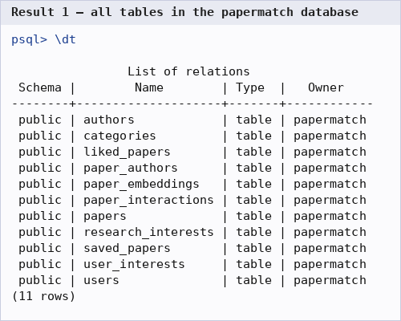
Figure 8.1: All 11 tables created by schema.sql
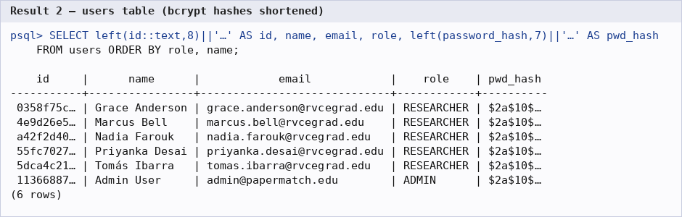
Figure 8.2: users table (5 researchers, 1 admin, bcrypt hashes)
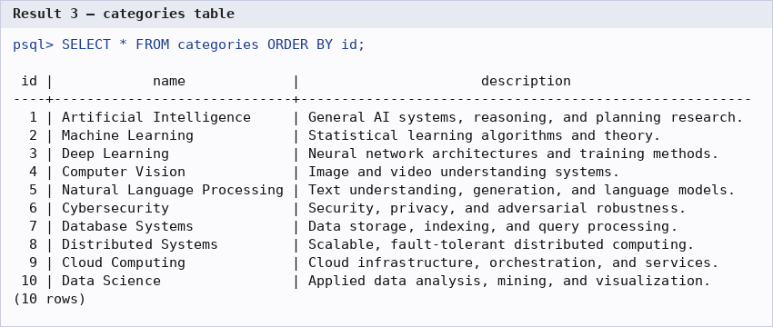
Figure 8.3: categories table
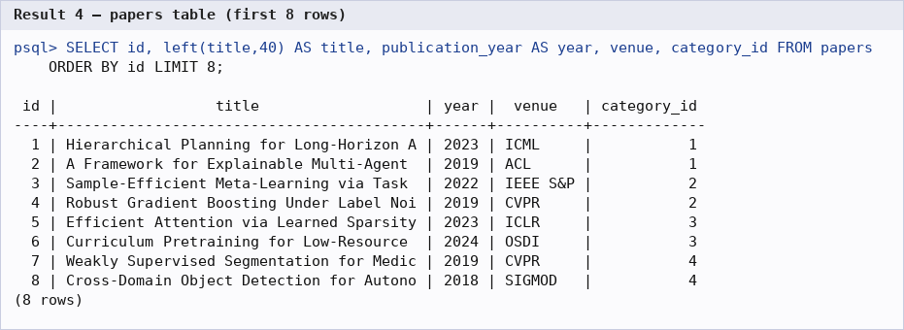
Figure 8.4: papers table (first rows)
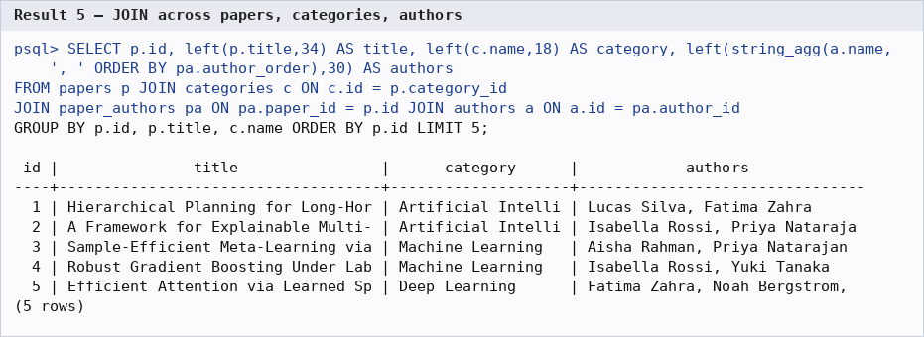
Figure 8.5: Join query across papers, categories and authors
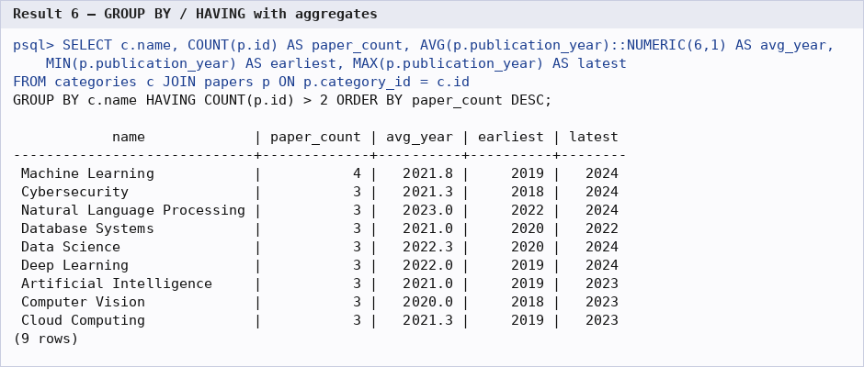
Figure 8.6: GROUP BY / HAVING with aggregate functions
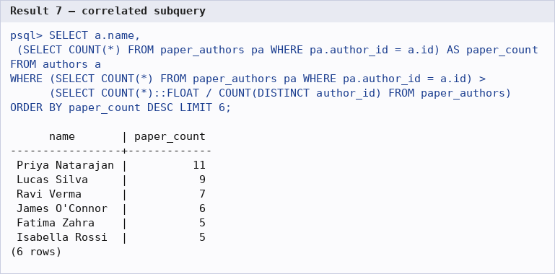
Figure 8.7: Correlated subquery
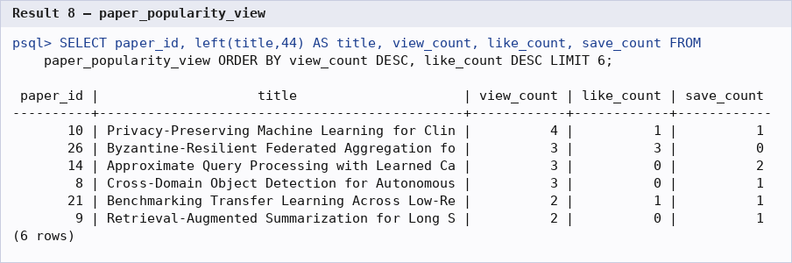
Figure 8.8: paper_popularity_view
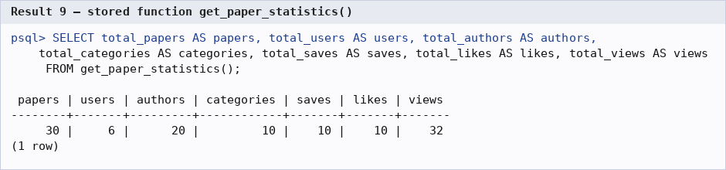
Figure 8.9: Stored function get_paper_statistics()
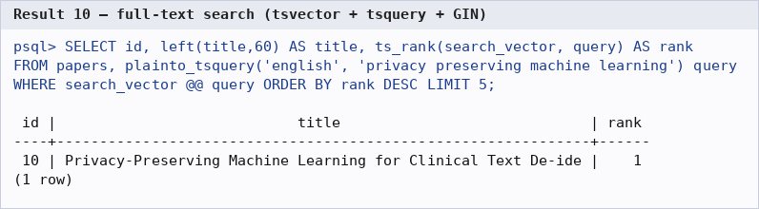
Figure 8.10: Full-text search with ts_rank
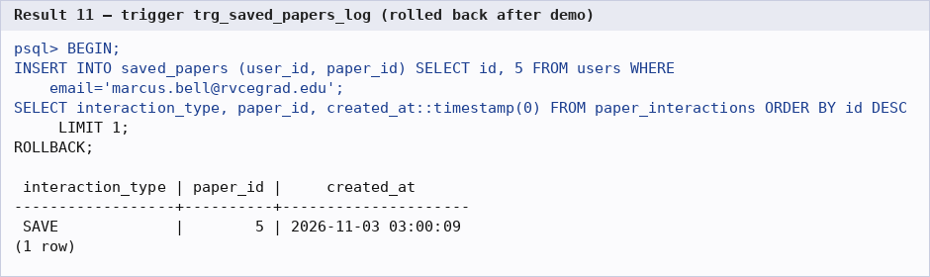
Figure 8.11: Trigger trg_saved_papers_log writes a SAVE event (transaction rolled back after the demo)
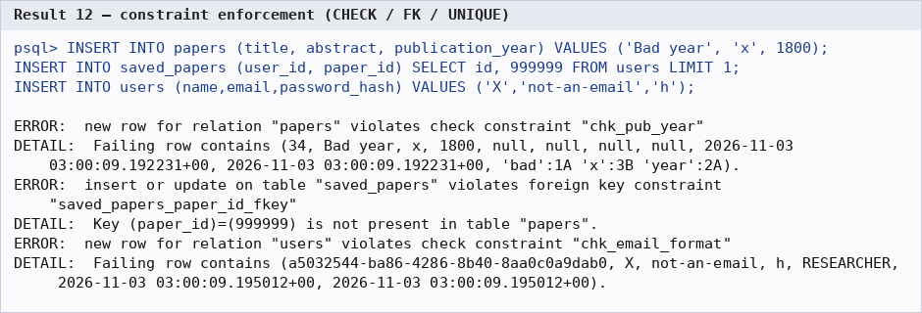
Figure 8.12: CHECK and FOREIGN KEY constraints rejecting invalid rows
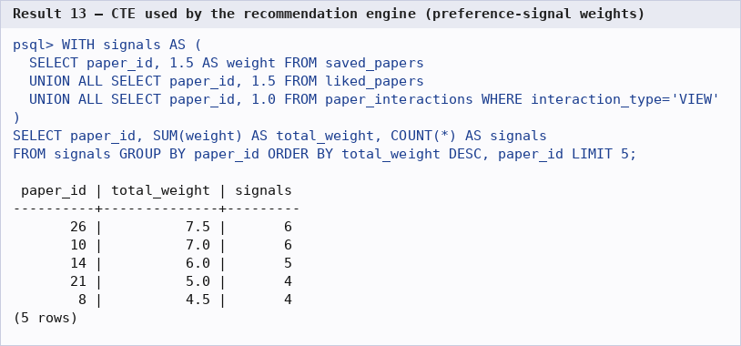
Figure 8.13: CTE computing weighted preference signals
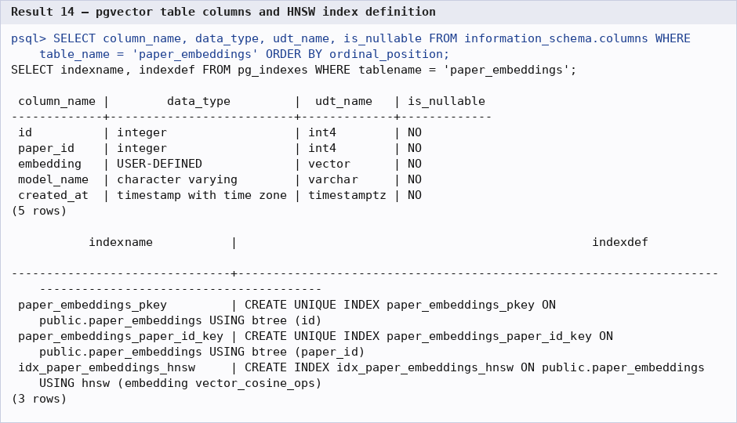
Figure 8.14: paper_embeddings structure with VECTOR(384), UNIQUE paper_id and HNSW index
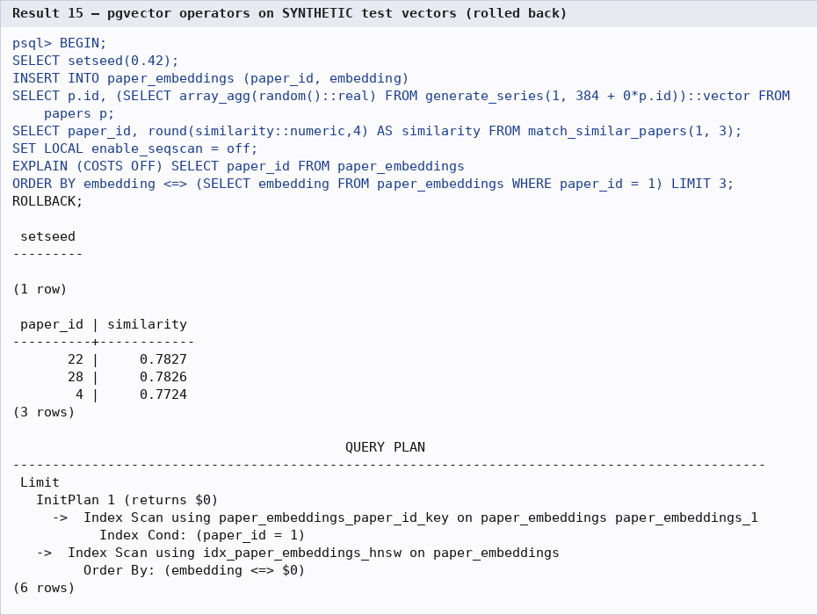
Figure 8.15: match_similar_papers() and EXPLAIN using the HNSW index
Note on Figure 8.15. The embedding model could not be downloaded in the environment where these captures were taken, so this demonstration inserted synthetic random 384-dimensional vectors inside a transaction that was rolled back afterwards. It demonstrates that match_similar_papers() and the HNSW index work; the similarity values are not real semantic scores. With the embedding service running (docker compose up -d, then npm run db:embed) the same commands return real MiniLM similarities.

9. Next.js Project Tree Structure
PaperMatch/
├── app/ # Next.js App Router: pages and API
│ ├── admin/ # Admin-only screens
│ │ ├── authors/
│ │ │ └── page.tsx # Manage authors
│ │ ├── categories/
│ │ │ └── page.tsx # Manage categories
│ │ ├── papers/
│ │ │ └── page.tsx # Manage papers
│ │ └── page.tsx # Admin dashboard and analytics
│ ├── api/ # REST route handlers (server side)
│ │ ├── admin/ # Admin-only endpoints
│ │ │ ├── analytics/
│ │ │ │ └── route.ts # GET admin analytics (ADMIN only)
│ │ │ ├── authors/
│ │ │ │ └── route.ts # GET / POST authors (ADMIN only)
│ │ │ ├── categories/
│ │ │ │ └── route.ts # GET / POST categories (ADMIN only)
│ │ │ └── papers/
│ │ │ └── [id]/
│ │ │ └── regenerate-embedding/
│ │ │ └── route.ts # POST regenerate embedding (ADMIN only)
│ │ ├── auth/ # Session endpoints
│ │ │ ├── login/
│ │ │ │ └── route.ts # POST login, sets session cookie
│ │ │ ├── logout/
│ │ │ │ └── route.ts # POST logout
│ │ │ ├── me/
│ │ │ │ └── route.ts # GET current session
│ │ │ └── register/
│ │ │ └── route.ts # POST register
│ │ ├── interactions/
│ │ │ └── route.ts # POST record VIEW / LIKE / SAVE
│ │ ├── interests/
│ │ │ └── route.ts # GET / POST / DELETE user interests
│ │ ├── liked/
│ │ │ └── route.ts # GET / POST / DELETE liked papers
│ │ ├── papers/
│ │ │ ├── [id]/
│ │ │ │ ├── similar/
│ │ │ │ │ └── route.ts # GET similar papers (pgvector)
│ │ │ │ └── route.ts # GET / PATCH / DELETE paper
│ │ │ └── route.ts # GET list, POST create paper (admin)
│ │ ├── recommendations/
│ │ │ └── route.ts # GET personalised recommendations
│ │ ├── saved/
│ │ │ └── route.ts # GET / POST / DELETE saved papers (transaction)
│ │ └── search/
│ │ ├── hybrid/
│ │ │ └── route.ts # Hybrid search endpoint
│ │ ├── semantic/
│ │ │ └── route.ts # Semantic search endpoint
│ │ └── route.ts # GET search (mode=keyword|semantic|hybrid)
│ ├── dashboard/
│ │ └── page.tsx # Recommendations and activity counts
│ ├── interests/
│ │ └── page.tsx # Choose research interests
│ ├── login/
│ │ └── page.tsx # Login form
│ ├── papers/
│ │ └── [id]/
│ │ └── page.tsx # Paper detail (VIEW, save/like, similar papers)
│ ├── profile/
│ │ └── page.tsx # Profile
│ ├── register/
│ │ └── page.tsx # Registration form
│ ├── saved/
│ │ └── page.tsx # Saved papers
│ ├── search/
│ │ └── page.tsx # Keyword / semantic / hybrid search UI
│ ├── globals.css # Tailwind base and global styles
│ ├── layout.tsx # Root layout (NavBar, footer)
│ └── page.tsx # Landing page
├── components/ # Reusable UI components
│ ├── NavBar.tsx # Navigation bar, role-aware links
│ └── PaperCard.tsx # Paper summary card
├── database/ # SQL files
│ ├── demo_queries.sql # Demonstration queries
│ ├── schema.sql # DDL: tables, indexes, triggers, views, functions
│ ├── seed.sql # Reference seed data (SQL)
│ └── seed_data.json # Seed data for scripts/seed.ts
├── docs/ # Documentation, diagrams, test notes
├── embedding-service/ # Python FastAPI microservice
│ ├── Dockerfile # Embedding service image
│ ├── main.py # FastAPI: /health, /embed, /embed/batch
│ └── requirements.txt # Python dependencies
├── lib/ # Server-side libraries
│ ├── auth.ts # bcrypt, JWT cookie, getSession(), requireRole()
│ ├── db.ts # pg Pool and withTransaction() helper
│ ├── embeddings.ts # Client for the embedding service
│ ├── recommendations.ts # Recommendation scoring engine
│ ├── search.ts # Keyword, semantic and hybrid search SQL
│ └── validation.ts # Zod request schemas
├── public/
├── scripts/ # CLI scripts
│ ├── generate-embeddings.ts # Bulk-generate paper embeddings
│ └── seed.ts # Seed users/papers/interactions (bcrypt)
├── .env.example # Environment variable template
├── docker-compose.yml # PostgreSQL+pgvector and embedding service
├── next.config.mjs # Next.js configuration
├── package.json # Dependencies and npm scripts
├── README.md # Setup and demo instructions
├── tailwind.config.ts # Tailwind configuration
└── tsconfig.json # TypeScript configuration

Purpose of important files
File / folder | Purpose
app/*/page.tsx | User-facing pages (React client components) that call the API with fetch()
app/api/**/route.ts | API route handlers; each checks the session (getSession) or role (requireRole) and runs parameterised SQL
lib/db.ts | Single pg Pool shared by the app; withTransaction() wraps BEGIN / COMMIT / ROLLBACK
lib/auth.ts | Password hashing (bcrypt), JWT creation/verification (jose), HTTP-only cookie handling, requireRole()
lib/search.ts, lib/recommendations.ts | Core logic: full-text, vector and hybrid search; weighted recommendation score
lib/embeddings.ts | Calls the embedding microservice and formats vectors as pgvector literals
database/schema.sql | Complete DDL, mounted into the PostgreSQL container for automatic creation
scripts/seed.ts, scripts/generate-embeddings.ts | Seed users/papers/interactions and bulk-generate embeddings
embedding-service/ | FastAPI microservice wrapping all-MiniLM-L6-v2
docker-compose.yml, .env.example | Infrastructure and configuration (DATABASE_URL, SESSION_SECRET, EMBEDDING_SERVICE_URL)
next.config.mjs, tailwind.config.ts, tsconfig.json | Framework, styling and TypeScript configuration

10. Sample Screenshots of Application Code and Demo

a) Working application
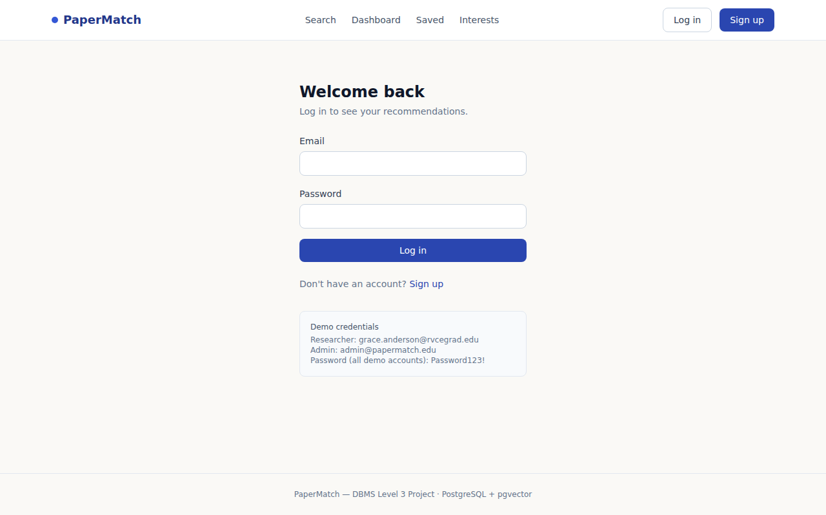
Figure 10.1: Login page
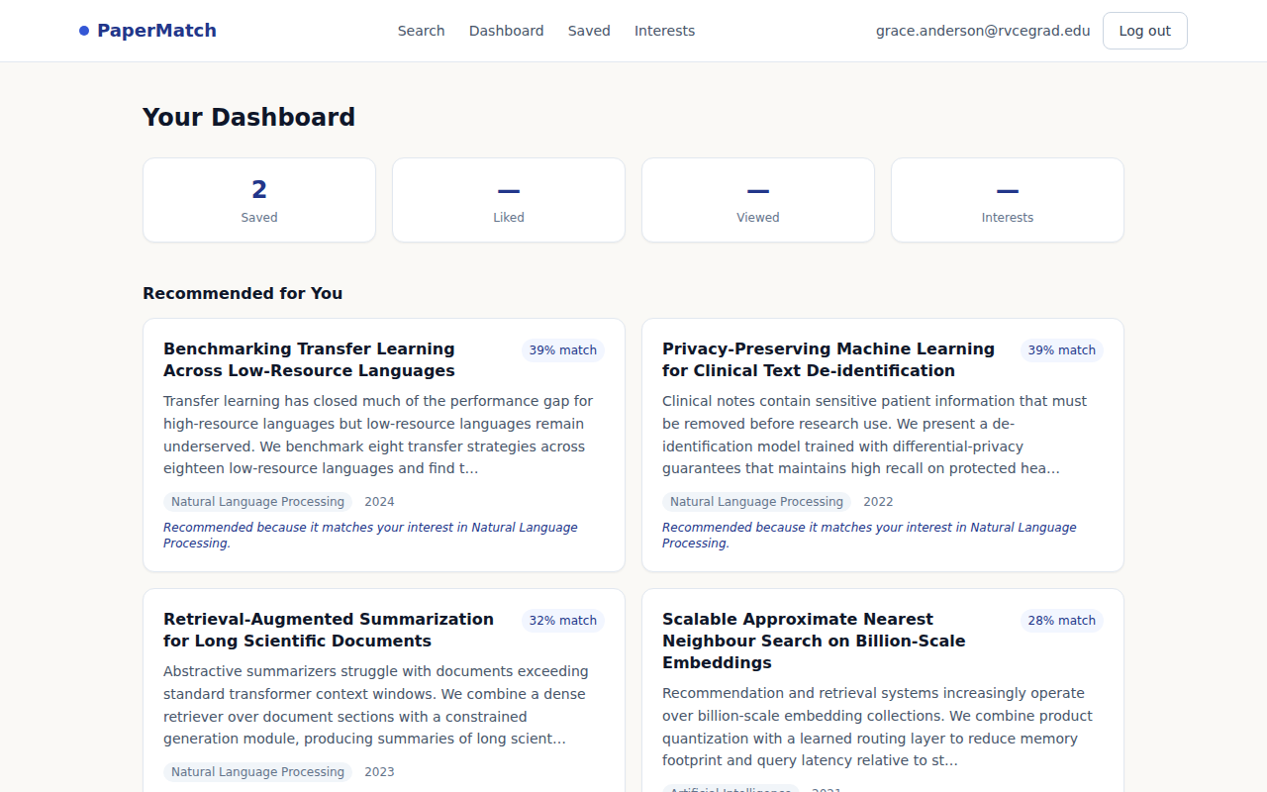
Figure 10.2: Personalised dashboard (recommendations with reasons and match scores)
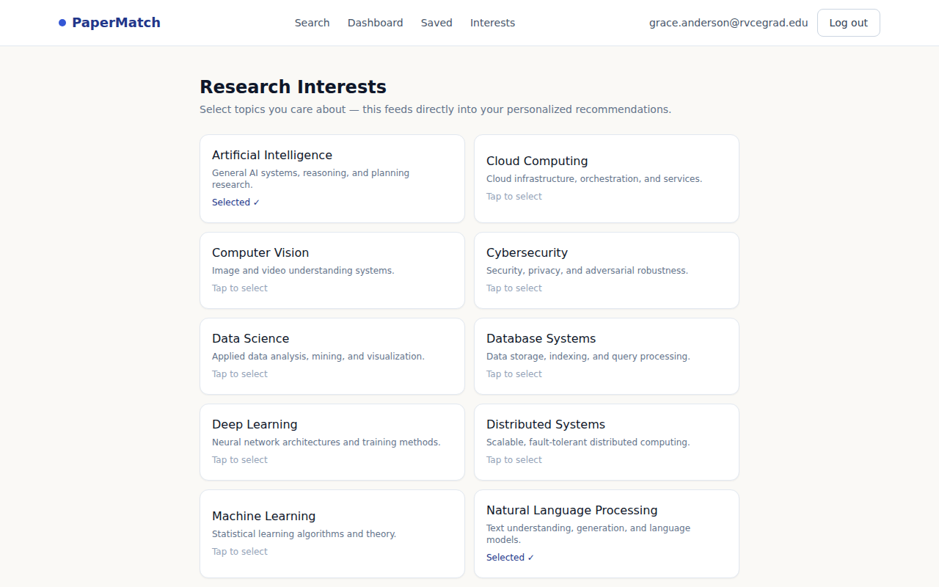
Figure 10.3: Research interests selection

Figure 10.4: Keyword search for “privacy preserving machine learning” with Keyword / Semantic / Hybrid modes
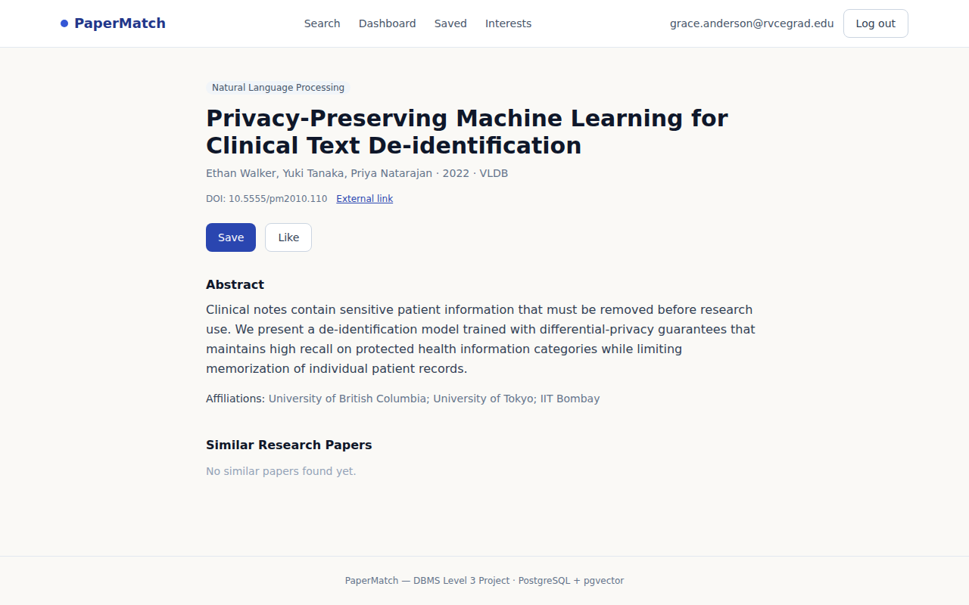
Figure 10.5: Paper detail page with Save / Like and Similar Research Papers section
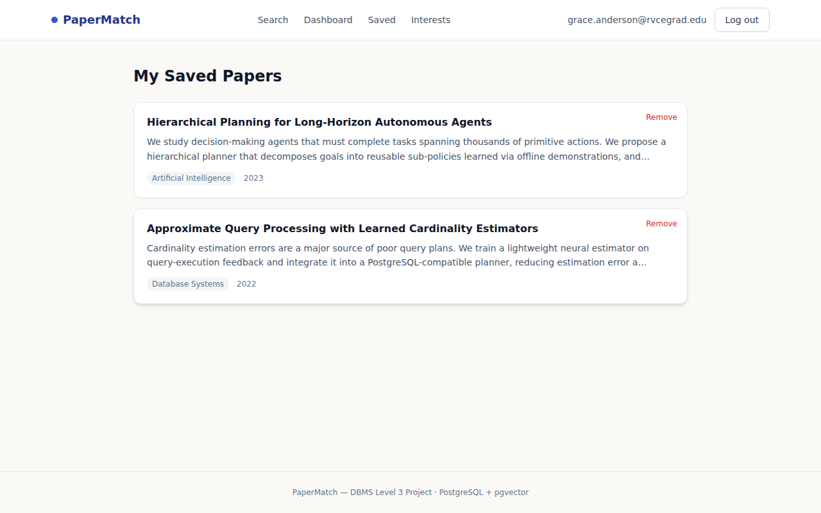
Figure 10.6: Saved papers
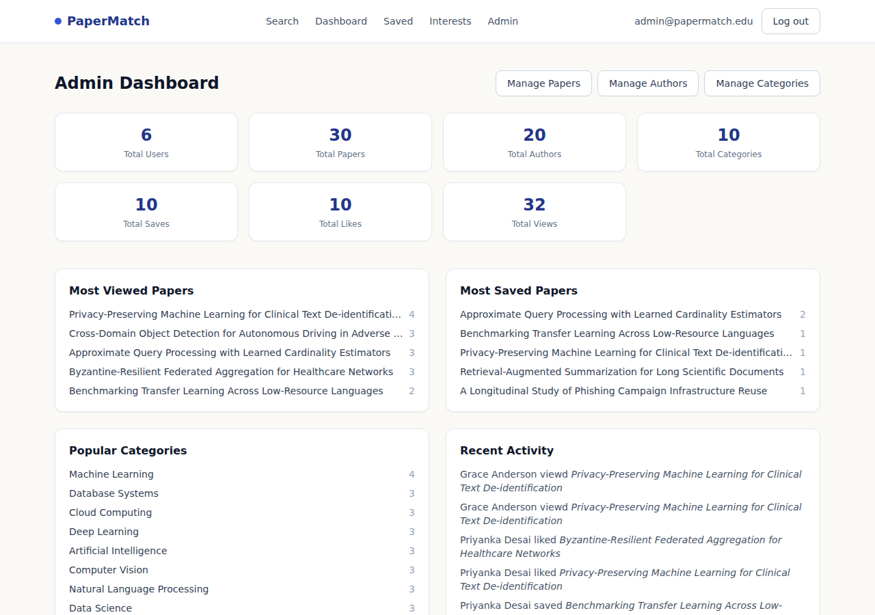
Figure 10.7: Admin dashboard with SQL-driven analytics
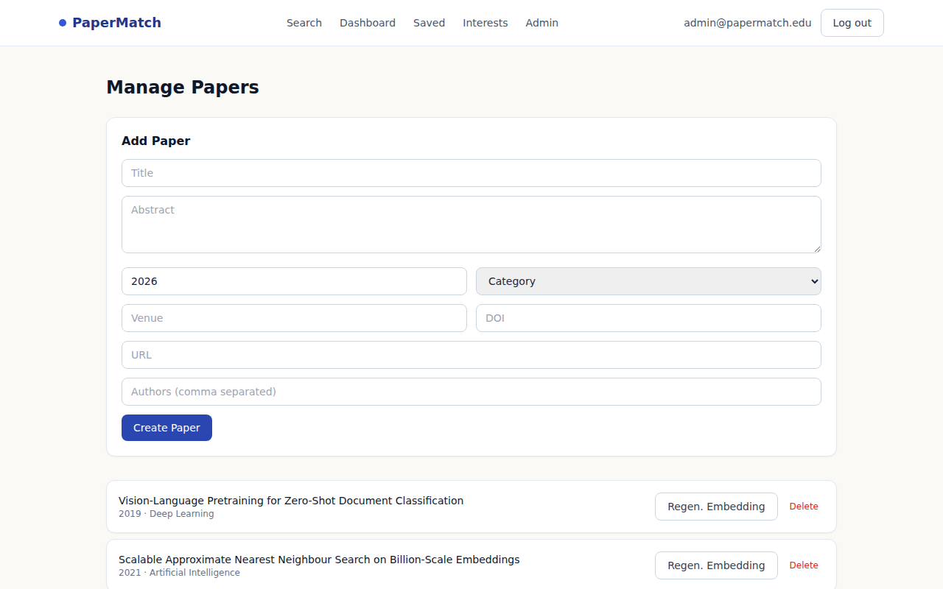
Figure 10.8: Admin – manage papers (create, delete, regenerate embedding)
In Figure 10.5 the “Similar Research Papers” section reads “No similar papers found yet” because embeddings had not been generated in the capture environment (the section is populated by match_similar_papers() once db:embed has run). Figure 10.2 therefore shows the cold-start path of the recommendation engine (interest match plus popularity).

b) Application code
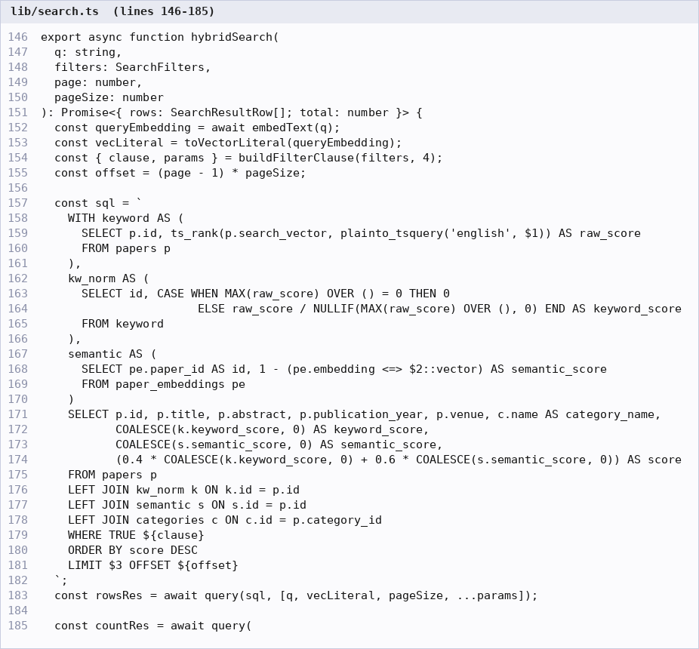
Figure 10.9: Hybrid search – CTEs combining normalised ts_rank (0.4) and cosine similarity (0.6) (lib/search.ts)
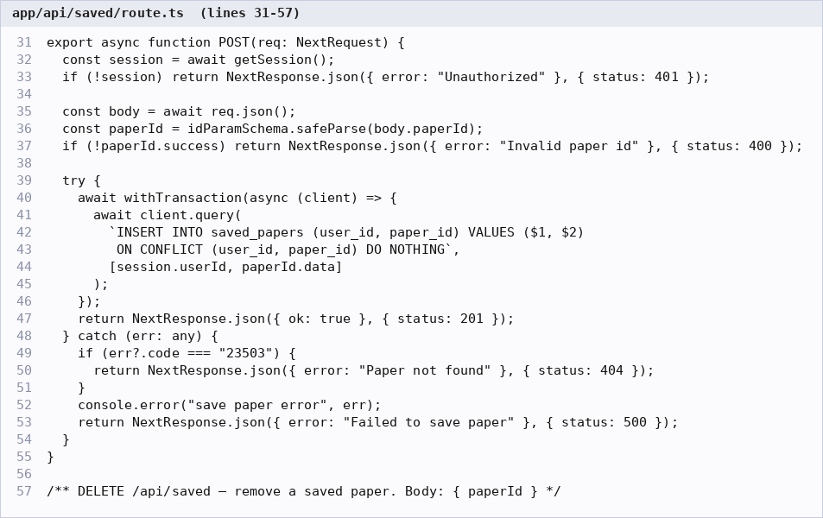
Figure 10.10: Save-paper API – explicit transaction; the trigger writes the SAVE event atomically (app/api/saved/route.ts)
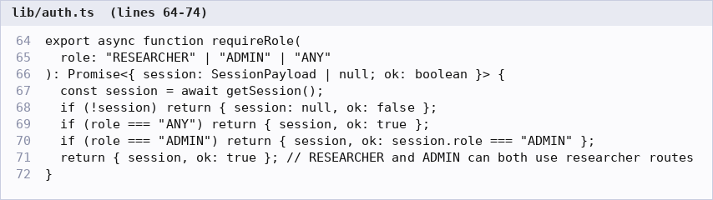
Figure 10.11: Role-based access check used by admin endpoints (lib/auth.ts)
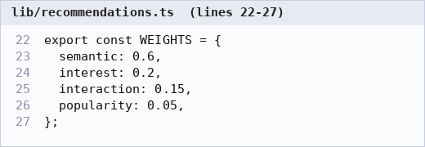
Figure 10.12: Recommendation score weights (lib/recommendations.ts)

c) API response and access-control output
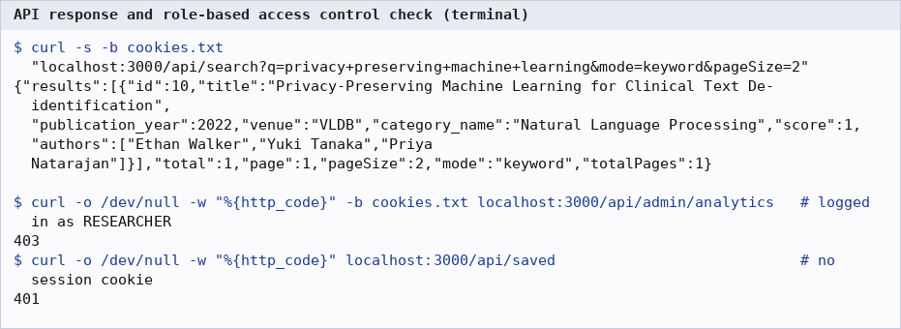
Figure 10.13: Keyword-search API response, and 403 / 401 responses for unauthorised access

11. Evaluation Rubrics – Completion Status

a) Evaluation rubric
# | Criteria | Distribution | Status
1 | Database Design | ER diagram , relational schema with keys, relationships, and constraints | Completed
2 | Database Creation | SQL database implementation - DDL with constraints , NoSQL/Vector database creation , Technology justification | Completed
3 | SQL Operations and Queries | DML operations , Nested/correlated/Recursive SQL queries, Join SQL queries | Partially Completed
4 | Advanced Database Concepts | Advanced database concepts (Procedure/function, trigger, CTE) , NoSQL/Vector feature RUD | Completed
5 | Web Application and Database Integration | Next.js interface , Backend/API and database integration | Completed
6 | Authentication and Authorization | Authentication implementation (front end and backend) and minimum two roles and role-based access control in database | Partially Completed
7 | Documentation, Git/GitHub, Demonstration, Testing, and Originality | Documentation, Git/GitHub , Originality and individual contribution | Partially Completed

b) Reasons for the ratings
• 3 – SQL Operations and Queries (Partially Completed): INSERT/UPDATE/DELETE, joins, GROUP BY/HAVING, nested, correlated and EXISTS subqueries and non-recursive CTEs are all implemented. No RECURSIVE query is used anywhere in the project.
• 6 – Authentication and Authorization (Partially Completed): login, registration, bcrypt hashing, HTTP-only JWT cookies, two roles and server-side role checks on every protected API route are implemented (unauthorised access returns 401 / 403, Figure 10.13), and admin pages show an access-denied message. Role-based access is enforced in the application layer only; the database has a role column and ENUM but no GRANT/REVOKE database roles or row-level security.
• 7 – Documentation, Git/GitHub, Demonstration, Testing, Originality (Partially Completed): documentation (docs/), a demo script and a test plan with recorded results are included. The repository has .gitignore and LICENSE, but no automated unit or integration test suite exists, and the GitHub link and commit history showing each member’s contribution still need to be added.

c) Feature-level completion status
# | Feature | Status | Notes
1 | Registration and login (bcrypt, JWT cookie) | Completed | Demonstrated, Figure 10.1
2 | Two roles with server-side role checks (RESEARCHER, ADMIN) | Completed | 401 / 403 verified, Figure 10.13
3 | Database-level access control (GRANT / RLS) | Not Completed | Roles live in an application column only
4 | Relational schema, 11 tables, constraints, 14 indexes | Completed | Figures 8.1 and 8.12
5 | Views, stored functions, triggers, transactions | Completed | Figures 8.8, 8.9, 8.11
6 | Keyword search (full-text search, GIN) | Completed | Figures 8.10 and 10.4
7 | Semantic and hybrid search (pgvector, HNSW) | Completed | Implemented in lib/search.ts; HNSW use shown in Figure 8.15 with synthetic vectors. Live MiniLM results require the embedding service and are not shown in this report
8 | Similar papers on paper page | Completed | Implemented via match_similar_papers(); empty until embeddings are generated (Figure 10.5)
9 | Personalised recommendations with explanations | Completed | Cold-start path shown (Figure 10.2); semantic component needs embeddings
10 | Save / like / view tracking, interests | Completed | Figures 10.3, 10.6, 8.11
11 | Admin analytics (SQL aggregation) | Completed | Figure 10.7
12 | Admin papers: create, delete, regenerate embedding | Completed | Update is available through PATCH /api/papers/[id]; the UI has no edit form
13 | Admin authors and categories | Partially Completed | List and create only; no edit or delete
14 | Recursive SQL query | Not Completed | Not used in the project
15 | Docker Compose deployment | Completed | PostgreSQL+pgvector and embedding service
16 | Automated test suite | Not Completed | Manual and SQL-level testing only (docs/testing.md, docs/test-results.md)
17 | GitHub repository and contribution history | Partially Completed | Repository structure ready; link and commit history to be added

d) Team contribution
Both members worked on all parts of the report; the code and database work was divided as follows, with an equal share of files and effort.
Area | Samarth S. Maladkar (PES1UG24AM396) | Krishna G Pai (PES1UG24AM372)
Database | Vector layer: paper_embeddings, HNSW index, match_similar_papers(), demo vector queries | Core schema: tables, constraints, indexes, triggers, views, functions, seed data
Backend | Search and recommendation engine, embedding client, similar-papers API, papers CRUD API, admin analytics and embedding-regeneration APIs | Database connection, authentication and authorization, validation, interaction/saved/liked/interests APIs, admin authors/categories APIs
Microservice / scripts | FastAPI embedding service, generate-embeddings script | Seed script, Docker Compose
Frontend | Search, dashboard, paper detail, admin dashboard and admin papers pages | Login, register, interests, saved, profile, admin authors/categories pages, NavBar
Report and docs | Sections 1, 2, 7, 10; recommendation and vector docs | Sections 3, 4, 5, 6, 11; ER and schema docs

