Relationship Analysis
Overview
The Power BI data model was enhanced by introducing additional relationships to improve data connectivity, filtering, and analytical capability. The updated model follows a more structured and optimized star-schema approach.

Before Adding Relations (Default Power BI relations) –

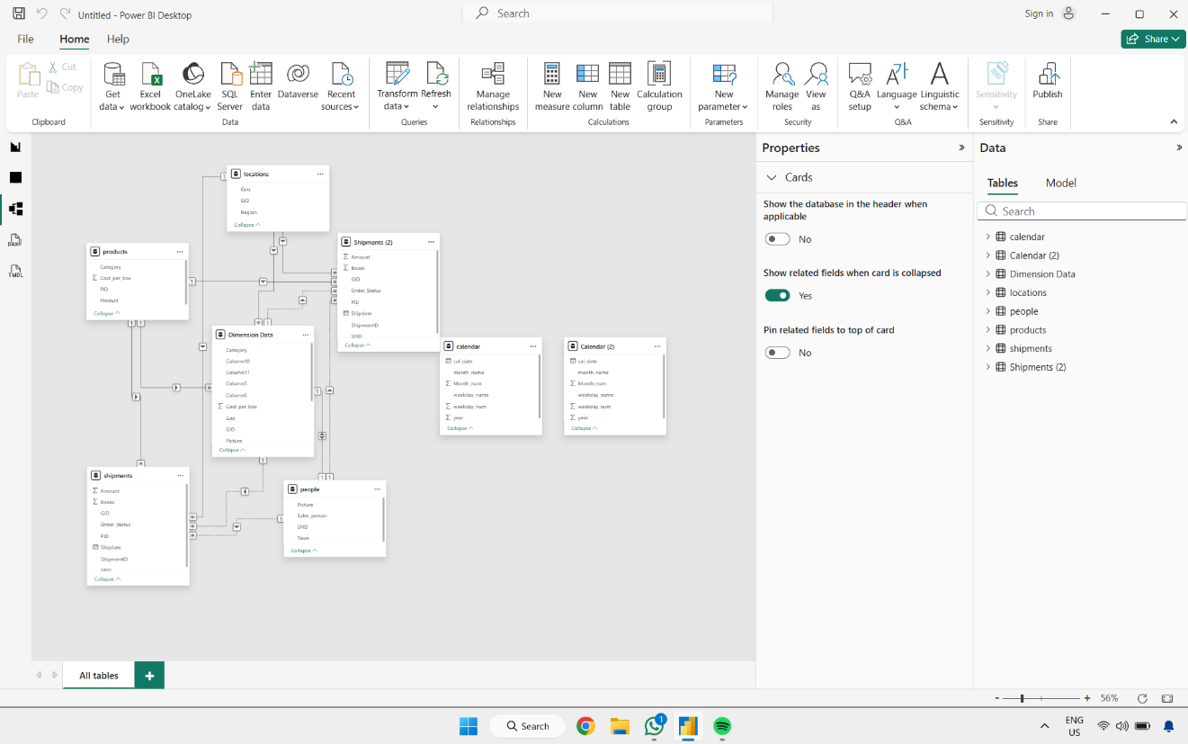

Newly Created Relationships
Calendar → Shipments
calendar[cal_date] → shipments [Shipdate]
Cardinality: One-to-Many (1:*)
Purpose: Enables time-based analysis on shipment data.

Calendar (2) → Shipments (2)
Calendar (2)[cal_date] → Shipments (2)[Shipdate]
Cardinality: One-to-Many (1:*)
Purpose: Enables date-based analysis for the second shipments table.

People → Shipments
people[SPID] → shipments[SPID]
Cardinality: One-to-Many (1:*)

People → Shipments (2)
people[SPID] → Shipments (2)[SPID]
Cardinality: One-to-Many (1:*)

Dimension Data → Shipments
Dimension Data[PID] → shipments[PID]
Cardinality: One-to-Many (1:*)

Dimension Data → Shipments (2)
Dimension Data[PID] → Shipments (2)[PID]
Cardinality: One-to-Many (1:*)

After adding custom Relations

