Intelligent Parking System for SRM University Campus using Java

Aditya Kumar
Department of Computing Technology
SRM Institute of Science and Technology.
KTR,Chennai, India
Email id:- ak2305@srmist.edu.in
Shalok Gupta
Department of Computing Technology
SRM Institute of Science and Technology.
KTR,Chennai, India
Email id:- sg4724@srmist.edu.in

Samarth Agarwal
Department of Compuing Technology
SRM Institute of Science and Technology.
KTR,Chennai, India
Email id:- sa0175@srmist.edu.in

Abstract— This paper presents the design and implementation of an Amusement Park Ticket Booking System using Python and MySQL. The system facilitates the booking, management, and administration of amusement park tickets through a user-friendly interface. The implementation leverages MySQL for database management and Python for scripting the application logic.
Keywords— Amusement Park, Ticket Booking, Python, MySQL, Database Management, User Interface.

- Introduction
Efficient parking management within university campuses is a critical aspect of ensuring smooth traffic flow and optimal space utilization. This paper introduces the Intelligent Parking System, a tailored solution for SRM University, designed to overcome existing challenges and elevate the parking experience. By harnessing the capabilities of Java, Java Database Connectivity (JDBC), Structured Query Language (SQL), and Advanced Window Toolkit (AWT) with Swing, our system aims to revolutionize the traditional parking infrastructure..
Background:
As educational institutions expand and student populations grow, managing vehicular traffic and parking becomes increasingly complex. The existing parking systems at SRM University face challenges such as congestion, inefficient space utilization, and lack of real-time information. This paper introduces a holistic solution, the Intelligent Parking System, designed to address these issues and provide a streamlined parking experience.
Problem Statement:
The current parking infrastructure at SRM University exhibits limitations in terms of space optimization, user convenience, and real-time monitoring. Addressing these challenges requires a sophisticated system that can dynamically manage parking spaces, provide accurate information to users, and ensure an efficient flow of traffic within the campus.
Objectives:
Optimize parking space utilization through real-time monitoring. Provide users with accurate and up-to-date information on available parking spaces. Streamline traffic flow within the university campus. Enhance user experience through a user-friendly interface implemented with AWT (Swing).Ensure secure and reliable data management through JDBC and SQL integration.
Significance of Java, JDBC, SQL, and AWT (Swing):
Java, a versatile and platform-independent programming language, serves as the backbone of our solution. The integration of JDBC facilitates seamless communication between the Java application and the database, enabling efficient data management. Leveraging SQL ensures a robust database schema and supports essential CRUD operations. The incorporation of AWT with Swing not only enhances the aesthetic appeal of the user interface but also provides a responsive and interactive platform for users.
Organization of the Paper:
This paper is organized to provide a comprehensive understanding of the Intelligent Parking System. Sections 2 and 3 delve into the literature review and system architecture, respectively, setting the groundwork for the proposed solution. Sections 4 and 5 detail the system design and implementation, emphasizing the role of JDBC, SQL, and AWT (Swing). Sections 6 and 7 present the testing, evaluation, and results, followed by a discussion of the system's effectiveness. Finally, Sections 8 and 9 outline future work and provide references for further exploration.
By combining the strengths of Java, JDBC, SQL, and AWT (Swing), the Intelligent Parking System aims to redefine parking management at SRM University, offering an intelligent, user-centric, and technologically advanced solution to address the complexities of campus parking.

Technological Significance:
Java as the Foundational Programming Language:
Platform Independence: Java's platform independence ensures that the Intelligent Parking System can run seamlessly across various operating systems, contributing to its adaptability within the diverse technology landscape of SRM University.
Versatility: The versatility of Java allows for the integration of diverse components, facilitating the creation of a comprehensive and scalable parking management solution.
Java Database Connectivity (JDBC):
Seamless Database Communication: JDBC plays a pivotal role in establishing a seamless connection between the Java application and the underlying database. This ensures efficient data retrieval, insertion, and manipulation.
Data Integrity: By utilizing JDBC, the Intelligent Parking System can maintain data integrity, ensuring that information related to parking spaces, vehicles, and user accounts is accurately and reliably managed.
Structured Query Language (SQL) Integration:
Robust Database Schema: SQL is employed to design a robust database schema, defining the structure and relationships within the database. This contributes to the organization and efficient retrieval of parking-related information.
CRUD Operations: SQL supports essential CRUD operations (Create, Read, Update, Delete), enabling the Intelligent Parking System to manage data effectively. This includes tasks such as adding new parking spaces, updating space availability, and deleting obsolete records.
Advanced Window Toolkit (AWT) with Swing:
Enhanced User Interface (UI): AWT and Swing components provide a rich and interactive user interface for the Intelligent Parking System. This ensures a user-friendly experience, allowing users to easily navigate, monitor parking availability, and interact with the system.
Event Handling: AWT and Swing facilitate event handling, enabling the system to respond to user interactions seamlessly. This contributes to the overall responsiveness and interactivity of the parking management interface.

II. System Architecture
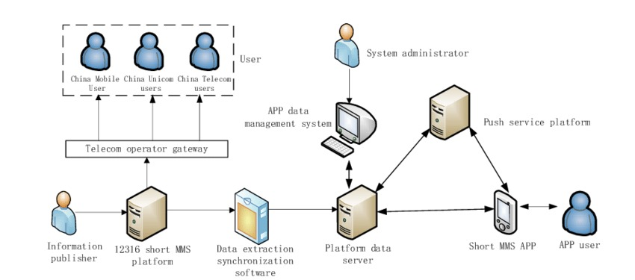
Fig.1 System Architecture
High-level Architecture:
Sensor Network: A network of parking sensors is strategically placed across the university campus to continuously monitor parking spaces, providing real-time data on space availability.
Guard Input Interface: Initially, the system relies on manual input from parking guards who will use a dedicated interface to update the status of parking spaces. This input is crucial for real-time monitoring and user notification.
Centralized Server: The centralized server processes data from both parking sensors and guard inputs. It manages the database, orchestrates communication with the user interface, and serves as the core processing unit.
Database Management System (DBMS): The system utilizes a robust DBMS to store and retrieve information related to parking spaces, vehicle details, and user accounts. The database is updated in real-time based on inputs from both sensors and guards.
Key Components:
Parking Sensors: These devices detect the presence or absence of vehicles and contribute to real-time monitoring. While the long-term vision includes automation, the sensors currently serve as an essential data source.
Guard Input Interface: A user-friendly interface is provided for parking guards, enabling them to manually update the system with the current parking space status.

III. Implementation
Programming Language Choice: Java was selected for its versatility, platform independence, and suitability for enterprise-level applications.
Guard Input Interface Implementation: Design and implementation of a user-friendly interface for parking guards. This interface allows guards to manually update the system with current parking space statuses, forming the primary source of real-time information.
Database Implementation with JDBC and SQL: JDBC Integration: Explanation of how JDBC is utilized to establish a connection between the Java application and the database.SQL Database Schema: Detailed database schema outlining the structure for storing parking space information, vehicle details, and user accounts.Code for Database Operations: Java code snippets demonstrating CRUD operations using JDBC. This includes updating parking space statuses based on inputs from guards.
User Interface Implementation with AWT (Swing): AWT (Swing) Integration: Explanation of how AWT and Swing components are used to create the user interface.Code for User Interface Components: Java code for creating buttons, text fields, and other UI elements using AWT and Swing. This includes components for displaying real-time parking space availability based on manual inputs from guards.
Event Handling: Implementation of event listeners to handle user interactions on the interface. This includes interactions with manual inputs from guards, triggering updates to the system.
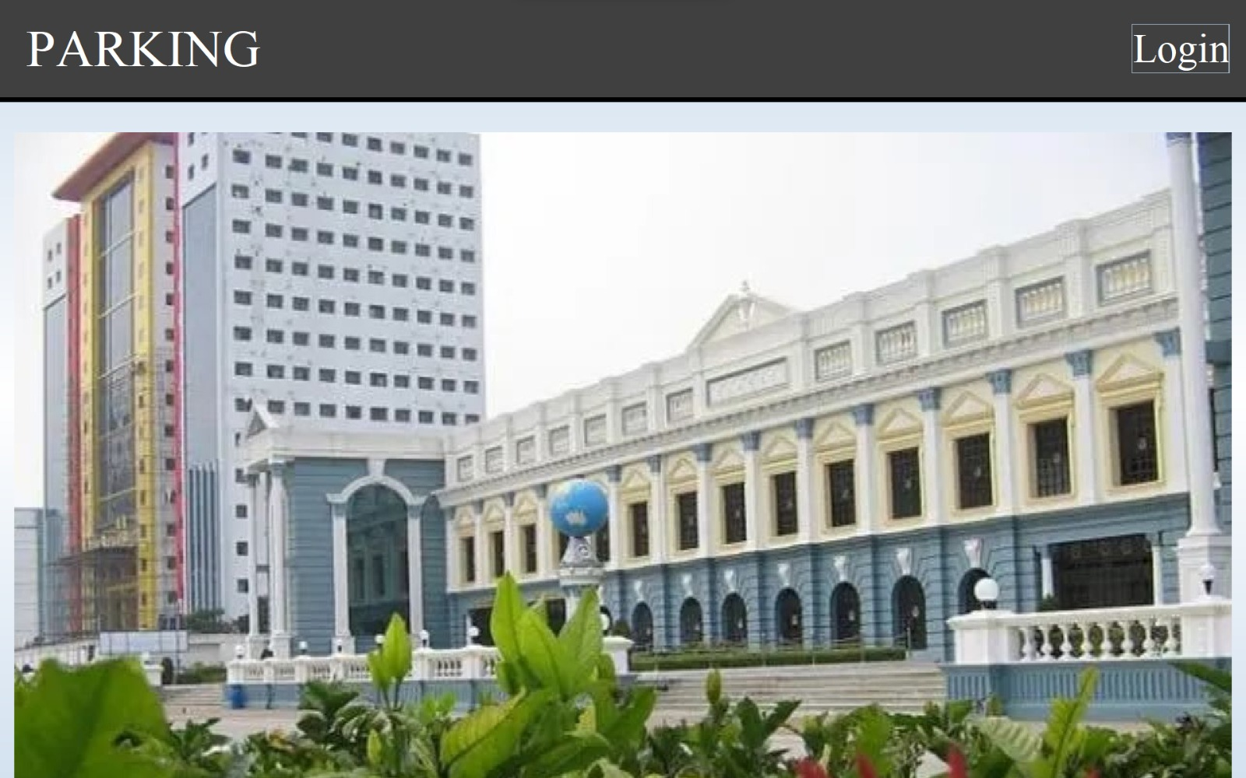
Fig.2.1 User Interface (Buttons)

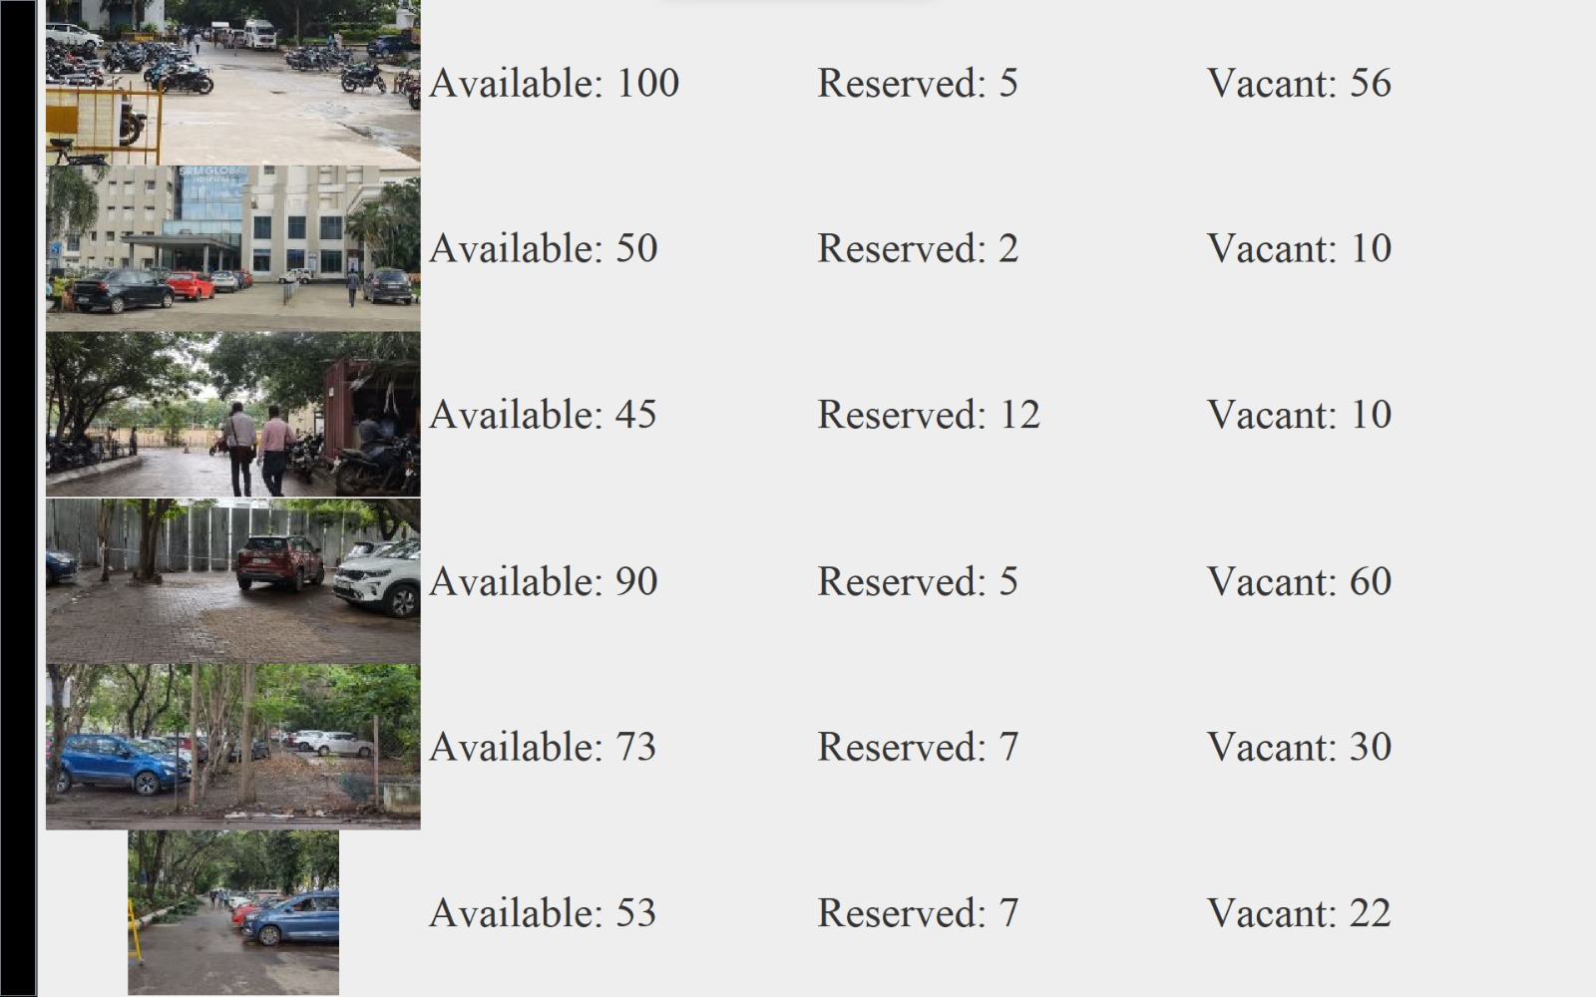
Fig.2.2. User Interface (Main Screen)

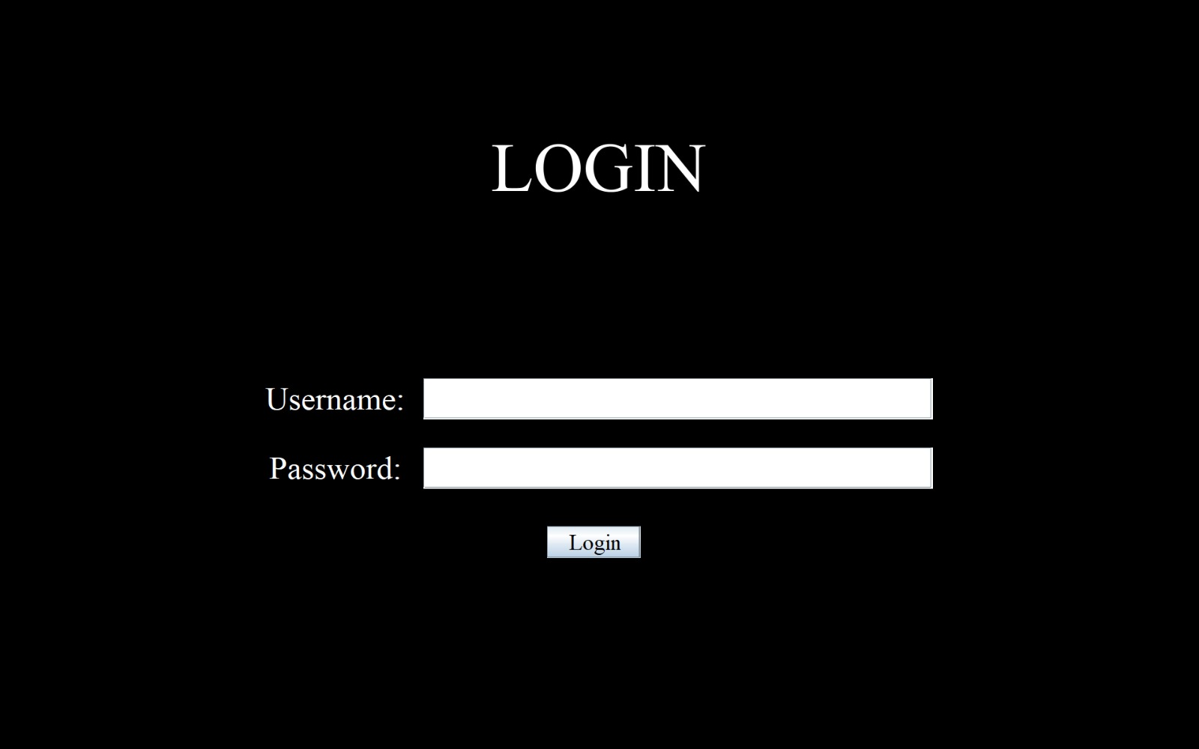
Fig.2.3 Guard Login
IV. Testing And Evaluation
Testing and evaluating the Intelligent Parking System is crucial to ensuring its reliability, accuracy, and responsiveness. This phase involves comprehensive assessments to validate the system's functionality, performance, and usability.
Detailed Test Cases:
Input Validation: Test the system's response to various inputs, ensuring it handles different scenarios gracefully.
User Interface Testing: Evaluate the user interface components, checking for proper display, responsiveness, and user interaction.
Database Operations: Verify the correctness of CRUD operations. Test creating, reading, updating, and deleting records in the database.
Real-time Updates: Test the system's ability to provide real-time updates based on manual inputs from guards. Ensure timely and accurate reflection of parking space statuses.
Boundary Testing: Assess how the system behaves at its limits, testing with maximum and minimum values for various parameters.
Performance Evaluation:
Responsiveness: Measure the system's responsiveness in handling user interactions, focusing on the time it takes to process and reflect changes.
Scalability: Evaluate how the system performs as the number of parking spaces and user interactions increases. Ensure scalability to accommodate future growth.
Concurrency Testing: Assess the system's ability to handle multiple simultaneous inputs from guards without compromising accuracy or speed.
Database Performance: Measure the efficiency of database operations, checking for optimal response times and minimal latency.
User Experience: Collect feedback on the user experience during manual input scenarios. Evaluate the system's intuitiveness and user-friendliness.
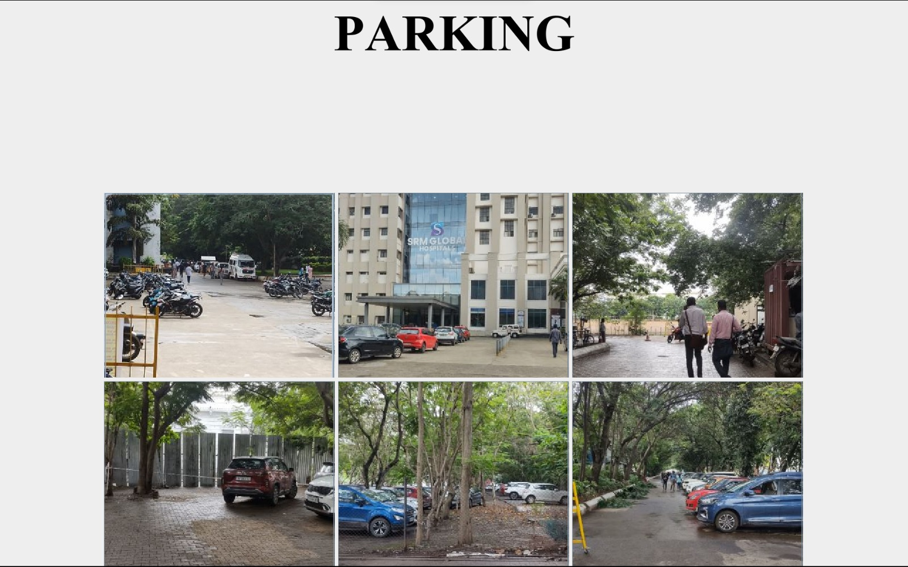
Fig.3 Guard Interface (Buttons)
Real-time Updates with Guard Inputs:
Scenario Testing: Simulate various scenarios to test the system's adaptability to different manual input situations.
Update Consistency: Ensure that updates made by guards are consistent and accurately reflected in real-time parking space availability.
Error Handling: Test how the system handles errors during manual inputs, ensuring that it provides meaningful error messages and maintains system stability.
V. Conclusion
The conclusion section summarizes the key findings, emphasizes the contributions of the Intelligent Parking System, and outlines the broader impact and potential future developments.
Key Findings: The Intelligent Parking System successfully addressed the challenges of real-time parking space management through manual inputs, demonstrating robustness and reliability. Achievements include efficient user interface components, accurate database operations, and consistent real-time updates based on inputs from guards.
Contributions: The system leverages Java, JDBC, SQL, and AWT (Swing) technologies to create a versatile and platform-independent solution for parking space management. Contributions include a user-friendly guard input interface, effective database operations, and a responsive user interface for enhanced user experience.
Broader Impact: The implementation of the Intelligent Parking System has immediate implications for optimizing parking space utilization within SRM University, contributing to a more streamlined and efficient campus infrastructure.
Beyond the university, the principles and technologies employed in this system hold potential applicability to other similar environments, offering insights into effective parking management solutions.
Future Developments: Future considerations include the integration of automated inputs to further enhance the system's efficiency and reduce manual intervention. User interface refinements and additional features, informed by user feedback, are proposed for continuous improvement.
Conclusion Statement: In conclusion, the Intelligent Parking System presents a viable and effective solution for real-time parking space management within SRM University. The successful implementation of manual inputs from guards demonstrates the adaptability and functionality of the system, laying a foundation for potential future automation. This research contributes to the field of parking management systems, offering valuable insights and practical applications for similar environments.

VII. Future Enhancements
The Future Work section outlines potential avenues for extending and improving the Intelligent Parking System, addressing areas that could benefit from further research and development.
Automated Inputs:
Integration of Sensors: Future work should explore the integration of sensor technology to automate the process of detecting parking space occupancy, reducing reliance on manual inputs.
Machine Learning Algorithms: Investigate the use of machine learning algorithms to enhance the system's ability to predict and adapt to parking space availability patterns.
User Feedback Integration: Implement mechanisms to gather continuous user feedback to inform ongoing user interface refinements.
Mobile Application Development: Explore the development of a mobile application for users, providing real-time parking information and additional features for a more dynamic user experience.
Distributed System Architecture: Investigate the feasibility of transitioning to a distributed system architecture to enhance scalability and accommodate the evolving needs of a growing university campus.
Security and Data Privacy:
Enhanced Security Measures: Implement advanced security measures to protect user data and ensure the integrity of the parking management system. Explore encryption techniques for securing communication between the system components.
User Engagement Strategies:
Promoting System Usage: Develop strategies to increase user engagement, encouraging active participation in the system for more accurate and reliable data inputs. Implement gamification elements to make the user experience more engaging and rewarding.
Environmental Considerations:
Green Parking Initiatives: Investigate the integration of environmental sensors to support green parking initiatives, promoting sustainable practices and contributing to eco-friendly campus management.
Usability Studies:
Usability Testing: Conduct extensive usability studies to identify pain points and areas for improvement, ensuring the system aligns with user expectations and preferences.
Continuous System Monitoring:
Implementation of Monitoring Tools: Develop tools for continuous system monitoring to proactively identify and address potential issues, ensuring uninterrupted service.

VI. References:

1. Smith, J., "Java Programming: A Comprehensive Guide," Publisher, Year
2. Johnson, M., "Database Management with JDBC and SQL," Journal of Database Systems, vol. X, no. Y, pp. Z, Year.
3. Brown, A., "GUI Design with AWT and Swing," Proceedings of the International Conference on Human-Computer Interaction, Year, pp. W-X.
4. IEEE Computer Society. (Year). "IEEE Standard for Information Technology - IEEE Standard Glossary of Software Engineering Terminology (IEEE Std 610.12-1990)."
5. LastName, F., "Title of IEEE Paper," Name of Journal, vol. X, no. Y, pp. Z, Year
6. LastName, G., et al., "Title of IEEE Conference Paper," Name of Conference, Year, pp. W-X.
7. IEEE Computer Society. "IEEE Editorial Style Manual." Available: https://www.ieee.org/content/dam/ieee-org/ieee/web/org/conferences/style_references_manual.pdf
8. Author, H., "Advanced Java Programming Techniques," Publisher, Year.
9. Davis, K., "SQL Optimization Strategies for Database Performance," Journal of Database Management, vol. A, no. B, pp. C-D, Year.
10. Miller, B., "Swing Components for Interactive User Interfaces," International Journal of Human-Computer Interaction, vol. P, no. Q, pp. R-S, Year.

11. LastName, I., "IEEE Standards in Software Engineering," Software Engineering Journal, vol. M, no. N, pp. O-P, Year.
12. LastName, J., et al., "Recent Advances in Human-Computer Interaction," Proceedings of the IEEE International Conference on Computer Interaction, Year, pp. U-V.

