**VISVESVARAYA TECHNOLOGICAL UNIVERSITY**

**“JnanaSangama”, Belgaum -590014, Karnataka.**



**LAB REPORT**

**on**

**Analysis and Design of Algorithms**

***Submitted by***

**SAMARTH M SHETTY(1BM21CS184)**

***in partial fulfillment for the award of the degree of***

**BACHELOR OF ENGINEERING**

***in***

**COMPUTER SCIENCE AND ENGINEERING**



**B.M.S. COLLEGE OF ENGINEERING**

**(Autonomous Institution under VTU)**

**BENGALURU-560019**

**June-2023 to September-2023**

**B. M. S. College of Engineering,**

**Bull Temple Road, Bangalore 560019**

(Affiliated To Visvesvaraya Technological University, Belgaum)

**Department of Computer Science and Engineering**



**CERTIFICATE**

This is to certify that the Lab work entitled “**Analysis and Design of Algorithms**” carried out by **Samarth M Shetty(1BM21CS184),** who is bonafide student of **B.M.S. College of Engineering.** It is in partial fulfillment for the award of **Bachelor of Engineering in Computer Science and Engineering** of the Visvesvaraya Technological University, Belgaum during the academic semester June-2023 to September-2023. The Lab report has been approved as it satisfies the academic requirements in respect of a **Analysis and Design of Algorithms (22CS4PCADA)** work prescribed for the said degree.

Prameetha Pai                Dr. Jyothi S Nayak

Assistant Professor Professor and Head

Department of CSE Department of CSE

BMSCE, Bengaluru BMSCE, Bengaluru

**INDEX**

|  |  |  |
| --- | --- | --- |
| **Lab Program No.** | **Program Details** | **Page No.** |
| 1 | Write program to do the following:  a. Print all the nodes reachable from a given starting node in a digraph using BFS method.  b. Check whether a given graph is connected or not using DFS method. | 5 |
| 2 | Write program to obtain the Topological ordering of vertices in a given digraph. | 10 |
| 3 | Implement Johnson Trotter algorithm to generate permutations. | 13 |
| 4 | Sort a given set of N integer elements using Merge Sort technique and compute its time taken. Run the program for different values of N and record the time taken to sort. | 17 |
| 5 | Sort a given set of N integer elements using Quick Sort technique and compute its time taken. | 20 |
| 6 | Sort a given set of N integer elements using Heap Sort technique and compute its time taken. | 23 |
| 7 | Implement 0/1 Knapsack problem using dynamic programming. | 26 |
| 8 | Implement All Pair Shortest paths problem using Floyd’s algorithm. | 29 |
| 9 | Find Minimum Cost Spanning Tree of a given undirected graph using Prim’s and Kruskal’s algorithm. | 31 |
| 10 | From a given vertex in a weighted connected graph, find shortest paths to other vertices using Dijkstra’s algorithm. | 36 |
| 11 | Implement “N-Queens Problem” using Backtracking. | 38 |
| 12 | Leet Code Problems | 41 |

**Course Outcome**

|  |  |
| --- | --- |
| CO1 | Analyze time complexity of Recursive and Non-recursive algorithms using asymptotic notations. |
| CO2 | Apply various design techniques for the given problem. |
| CO3 | Apply the knowledge of complexity classes P, NP, and NP-Complete and prove certain  problems are NP-Complete |
| CO4 | Design efficient algorithms and conduct practical experiments to solve problems. |

**1.Write program to do the following:**

**a. Print all the nodes reachable from a given starting node in a digraph using BFS method.**

**b. Check whether a given graph is connected or not using DFS method.**

**Code:**

#include<stdio.h>

#include<conio.h>

int a[15][15],n;

void bfs(int);

void main() {

int i,j,root;

printf("\nEnter the no of nodes:\t");

scanf("%d",&n);

printf("\nEnter the adjacency matrix:\n");

for(i=1;i<=n;i++)

for(j=1;j<=n;j++)

scanf("%d",&a[i][j]);

printf("\nEnter the source node:\t");

scanf("%d",&root);

bfs(root);

}

void bfs(int root) {

int q[15],f=0,r=-1,vis[15],i,j;

for(j=1;j<=n;j++)

vis[j]=0;

vis[root]=1;

r=r+1;

q[r]=root;

while(f<=r) {

i=q[f];

f=f+1;

for(j=1;j<=n;j++)

{

if(a[i][j]==1&&vis[j]!=1) {

vis[j]=1;

r=r+1;

q[r]=j;

}

}

}

for(j=1;j<=n;j++) {

if(vis[j]!=1)

printf("\nNode %d is not reachable",j);

else{

printf("\nNode %d is reachable",j);

}

}

**Output:**

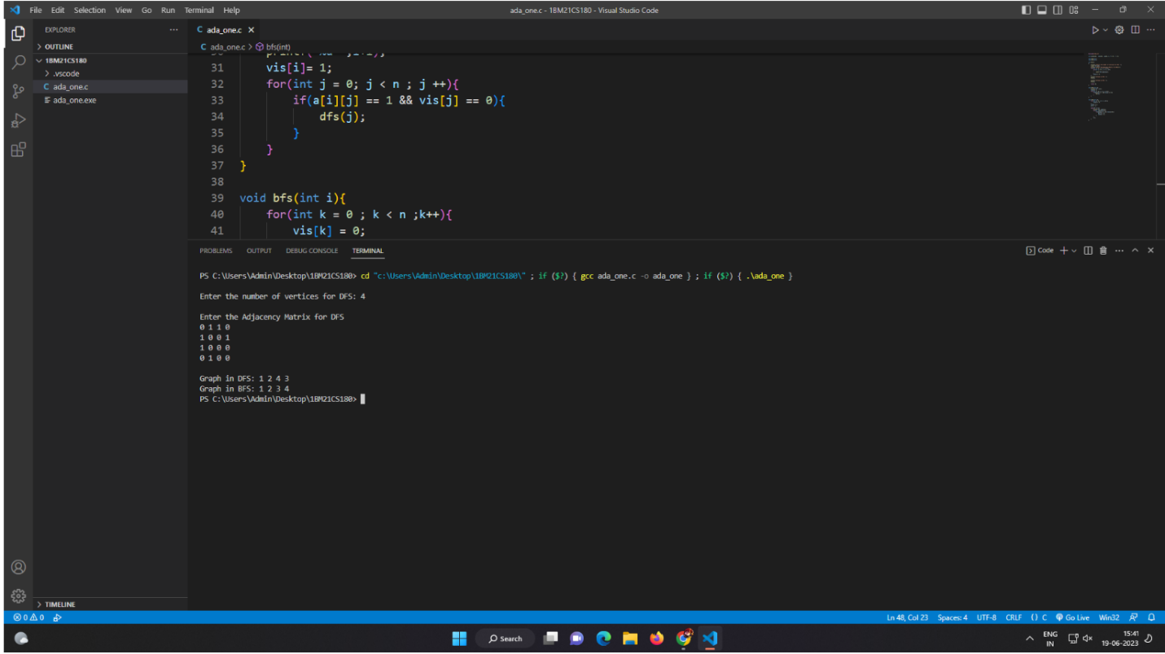

#include<stdio.h>

#include<conio.h>

int a[10][10],n,vis[10];

int dfs(int root){

int j;

vis[root]=1;

for(j=1;j<=n;j++)

if(a[root][j]==1&&vis[j]!=1)

dfs(j);

for(j=1;j<=n;j++) {

if(vis[j]!=1)

return 0;

}

return 1;

}

void main()

{

int i,j,root,ans;

for(j=1;j<=n;j++)

vis[j]=0;

printf("\nEnter the no of nodes:\t");

scanf("%d",&n);

printf("\nEnter the adjacency matrix:\n");

for(i=1;i<=n;i++)

for(j=1;j<=n;j++)

scanf("%d",&a[i][j]);

printf("\nEnter the source node:\t");

scanf("%d",&root);

ans=dfs(root);

if(ans==1)

printf("\nGraph is connected\n");

else

printf("\nGraph is not connected\n");

getch();

}

**Output:**

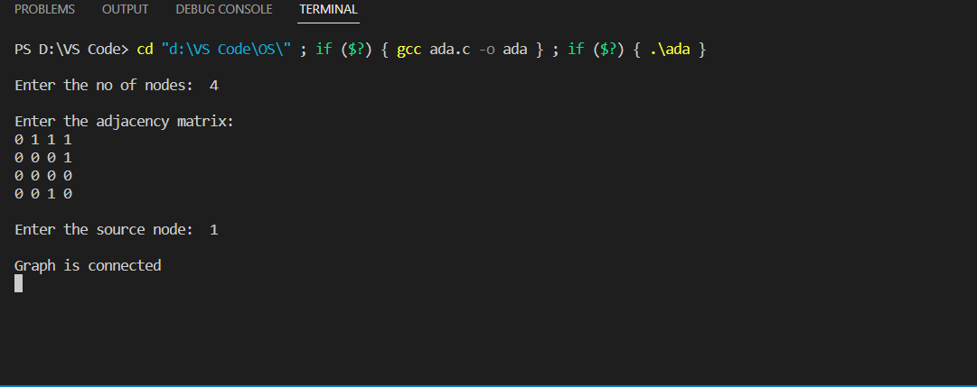

**2. Write a program to obtain the Topological ordering of vertices in a given digraph.**

Code:

#include<stdio.h>

#include<conio.h>

void main(){

int a[10][10],n,i,j;

int indeg[10],flag[10],c=0;

printf("Enter number of vertices \n");

scanf("%d",&n);

printf("Enter adjacency matrix: \n");

for(i=0;i<n;i++)

for(j=0;j<n;j++)

scanf("%d",&a[i][j]);

for(i=0;i<n;i++)

indeg[i]=0;

for(i=0;i<n;i++)

flag[i]=0;

for(i=0;i<n;i++)

for(j=0;j<n;j++)

if(a[i][j]==1)

indeg[j]+=1;

printf("Order is : ");

while(c<=n)

{

for(i=0;i<n;i++)

{

if(indeg[i]==0 && flag[i]==0)

{

printf("%d ",i+1);

flag[i]=1;

}

}

for(i=0;i<n;i++)

{

if(flag[i]==1)

{

for(j=0;j<n;j++)

{

if(a[i][j]==1)

{

indeg[j]-=1;

a[i][j]=0;

}

}

}

}

c++;

}

}

**Output:**

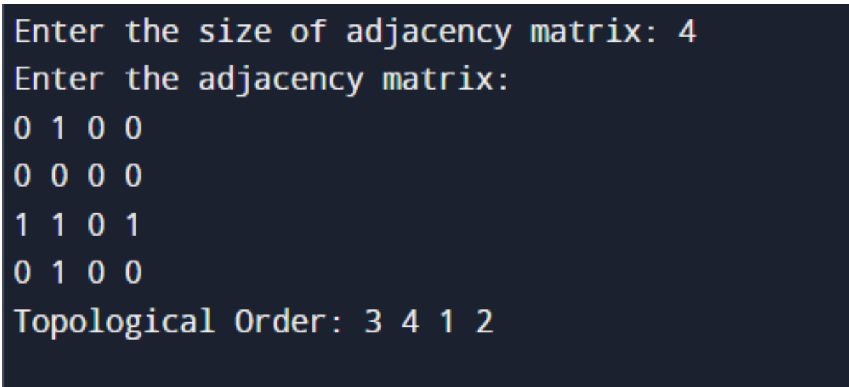

**3.** **Implement Johnson Trotter algorithm to generate permutations.**

**Code:**

#include<stdio.h>

#include<stdbool.h>

#define left_to_right true

#define right_to_left false

int getPosOfMobile(int a[], int n, int mobile) {

for (int i = 0; i < n; i++) {

if (a[i] == mobile)

return i + 1;

}

return 0;

}

int getMobile(int a[], bool dir[], int n) {

int mobile_prev = 0, mobile = 0;

for (int i = 0; i < n; i++) {

// direction 0 represents RIGHT TO LEFT.

if (dir[a[i] - 1] == right_to_left && i != 0) {

if (a[i] > a[i - 1] && a[i] > mobile_prev) {

mobile = a[i];

mobile_prev = mobile;

}

}

// direction 1 represents LEFT TO RIGHT.

if (dir[a[i] - 1] == left_to_right && i != n - 1) {

if (a[i] > a[i + 1] && a[i] > mobile_prev) {

mobile = a[i];

mobile_prev = mobile;

}

}

}

if (mobile == 0 && mobile_prev == 0)

return 0;

else

return mobile;

}

void produceOnePermutation(int a[], bool dir[], int n) {

int mobile = getMobile(a, dir, n);

int pos = getPosOfMobile(a, n, mobile);

if (dir[a[pos - 1] - 1] == right_to_left) {

int temp = a[pos - 1];

a[pos - 1] = a[pos - 2];

a[pos - 2] = temp;

} else if (dir[a[pos - 1] - 1] == left_to_right) {

int temp = a[pos];

a[pos] = a[pos - 1];

a[pos - 1] = temp;

}

// changing the directions for elements

// greater than largest mobile integer.

for (int i = 0; i < n; i++) {

if (a[i] > mobile) {

if (dir[a[i] - 1] == left_to_right)

dir[a[i] - 1] = right_to_left;

else if (dir[a[i] - 1] == right_to_left)

dir[a[i] - 1] = left_to_right;

}

}

for (int i = 0; i < n; i++)

printf("%d ", a[i]);

printf("\n");

}

int fact(int n)

{

int result=1;

for(int i=1;i<=n;i++)

{

result*=i;

}

return result;

}

void producePermutation(int n) {

// To store the current permutation

int a[n];

// To store the current directions

bool dir[n];

// Storing the elements from 1 to n and

// printing the first permutation.

for (int i = 0; i < n; i++) {

a[i] = i + 1;

printf("%d ", a[i]);

}

printf("\n");

// Initially all directions are set

// to RIGHT TO LEFT i.e. 0.

for (int i = 0; i < n; i++)

dir[i] = right_to_left;

// For generating permutations in order.

for (int i = 1; i < fact(n); i++)

produceOnePermutation(a, dir, n);

}

void main()

{

int n;

printf("\nEnter the number of objects whose permutations are to be generated: ");

scanf("%d",&n);

producePermutation(n);

}

**Output:**

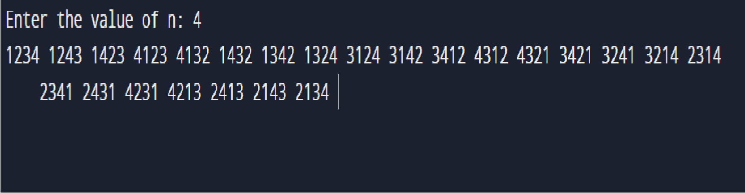

**4. Sort a given set of N integer elements using Merge Sort technique and** **compute its time taken. Run the program for different values of N and record** **the time taken to sort.**

**Code:**

#include<stdio.h>

#include<time.h>

int n;

void merge_sort(int a[],int low,int high)

{

int mid;

if(low<high)

{

mid = (low+high)/2;

merge_sort(a,low,mid);

merge_sort(a,mid+1,high);

merge(a,low,mid,high);

}

}

void merge(int a[],int low,int mid,int high)

{

int i,j,k,b[n];

i = low;

k = low;

j = mid+1;

while(i<=mid && j<=high)

{

if(a[i] < a[j])

{

b[k] = a[i];

i++;

k++;

}

else{

b[k] = a[j];

j++;

k++;

}

}

while(i<=mid)

{

b[k] = a[i];

i++;

k++;

}

while(j<=high)

{

b[k] = a[j];

j++;

k++;

}

for(int i=low; i<=high; i++)

{

a[i]=b[i];

}

}

int main()

{

int low, high,n;

printf("Enter size of array: ");

scanf("%d", &n);

int a[n];

printf("Enter array elements: ");

for(int i=0; i<n; i++){

// scanf("%d",&a[i]);

a[i] = rand()%10000;

printf("%d\t",a[i]);

}

low =0;

high = n-1;

clock_t start,end;

start = clock();

merge_sort(a,low,high);

end = clock();

printf("\nSorted array elements: ");

for(int i=0; i<n; i++)

printf("%d\t",a[i]);

printf("\nStart time: %f", (double)start);

printf("\nEnd time: %f",(double)end);

printf("\nTime take is %f ", (double)(end-start)/CLOCKS_PER_SEC );

}

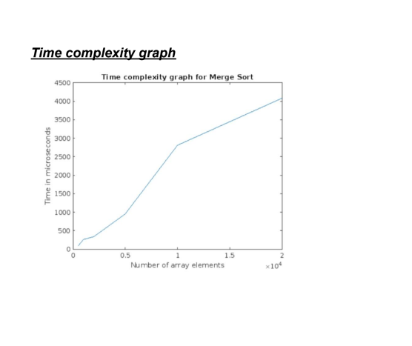

**Output:**

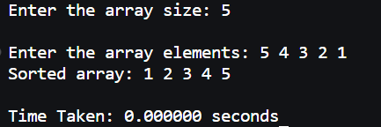

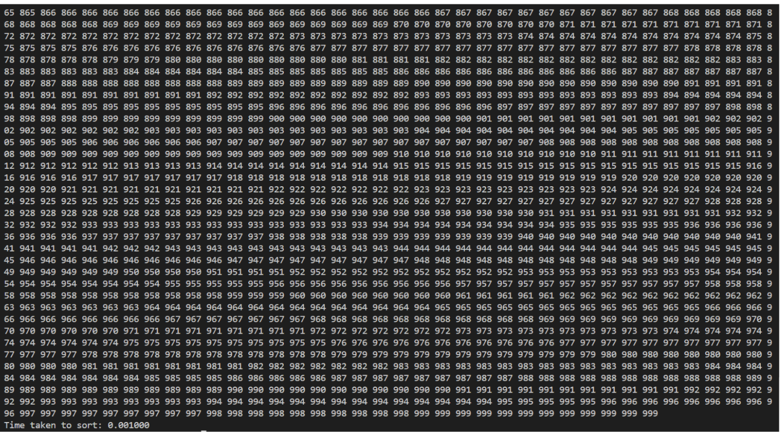

**5.** **Sort a given set of N integer elements using Quick Sort technique and** **compute its time taken.**

**Code:**

#include<stdio.h>

#include<stdlib.h>

#include<time.h>

void quick_sort(int a[],int low,int high)

{

int j;

if(low<high)

{

j = partition(a,low,high);

quick_sort(a,low,j-1);

quick_sort(a,j+1,high);

}

}

int partition(int a[],int low,int high)

{

int i,j,pivot;

i = low;

j= high+1;

pivot = a[low];

while(i<=j)

{

do

{

i++;

}while(pivot>=a[i]);

do

{

j--;

}while(pivot<a[j]);

if(i<j)

swap(&a[i],&a[j]);

}

swap(&a[low],&a[j]);

return j;

}

void swap(int *a, int *b)

{

int temp;

temp = *a;

*a = *b;

*b= temp;

}

int main()

{

int n;

printf("Enter size of array: ");

scanf("%d", &n);

int a[n], low, high;

printf("Enter array elements: ");

for(int i=0; i<n; i++){

// scanf("%d",&a[i]);

a[i] = rand()%10000;

// printf("%d\t",a[i]);

}

low =0;

high = n-1;

clock_t start,end;

start = clock();

quick_sort(a,low,high);

end = clock();

// printf("\nSorted array elements: ");

// for(int i=0; i<n; i++)

// printf("%d\t",a[i]);

printf("\nStart time: %f", (double)start);

printf("\nEnd time: %f",(double)end);

printf("\nTime take is %f ", (double)(end-start)/CLOCKS_PER_SEC );

}

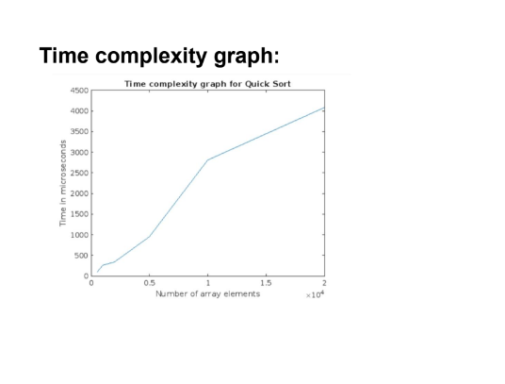**Output:**



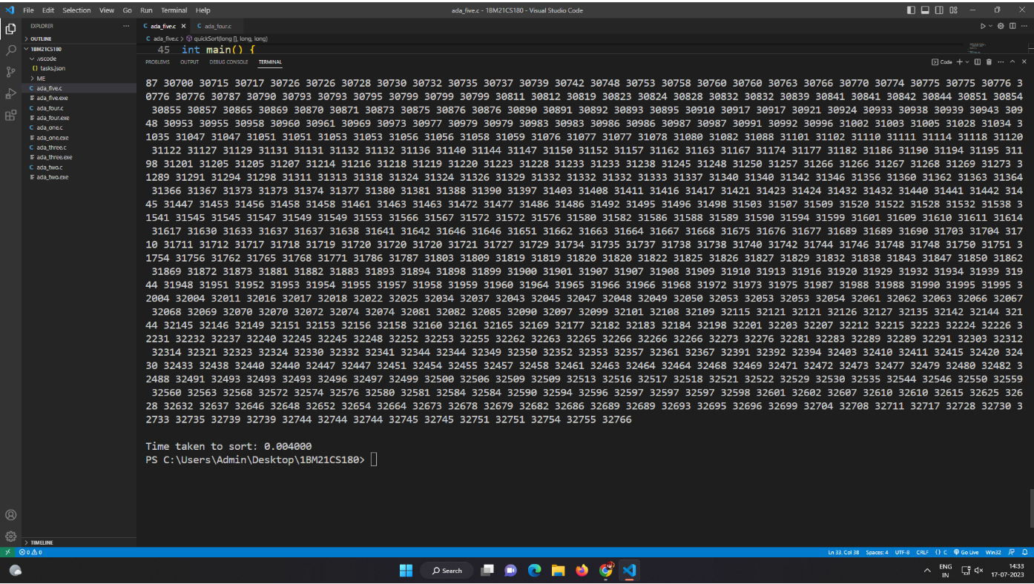

**6. Sort a given set of N integer elements using Heap Sort technique and compute its time taken.**

**Code**

#include <stdio.h>

#include<time.h>

void swap(int* a, int* b)

{

int temp = *a;

*a = *b;

*b = temp;

}

void heapify(int arr[], int N, int i)

{

int largest = i;

int left = 2 * i + 1;

int right = 2 * i + 2;

if (left < N && arr[left] > arr[largest])

largest = left;

if (right < N && arr[right] > arr[largest])

largest = right;

if (largest != i) {

swap(&arr[i], &arr[largest]);

heapify(arr, N, largest);

}

}

void heapSort(int arr[], int N)

{

for (int i = N / 2 - 1; i >= 0; i--)

heapify(arr, N, i);

for (int i = N - 1; i >= 0; i--) {

swap(&arr[0], &arr[i]);

heapify(arr, i, 0);

}

}

void printArray(int arr[], int N)

{

for (int i = 0; i < N; i++)

printf("%d ", arr[i]);

printf("\n");

}

int main()

{

int N;

printf("Enter no of nodes: ");

scanf("%d",&N);

int arr[N];

printf("Enter elements: ");

for (int i = 0; i < N; i++)

{

// scanf("%d",&a[i]);

arr[i] = rand()%10000;

printf("%d\t",arr[i]);

}

clock_t start,end;

start = clock();

heapSort(arr, N);

end = clock();

printf("\nSorted array is\n");

printArray(arr, N);

printf("\nStart time: %f", (double)start);

printf("\nEnd time: %f",(double)end);

printf("\nTime take is %f ", (double)(end-start)/CLOCKS_PER_SEC );

}

**Output**



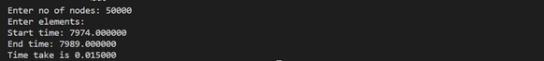

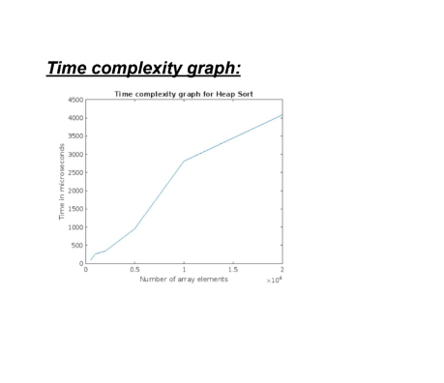

**7. Implement 0/1 Knapsack problem using dynamic programming.**

**Code:**

#include<stdio.h>

int n,m;

int max(int a,int b){

if(a>b){

return a;

}

else{

return b;

}

}

void selectObj(int v[n+1][m+1],int w[n],int n){

int i,j,x[n];

for(i=1;i<=n;i++){

x[i]=0;

}

i=n;

j=m;

while(i!=0 && j!=0){

if(v[i][j]!=v[i-1][j]){

x[i]=1;

j=j-w[i];

}

i--;

}

for(i=1;i<=n;i++){

if(x[i]==1){

printf("\n%d is selected",i);

}

else{

printf("\n%d not selected",i);

}

}

}

int* knapsack(int v[n+1][m+1],int w[n],int p[n]){

int i,j;

for(i=0;i<=n;i++){

for(j=0;j<=m;j++){

if(i==0 || j==0){

v[i][j]=0;

}

else if(w[i]>j){

v[i][j]=v[i-1][j];

}

else {

int x,y;

x=v[i-1][j];

y=v[i-1][j-w[i]]+p[i];

v[i][j]=max(x,y);

}

}

}

printf("\n");

for(i=0;i<=n;i++){

for(j=0;j<=m;j++){

printf("%d\t",v[i][j]);

}

printf("\n");

}

printf("\nOptimal solution: %d",v[n][m]);

return v[n+1][m+1];

}

void main(){

int i,j;

printf("\n enter no. of items: ");

scanf("%d",&n);

int w[n],p[n];

for(int i=1;i<=n;i++){

printf("\n enter weight and value of %d: ",i);

scanf("%d%d",&w[i],&p[i]);

}

printf("\n enter knapsack capacity: ");

scanf("%d",&m);

int v[n+1][m+1];

v[n+1][m+1]=knapsack(v,w,p);

selectObj(v,w,n);

}

**Output:**

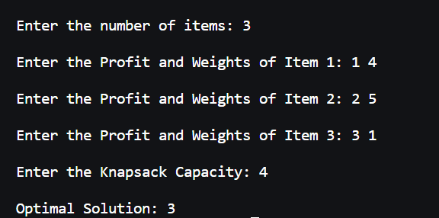

**8. Implement all pair shortest path problem using Floyd’s Algorithm.**

**Code:**

#include<stdio.h>

void main()

{

int i,j,k,n,p[10][10],o[10][10];

printf("Enter number of nodes \n");

scanf("%d",&n);

printf("Enter %dX%d adjacency matrix of \n",n,n);

for(i=0;i<n;i++)

{

for(j=0;j<n;j++)

scanf("%d",&p[i][j]);

}

for(i=0;i<n;i++)

for(j=0;j<n;j++)

o[i][j]=p[i][j];

for(k=0;k<n;k++)

for(i=0;i<n;i++)

for(j=0;j<n;j++)

if(p[i][j] > p[k][j]+p[i][k])

p[i][j]=p[k][j]+p[i][k];

printf("\nOringinal Adjacency Matrix \n");

for(i=0;i<n;i++)

{

for(j=0;j<n;j++)

printf("%d ",o[i][j]);

printf("\n");

}

printf("\nUpdated Adjacency Matrix \n");

for(i=0;i<n;i++)

{

for(j=0;j<n;j++)

printf("%d ",p[i][j]);

printf("\n");

}

}

**Output:**

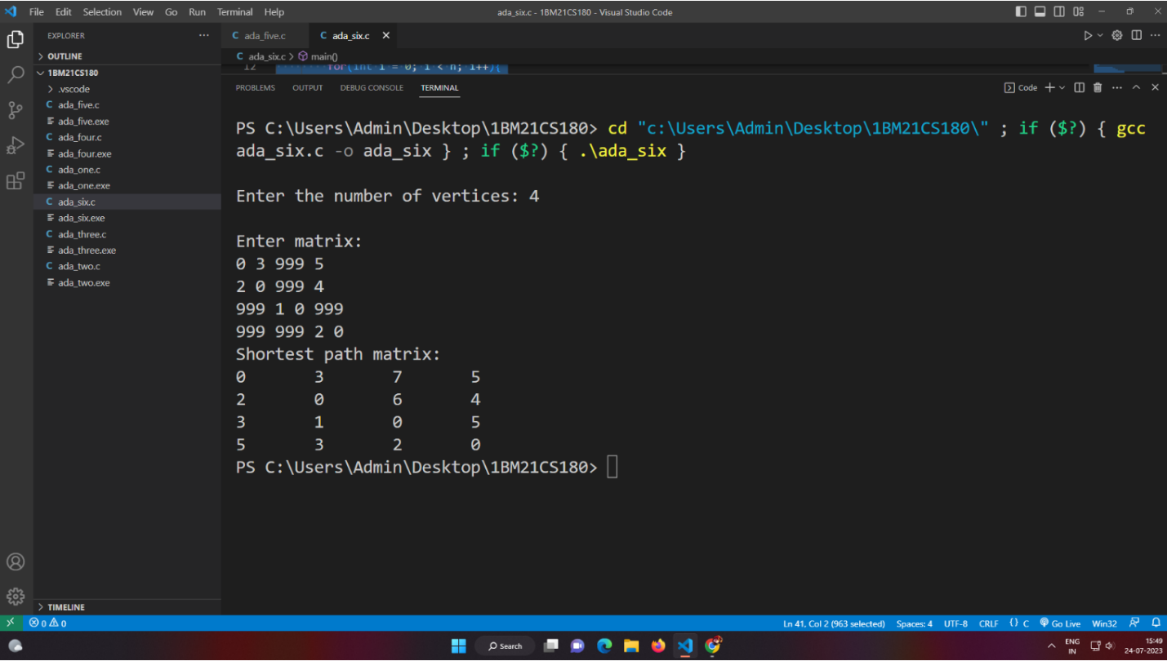

**9. Find Minimum Cost Spanning Tree of a given undirected graph using prims and kruskals Algorithm.**

**Prims Code:**

#include<stdio.h>

float cost[10][10];

int vt[10],et[10][10],vis[10],j,n;

float sum=0;

int x=1;

int e=0;

void prims();

void main()

{

int i;

printf("Enter the number of vertices\n");

scanf("%d",&n);

printf("Enter the cost adjacency matrix\n");

for(i=1;i<=n;i++)

{

for(j=1;j<=n;j++)

{

scanf("%f",&cost[i][j]);

}

vis[i]=0;

}

prims();

printf("Edges of spanning tree\n");

for(i=1;i<=e;i++)

{

printf("%d,%d\t",et[i][0],et[i][1]);

}

printf("weight=%f\n",sum);

}

void prims()

{

int s,m,k,u,v;

float min;

vt[x]=1;

vis[x]=1;

for(s=1;s<n;s++)

{

j=x;

min=999;

while(j>0)

{

k=vt[j];

for(m=2;m<=n;m++)

{

if(vis[m]==0)

{

if(cost[k][m]<min)

{

min=cost[k][m];

u=k;

v=m;

}

}

}

j--;

}

vt[++x]=v;

et[s][0]=u;

et[s][1]=v;

e++;

vis[v]=1;

sum=sum+min;

}

}

Output:

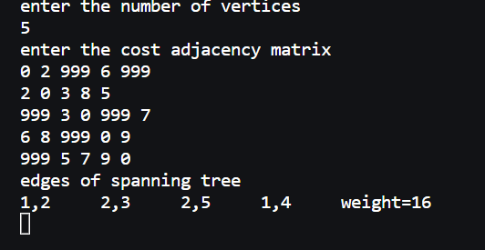

**Kruskals Code:**

#include<stdio.h>

#include<conio.h>

int find(int v,int parent[10])

{

while(parent[v]!=v)

{

v=parent[v];

}

return v;

}

void union1(int i,int j,int parent[10])

{

if(i<j)

parent[j]=i;

else

parent[i]=j;

}

void kruskal(int n,int a[10][10])

{

int count,k,min,sum,i,j,t[10][10],u,v,parent[10];

count=0;

k=0;

sum=0;

for(i=0;i<n;i++)

parent[i]=i;

while(count!=n-1)

{

min=999;

for(i=0;i<n;i++)

{

for(j=0;j<n;j++)

{

if(a[i][j]<min && a[i][j]!=0)

{

min=a[i][j];

u=i;

v = j;

}

}

}

i=find(u,parent);

j=find(v,parent);

if(i!=j)

{

union1(i,j,parent);

t[k][0]=u;

t[k][1]=v;

k++;

count++;

sum=sum+a[u][v];

}

a[u][v]=a[v][u]=999;

}

if(count==n-1)

{

printf("spanning tree\n");

for(i=0;i<n-1;i++)

{

printf("%d %d\n",t[i][0]+1,t[i][1]+1);

}

printf("cost of spanning tree=%d\n",sum);

}

else

printf("spanning tree does not exist\n");

}

void main()

{

int n,i,j,a[10][10];

printf(“Kruskal’s Algorithm”);

printf("Enter the number of nodes\n");

scanf("%d",&n);

printf("Enter the adjacency matrix\n");

for(i=0;i<n;i++)

for(j=0;j<n;j++)

scanf("%d",&a[i][j]);

kruskal(n,a);

}

**Output:**

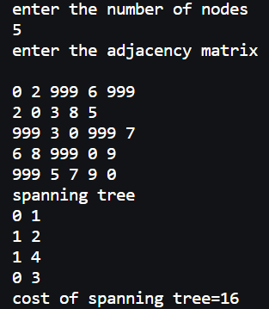

**10. From a given vertex in a weighted connected graph, find shortest paths to other vertices using Dijikstra’s Algorithm**

**Code:**

#include<stdio.h>

#include<conio.h>

void dijkstras();

int c[10][10],n,src;

void main()

{

int i,j;

printf("\nEnter number of vertices:");

scanf("%d",&n);

printf("\nEnter the adjacency matrix:\n");

for(i=1;i<=n;i++)

{

for(j=1;j<=n;j++)

{

scanf("%d",&c[i][j]);

}

}

printf("\nEnter the source node:\t");

scanf("%d",&src);

dijkstras();

getch();

}

void dijkstras()

{

int vis[10],dist[10],u,i,j,count,min;

for(j=1;j<=n;j++)

{

dist[j]=c[src][j];

}

for(j=1;j<=n;j++)

{

vis[j]=0;

}

dist[src]=0;

vis[src]=1;

count=1;

while(count!=n)

{

min=9999;

for(j=1;j<=n;j++)

{

if(dist[j]<min&&vis[j]!=1)

{

min=dist[j];

u=j;

}

}

vis[u]=1;

count++;

for(j=1;j<=n;j++)

{

if(min+c[u][j]<dist[j]&&vis[j]!=1)

{

dist[j]=min+c[u][j];

}

}

}

printf("\nThe shortest distance is:\n");

for(j=1;j<=n;j++)

{

printf("\n%d to %d=%d ",src,j,dist[j]);

}

}

**Output:**

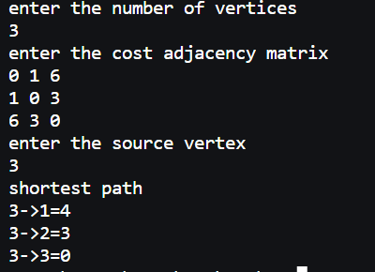

**11. Implement “N-Queen’s Problem” using backtracking**

**Code:**

#include<stdio.h>

#include<math.h>

int board[20],count;

int main()

{

int n,i,j;

void queen(int row,int n);

printf("\n\nEnter number of Queens:");

scanf("%d",&n);

queen(1,n);

return 0;

}

void print(int n)

{

int i,j;

printf("\n\nSolution %d:\n\n",++count);

for(i=1;i<=n;i++)

printf(" %d",i);

for(i=1;i<=n;i++)

{

printf("\n\n%d",i);

for(j=1;j<=n;j++)

{

if(board[i]==j)

printf(" Q");

else

printf(" -");

}

}

}

int place(int row,int column)

{

int i;

for(i=1;i<=row-1;i++)

{

if(board[i]==column)

return 0;

else

if(abs(board[i]-column)==abs(i-row))

return 0;

}

return 1;

}

void queen(int row,int n)

{

int column;

for(column=1;column<=n;column++)

{

if(place(row,column))

{

board[row]=column;

if(row==n)

print(n);

else

queen(row+1,n);

}

}

}

**Output:**

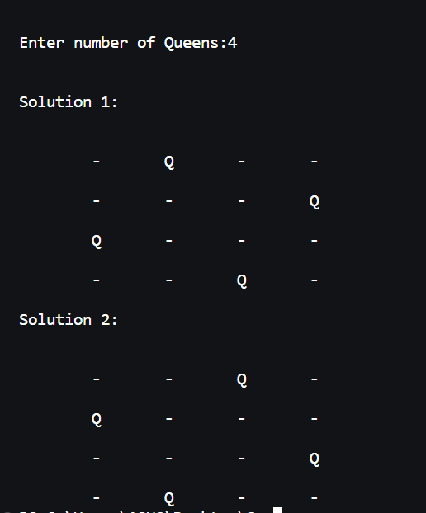

**12. Leet Code Problems**

**Contains Duplicate**

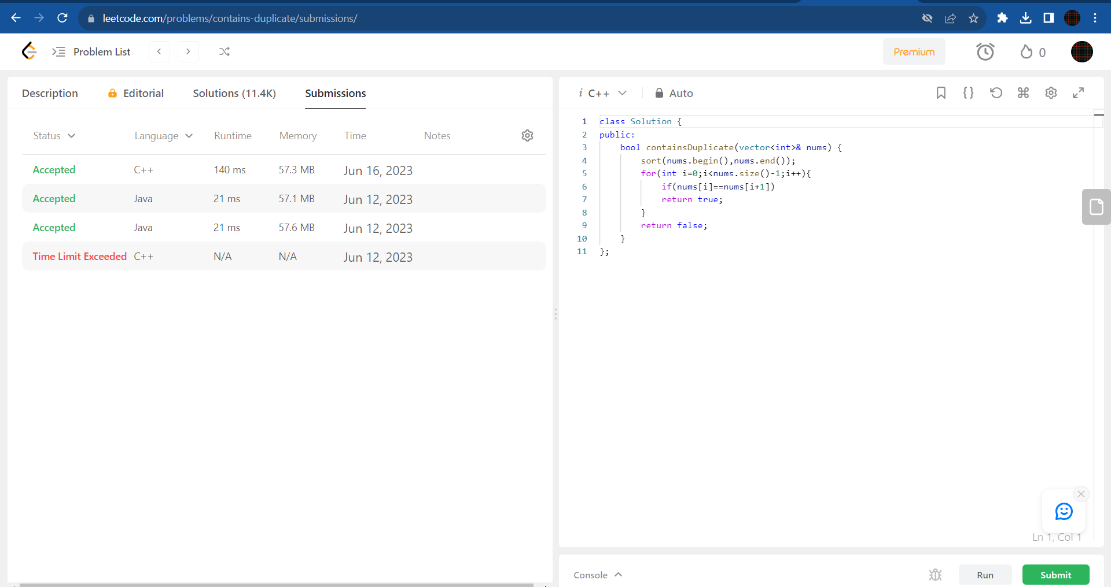

**Count the number of complete components**

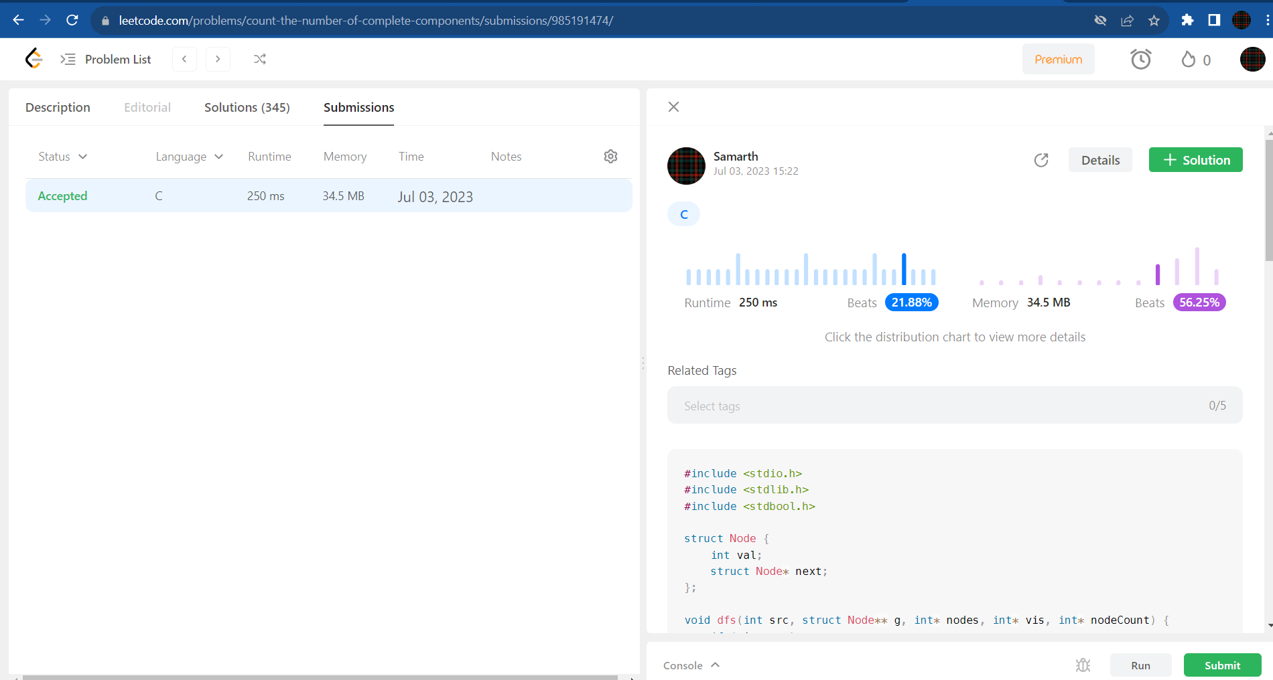

**Minimum Path Sum**

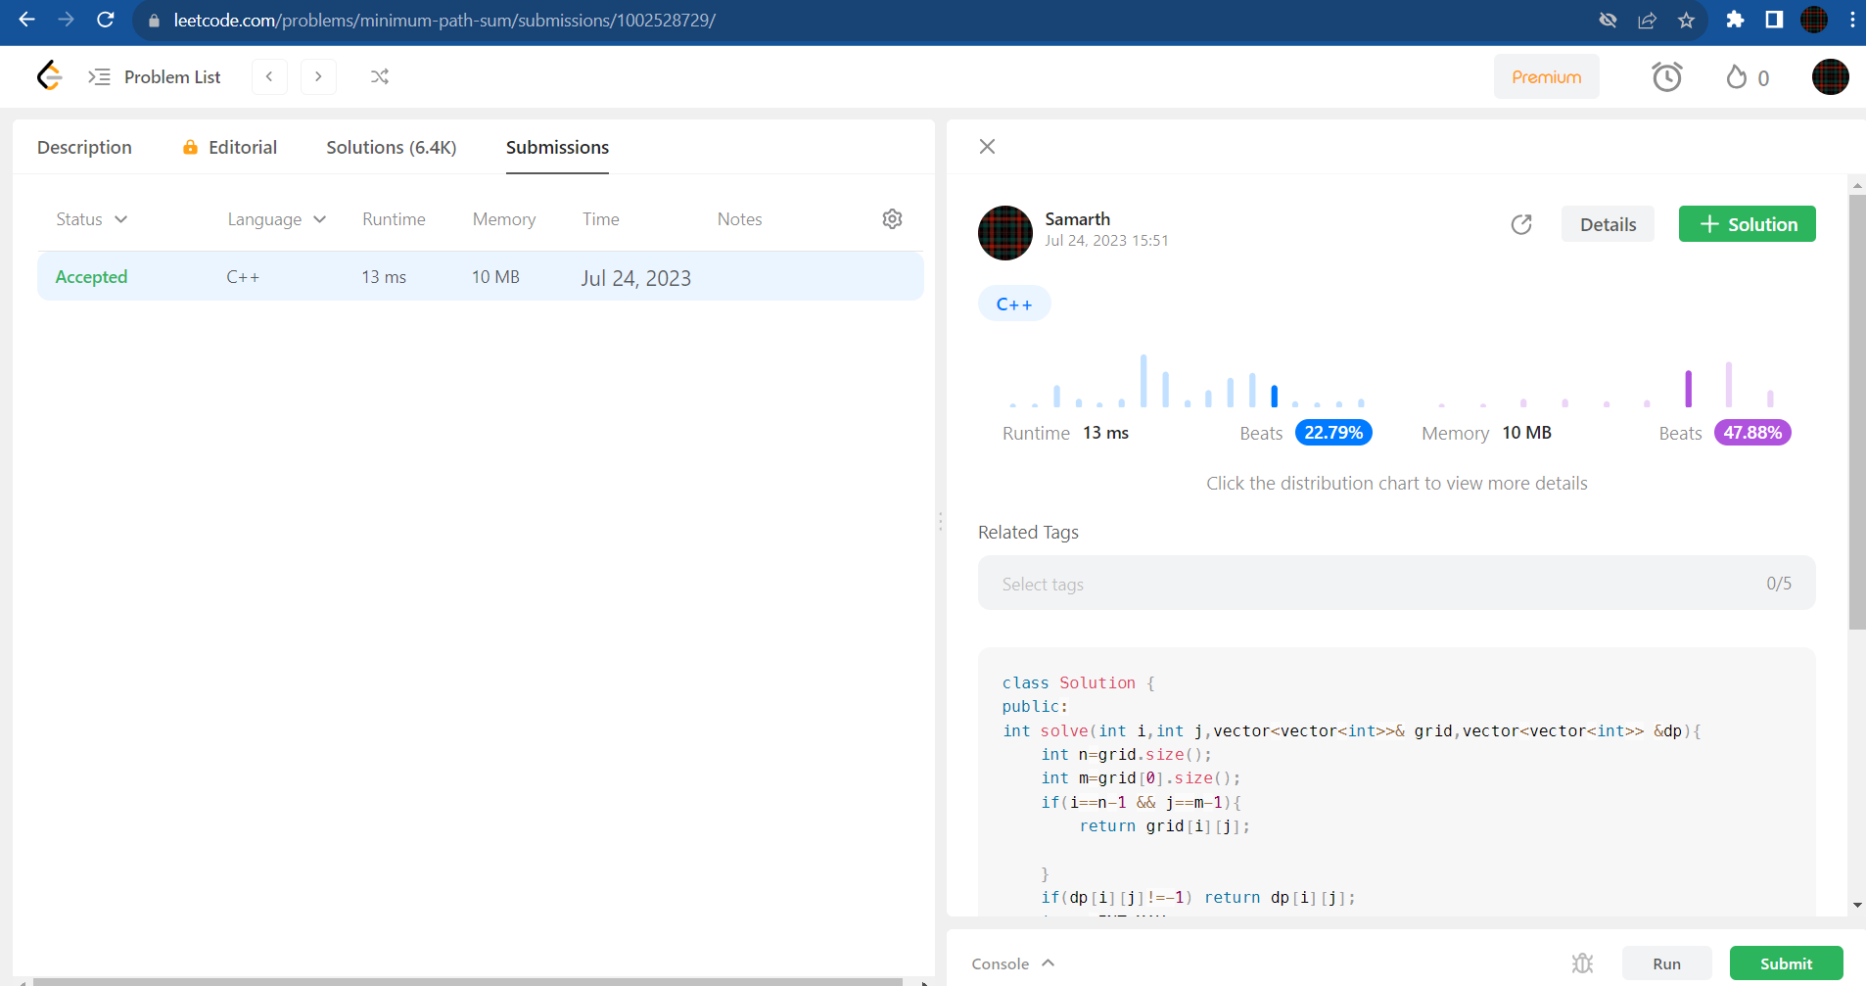

**Best Time to Buy and Sell Stock**

