Game Design Document

Fill up the following document

1. Write the title of your project.

**Identifying the words**

1. What is the goal of the game?

Identifying words using given hints or pictures in a fix period of time

1. Write a brief story of your game.

It will be a multiplayer game where we have to find words using the

given hints or pictures . The game will have 5 rounds. The one who

identifies the words fast will win.

1. Which are the playing characters of this game?

* Playing characters are the ones who respond to the user based on the input from the user.
* Cars, monkeys, dinos, wizards, etc., are the playing characters in the game.

|  |  |  |
| --- | --- | --- |
| Number | Character Name | What can this character do? |
| 1 | The players | They will answer the words |
| 2 |  |  |
| 3 |  |  |
| 4 |  |  |
| 5 |  |  |
| 6 |  |  |
| 7 |  |  |
| 8 |  |  |

1. Which are the Non-Playing Characters of this game?

* Non-Playing characters are the ones that don't have an action or behavior when the user interacts with the game.
* Hurdles, stones, bananas, coins, etc., are non-playing characters in the game.

|  |  |  |
| --- | --- | --- |
| Number | Character Name | What can this character do? |
| 1 | Lives | They will give lives when the player goes wrong.(3 lives) |
| 2 | Hints | They will give hints to the player when they require.(3 hints) |
| 3 | Qusetion | The questions will be asked through pictures. |
| 4 | Points | Points will be given after answer5ing every Question. |
| 5 | Feedback | It will give feedback to the player after completing the game. |
| 6 |  |  |
| 7 |  |  |
| 8 |  |  |

Draw your imagination of this game. What does this game look like?

* Draw the game either on your computer or on paper.
* Add images of the game scenes to show each of the playing and non-playing characters at least once.

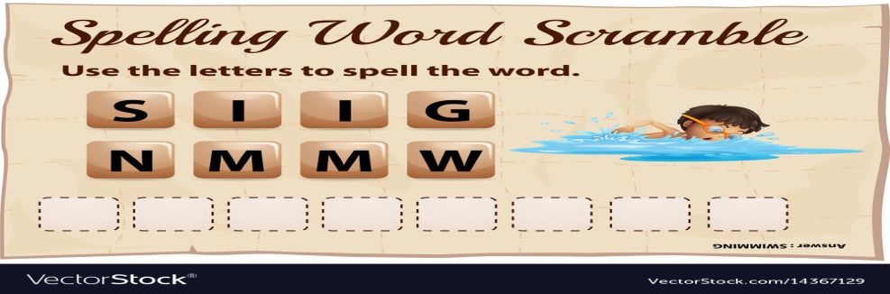

How do you plan to make your game engaging?

By giving points after clearing a round and also increase in difficulty level after each round.