AI Lab Assignment 1
Name: Samarth Bagde
Roll no.: 20
Class: TY-CS
Div: A
PRN: 12210348
__________________________________

Implementation of AI and Non-AI technique by implementing any two-player game

AI tic-tac-toe

Code:
#include <iostream>
#include <bits/stdc++.h>

using namespace std;

char ai = 'X';
char palyer = 'O';
char board[3][3];

void displayBoard()
{
for (int i = 0; i < 3; i++)
{
for (int j = 0; j < 3; j++)
{
cout << board[i][j] << " ";
}
cout << "\n";
}
}

int checkTie()
{
for (int i = 0; i < 3; i++)
{
for (int j = 0; j < 3; j++)
{
if (board[i][j] == '-')
{
return 0;
}
}
}
return 1;
}

int checkWinner(char player)
{

bool isWin = false;
for (int i = 0; i < 3; i++)
{
isWin = true;
for (int j = 0; j < 3; j++)
{
if (board[i][j] != player)
{
isWin = false;
break;
}
}
if (isWin)
{
return 1;
}
}
for (int i = 0; i < 3; i++)
{
isWin = true;
for (int j = 0; j < 3; j++)
{
if (board[j][i] != player)
{
isWin = false;
break;
}
}
if (isWin)
{
return 1;
}
}
if (board[0][0] == player && board[1][1] == player && board[2][2] == player)
{
return 1;
}
if (board[0][2] == player && board[1][1] == player && board[2][0] == player)
{
return 1;
}
return 0;
}

int minimax(int depth, int isMaximizing)
{
if (checkWinner(ai))
{
return 1;
}
else if (checkWinner(palyer))
{
return -1;
}
else if (checkTie())
{
return 0;
}
if (isMaximizing)
{
int bestScore = INT_MIN;
for (int i = 0; i < 3; i++)
{
for (int j = 0; j < 3; j++)
{
if (board[i][j] == '-')
{
board[i][j] = ai;
int score = minimax(depth + 1, 0);
board[i][j] = '-';
bestScore = max(score, bestScore);
}
}
}
return bestScore;
}
else
{
int bestScore = INT_MAX;
for (int i = 0; i < 3; i++)
{
for (int j = 0; j < 3; j++)
{
if (board[i][j] == '-')
{
board[i][j] = palyer;
int score = minimax(depth + 1, 1);
board[i][j] = '-';
bestScore = min(score, bestScore);
}
}
}
return bestScore;
}
}

void bestMove()
{
int bestScore = INT_MIN;
int row = -1, col = -1;
for (int i = 0; i < 3; i++)
{
for (int j = 0; j < 3; j++)
{
if (board[i][j] == '-')
{
board[i][j] = ai;
int score = minimax(0, 0);
board[i][j] = '-';
if (score > bestScore)
{
bestScore = score;
row = i;
col = j;
}
}
}
}
if (row != -1 && col != -1)
{
board[row][col] = ai;
}
}

int main()
{
for (int i = 0; i < 3; i++)
{
for (int j = 0; j < 3; j++)
{
board[i][j] = '-';
}
}
displayBoard();
cout << "Start the game!!\n";
while (1)
{
int row, col;
cout << "Enter row and column number : ";
cin >> row >> col;
if (row >= 0 && row < 3 && col >= 0 && col < 3 && board[row][col] == '-')
{
board[row][col] = palyer;

cout << "Player move : \n";
displayBoard();

if (checkWinner(palyer))
{
cout << "Player wins!!\n";
break;
}
if (checkTie())
{
cout << "----------- Game Tie -----------";
break;
}
bestMove();
cout << "AI move : \n";
displayBoard();
if (checkWinner(ai))
{
cout << "AI wins!!\n";
break;
}
if (checkTie())
{
cout << "----------- Game Tie -----------";
break;
}
}
else
{
cout << "Invalid move. Try again.\n";
}
}
return 0;
}

Output:
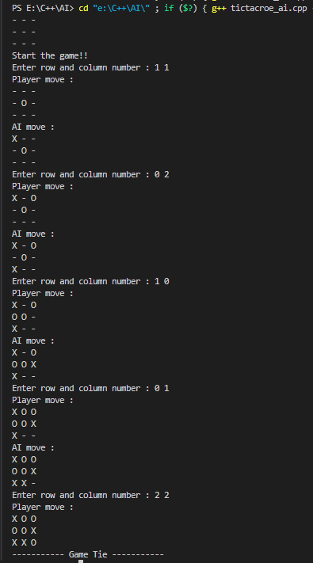

Non-AI tic-tac-toe
Code:
#include <iostream>
#include <bits/stdc++.h>

using namespace std;

class tictactoe
{
public:
bool winner = false;
vector<vector<char>> board;
tictactoe() : board(3, vector<char>(3, '-'))
{
cout << "Player 1 : O || Player 2 : X \n";
}
void checkWinner()
{
for (int i = 0; i < 3; i++)
{
if (board[i][0] != '-' && board[i][0] == board[i][1] && board[i][1] == board[i][2])
{
winner = true;
break;
}
if (board[0][i] != '-' && board[0][i] == board[1][i] && board[1][i] == board[2][i])
{
winner = true;
break;
}
}
if (board[0][0] != '-' && board[0][0] == board[1][1] && board[1][1] == board[2][2])
{
winner = true;
return;
}
if (board[0][2] != '-' && board[0][2] == board[1][1] && board[1][1] == board[2][0])
{
winner = true;
return;
}
}

void play()
{
int curPlayer = 1;
int count = 0;
while (count < 9)
{
int i, j;
cout << "\nCurrent Board\n";
for (auto row : board)
{
for (auto it : row)
{
cout << it << " ";
}
cout << endl;
}
if (curPlayer == 1)
{
cout << "Player 1 move : Enter row and column number : ";
cin >> i >> j;
if (i < 0 || i >= 3 || j < 0 || j >= 3 || board[i][j] != '-')
{
cout << "Invalid move. Try again.\n";
continue;
}
board[i][j] = 'O';
curPlayer = 2;
}
else if (curPlayer == 2)
{
cout << "Player 2 move : Enter row and column number : ";
cin >> i >> j;
if (i < 0 || i >= 3 || j < 0 || j >= 3 || board[i][j] != '-')
{
cout << "Invalid move. Try again.\n";
continue;
}
board[i][j] = 'X';
curPlayer = 1;
}
count++;

checkWinner();
if (winner)
{
for (auto row : board)
{
for (auto it : row)
{
cout << it << " ";
}
cout << endl;
}
cout << "Player " << (curPlayer == 1 ? "2 " : "1 ") << "wins!\n";
break;
}
}
if (count == 9)
{
cout << "----------- Game Tie -----------";
}
}
};

int main()
{
tictactoe game;
game.play();
return 0;
}

Output:
