Barcode Stock Management & Manufacturing ERP
Legacy vs. New Workflow & UI Comparison
Comprehensive Page-by-Page Migration & Visual Audit Report
Based on Official Notion Architecture Document

1. Executive Summary & Stack Comparison
Attribute | Legacy System (Baseline) | Modern System (New Implementation)
Technology Stack | PHP 7.3, CodeIgniter 3.1.11, AdminLTE 3, MySQL | React 18, Vite, NestJS v10, TypeORM, MySQL 8.0
Authentication & Security | Session-based, plain text passwords exposed | Token-based JWT, BCrypt encrypted, masked UI
Responsive UI | Desktop only, fixed Bootstrap 3 grid | Full responsive layout (desktop, tablet, mobile touch)
Barcode Generation & Printing | Basic SVG/image, separate view modal | Immediate inline Barcode Cards, exact CSS print & download
Workflow Integrity | Manual paper tracking, unverified dispatch | Full automated gate-check verification and audit reports

1. Login & Authentication
Legacy Login: Simple white card with centered inputs, plain text password handling.
New Modern Login: Enterprise card composition with SofTech branding, JWT authentication, responsive mobile layout.
Legacy UI (Baseline) | Modern UI (New Implementation)
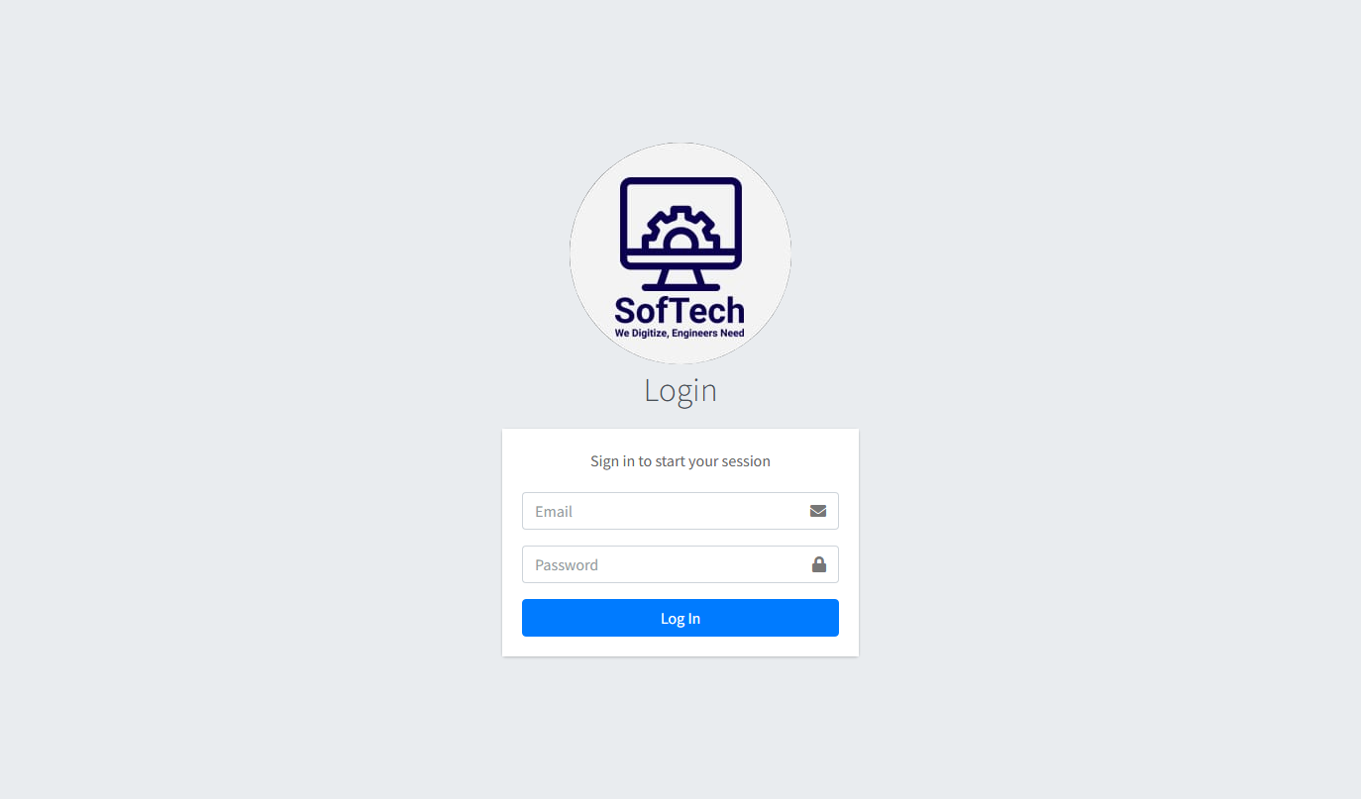 | 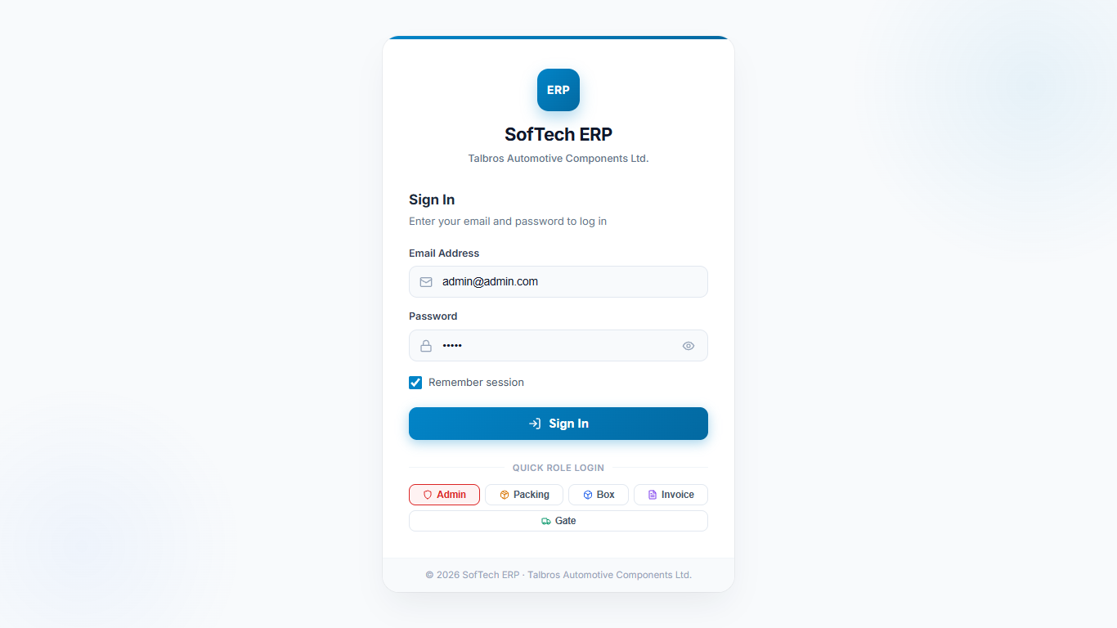

2. Admin Dashboard
Legacy Dashboard: Four basic KPI cards with empty workspace; no real-time analytical charts.
New Dashboard: Four vibrant KPI cards, real-time Category Breakdown Bar Chart, and Category Distribution Donut Chart.
Legacy UI (Baseline) | Modern UI (New Implementation)
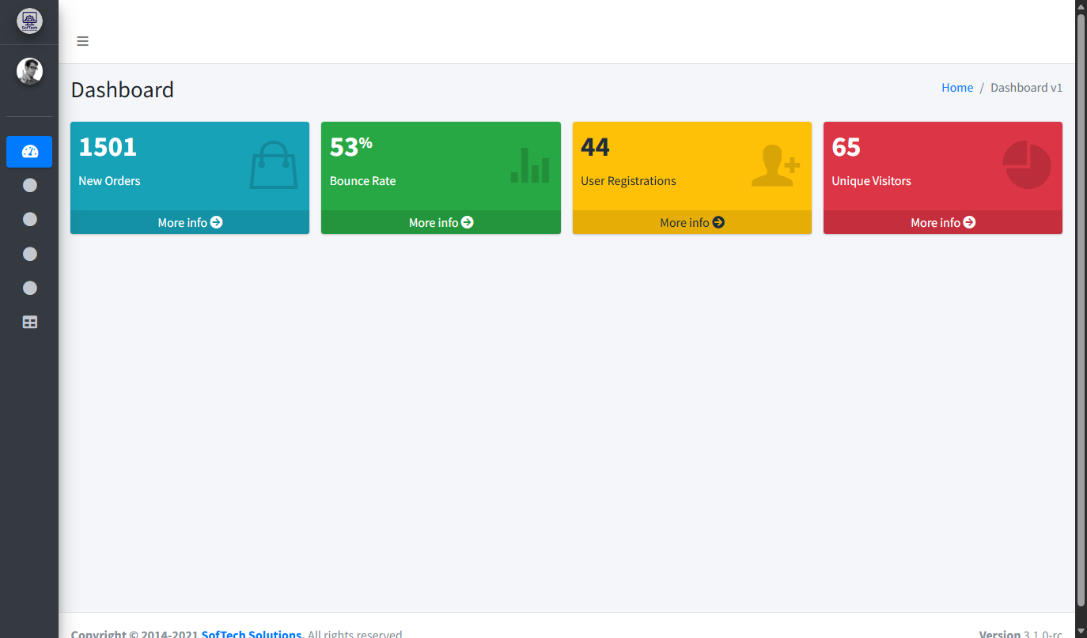 | 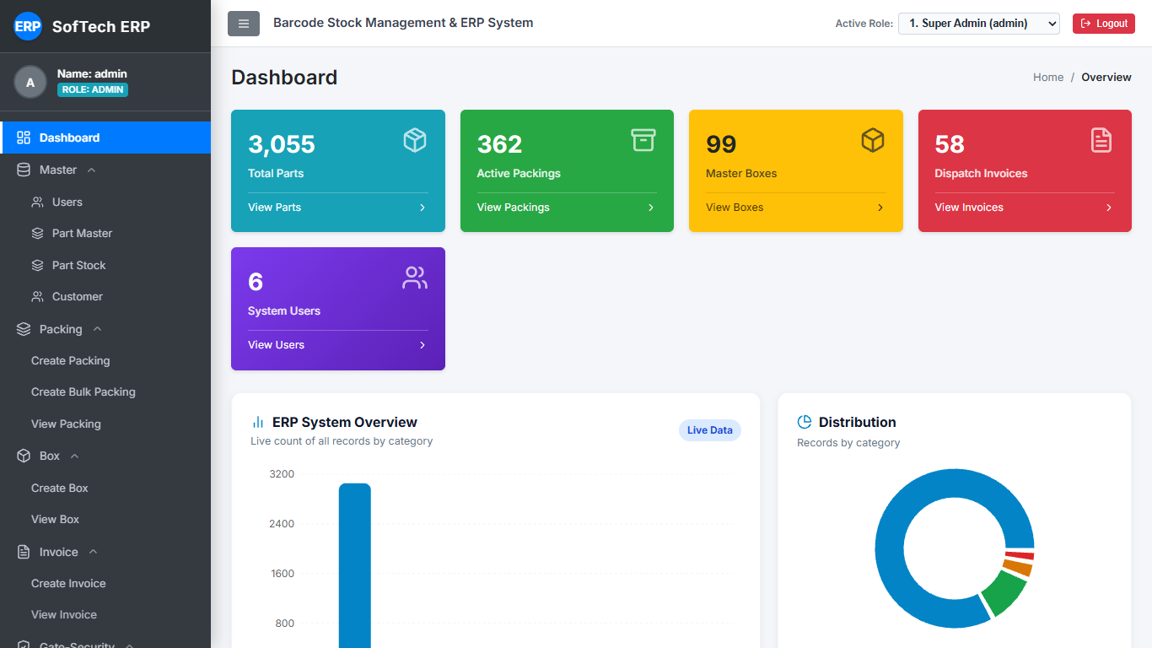

3. Part Master
Legacy Part Master: Basic table with native search, basic pagination, and unstyled actions.
New Part Master: Modern data table with real-time search, adjustable page size, Excel export, and styled action triggers.
Legacy UI (Baseline) | Modern UI (New Implementation)
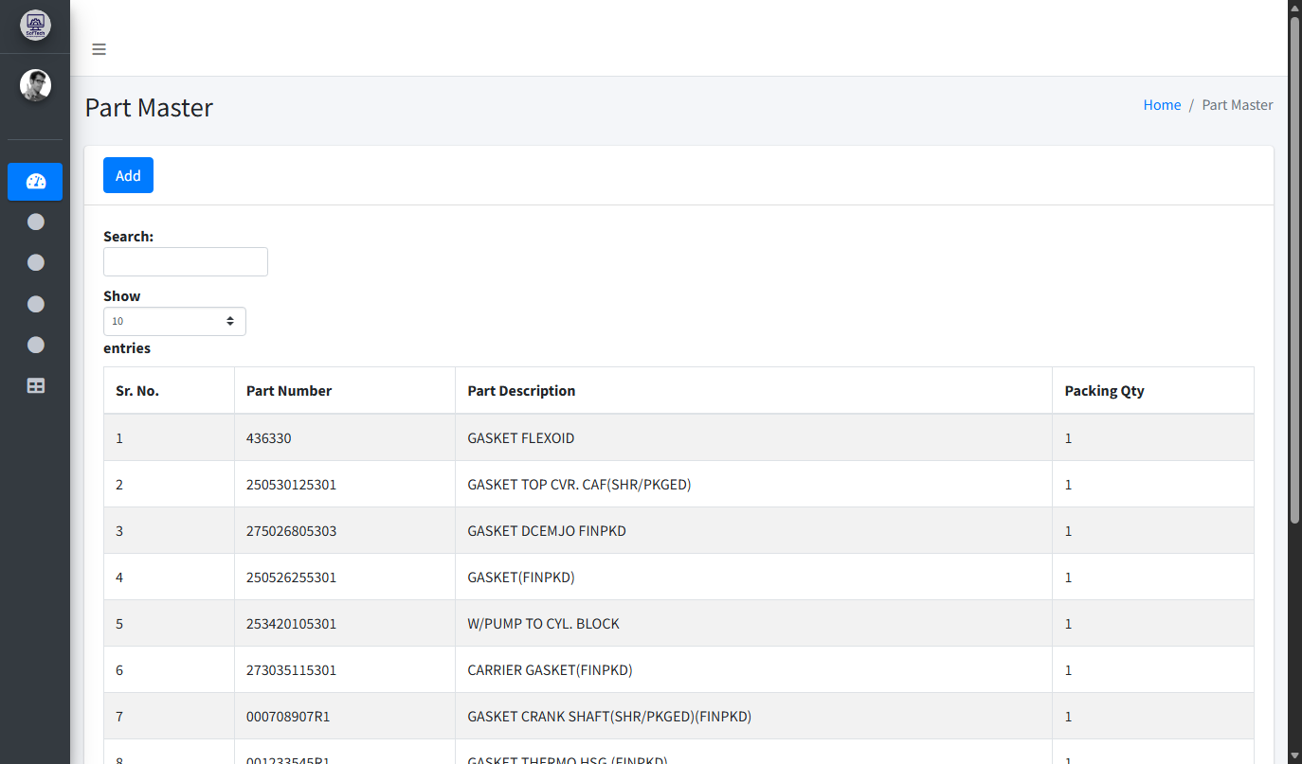 | 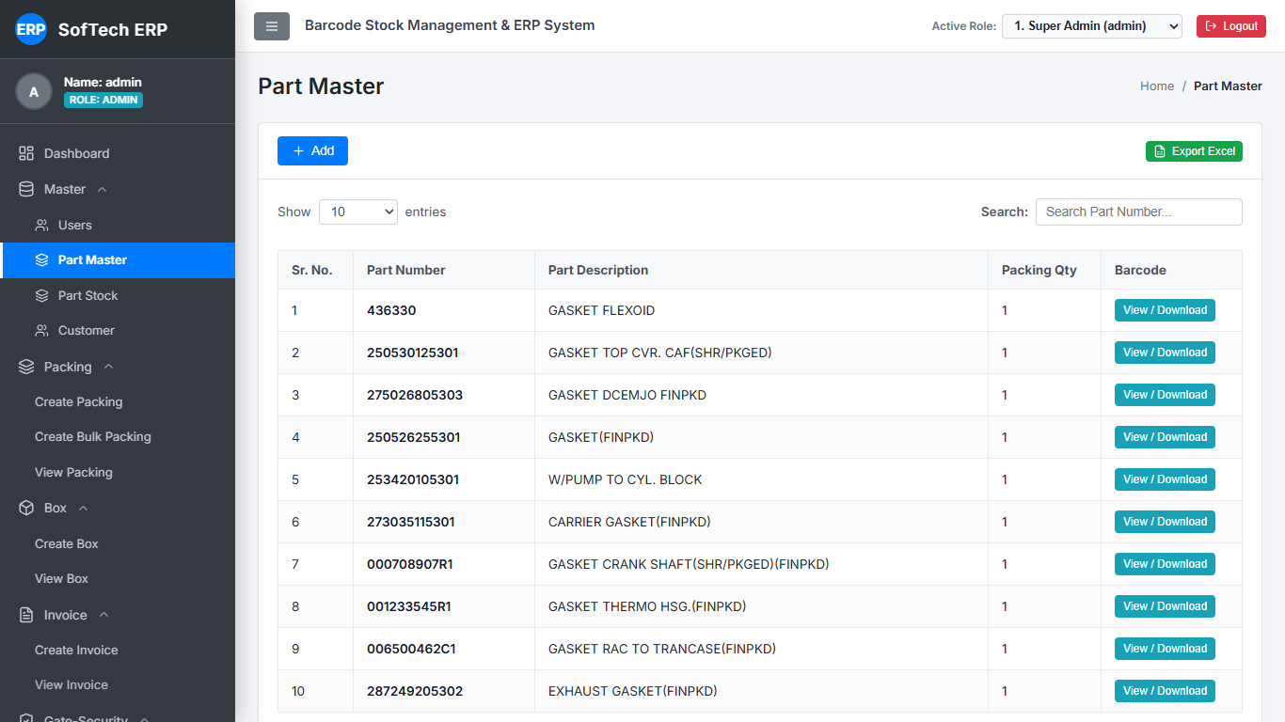

4. Part Stock (3-Stage Inventory)
Legacy Part Stock: 3 stock columns (FG Rack stock, Box pack stock, Invoice stock) with basic styling.
New Part Stock: Preserves the 3 stock-stage balance tracking with responsive grid, badges, and instant Excel export.
Legacy UI (Baseline) | Modern UI (New Implementation)
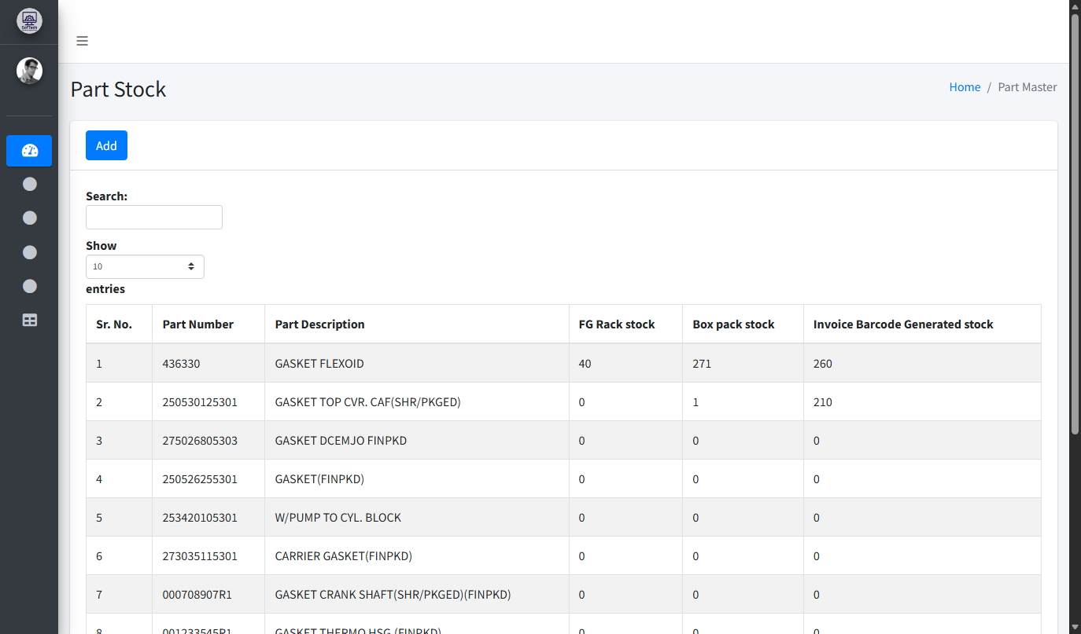 | 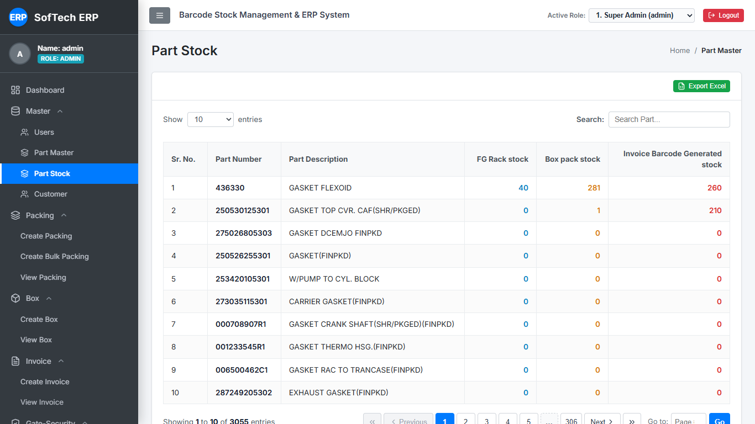

5. Customer Master
Legacy Customer Master: Simple list of customers with minimal action feedback.
New Customer Master: Customer cards/table with avatar badges, Add Customer modal, and direct Edit action.
Legacy UI (Baseline) | Modern UI (New Implementation)
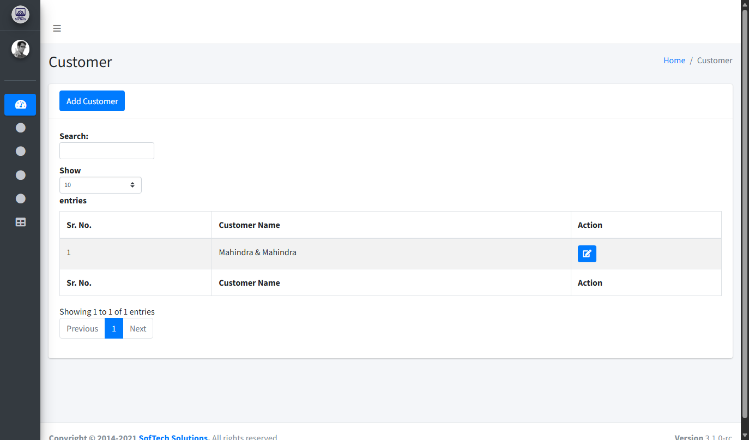 | 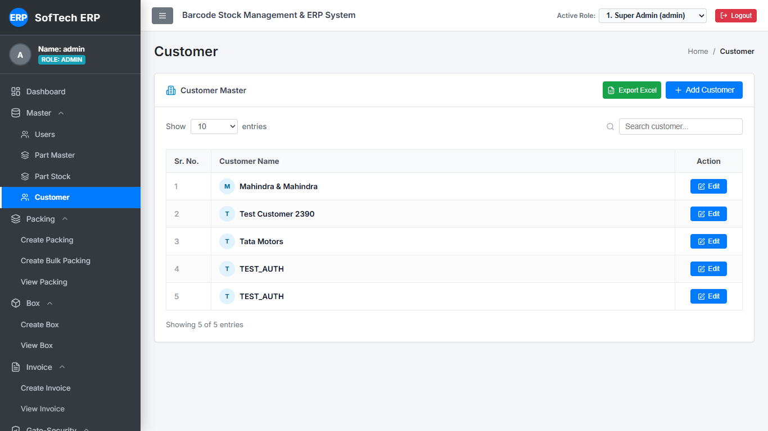

6. Customer Edit Modal
Legacy Customer Edit: Basic popup form.
New Customer Edit: Clean glassmorphism modal with animated backdrop, active customer name indicator, and validated inputs.
Legacy UI (Baseline) | Modern UI (New Implementation)
 | 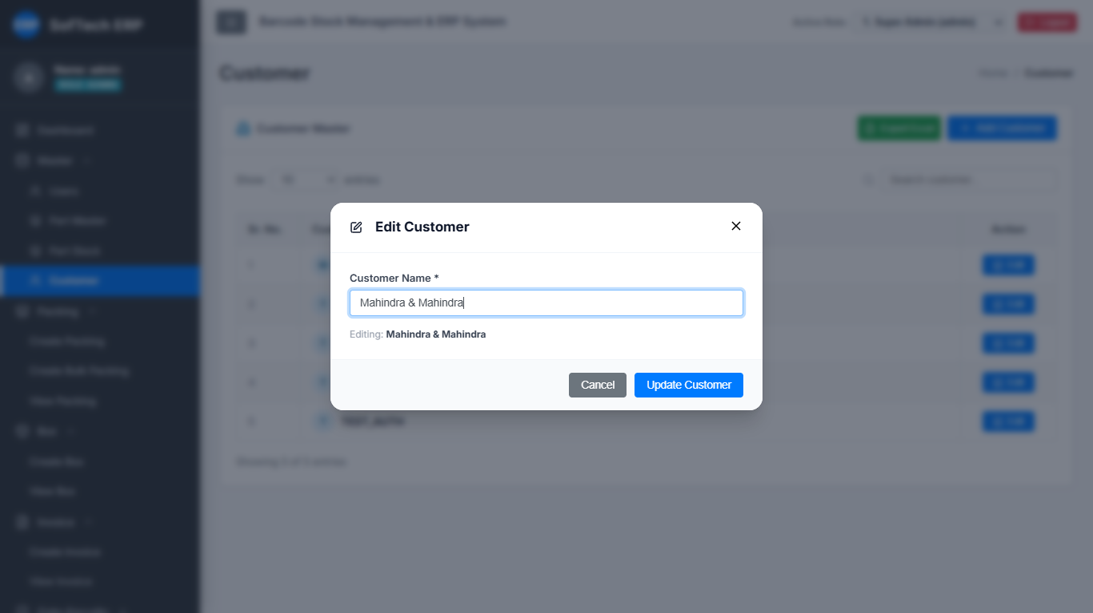

7. Create Packing (Single)
Legacy Create Packing: Basic form requiring separate page navigation; barcodes did not have immediate preview.
New Create Packing: Part selection list with immediate Pack trigger and direct inline rendering of generated Barcode Cards.
Legacy UI (Baseline) | Modern UI (New Implementation)
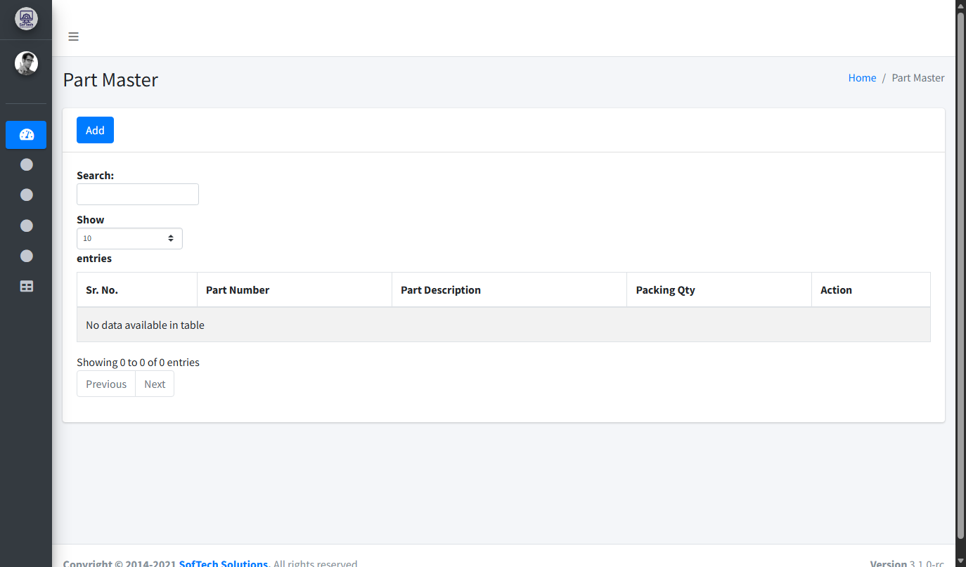 | 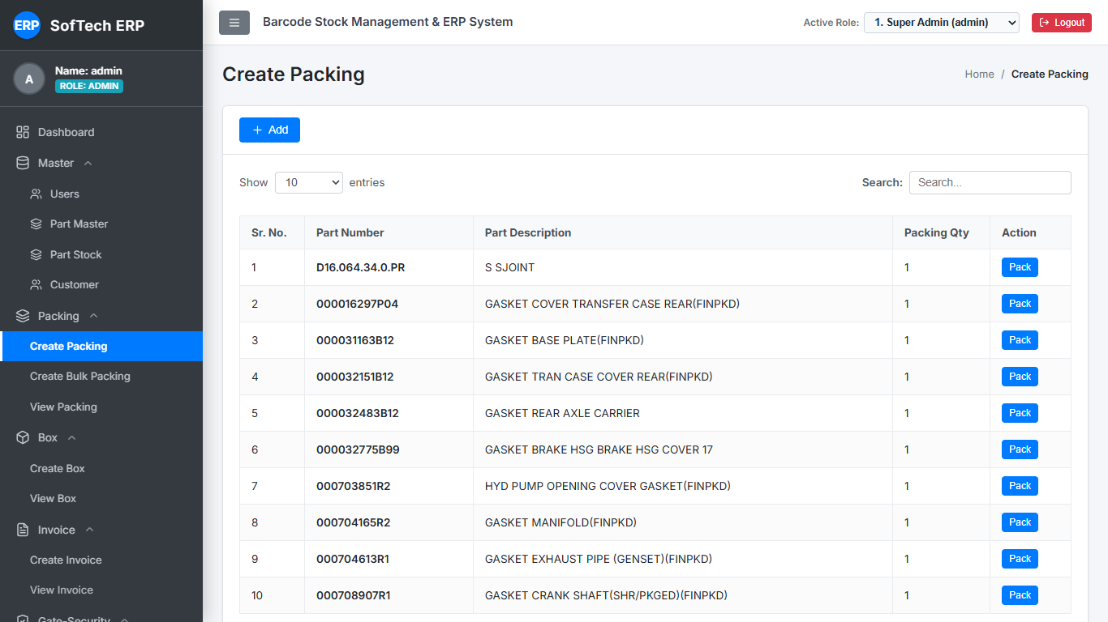

8. Create Packing Bulk
Legacy Bulk Packing: Separate bulk screen with standard form controls.
New Bulk Packing: Streamlined bulk generation with quantity calculators and bulk print support.
Legacy UI (Baseline) | Modern UI (New Implementation)
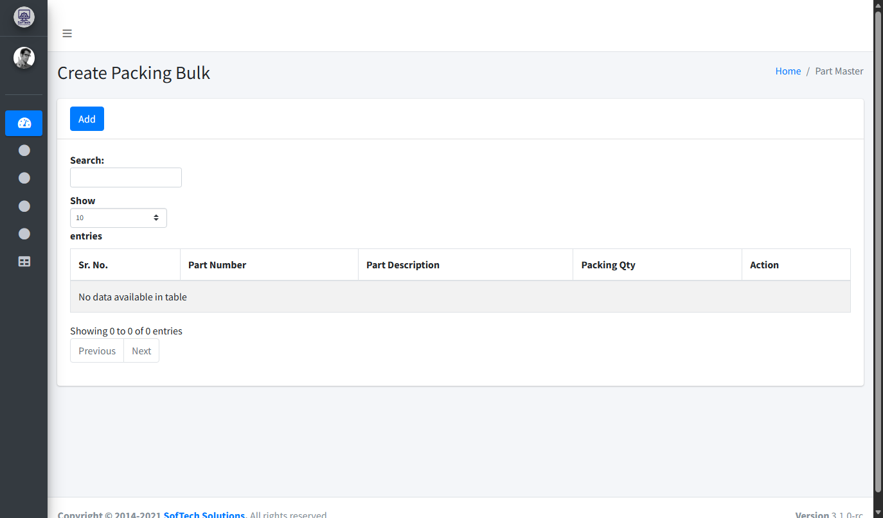 | 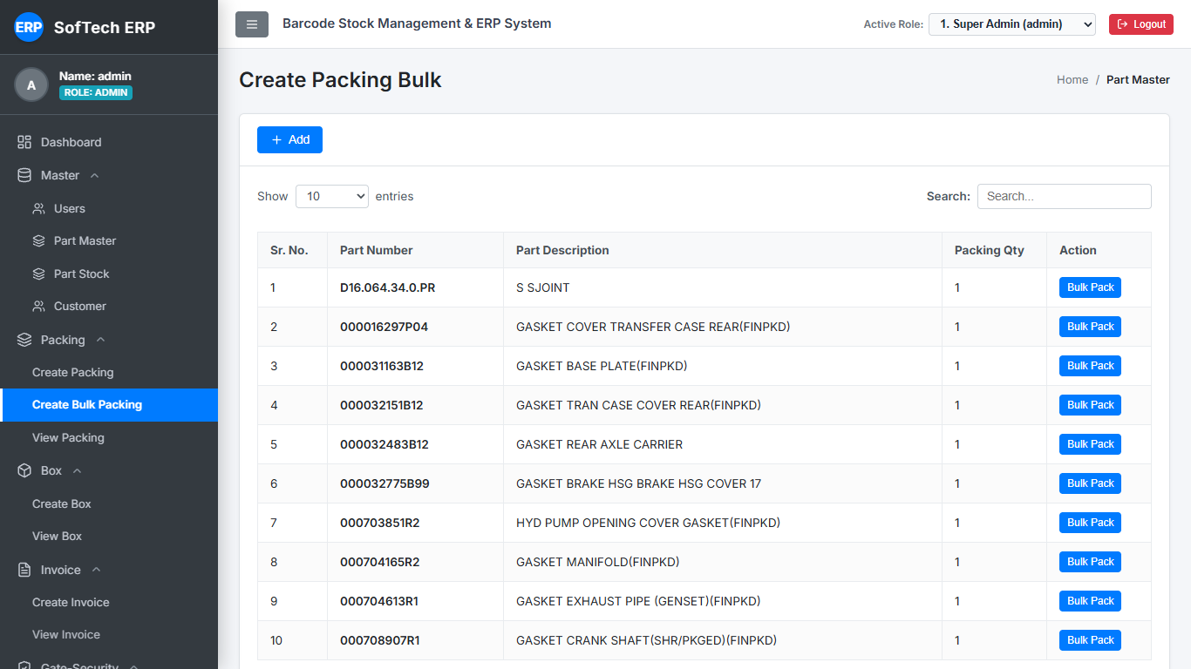

9. View Packing (Packing Ledger)
Legacy View Packing: History table with date filters and simple barcode download link.
New Packing Ledger: Comprehensive ledger with embedded thermal Barcode Cards, direct single-click print, instant PNG download, and status tags.
Legacy UI (Baseline) | Modern UI (New Implementation)
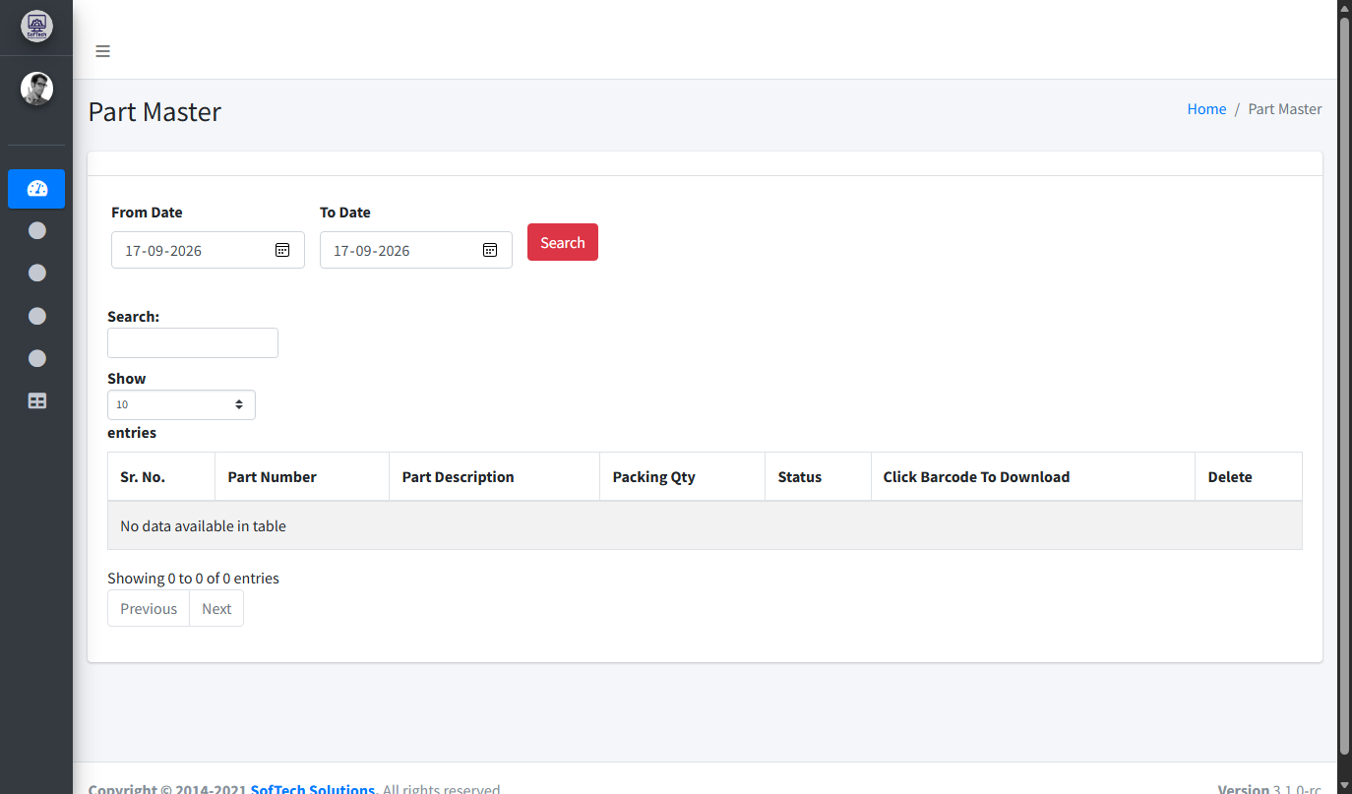 | 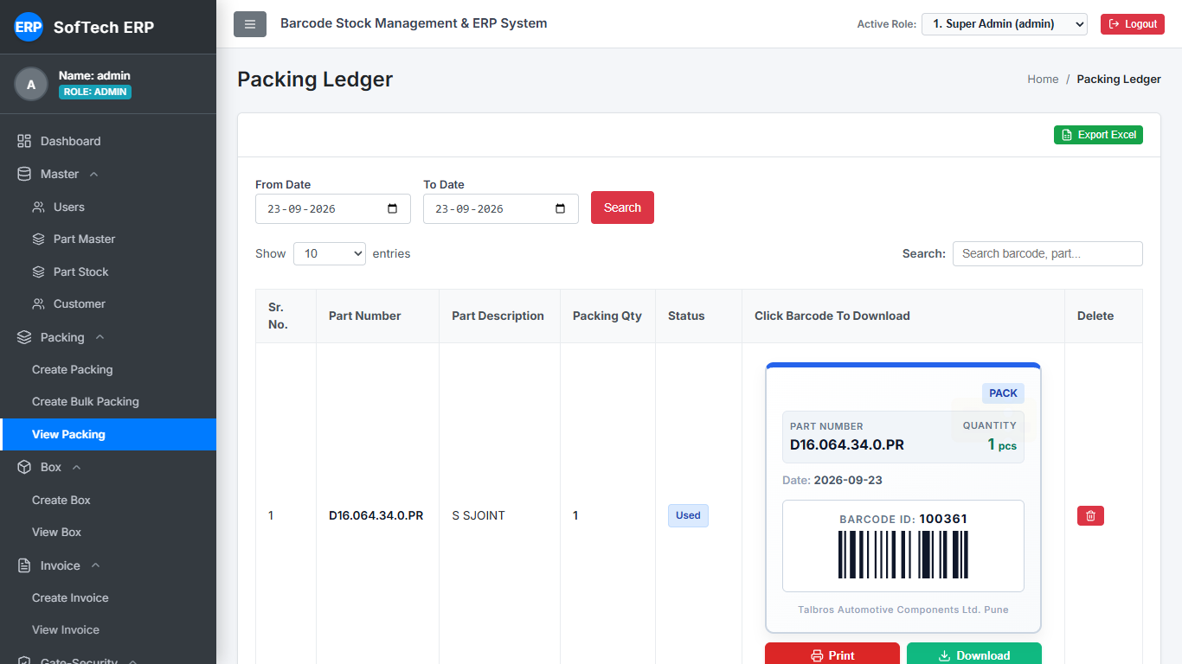

10. Create Box
Legacy Create Box: Dropdown selection of parts and customers to initialize a box.
New Create Box: Modern dropdown picker with search and instant box initialization.
Legacy UI (Baseline) | Modern UI (New Implementation)
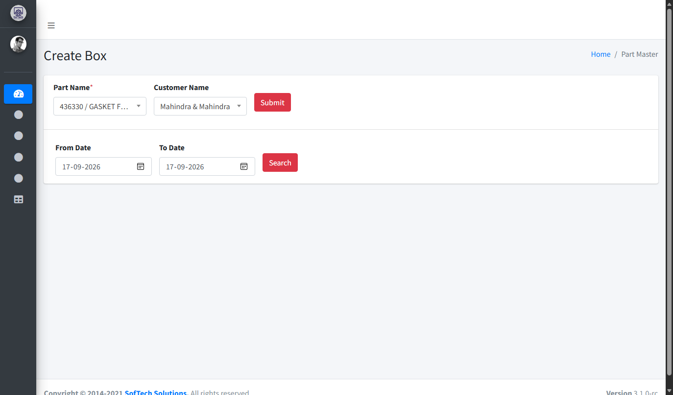 | 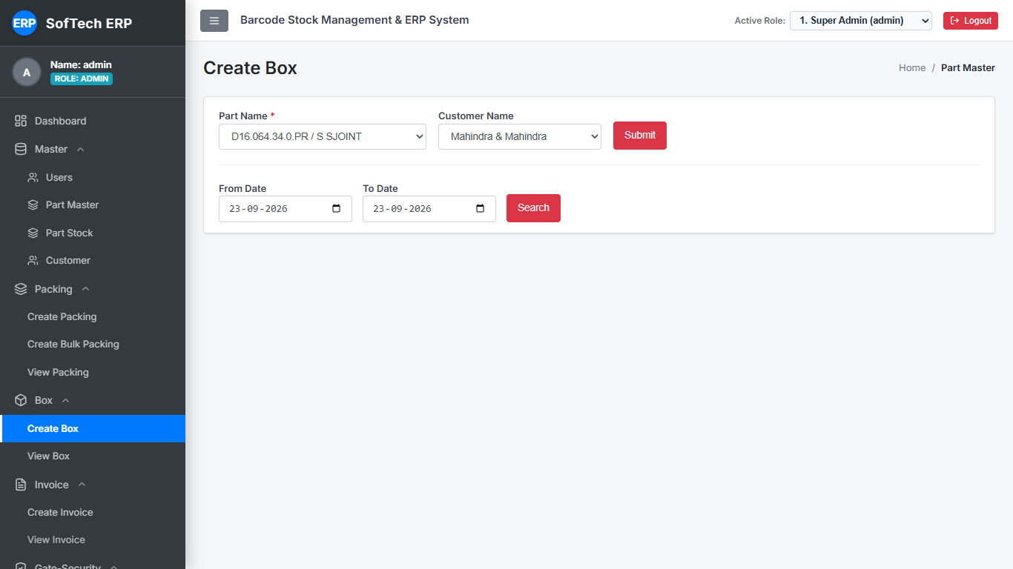

11. View Box
Legacy View Box: Box list with box barcode, status, and add packing links.
New View Box: Real-time status indicators (Locked, Pending), visual barcode codes, and quick packing assignment.
Legacy UI (Baseline) | Modern UI (New Implementation)
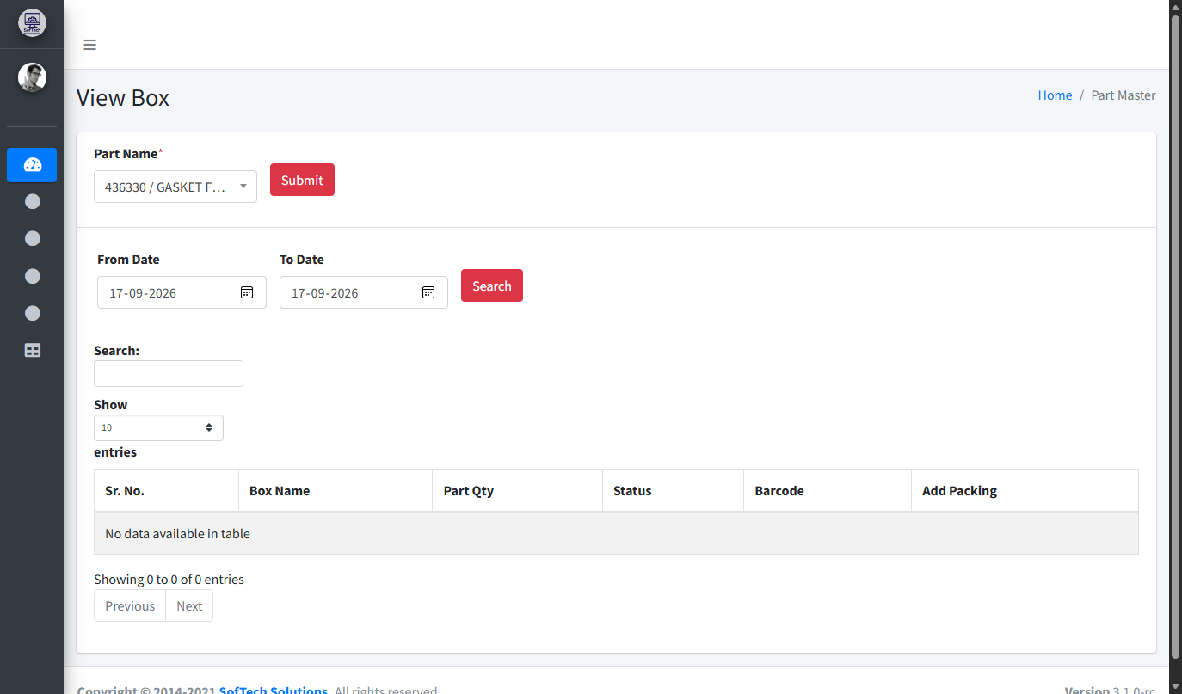 | 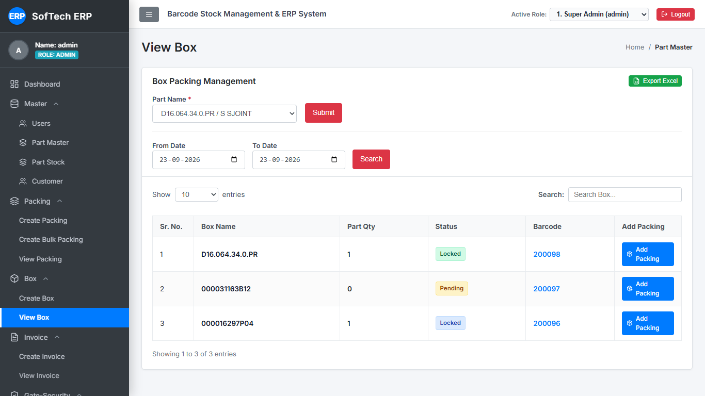

12. Create Invoice
Legacy Create Invoice: Invoice number, part selection, target quantity, and box assignment.
New Create Invoice: Modern invoice generation form with box verification and date filter search.
Legacy UI (Baseline) | Modern UI (New Implementation)
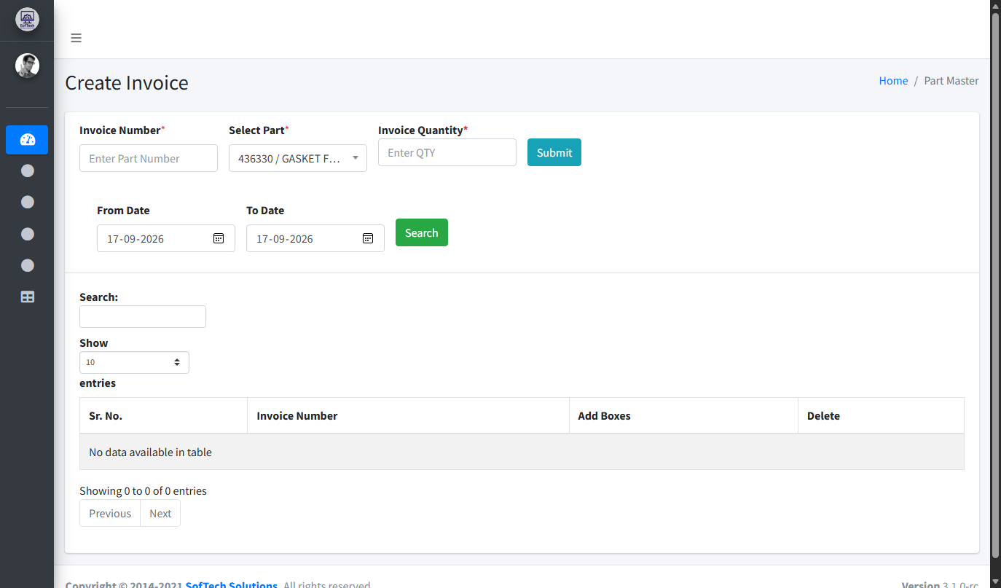 | 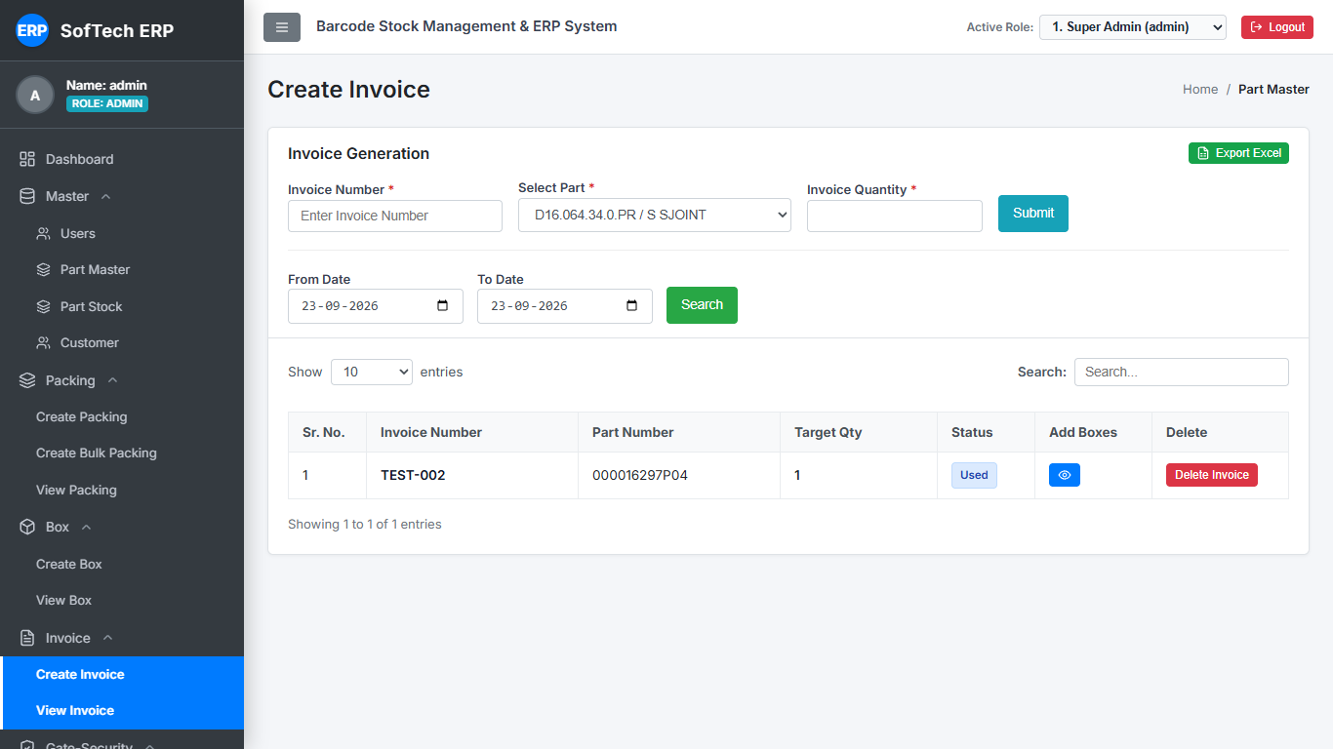

13. Verify Invoice (Gate Security)
Legacy Verify Invoice: Barcode input box for gate scanner, invoice list with View Details and Return Invoice.
New Verify Invoice: High-visibility scanner input, clear status badges (Verified), detail view, and return processing.
Legacy UI (Baseline) | Modern UI (New Implementation)
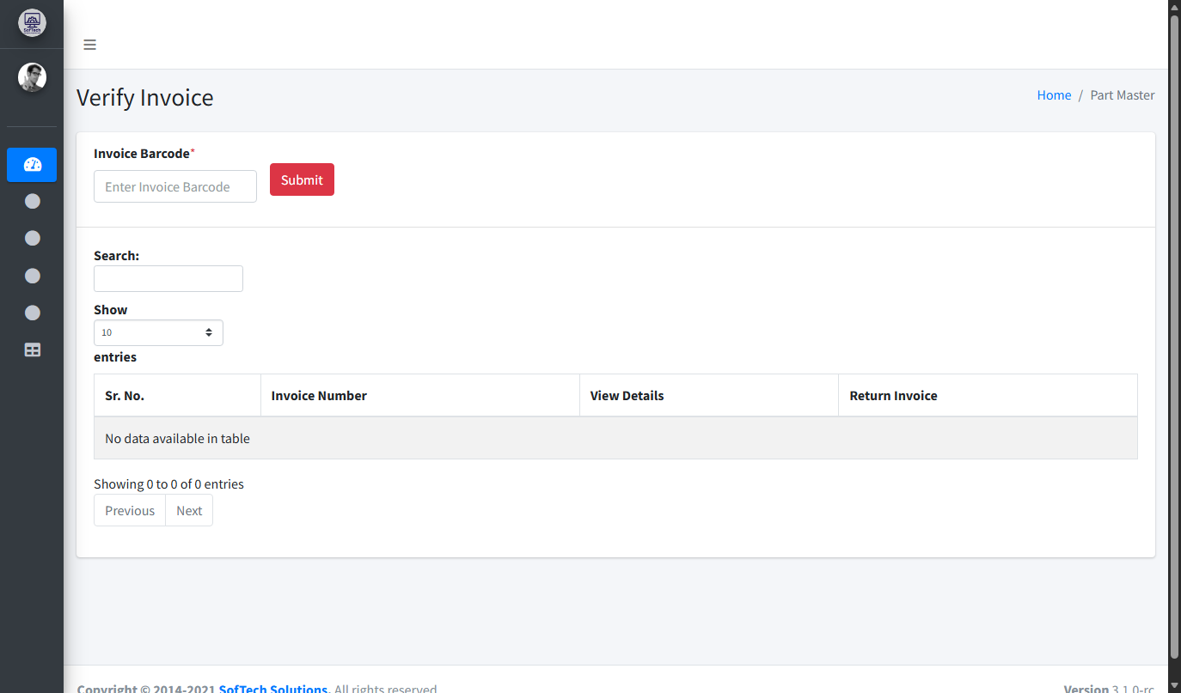 | 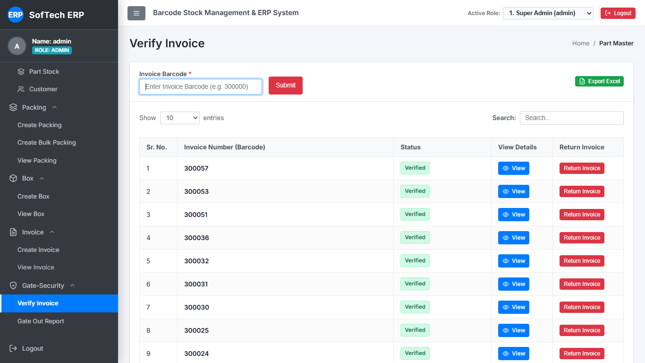

14. Gate-Out Report
Legacy Gate Out Report: Standard audit table showing Invoice No, Part Code, Qty, Gateout Code, Gate Out Date.
New Gate Out Report: Dispatched & Gate Cleared Records panel with instant Print Report and Excel Export features.
Legacy UI (Baseline) | Modern UI (New Implementation)
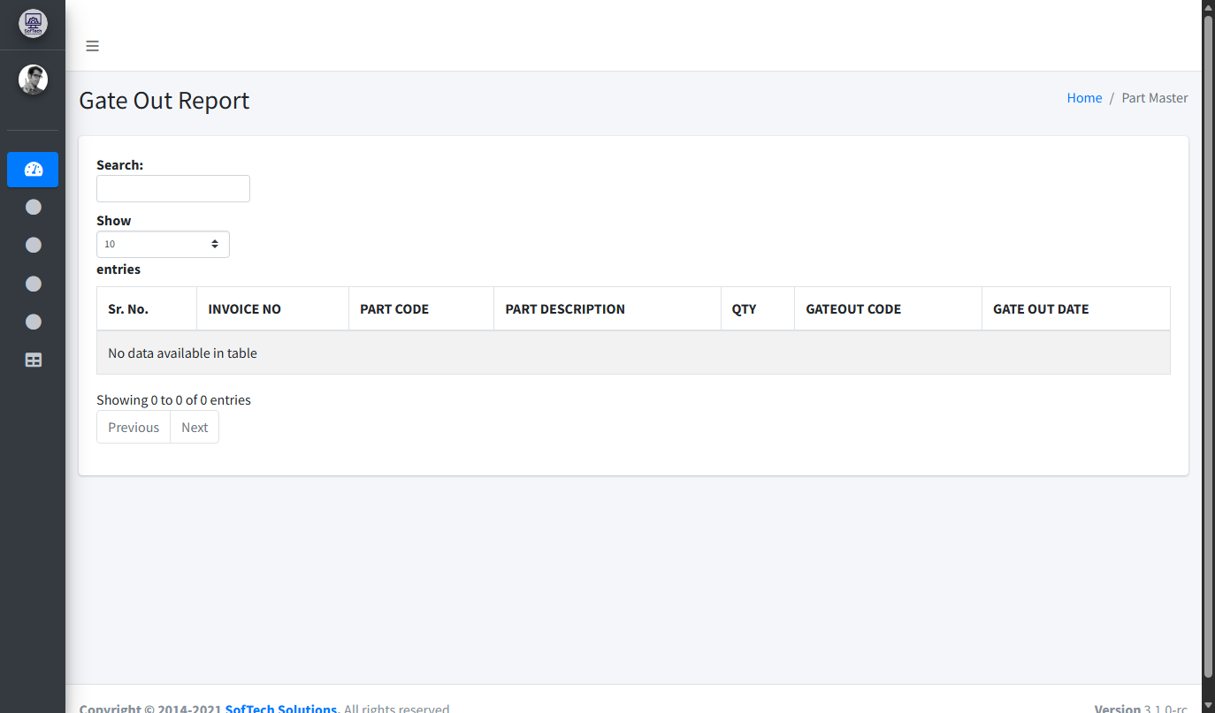 | 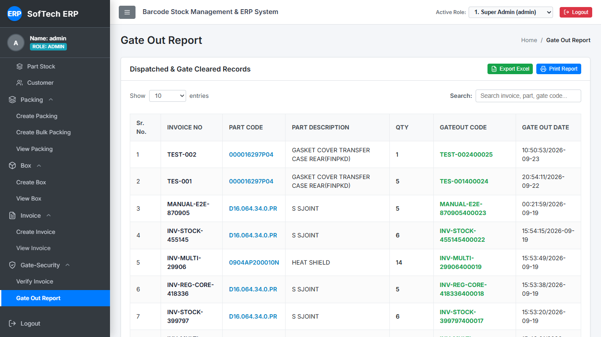

15. ERP Users & Access Control
Legacy ERP Users: User table with plain passwords visibly printed in table rows.
New ERP Users: Role-based access control (Admin, Packing, Box, Invoice, Gate), masked passwords with Show Passwords toggle, and avatar badges.
Legacy UI (Baseline) | Modern UI (New Implementation)
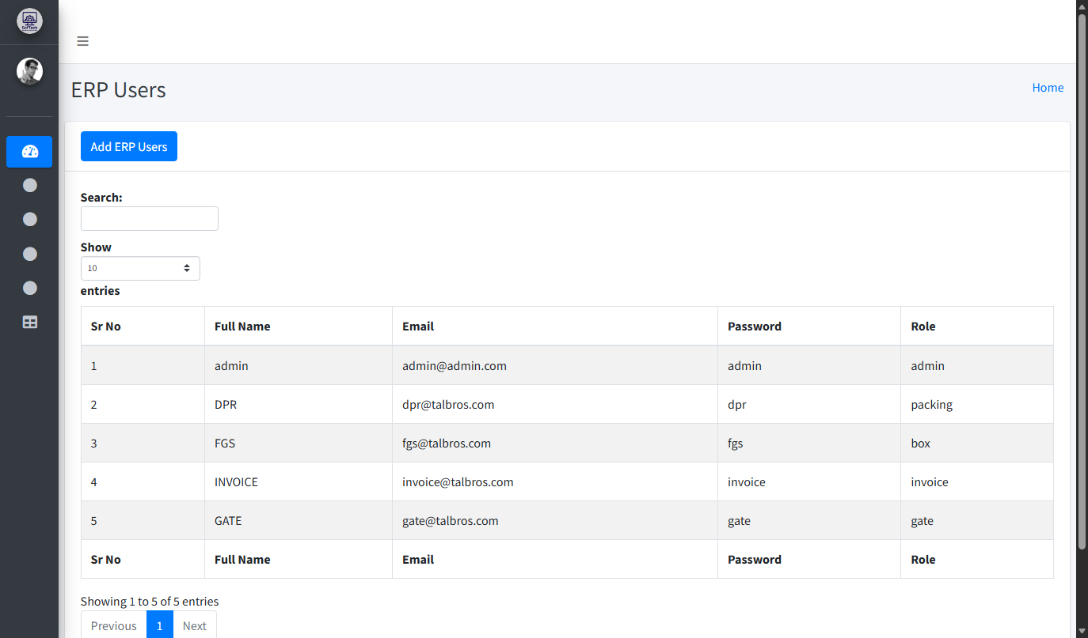 | 