SUPPORTDESK

Product Requirements
Document
Customer Support Ticket Management System

Document field | Value
Status | DRAFT — Submitted for senior review and approval
Version | 0.1
Prepared on | 23 October 2026
Prepared by | Samarth
Project | SupportDesk
Audience | Project senior/lead, product stakeholders, design and engineering team
Approval status | Not yet approved

A centralized workflow for raising, managing, and resolving customer support requests.

Contents
1. Executive Summary
2. Background and Problem Statement
3. Vision, Goals and Success Measures
4. Stakeholders and User Roles
5. Scope and Boundaries
6. Assumptions, Dependencies and Constraints
7. User Journeys and Ticket Workflow
8. Functional Requirements
9. User Stories and Acceptance Criteria
10. Non-Functional Requirements
11. Data Requirements
12. Proposed Architecture and Technology
13. Proposed API Outline
14. Security and Privacy
15. UX Expectations
16. Testing and Acceptance
17. Delivery Plan
18. Risks and Mitigations
19. Open Questions
20. Glossary

1. Executive Summary
SupportDesk is a proposed web-based application for centralizing customer support requests. Customers can raise and track tickets; support agents can review, respond to, prioritize, assign, and resolve them; administrators can manage access and review approved system activity.
This PRD establishes a reviewable starting point for the product: intended users, proposed MVP scope, ticket workflow, functional and quality expectations, and ways to verify the requirements.
- Proposed MVP: authentication and role-based access, ticket creation and viewing, agent responses, assignment and priority, ticket status/resolution, and limited administration/reporting.
- Potential future capabilities—not assumed in MVP: AI responses, advanced automation, third-party integrations, live chat, native mobile applications, and advanced analytics.
Implementation should begin only after the project senior approves the scope, business rules, priorities, and technical direction.

2. Background and Problem Statement
Support requests can be difficult to track when they are distributed across separate messages or disconnected records. Customers may lack visibility into progress, agents may not share a consistent view of ownership and priority, and administrators may have limited oversight.
SupportDesk proposes a common workflow for recording requests, tracking status, assigning responsibility, recording responses, and providing role-appropriate visibility.

2.1 Problem hypothesis
- Provide one consistent place to submit and reference support requests.
- Make ticket status, ownership, priority, and response history easier to understand.
- Help agents manage work consistently and traceably.
- Give administrators controlled access management and basic operational visibility.
These are proposed problem statements, not findings from a verified audit. The senior should confirm the actual current process, pain points, and target users.

3. Vision, Goals and Success Measures

3.1 Vision
Make support requests easier to submit, track, assign, and resolve through one clear and secure workflow.

3.2 Proposed goals
- Allow customers to submit tickets and view their status.
- Provide agents with a shared, permission-controlled workflow.
- Limit administrative actions to authorized users.
- Keep important ticket changes traceable.
- Create a maintainable foundation for future improvements.

3.3 Proposed success measures
Measure | Possible measurement | Target
Ticket submission success | Valid submissions completed without system error | To be agreed
Ticket visibility | Tickets have a visible, valid status | To be agreed
Assignment coverage | Active tickets have an assignee or clear unassigned state | To be agreed
Resolution tracking | Resolved tickets have status and timestamp recorded | To be agreed
Usability | Feedback from customer/agent acceptance testing | To be agreed

Targets should be agreed after expected usage and a measurement baseline are understood.

4. Stakeholders and User Roles
Role | Purpose | Proposed capabilities
Customer | Requests help and follows their tickets. | Create ticket; view own tickets; read permitted responses; see status.
Support Agent | Handles support work. | View permitted queue; respond; update status; set priority; assign/reassign; resolve.
Administrator | Manages access and oversees system activity. | Manage roles/access; view approved reports or activity summaries.
Project Senior / Lead | Owns product direction and approval. | Confirm scope, workflow, priorities, permissions, architecture, and acceptance.

5. Scope and Boundaries

5.1 Proposed MVP scope
- Authentication and role-based access for Customer, Support Agent, and Administrator.
- Ticket creation with validation and a unique reference.
- Ticket list and detail views showing status and relevant information.
- Agent responses or updates recorded against a ticket.
- Ticket priority and assignment management.
- Approved ticket status transitions and resolution.
- Basic access administration and limited reporting, if approved.
- Input validation, clear error handling, and basic history for important changes.

5.2 Proposed exclusions
- AI-generated answers or automatic classification.
- Live chat, voice support, and social-media support channels.
- Native iOS or Android apps.
- Complex SLA timers, escalations, and automation.
- External CRM, email, messaging, or identity-provider integrations.
- Advanced analytics and custom report builders.
These scope decisions are provisional. The senior may add, remove, or reprioritize items.

6. Assumptions, Dependencies and Constraints
Type | Item | Action
Assumption | The first release is a web application. | Confirm.
Assumption | Three roles are sufficient for the MVP. | Confirm role model.
Assumption | Tickets have status, priority, creator, and timestamps. | Confirm required fields.
Proposed stack | React + Vite + Tailwind CSS; Node.js + Express; PostgreSQL. | Confirm approved stack. MongoDB is not proposed.
Dependency | Approved requirements and acceptance criteria. | Senior review required.
Dependency | Development, testing, and deployment environments. | Confirm ownership and availability.
Constraint | Customer/ticket data must be protected. | Confirm security and retention policy.
Constraint | Timeline and team capacity are not confirmed. | Plan after review.

7. User Journeys and Ticket Workflow

7.1 Customer journey (proposed)
- Customer signs in.
- Customer completes the ticket form.
- System validates the input and creates a ticket with a unique reference.
- Customer sees confirmation and can view the ticket's status and permitted responses.

7.2 Agent journey (proposed)
- Agent opens the permitted ticket queue.
- Agent reviews the request, status, priority, and ownership.
- Agent responds and updates assignment or status when authorized.
- Agent records the outcome and resolves the ticket when agreed conditions are met.

7.3 Candidate ticket lifecycle
Status | Meaning | Decision to confirm
Open | Submitted and needs attention. | Is this the initial status?
In Progress | Agent is actively working on it. | What action moves a ticket here?
Pending | Waiting for customer or external information. | Is this state needed?
Resolved | Request is considered addressed. | Can the customer reopen it?
Closed | Work is considered complete. | Is this separate from Resolved?

Status names and transitions are suggestions only. The final state model and transition rules require senior approval.

8. Functional Requirements
MoSCoW values are provisional recommendations for discussion, not approved commitments.
ID | Area | Requirement | Priority
FR-01 | Authentication | The system shall allow authorized users to sign in and sign out. | Must (proposed)
FR-02 | Role access | The system shall restrict protected actions by assigned role. | Must (proposed)
FR-03 | Create ticket | Customers shall be able to submit a ticket with required fields. | Must (proposed)
FR-04 | Unique reference | The system shall provide a unique reference after successful creation. | Must (proposed)
FR-05 | View tickets | Customers shall be able to view their permitted tickets and status. | Must (proposed)
FR-06 | Ticket details | Authorized users shall be able to view permitted ticket details and history. | Must (proposed)
FR-07 | Respond | Authorized agents shall be able to record responses or updates. | Must (proposed)
FR-08 | Priority | Authorized agents shall be able to set or update priority. | Should (proposed)
FR-09 | Assignment | Authorized users shall be able to assign or reassign tickets. | Must (proposed)
FR-10 | Status | Authorized agents shall update status using approved transitions. | Must (proposed)
FR-11 | Resolution | Authorized agents shall resolve tickets and record relevant resolution information. | Must (proposed)
FR-12 | Access management | Administrators shall manage user roles/access within approved boundaries. | Must (proposed)
FR-13 | Reports | Authorized administrators shall view agreed support activity metrics. | Should/Could (proposed)
FR-14 | Change history | Important ticket changes should record actor and timestamp. | Should (proposed)
FR-15 | Validation | The system shall validate inputs and provide understandable feedback. | Must (proposed)

9. User Stories and Acceptance Criteria
These eight stories match the titles currently visible in the project board. They are proposed drafts and must be checked against the approved PRD.

US-01: Submit a support ticket
User story: As a customer, I want to submit a support ticket so that I can request help.
Acceptance criterion 1: Given I am signed in and required fields are valid, when I submit the form, then the system creates a ticket and displays its reference.
Acceptance criterion 2: Given a required field is missing or invalid, when I submit the form, then the system explains the validation issue and does not create a ticket.
Provisional MoSCoW priority: Must (proposed)

US-02: View ticket details
User story: As an authorized user, I want to view ticket details so that I can understand the request and status.
Acceptance criterion 1: Given I have permission to access a ticket, when I open it, then the system displays permitted details and status.
Acceptance criterion 2: Given I lack permission to access a ticket, when I try to open it, then the system denies access without exposing protected details.
Provisional MoSCoW priority: Must (proposed)

US-03: Respond to a ticket
User story: As a support agent, I want to respond to a ticket so that I can help the customer.
Acceptance criterion 1: Given I am authorized to respond, when I submit a non-empty response, then the response is saved and shown to the appropriate audience.
Acceptance criterion 2: Given the response is empty or I lack permission, when I try to submit it, then the system rejects the action.
Provisional MoSCoW priority: Must (proposed)

US-04: Prioritize tickets
User story: As a support agent, I want to set priority so that urgent requests can be handled appropriately.
Acceptance criterion 1: Given I can update priority, when I select a valid priority, then the system saves and displays it.
Acceptance criterion 2: Given I lack permission or select an unsupported value, when I attempt the change, then the system rejects the update.
Provisional MoSCoW priority: Should (proposed)

US-05: Resolve a ticket
User story: As a support agent, I want to resolve a ticket so that the outcome is recorded.
Acceptance criterion 1: Given the ticket meets approved resolution conditions, when I mark it resolved, then status and resolution timestamp are recorded.
Acceptance criterion 2: Given the ticket cannot be resolved under approved rules, when I try to resolve it, then the system prevents the transition and explains why.
Provisional MoSCoW priority: Must (proposed)

US-06: Assign support tickets
User story: As an authorized support user, I want to assign a ticket so that ownership is clear.
Acceptance criterion 1: Given I have permission and the selected agent is eligible, when I assign the ticket, then the owner is saved and visible to authorized users.
Acceptance criterion 2: Given the selected agent is invalid or I lack permission, when I attempt assignment, then the system rejects it.
Provisional MoSCoW priority: Must (proposed)

US-07: Manage system access
User story: As an administrator, I want to manage user access so that only authorized people can use protected capabilities.
Acceptance criterion 1: Given I am an authorized administrator, when I make a permitted access change, then the system saves it and records who made it.
Acceptance criterion 2: Given I am not authorized, when I attempt access management, then the system denies the request.
Provisional MoSCoW priority: Must (proposed)

US-08: Monitor reports
User story: As an administrator, I want to view support reports so that I can monitor agreed activity and performance.
Acceptance criterion 1: Given report data is available and I am authorized, when I open an approved report, then the system displays the agreed information.
Acceptance criterion 2: Given no matching data is available, when I request the report, then the system displays a clear empty state.
Provisional MoSCoW priority: Should (proposed)

10. Non-Functional Requirements
ID | Expectation
NFR-01 Security | Enforce authorization on the server, not only by hiding UI controls.
NFR-02 Privacy | Users can only access ticket data permitted by the approved role model.
NFR-03 Reliability | Handle validation/server errors without misleading success messages or corrupting confirmed data.
NFR-04 Usability | Use clear labels, consistent navigation, and understandable status messages.
NFR-05 Performance | Agree response-time targets after expected load and environment are known.
NFR-06 Maintainability | Use consistent code organization and documented API contracts.
NFR-07 Compatibility | Agree supported browsers and screen sizes.
NFR-08 Accessibility | Support keyboard use, readable contrast, field labels, and clear validation feedback.
NFR-09 Auditability | Record required important actions with actor and timestamp.
NFR-10 Recovery | Define backup and recovery expectations before production use.

Numeric targets for performance, availability, retention, and recovery are intentionally left open for senior confirmation.

11. Data Requirements and Proposed Data Model
The proposed model is documented through the conceptual ER diagram and is complemented by the class diagram for candidate domain objects and operations. These views are illustrative and must be reconciled before schema implementation.
Entity | Purpose | Illustrative fields
User | Account and role information. | id, name, email, role, active, created_at; secure password hash or identity reference if applicable.
Ticket | Main support request. | id, reference, title, description, status, priority, customer_id, assignee_id, created_at, updated_at, resolved_at.
TicketResponse | Replies or notes, if approved. | id, ticket_id, author_id, body, visibility, created_at.
TicketHistory | Traceable ticket changes. | id, ticket_id, actor_id, action, old_value, new_value, created_at.

Data questions to confirm
- Required fields and field length limits.
- Whether attachments are supported, including file type/size/storage controls.
- Whether internal agent notes are separate from customer-visible replies.
- Retention, deletion, archiving, and export rules.
- Whether soft deletion is required.

12. Proposed System Architecture and Technology
Layer | Responsibility | Candidate technology
Frontend | Pages, forms, role-aware navigation, client validation and API calls. | React, Vite, Tailwind CSS
Backend API | Authentication, authorization, business rules, validation and ticket workflow. | Node.js, Express
Database | Persistent users, tickets, responses and history. | PostgreSQL
Delivery/testing | Automated checks, QA/UAT, configuration and deployment. | To be confirmed

Conceptual flow: User browser → Frontend → Backend API → PostgreSQL. The backend validates requests and enforces permissions before accessing or changing data.

13. Proposed API Outline
Illustrative routes only; the final contract must define methods, payload schemas, errors, pagination, and authorization.
Area | Example routes | Purpose
Authentication | POST /api/auth/login; POST /api/auth/logout; GET /api/auth/me | Sign in/out and retrieve current user.
Tickets | POST /api/tickets; GET /api/tickets; GET /api/tickets/{id} | Create and retrieve permitted tickets.
Responses/status | POST /api/tickets/{id}/responses; PATCH /api/tickets/{id}/status | Record replies and update status.
Assignment/priority | PATCH /api/tickets/{id}/assignee; PATCH /api/tickets/{id}/priority | Update ownership and priority.
Administration | GET /api/admin/users; PATCH /api/admin/users/{id}/role | Manage access, subject to authorization.
Reports | GET /api/reports/summary | Retrieve approved metrics.

14. Security and Privacy
- Enforce authentication and server-side authorization for all protected actions.
- Apply least privilege so each role receives only necessary permissions.
- If local passwords are used, store only secure password hashes; never store plain-text passwords.
- Validate input on the server and use safe database access patterns.
- Keep secrets and credentials out of source control; use environment or secret-management practices.
- Use HTTPS in deployed environments and define token/session expiry and logout behavior.
- Prevent one customer from accessing another customer's ticket.
- Define audit events, log access, and retention policy.
- Agree on data retention, deletion, backups, and incident handling before production use.
These are baseline recommendations; confirm applicable organizational security and compliance policies.

15. UX and Accessibility Expectations
- Use consistent navigation and clear page titles for approved screens.
- Show status and priority in text, not color alone.
- Provide field-level validation and understandable errors.
- Provide loading, success, error, empty, and permission-denied states.
- Confirm consequential actions where appropriate.
- Use responsive layouts, readable contrast, keyboard-accessible controls, and labelled form inputs.

16. Testing and Acceptance
Test level | Purpose | Example
Unit | Check individual rules/functions. | Validate status transition rules.
API/integration | Check API behavior and database interaction. | Create a ticket and retrieve it with an authorized account.
Permission/security | Verify unauthorized access is denied. | Customer A cannot view Customer B's ticket.
UI/workflow | Check end-to-end actions. | Customer submits a ticket and receives a reference.
UAT | Stakeholders confirm business needs and criteria. | Agent reviews assignment and resolution workflow.

Proposed acceptance conditions
- Approved MVP requirements have testable acceptance criteria.
- Critical ticket flows pass agreed tests in the test environment.
- Role and ticket-data restrictions are tested.
- Known defects and workarounds are documented and accepted by the appropriate reviewer.
- Senior or delegated stakeholder records acceptance before release.

17. Risks and Mitigations
Risk | Potential impact | Mitigation proposal
Requirements not approved | Rework or conflicting expectations. | Review PRD with senior; record decisions and changes.
Unclear role permissions | Data exposure or blocked legitimate work. | Approve permission matrix and test negative access cases.
Unclear ticket lifecycle | Inconsistent status handling. | Approve states, transitions and reopen/close rules.
Scope expansion | Delay and complexity. | Agree MVP exclusions and change control.
Insufficient testing | Defects reach users. | Map acceptance criteria to tests.
Sensitive data exposure | Loss of trust and policy impact. | Enforce server-side authorization and secure configuration.
Unconfirmed technical choices | Implementation rework. | Approve stack, hosting, authentication and repository standards.

18. Glossary
Term | Meaning
PRD | Product Requirements Document; describes goals, scope, users and requirements.
MVP | Minimum Viable Product; the smallest useful release agreed for initial delivery.
User story | User-focused description of a capability and its value.
Acceptance criteria | Testable conditions used to decide whether a story meets requirements.
MoSCoW | Must have, Should have, Could have, Won't have this time.
QA | Quality Assurance; practices used to support product quality.
UAT | User Acceptance Testing; stakeholder verification against agreed needs.
API | Application Programming Interface; a defined way for software components to communicate.
RBAC | Role-Based Access Control; permissions assigned based on role.

11.1 Entity Relationship (ER) Diagram
The diagram below illustrates the proposed relationships among users, tickets, ticket responses, and ticket history. It is a conceptual draft to support senior review, not a finalized database schema.
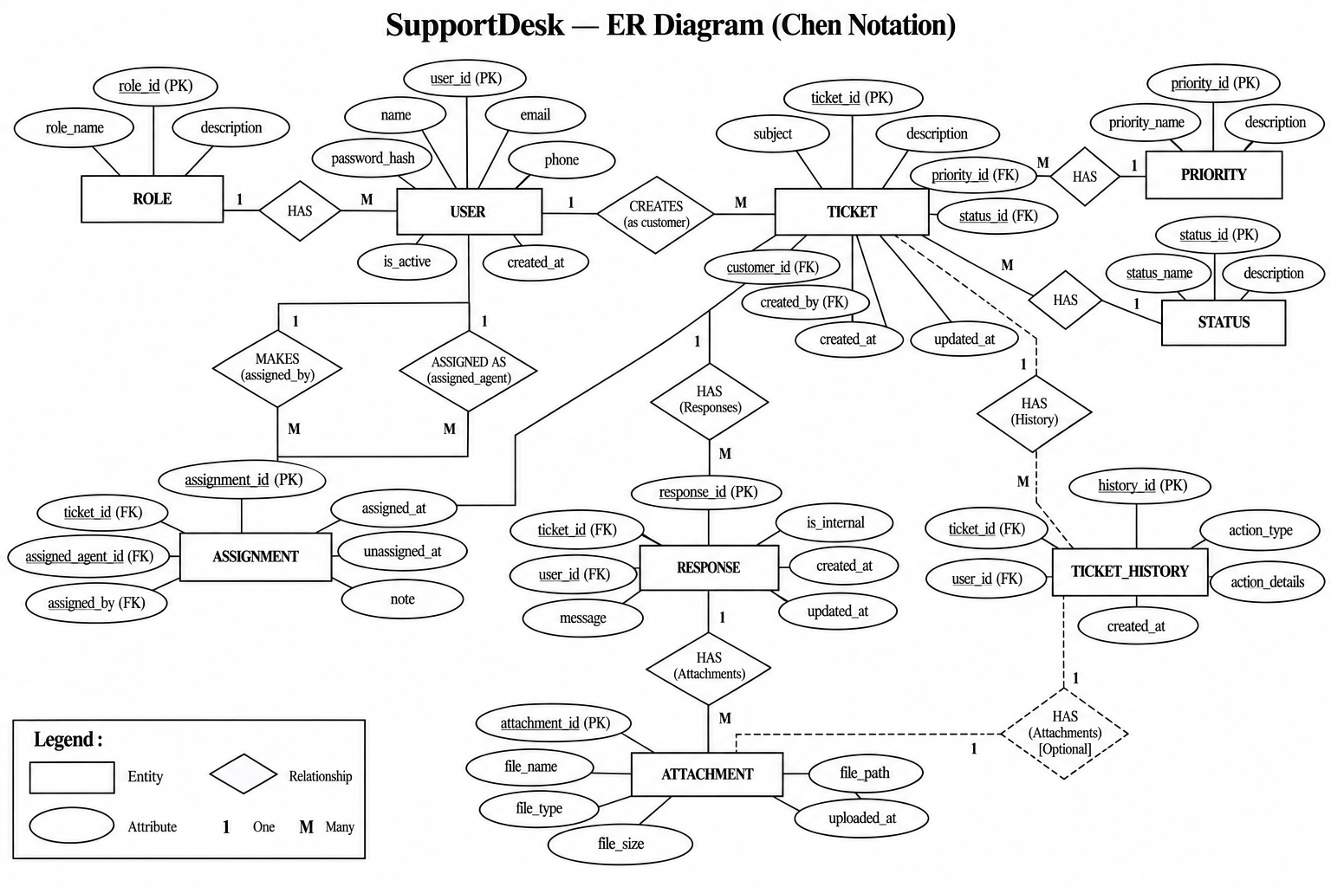
Figure 1. Proposed SupportDesk ER diagram. PK = primary key; FK = foreign key; UQ = unique constraint.

11.2 Relationship Notes
- One user (as customer) may create many tickets; each ticket has one customer.
- One user (as agent) may be assigned many tickets; a ticket may be unassigned until assigned.
- One ticket may have many responses; each response belongs to one ticket and has one author.
- One ticket may have many history records; each history record identifies the actor who made the change.
- The same Users entity serves multiple roles; customer_id, assignee_id, author_id, and actor_id refer to different relationships with Users.

A.1 Use Case Diagram
Illustrates the role-based use cases for customers, support agents, administrators, and the project senior/lead, showing how each role interacts with the proposed ticket management functions.
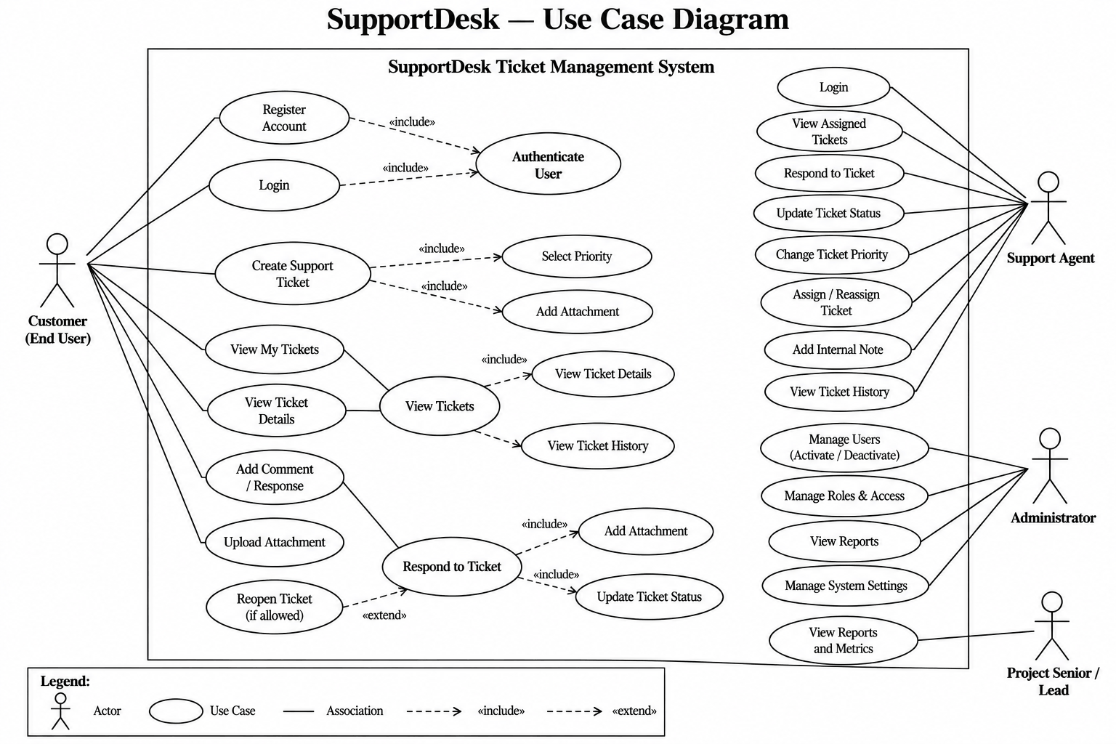
Figure A1. SupportDesk role-based use cases.

A.2 Data Flow Diagram (DFD)
Illustrates the movement of ticket requests through identity/permission checks and ticket processing, with candidate user, ticket, response, and history data stores.
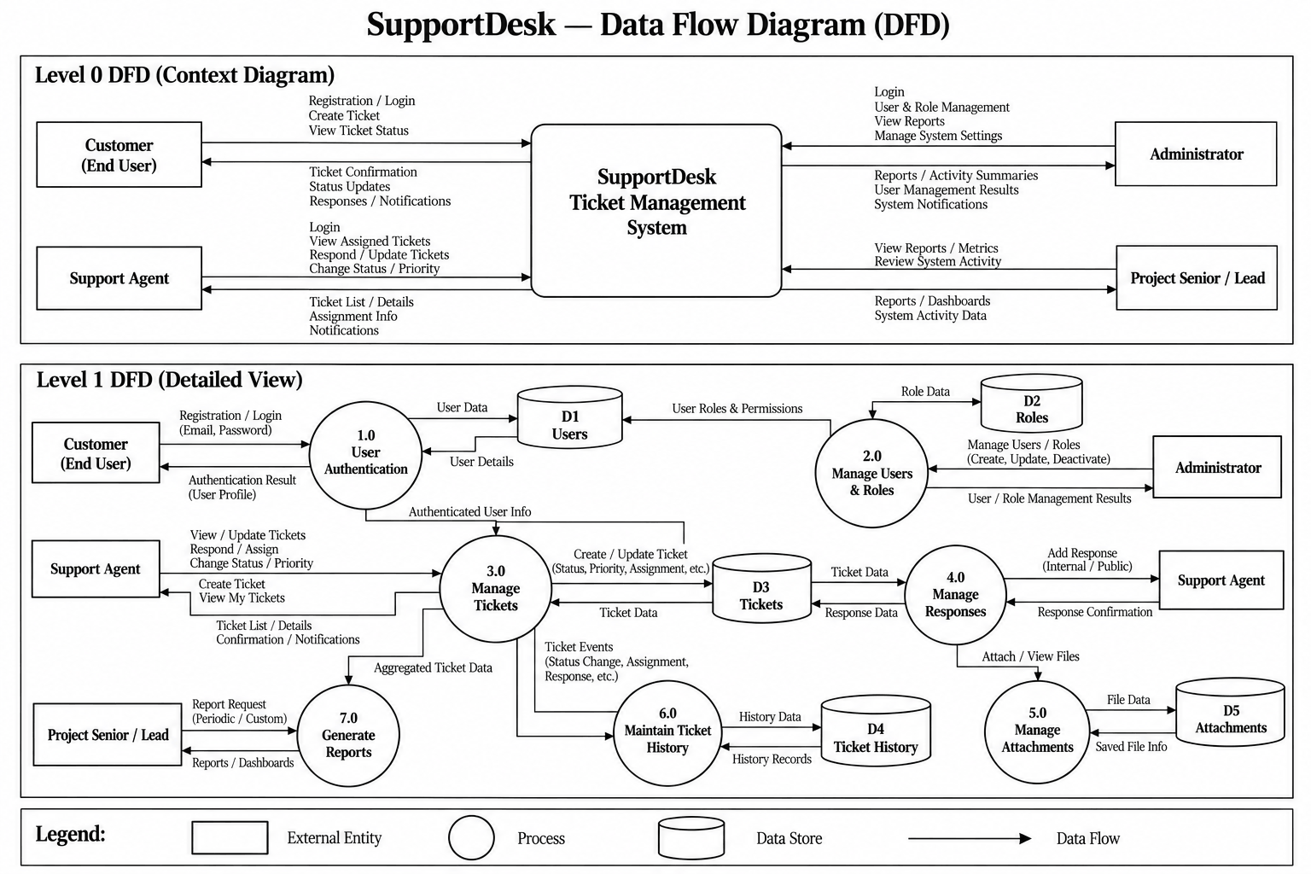
Figure A2. SupportDesk Level 0 and Level 1 data flow.

A.3 Class Diagram
The class diagram provides a proposed object-oriented view of the main SupportDesk domain classes, including their candidate attributes, operations, and associations. It complements the conceptual ER diagram; the class methods are illustrative and must be aligned with the final service and domain design.
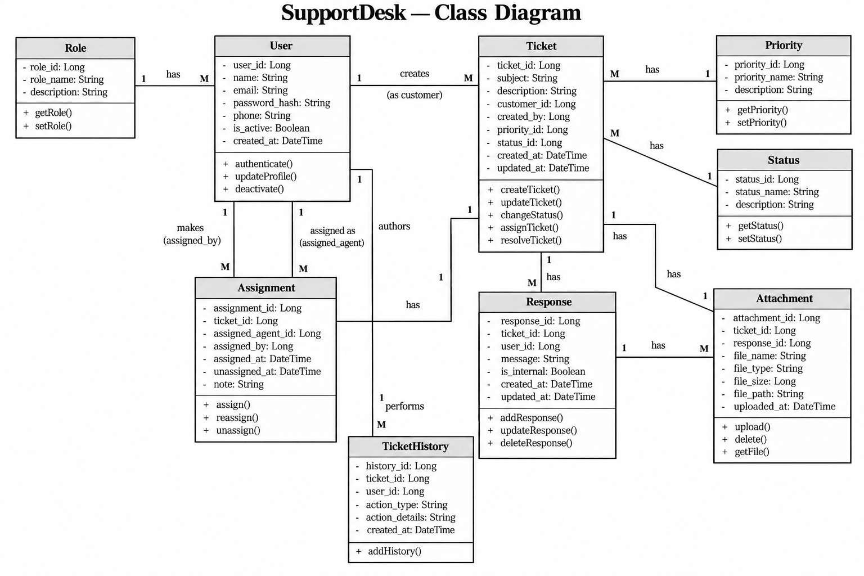
Figure A3. SupportDesk class diagram.

