Day 13 — Frontend Foundations — EOD
Project: SupportDesk — Customer Support Ticket Management System
Date: 12 November 2026
Track: Full-Stack TypeScript Engineering

1. Branch and PR link
- Branch: feat/web-login-foundation (branched from samarth at 30df21e).
- Local Commits: 1f70728, 4e4fbae (ready for push via git push -u origin feat/web-login-foundation; PR link to be added after push).

2. Existing frontend/backend contract inspected
- apps/api/src/routes/auth.routes.ts: POST /auth/login and POST /auth/register (no /auth/logout or /auth/me endpoint).
- apps/api/src/validations/auth.validation.ts: loginSchema expects trimmed, lowercased valid email and non-empty password.
- apps/api/src/services/auth.service.ts & auth.controller.ts: POST /auth/login returns 200 OK { data: { accessToken, user: { id, name, email, role } }, error: null, meta: {} }.
- apps/api/prisma/schema.prisma: Role (customer, agent, admin), TicketStatus (open, in_progress, waiting_on_customer, resolved, closed), TicketPriority (P1-P4).
- apps/api CORS allows http://localhost:5173.

3. Wireframe/plan completed
- Completed Google Stitch desktop and mobile (390px) UI prototypes with organized overview notes: https://stitch.google.com/projects/5142013918804021795?pli=1
- Aligned frontend tokens with Navy (#172B4D), Blue (#2563EB), Teal (#0D9488), and Slate (#F8FAFC / #334155 / #64748B / #E2E8F0).

4. Folder structure created or updated
- Root config: apps/web/package.json, tsconfig.json, vite.config.ts, index.html, .env.example (committed), .env (gitignored).
- Core & Lib: apps/web/src/index.css, test-setup.ts, lib/api-client.ts, lib/auth.tsx, lib/__tests__/api-client.test.ts.
- Components & Routes: components/AppLayout.tsx, components/ProtectedRoute.tsx, components/__tests__/ProtectedRoute.test.tsx.
- Tickets Feature: features/tickets/api/tickets.api.ts, hooks/useTickets.ts, components/TicketsOverview.tsx.
- Pages & Entry: pages/LoginPage.tsx, pages/TicketsPage.tsx, pages/__tests__/LoginPage.test.tsx, App.tsx, main.tsx.

5. API client implementation
- Centralized typed wrapper in apps/web/src/lib/api-client.ts (apiClient.get, post, patch, delete).
- Reads import.meta.env.VITE_API_BASE_URL; zero hardcoded localhost URLs or fetch() calls in UI components.
- Injects Authorization: Bearer <token> via configureApiAuth(...), maps error envelopes and network failures to ApiError, and triggers unauthorized callback on 401.

6. Environment variable configuration
- Committed apps/web/.env.example with VITE_API_BASE_URL=http://localhost:3000.
- Created local apps/web/.env with VITE_API_BASE_URL=http://localhost:3000 (verified gitignored).

7. Login page and layout
- LoginPage (pages/LoginPage.tsx): React Hook Form email/password validation, accessible labels and aria attributes, loading state (Signing in...) preventing double-submit, and role="alert" error banner.
- AppLayout (components/AppLayout.tsx): Responsive #172B4D Navy desktop sidebar, mobile hamburger slide-over drawer, and top header with user name, Teal role badge, and Sign out.
- TicketsPage & TicketsOverview: Protected /tickets landing view backed by useTickets() with loading, error+retry, empty, desktop table, and mobile card views.
Captured Screenshot — http://localhost:5173/login (Desktop 1440x900):
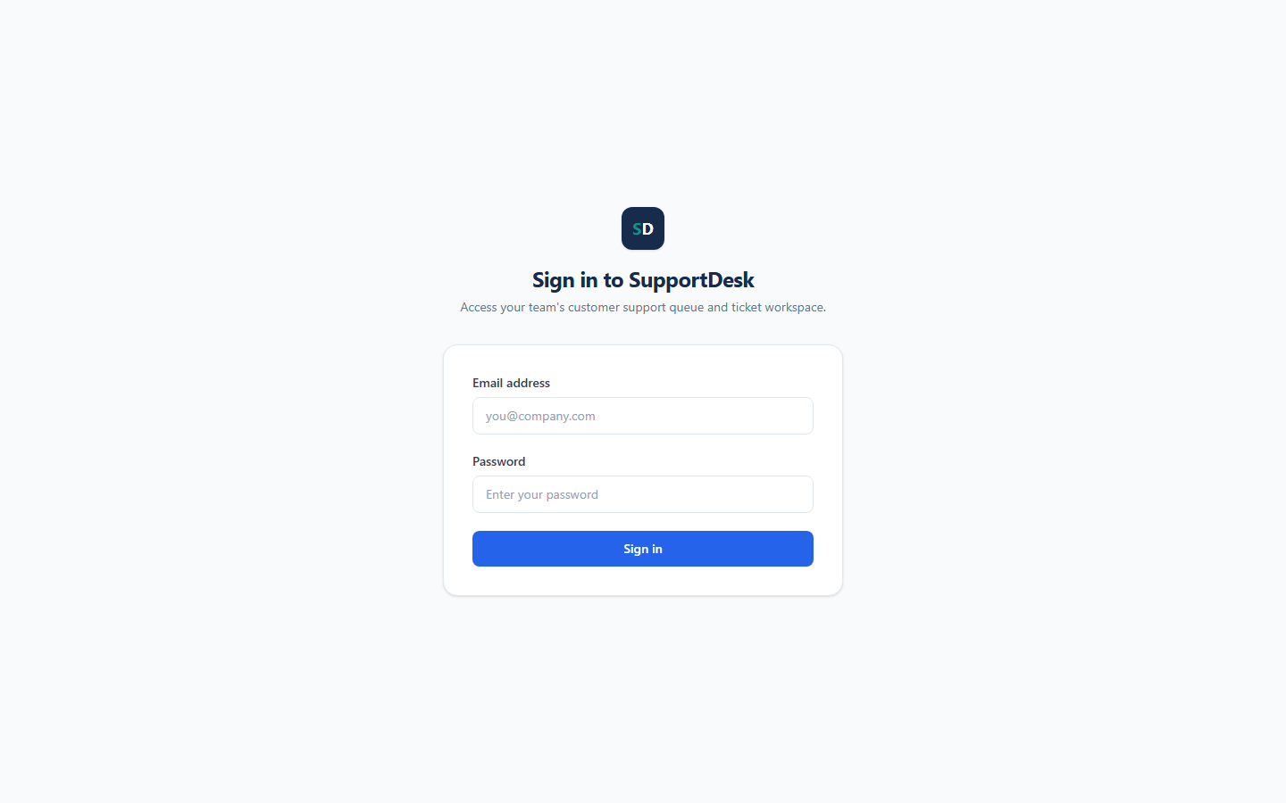

8. Authentication/protected-route behaviour
- AuthProvider (lib/auth.tsx) persists { accessToken, user } in localStorage (supportdesk_auth_session) and calls POST /auth/login.
- ProtectedRoute redirects unauthenticated visitors from /tickets to /login; PublicOnlyRoute redirects authenticated users from /login to /tickets.
- HTTP 401 automatically clears the stored session; / and * fallback routes redirect to /tickets.

9. Manual scenarios executed and results
- Visual Login Page Render (http://localhost:5173/login): Verified live render via Vite dev server and headless Edge desktop screenshot (attached below).
- Architecture & Git Audit: Confirmed fetch( appears only in src/lib/api-client.ts and .env is not tracked in Git.
- Pending local DB login check: Sandbox loopback probe to http://localhost:3000/health could not complete inside sandbox; live end-to-end login against PostgreSQL is ready to run locally.

10. Tests run and actual output
- Build (npm --prefix apps/web run build -> tsc -b && vite build): Exited 0, 96 modules transformed (dist/index.html, CSS 21.07 kB, JS 347.95 kB).
- Vitest (npm --prefix apps/web test -> vitest run): Test Files 3 passed (3), Tests 8 passed (8) — api-client.test.ts (3/3), ProtectedRoute.test.tsx (2/2), LoginPage.test.tsx (3/3).

11. AI review findings and verified fixes
- Replaced uninstalled @testing-library/user-event with fireEvent from @testing-library/react in LoginPage.test.tsx and aligned ApiError constructor arguments.
- Updated api-client.test.ts header check to match Record<string, string> headers in api-client.ts.
- Re-ran build and Vitest after final edits; all checks passed.

12. Prompt Journal updated
- Appended Entry 19 — Day 13: Frontend Foundations, Auth State, and Typed API Client (apps/web) to docs/prompt-journal.md.

13. Blockers or deviations
- Sandbox loopback restriction prevented completing the live apps/api + PostgreSQL probe inside the sandboxed terminal; unit/component tests, build, and Vite /login render all succeeded.

14. What I learned
- Inspecting backend Zod schemas and response envelopes before writing frontend types eliminates contract mismatches.
- Centralizing HTTP transport and Bearer token injection in api-client.ts keeps components decoupled and easy to test.

15. Term of the day — Wireframe
- A wireframe is a low-fidelity visual blueprint of a screen or user flow that defines layout structure, content hierarchy, navigation, and key interactions before writing production UI code.

