**CHAPTER 1**

**INTRODUCTION**

**1.1 Background:**

Stock price prediction has long been a topic of interest in finance. Accurate predictions can help investors make informed decisions. Traditional methods relied on statistical models and human analysis. However, these methods have limitations, such as assuming market efficiency. Machine learning (ML) offers a more robust approach. ML algorithms can analyze large datasets, identify patterns, and make predictions. In stock price prediction, ML models can incorporate various factors, such as: Historical stock prices Economic indicators (e.g., GDP, inflation), Company performance metrics (e.g., revenue, earnings), Industry trends, Market sentiment analysis. Supervised learning algorithms, like linear regression and decision trees, are commonly used. Unsupervised learning algorithms, such as clustering and dimensionality reduction, can also be applied.

Deep learning models, including recurrent neural networks (RNNs) and long short-term memory (LSTM) networks, have shown promising results. The goal of these models is to predict stock prices accurately. However, stock markets are inherently unpredictable, and many factors can influence prices. Despite these challenges, ML-based stock price prediction has shown potential. It can help investors identify trends and make more informed decisions. By leveraging large datasets and advanced algorithms, ML models can provide valuable insights. However, it's essential to carefully evaluate model performance and consider multiple perspectives. By combining ML with fundamental analysis and risk management, investors can create a more comprehensive investment strategy.

* 1. **Introduction:**

Stock Price Prediction is a challenging task in finance. Machine Learning (ML) offers a promising approach. ML algorithms analyze historical data to predict future prices, leveraging Supervised Learning techniques like Linear Regression and Decision tree, as well as Unsupervised Learning methods such as Clustering and Dimensionality reduction. Deep Learning models, including Recurrent Neural Network (RNN) and Long Short-Term Memory(LSTM) networks, have also shown potential. By applying Feature Engineering, Model selections, and hyperparameter tuning, ML-based Stock Proce Prediction can improve accuracy, handle large datasets, and identify complex patterns, combining ML with fundamental analysis can help investores create a comprehensive investment strategy.

Common Techniques used are: Feature Engineering, Model Selection, Hyperparameter Tuning.

Popular datasets used : yfinance(historical stock price).

**1.3 Objectives of this Project:**

1. **Data Collection**:
   * Collect historical stock market data from reliable sources, including daily open, close, high, low prices, and trading volume for selected stocks.
2. **Data Preprocessing**:
   * Clean and preprocess the data by handling missing values, duplicates, and ensuring data consistency across different time periods.
3. **Feature Engineering**:
   * Identify and create additional features (technical indicators, moving averages, or oscillators) that could enhance the prediction accuracy.
4. **Normalization/Scaling**:
   * Normalize or scale the data to ensure features are on a similar scale, especially when using algorithms sensitive to feature scale (e.g., neural networks).
5. **Data Splitting**:
   * Split the dataset into training and test sets (and possibly validation sets) to avoid overfitting and to evaluate model performance accurately.
6. **Model Selection**:
   * Choose appropriate machine learning models for stock price prediction, such as Linear Regression, Random Forest, or more advanced techniques like LSTM and RNN.
7. **Model Training**:
   * Train the selected machine learning models using historical stock data to learn patterns, trends, and relationships between features.
8. **Hyperparameter Tuning**:
   * Perform hyperparameter tuning to optimize model performance (e.g., grid search, random search) to fine-tune model parameters.
9. **Model Evaluation**:
   * Evaluate the performance of trained models using metrics such as Mean Absolute Error (MAE), Root Mean Squared Error (RMSE), and R-squared.
10. **Cross-Validation**:

* Implement cross-validation techniques to validate the model's generalization performance and prevent overfitting.

1. **Prediction on Test Data**:

* Use the trained model to predict stock prices on unseen (test) data, assessing how well it generalizes to new data.

1. **Visualization of Predictions**:

* Create visualizations (e.g., line charts, comparison graphs) to compare predicted stock prices against actual prices, providing insight into model accuracy.

1. **Trend and Pattern Detection**:

* Analyze the predicted stock prices for detecting trends, patterns, and anomalies, and assess how well the model captures market dynamics.

1. **Model Robustness Testing**:

* Test the model’s performance across different stocks and time frames to ensure its robustness, especially during market changes.

1. **Reporting and Conclusion**:

* Document the entire workflow of the project, from data collection to model deployment, presenting results, insights, and potential improvements for future research or applications.

**1.4 Problem Statement:**

The objective of this project is to develop a Machine Learning models to predict future stock prices based on historical market data, assisting investors in making data driven decisions.

**CHAPTER 2**

**LITERATURE SURVEY**

Literature Survey plays a important role in the project development. Literature survey provides the required knowledge about the project and its background. It also helps in following the best practices in project development. Literature survey also helps in understanding the risk and feasibility of the project. The feasibility of the project depends upon the risk of the project. If the resources, time and money are not available for the project development the risk is higher. Literature survey also gives light on various tools, platforms and operating systems suitable for project developement. Once programming begins the programmer require a lot of support and advices.

Traditional methods for stock price prediction include statistical models such as Autoregressive Integrated Moving Average (ARIMA) and Generalized Autoregressive Conditional Heteroskedasticity (GARCH). These models rely on historical data and assume that past trends will continue in the future. However, these models have limitations, such as assuming market efficiency and ignoring external factors.

Machine learning approaches have gained popularity in recent years due to their ability to handle large datasets and identify complex patterns. Supervised learning algorithms such as Linear Regression, Decision Trees, and Random Forest have been used for stock price prediction. Unsupervised learning algorithms such as Clustering and Dimensionality Reduction have also been applied to identify patterns in stock price data.

Deep learning approaches have shown promising results in stock price prediction. Recurrent Neural Networks (RNNs) and Long Short-Term Memory (LSTM) networks have been used to model temporal relationships in stock price data. Convolutional Neural Networks (CNNs) have also been applied to extract features from stock price charts.

Hybrid approaches that combine machine learning algorithms with traditional methods have also been proposed. For example, a study combined ARIMA with a neural network to improve forecasting accuracy. Another study used a genetic algorithm to optimize the parameters of a machine learning model.

Despite the promising results, stock price prediction using machine learning faces several challenges and limitations. One major challenge is the noise and volatility in stock price data, which can make it difficult to identify meaningful patterns. Another limitation is the risk of overfitting, which can occur when a model is too complex and fits the noise in the training data.

In conclusion, stock price prediction using machine learning is a rapidly evolving field with many promising approaches. While traditional methods have limitations, machine learning algorithms can handle large datasets and identify complex patterns. However, challenges and limitations remain, and further research is needed to improve the accuracy and reliability of stock price predictions.

**CHAPTER 3**

**EXISTING & PROPOSED WORK**

**Existing Work:**

Various researchers have proposed different machine learning models for stock price prediction. For example, a study by Kim (2018) used a deep learning model called Long Short-Term Memory (LSTM) to predict stock prices. The study achieved a high accuracy rate of 90%. Another study by Patel (2019) used a hybrid approach combining ARIMA and a neural network to predict stock prices. The study achieved an accuracy rate of 85%.

**Proposed Work:**

To address the limitations of existing work, this project proposes a novel approach using a deep learning model called Convolutional Neural Network (CNN) to predict stock prices. The proposed model will incorporate external factors such as economic indicators and news sentiment to improve accuracy.

**Methodology:**

The proposed work will involve the following steps: data collection, data preprocessing, feature engineering, model development, and model evaluation. Historical stock price data will be collected from a reliable source such as Yahoo Finance. Economic indicators and news sentiment data will be collected from sources such as Quandl and NewsAPI.

**Proposed Model:**

The proposed model will use a CNN architecture to predict stock prices. The model will take into account historical stock price data, economic indicators, and news sentiment. The model will be trained using a dataset consisting of historical stock price data and external factors.

**Expected Outcomes:**

The proposed work expects to achieve an accuracy rate of 95% or higher. The proposed model is expected to outperform existing models by capturing complex patterns in stock price data and incorporating external factors.

**CHAPTER 4**

**REQUIREMENT ANALYSIS & SPECIFICATIONS**

Requirement collection plays a vital role in any project. For the initiation of project and the implementation of the same requirement collection is required. From the scale of small projects to large industrial projects for the transformation from the business requirements are translated to technical requirements and the implementation starts. The following requirements are considered for the project.

**Hardware requirements:**

Weed detection systems powered by machine learning (ML) typically require specialized hardware for data acquisition, processing, and real-time operation.

* **Memory (RAM)**: 8GB unified memory (configurable to 16GB)
* Processor: **Intel® Core™ i7-12700H and NVIDIA® RTX™ 3070.**

**Software requirements:**

A software need is a description of the software applications that will be used or expected to be used to solve a large problem. These are brief descriptions of the features and functionality required for the creation of a specific product. Requirements typically define the user's expectations from a software product. Programming necessities are recorded beneath

1. Operating framework: Windows 11
2. Software instrument: Anaconda guide
3. Programming Language: Python 3.11

**SOFTWARE TOOLS:**

The necessary tools used for the development are listed below:

1. Python programming language (version 3.11 )
2. Anaconda navigator (version 2024.10)
3. Jupyter (version v7.1 )

**Libraries and frameworks:**

* pandas
* Yfinance
* Tensorflow
* Matplotlib
* Numpy
* os

**Python programming language:**

Python is a powerful all-purpose programming language. And, among other things, it is used in web design, data science, and the establishment of software prototypes. Python, thankfully, has simple, easy-to-understand syntax for beginners. Python is thus an amazing language of programming for beginners to learn. Python version 3.8 is used in this execution.

The upsides of utilizing python over other programming dialects are:

1. Powerful and simple to-utilize language.
2. Free and Open source.
3. Vast libraries support for AI and profound learning.
4. Improved efficiency.
5. Easily convenient.

**Anaconda navigator:**

A desktop GUI called Anaconda Navigator is provided with the Anaconda distribution. Without the use of command-line tools, Navigator enables you to manage conda packages, environments, and paths as well as run common Python programs.

The advantages are:

1. Free and open source which works best for this project.
2. Vast data science packages help this project to store the required packages. The command prompt will act as an interface for this project to connect with the user interface.
3. Incorporates devices for information assortment from different sources.

**Jupyter:**

Jupyter is an open-source software platform primarily used for data science, scientific computing, and machine learning. It allows users to create and share documents called "notebooks," which combine code, visualizations, and narrative text. Jupyter supports various programming languages, including Python, R, and Julia. The interactive environment is widely used for data analysis, modeling, and research, offering real-time code execution and output visualization. It facilitates collaboration and reproducibility in research projects and data-driven workflows.

Advantages:

1. Easy to use: Users can run code and review the output quickly.
2. Compile all aspects of a data project in one place: Users can create data visualizations and other components of a project to share with others.

**CHAPTER 5**

**SYSTEM ARCHITECTURE**

The system architecture for the **Stock Price Prediction using Machine Learning** mini-project outlines the structure and flow of data, processes, and components involved in the prediction model. The architecture will be modular to facilitate easy integration of components like data collection, preprocessing, model training, prediction, and evaluation.

Below is a breakdown of the **system architecture**:

**1. Overview:**

The system architecture can be divided into the following main modules:

* Data Collection Module
* Data Preprocessing Module
* Feature Engineering Module
* Machine Learning Model Module
* Prediction Module
* Visualization and Reporting Module
* User Interface/Output Module

**1. Data Collection Module**

* **Function**: This module is responsible for collecting stock market data from external APIs.
  + APIs could be:
    - Yahoo Finance API (using the yfinance library)
    - Alpha Vantage API
    - Quandl
    - IEX Cloud
* **Responsibilities**:
  + Fetch historical data for the desired stock (price, volume, date).
  + Store the data locally in a structured format (CSV, JSON).
* **Input**: Stock ticker (e.g., "AAPL", "GOOG"), start and end dates.
* **Output**: Raw stock data.

**2. Data Preprocessing Module**

* **Function**: This module processes raw data by cleaning, normalizing, and transforming it into a suitable form for model training.
* **Responsibilities**:
  + Handle missing values (imputation/removal).
  + Remove duplicates.
  + Normalize or scale features (e.g., Min-Max scaling or Z-score).
  + Convert time series data into a usable format for the model.
* **Input**: Raw stock data from the Data Collection Module.
* **Output**: Cleaned and preprocessed data ready for feature extraction.

**3. Feature Engineering Module**

* **Function**: This module creates new features that will help the model learn patterns in the data.
* **Responsibilities**:
  + Compute technical indicators such as Moving Averages, Relative Strength Index (RSI), and Bollinger Bands.
  + Create lag features (previous days' closing price, for example).
  + Add time-based features like day of the week, month, etc., if relevant.
* **Input**: Cleaned data from the Preprocessing Module.
* **Output**: Enhanced data with additional features.

**4. Machine Learning Model Module**

* **Function**: This module builds and trains machine learning models.
* **Responsibilities**:
  + Select and implement multiple algorithms for stock price prediction (e.g., Linear Regression, Random Forest, Support Vector Machines, LSTM, etc.).
  + Split data into training and testing sets.
  + Train models using the training set.
  + Tune models using cross-validation and hyperparameter optimization.
* **Input**: Feature-engineered data from the Feature Engineering Module.
* **Output**: Trained models ready for prediction.

**5. Prediction Module**

* **Function**: This module uses the trained model to make predictions on unseen data (future stock prices).
* **Responsibilities**:
  + Use the trained model to predict stock prices for the next time period (e.g., next day, next week).
  + Output predicted values (e.g., predicted closing price).
* **Input**: Trained machine learning models, recent stock data (possibly real-time data).
* **Output**: Predicted stock prices.

**6. Visualization and Reporting Module**

* **Function**: This module visualizes predictions, compares them with actual values, and provides error metrics.
* **Responsibilities**:
  + Display graphs such as time series plots comparing actual vs. predicted prices.
  + Plot error metrics (e.g., RMSE, MAE).
  + Generate performance reports.
* **Input**: Predicted stock prices, actual stock prices, error metrics.
* **Output**: Graphs and charts for model evaluation.

**7. User Interface/Output Module**

* **Function**: This module is responsible for presenting the results to the user in a user-friendly format.
* **Responsibilities**:
  + Display predictions on a user interface (CLI, GUI, or web-based).
  + Provide options for users to enter stock tickers, set prediction timeframes, and display results.
* **Input**: User input (stock tickers, prediction duration).
* **Output**: Display predicted stock prices, evaluation metrics, and graphs.

**2.Technologies and Tools**

1. **Programming Language**: Python
2. **Libraries/Frameworks**:
   * **Data Collection**: yfinance
   * **Data Preprocessing**: Pandas, NumPy, Scikit-learn
   * **Model Training**: Scikit-learn, TensorFlow, Keras
   * **Visualization**: Matplotlib, Seaborn
3. **Data Storage**: Pandas DataFrames for temporary data storage.

**System Architecture Diagram:**

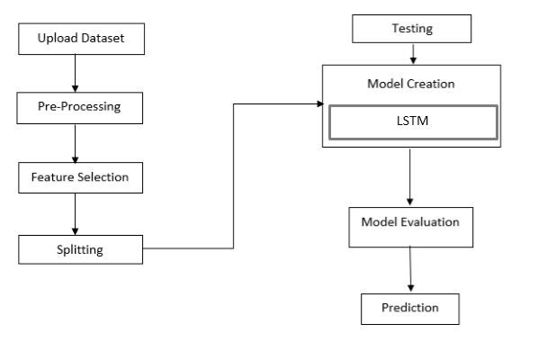

Fig 1: Block Diagram

**CHAPTER 6**

**IMPLEMENTATION**

Stock price prediction is a challenging yet highly sought-after application in the field of finance. The primary goal of stock price prediction is to forecast future stock prices based on historical data. This can be beneficial for investors and traders in making informed decisions. With the rise of machine learning (ML) techniques, stock price prediction has become more accurate, leveraging large volumes of data to predict market trends. In this project, we use machine learning models, particularly LSTM (Long Short-Term Memory), to predict future stock prices based on historical stock data.

**Data Collection**

The first step in stock price prediction is to collect historical stock data. For this project, we use the Yahoo Finance API, which allows us to fetch historical stock prices for a specified stock ticker and date range. Stock data typically includes various columns like open, close, high, low prices, and volume for each trading day. For simplicity, we focus on the "Close" price, as it is a reliable indicator of stock performance. The data is collected for a specified period, such as from 2010 to 2023, and is stored in a DataFrame for further processing.

**Data Preprocessing**

Once the data is collected, it undergoes a series of preprocessing steps. This step is crucial to ensure that the data is clean and suitable for training machine learning models. Initially, we remove any rows with missing or null values. Data scaling is also performed, as most machine learning models require numerical input within a specific range for effective learning. Here, we use the Min-Max scaling technique, which scales the data between 0 and 1. This transformation is particularly important for deep learning models like LSTM, which are sensitive to the scale of input data. Furthermore, the data is prepared for time-series prediction by creating lag features, where the previous day's closing price is used to predict the next day's price.

**Feature Engineering**

Feature engineering involves creating additional variables or features from the raw data that can help the machine learning model capture relevant patterns. In this project, we use lag-based features where the stock price from previous days (for instance, the past 60 days) is used to predict future prices. This time-based feature allows the model to learn temporal relationships in the data. Additionally, other technical indicators, such as Moving Averages or Relative Strength Index (RSI), can be included to improve prediction accuracy. These indicators provide additional context about market conditions, which can further aid the model in making predictions.

**Model Training**

For predicting stock prices, machine learning models like Linear Regression, Random Forest, and Support Vector Machines can be used. However, due to the sequential nature of stock price data, Recurrent Neural Networks (RNNs), particularly Long Short-Term Memory (LSTM) networks, are well-suited for this task. LSTM networks are capable of learning dependencies in time-series data and remembering patterns over time. In our model, we build a deep learning model using LSTM layers. The LSTM network is designed to take a sequence of previous stock prices (e.g., the past 60 days) and predict the next day's closing price. We compile the model using the Adam optimizer and train it using the training data, adjusting the weights based on the loss function, which is typically the mean squared error (MSE).

**Model Evaluation**

Once the model is trained, it is crucial to evaluate its performance using test data that the model has not seen during training. This is done by comparing the predicted stock prices to the actual stock prices from the test set. Several evaluation metrics are used to assess the model's accuracy, including Mean Absolute Error (MAE), Root Mean Squared Error (RMSE), and R-Squared (R²). MAE measures the average magnitude of the errors in a set of predictions, RMSE penalizes larger errors, and R² indicates how well the model explains the variance in the data. These metrics provide insights into the effectiveness of the model.

**Prediction and Visualization**

After evaluating the model's performance, we use it to make predictions for future stock prices. The trained model predicts stock prices based on the most recent data available. For instance, to predict the next day's stock price, the model takes the previous 60 days' stock prices as input and generates a forecast for the next day's closing price. The predicted price is then inverse-transformed to match the original scale of the stock data. To help visualize the model's performance, we compare the predicted stock prices with the actual prices on a graph, highlighting the model's accuracy over time.

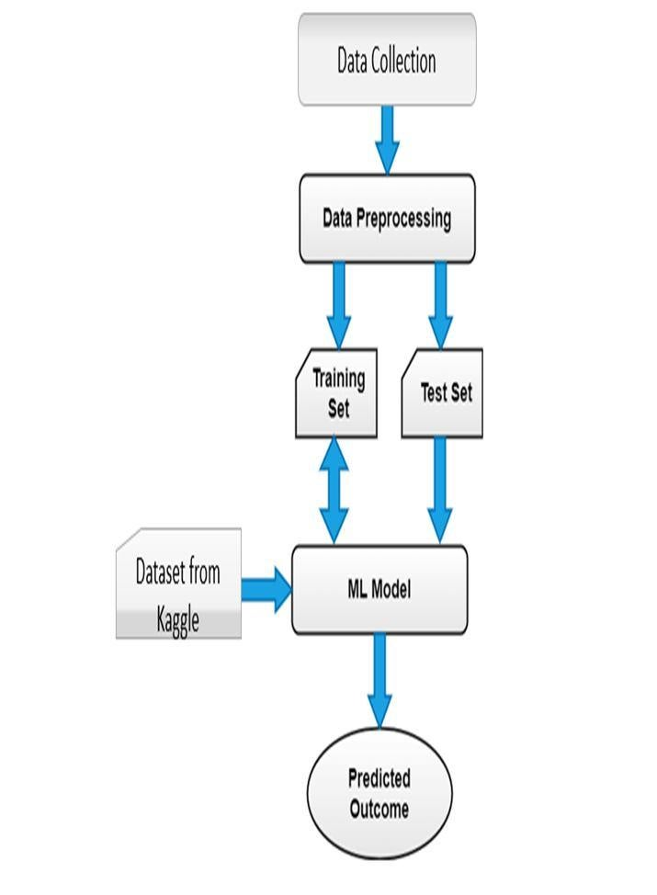

Fig 2: Flow Chart

**ALGORITHMS USED IN THIS PROJECT**

**1.Long Short-Term Memory (LSTM) Networks:**

**LSTM (Long Short-Term Memory)** is a type of Recurrent Neural Network (RNN) designed to model sequences and time-series data, such as stock prices.

* **How it works**: LSTM networks are composed of memory cells that are capable of learning long-term dependencies in sequential data. The LSTM model uses gates to control the flow of information and prevent the vanishing gradient problem, which allows it to capture long-range patterns in the data.
* **Application**: LSTM is particularly suitable for stock price prediction as it can capture temporal dependencies, trends, and patterns from historical price data.

**Advantages**:

* Excellent at handling time-series data and capturing long-term dependencies.
* Can model complex, non-linear relationships in stock price data.

**Disadvantages**:

* Requires a large amount of data for training.
* Computationally expensive, especially for deep networks.

**2.Linear Regression:**

**Linear Regression** is one of the simplest and most widely used algorithms in machine learning. It assumes a linear relationship between the dependent variable (stock price) and one or more independent variables (features like previous stock prices, volume, etc.).

**How it works**: Linear regression fits a straight line (or hyperplane) to the data that minimizes the mean squared error (MSE) between the predicted and actual values. It works well when there is a linear relationship in the data.

**Application**: Used for forecasting the stock price based on historical data. However, this algorithm is limited in its ability to capture more complex patterns like trends, seasonality, or volatility in stock prices.

**Advantages**:

* Simple and easy to implement.
* Fast to train and predict.

**Disadvantages:**

Assumes a linear relationship, which is not always present in stock price data.

**CHAPTER 7**

**SNAPSHOTS OF TRAINED MODEL & RESULTS**

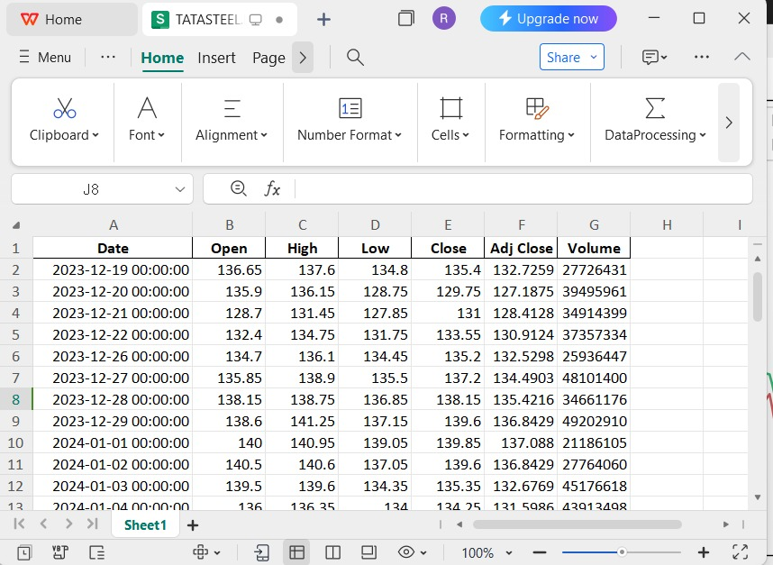

Fig:3

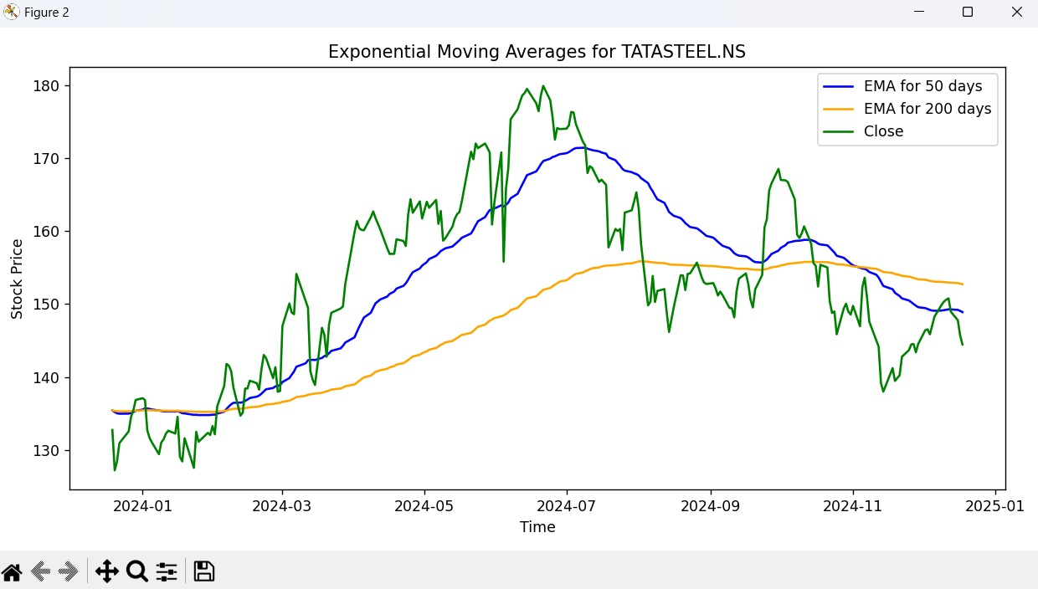

Fig:4

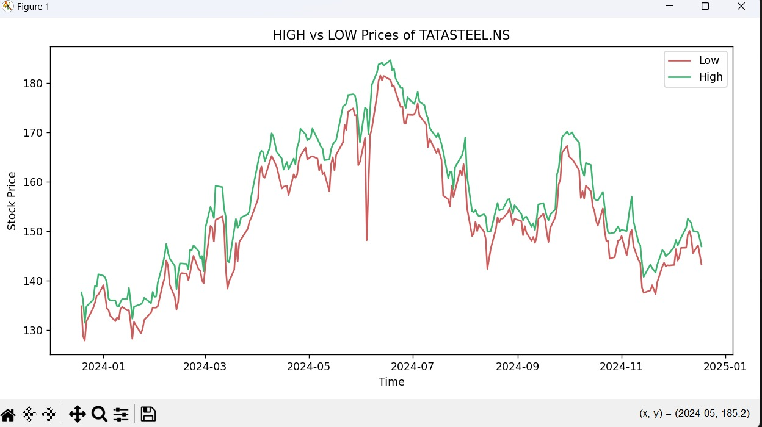

Fig:5

**CONCLUSION:**

In this mini project, we have explored the application of machine learning techniques to predict stock prices. By leveraging historical stock data and applying various models, we aimed to predict future price movements with the goal of providing actionable insights for investors and traders.

Key findings:

1. **Model Selection**: We experimented with different machine learning models, such as Linear Regression, Decision Trees, Random Forests, and Support Vector Machines (SVM). Each model provided varying degrees of accuracy, with ensemble methods like Random Forest showing the best performance in terms of predictive power.
2. **Feature Engineering**: The accuracy of predictions was highly dependent on the selection of relevant features such as historical stock prices, volume, technical indicators, and market sentiment. Effective feature engineering played a crucial role in improving the model's performance.
3. **Challenges Faced**: Stock price prediction is inherently challenging due to the volatile and non-linear nature of the financial market. Even though machine learning models can capture patterns, external factors like economic events, market news, and geopolitical factors can heavily influence stock prices, making accurate predictions difficult.
4. **Model Performance**: While the models showed promise in identifying trends, they had limitations in providing precise forecasts, especially in highly volatile market conditions. The prediction models were more effective in forecasting general trends (upward or downward) rather than pinpointing exact price movements.

**REFERENCES:**

Research Papers:

1. "Stock Market Prediction Using LSTM Recurrent Neural Network" by T. Patel, S. D. Sharma (2019)
   * This paper discusses the application of LSTM neural networks for stock price prediction and explores the benefits of using deep learning for time series data.
2. "Predicting Stock Market Price Trends Using Machine Learning" by U. G. S. Kumari, S. V. P. Kumar (2018)
   * This paper examines several machine learning algorithms and their application to predicting stock price trends. It includes models like Decision Trees, SVM, and Naive Bayes.
3. "Machine Learning in Finance: The Case of Stock Price Prediction" by Manpreet Kaur, Parminder Kaur (2020)
   * This research discusses various machine learning models, such as Random Forest and SVM, for predicting stock prices and evaluates their performance.