Write a C# program to retrieve data if nothing is provided on prompt. Else must display employee details of specified deptno on prompt. For ex if u run program as dotnet run 10 it must display all employees of dept 10

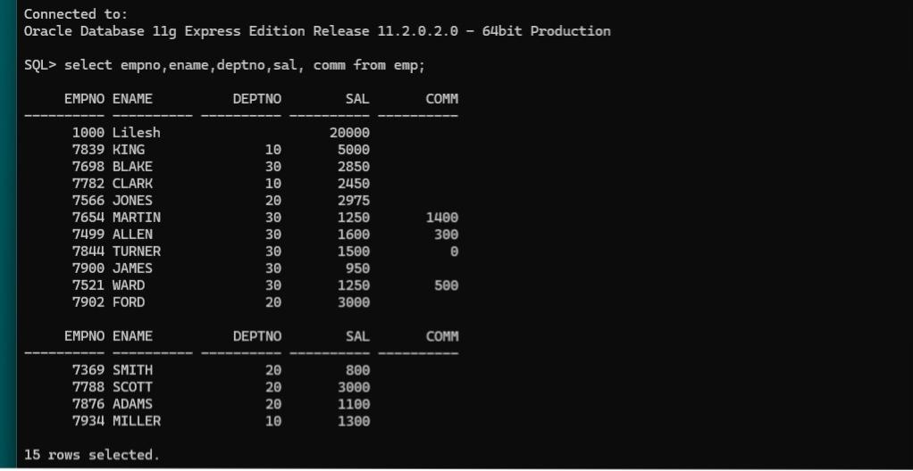Create table emp with above structure and data on mysql. Create table on respective group login with name as Rno_emp so that there are no conflicts