PCA-Based Anatomical Femorotibial Angle (FTA)
Detailed Mathematical Methodology
Complete calculation from the patient's knee X-ray and binary mask to PCA-derived anatomical axes and FTA
Worked case: acute FTA = 6.65°; obtuse/external FTA = 173.35°; femoral orientation = 95.02°; tibial orientation = 88.37°. This document concerns the anatomical axis, not the mechanical axis.

Aim and definition
The objective is to estimate the directions of the femoral and tibial anatomical axes from a segmented knee X-ray and calculate the angle between them. U-Net supplies the bone pixels; PCA converts the spatial distribution of those pixels into a dominant direction; vector geometry converts the two directions into an angle.
The anatomical femorotibial angle is defined by the femoral and tibial anatomical axes. Published radiological methods generally construct these axes from the diaphyseal/shaft geometry rather than from the femoral head and ankle landmarks.

Patient X-ray and binary segmentation mask
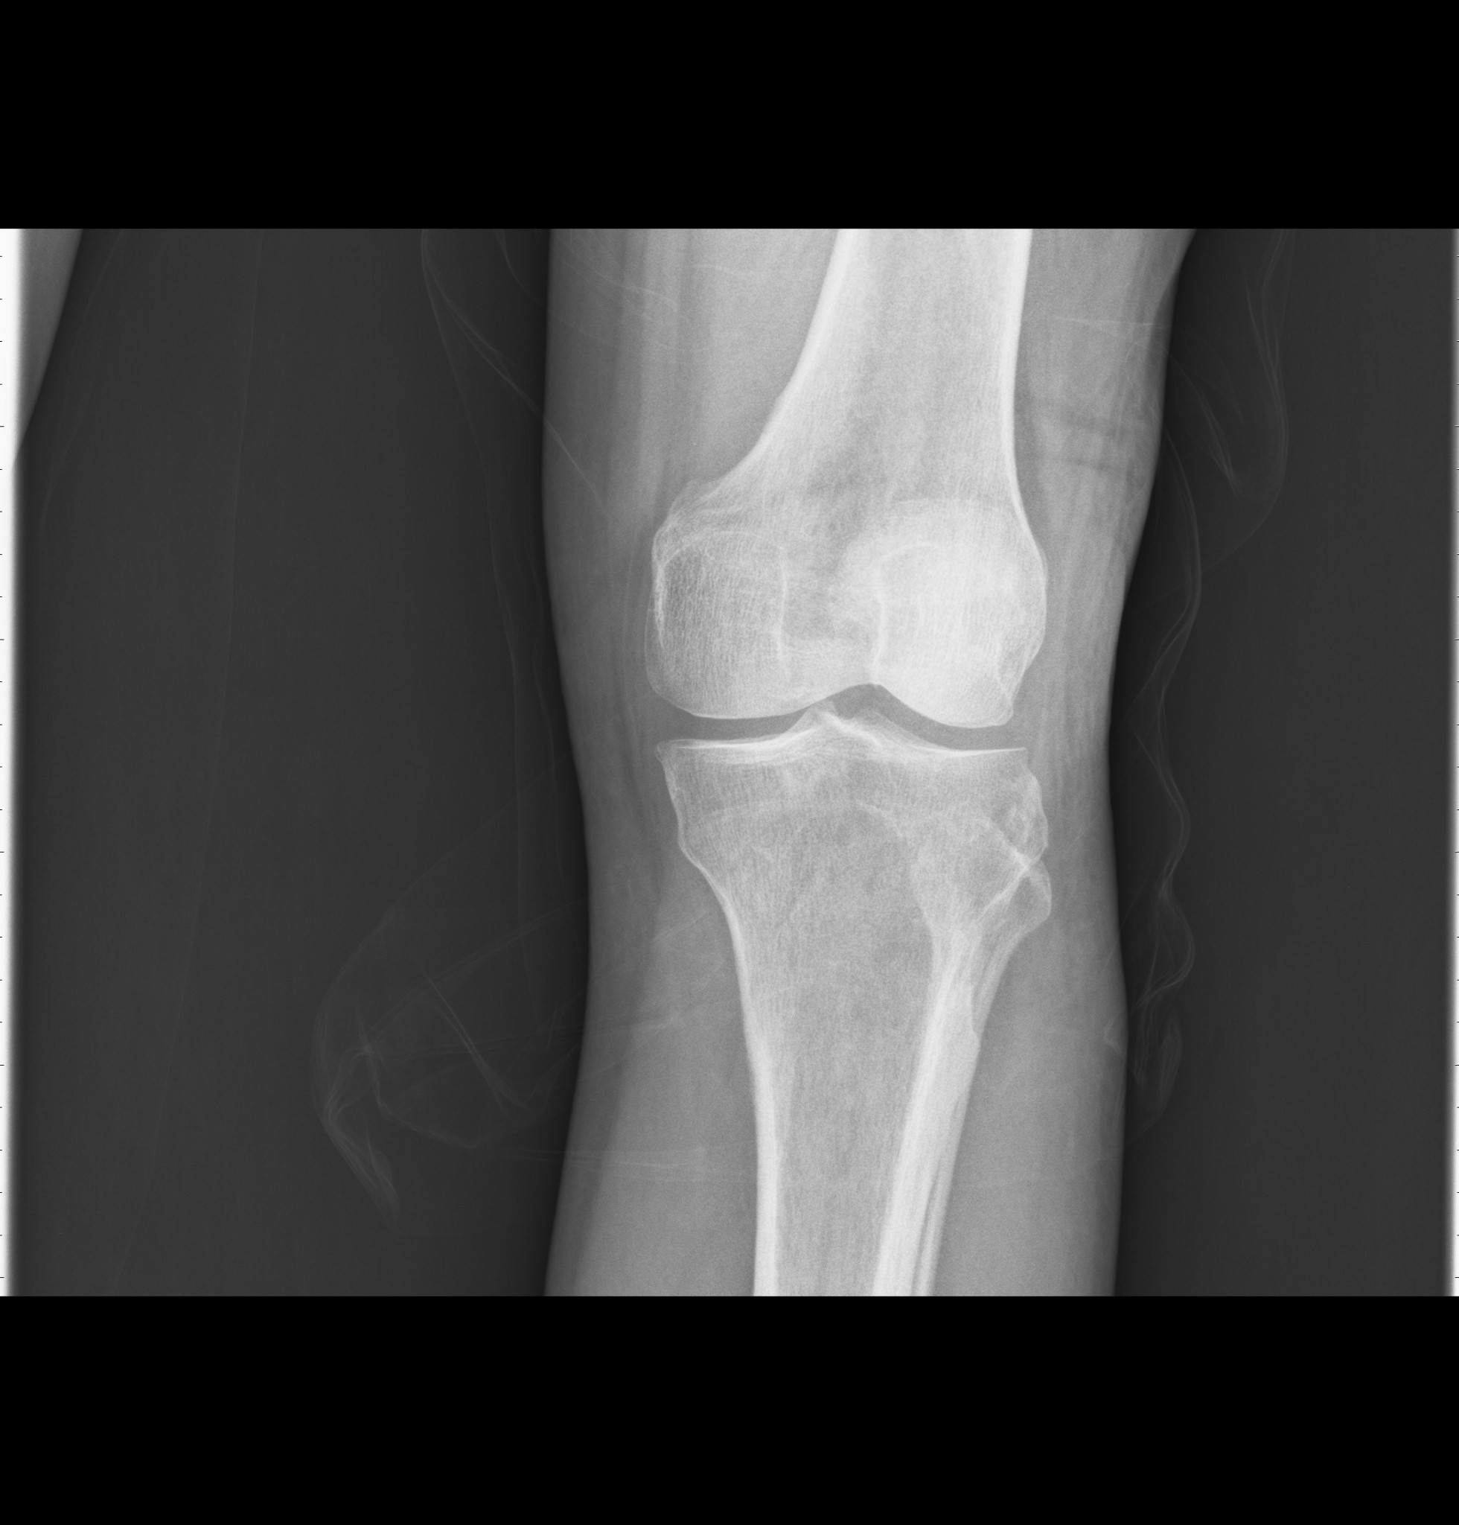
Figure 1. Supplied patient's knee X-ray used as the image input.


Figure 2. Supplied single-channel binary mask used as the geometric input.

Complete mathematical flow
X-ray → U-Net segmentation → separate femur/tibia → foreground pixels → centroid → centred coordinates → covariance matrix → PCA eigenvectors → PC1 → femoral/tibial axis vectors → dot product → acute angle → supplementary obtuse FTA.

Step 1 — Convert each segmented bone into coordinates
For each foreground pixel, the implementation uses image-array coordinates in the order (y,x):

  - Foreground pixel representation
N is the number of foreground pixels in the selected bone. Femur and tibia are analysed separately.

Step 2 — Calculate the centroid
The centroid is the average position of all foreground pixels:
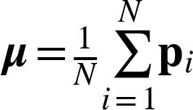
- Centroid
The centroid gives the centre of the point cloud and allows PCA to describe orientation independently of the bone's absolute position in the image.

Step 3 — Centre the point cloud
Each coordinate is translated relative to the centroid:


- Centred coordinate

This makes the centroid the origin and leaves the spatial shape/orientation information for PCA.

Step 4 — Form the covariance matrix
The covariance matrix summarizes the spread of the centred point cloud:
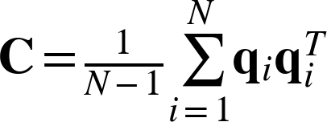
- Two-dimensional covariance matrix
For a 2-D point cloud, the diagonal terms represent variance and the off-diagonal terms represent covariance between the image directions.

Step 5 — PCA gives the dominant direction
PCA solves the covariance eigenvalue problem:
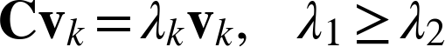

- Eigenvalue/eigenvector equation
The eigenvector associated with the largest eigenvalue is PC1:

- First principal component
The two PCA-derived directions are:

- Femoral and tibial PC1 vectors

Interpretation: PC1 is the direction of maximum variance of the segmented point cloud. It is an anatomical-axis estimate only when the segmented geometry adequately represents the shaft.

Step 6 — Calculate the angle between the two axes
The dot product of two vectors is related to their included angle by:

- Dot-product identity
Therefore the acute angle between the two axis lines is:
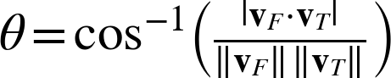
- Acute angle between femoral and tibial axis lines
The absolute value is important because PCA may return either v or −v. Both represent the same geometric line. The arccosine result is converted to degrees.

Numerical calculation for the supplied case
The reported femoral orientation is 95.02° and the reported tibial orientation is 88.37°. In the implementation the orientation is obtained from atan2(axis[1], axis[0]). Because the vector is stored as [y,x]
,this is the coordinate convention:
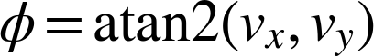

- Orientation convention
Using the reported orientations, the corresponding unit direction vectors are approximately:

- Femoral direction vector

Their dot product is approximately:

Hence the acute angle is:
- Tibial direction vector



- Numerical dot product

- Acute femorotibial angle

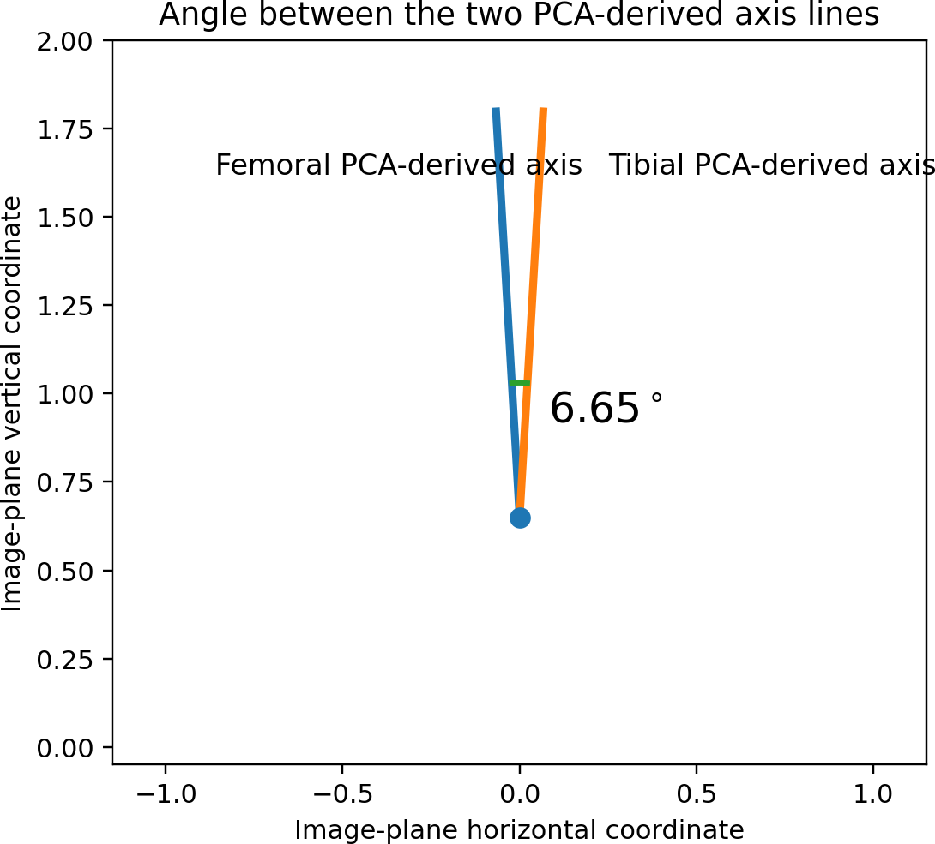
Figure 3. Geometric interpretation of the 6.65° acute angle.

Step 7 — Convert to the obtuse/external FTA
The same two axis lines form supplementary angles. Therefore:

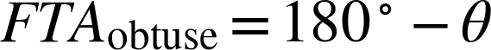

For this case:
- Supplementary-angle relation
Thus 6.65° acute and 173.35° obtuse describe the same two axis lines; they are not two different anatomical measurements.

- Final obtuse/external FTA

Normal/reference range
A recent radiological measurement guide reports an adult femoral-shaft/tibial-shaft anatomical angle of approximately 173°–175° when measured obtusely, or 5°–7° when the acute supplementary angle is used.

- Commonly reported adult reference range
Therefore, the supplied 173.35° result lies inside that commonly cited reference interval. This is not, by itself, a clinical diagnosis or proof of normality; measurement validity and radiographic positioning must also be considered.

Compact mathematical chain

Step | Operation | Equation
1 | Pixel coordinates
2 | Centroid
3 | Centre
4 | Covariance
5 | PCA eigen problem
6 | PC1
7 | Axis vectors
8 | Acute angle
9 | Obtuse FTA

Genuine supporting references
- Jolliffe IT, Cadima J. Principal component analysis: a review and recent developments. Philosophical Transactions of the Royal Society A. 2016;374:20150202. DOI: 10.1098/rsta.2015.0202. — Mathematical foundation of PCA.
- Radiological assessment of lower limb alignment. 2021. PMC8246117. — Describes femoral and tibial anatomical axes from diaphyseal geometry and the anatomical tibiofemoral angle.
- Guide to lower extremity radiologic measurements: part 1 hip. Skeletal Radiology. 2026. DOI: 10.1007/s00256-026-05189-0. — Reports approximately 173°–175° obtuse or 5°–7° acute for the adult femoral-shaft/tibial-shaft angle and discusses radiographic limitations.
- Mechanical, Anatomical, and Kinematic Axis in TKA: Concepts and Practical Applications. Orthopedic Reviews. 2014;6:5165. — Describes anatomical and mechanical axes and the femorotibial angle.
- Non-weight-bearing short knee radiographs to evaluate coronal alignment before total knee arthroplasty. 2021. PMC8739098. — Describes anatomical-axis construction on short and whole-leg radiographs.
- Comparative radiographic analysis on the anatomical axis in knee osteoarthritis cases: inter and intraobserver evaluation. 2015. PMC4519661. — Describes anatomical-axis construction using shaft-centred points.

conclusion
The mathematical chain is: U-Net identifies bone pixels; the pixels form a point cloud; the centroid recentres the cloud; the covariance matrix describes spatial variation; PCA finds the eigenvector of maximum variance; PC1 becomes the PCA-derived anatomical-axis direction; the femoral and tibial vectors are compared using the dot product; the supplied numerical output gives an acute angle of 6.65°; and the supplementary obtuse representation is 173.35°.

