### EXPENSE TRACKER

A MINI PROJECT REPORT

Submitted by

Group/Team No.: G25/T10

SAKSHAM GROVER, 2310992200

SAKSHAM SINGH, 2310992201

SAMARTH KAPOOR, 2310992202

***In partial fulfillment for the award of the degree***

***Of***

**BACHELEOR OF ENGEINEERING**

in

COMPUTER SCIENCE & ENGINEERING



CHITKARA UNIVERSITY

CHANDIGARH-PATIALA NATIONAL HIGHWAY

RAJPURA (PATIALA) PUNJAB- 140401 (INDIA)

NOVEMBER- 2023

###### **TABLE OF CONTENT**

|  |  |  |
| --- | --- | --- |
| Sr.no | Section | Page no |
| 1. | Introduction |  |
| 2. | Problem statement |  |
| 3. | Technical details |  |
| 4. | Key features |  |
| 5. | Project advantages |  |
| 6. | Bonus features |  |
| 7. | Result |  |
| 8. | Conclusion with future scope |  |

**ABSTRACT**

The Expense Tracker is a comprehensive financial management system that provides users with a user-friendly and feature-rich platform for managing their finances. The system offers a range of features that cater to the needs of individuals. Some of the key features of the Expense Tracker include expense logging, categorization, and visualization. Users can input and categorize their expenditures on-the-go, offering a seamless experience through both web and mobile applications. The system employs robust data security measures to ensure the confidentiality of financial information. Moreover, the project integrates data analytics and visual representations of spending patterns. This analytical component empowers users to make informed financial decisions, identify areas for potential savings, and set personalized budget goals. To enhance user engagement and motivation, the Expense Tracker incorporates gamification elements, rewarding users for achieving financial milestones and adhering to budgetary constraints. The Expense Tracker not only serves as a practical financial management solution but also contributes to fostering a culture of fiscal responsibility and awareness. By promoting mindful spending and strategic financial planning, this project endeavours to empower individuals and businesses to achieve their long-term financial goals.

**1. INTRODUCTION**

1.1. **TITLE:** Expense tracker/ Expenso

**1.**2. **DEVELOPERS:** Saksham Grover

Saksham Singh

Samarth Kapoor

1.3. **PURPOSE AND GOALS:**

**1.3.1. Budgeting: -** Control spending and set budgets for different categories to manage money effectively.

**1.3.2. Financial Awareness:** - Monitor income and expenses, identify spending trends, and gain a comprehensive view of financial health.

**1.3.3. Tax Preparation: -** Keep accurate records of deductible expenses for simplified tax preparation.

**1.3.4. Goal Setting:** - Set and track savings goals for specific purposes such as vacations, home purchases, or emergency funds.

**1.3.5. Financial Planning: -** Gain insights into income, expenses, and savings trends for effective long-term financial planning.

**1.3.6. Debt Management: -** Monitor debt payments and track progress toward reducing or eliminating debts.

**1.3.7. Decision Making:** - Make informed decisions about major purchases, investments, and other financial commitments.

**1.3.8. Emergency Preparedness:** - Encourage the creation and maintenance of an emergency fund for financial security in unexpected situations.

**2. PROBLEM STATEMENT**

Create an advanced expense tracker to address the contemporary challenges of personal finance management. Users currently struggle with recording and categorizing expenditures, resulting in a lack of clarity regarding their financial health. The proposed solution entails a user-friendly platform that allows easy entry and categorization of expenses, supported by real-time analytics for immediate insights. Comprehensive reports will enable users to track spending trends, identify potential savings, and set realistic budget goals. Leveraging modern technology, such a tracker should offer a seamless, cross-device experience, potentially incorporating features like banking system integration and receipt scanning for enhanced accuracy. The primary objective is to empower individuals to take control of their finances, promoting fiscal responsibility and long-term financial well-being.

**3. TECHNICAL STATEMENT**

** 3.1. VISUAL STUDIO CODE:** Visual Studio Code is a powerful and lightweight source code editor developed by Microsoft, offering robust features, a customizable interface, and a vast extension ecosystem, making it a favorite among developers for efficient coding workflows.All the code is written and debugged on visual studio code.

**3.2.** **HTML**: HTML is the foundational language for creating web content, using tags to structure and present information on the internet. It defines the structure of web pages, incorporating elements such as headings, paragraphs, links, and images. Hyperlinks and all other text is presented by the use of html.

**3.3. CSS**: CSS is a styling language that complements HTML by controlling the layout and presentation of web pages. It allows developers to define styles, such as colors, fonts, and spacing, to enhance the visual appeal and responsiveness of websites The designing and styling of the website is done by css. Animation are also the part of css.

**3.4. JAVASCRIPT:** JavaScript is a versatile programming language that enables dynamic and interactive web development. Executed on the client side, it enhances user interfaces, facilitates asynchronous operations, and enables the creation of feature-rich, responsive web applications. The calculations and data selection part of website is done through java

**4. KEY FEATURES**

**4.1. User-friendly Interface:**

- Easy to use and navigate so you can quickly put in and find your money information.

**4.2. Expense Logging:**

- Write down different kinds of spending, like regular bills or one-time purchases.

**4.3. Category Management:**

- Sort your spending into groups like food, transportation, and fun stuff.

**4.4. Multiple Currency Support:**

- Works with different types of money for people who spend in other countries.

**4.5. Budget Tracking:**

- Helps you set limits on spending and shows how much you've used.

**4.6**. **Real-time Updates:**

- Shows your info right away on all your devices.

**4.7. Data Analytics:**

- Makes pictures and graphs to help you see how you spend your money.

**4.8. Reminder and Alerts:**

- Tells you when bills are due or when you're getting close to spending too much.

**4.9. Cloud Sync:**

- Keeps your info safe online so you won't lose it.

**5. PROJECT ADVANTAGES**

**5.1. Time Efficiency:**

- Saves you time by doing some things automatically.

**5.2. Financial Awareness:**

- Helps you understand how you spend your money better.

**5.3. Cost Savings:**

- Shows where you can save money.

**5.4. Goal Setting:**

- Helps you set and reach money goals.

**5.5. Security Measures:**

- Keeps your money info safe and private.

**5.6. Accessibility:**

- Lets you use it on different devices wherever you are.

**5.7. Customization:**

- Lets you change things to fit how you like.

**5.8. Integration with Banking Systems:**

- Works together with your bank to keep things up to date.

**5.9. Compliance and Regulations:**

- Follows rules to keep your money info safe and legal.

**5.10. Continuous Improvement:**

- Keeps getting better with updates based on what users say.

**6. BONUS FEATURES**

**6.1. Simple and user-friendly website:**

- Our website is simple and user-friendly anyone can use it for their ease and give the ability to organise the financial terms for efficiently.

**6.2. Category Management:**

- Sort your spending into groups like food, transportation, and fun stuff.

**6.3. Pie chart view:**

- Our website has a feature which gives a pie chart view of the balance and expenditures on different entities.

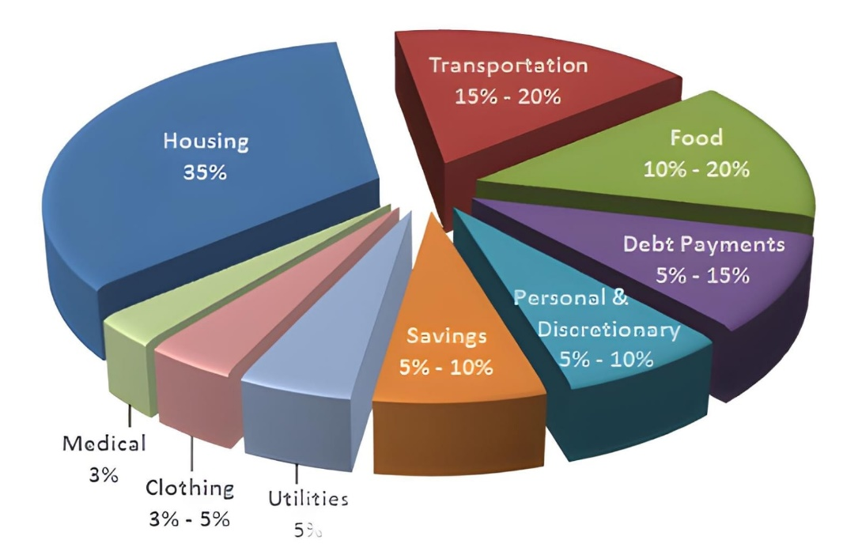

**7. RESULT**

**7.1. HOMEPAGE:**

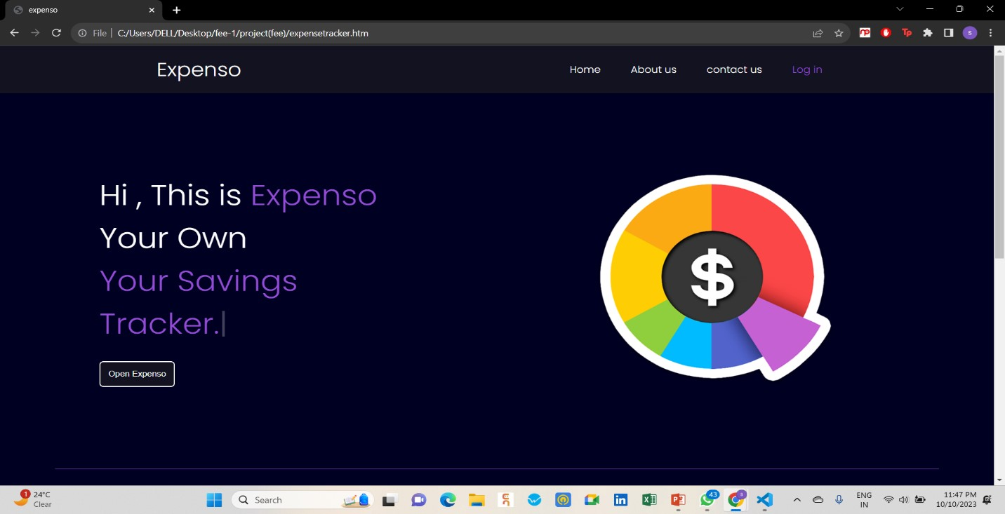

START BUTTON

LOG IN

TASKBAR

ABOUT US

CONTACT US

HOME

INTRO TEXT

LOGO

**7.2. EXPENSO:**

MONEY ADDED

MONEY DEDUCTED

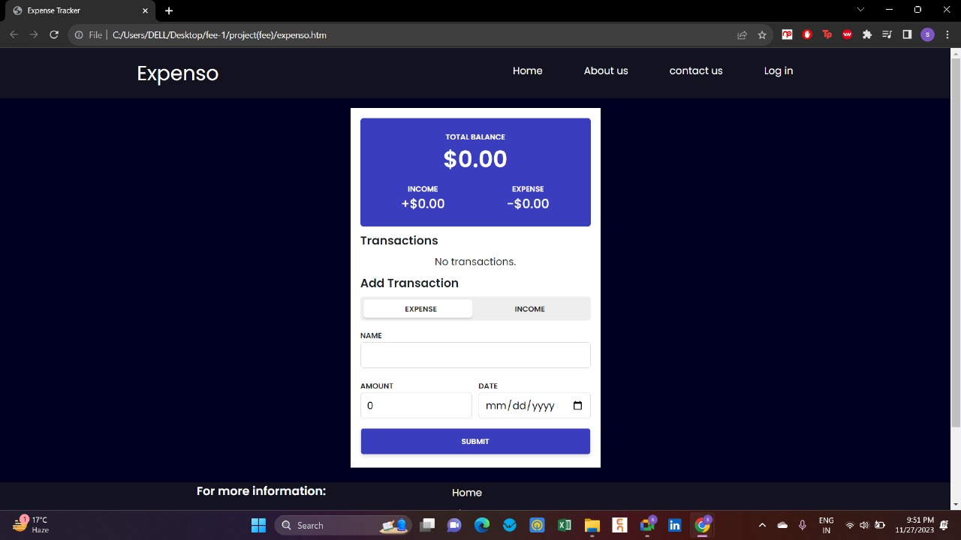

AMOUNT

DATE

CATEGORY

**7.3. ABOUT US:**

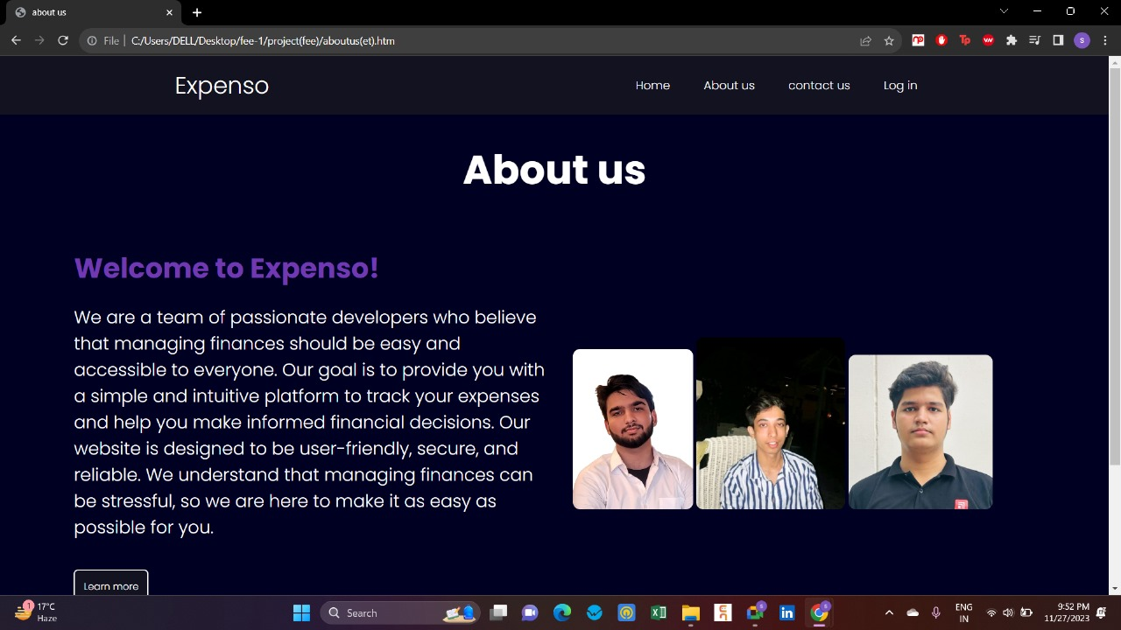

**7.4. CONTACT US:**

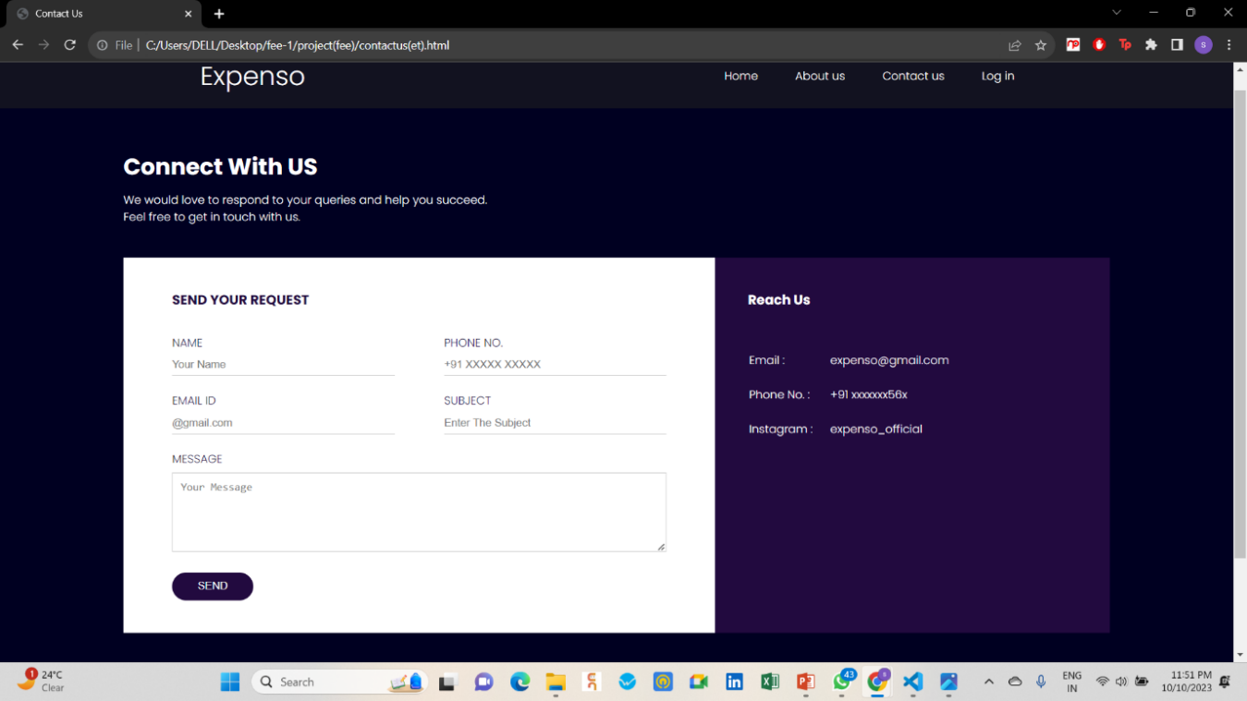

**7.5. LOGIN IN**

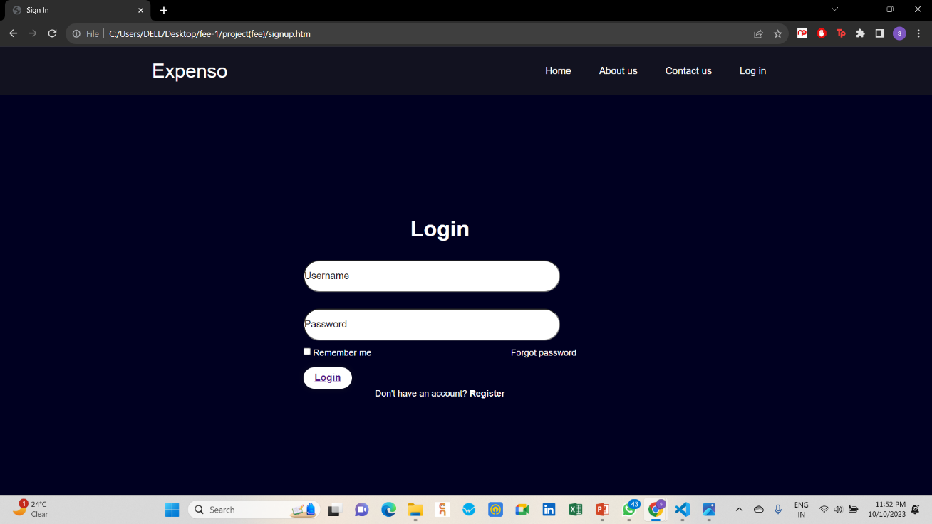

**8. CONCLUSION AND FUTURE SCOPE**

**9.1. CONCLUSION** Based on the features and benefits discussed, it is clear that our website on expense tracking is a valuable tool for individuals to effectively manage their finances. With its user-friendly interface, budget setting capabilities, and comprehensive expense analysis, your website provides users with the necessary tools to track their spending and make informed financial decisions. By utilizing our website, individuals can gain greater control over their expenses and work towards achieving their financial goals.

**9.2. FUTURE SCOPE**

**9.2.1. Smart Predictions:** Imagine your expense tracker learning from your spending habits and helping you predict future expenses more accurately.

**9.2.2. Automation:** The app could become even smarter in sorting your expenses automatically, saving you the trouble of doing it manually.

**9.2.3. Instant Updates:** Instead of checking your spending at the end of the month, the app could give you real-time updates, maybe even a heads-up if you're close to overspending.

**9.2.4. Use Anywhere:** Picture your expense tracker seamlessly working on your phone, smartwatch, and other devices, making it super convenient.

**9.2.5. Share with Others:** If you're sharing expenses with roommates or family, the app might help everyone stay on the same page, updating in real-time.

**9.2.6. Deep Insights:** Think of your expense tracker as a financial advisor, giving you more insights into your spending habits and suggesting ways to save money.

**9.2.7. Super Secure:** Your financial data would be like Fort Knox—protected with top-notch security features, perhaps even using your fingerprint or face to access it.

**9.2.8. Connect with Everything:** The app might connect with your bank, investment accounts, and tax services, giving you a full picture of your financial situation in one place.

**9.2.9. Easy to Use:** A future expense tracker would be even simpler to use, with a design that suits you and maybe even adjusts based on how you like to manage your money.

**10. REFERENCES**

**10.1. Reference codes:**

1. [**www.geekforgeeks.com**](http://www.geekforgeeks.com/)
2. [**www.w3schools.com**](http://www.w3schools.com/)

**10.2. Fonts:**

1. [**https://fonts.google.com/**](https://fonts.google.com/) **(poppins)**

**10.3. Reference idea:**

1. **Notion**