Global Health

Carbon Footprint Simulation

Jonathan Denzler  
 Friedrich-Alexander-Universität  
 Erlangen, Germany  
 jonathan.denzler@fau.de

Florian Enders  
Friedrich-Alexander-Universität  
 Erlangen, Germany  
 florian.enders@fau.de

Samarth Kumar  
 Friedrich-Alexander-Universität  
 Erlangen, Germany   
 samarth.kumar@fau.de

Abstract

This report details the creation and implementation of the Unity-based "Global Health" Virtual Reality project called “The Small Things in Life”. The project combines the strength of serious games and Virtual Reality technology to re-create an immersive experience of a regular day in the user's apartment, where they are given a situation and are needed to complete various everyday home activities. The user's carbon footprint is influenced by their gameplay choices, which is then scaled both in time and value to represent as if they were the choices of global population, over the timescale of 50 years. By making players aware of their energy-use habits and the global impact of their decisions, the game hopes to increase environmental consciousness among its players. This report describes the project's planning, execution, and assessment, as well as its technical and educational aspects.

1. Motivation

Promoting user engagement that can inspire people to change is one of the main problems in environmental awareness and education. Online carbon emission calculators are a popular tool for assisting users in understanding their environmental impact, however these calculators sometimes lack a sense of engagement and intrigue, failing to properly relate to their users. In contrast, a project like "Global Health", provides an interactive and engaging learning experience that can be more compelling and effective in convincing individuals to change their lifestyle. It creates a sense of presence and immersion by reproducing a real-world environment in Virtual Reality, that could help users better understand and relate to the impacts of their choices. Furthermore, Virtual Reality technology and serious games are great teaching aids that may make complicated subjects more understandable and interesting. It has been proven that serious games, which are both interactive and educational, are very successful at enhancing learning results. Finally, a major source of inspiration for doing this was the bachelor's thesis by Manuel Schildknecht (Schildknecht, 2020). They created a game with a similar goal and so we built upon their idea and further improved it by doing it in Virtual Reality instead of First-Person Perspective, along with many other additions.

1. Prior Work

The main source of inspiration for this project was the work “CO2 -Fußabdruck Simulation mit Unity” (Schildknecht, 2020). This interactive CO2 calculator places the player into an apartment with certain tasks to complete, while tracking CO2 emissions that arise from completing the given tasks. The tasks fall into five different categories, namely diet, waste, electricity, heating, transport, and consumption. For “The Small Things in Life” there are only 6 tasks covering the categories diet, electricity, heating, and transport (more details in chapter 3.2). Schildknecht showed the impacts of the player’s actions via an earth model that changes based on the decisions the player takes in the game. The approach for “The Small Things in Life” was to show impacts continuously throughout the game, as well as after the player finished the game (more details in chapters 3.2 and 3.4). Schildknecht’s project was implemented in “normal” first person perspective, while “The Small Things in Life” was implemented in Virtual Reality (VR) to reach a higher level of immersion and virtual embodiment.

Another group of researchers looked at gamification for global warming (Ouariachi, Li, & Elving, 2020). They analyzed six games via two analysis frameworks to determine how well these games would impact players on a cognitive, emotional, and behavioral level. What they could find out was that the best gamification projects not only focus on positive emotions and find a balance between extrinsic and intrinsic core drives, but also include negative emotions as motivation. The idea for “The Small Things in Life” was to use the impacts (described in chapter 3.2) as negative extrinsic motivators, the story-nuggets (described in chapter 3.2) as positive intrinsic motivators. Figure 1 in the appendix shows the kind of attributes Ouariachi et al. identified for the six games, where one can see that the aspects of “narrative driven” and “simulated” weren’t nearly as utilized as others. “The Small Things in Life” aims to fill that gap.

1. Artifacts
   1. Game Approach/ Framing

The core concept of this game is that the player is presented a flat, where they are told to finish some routine tasks before the character must pick up their daughter. These tasks are not outright listed but rather are intended to be discovered when exploring the apartment. The question that this game is asking the player throughout its five-to-ten-minute gameplay is what would happen if everybody on earth would behave the way the player does for the next 50 years during the game. So, this only includes emissions from activities/decisions that are being taken in the gameplay, no extraordinary ones. This specifically aims to make the player think about how they are going about their day-to-day routines that most likely are usually not given much thought. Activities like booking a vacation trip would thus not be included. Another aspect is that the player should not only receive feedback for his actions at the end of the game but rather also while playing. This feedback should be smoothly integrated in the gameplay.

Therefore, the intended player persona for this game is a person that enjoys exploration in general. It should not be a player that only wants to do the bare minimum to get the game done, but rather a person who looks outside of what they are specifically told they need to do. Alas, the player should feel rewarded if they discover something and thus receive information that is not part of the required minimal game flow. Since the player is not given the tasks outright, but only hints on where to go first, the player starts in a state where they want to do tasks but don’t have any discovered yet. This leads to a (small) gameplay loop where the player needs to explore first. There, they will either find tasks or small background story nuggets. When a task is found it can be completed, and the player is either required to explore further (if the global CO2 didn’t rise the temperature too far in the meantime) or an impact takes place. If an impact takes place the player will be notified by a distinct sound for the specific impact, and this will again invoke curiosity which then also includes finding the impact in the exploration phase. This gameplay loop is illustrated in Figure 2 in the appendix.

* 1. Game Mechanics

As mentioned, the game builds on the player actively exploring the apartment. Without exploration, many of the smaller things might be easily missed by the player. The goal of the player should therefore not be to rush through the game as fast as possible. Three main mechanics are being used to progress the game and make it interesting: Nuggets, Impacts and Tasks.

Nuggets are triggered by looking at certain objects closely. When triggered, a voice line conveys a small background story as a thought of the player. The general storyline of the game is that the player was enjoying his free time watching TV but must pick up their daughter later in the evening. These nuggets are then meant to make the main character’s life more relatable and interesting by simply elaborating on the life of the two. A picture might tell a story about their vacation, or a chess board might be about the lacking interest in chess of the daughter that the player character would wish her to have. These nuggets, however, aren’t creating a coherent storyline for the player to follow throughout the game which might create more engagement to the game. However, too much focus on the story might lead to less emphasis on the ecological aspect of the game. This could be done intentionally if it wouldn’t be disclosed at the start of the game to eventually enforce a more sincere playstyle of the player. There definitely is room for different approaches to be tested.

Impacts on the other hand are the in-game representations of how the world around you could be changing with rising CO2 emissions and global temperature. These include floods, occurrences of mosquitoes and loss of species. Floods are represented by a message of an aunt asking if they could stay with the player after a flood hit them in New York City. Mosquitoes are hinted at by spawning nets on the windows and a buzzing sound being played when going near them. Lastly, the loss of species is shown by altering the vacation pictures. All these impacts have a specific sound played when they occur to make them more noticeable by the player. More detail on the calculation of when these occur and the CO2 tracking system in general will be in the next chapter.

Lastly, the tasks are the objectives the player needs to complete to trigger the game end. Focus was put on insuring that none of these tasks are tedious, so the player will not have a bad time when completing them. Also, they should fit in the frame of continuous ten minutes of an average day and should be well representable in the apartment setting. E.g., the task concerning food has a few issues regarding how it should be presented. Presenting the player with a full fridge and having them choose between anything would imply the rest being thrown away which should not be recommended behavior. The problem of having the character going shopping means it would need to leave the scene of apartment and thus break the average ten-minute setting used. Therefore, a recipe inspiration app like ‘Chefkoch’ is used, where the player decides on a meal they will cook later and goes shopping for with their daughter after the pickup.

* 1. Ecological Impact

The main aspect of this game is of course tracking CO2 emissions of the player throughout and translating these into a corresponding global temperature rise. As mentioned before, only events occurring in the game itself are tracked, the player should also always have a choice or possibility to influence the amount. So, this would not include once a year events like a vacation or generally energy needed for warmwater supply to the apartment. Continuously tracked emissions are these for wasted electricity like leaving the TV on or lights of rooms the player isn’t currently in. Also, it is tracked whether the player opened the windows without turning the radiator down thus wasting energy on heating. Once tracked emissions are these for the food/drinks, laundry, and recreation. Also, at the end, depending on how fast the player managed to finish the game they can take the car or walk their daughter. Emissions for that short ride are tracked as well. This distance of course is nowhere close to what some people might commune daily to their workplace.

The emissions are then translated into an according global temperature. This mapping is based on work done by Zickfeld et al in 2016 (Zickfeld, MacDougall, & Matthews, 2016). Their thresholds were translated into a polynomial formula to be able to estimate a continuous global temperature for values of up to 5000 pgc CO2, seen below. This range suffices for normal playthroughs.

Formula 1. Temperature-rise in degree Celsius for x pgc of CO2

As soon as the global temperature/emissions reach one of three thresholds an impact is triggered in the game. The first one occurs after 1160 pgc of CO2 or roughly at a 2.0-degree temperature rise. At this point an event regarding floods is triggered. This is inspired by research done by Rasmussen et al. outlining the implications of certain global degree targets (Rasmussen, et al., 2018). The second impact will be triggered at 2090 pgc produced (about 3.4-degree rise) and includes the occurrence of mosquitoes and nets at the windows. With rising temperatures “a northward shift of the malaria-epidemic belt in North America, central northern Europe, and northern Asia” (Colón-González, et al., 2021) will take place which will lead to mosquitoes and related diseases to also show up in Europe as well. This will most likely be manageable if reacted to in time, which is why the impact in-game is not showing anything drastic but rather just hints to the mosquitoes’ existence. Lastly, at 2890 pgc of CO2 produced, translated to an about 4.4-degree rise, 15% of all animals will face risks to the high heat (Trisos, Merow, & Pigot, 2020). Lost biodiversity can drastically endanger ecosystems leading to unforeseeable consequences. However, displaying risks to animals in-game might not be the best mean of shocking/rousing the player since some players might not be able to identify enough with animals. Generally, it is problematic finding detailed research to what exactly will happen at specific temperature increases. But especially the loss of species impact might be fit for rework or even replacement.

* 1. Player Feedback

After all tasks have been completed, the player gets teleported to a room that contains some statistics on how well they did (see Figure 3 in appendix). In the left column we can see the emission source, corresponding to how much the player left the lights and TV on, if the player reached the walking ending or the driving ending, the completion of the four tasks and a total. In the middle column the player can see how well they did for each emission source. These values are being calculated while playing the game, as mentioned in the previous chapter. In the right column, one can see the daily German’s average emissions for all six aspects. German averages have been difficult to find exact data on, but the sources used for the different averages are as follows:

“Lights & TV”: (Federal Statistical Office Germany, 2020a). “Transportation”: (Federal Statistical Office Germany, 2020b) and (Federal Statistical Office Germany, 2020c).

“Washing Machine”: There was no accurate data to be found so the game uses the middle choice of the tablet as the German average.

“Heating” (Federal Statistical Office Germany, 2020a).

“Recreation” doesn’t have a value because it is difficult to find data on this topic.

“Food”: (Dräger de Teran & Tilo, 2021).

At the bottom left of the screen is the temperature rise that the player caused. When the player clicks the “Next” button, they get shown three different screens that highlight the impacts of their actions. Firstly, they will get a description of that impact, in terms of at which temperature it will be reached, what exactly the impact is and a short trigger warning for the following video. When they click “Next” again, they can choose to play a video showing the extend of the corresponding impact. The first video is a compilation of floodings in different parts of the world, the second one a showcase of how malaria affects children in Africa and the third a video of a coral dying/bleaching.

* 1. Virtual Reality & User Interface

Aside from the research, the actual implementation of this project was made possible with the help of Unity as the development platform, along with Visual Studio as the IDE for coding scripts in the C# language. VR integration was made possible with the OpenXR plugin for Unity. OpenXR was used because it provides cross-platform support, meaning any VR HMD can be used to run the project with minimal setup. One of the most important assets used is ‘Autohand’ which was used for the VR physics Interaction system and for custom, realistic Hand-poses to all the “grabbable” objects in the scene. As the user is using the hands they see in VR as their hands, it's important to make the hand movement as smooth and realistic as possible. This was done with hand-poses, which allowed us to create, and transition between natural-looking hand movements. Some examples of this in the game are when using the tablet or when interacting with certain objects in the scene like the light switch and the chess board, thus adding another layer of realism to the game. The game primarily uses continuous movement, but also supports teleportation for the player movement for the users who may get motion sick. Another key asset was the apartment itself, which was improvised to be compatible with VR. Most of the objects in the scene were made to be physically interactable with the hands instead of just animated movements, this includes fridge, drawers, cupboards, and even the kitchen/bathroom faucets, etc. These objects were also highlighted in the scene for additional visibility and intuition for the user. These objects do not have any real contribution towards the game design but are simply there for the sake of adding realism to the scene and to also make the user comfortable with the VR environment and controls. We also added a thermostat model to the scene which is linked with the game managing system and shows the current inside and global temperatures. Other additions to the apartment include the radiator, washing machine, TV, Alexa, mosquito nets, paintings, and plants. Other than giving crucial information, these objects also serve the purpose of triggering various events and voice lines which guide or hint the player towards the tasks and Impacts.

The user also interacts with the UI on several occasions, some of them include the main menu, thermostat display and the final screen with stats, but the most significant of them is the tablet (refer to Figure 4), which serves as the backbone for the entire project as it acts as a single place for the user to track the tasks and make their decisions as they complete them. The tablet interface works like a ‘touchscreen’ UI, like how the user would expect it to work in real life. It has a ‘main screen’ with the icons for all the currently discovered tasks. The user can tap the icons with their finger, this opens the specific screen for that task. Since the Canvas in Unity does not directly interact with the physical touch, an alternative system had to be created where all the buttons on the canvas were given a collision box. These would then register collision events from the raycasts fired from the ‘fingertip’ object attached to the index finger of the right hand of the player. A separate object was created for this purpose just to have control over the origin of the raycasts while also having the ability to enable/disable the object as necessary. Furthermore, both the raycast and the object are extremely small and close to the right index finger (refer to Figure 7) to make sure that it's not visible and the user feels as if they are touching the screen directly with their finger. The algorithm for this goes as follows:

1. Raycasts fired from “fingerTip” gameObject checks for collision in each frame.
2. On raycast collision, check if the collider is a “button” and check if we are not already touching a button.
   1. If the above conditions are matched, then set “isTouching” to true before moving to Step 3.
3. Enter a switch-case based on the Name of the collider object (I.e., the button on screen)
   1. Set the values for Current/Next screens.
   2. Trigger all the required Audio and Game logic for that Button.
   3. Break from switch case.
4. Close the current screen and show the next screen.
5. Start again at step 1.
   1. This time isTouching is already true, wait for the cooldown period before setting it to false then proceed to 2. – this prevents multiple touches in quick succession.
   2. Audio

To implement a realistic sounding virtual environment, the audio middleware FMOD was used. FMOD handles a lot of the technical groundwork that must be done when implementing audio. All sounds used were either specifically recorded for the game or sourced from the internet (if they were not copyright-protected). So called FMOD events were created for each sound/sound source and triggered in Unity during runtime when necessary. These sound sources include for example the washing machine starting up and running, environmental sounds, sound cues for the impacts (as mentioned in chapter 3.2) and voice lines for the voiceover/internal monologue of the player character. To create a more realistic sound scape, the Resonance Audio plugin by Google was used which utilizes interaural time differences, interaural level differences and head related transfer functions among other technologies to create a realistic sounding environment (Resonance Audio: Fundamental Concepts, n.d.). Another important contribution to realism and immersion was the implementation of occlusion, meaning walls and other objects that exist between the player and an audio source make this particular sound a little quieter and muffled.

1. Evaluation

To evaluate the prototype, a testing session was held, and the project was presented at an exposition event (in the following called “expo”). A feedback form was given to participants after the playthrough which included a questionnaire with seven questions they could rate on a Likert scale. In this chapter, the results of these two events will be presented and a comparison will be drawn at the end.

The testing session was conducted in a private setting with five people in total. Each tester was brought into a testing room where the game was set up while the other participants were waiting in a separate room. This was done to ensure a more private and intimate experience to hopefully help people immerse themselves better and thus get more accurate results. The participants were aged from 21 to 25, three students and two full-time workers, with a wide range of gaming experience (from zero to 18 hours per week). The results of the feedback form can be found in Figure 5 (results of questionnaire on MS Forms) and Figure 6 (results of questionnaire in extra table). In summary it can be said that most of them had fun while playing (avg. 4.2), they learned something new (avg. 3.8), the consequences of their actions were understandable (avg. 4.6), the game reached them on an emotional level fairly well (avg. 3.6) and the game was relatively fair (avg. 3.8). On the other hand, it was a little difficult for a lot of people to understand the tasks they were given (avg. 3), and the tablet was relatively difficult to find for most of them (avg. 2.6). So, two big aspects that had to be improved for the expo were the explanations for the tasks and the tablet.

The expo was held in a public location and people could freely test different projects at different booths. Even though around 10 to 15 people tried the game, only two questionnaires were filled out. These two people were students aged 24 and 26 and both have around 10 hours per week of gaming experience. The results of the Likert questionnaire were very close to the ones of the testing sessions when it came to the fun of the game, the learning experience, the impacts of their actions and the fairness of the game. Significant differences could be found in the aspects of understanding the tasks (avg. of 3.5 compared to 3), finding the tablet (avg. of 5 compared to 2.6) and the emotional impact of the game (avg. of 3 compared to 3.6). The reasons that the tasks were more easily understandable, and the tablet was easier to be found might be due to the added explanation screen at the beginning and more help from our side during play. The lower emotional impact might be since it’s more difficult to immerse oneself and be more emotional/vulnerable at a public event like the expo compared to a more intimate event like the testing session.

A couple of interesting statements from the testers will be listed here (all of them are paraphrased here):

“The tasks were very restrictive and didn’t coincide with how one would go about them in real life.”

“Completing tasks only via tablet is uninteresting and unintuitive.”

“The tasks were difficult to understand, and which objects are interactable difficult to discern.”

These statements show clearly what must be improved in the future: The VR environment must be utilized more, and tasks should not be done via tablet. Also, the tasks as well as all objects that are important to completing the tasks must be made easier to understand, find and interact.

1. Discussion
   1. Conclusion

In this study, it was shown how Virtual Reality and serious games can be effective tools for creating environmental awareness and encouraging behavior change. The immersive and interactive nature of Virtual Reality helps users to better understand the impacts of their daily individual decisions and creates a sense of presence that can inspire them to think more cautiously towards climate change. Furthermore, through scaling the time and the player's gameplay choices to represent the choices of the global population, the project enables users to better comprehend the worldwide impact of their choices in a real and relevant way. This conclusion aligns with the feedback received from the participants during the exposition event. Furthermore, the evaluation results provided valuable feedback and highlighted the areas for improvements in future iterations of the project.

* 1. Limitations & Future Research

There are several areas for improvement that can be addressed in future iterations of the project. One such area that needs major improvement is having more impactful consequences for the player’s actions. This project focuses more on the impacts which the user might see in their day-to-day life and less on the global effects or calamities, this could be focused more on the future iterations of the game. Also, the storyline of the game could be made more interesting to follow, as this too plays a crucial role in making the user more involved and thus might take more care as they make decisions within the game.

The tablet-based gameplay was not well received by some participants. Future iterations of the game should be made much more on direct interactions with the objects than through the tablet. This follows up with the fact that the tasks need to be made more intuitive, and the items in VR should be easier to interact with. Participants without any gaming background found it quite difficult to understand the tasks that were given and even had trouble figuring out which objects were interactable. This can be remedied by making the tasks more realistic and could be made clearer with added instructions on screen or via audio, and by specifically pointing out the objects needed for completing the tasks by adding more obvious effects or animations. An optional tutorial in the beginning of the game could also prove beneficial for learning the movement and interaction for those who never experienced VR before. Finally, the overall immersion factor of the game can be greatly improved by building a more convincing world for players to engage with, this can be achieved by addition of more lifelike sounds and graphics which might contribute to a greater sensation of the player being actually there within the game.

To better assess if the players experienced learning and behavioral changes after playing the game, the testing session could be modified to promote reflection of the learned facts. Based on the research of Boud, Keogh and Walker (Boud, Keogh, & Walker, 1985), the first stage of reflection in learning is “returning to experience”. This stage of learning for the players can be supported by asking them questions in order for them to describe what they just experienced in the game. The second stage “attending to feelings” can be supported by asking the participants what they felt during gameplay and after experiencing the whole game. Questions could be asked that help remove obstructing feelings and utilize learning-positive feelings. An example of obstructing feelings could be denial of the impact of their actions. The player has to find out where that feeling comes from and confront themselves with the reality of the situation. The third stage “re-evaluation” could take place in a group discussion with all participants where they can discuss and re-evaluate their experience.

Next to helping players learn, there should also be more focus on the evaluation of actual behavioral changes after the gameplay session. The New Ecological Paradigm Scale (Dunlap, Van Liere, Mertig, & Jones, 2000) could be used for that. The 15-question questionnaire could be utilized before the session to assess where on the scale the participant lies at that moment in time. After the session, either a couple days and/or several weeks/months later, the players could be given the questionnaire again to assess where they stand after a certain amount of time. This way, assessing if there was lasting impact on the behavior of the individuals is possible.

To summarize, future testing sessions should be conducted like the following:

1. Give participants the New Ecological Paradigm Scale questionnaire to fill out.
2. Have the participants play through the game solo (with a researcher watching and noting important observations).
3. After playthrough, help players describe and relive the experience in an objective fashion.
4. Help them identify feelings (positive and negative) and how they relate to the experience.
5. Have a group discussion at the end to help players re-evaluate the game.
6. After some time, give them the New Ecological Paradigm Scale questionnaire again to assess long-term changes.

Ein Bild, das Text enthält.
**Declaration of Academic Integrity**  
Ich versichere, dass ich die Arbeit ohne fremde Hilfe und  
ohne Benutzung anderer als der angegebenen Quellen  
angefertigt habe und dass die Arbeit in gleicher oder  
ähnlicher Form noch keiner anderen Prüfungsbehörde  
vorgelegen hat und von dieser als Teil einer  
Prüfungsleistung angenommen wurde. Alle Ausführungen, die  
wörtlich oder sinngemäß übernommen wurden, sind als  
solche gekennzeichnet. Auf den Einsatz von Diensten zur  
Generierung von Texten mit der Hilfe künstlicher  
Intelligenz wurde verzichtet.

____________________________  
Jonathan Denzler, Erlangen, 2023-02-26

  
____________________________  
Florian Enders, Erlangen, 2023-02-26

____________________________  
Samarth Kumar, Erlangen, 2023-02-26

REFERENCES

Boud, D., Keogh, R., & Walker, D. (1985). Promoting Reflection in Learning: a Model. In D. Boud, R. Keogh, & D. Walker, *Reflection: turning experience into learning* (pp. 18-40). London: Routledge.

Colón-González, F., Sewe, a., Tompkins, A., Sjödin, H., Casallas, A., Rocklöv, J., . . . Lowe, R. (2021, July). Projecting the risk of mosquito-borne diseases in a warmer and more populated world: a multi-model, multi-scenario intercomparison modelling study. *The Lancet, 5*(7).

Dräger de Teran, T., & Tilo, S. (2021). *Klimaschutz, landwirtschaftliche Fläche und natürliche Lebensräume.* Berlin: WWF Deutschland.

Dunlap, R. E., Van Liere, K. D., Mertig, A. G., & Jones, J. o. (2000). New Trends in Measuring Environmental Attitudes: Measuring Endorsement of the New Ecological Paradigm: A Revised NEP Scale. *Journal of Social Issues*, 425-442.

Federal Statistical Office Germany. (2020a, September 4). *Energy consumption of private households (temperature adjusted): destatis*. Retrieved from destatis: https://www.destatis.de/EN/Themes/Society-Environment/Environment/Material-Energy-Flows/Tables/energy-consumption-households.html

Federal Statistical Office Germany. (2020b, December 18). *Mileage and fuel consumption of private household's cars: destatis*. Retrieved from destatis: https://www.destatis.de/EN/Themes/Society-Environment/Environment/Material-Energy-Flows/Tables/mileage-fuel-consumption.html

Federal Statistical Office Germany. (2020c, September 4). *Electricity consumption of private households by household size: destatis*. Retrieved from destatis: https://www.destatis.de/EN/Themes/Society-Environment/Environment/Material-Energy-Flows/Tables/electricity-consumption-households.html

Ouariachi, T., Li, C.-Y., & Elving, W. J. (2020). Gamification Approaches for Education and Engagement on Pro-Environmental Behaviors: Searching for Best Practices. *Sustainability*, 4565-4579.

Rasmussen, D., Bittermann, K., Buchanan, M., Kulp, S., Strauss, B., Kopp, R., & Oppenheimer, M. (2018). Extreme sea level implications of 1.5 °C, 2.0 °C,and 2.5 °C temperature stabilization targets in the21st and 22nd centuries. *Environmental Research Letters, 13*(3).

*Resonance Audio: Fundamental Concepts*. (n.d.). Retrieved from Resonance Audio: https://resonance-audio.github.io/resonance-audio/discover/concepts#simulating-sound-waves-interacting-with-human-ears

Schildknecht, M. (2020). *CO2 -Fußabdruck Simulation mit Unity.*

Trisos, C., Merow, C., & Pigot, A. (2020). The projected timing of abrupt ecological disruption from climate change. *Nature*(580), 496-501.

Zickfeld, K., MacDougall, A., & Matthews, H. (2016). On the proportionality between global temperature change and cumulative CO2 emissions during periods of net negative CO2 emissions. *Environmental Research Letters, 11*(5).

Conference Name:ACM Woodstock conference

APPENDIX

Figure 1. Game attributes by Ouariachi et al.

​​​​​​​​​

Figure 2. Gameplay Loop

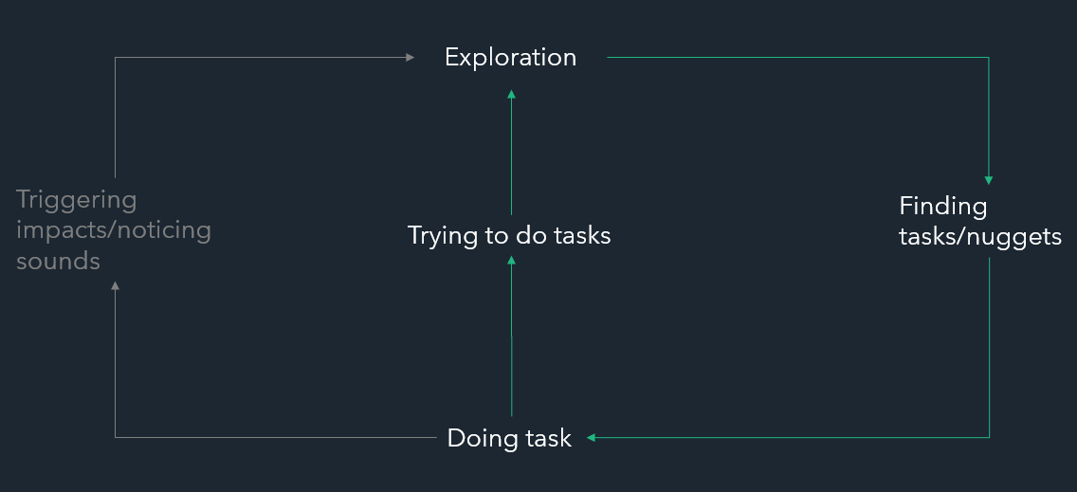

Figure 3: User Interacting with the tablet in VR

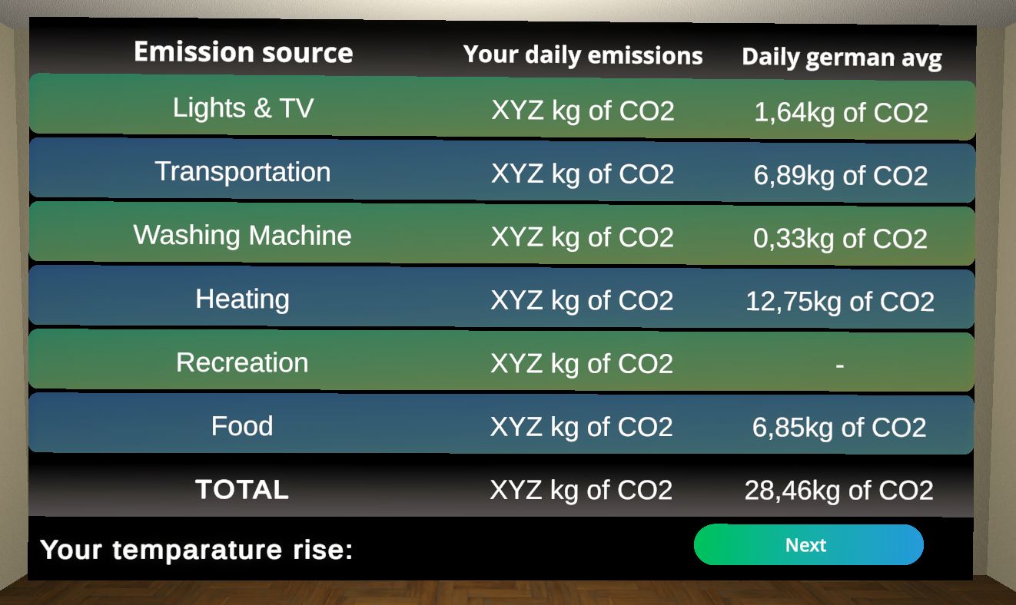

Figure 4: User Interacting with the tablet in VR

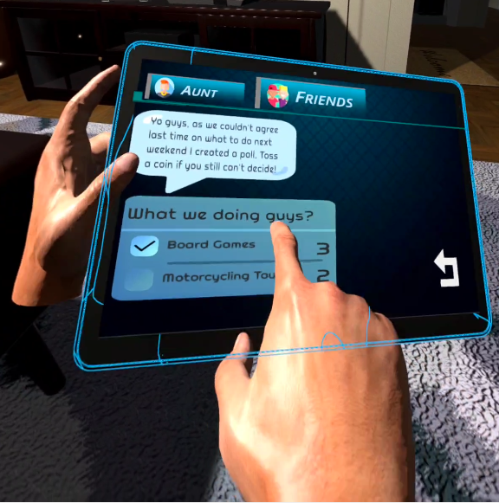

Figure 5: Likert results MS Forms

Figure 6: Likert results table

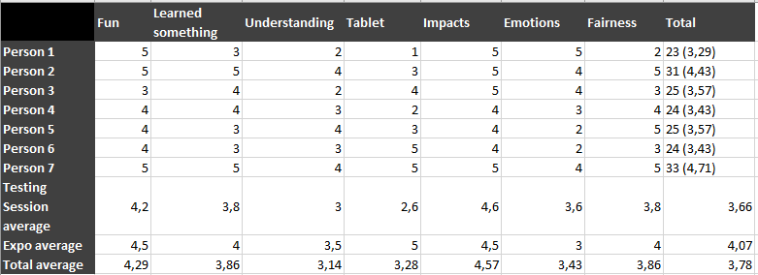

Figure 7: “FingerTip” object near the VR Hand (Marked with a red arrow).

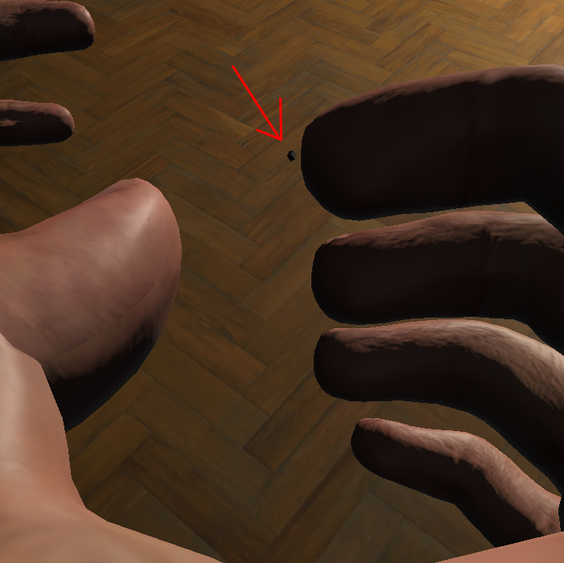

**Authors**

Jonathan: Chapters - 3.1, 3.2, 3.3

Florian: Chapters – 2, 3.4, 3.6, 4, 5.2

Samarth: Abstract & Chapters - 1, 3.5, 5.1, 5.2

**Contributions**

Jonathan: In-game logic, impacts/nuggets/tasks, research

Florian: Audio & voice lines, research, evaluation

Samarth: VR and UI, interactions

Conference Short Name:WOODSTOCK’18

Conference Location:El Paso, Texas USA

ISBN:978-1-4503-0000-0/18/06

Year:2018

Date:June

Copyright Year:2018

Copyright Statement:rightsretained

DOI:10.1145/1234567890

RRH: F. Surname et al.

Price:$15.00