**Analysis and Insights-**

**HR Data Analysis -**

Distribution of Age –> 18<=Age<=60

Majority Age Group -> 30-40

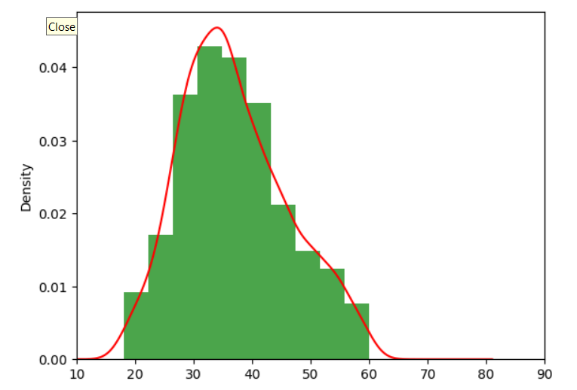

Attrition counts - Very Less Employees Leave Company

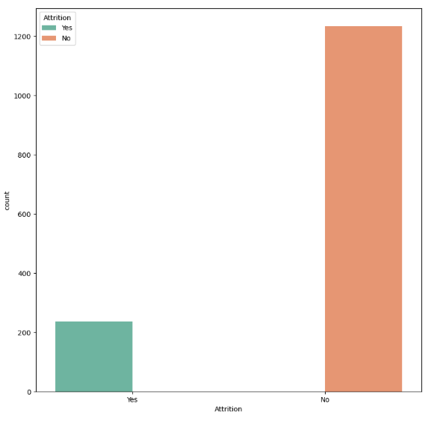

Attrition W.R.T Travelling -

Almost Equal Across All Since People Are Also Less In Some Fields

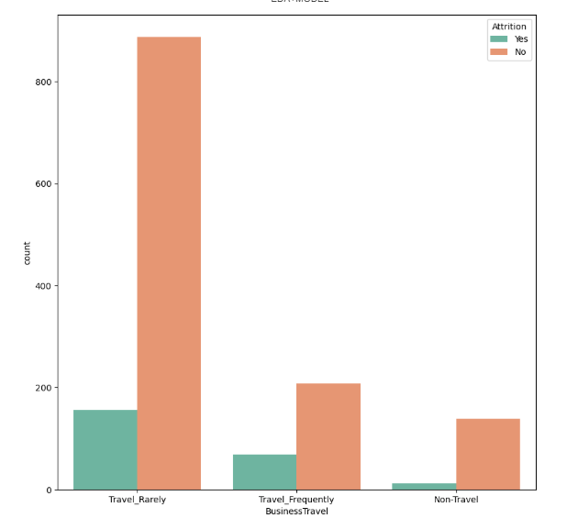

Attrition W.R.T Department - Almost Equal Across All

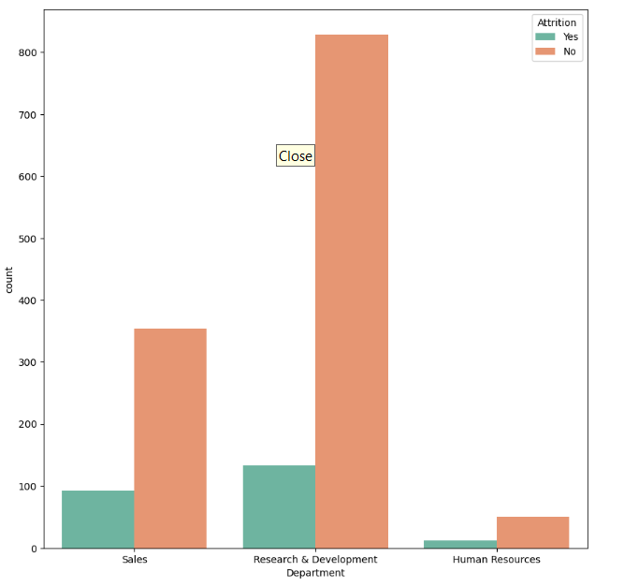

Attrition W.R.T Years in Organisation - After 10 years the attrition rate decreases

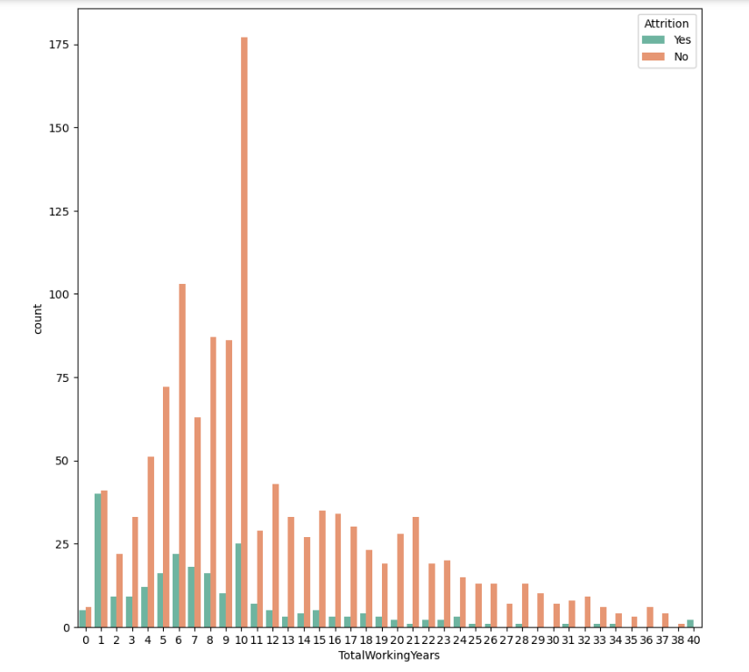

Attrition W.R.T Stocks(ESOs) - Peoples with ESOs benefit doesn’t leave company easily

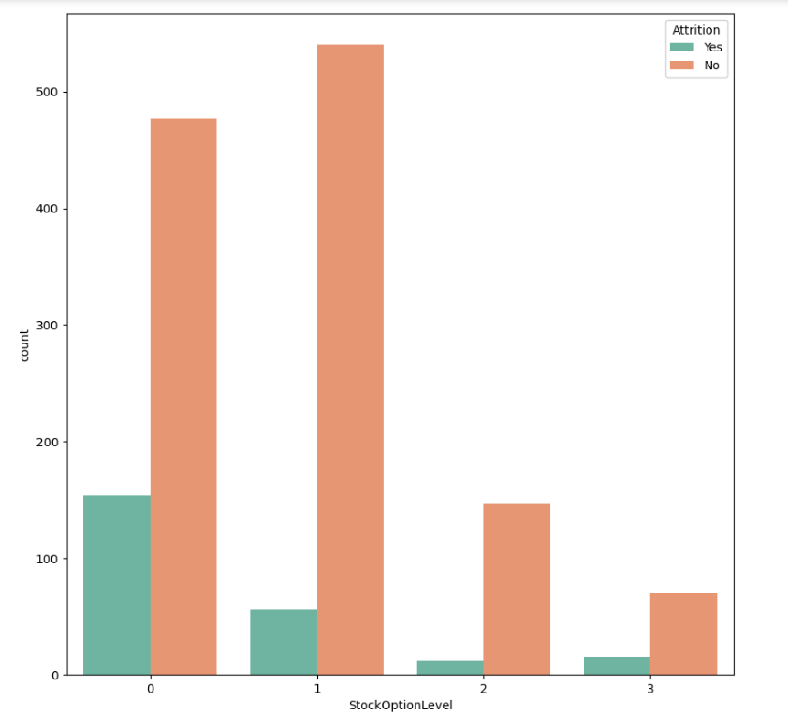

Attrition W.R.T PercentSalaryHike -

Employees with higher hike stay in company

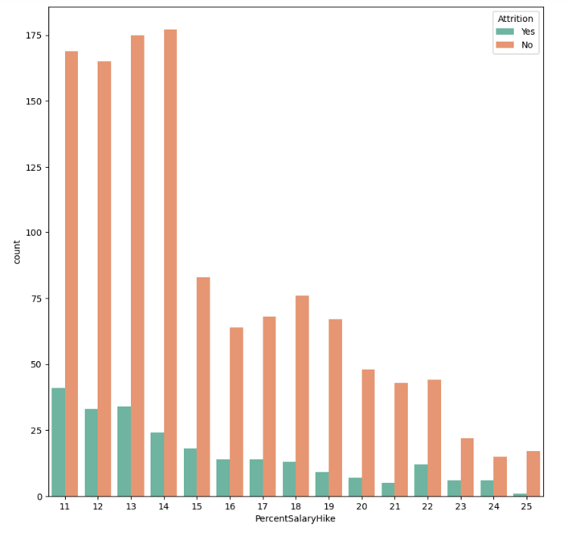

Attrition W.R.T Marital Status -

Married and Divorced People Stay In Organisation

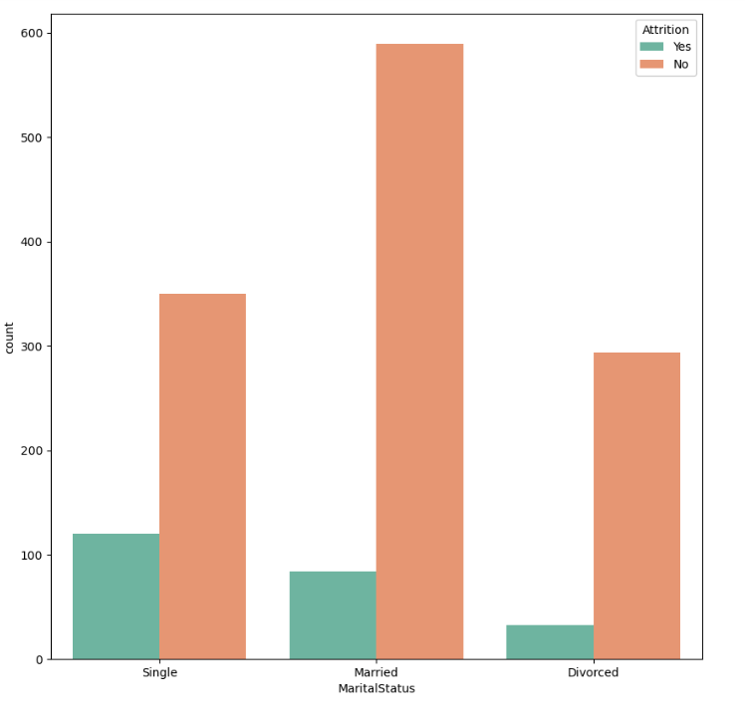

Attrition W.R.T JobSatisfaction -

Satisfied Employees Stays In Company

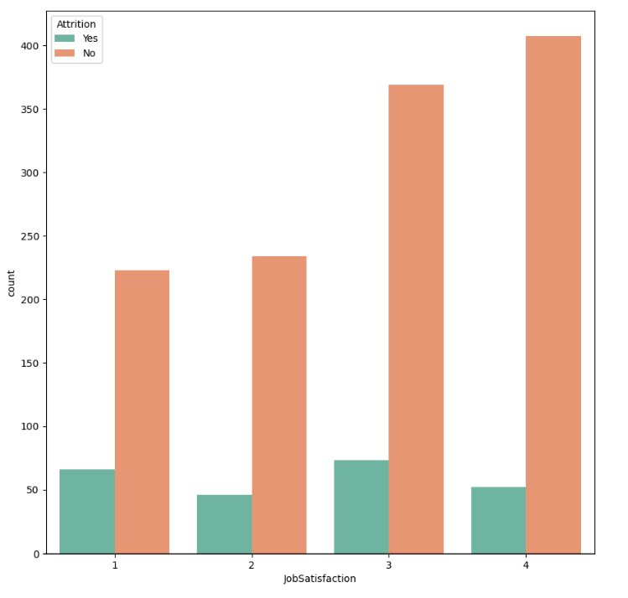

Attrition W.R.T JobLevel -

Employees at higher level stays in company

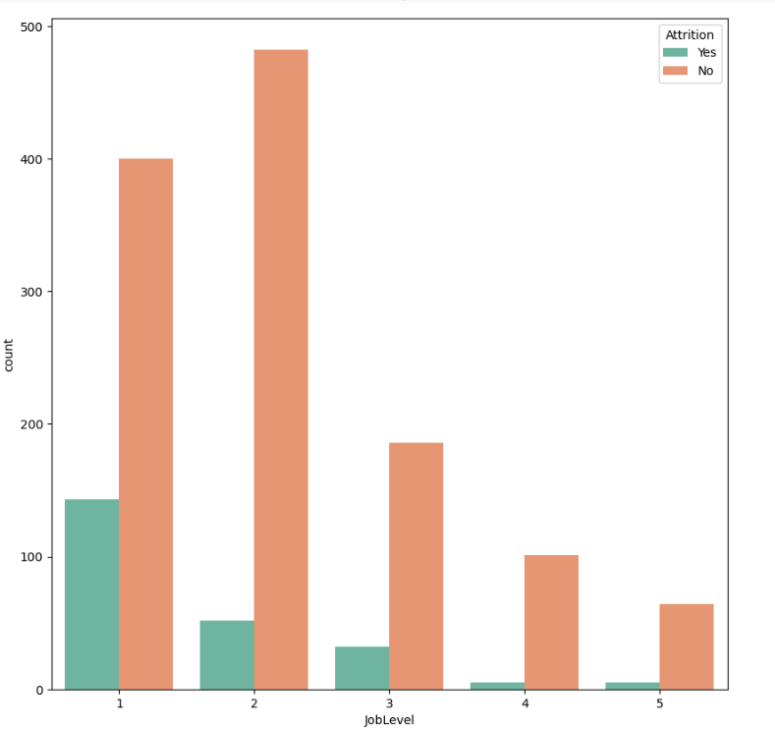

Attrition W.R.T JobInvolvement

Its Good To make employee more involved

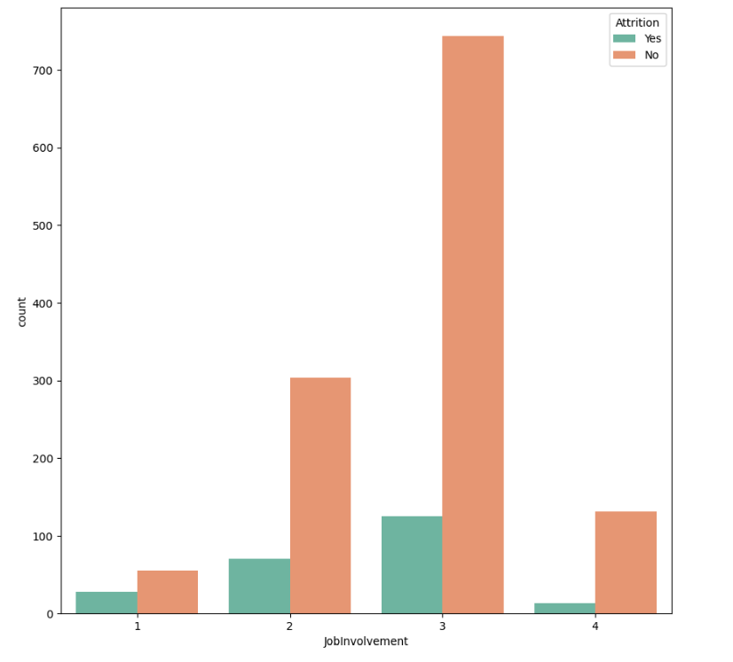

Attrition W.R.T job role -

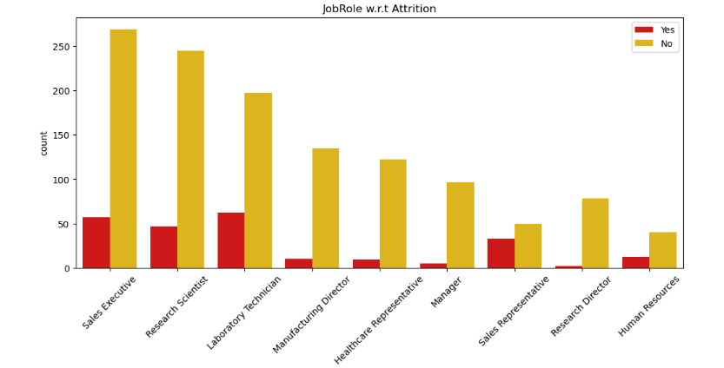Managers , healthcare representative , manufacturing director and research directors stays in company