FOUNDATION OF GEN AI – LAB 1 Name: Samarth Pyati USN: 1RVU23CSE400
- E mail text generation Date: 13/01/2026 Tools – Gemini (pro)
Prompt:
  - Act as the Sports Coordinator of a college/university.
  - Write a professional, motivational, and high-energy email announcing the Annual Sports Fest.
  - The target audience includes students, faculty members, and all university staff.
  - Highlight the importance of sports, teamwork, fitness, unity, and competitive spirit.
  - The main highlights will be atheletics such as 100,200,400m, shot put and discus throw.
  - Encourage maximum participation across all departments.
  - Maintain a formal yet energetic tone.
  - The email should be 200–250 words and suitable for official college communication.

Output:

Subject: Unleash Your Inner Athlete: [University Name] Annual Sports Fest 2026!
Dear Students, Faculty, and Staff,
It is time to trade the library for the track and the boardroom for the field! We are thrilled to announce the most anticipated event of our academic calendar: The [University Name]

Annual Sports Fest 2026.
This festival is more than just a series of games; it is a celebration of our collective resilience, health, and unity. In the pursuit of academic excellence, we must not overlook the vital
importance of physical fitness and the spirit of sportsmanship. Whether it is the adrenaline of a sprint or the calculated strength of a throw, sports teach us the invaluable lessons of teamwork, discipline, and the drive to transcend our limits.
Mark your calendars, because the stadium will come alive on Tuesday, January 20th, featuring premier athletic events including:
- The Sprints: 100m, 200m, and 400m dashes.
- Field Power: Shot Put and Discus Throw.
We call upon every department—from first-year students to our esteemed faculty and staff—to participate with vigor. Let us break departmental silos and build bridges through healthy competition. Whether you are competing for the gold or cheering loud from the stands, your energy is what defines this community.
Registration Details:
Sign-up sheets are now available at the Sports Office and via the university portal. Ensure your participation before the deadline.
Lace up your sneakers, find your rhythm, and let the games begin. Let’s make this January 20th a historic display of grit and glory!
In Sport and Unity, [Your Name] Sports Coordinator [University Name]

- Image Poster Generation Tools: Dall-E
Prompt:

A high-energy, professional poster for a college annual sports fest, featuring multiple athletes in dynamic action poses (running)
Cinematic lighting, dramatic shadows, stadium background with floodlights, motion blur for speed.
Modern bold typography area at the top reading “ANNUAL SPORTS FEST” with space below for tagline and event details.
Color palette: vibrant reds, blues, and yellows.
Style: realistic + semi-illustrated, university-level design.
Vertical A3 poster, high resolution, clean composition, no watermark, no cluttered text.

Output:
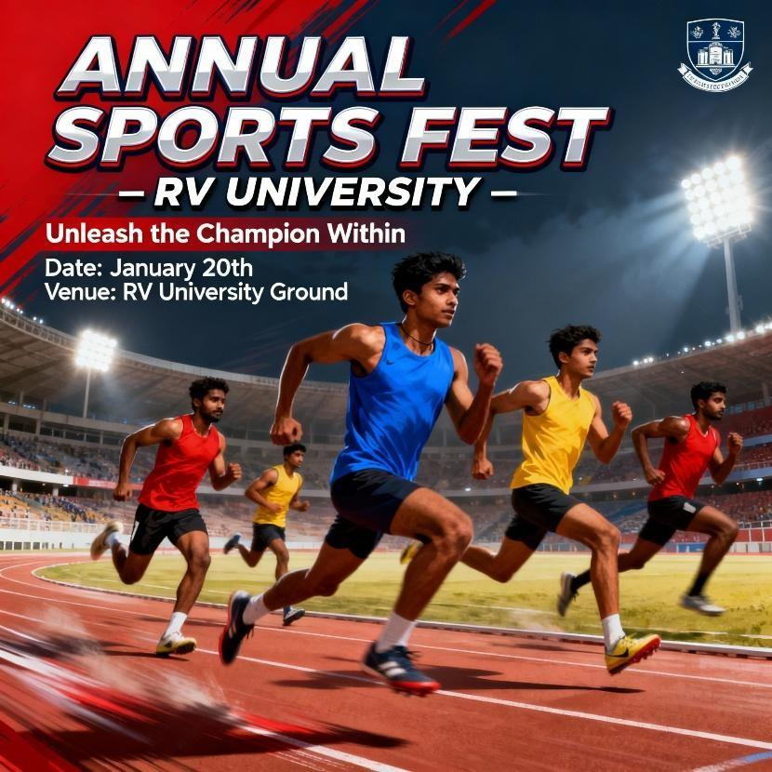
- Video Generation Tools: Fliki.ai Prompt:
Create a 60–75 second promotional video for a college Annual Sports Fest. Tone: Professional, energetic, motivational.
Style: Cinematic sports visuals, fast-paced transitions, stadium atmosphere. Use short impactful lines, suitable for voiceover.

Script:
The roar of the crowd.
The thrill of competition. The spirit of champions.
Get ready for the Annual Sports Fest 2025.
A celebration of strength, speed, teamwork, and determination. Where passion meets performance.
Where every player becomes a warrior. From track to field.
From courts to grounds.
Every game. Every move. Every moment counts. Unite. Compete. Conquer.
Join us as students and faculty come together
to celebrate sportsmanship, discipline, and excellence.

Annual Sports Fest 2025
Unleash the Champion Within
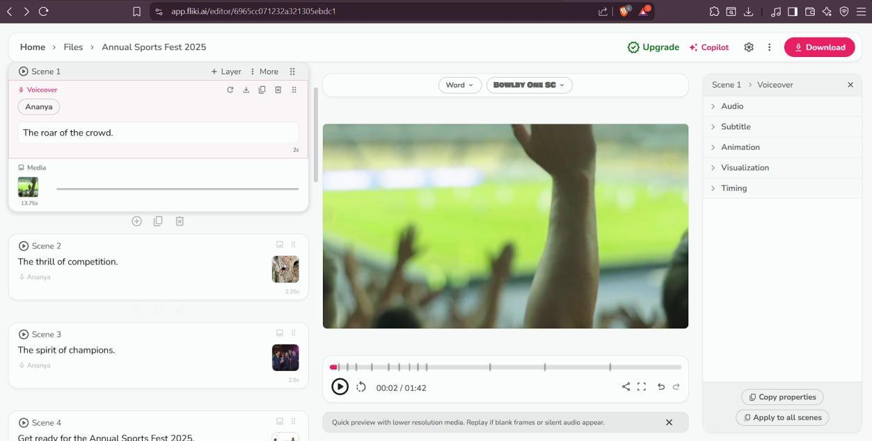
[Add date, venue, and college name] Output:

