Question 1) study on different types of the cables and connector used in the computer networking ?
Answer:-
1) Coaxial Cable :-
Also called coax cable. Consist of conducting core which is surrounded by the conducting layer both layer is separated by the insulator
Used to transfer high frequency signal with less loss of energy
Data transmitted as an electric signal and the shielding reduce the electromagnetic interference (EMI)
Used in old enthernet LANs, Cable TV, CCTV

Features:-
- Single copper conductor
- Better shielding than twisted pair
Advantage:-
- Less noise than twisted pair
- Can transmit over long distances
- Durable and strong
Disadvantage:-
- Bulky
- Expensive campare to twisted cable
- Lower speed than the fiber optical
Connector Used:-
- BNC connocter
- BNC-T connector
- BNC Treminator

2)Twisted pair cable :-
Also called twisted cable
It consists of two insulated copper wires twisted together to reduce noise and interference.
Used to transfer data signals over short distances.
Data is transmitted as electrical signals, and twisting helps reduce electromagnetic interference (EMI).
Used in modern Ethernet LANs, telephone lines, and home/office networks. This are colour coded

Features :-
• Two insulated copper wires twisted together
• Available as UTP (Unshielded Twisted Pair) and STP (shielded Twisted Pair)
• Lightweight and flexible

Basis | UTP (Unshielded Twisted Pair) | STP (Shielded Twisted Pair)
Full Form | Unshielded Twisted Pair | Shielded Twisted Pair
Shielding | No extra shielding | Has metallic shielding
Protection from EMI | Less protection | Better protection
Cost | Cheaper | More expensive
Flexibility | More flexible | Less flexible
Installation | Easy to install | Difficult to install
Weight | Lightweight | Heavier
Noise / Crosstalk | More affected | Less affected
Usage Area | Homes, offices | Industrial areas
Speed & Performance | Good | Better than UTP

Advantage :-
• Low cost
• Easy to install and maintain
• Widely used in LAN networks

Disadvantage :-
• Shorter distance compared to coaxial cable
• Affected by noise (especially UTP)
• Lower speed than fiber optic cable

Connector Used :-
• RJ-45 connector (used in Ethernet networks)
• RJ-11 connector (used in telephone lines)

3)Optical pair cable :-
Also called fiber optic cable.
It consists of thin strands of glass or plastic fibers that transmit data in the form of light signals.
Used to transfer data at very high speed over long distances with minimum signal loss.
Since data is transmitted as light, it is not affected by electromagnetic interference (EMI).
Used in internet backbone, WANs, LANs, and telecommunication networks.

Features :-
• Made of glass or plastic fiber
• Uses light instead of electrical signals
• Very high bandwidth

Advantage :-
• Very high speed and bandwidth
• No electromagnetic interference
• Can transmit data over long distances
• Highly secure

Disadvantage :-
• Expensive
• Difficult to install and repair
• Fragile compared to copper cables

Types :-
• Single Mode Fiber (SMF)
SMF is a type of optical fiber that allows only one light signal (mode) to travel through the fiber.
It has a very small core diameter, so light travels in a straight path.
Used for very long-distance communication with high speed and low signal loss.
• Multi Mode Fiber (MMF)
MMF is an optical fiber that allows multiple light signals (modes) to travel at the same time.
It has a larger core diameter, so light reflects inside the fiber.
Used for short-distance communication.

Connector Used :-
• SC connector
• LC connector
• ST connector

Difference and conclusion
The best cable is the optical fiber
Feature | Coaxial | Twisted Pair | Optical Fiber
Data Speed | Medium | Medium–High | Very High
Distance | Medium | Short | Very Long
Interference | Medium | Affected by EMI | No EMI
Security | Medium | Low | Very High
Bandwidth | Low | Medium | Very High
Cost | Medium | Low | High

Question 2) Process of crimping of LAN cable?
Answer:- the crimpling is the process of attaching an RJ45 connector to the end of an Ethernet (LAN) cable so it can be used for networking.
The step by step process :-
  - Using Crimping Tool :-
So the first step is the Strip the cable back 1 inch from the end. Insert the cable into the stripper section of the tool and squeeze it tight. Then, rotate the crimping tool around the cable in a smooth and even motion to create a clean cut. Keep the tool clamped and pull away towards the end of the wire to remove the sheathing

  - Untwist and straighten the wires inside of the cable :-
Inside of the cable you’ll see a bunch of smaller wires twisted together. Separate the twisted wires and straighten them out so they’re easier to sort into the right order
- Cut off the small plastic wire separator or core so it’s out of the way.
- Don’t cut off or remove any of the wires or you won’t be able to crimp them into the connector.

  - Arrange the wire into right order :-
Use your fingers to put the wires in the correct order so they can be properly crimped. There are 8
wires in total that need to be arranged in the right sequence .

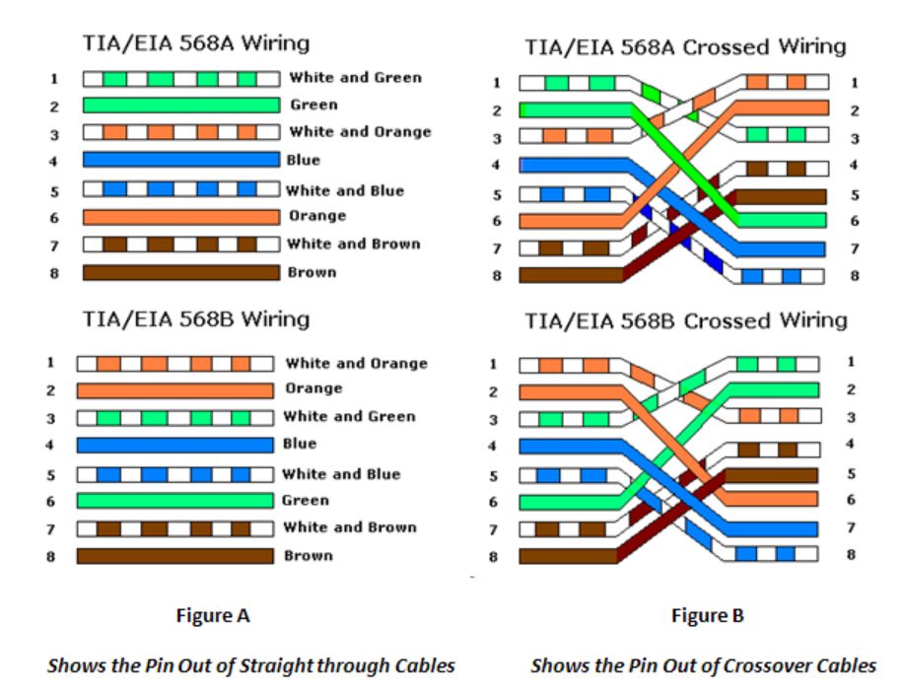

  - Cut the wires into an even line :-
The wires must be in an even line to be crimped into the RJ-45 connector properly. If you cut them
in an uneven line, move further down the wires and cut them again.

  - Instert the wire into the RJ45 connector:-
Hold the RJ-45 connector so the clip is on the underside and the small metal pins are facing up.
Insert the cable into the connector so that each of the small wires fits into the small grooves in the
connector.
- The sheathing of the cable should fit just inside of the connector so it’s past the base.
- If any of the small wires bend or don’t fit into a groove correctly, take the cable out and straighten the wires with your fingers before trying again.
- The wires must be inserted in the correct order and each wire must fit into a groove before you crimp the connector.

  - Stick the connector into the crimping part of the tool and squeeze twice:-
The crimping tool pushes small pins in the grooves down onto the wires to hold and connect them
to the RJ-45 connector.

  - Remove the cable from the tool and check that all of the pins are down :-
If any of the pins aren’t pushed down, put the wire back into the crimping tool and crimp it again

Question 3) What is the cross connection and straight connection in the networking device ?
Answer:-
- Straight connection

When connecting between two dissimilar devices, for example, from the computer to the router, a straight-through cable will be needed. There are no left or right constrictions on the straight-through cable, as both ends have the same wiring signals, so the wires correspond to the same pins at the other end, too. In such a way, the transceiver protocol can be set up in such a manner that the information is transmitted from one device to another without any need for manual configuration
Features of Straight-Through Cable:-
Direct Connection: Links devices of different categories for instance a computer with a switch or a router, Computer-to-Device connection.
Standard Ethernet Cable: It is particularly used in Ethernet networks for data transmission purposes.
Color Code Consistency: The endings of the electrodes have identical sequences in terms of the color codes applied to the wires.
Common Usage: Sometimes used in home and office networks for sharing devices among the nodes and link points.
- Cross connection
Crossover cables are found primarily on connections between similar devices like two computers or two switches. A difference between straight-through and crossover cables is that the order of the wires differs at each end of the cable. This will allow communication of devices indicating if they are transmitting or receiving by 'crossovering' the 'Tx' and 'Rx' so that data can be obtained by both similar devices.
Features of Crossover Cable:-
Device-to-Device Connection: Mostly used in direct connectivity between composites of similar types like two computers or two switches.
Pin Configuration: Pins connected on two ends with different arrangements for example T568 A on one end and T568B on the other end.
Transmit/Receive Swapping: Exchange the two ports' T/R signal between the two ends.
Specific Purpose: Typically employed in scenarios where devices must be able to interface without requiring a hub or switch.
Colour Code Variation: In a crossover, some wires at each end have colour-coded sequences different from the other end

Basis | Straight-Through Cable | Crossover Cable
Type of Devices Connected | Connects dissimilar devices (e.g., computer to switch/router) | Connects similar devices (e.g., computer to computer, switch to switch)
Wiring Order | Same wire order on both ends | Different wire order on each end
Pin Configuration | Uses same standard on both ends (T568A–T568A or T568B–T568B) | Uses different standards (T568A on one end and T568B on the other)
Transmit (Tx) and Receive (Rx) | Tx and Rx pins are not crossed | Tx and Rx pins are crossed
Purpose | Allows communication between different types of devices | Allows communication between same types of devices
Color Code | Identical color sequence on both ends | Different color sequence on each end
Use of Hub/Switch | Requires a switch or hub between similar devices | No switch or hub required
Common Usage | Used in home and office networks | Used for direct device-to-device connections
Example | Computer ↔ Switch | Computer ↔ Computer

