🌱
AgroPilot AI
Smart Greenhouse Intelligence System

App Development Course Project Report

Project Name | AgroPilot AI – Smart Greenhouse Intelligence
Course | App Development
Build | End-Semester Demo (2026)
Version | App Version 1.0.0
ML Model | XGBoost v1
IoT Platform | ESP32 → Firebase RTDB
Database | Firebase Firestore

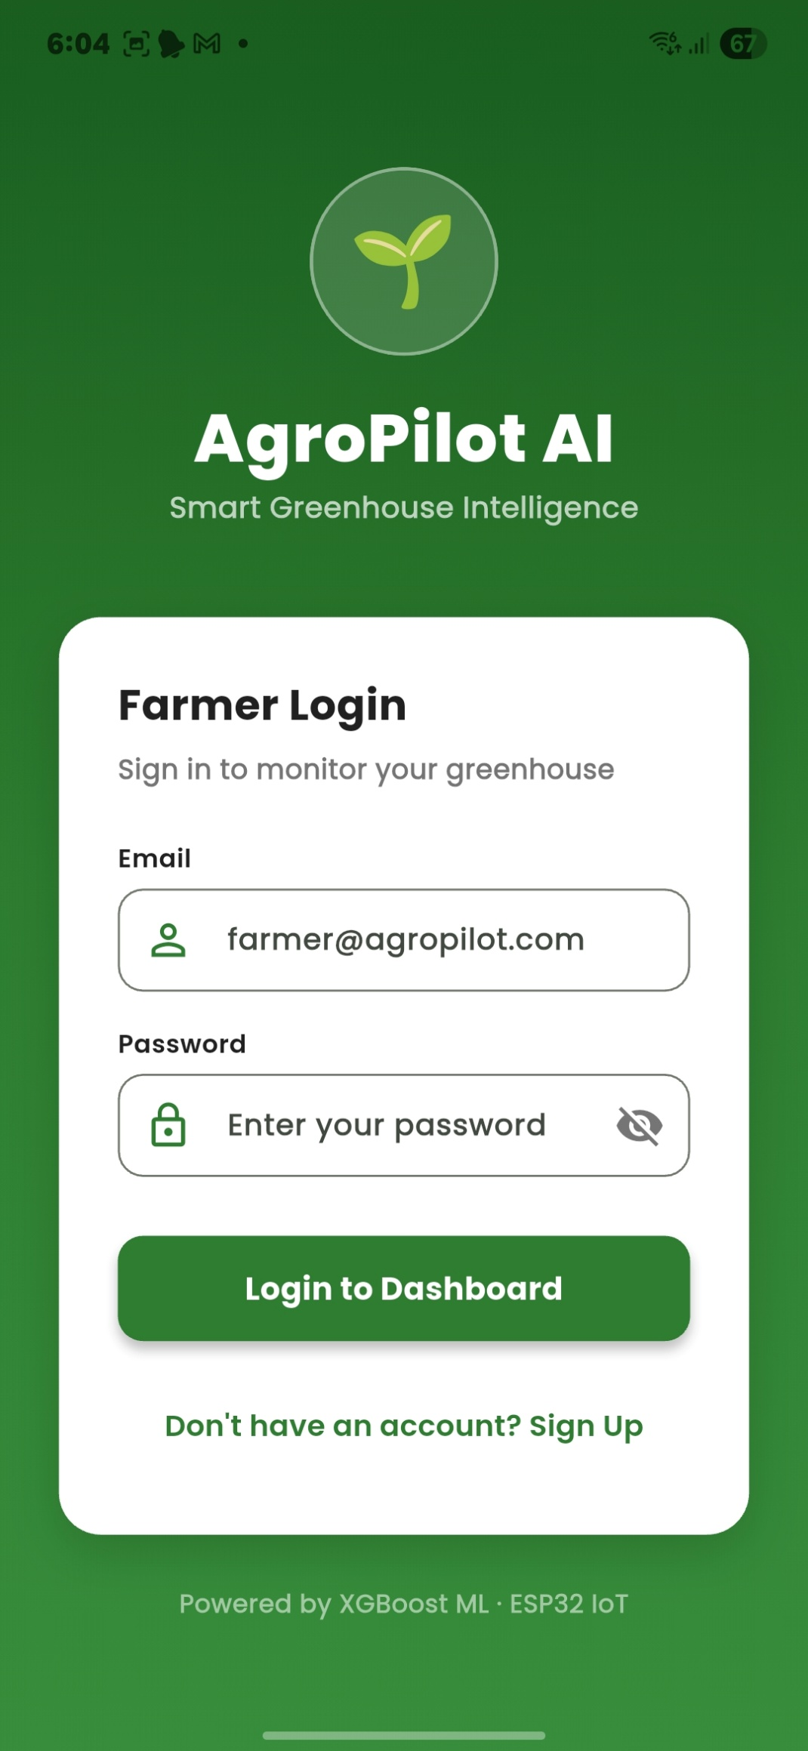
App Login Screen

Powered by XGBoost ML · ESP32 IoT · Firebase

1. Project Overview
AgroPilot AI is a mobile application designed to enable smart greenhouse management for farmers using IoT sensors and machine learning. The app integrates real-time environmental monitoring, AI-based crop predictions, and a multilingual interface to make precision agriculture accessible.

Key Objectives
- Real-time monitoring of greenhouse conditions (temperature, humidity, CO₂, soil moisture)
- AI-powered crop health insights and yield forecasting using XGBoost ML
- IoT integration via ESP32 sensors and Firebase RTDB for live data streaming
- Multilingual support (Hindi, Marathi, English, Kannada, Telugu, Tamil, Malayalam)
- Harvest tracking and Mandi market price integration
- PID controller auto-setpoints based on crop type and growth stage

2. Technology Stack
Frontend | Flutter (Android / iOS)
Backend / Auth | Firebase Firestore + Firebase Auth
IoT Hardware | ESP32 Microcontroller
Real-time Data | Firebase Realtime Database (RTDB)
Machine Learning | XGBoost v1 – Crop Yield Prediction
Languages Supported | English, Hindi, Marathi, Kannada, Telugu, Tamil, Malayalam
Export | Structured JSON export for LLM training data

3. Application Screens
3.1 Authentication
The login screen provides secure farmer authentication. The app greets users with the AgroPilot AI branding and connects directly to the greenhouse dashboard on login.


Login Screen

3.2 Farmer Profile
The profile screen displays farmer information, crop configuration, app build details and a motivational tagline. Key statistics like days planted, alert count, and days remaining are shown at a glance.

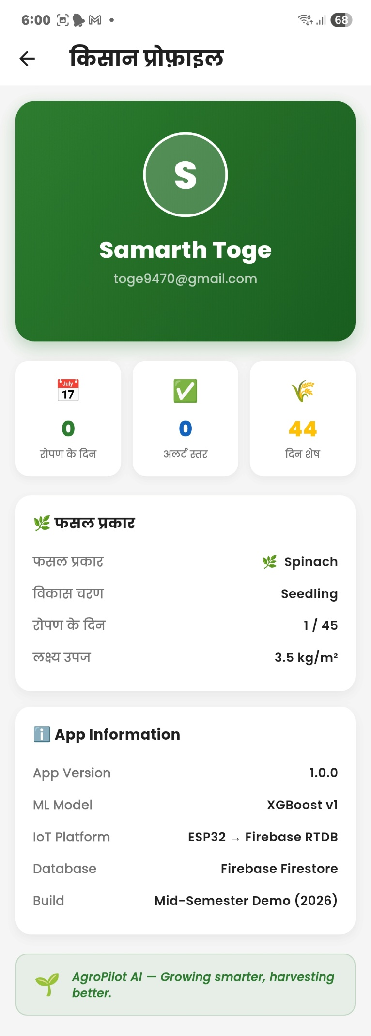
Farmer Profile

3.3 Language & Settings
AgroPilot AI supports 7 Indian languages. Farmers can select their preferred language, configure crops (Spinach / Capsicum), growth stage, planting days, and target yield. Notifications for critical alerts, daily summaries, and harvest reminders are also configurable here.
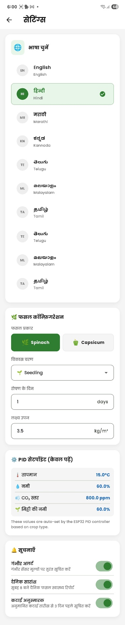
Settings – Language & Crop Config

3.4 Sensor Detail View
Detailed sensor screens show real-time readings for temperature, humidity, CO₂ levels, and soil moisture. Each sensor view includes a 24-hour chart comparing actual vs. ideal values, with min, max, and average statistics.

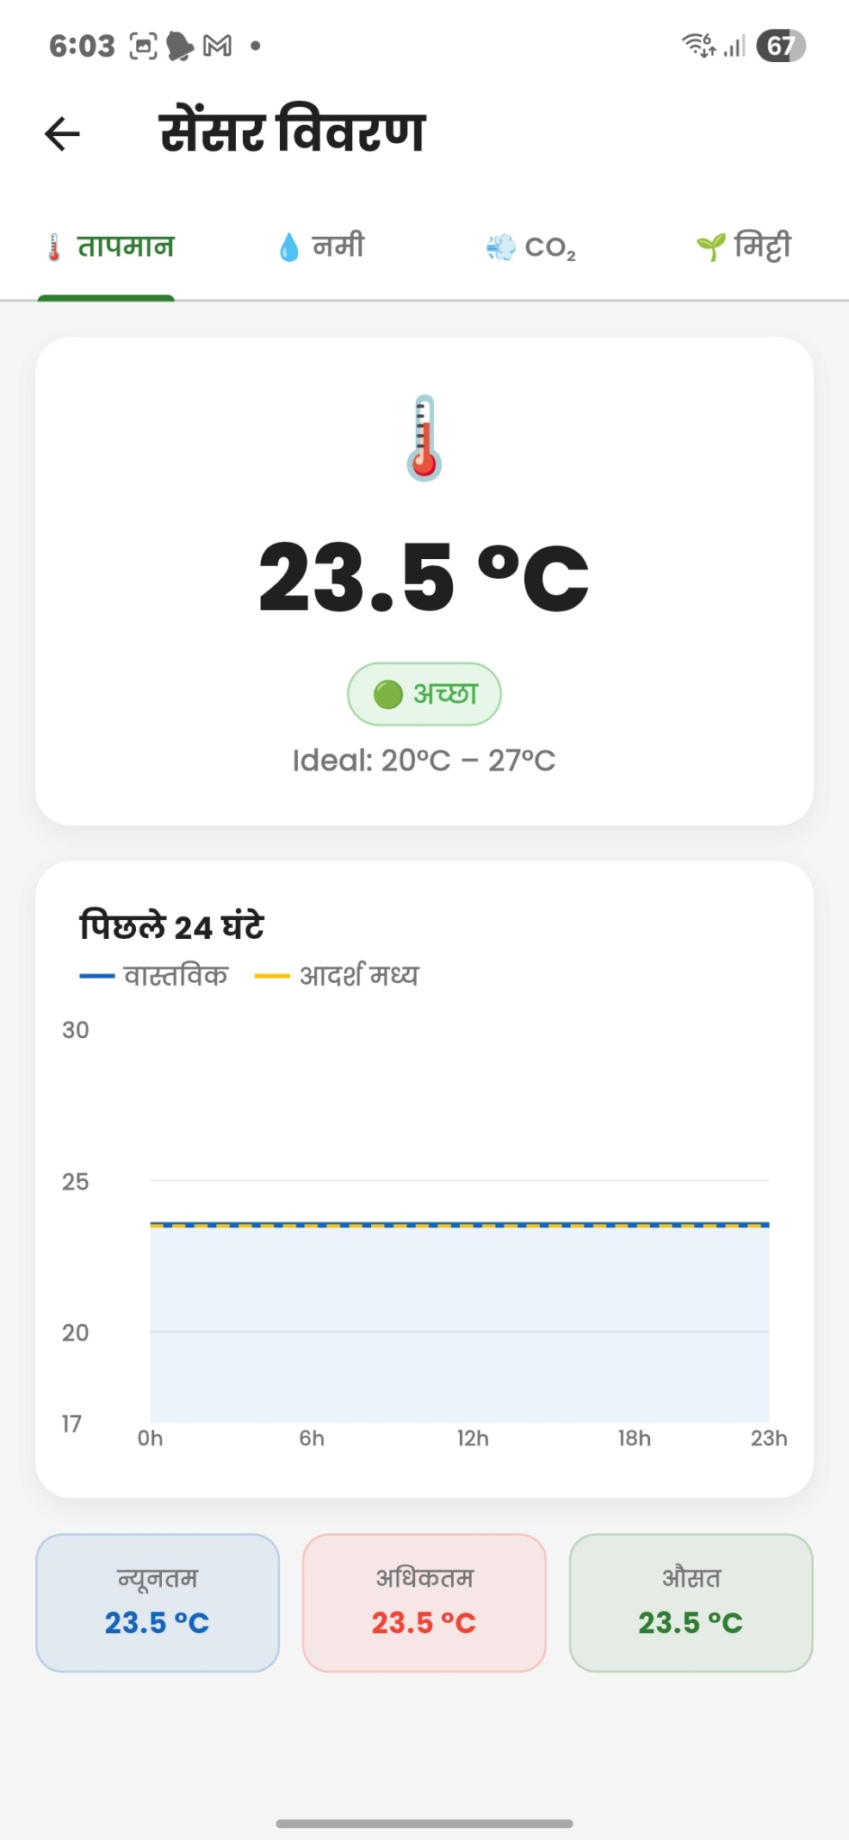  Temperature | 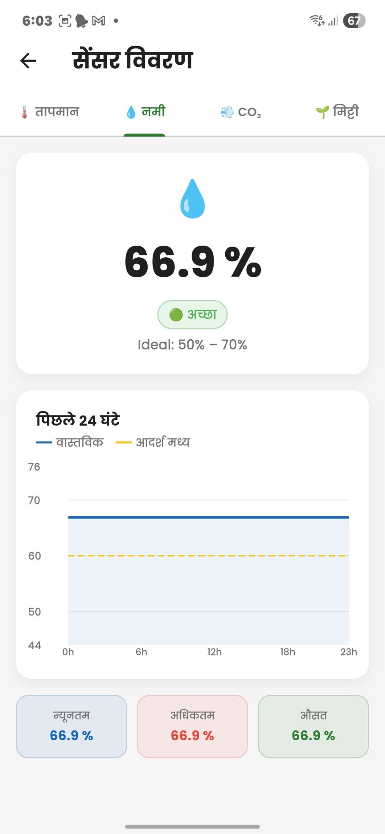  Humidity | 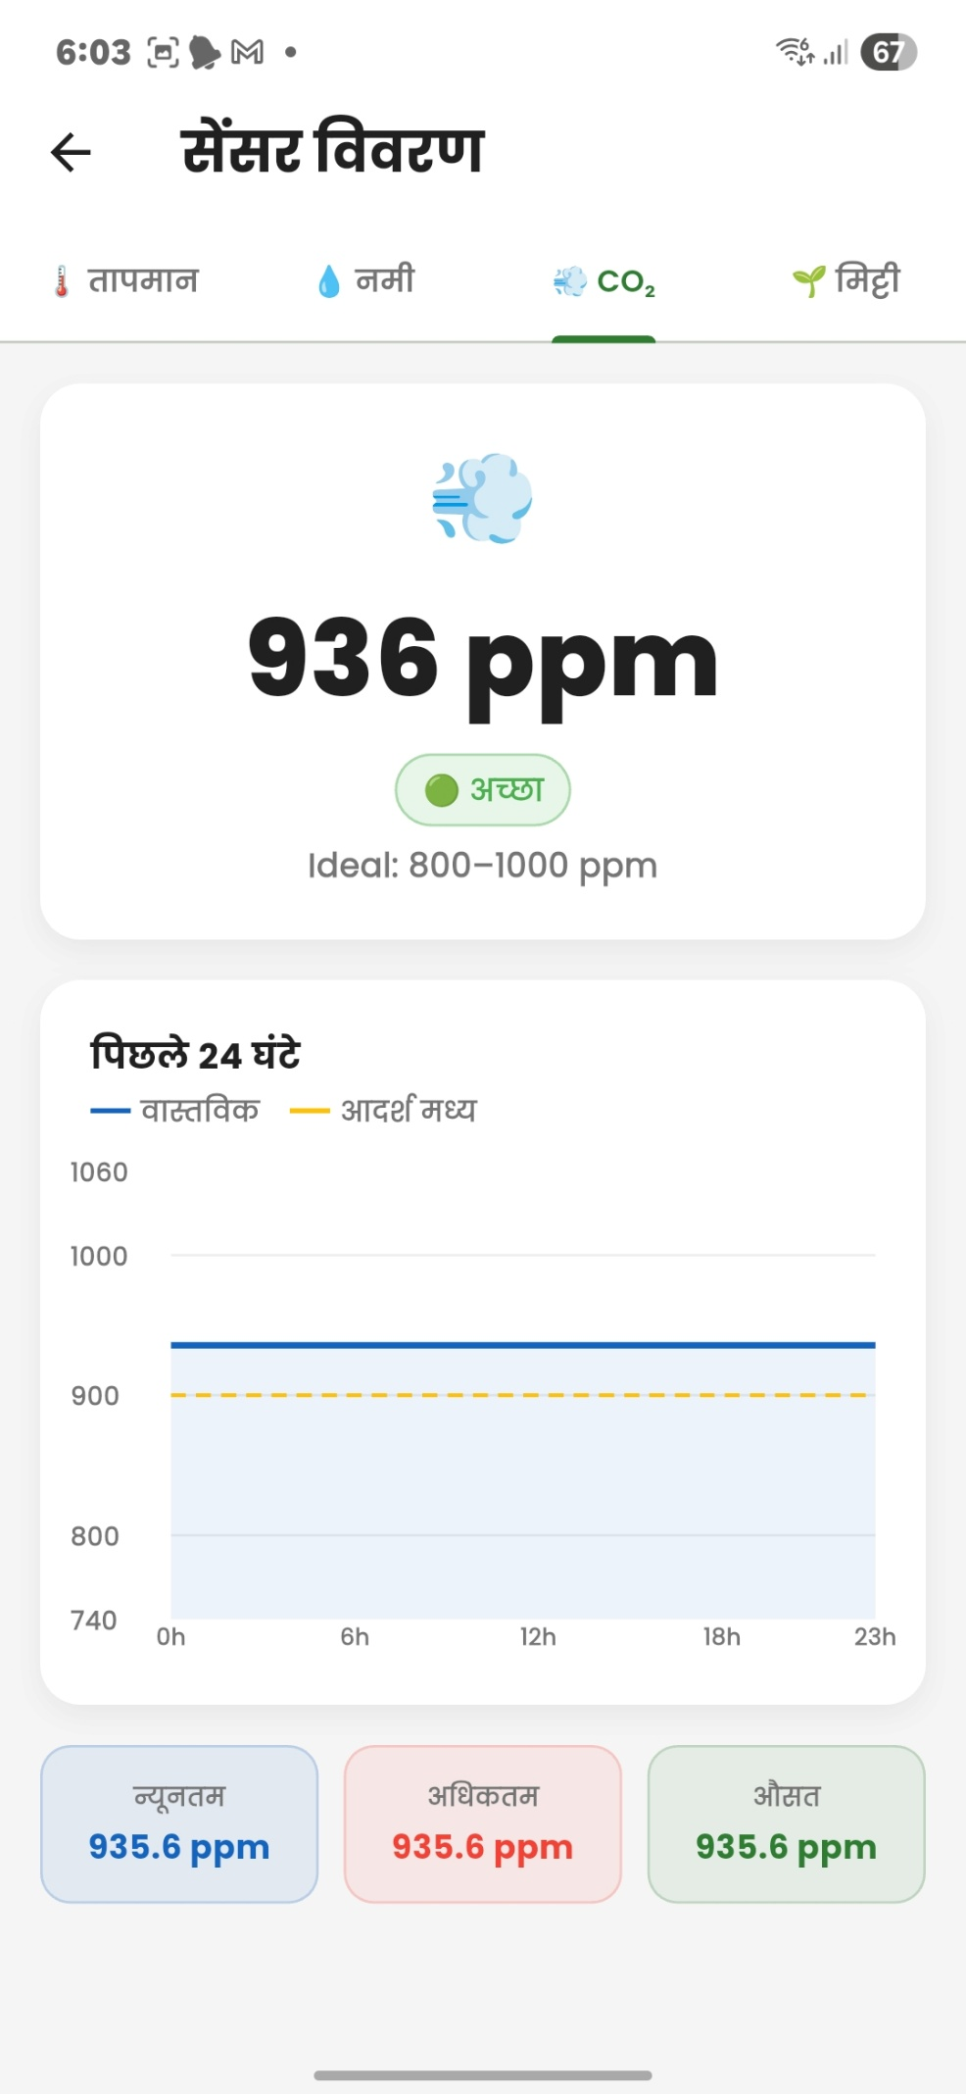  CO₂ | 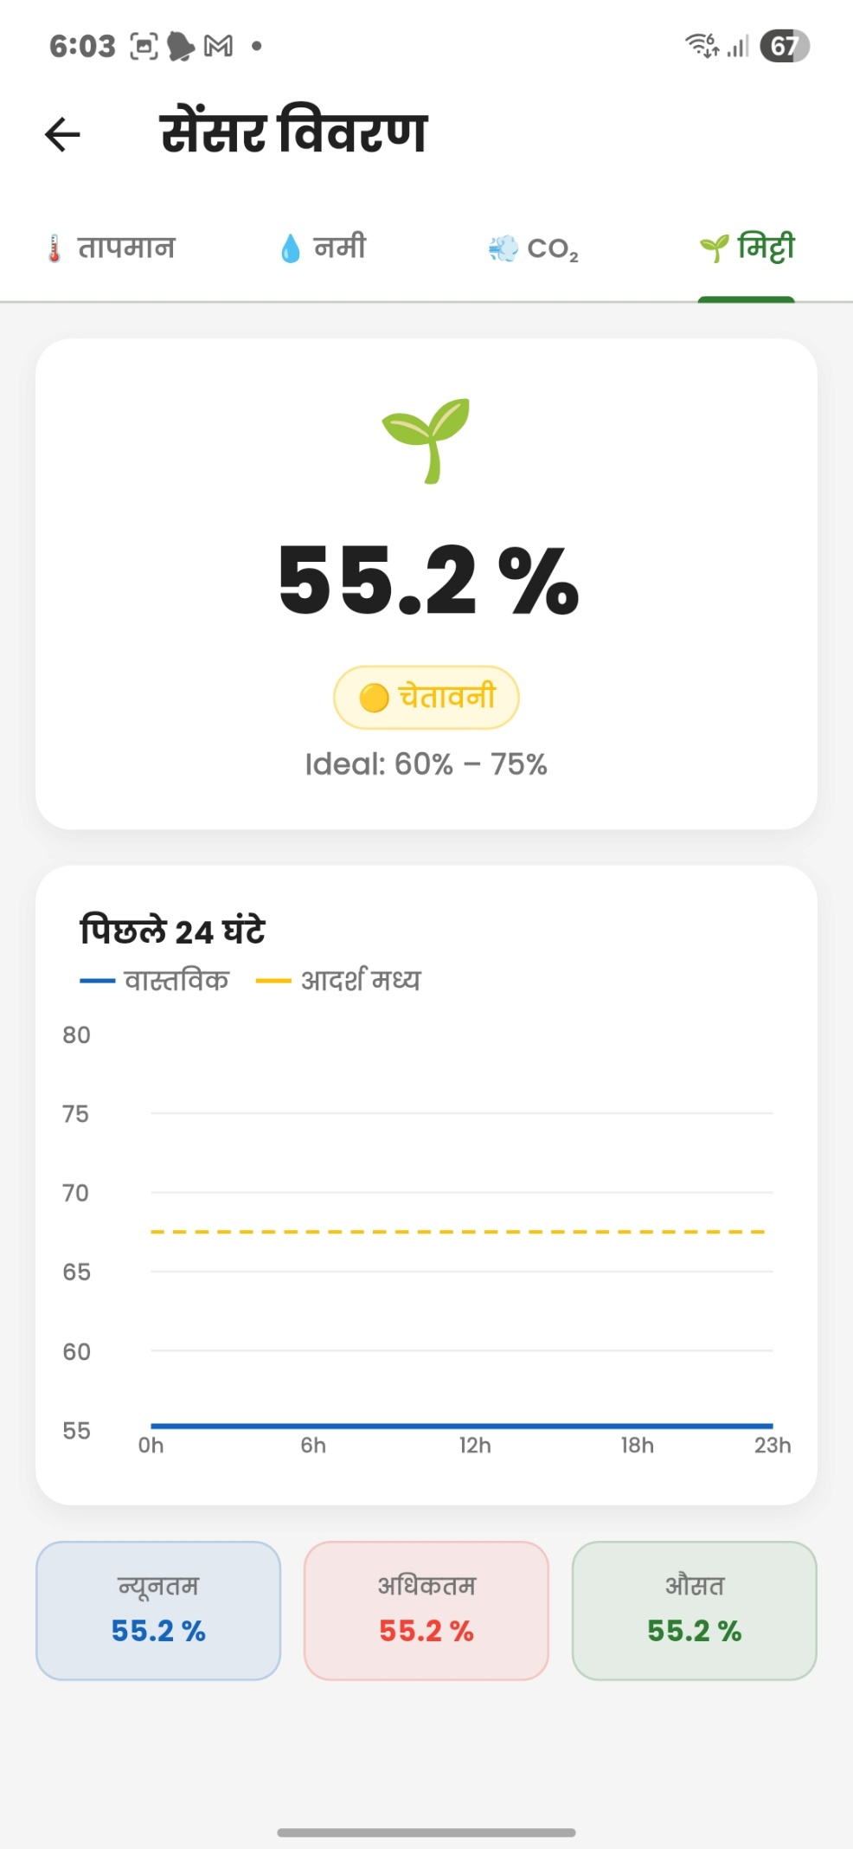  Soil

3.5 History & Reports
The history screen provides a 4-week trend chart of greenhouse conditions alongside average sensor readings and a timestamped alert log. This enables farmers to identify patterns and take preventive action.

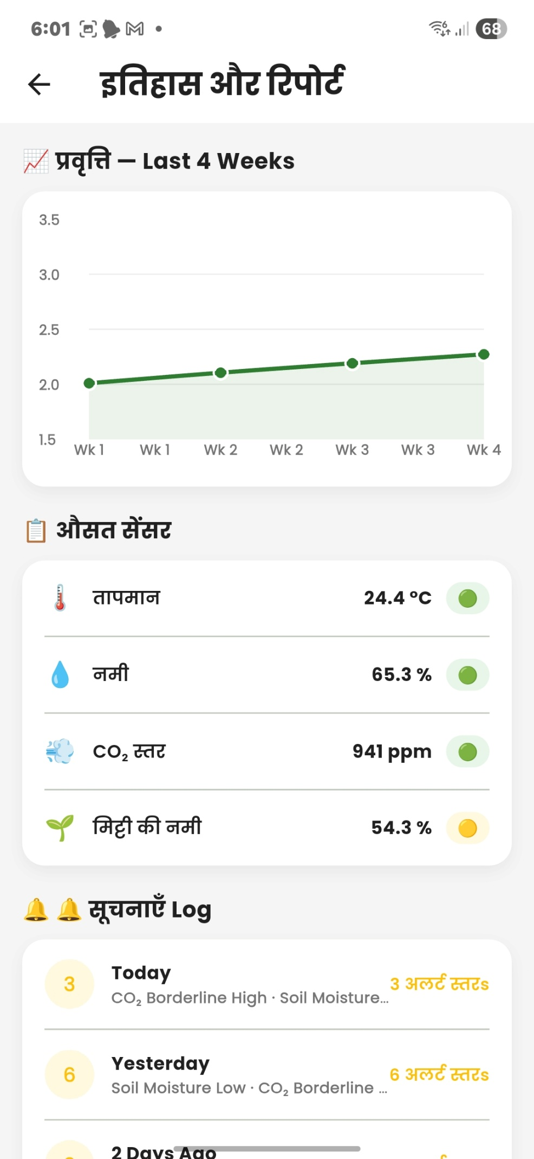
History & Reports

3.6 AI Analysis
The AI analysis screen presents smart insights generated from 13,058 data points. It includes categorized insights for temperature stability, soil moisture concerns, CO₂ trend, and yield forecast. Alert statistics for the last 30 days are also shown here.

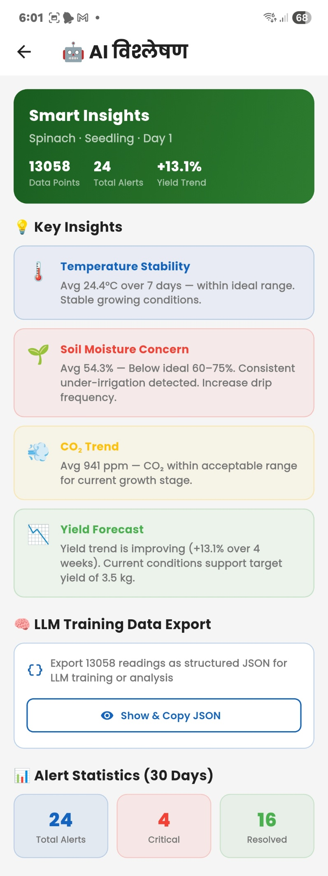
AI Analysis – Smart Insights

3.7 Harvest Entries
Farmers can log their harvest entries with crop type, quality grade, quantity, and market price. The app calculates total earnings and tracks sales venue (Mandi). A detailed harvest record sheet is accessible per entry.

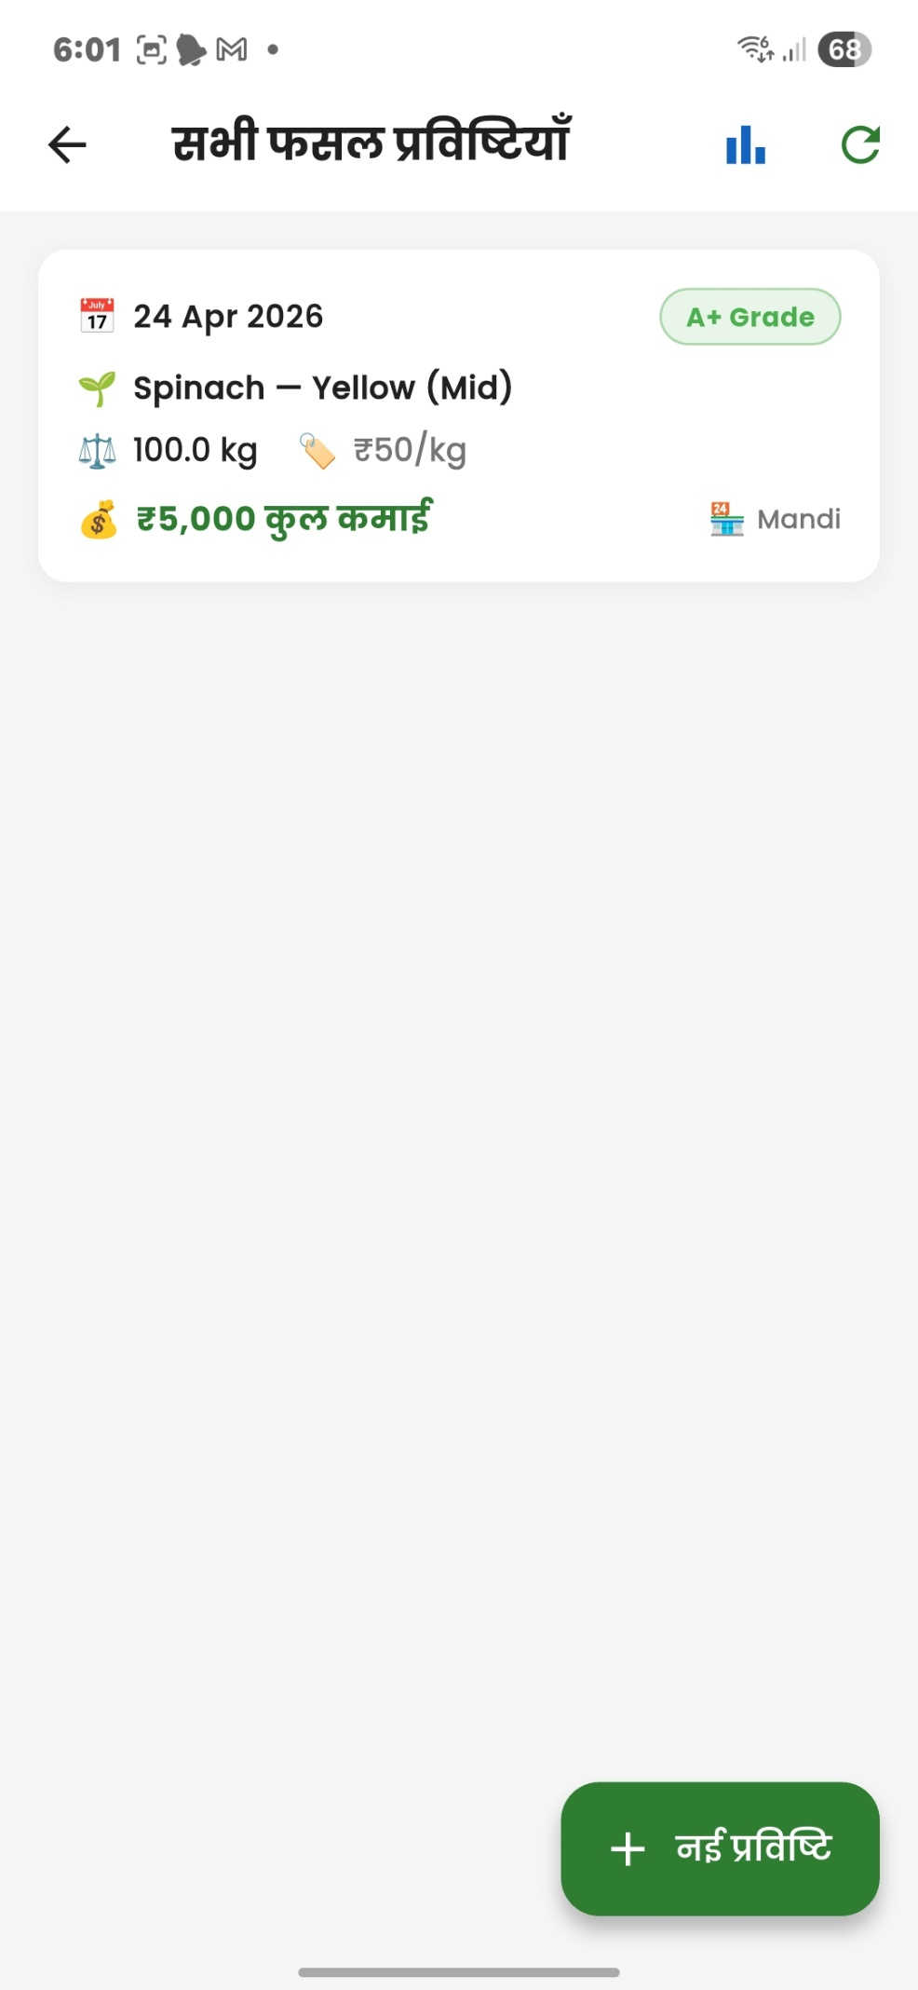  Harvest List | 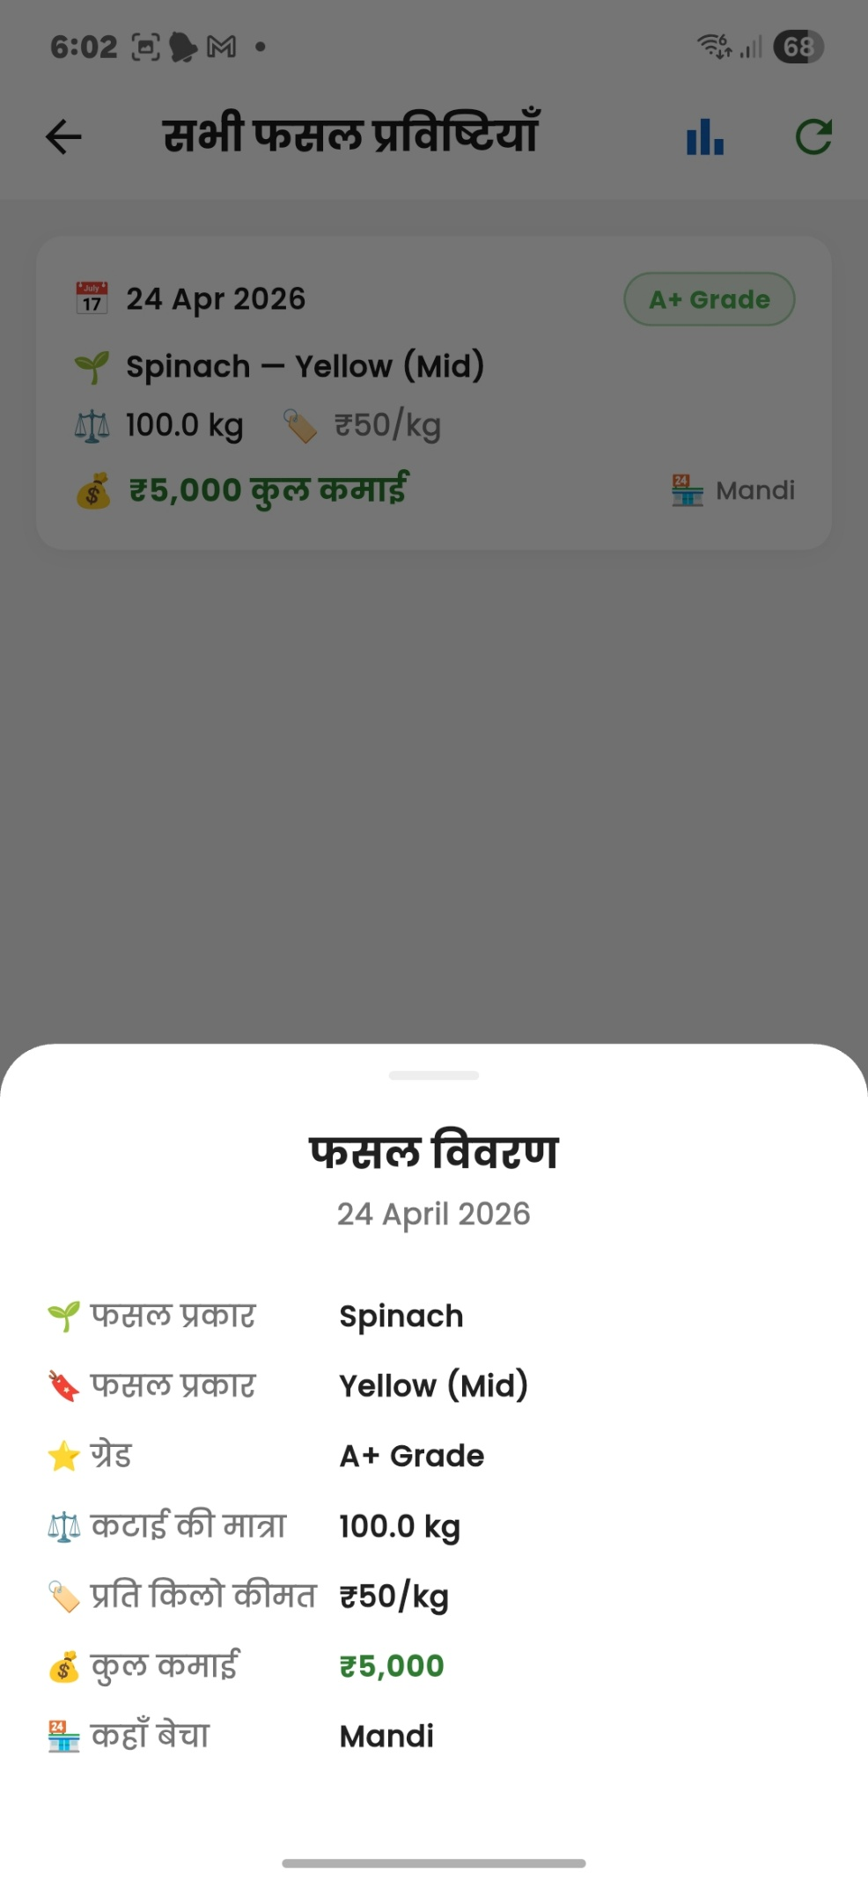  Harvest Detail

4. Feature Highlights
Real-time IoT Monitoring | ESP32 streams temperature, humidity, CO₂, soil moisture to Firebase RTDB
XGBoost ML | Predicts yield trends; +13.1% yield improvement detected over 4 weeks
PID Auto-Setpoints | Auto-configured greenhouse targets by crop type and growth stage
Multilingual UI | 7 Indian languages including Hindi, Marathi, Kannada, Tamil
Alert System | Critical, borderline, and resolved alerts with 30-day statistics
LLM Data Export | Export 13,058 sensor readings as structured JSON for AI training
Harvest Tracker | Grade-based harvest logging with market price & earnings tracking
Offline-Resilient | Firebase handles sync when connectivity is intermittent

5. AI & Machine Learning
The XGBoost model is the core intelligence engine of AgroPilot AI. It processes time-series sensor data to generate the following outputs:

- Temperature Stability — Avg 24.4°C over 7 days, within the ideal 20–27°C range
- Soil Moisture Concern — Avg 54.3%, below the ideal 60–75%, flagging under-irrigation
- CO₂ Trend — Avg 941 ppm, within acceptable range for current growth stage (Seedling)
- Yield Forecast — +13.1% yield trend over 4 weeks, on track for 3.5 kg/m² target

The app also supports LLM training data export, generating 13,058 structured JSON records from sensor history for further model fine-tuning.

6. Conclusion
AgroPilot AI successfully demonstrates a full-stack app development approach integrating Flutter, Firebase, ESP32 IoT hardware, and machine learning. The mid-semester demo build (v1.0.0) showcases real-time greenhouse monitoring, multilingual accessibility, AI-driven crop insights, and harvest management in a single cohesive platform.

The app has strong potential for real-world adoption by smallholder greenhouse farmers across India, with future plans to expand crop types, add weather API integration, and improve the ML model with farmer-contributed data.

AgroPilot AI — Growing smarter, harvesting better.
April 2026 · End-Semester Demo Build ·

