
SYMBIOSIS INSTITUTE OF TECHNOLOGY, PUNE
Symbiosis International (Deemed University)
(Established under section 3 of the UGC Act, 1956)
Re-accredited by NAAC with ‘A’ grade (3.58/4) | Awarded Category – I by UGC
Founder: Prof. Dr. S. B. Mujumdar, M. Sc., Ph. D. (Awarded Padma Bhushan and Padma Shri by President of India)

Assignment No. 05

Subject: | DevOps Lab
TCODE: | TE7950
Name of Student | Samartha Shrestha
PRN No. | 23070122189
Branch | CSE, Batch (2023-27), L3
Academic Year &  Semester | 2026, Sem VII
Date of Performance | 16th July, 2026
Title of Assignment: | Continuous Integration with Jenkins
Theory: | Theory  Jenkins is an open-source automation server used to implement Continuous Integration (CI) and Continuous Delivery (CD). It automates software development tasks such as building, testing, and deploying applications. Jenkins integrates with version control systems like Git to automatically retrieve source code and execute predefined build steps.  In this experiment, Jenkins was installed using Docker, configured with the Git plugin, and connected to a GitHub repository. A Freestyle project was created to pull source code from the repository and execute shell commands. The build was then triggered manually, and the console output was examined to verify successful execution.  Commands Used  - docker --version – Verified that Docker was installed on the system.  - docker ps – Checked whether the Jenkins Docker container was running.  - docker run -d -p 8080:8080 -p 50000:50000 -v jenkins_home:/var/jenkins_home --name myjenkins jenkins/jenkins:lts-jdk17 – Created and started the Jenkins Docker container.  - docker logs myjenkins – Displayed the Jenkins logs to obtain the initial administrator password during the initial setup.  - docker exec myjenkins cat /var/jenkins_home/secrets/initialAdminPassword – Retrieved the initial administrator password generated by Jenkins.  Execute Shell Commands  - echo "BUILDING: ${JOB_NAME}" – Displayed the Jenkins job name.  - echo "BUILD NUMBER: ${BUILD_NUMBER}" – Displayed the current build number.  - echo "WORKSPACE: ${WORKSPACE}" – Displayed the Jenkins workspace path.  - ls -la – Listed all files present in the Jenkins workspace.  - echo "Hello Jenkins!" – Displayed a sample message to verify successful execution of the build step.
Implementation: | Step 1: Verify Docker and Jenkins Container  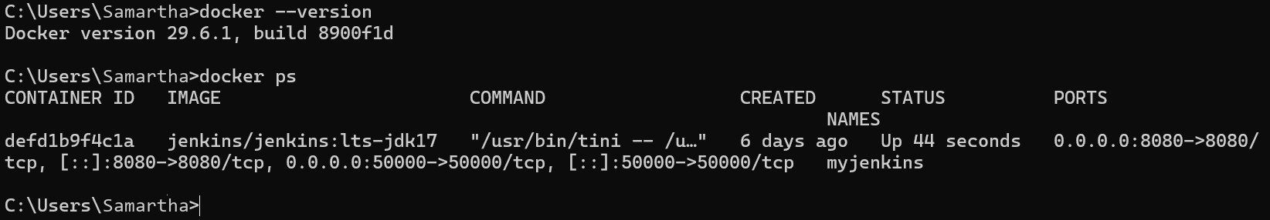  Verified Docker and Jenkins Container — Verified Docker installation and confirmed that the Jenkins Docker container (myjenkins) was running successfully.  Step 2: Access Jenkins Dashboard  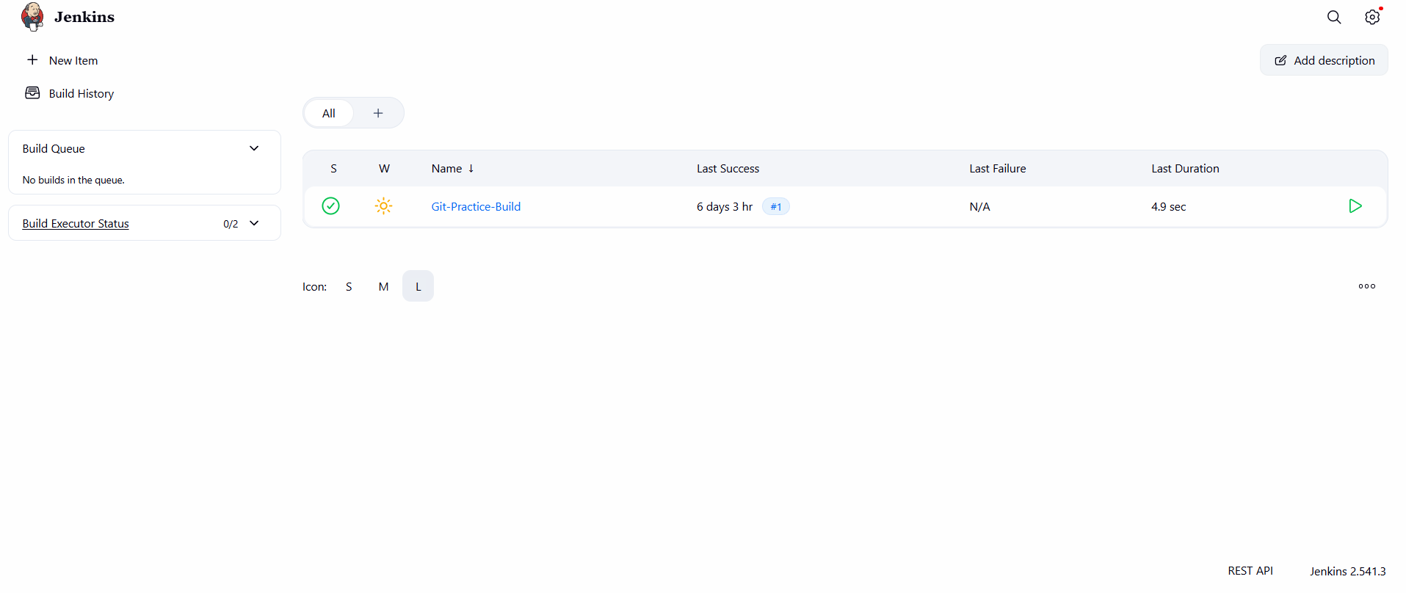  Accessed Jenkins Dashboard — Successfully accessed the Jenkins Dashboard and verified that the existing Freestyle project (Git-Practice-Build) was available.  Step 3: Verify Git Plugin Installation  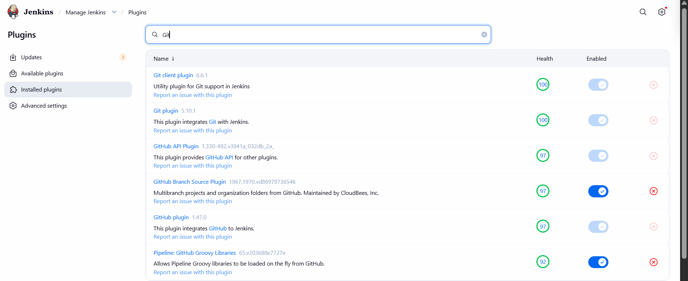  Verified Git Plugin — Verified that the Git plugin was installed and enabled, allowing Jenkins to integrate with Git repositories for source code management.  Step 4: Open the Freestyle Project  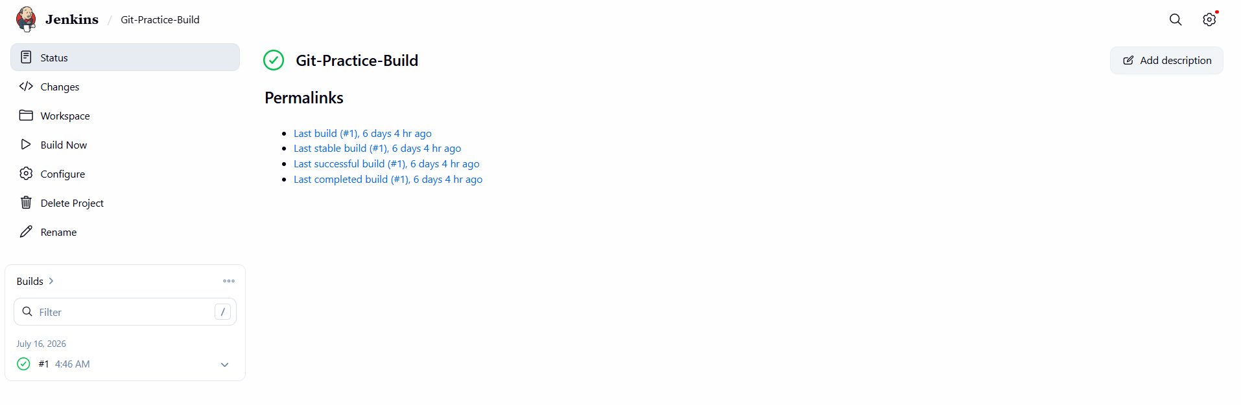  Opened Freestyle Project — Opened the existing Freestyle project (Git-Practice-Build) to verify its configuration and prepare it for executing the build process.  Step 5: Verify Source Code Management (Git)  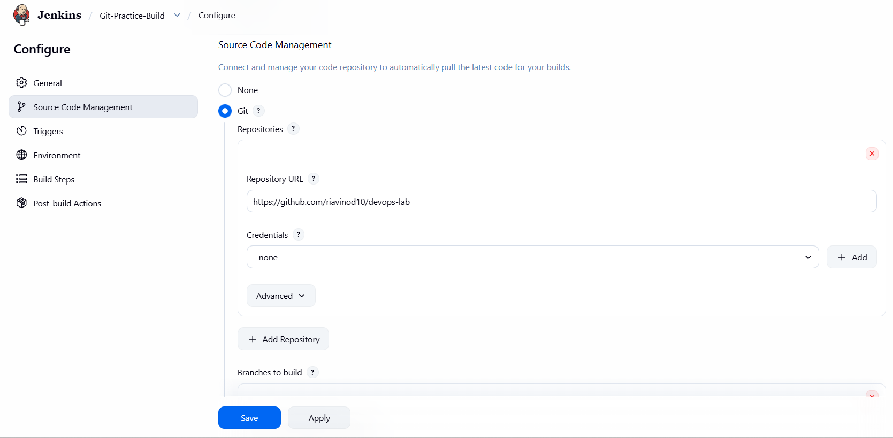  Configured Source Code Management — Configured the Freestyle project to retrieve source code from the GitHub repository by selecting Git as the Source Code Management option and specifying the repository URL.  Step 6: Verify Build Step  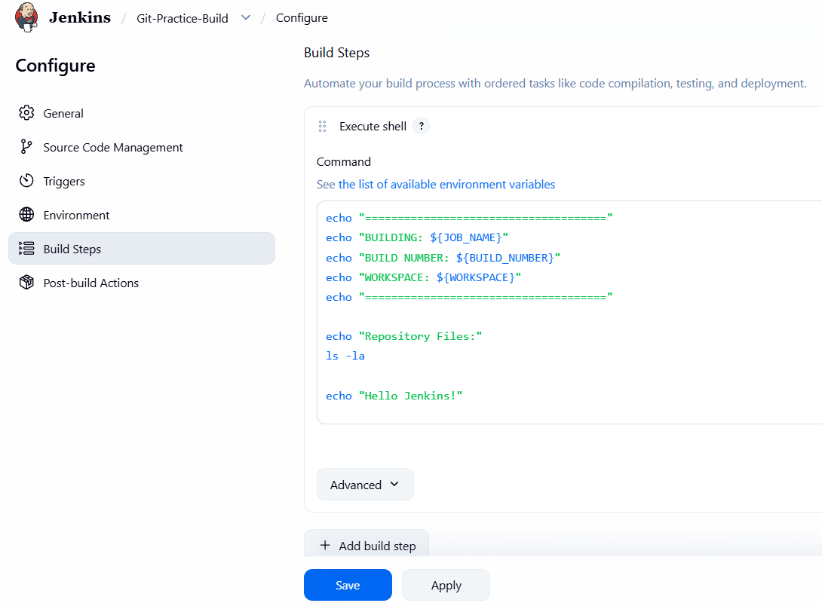  Configured Build Step — Verified the Execute shell build step containing shell commands to display build information, list the repository files, and print a sample message during the build process.  Step 7: Save and Run the Build  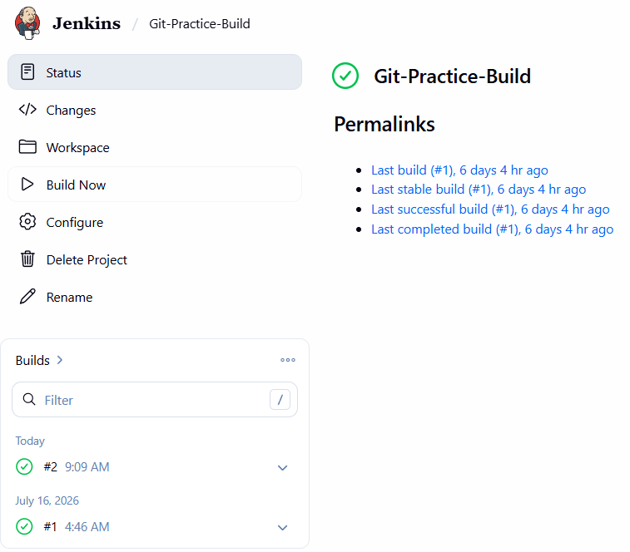  Executed Build — Successfully executed the Freestyle project using Build Now and verified that the build completed successfully with a SUCCESS status.  Step 8: View Console Output  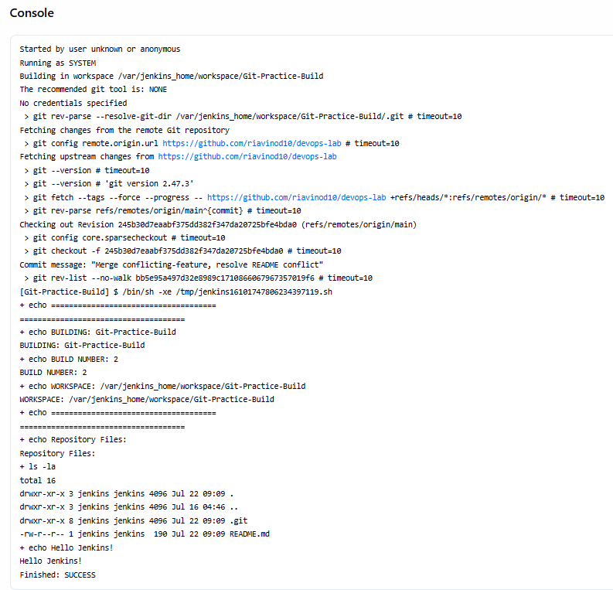  Verified Console Output — Examined the console output and verified that Jenkins successfully cloned the Git repository, executed the configured shell commands, and completed the build with a SUCCESS status.

Subject Faculty Name: Prof. Arijit Dutta

