
SYMBIOSIS INSTITUTE OF TECHNOLOGY, PUNE
Symbiosis International (Deemed University)
(Established under section 3 of the UGC Act, 1956)
Re-accredited by NAAC with ‘A’ grade (3.58/4) | Awarded Category – I by UGC
Founder: Prof. Dr. S. B. Mujumdar, M. Sc., Ph. D. (Awarded Padma Bhushan and Padma Shri by President of India)

Assignment No. 11

Subject: | DevOps Lab
TCODE: | TE7950
Name of Student | Samartha Shrestha
PRN No. | 23070122189
Branch | CSE, Batch (2023-27), L3
Academic Year &  Semester | 2026, Sem VII
Date of Performance | 23rd July, 2026
Title of Assignment: | Docker Compose for Multi-Container App
Theory: | Docker Compose is a tool used to define and manage multi-container Docker applications using a single docker-compose.yml file. It allows multiple services, such as a web application and a database, to be configured, started, and managed together with a single command. Docker Compose automatically creates a network for communication between services, manages named volumes for persistent storage, and simplifies deployment by eliminating the need to start each container individually. This makes it easier to develop, test, and maintain applications that consist of multiple interconnected containers.  Commands Used  - Created a new project directory and navigated into it:  mkdir my-multi-app  cd my-multi-app  - Started the multi-container application in detached mode:  docker compose up -d  - Verified the running containers:  docker compose ps  (or docker ps if docker compose ps was not available)  - Stopped and removed the containers and network created by Docker Compose:  docker compose down
Step 1: Create the Project Directory
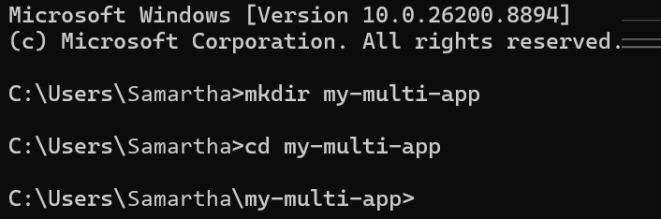
Created Project Directory — Created a new project directory named my-multi-app and navigated into it to store the Docker Compose configuration.
Step 2: Create docker-compose.yml
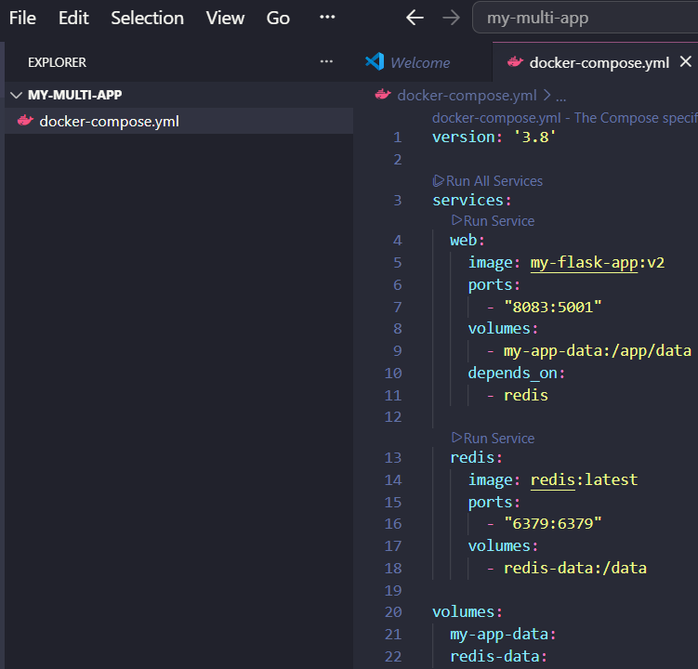
Created Docker Compose Configuration — Created and saved the docker-compose.yml file defining the Flask web service, Redis service, Docker volumes, and networking configuration for the multi-container application.
Step 3: Start the Multi-Container Application
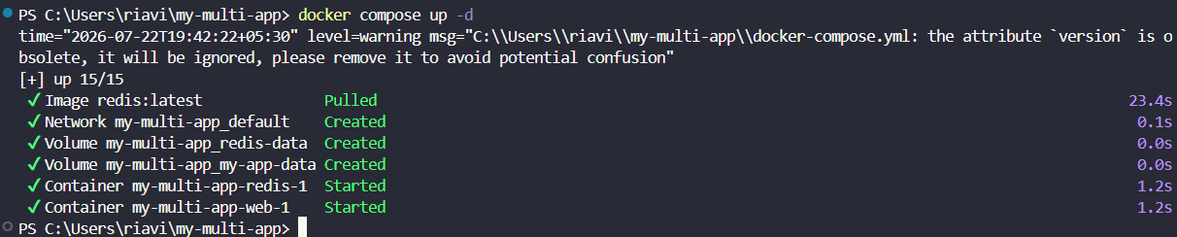
Started Multi-Container Application — Started the multi-container application using Docker Compose, which created the required network, volumes, and launched both the Flask web service and Redis service.
Step 4: Access the Web Application
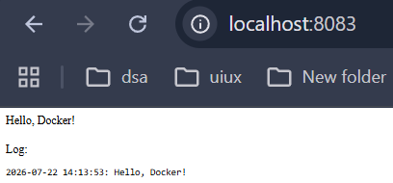
Verified Web Application — Accessed the Flask application through http://localhost:8083 and verified that the web service was successfully running as part of the Docker Compose application.
Step 5: Verify the Running Services
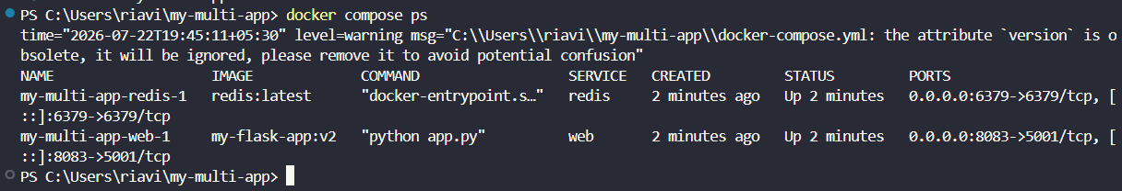
Verified Running Services — Verified that the Docker Compose application was running successfully by listing the active containers, including the Flask web service and the Redis service.
Step 6: Stop and Remove the Multi-Container Application
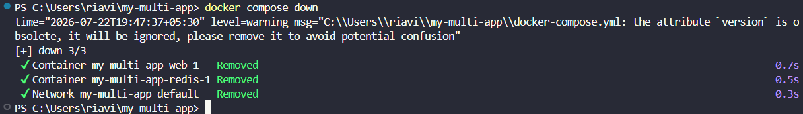
Stopped Multi-Container Application — Stopped and removed the Docker Compose application, including the running containers and the automatically created network, using the docker compose down command.

Subject Faculty Name: Prof. Arijit Dutta

