
SYMBIOSIS INSTITUTE OF TECHNOLOGY, PUNE
Symbiosis International (Deemed University)
(Established under section 3 of the UGC Act, 1956)
Re-accredited by NAAC with ‘A’ grade (3.58/4) | Awarded Category – I by UGC
Founder: Prof. Dr. S. B. Mujumdar, M. Sc., Ph. D. (Awarded Padma Bhushan and Padma Shri by President of India)

Assignment No. 04

Subject: | DevOps Lab
TCODE: | TE7950
Name of Student | Samartha Shrestha
PRN No. | 23070122189
Branch | CSE, Batch (2023-27), L3
Academic Year &  Semester | 2026, Sem VII
Date of Performance | 16th July, 2026
Title of Assignment: | Jira Project & Issue Tracking
Theory: | Jira is a project management and issue tracking tool developed by Atlassian that helps teams plan, organize, assign, and monitor project tasks efficiently. It supports Agile methodologies such as Scrum and Kanban, allowing teams to manage work through customizable workflows.  In this experiment, a Team-managed Kanban project was created to simulate a software development workflow. Three different issue types—Story, Task, and Bug—were created to represent a feature request, a development task, and a software defect. These issues were tracked visually on the Kanban board by moving them through the workflow stages To Do, In Progress, and Done.  This experiment demonstrates how Jira helps in organizing project activities, tracking task progress, managing software issues, and improving collaboration among team members using an efficient issue-tracking system.
Implementation: | Step 1: Create a New Jira Project  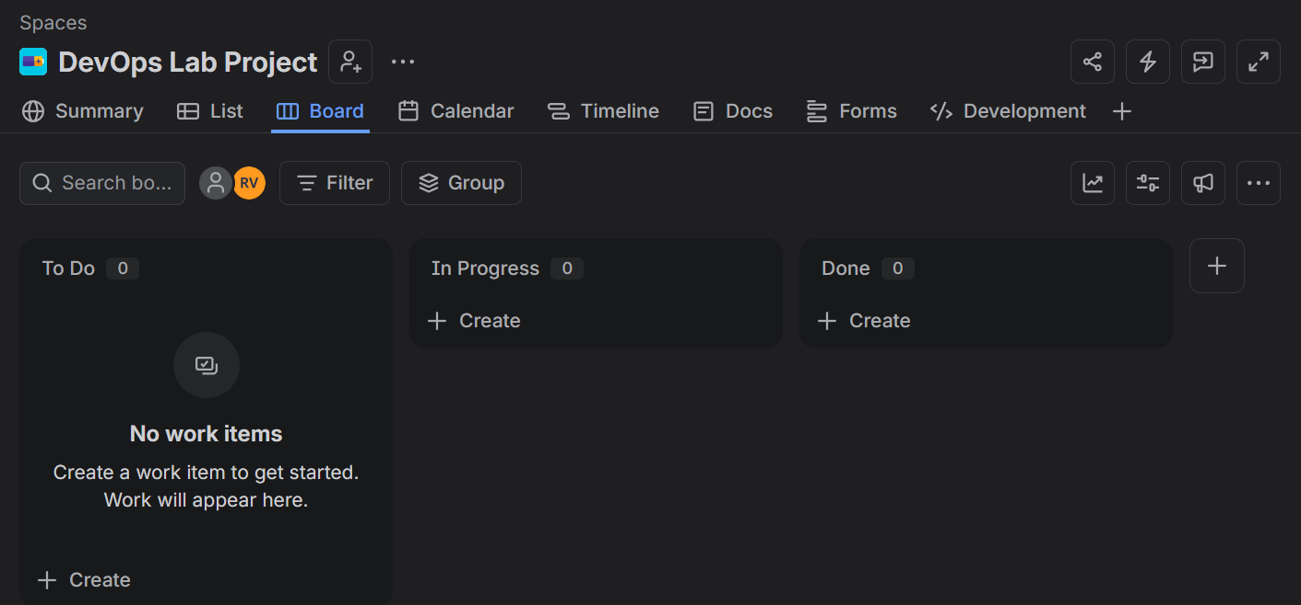  Created Kanban Project — Successfully created a Team-managed Kanban project named DevOps Lab Project and verified the Kanban board with the default workflow columns (To Do, In Progress, and Done).  Step 2: Create a Story Issue  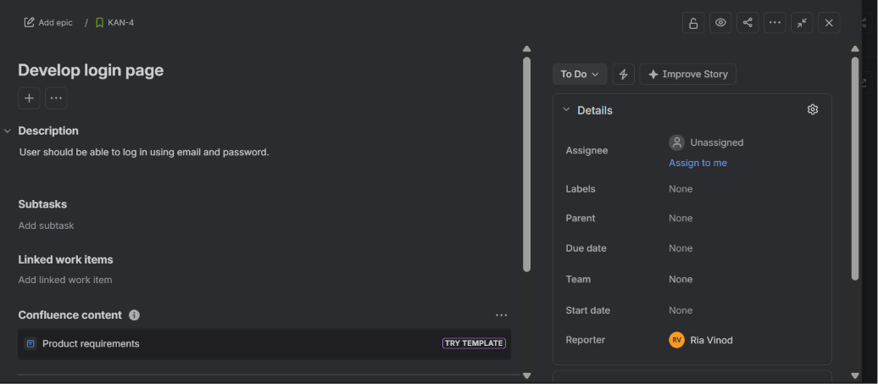  Created Story Issue — Created a Story issue named Develop login page with the description "User should be able to log in using email and password" to represent a new feature in the project.  Step 3: Create the Task Issue  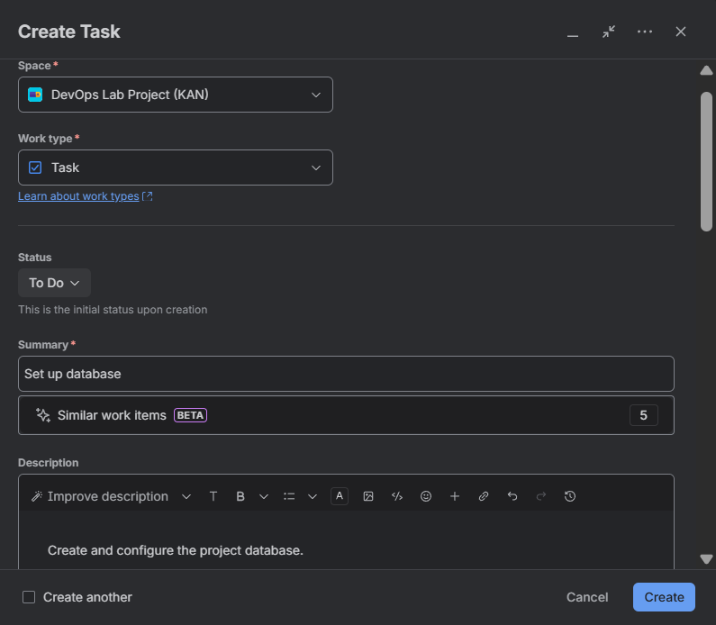  Created Task Issue — Created a Task issue named Set up database with the description "Create and configure the project database" to represent a development task in the project.  Step 4: Create the Bug Issue  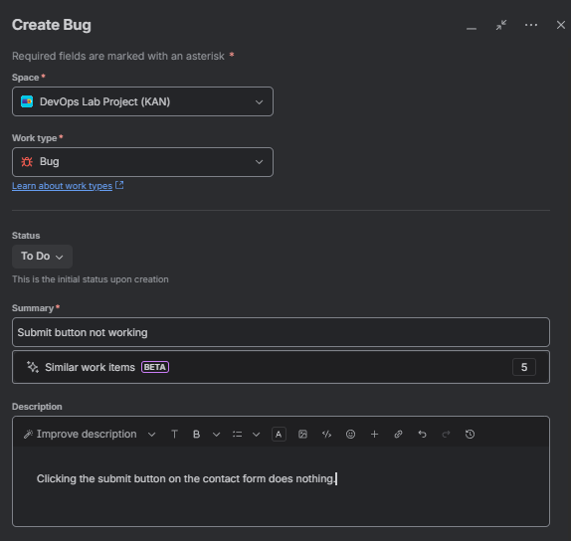  Created Bug Issue — Created a Bug issue named Submit button not working with the description "Clicking the submit button on the contact form does nothing" to report a defect in the application.  Step 5: Verify All Issues on the Board  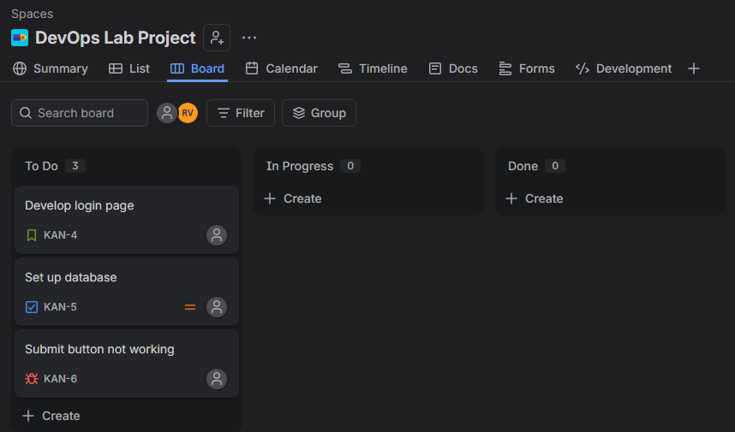  Initial Board View — Verified that the Story, Task, and Bug issues were successfully created and appeared in the To Do column of the Kanban board.  Step 6: Move the Task  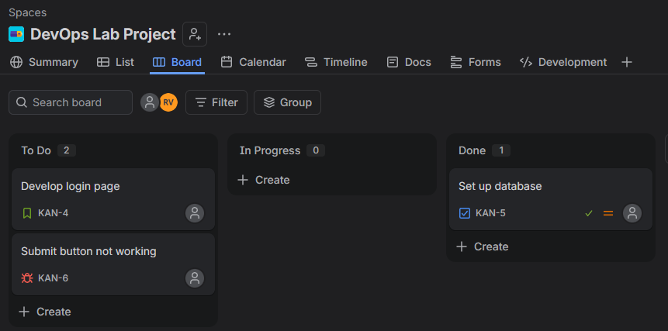  Task Completed — Moved the Set up database task from To Do to Done, indicating successful completion of the task.  Step 7: Move the Story  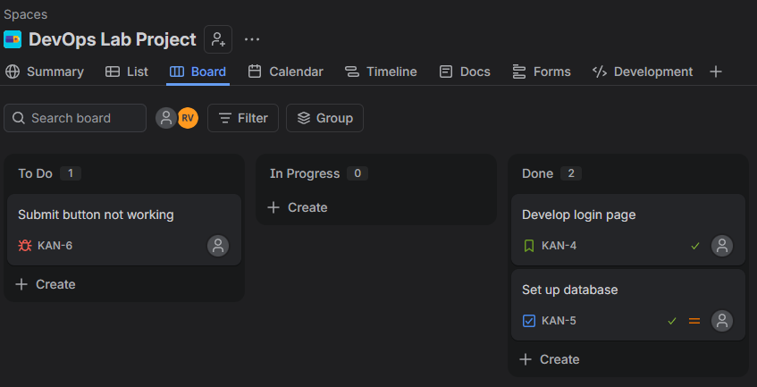  Story Completed — Moved the Develop login page Story issue from To Do to Done, indicating successful completion of the feature implementation.  Step 8: Move the Bug  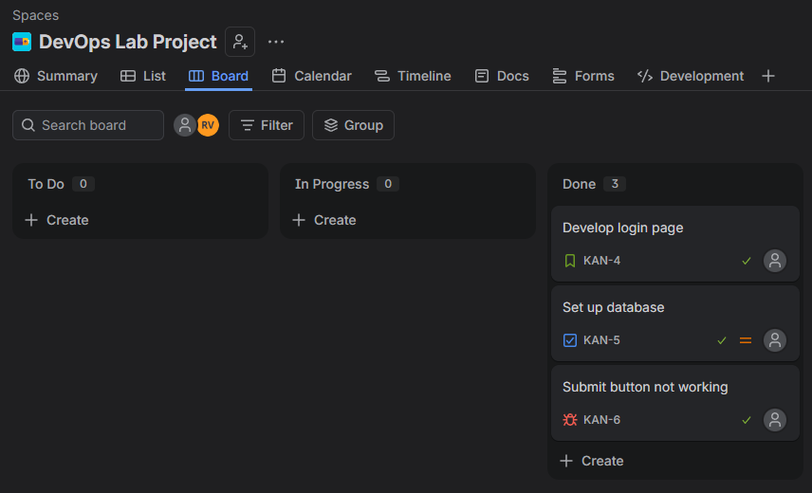  Bug Resolved — Moved the Submit button not working Bug issue from To Do to Done, indicating that the reported defect was successfully resolved.  Step 9: Final Verification  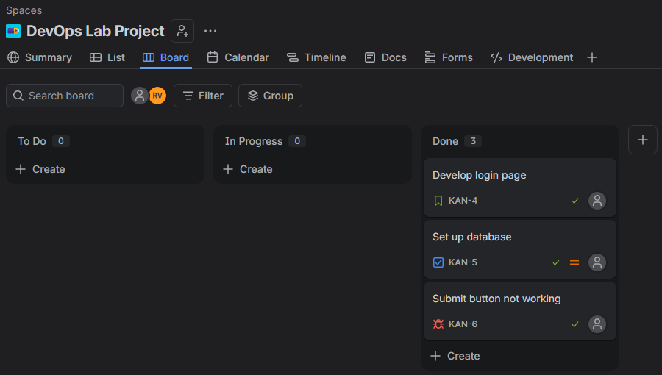  Project Verification — Verified that all issues were successfully created and progressed through the Kanban workflow from To Do to Done, demonstrating effective issue tracking and project management in Jira.

Subject Faculty Name: Prof. Arijit Dutta

