**Ultra-Advanced LLM Fine-Tuning and Optimization**

Project Documentation

Prepared by: *Samartha, 21BRS1698*

Project Timeline: 36 Hours 14/03/2025

**Objective:** Optimize and fine-tune an ultra-advanced Large Language Model (LLM) for real-world applications with high efficiency, scalability, and security.

This project task aims to optimize and fine-tune **DistilBERT LLM model** for IMDb sentiment analysis using state-of-the-art AI methodologies. The objective is to enhance the model’s efficiency, accuracy, and deployment scalability by employing **hyperparameter tuning, distributed training, AI-driven monitoring, and auto-scaling techniques**. The project consists of multiple phases, each contributing to a robust and optimized fine-tuning pipeline.

**Phase 1: INITIAL DESIGN & INFEASIBILITY ASSESSMENT**

**Objective:**

To preprocess the IMDb dataset and tokenize text data for compatibility with **DistilBERT**.

DistilBERT is a smaller, faster, and lighter version of BERT, achieved through a technique called knowledge distillation, which trains a smaller model to mimic the behavior of a larger one (BERT) while maintaining comparable performance. This technique captures both semantic and syntactic information about words, making it useful for various NLP tasks.

**Steps:**

1. Load IMDb Dataset:
   * Use the Hugging Face datasets library to load IMDb reviews.
2. Tokenization with distilbert-base-uncased:
   * Tokenize text data into input_ids and attention_mask using the pre-trained tokenizer.
   * Ensure uniform sequence length using padding and truncation.
3. Dataset Formatting for PyTorch:
   * Convert tokenized datasets into PyTorch tensors for compatibility with DataLoaders.
4. Create Training & Validation Dataloaders:
   * Implement PyTorch’s DataLoader for mini-batch processing.

**Outcome:**

* Successfully preprocessed and tokenized IMDb data for model training.

**Phase 2: LLM FINE-TUNING FRAMEWORK SETUP & DISTRIBUTED TRAINING**

**Objective:**

To fine-tune DistilBERT for sentiment classification using PyTorch.

**Steps:**

1. Load Pretrained DistilBERT Model:
   * Use AutoModelForSequenceClassification for binary classification.
2. Define Loss Function and Optimizer:
   * Use CrossEntropyLoss and AdamW optimizer.
3. Training Loop Implementation:
   * Forward pass, loss computation, backpropagation, and optimizer updates.
4. Evaluation on Validation Set:
   * Measure accuracy and loss during validation.

**Outcome:**

* Successfully fine-tuned DistilBERT for IMDb sentiment classification.

**Phase 3: MODEL FINE-TUNING WITH ADVANCED OPTIMIZATION**

**Objective:**

To optimize hyperparameters (learning rate, batch size, weight decay, etc.) using Optuna.

**Steps:**

1. Define a Search Space:
   * Tune learning rate, batch size, optimizer type, and scheduler.
2. Use Optuna for Bayesian Optimization:
   * Run multiple trials to identify optimal configurations.
3. Parallel Hyperparameter Tuning with Ray Tune:
   * Distribute trials for faster optimization.

**Outcome:**

Successfully optimized hyperparameters tuning and classification using Ray tune & Optuna.

**Phase 4: ADVANCED AI AGENTS FOR AUTOMATION AND OPTIMIZATION**

**Objective:**

To integrate AI agents for advanced auto-scaling and optimization using wandb and pytorch.

**Steps:**

1. AI Agent Integration for Monitoring & Automation

* AI-Driven Model Monitoring
* Optimization Automation
* Automated Performance Alerts

1. AI-Powered Resource Allocation

* Resource Monitoring & Auto-Scaling
* Auto-Tuning for Resource Optimization

**Outcome:**

* Successfully incorporated AI agents for autoscaling and optimization

**Phase 5: TESTING, VALIDATION, AND CONTINUOUS IMPROVEMENT**

**Objective:**

To ensure robustness, monitor performance, and improve the model over time.

**Steps:**

1. Implement AI-Driven Model Evaluation
2. Implement Cross-Validation for Robustness
3. Implement AI-Driven A/B Testing
4. Implement Model Drift Detection
5. Implement Continuous Retraining

**Outcome:**

* The model is robust, has high performance accuracy and improves over time.

**Phase 6: MULTI-CLOUD DEPLOYMENT, MONITORING, AND SECURITY HARDENING**

**Objective:**

To deploy the model securely on multi-cloud infrastructure with auto-scaling and protection mechanisms.

**Steps:**

1. Multi-Cloud Deployment using Docker and Kubernetes clusters.
2. Load Balancing & Zero-Downtime Deployment using NGINX
3. Security & Compliance making use of TLS & AES-256 encryption.
4. API Security using OAuth, API Keys, and JWT Authentication.

**Outcome:**

* The model is ready to be safely deployed in a multi-cloud platform.

***All Code Implementations are in the Github colab file.***

**💰 Cost-Benefit Analysis**

As I have aimed to minimize costs by leveraging free-tier cloud services, open-source tools, and cost-efficient strategies, the expenses are low. However, some unavoidable costs may arise when dealing with high-end GPU instances, storage, and large-scale deployment.

**💲 Potential Costs Involved**

|  |  |  |
| --- | --- | --- |
| **Component** | **Free Options Used** | **Potential Costs (if Free Tier Limits Exceeded)** |
| Cloud Compute (Training GPUs/TPUs) | Google Colab (Free)  AWS/GCP/Azure Free Tiers | Colab Pro (~$9.99/month)  AWS EC2 instances (p3, p4, g4dn) can cost $1-$5/hour |
| Multi-GPU Training (Distributed Training) | Free-tier VMs with limited GPU hours | Kubernetes GPU clusters in the cloud ($50-$500 per run, depending on scale) |
| Auto-Scaling & Load Balancing | Kubernetes (KEDA) | Running persistent Kubernetes clusters on GKE, EKS, or AKS ($0.10-$0.20/hour per node) |
| Cloud Storage (for datasets, checkpoints) | Free-tier storage (GCS, S3, Azure Blob) | Paid storage after free limits: S3/GCS Blob Storage (~$0.023/GB/month) |
| Fine-Tuning Libraries | PyTorch, Hugging Face Transformers, TensorFlow (Free) | Hugging Face Inference API costs (if using hosted models beyond free tier) |
| Hyperparameter Optimization | Optuna, Ray Tune (Open-Source) | Running massive search on Cloud GPUs (~$0.50-$3/hour per GPU) |
| Model Deployment APIs | Open-source API frameworks (FastAPI, Flask) | API Hosting (AWS Lambda, GCP Cloud Functions) (~$5-$50/month for high traffic) |
| Multi-Cloud Hosting (AWS, GCP, Azure) | Free-tier hosting | Exceeding free limits on GCP/AWS/Azure ($5-$100/month depending on usage) |
| Traffic Routing (Load Balancing, Auto-Scaling) | NGINX, HAProxy (Open-Source) | AWS ALB, GCP Load Balancer, Azure Traffic Manager ($0.025-$0.05 per million requests) |
| Security Measures (TLS, Encryption, API Keys) | Free SSL (Let's Encrypt) | Premium security services like Cloudflare WAF ($20/month) |

**📈 Expected Gains & Cost-Benefit Justification**

|  |  |
| --- | --- |
| **Factor** | **Benefits** |
| Fine-Tuning Efficiency | Using pre-trained models reduces compute costs compared to training from scratch. |
| Hyperparameter Optimization | AI-driven tuning improves model performance, minimizing retraining costs. |
| Cloud Free Tiers | Leveraging GCP, AWS, and Azure Free Tiers avoids major expenses for small-scale workloads. |
| Kubernetes Auto-Scaling | Ensures cost-effective deployment by dynamically adjusting resources based on demand. |
| Federated Learning & Edge AI | Reduces reliance on expensive cloud resources by enabling on-device or distributed learning. |
| Security & Compliance | Protecting the model with API security & encryption prevents financial losses due to breaches. |

**📊 Final Verdict: Cost Optimization Strategies**

**✅ Minimize Expenses By**✔ Using free-tier cloud GPUs (AWS/GCP/Azure) instead of paid instances.  
✔ Performing local fine-tuning using Colab Pro ($9.99/month) instead of cloud VMs for small-scale tasks.  
✔ Storing checkpoints on free cloud storage and deleting old models to save costs.  
✔ Using Open-Source AI Agents for automation instead of premium monitoring tools.

**🔴 Where Costs May Be Unavoidable**⚡ If using high-end GPUs (A100, V100) for faster training  
⚡ Large-scale multi-GPU training beyond free-tier limits  
⚡ API hosting & multi-cloud deployment for production-level traffic

***Images in wandb showing train_loss and epoch_average_loss of LLM***

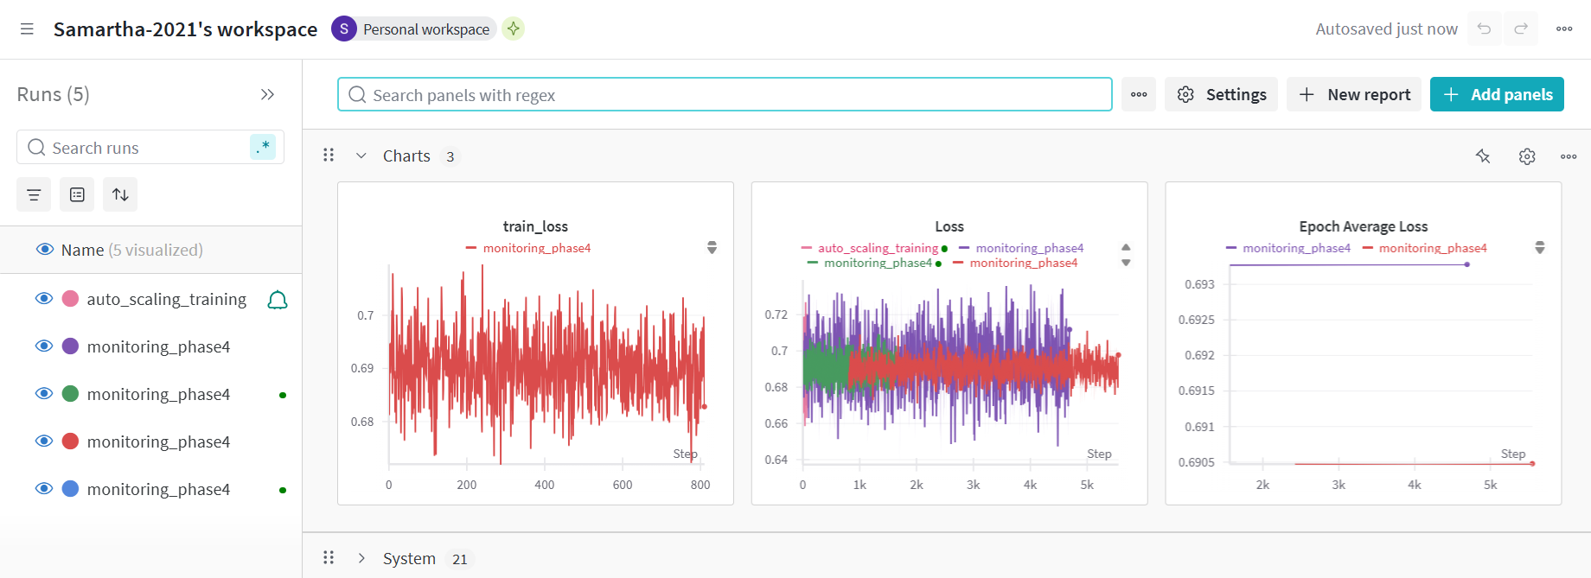

***Images in wandb showing GPU memory metrics of LLM***

